


Version: 5.1.2
Published date: August 2026
Copyright © 2026 by ESW. All rights reserved. Information contained herein is subject to change without notice.

Global Returns INTEGRATION GUIDE

SFCC - ESW Cartridge
+
Contents
1 Global Returns 3
1.1 Package Exports 3
1.1.1 Feature configuration 3
1.1.2 Manual Export 3
1.1.3 Automated Export 7
1.2 ESW->SFCC Order Return 7
1.2.1 ESW Webhooks Configuration 8
1.2.2 Workflow to Return Order in SFCC 8
2 Global Return Integration Configuration 8
2.1 Import Metadata 8
2.2 Cartridge Path 9
2.3 EswOAuthService 9

Global Returns
ESW SFCC Cartridge provides the capability to synchronize the returns initiated on ESW returns portal. When an order is marked for returns on ESW returns portal, relevant returns payload information is stored in SFCC custom order attributes which can be used to further synchronize with other downstream systems.
  - Package Exports

ESW cartridge allows to manage the package ASN from the Business Manager.

    - Feature configuration
The feature can be controlled from the BM module. Clicking on the link from Merchant Tools > ESW > Cartridge Management and then Returns > Returns Configuration will open the returns configuration page. The preference ESW Checkout Only Package Export can be used as a toggle switch for this feature. 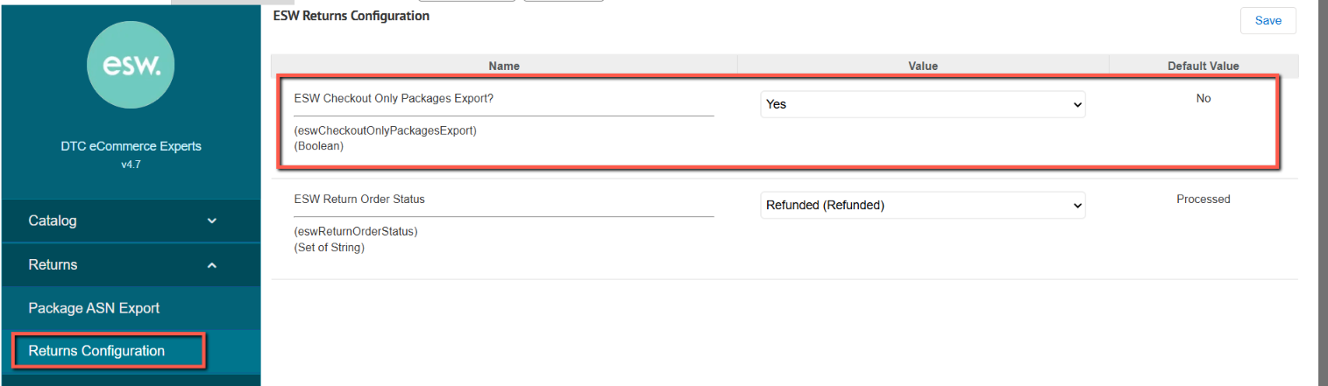
    - Manual Export

Navigate to Merchant Tools > ESW > Cartridge Management
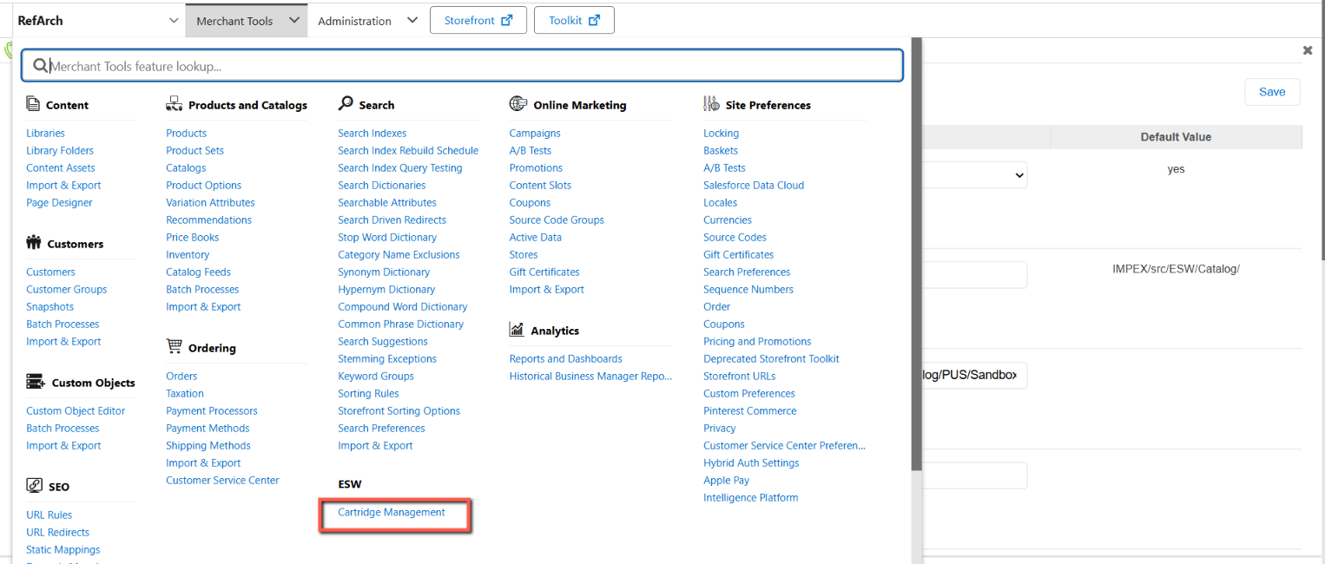

And then Returns > Package ASN Export. The following screen will be displayed, showcasing the orders. 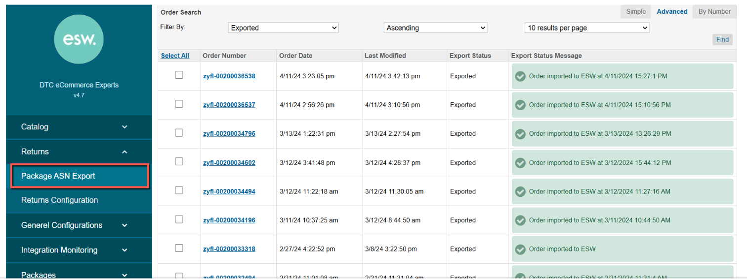

Selected orders’ ASNs can be exported manually by selecting the orders and clicking Export Selected. Here are the details, regarding the custom action and fields on the page
- Export All: This button is used to Export All the non exported ASNs.
- Export Selected: This button is used to export selected ASNs.
Export Status and Export Status Message will be updated
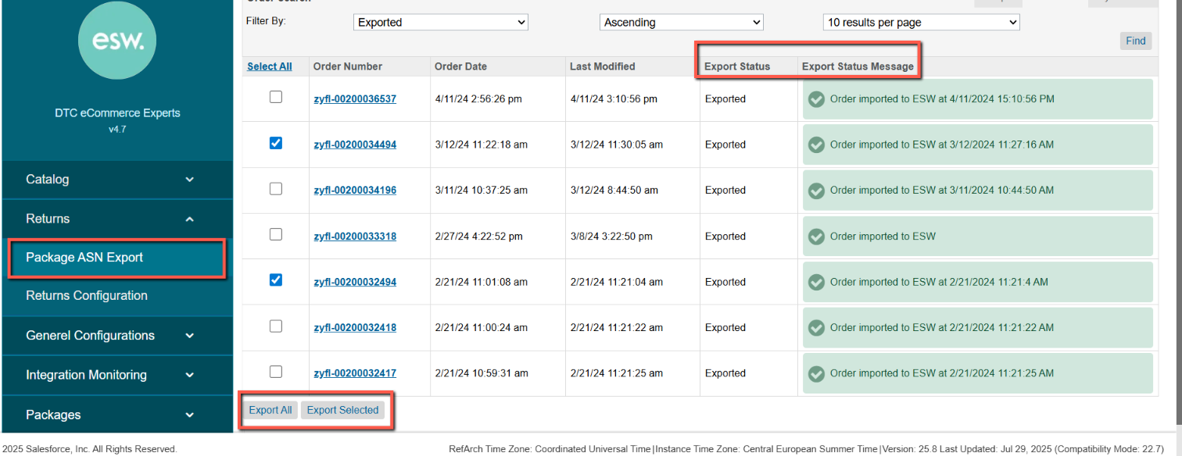

Field | Description | Status
Export Status | This field indicates if the ASN is exported to ESW | Exported: Indicates that the order’s package ASN has been successfully exported to ESW  Not Exported: Indicates that the order’s package ASN has not been exported to ESW yet.  Export Failed: Indicates that the package export has been failed
Export Status Message | This field indicates the export status of the package ASN with ESW along with the timestamp | Waiting for export: Indicates a newly shipped order for which the package ASN has not been exported yet.  Order imported to ESW: Indicates that order has been imported into ESW successfully  Apart from the above values, the package API’s status messages will show incase of any error.

Within the shipment details of a specific order, users can review the information pertaining to ASN (Advanced Shipping Notice) export. The attribute labelled "ESW Outbound Shipment Response" provides insight into the response generated by the ESW's Package ASN. In the event of an error, the response also contains detailed information about the specific error encountered.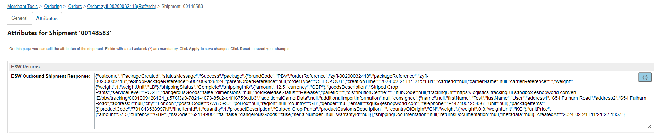

Furthermore, in the case of orders where ASN exports have been successfully completed, the order level attribute is set to "true."
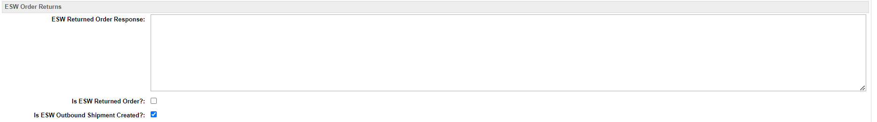

    - Automated Export
The outlined procedure can be automated through the execution of the following job. Initiating this job will facilitate the export of ASNs specifically for orders marked with a "shipped" status.
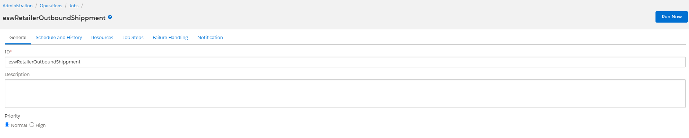

  - ESW->SFCC Order Return

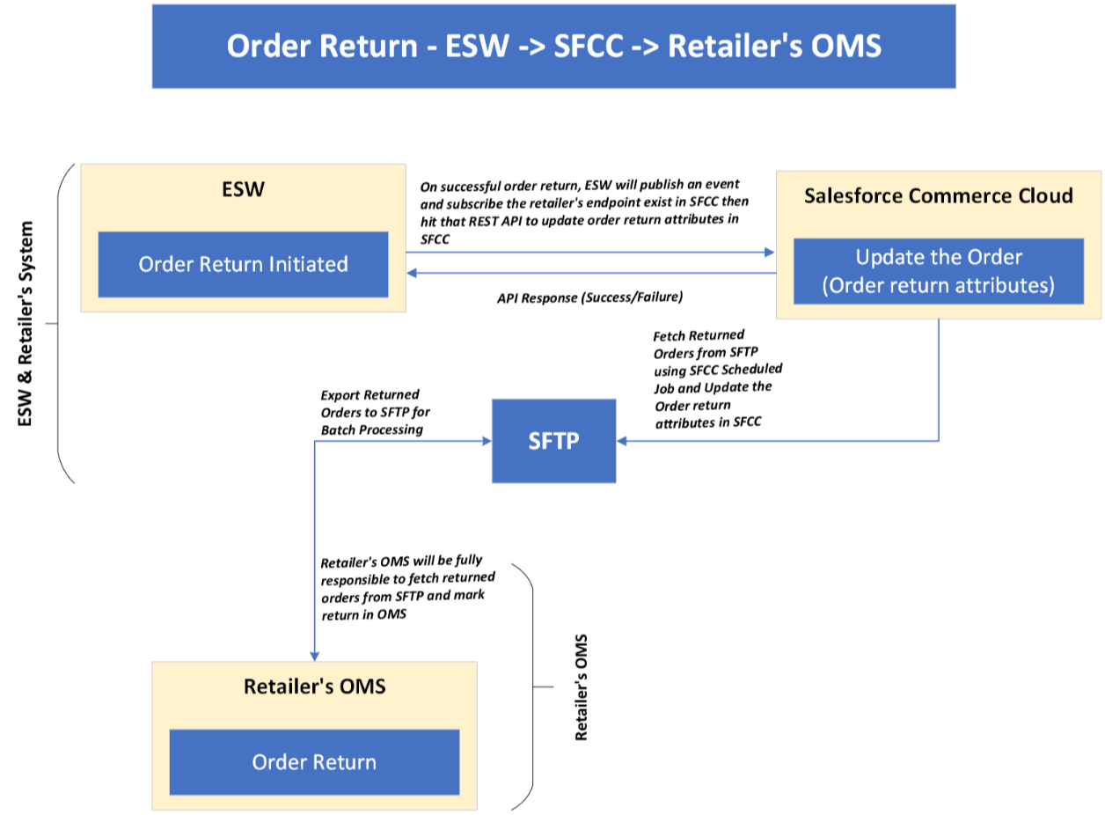
    - ESW Webhooks Configuration
Retailers need to subscribe SFCC API endpoint in ESW tenant configuration that will trigger on OrderReturnSucceedEvent. The ESW-SFCC cartridge provides the OOTB SFCC endpoint to subscribe with ESW order cancellation webhook event. ESW integration engineer can help retailers to subscribe this endpoint.
SFCC Endpoint Example:
https://example.com/on/demandware.store/Sites-RefArch-Site/default/EShopWorld-ProcessWebHooks
Retailers can update example.com with their storefront domain.
    - Workflow to Return Order in SFCC
The ESW-SFCC Cartridge performs the following actions to return the order in SFCC if the order is returned from ESW CSP first. This synchronizes the order status in both systems.
On successful order return in ESW CSP, webhook will trigger the retailers provided subscribed SFCC endpoint (EShopWorld-ProcessWebHooks) with returned order detail in request body.
- SFCC endpoint will park cancelled order data in SFCC custom objects eswRmaJson and make eswIsReturned as true like below.
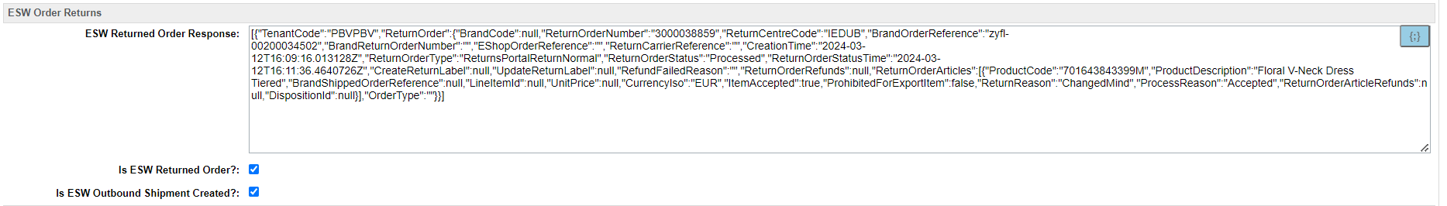

Global Return Integration Configuration
  - Import Metadata
Import order level custom attributes (systemobjects.xml) from link_eshopworld\Metadata\meta.
The following ESW Order Returns custom attribute group will be present in Order Custom Attributes:
- ESW Return Order Response: This custom attribute will be filled with transaction reference if order successfully or even unsuccessfully returned in ESW and this will be in ESW Order API response.
- Is ESW Returned Order?: This mark order as return.
- Is ESW Outbound Shipment Created?: Shows if the orders ASN has been successfully exported

The following attribute will be present in the shipment custom attribute
- ESW Outbound Shipment Response: This attribute will be populated with Package ASN response from ESW.
  - Cartridge Path
The ESW BM cartridge should be set in the cartridge path to view the catalog menu. The path in BM should be set as int_eshopworld_core:bm_eshopworld_core:bm_custom_plugin
  - EswOAuthService
This service is used to get the authentication token from ESW. This token is used by other ESW services and APIs, such as Price Feed, Checkout, and Package.
Services can Import service from link_eshopworld\Metadata\services.xml
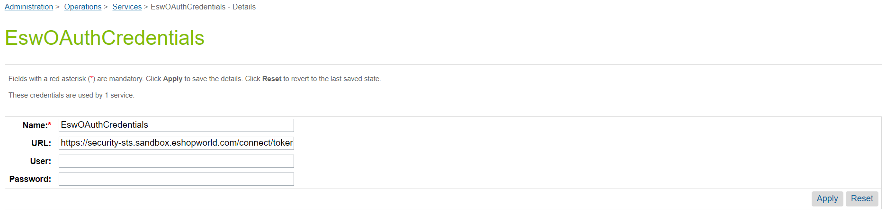
ESW OAuth Credentials

