


Version: 5.1.2
Published date: August 2026
Copyright © 2026 by ESW. All rights reserved. Information contained herein is subject to change without notice.

ESW INTEGRATION MONITORING GUIDE

SFCC - ESW Cartridge
+

Contents
- ESW Integration Monitoring 3
  - ESW Integration Monitoring Menu………………….………………………………………....……….3
  - ESW Integration Monitoring Report Fields………...………………………………………….…...….5

- ESW Integration Monitoring Configuration 6
  - ESW Integration Monitoring Menu………………….………………………………………………….6
  - Cartridge Path……………………………………………………………………………………………7

ESW Integration Monitoring
The ESW Integration Monitoring module provides a comprehensive configuration analysis report for plugins within Salesforce Commerce Cloud (SFCC). This report serves as a valuable resource for identifying and troubleshooting potential issues stemming from misconfigurations. By leveraging the generated report, users gain the ability to:

- Proactively Identify Misconfigurations: The report highlights deviations from recommended or expected plugin configuration settings. This proactive approach helps to prevent unexpected behaviour or functionality issues within the plugins.

- Expedite Troubleshooting: The detailed report streamlines the troubleshooting process by pinpointing potential configuration errors that might be causing problems. This allows users to focus their efforts on resolving the root cause of the issue more efficiently.

The Plugin Integration Monitoring tool, through its configuration analysis report,
empowers users to maintain optimal plugin functionality and performance within their
SFCC environment.

  - ESW Integration Monitoring Menu

ESW cartridge allows to manage the Integration Monitoring from the Business Manager.

Navigate to Merchant Tools > ESW > Integration Monitoring

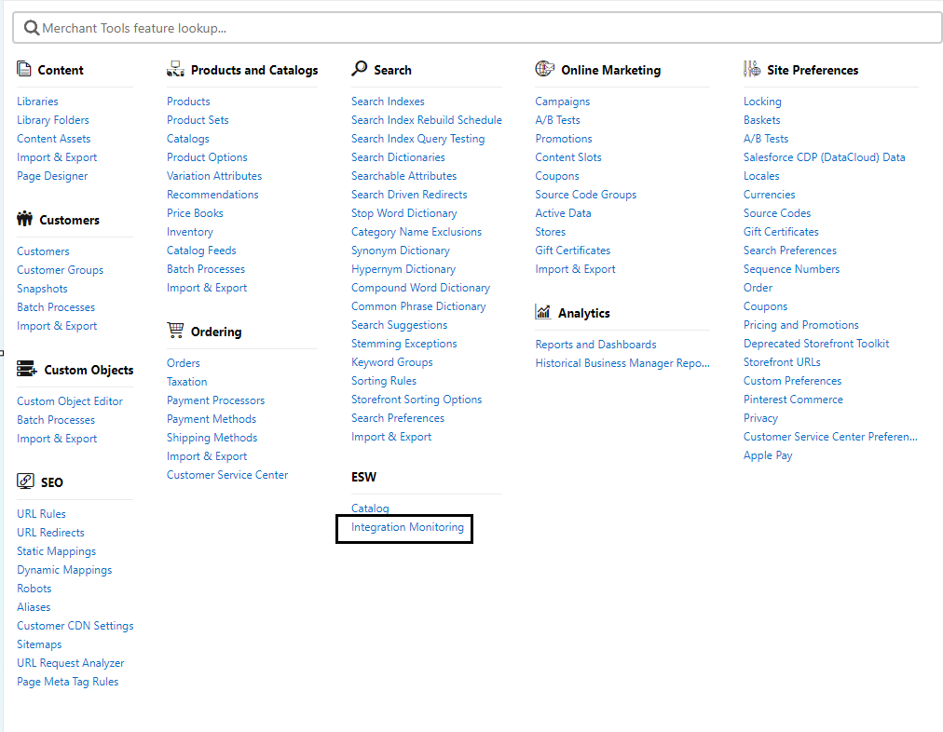

Upon navigation, the following screen will be displayed, showcasing the PIM Report.

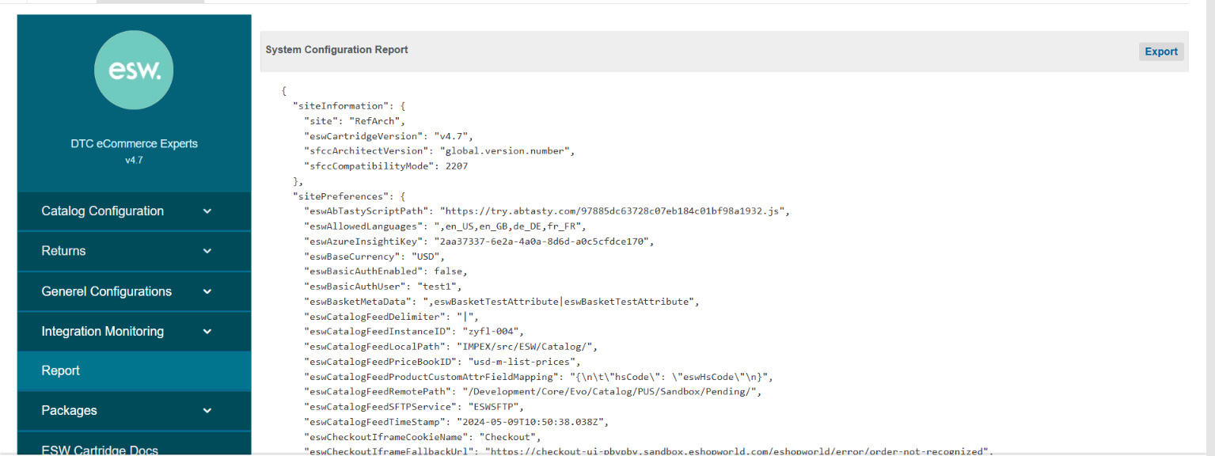

The integration monitoring report contain the System Configurations, Site Preferences, and custom object related data in JSON format.

- Export: This button is used to export/download the report.

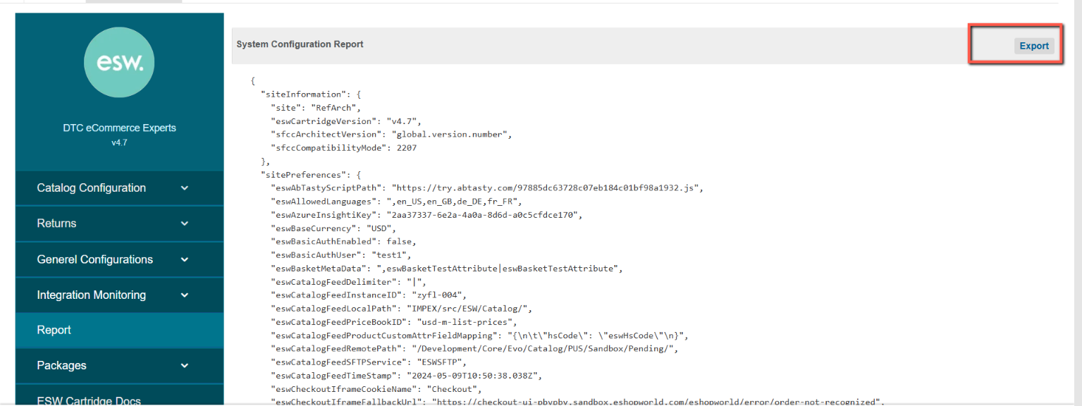

  - ESW Integration Monitoring Report Fields
Component | Included Fields
siteInformation | Site: site ID  eswCartridgeVersion: Esw Cartridge Version number  sfccArchitectVersion: SFCC Architect Version  sfccCompatibilityMode: SFCC Sandbox Compatibility Mode
sitePreferences | - Contains all information that is related to the Esw configs (all groups under custom site preferences)
customObjects | - All information related to all ESW related custom objects includes ESW_COUNTRIES, ESW_PA_DATA related configs
services | - All ESW related services along with URLs and service name includes, checkout pricing, auth and other package related services
globalConfigs | - Contains following:  - Allowed locales  - Allowed currencies  - Shipping methods configured  - Order related configurations

ESW Integration Monitoring Configuration

Import Metadata
Import Custom Object (customobjects.xml) from link_eshopworld\Metadata\meta.
The following ESW_INTEGRATION_MONITORING custom Object will be present in Custom Objects:

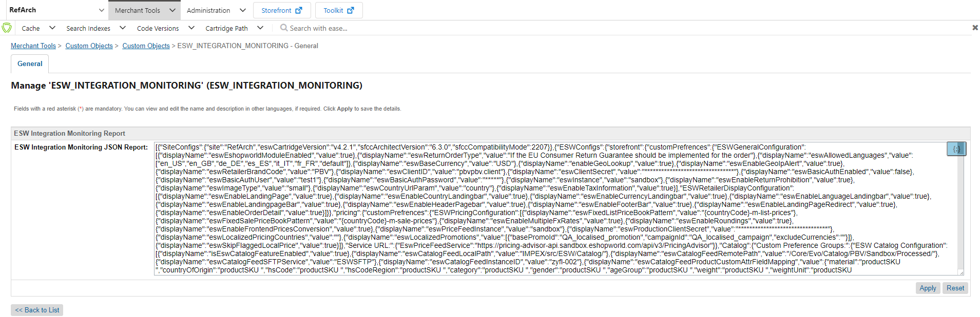

  - Cartridge Path
The ESW BM cartridge should be set in the cartridge path to view the Integration Monitoring menu. The path in BM should be set as
int_eshopworld_core:bm_eshopworld_core:bm_custom_plugin

Note: For the Business Manager (BM) user to successfully export a report that includes shipping methods, they must have access to the Shipping Module within the BM. Without this access, shipping information will not be retrievable and consequently, will not be included in the report

