


Version: 5.1.2
Published date: August 2026
Copyright © 2026 by ESW. All rights reserved. Information contained herein is subject to change without notice.

PAGE DESIGNER
INTEGRATION GUIDE

SFCC - ESW Cartridge
+
Contents
1. Page Designer 3
2. ESW Cartridge setup with SFCC Page Designer 3
2.1. Setup with SiteGenesis 3
2.2. Setup with SFRA 4
2.3. Import ESW sample pages 4
2.4. Setup Page using Page Designer 5

Page Designer

This feature enhances the capabilities of Salesforce Commerce Cloud (SFCC) by allowing retailers to create dynamic and localized front-end experiences for their shoppers. Here’s a breakdown of the key points:
- The Esw cartridge seamlessly integrates with the Page Designer module within SFCC.
- This integration enables retailers to design and customize their storefront pages with ease, enhancing the overall shopping experience for customers.
- By leveraging the ESW cartridge, retailers gain access to additional features and functionalities that go beyond the out-of-the-box capabilities of SFCC.

Localized Front-End Prices:
- The primary benefit of this integration lies in the ability to display localized front-end prices.
- Retailers can create dynamic pricing displays that cater to different regions, currencies, and languages.
- When designing pages using the Page Designer, retailers can add components specifically for showing prices in the shopper’s preferred currency.
- These localized prices are automatically converted based on exchange rates or other business rules.
- For example, if a shopper from Japan views a product, the ESW cartridge can dynamically convert the base price to Japanese Yen (JPY) and display it on the page.
- In summary, the ESW cartridge bridges the gap between the Page Designer and localized pricing, allowing retailers to enhance their storefronts and provide a personalized shopping experience for their customers. Whether on SFRA or SiteGenesis, this integration empowers retailers to showcase accurate and relevant prices to shoppers worldwide.

ESW Cartridge setup with SFCC Page Designer

Setup with SiteGenesis
Retailers can enable page designer support for site genesis using following:
- Make sure to upload following cartridges for storefront cartridge path
  - app_pagedesigner_sg
  - module_pagedesigner
- Add `bm_pagedesigner` to the cartridge path of the Business Manager site.
- For a SiteGenesis site, the cartridge path would look like this:
  - app_pagedesigner_sg:int_eshopworld_core:int_eshopworld_controllers:SG_core:SG_controllers:module_pagedesigner
- To support ESW cartridge following code changes are required if retailer already have enabled Page Designer support for SiteGenesis
  - In file “sg-pagedesigner\cartridges\app_pagedesigner_sg\cartridge\controllers\Page.js” Add following code in show() function 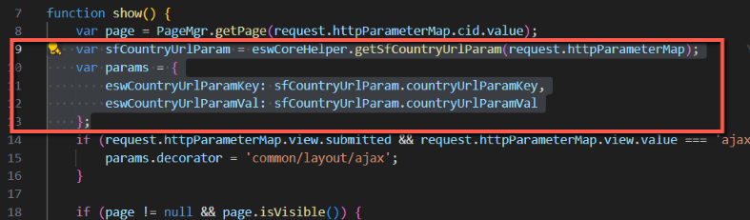

  - In file “sg-pagedesigner\cartridges\app_pagedesigner_sg\cartridge\scripts\util\Resource.ds” add highlighted code in function “ResourceHelper.getUrls” 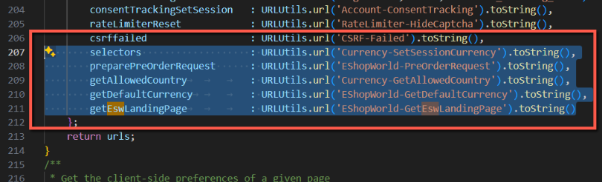

- Now you can use page designer feature with Site Genesis

Setup with SFRA
Page designer support for SFRA is enabled by default. Retailer needs to make sure that ESW cartridge version supports page designer.

Import ESW sample pages
ESW cartridge provides sample pages so that retailer can import and see the use of components in page designer module.
- Sample page designer for SFRA can be found at:
  - \Metadata\sites\RefArch\esw-page-designer-example-sfra.xml
- Sample page designer for SG can be found at:
  - \Metadata\sites\SiteGenesis\esw-page-designer-example-sg.xml
- Now go to “Merchant Tools > Content > Import & Export > Library Import Step 1 - Select File” and import the required page designer file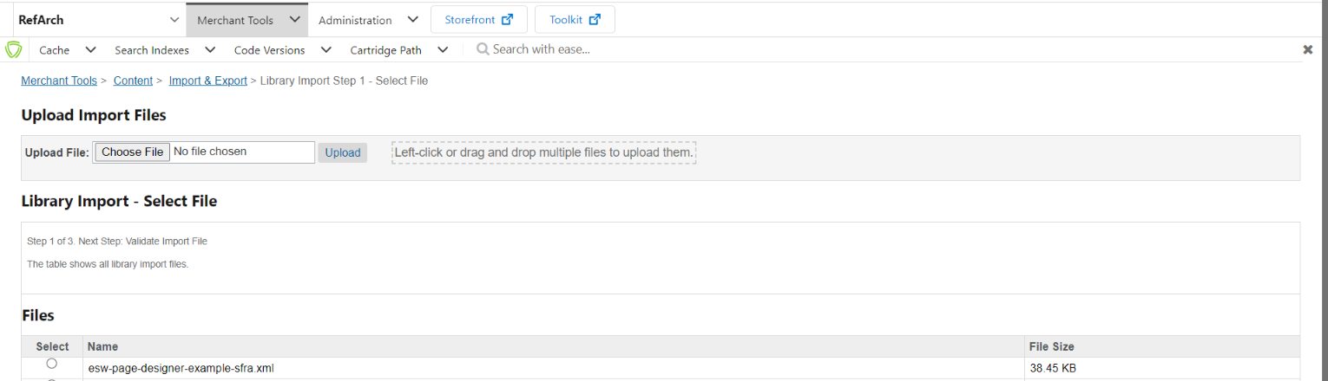

Setup Page using Page Designer
Retailer can use following steps to use ESW cartridge with page designer.
- Make sure the ESW cartridge is uploaded
- Go to “Merchant Tools -> Content -> Page Designer”
- Select or create a new page
- In the page designer select component “ESW HTML Content” component under “esw_components” 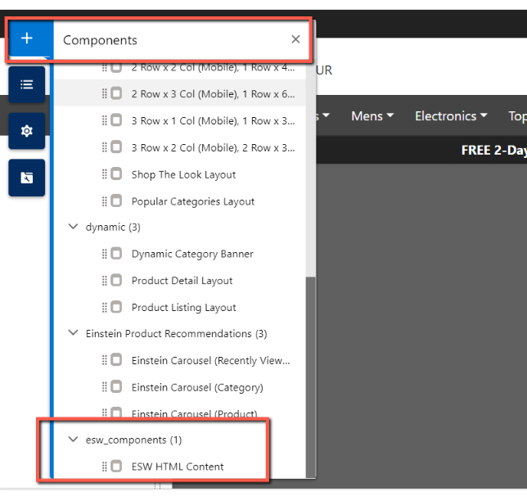
- From this component retailer can add raw HTML 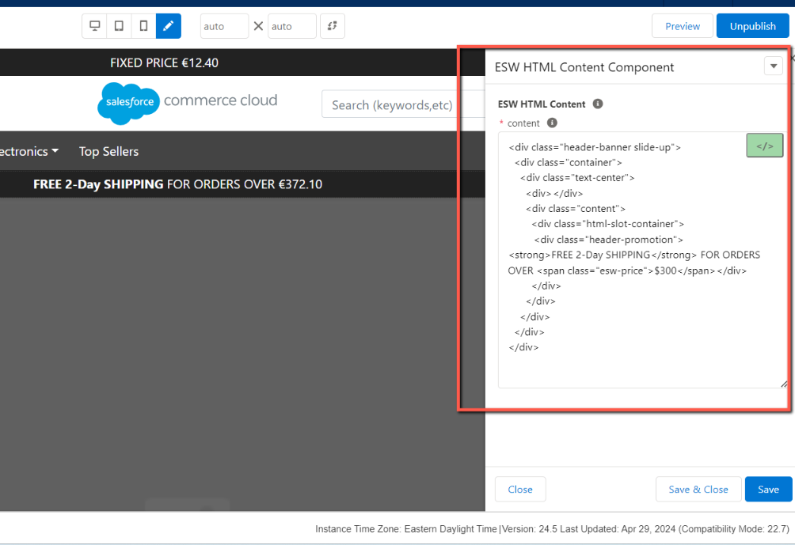
- This HTML can be seen in the storefront with converted prices 