


Version: 5.1.2
Published date: August 2026
Copyright © 2026 by ESW. All rights reserved. Information contained herein is subject to change without notice.

Self Hosted Order Confirmation Page

SFCC - ESW Cartridge
+
Contents
1.Self Hosted Order Confirmation Page 3
2.Configurations in SFCC Business Manager 3
2.1.Import Metadata 3
2.2.Feature Configuration 3
3.Storefront Implementation 4
3.1.Checkout Shopper Registration……………………………………………………………………...7
4.Preorder updates 9

Self Hosted Order Confirmation Page
ESW cartridge supports self hosted checkout which lets retailers choose where to send shoppers after a successful ESW checkout. In SFCC, they can set a custom path on their site or a completely different external URL as the order confirmation page. The correct link along with the order id is created during the preorder process and sent to ESW. Retailers can use this page to show their brand, recommend products, or display any other content they want.
This feature also offers full support for SFRA, SG , Headless and PWA storefronts solution, ensuring a more flexible and branded customer experience after checkout.

Configurations in SFCC Business Manager
Activating this feature requires a one time configuration in the Business Manager Site Preferences.

Import Metadata
Import system level attributes (systemobjects.xml) from link_eshopworld\Metadata\meta.
The following custom attribute will be present at site level custom preferences under ESW Checkout Configuration group:
- ESW Enable Order Confirmation Success Page: This feature is controlled by this site level preference that acts as a master switch to on or off the feature.
- ESW Order Confirmation Success URL: The URL of the success page, it can be an empty value, a controller path or an absolute URL.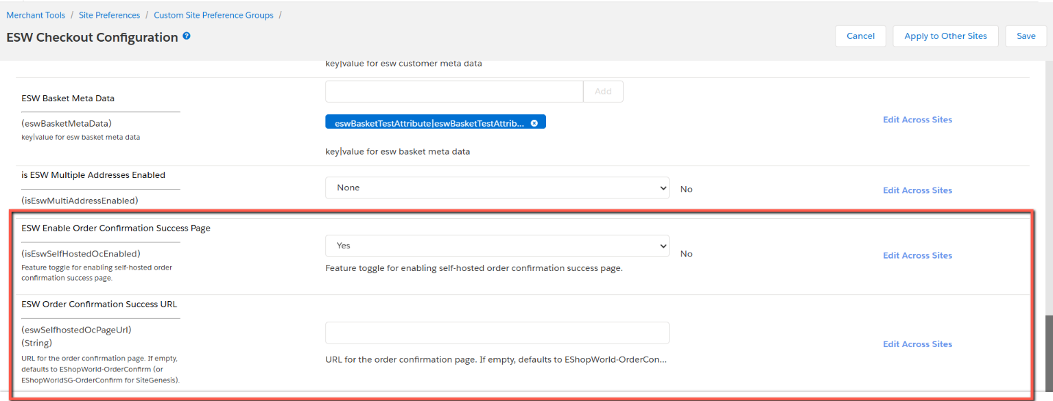

Feature Configuration
- Navigate to Merchant Tools > Site Preferences > Custom Preferences.
- Select the preference group ESW Checkout Configuration.
- Locate the custom preference ESW Enable Order Confirmation Success Page.
- Set its value to Yes to enable the feature.
By default, there is no need to enter any value in ESW Order Confirmation Success URL, however it can accept following:
- An empty value, in case of empty value the default URLs will be generated by the ESW cartridge as follows:
  - SFRA: https://storefronturl.com/EShopWorld-OrderConfirm?orderId={orderID}
  - SG: https://storefronturl.com/EShopWorldSG-OrderConfirm?orderId={orderID}
  - PWA: https://storefronturl.com/checkout/confirmation/{orderID}
    - Make sure the PWA URL is configured in “Merchant Tools > Site Preferences > Custom Site Preference Groups > ESW PWA Integration Configuration”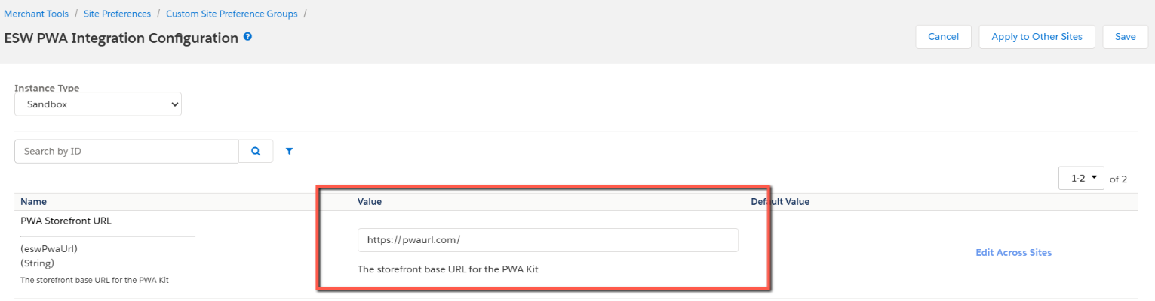
  - Headless: https://storefronturl.com/checkout/confirmation/{orderID}
    - Make sure headless storefront URL is configured in “Merchant Tools > Site Preferences > Custom Site Preference Groups > ESW Headless Integration Configuration” 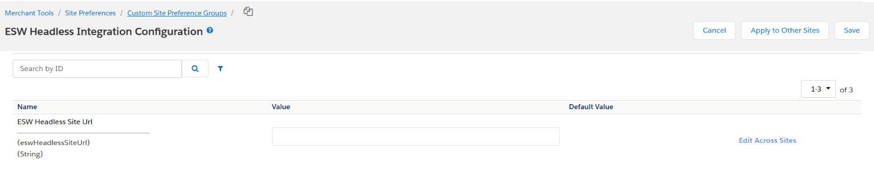
- A controller or route path like EShopWorld-OrderConfirm or checkout/confirmation
- Or an absolute URL for example https://orderconfirmurl.com
The query string ?orderId={orderID} is automatically appended to the URL, so it does not need to be explicitly included in the configuration.

Storefront Implementation
The ESW cartridge uses the default storefront design to show the order confirmation page. However, retailers can customize this page based on their specific needs. Screenshots for different architectures are provided below.

SFRA
Guest Shopper | Registered Shopper
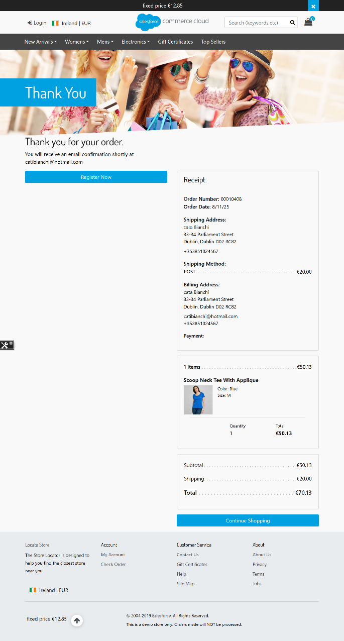 | 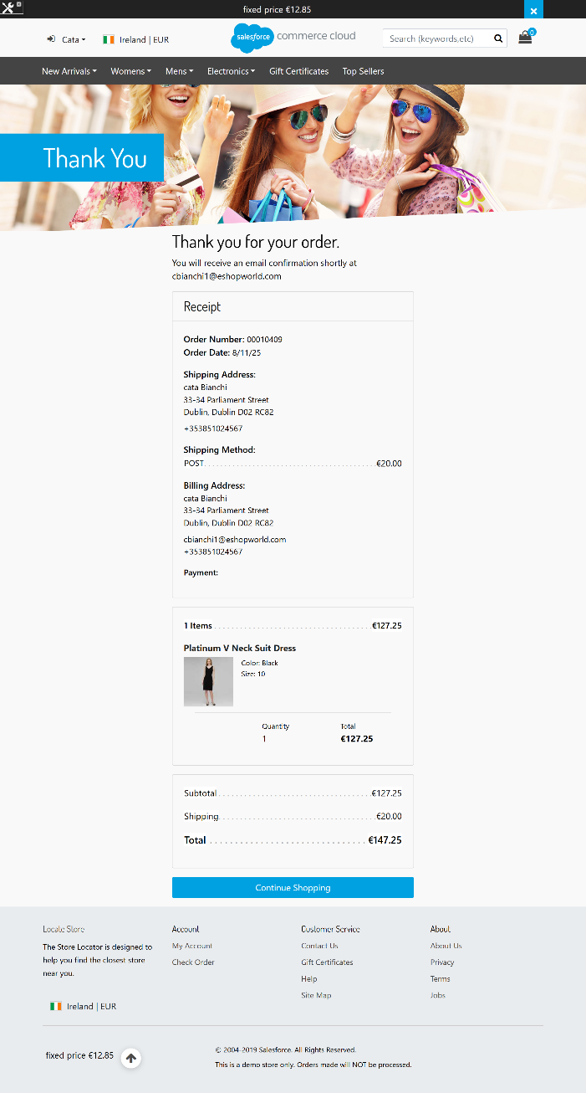

SiteGenesis
Guest Shopper | Registered Shopper
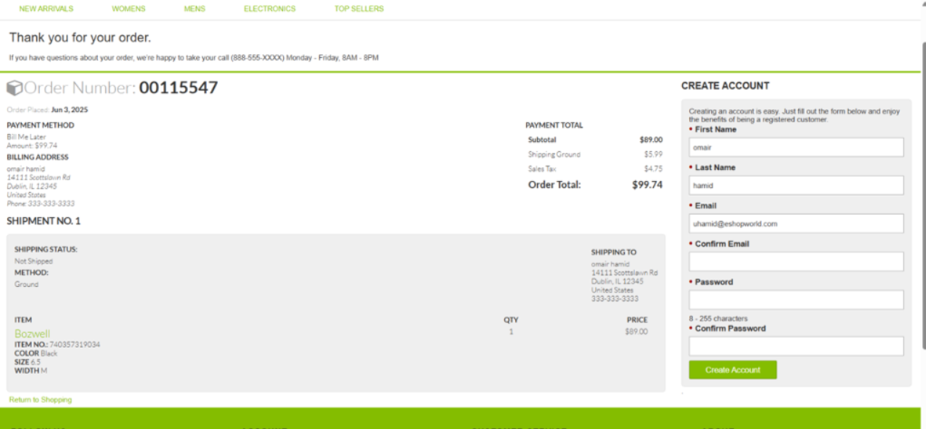 | 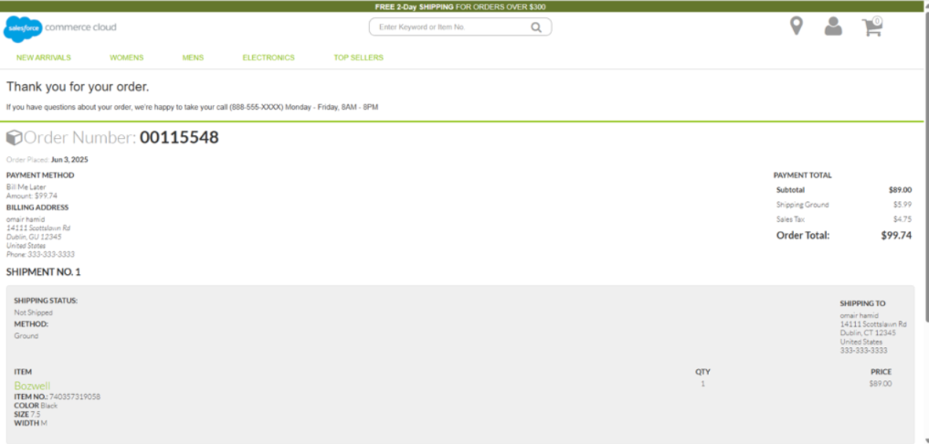

PWA
Guest Shopper | Registered Shopper
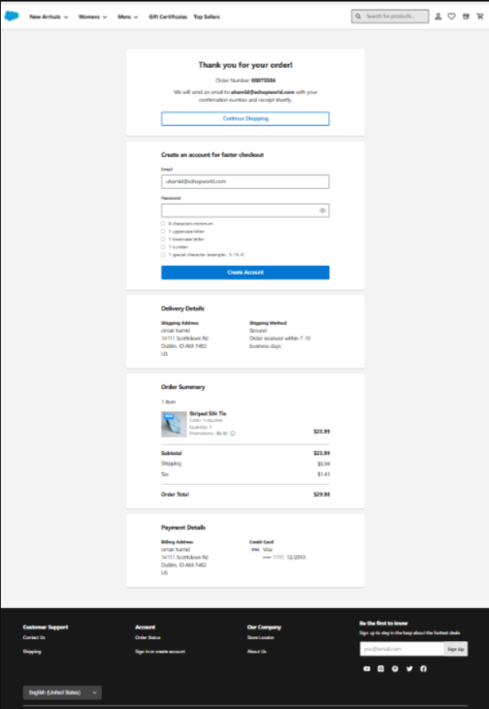 | 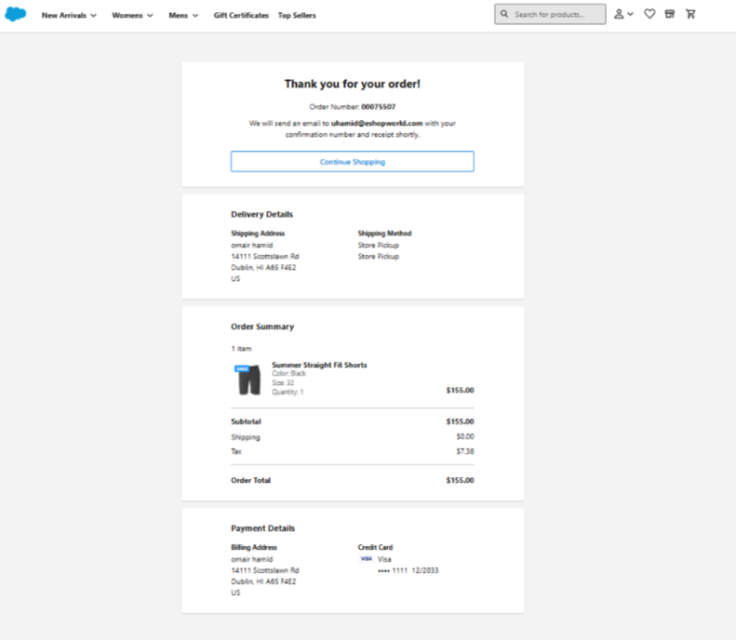

  - Checkout Shopper Registration
If the checkout shopper registration feature (Checkout Shopper Registration - Developer Resources - ESW Knowledge Centre) is enabled, the forms will be replaced with a registration button. Screenshots for different architectures are provided below.

SFRA
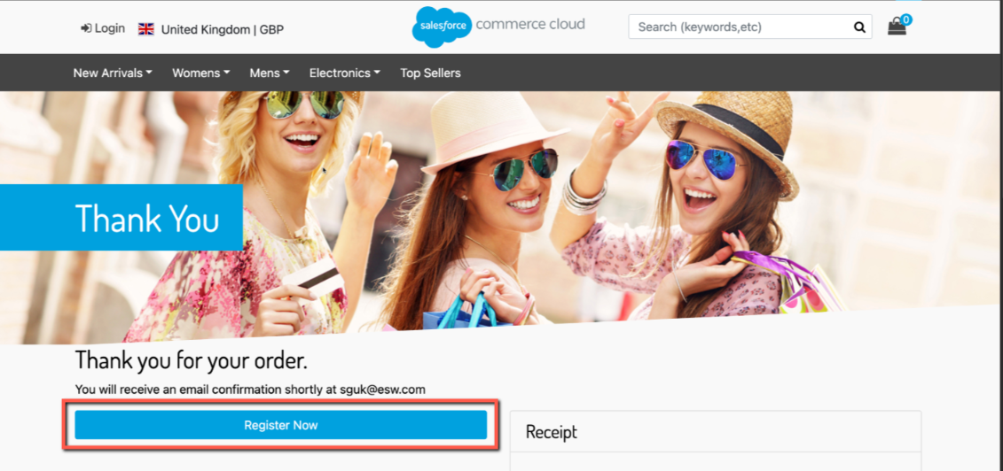
SG
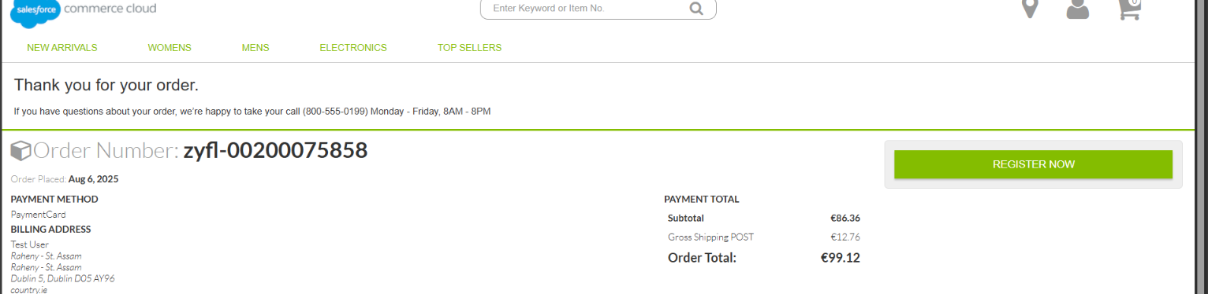

PWA
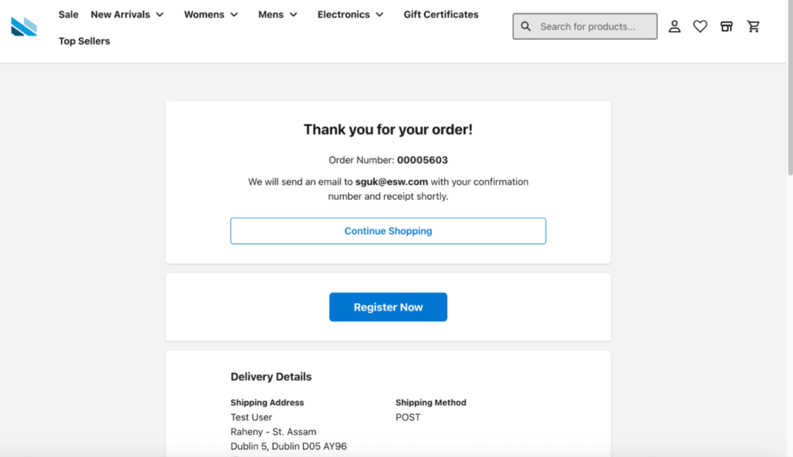

Preorder updates
When the feature is enabled, a new metadata item is added to retailerCheckoutExperience.metadataItems in the preorder payload. This item includes Name: ConfirmationPageUrl and a Value: https://storefronturl.com/EShopWorld-OrderConfirm?orderId={orderID} as shown: 