


Version: 5.1.2
Published date: August 2026
Copyright © 2026 by ESW. All rights reserved. Information contained herein is subject to change without notice.

SHIPPING METHODS INTEGRATION GUIDE

SFCC - ESW Cartridge
+
Contents
1 Shipping Methods Integration 3
1.1 Displaying Override Shipping Methods on Cart Page 3
1.1.1 ESW Override Shipping methods on cart page Configuration Site Preferences 3
1.1.2 Work flow displaying Override Shipping Methods on Cart Page 3
1.2 Displaying the SFCC Shipping Methods 5
1.3 Using the ESW Shipping Methods 9
1.4 Displaying Shipping Methods on the Cart Page 11
1.5 Updating the Order in SFCC after ESW Order Confirmation 14
1.6 Applying Free Shipping Promotion to ESW Shipping Methods 15
1.7 Shipping Threshold Promotions 17
2 Shipping Methods Integration Configuration 17
2.1 ESW Pricing Configuration 17
2.2 ESW Checkout Configuration site preferences 22

Shipping Methods Integration
The shipping methods are displayed on the ESW checkout and cart page depending on how the ESW Override Shipping custom preference in ESW Checkout Configuration is set. Setting the ESW Override Shipping option means overriding the ESW Shipping Methods with Standard SFCC Shipping Methods.

Displaying Override Shipping Methods on Cart Page

ESW Override Shipping methods on cart page Configuration Site Preferences

- You can use Custom Preferences to manage ESW-specific configurations of the cartridge. You can access Custom Preferences by navigating to Merchant Tools > Site Preferences > Custom Preferences > ESW Retailer Configuration.
- The following Flag is present ESW Retailer Configuration group:
- ESW Hide Native Shipping: To override Shipping methods on cart page and hide native shipping methods.

Work flow displaying Override Shipping Methods on Cart Page

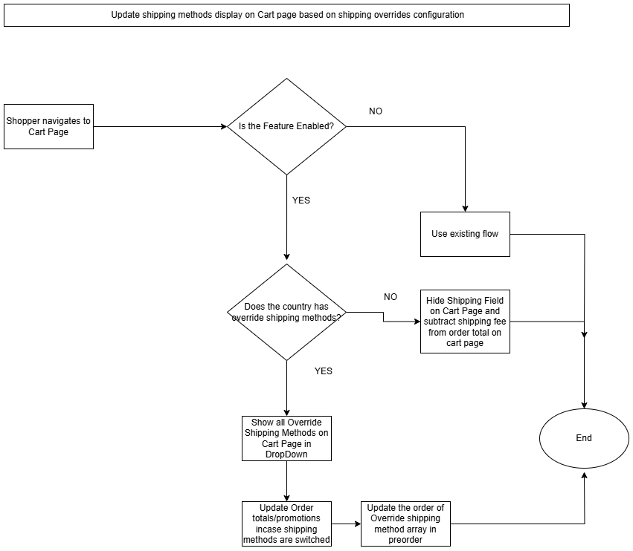

If the ESW Hide Native Shipping flag is enabled and ESW Override Shipping preference is set for a specific country, all the shipping methods will be shown on the cart page.

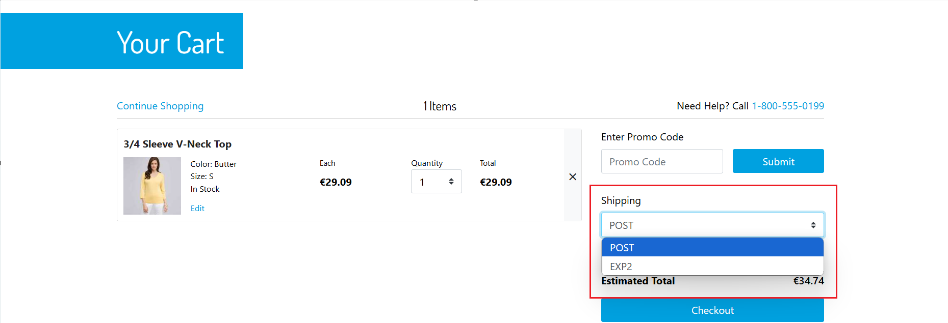

Two Override Shipping Methods

In case of single override shipping method, the estimated shipping fee will be displayed on the cart page.

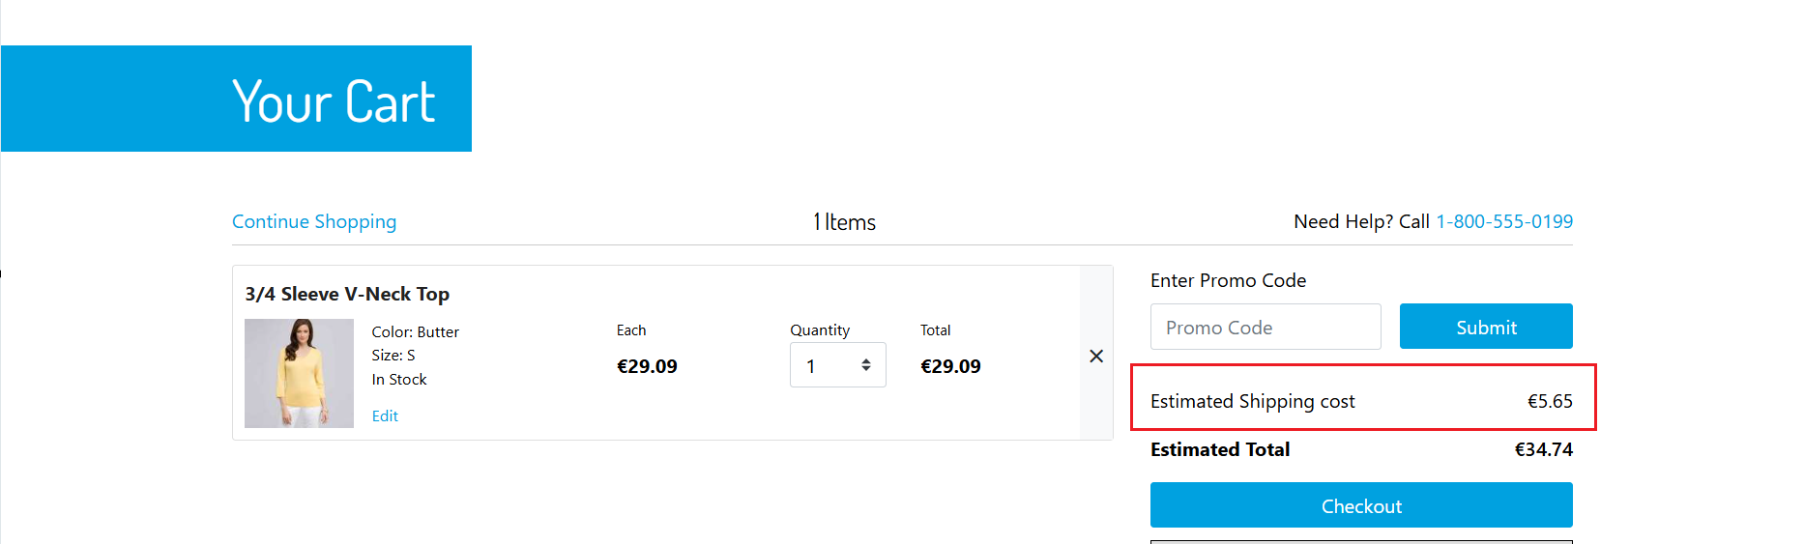

One Override Shipping Method

If ESW Hide Native Shipping flag is enabled and a country doesn’t have override shipping methods, the shipping field will be hidden on the cart page and the order total won’t contain the shipping fee. A declaimer message will be shown on cart page

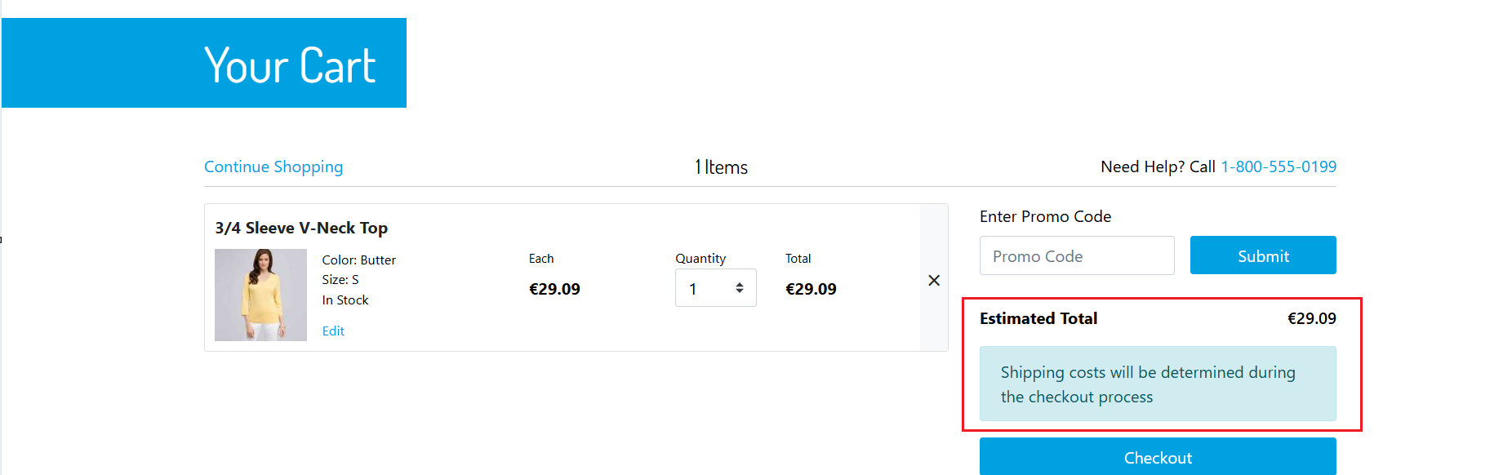

No Override Shipping Method

If the ESW Override Shipping preference is not set for a specific country, the ESW shipping methods are called from the Checkout tenant configuration or the database and then displayed at the checkout.

Displaying the SFCC Shipping Methods
The standard SFCC shipping methods are created with a specific currency. In the custom site preference, the ID of the shipping methods is mapped with a specific country.
Perform the following steps to display the standard SFCC shipping methods at the ESW checkout:
- Create the shipping methods in SFCC by navigating to SFCC Business Manager > Merchant Tools > Ordering > Shipping Methods.
- Create the shipping methods with shipping names and types for currencies available to the shoppers at the storefront. The name and type of the shipping method (for example, POST for standard shipping and EXP2 for express shipping) must be supported by ESW.
Configuring POST, EXP2, or any one of these two options for different currencies depends on the retailer’s business requirement.
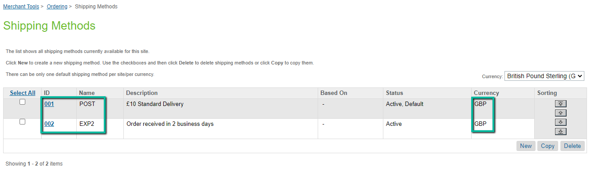
Shipping Methods
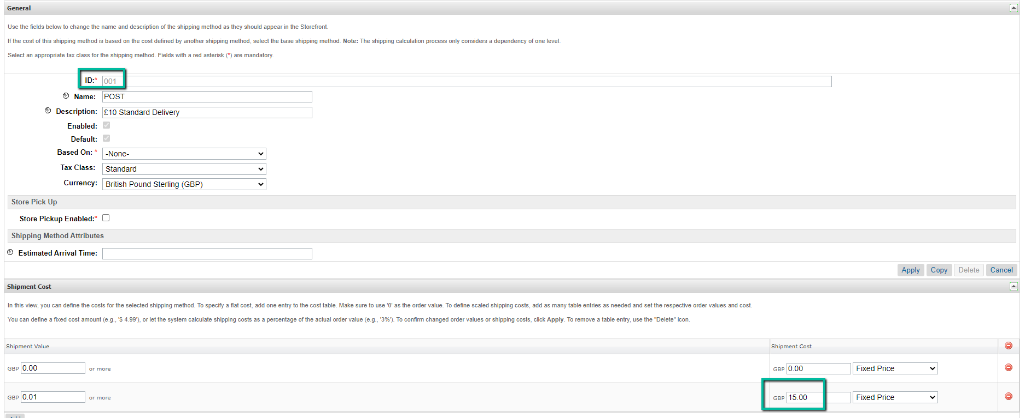
Shipping Method - POST
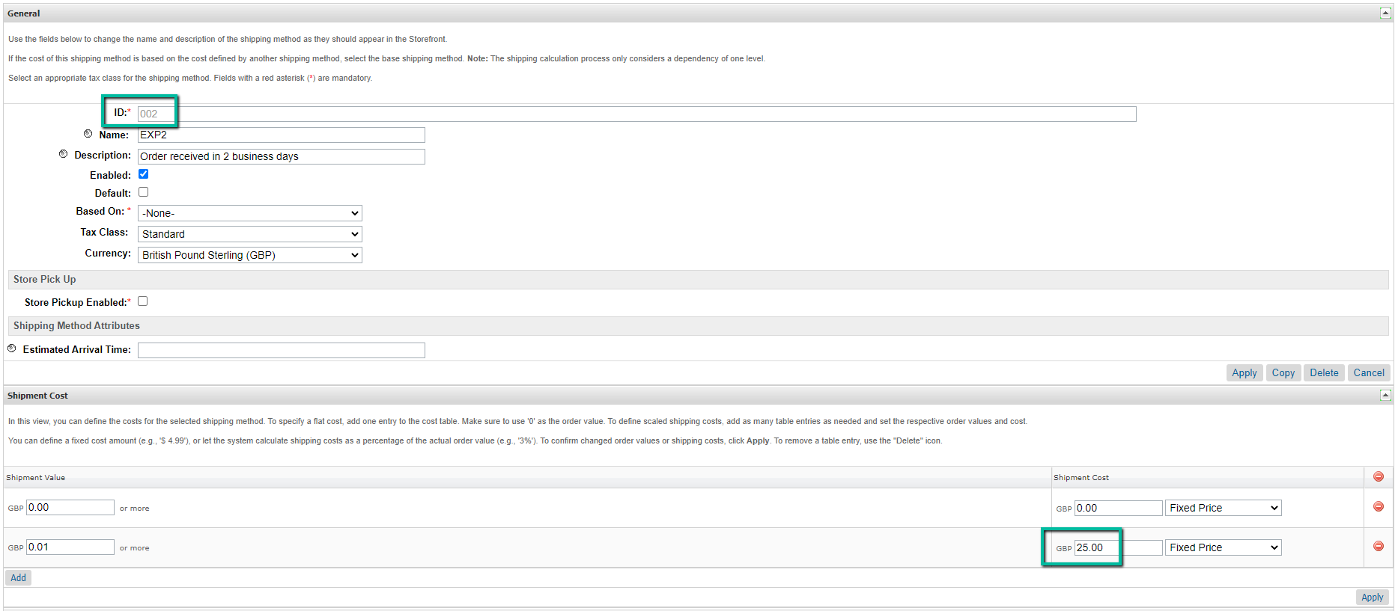
Shipping Method - EXP2
Note: The shipping method names must be either POST or EXP2. This naming rule is required by ESW. However, the ID can be any value.
- Configure the shipping method IDs for the country. You can configure the IDs in a JSON format using the ESW Override Shipping custom site preference in ESW Checkout Configuration.
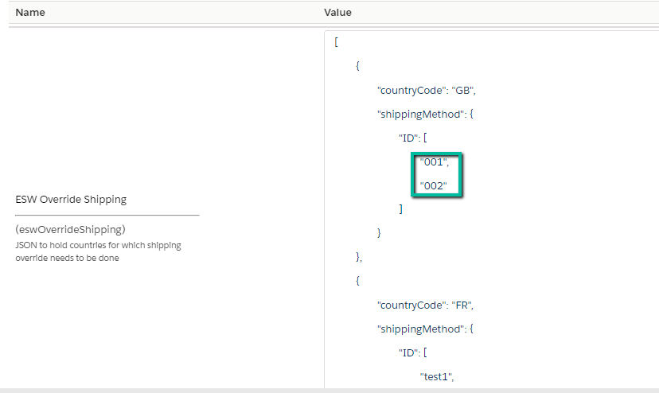
ESW Override Shipping
Once configured, the shipping methods are displayed at the checkout for the particular country. The following screenshot shows the shipping methods configured for Britain.
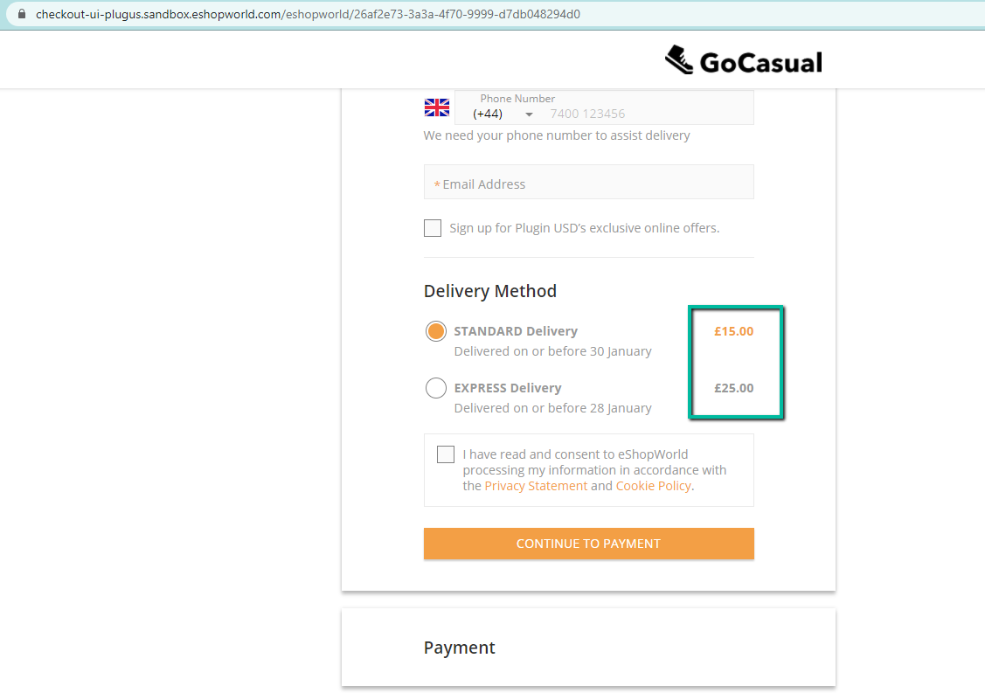
SFCC Shipping Methods at the ESW Checkout
Additional information:
- For countries using the Fixed Pricing model, you must create shipping methods with the currencies specific to the country. For example, if the United Kingdom is a fixed price country, the shipping methods must be created with GBP as the currency.
- For countries using the Dynamic Pricing model, you must create shipping methods with the base currency. For example, if France is a dynamic price country and the base currency is USD, the shipping methods must be created with USD as the currency.
- If the ESW Override Pricebook preference under ESW Pricing Configuration is configured for a country, the shipping methods matching the override price book currency must be created.
- If only one shipping method is configured in ESW Shipping Override for a specific country, and the ESW Checkout tenant is configured to display two shipping methods, the other (second) method from the ESW shipping methods is displayed at the ESW checkout.
- If two shipping methods are configured in ESW Shipping Override for a specific country, and the ESW Checkout tenant is configured to display only one shipping method, the other (second) method is ignored and not displayed at the ESW checkout.

Using the ESW Shipping Methods
ESW allows retailers to use the ESW shipping methods, instead of configuring and maintaining various shipping methods within the SFCC Business Manager.
To display the ESW shipping methods on the ESW checkout for a country, do not set any override shipping methods in the ESW Override Shipping preference. When the ESW Override Shipping preference is not set for a specific country, the ESW Checkout API sends the DeliveryOptions parameter as null ("DeliveryOptions": null) in the request. This triggers the ESW shipping methods from the ESW tenant configuration and displays it on the ESW Checkout.
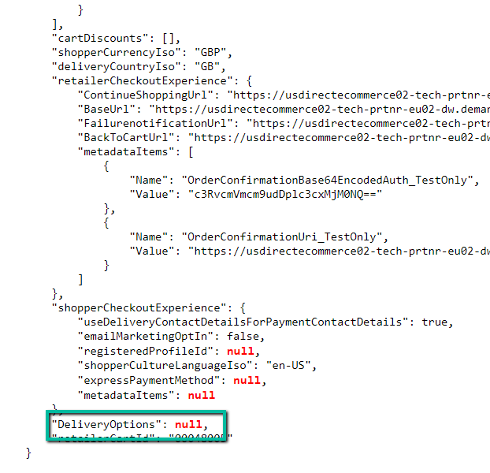
"DeliveryOptions": null
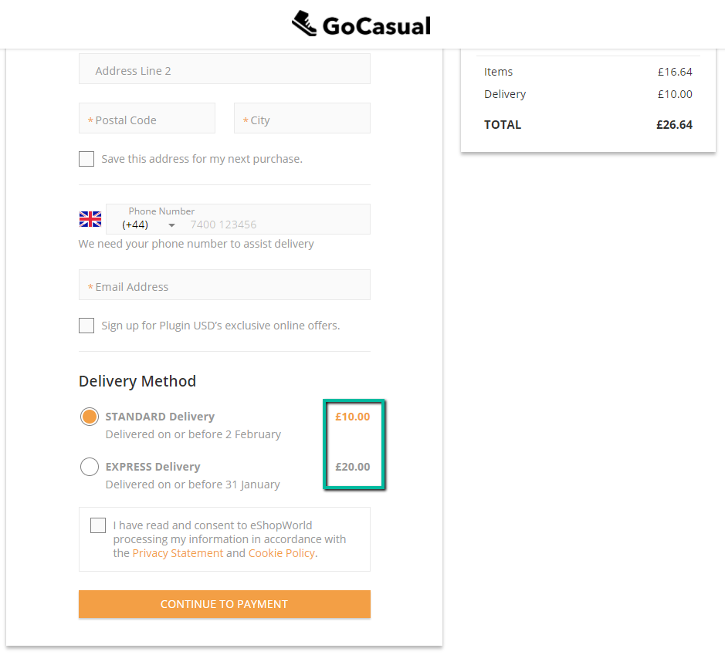
ESW Shipping Methods at the ESW Checkout

Displaying Shipping Methods on the Cart Page
The shipping methods on the Cart page are displayed based on the ESW Override Shipping preference.
- If the ESW Override Shipping preference is set, the first shipping method configured in override shipping is applied to the cart.
- If the ESW Override Shipping preference is not set and no shipping method is assigned to the order, the default shipping method is used to create and display the order in the SFCC Business Manager. The shipping cost associated with the default shipping method is displayed as 'Estimated Shipping Cost' on the Cart page (SFRA).
In the following example, the ESW Override Shipping preference is not set and 002 is the default shipping method ID and the shipping cost of this method is 9.99 GBP in the SFCC Business Manager:
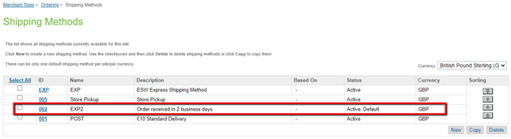

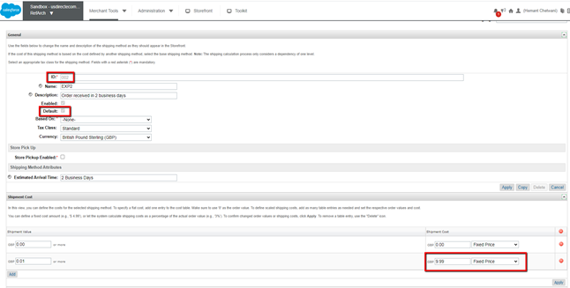
On the Cart page, the shipping is displayed as Estimated Shipping Cost with a value of 9.99 GBP.
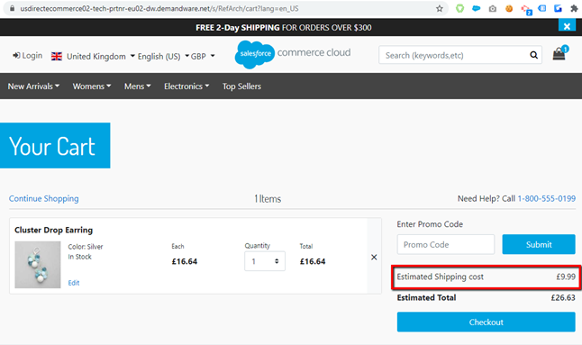
Shipping cost in the cart
The shipping cost of 10.00 GBP for Standard Delivery and 20.00 GBP for Express Delivery is applied from the tenant configuration and displayed on the ESW Checkout:
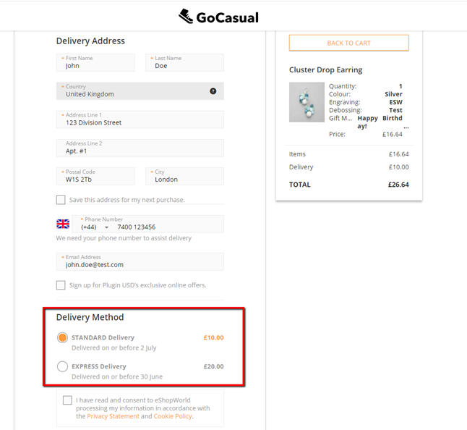
Based on the standard SFCC Shipping Methods fallback, if no 'Default Shipping Method' exists in the SFCC Business Manager, the 'First Applicable Shipping Method' is applied to the order and displayed in the SFCC Business Manager. On the Cart page, the shipping cost associated with the 'First Applicable Shipping Method' is displayed as the 'Estimated Shipping Cost'.

Updating the Order in SFCC after ESW Order Confirmation
- If the override shipping methods are used and the shopper selects EXP2 as the shipping method at the checkout, then during the Order Confirmation request to SFCC, the ESW plugin updates the shipping method ID from the Post (for example, 001) to EXP2 (for example, 002). The ESW Shopper Currency Delivery Price Info and ESW Retailer Currency Delivery Price Info order custom attributes also contain the correct delivery cost in both retailer and shopper currencies.
- If the override shipping methods are not used, the shipping methods are not updated. You can extract the correct delivery cost in both retailer and shopper currencies by using the ESW Shopper Currency Delivery Price Info and ESW Retailer Currency Delivery Price Info order custom attributes.

Applying Free Shipping Promotion to ESW Shipping Methods
SFCC allows you to create promotions on shipping, for example, free shipping for certain customer groups or on qualifying products and categories. Shipping promotions can be created by navigating to Merchant Tools > Online Marketing > Promotions.
Once created, the shipping promotions are applied to the SFCC shipping methods by providing the Shipping Method IDs:
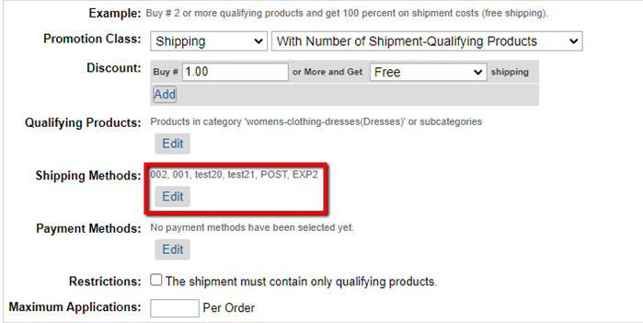
Shipping IDs
The ESW cartridge allows you to apply the SFCC Free Shipping promotions to the ESW shipping methods. You can do so by specifying the POST 'Default Shipping Method' in the Shipping Promotion. The default shipping method is applied to the cart when the order is being created.
When the shipping promotion is applied to the Cart page, the ESW cartridge detects the free shipping promotion and sends the Free POST shipping method to the ESW Checkout through the Checkout API. The free shipping promotion is displayed as follows:
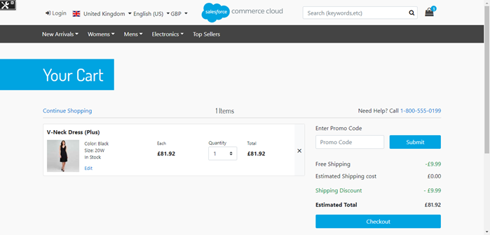
Free shipping promotion on the Cart page
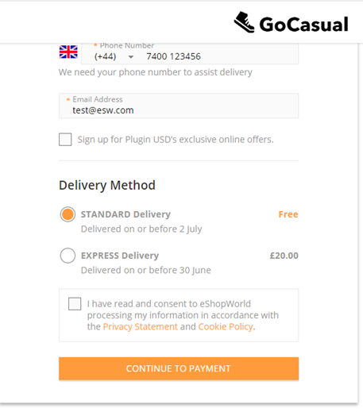
Free shipping promotion on the ESW Checkout Page

Shipping Threshold Promotions
The ESW cartridge allows retailers with dynamic pricing model using shipping override to set shipping promotions based on threshold value. For more details, Please refer to “eShopWorld_Promotions_Integration.docx”

Shipping Methods Integration Configuration

ESW Pricing Configuration
You can use the following Custom Preferences and Custom Objects to manage ESW-specific configurations of the cartridge.
The following ESW Pricing Configuration options are present:

Custom Objects:

- ESW Pricing Advisor Data: The Retailer Pricing feed job fetches Pricing advisor data into the ESW_PA_DATA custom objects. ESW recommends this job to be configured nightly before ESW Retailer Auto Configurator job. The pricing advisor data contains the FX Rates, country adjustments and rounding rules for the ESW Supported countries.
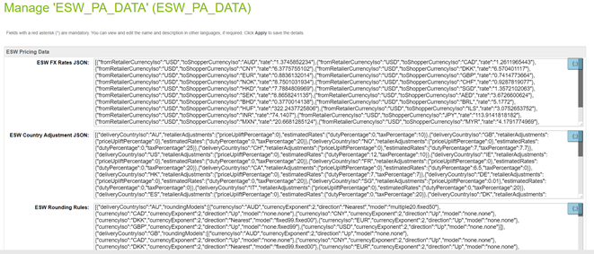

- ESW Fixed Price Model Countries: When the ESW Retailer Auto configurator job is executed the ESW supported countries’ custom object are instantiated. For Fixed price model country the ‘is Fixed Price Model’ needs to be checked manually, by default country will be created with dynamic/calculated pricing model
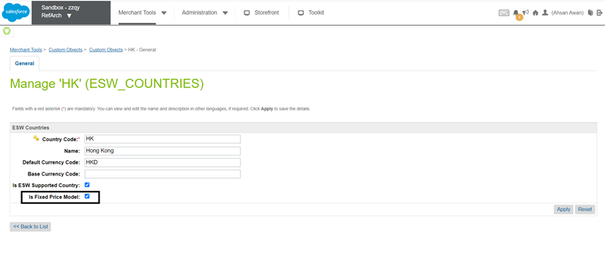

Custom Preferences:
- ESW Override Price Book This option sets the override price corresponding to the country. To set the default currency on the chosen country, and the currency for the respective country must be set under Country JSON.. The following is a sample JSON to hold countries for which price override needs to be done:
[
{
"countryCode": "US",
"currencyCode": "USD",
"priceBooks": [
"usd-list-prices",
"usd-sale-prices"
]
},
{
"countryCode": "GB",
"currencyCode": "GBP",
"priceBooks": [
"gbp-list-prices",
"gbp-sale-prices"
]
}
]
For Currency Overrides, you must configure the related Shipping Method with the appropriate currency at the SFCC end.
- ESW Enable Multiple FX Rates: Enables or disables the Multiple FX Rates feature for the current site.
- ESW Enable Roundings: Enables or disables the rounding on the prices across all applicable countries for the current site. If the option is enabled, the appropriate rounding models are applied to the prices in the applicable countries.
- ESW Enable Frontend Prices Conversion: Enables or disables the Localized Front-end Prices feature across storefront.
- ESW Price Feed Instance Switcher: Indicates the Price Feed mode for the current site. If you select Production, the Price Feed job uses the Production Price Feed service called EswPriceFeedV3Service.PROD.
- ESW Production Client Secret for Price Feed Authorization Request: Indicates the Production Client Secret key for the Price Feed authorization request. If the ESW Price Feed Instance Switcher is selected as Production, the Price Feed job uses the production client secret while making a call to the ESW Pricing Advisor API.
- ESW Localized Pricing Countries: Indicates the shopper country, currency, and local price books for which local prices are required. This preference also defines the base price book from where the prices, country adjustment, and rounding rules can be used.
[
{
"localizeCountryObj": {
"countryCode": "FR",
"currencyCode": "EUR",
"localListPriceBook": "eur-m-list-prices",
"localSalePriceBook": "eur-m-sale-prices"
},
"baseListPriceBook": "usd-m-list-prices",
"baseSalePriceBook": "usd-m-sale-prices",
"applyCountryAdjustments": "true",
"applyRoundingModel": "true"
}
]
The following table describes these parameters:
Parameter | Description
countryCode | (Required) The two-letter ISO code of the shopper country.
currencyCode | (Required) The three-letter ISO code of the shopper's local currency.
localListPriceBook | (Required) The price book ID of the local list price.
localSalePriceBook | (Optional) The price book ID of the local sale price.
baseListPriceBook | (Required) The price book ID of the base list price. The price book currency must match the tenant base currency.
baseSalePriceBook | (Required if 'localSalePriceBook' is provided) The price book ID of the base sale price. The price book currency must match the tenant base currency.
applyCountryAdjustments | (Required) Indicates if you want to apply country adjustments while calculating the local price. The values are True or False.
applyRoundingModel | (Required) Indicates if you want to apply the rounding model while calculating the local price. The values are True or False.
- ESW Localized Promotions: A JSON object containing single or multiple base promotion configurations, which can be used to generate localized promotions.
[
{
"basePromoId":"10%offordersover150",
"campaignId":"",
"excludeCurrencies":[
"GBP",
"SEK"
]
},
{
"basePromoId":"Buy5for50",
"campaignId":"Automation",
"excludeCurrencies":""
}
]
Each promotion object contains the following attributes:
Parameter | Description
basePromoId | (Required) The ID of the base promotion configuration.
campaignId | (Optional) The ID of the campaign.  This parameter can be left blank if you want to assign the same ID as the base promotion. However, if you want to assign localized promotions as a separate campaign, you must provide the new campaign ID.  You must also ensure that the campaign ID provided in this parameter is already created because the job only generates localized promotions, not campaigns.
excludeCurrencies | (Optional) The currencies for which you do not want to generate localized promotions.  If no value is provided, localized promotions are generated for all allowed currencies.

ESW Checkout Configuration site preferences
You can use Custom Preferences to manage ESW-specific configurations of the cartridge. You can access Custom Preferences by navigating to Merchant Tools > Site Preferences > Custom Preferences.
The following ESW Checkout Configuration options are present:
- ESW Checkout Service Name: The name of the service that is associated with the Checkout. The value in this field is used for the current site. For more information, see Services.
- ESW URL Expansion Pairs: This option sets the URL that ESW will redirect to. The following URLs must be set in the Name of URL|Name of Controller format:
  - ContinueShoppingUrl
  - BaseUrl
  - BackToCartUrl
  - InventoryCheckFailurePageUrl
The above values are set by default once the job ESW Retailer Auto Configurator is executed successfully.

Format | Example
Name of URL|url | ContinueShoppingUrl|Home page URL
Additionally, the ContinueShoppingUrl (URL of the home page) and BackToCartUrl (URL of the Cart page) attributes must be sent with all requests:
- ESW Metadata Items: This option stores the basic authentication URL and the default value. The default value of 1 is stored in the OrderConfirmationBase64EncodedAuth_TestOnly parameter for when basic authentication is not enabled.
The OrderConfirmationUri_TestOnly|EShopWorld-Notify and OrderConfirmationBase64EncodedAuth_TestOnly|1 parameters are required for the Sandbox environments only.
The above values are set by default once the job ESW Retailer Auto Configurator is executed successfully.
- ESW Product Line Metadata Items: This option is used for display purposes only and it stores the product line metadata items information that you want to send in the Checkout request. Options include loyalty points, engraving, debossing, gift message, and so on. The information must be stored in the following format:
Format | Example
EswKeyField|ProductLineItemCustomAttributeID | Gift Message|GiftWrapMessage
In the following example, the Gift Messageattribute is sent with name in the metadataItems object. For the GiftWrapMessage product line custom attribute, the value is sent with value in the metadataItems object. The metadataItems are sent under Product JSON in the Checkout request.
"cartItems": [ {
………………
………………
“product”: {
…………………………
…………………………
"metadataItems": [ {
"name": "Gift Message",
"value": "Congratulations!"
} ]
},
…………………
…………………
}]
If you want to send any product information under metadataItems in the Checkout request, you can do so by copying the product information in the product line item and by configuring that productLineItem custom attribute ID in this configuration.
- ESW Redirect: This preference indicates from where the shopper (Guest User) will be redirected to ESW Checkout Page. The options are Cart and Login. When the shopper is logged in, the ESW Checkout Redirect will be from the Cart page. The preference selection is ignored.
  - If the Cart option is selected, the ESW Checkout Redirect will happen from the Cart page, and the preorder request will be sent.
  - If the Login option is selected, the ESW Checkout Redirect will happen from the Login page, and the pre order request will be sent. The login value is set by default once the ESW Retailer Auto Configurator Job is executed successfully.
- ESW Override Shipping: This option sets the shipping override for specific countries. It allows you to override the shipping prices for a shipping method. In the following example, ID represents the shipping method IDs. 001 is the POST shipping method and 002 is the EXP2 shipping method. Shipping methods are sent as per the order in ID array.
  - For the UK, the EXP2 shipping method is sent first and then POST.
  - For the US, the POST shipping method is sent first and then EXP2.
  - For NL, only the POST shipping method is sent.
[
{
"countryCode": "GB",
"shippingMethod": {
"ID": ["002", "001"]
}
},
{
"countryCode": "US",
"shippingMethod": {
"ID": ["001","002"]
}
},
{
"countryCode": "NL",
"shippingMethod": {
"ID": ["001"]
}
}
]
- The shipping method names must be POST or EXP2. This naming rule is required by ESW. However, the ID can be any value.
- If ESW Override Pricebook under ESW Pricing Configuration is configured for a country, then the shipping methods matching the override pricebook currency must be configured in ESW Override Shipping.
- ESW Use Delivery Contact Details for Payment: This option allows you to select the default behavior of the Billing address same as delivery address field on the ESW Checkout.
- ESW Update Order Payment Status to Paid After Successful Order Confirmation: This option allows you to change the order payment status to Paid after successful order confirmation.
- ESW Russian Data Storage Url: This option allows retailers to process and store the Russian shoppers pre-order and checkout data via a dedicated endpoint. This endpoint route and store the Russian shoppers data via Russian hosted servers to ensure the Russian data compliance. This Url value will be provided by ESW onboarding team.
- ESW Checkout Session Timeout: This allows retailers to control the session time out duration on the ESW checkout. Retailers can set the session time out value in minutes in this preference and on ESW checkout page session will be alive for this duration in minutes.
- ESW Top Level Domain: This allows retailers to configure top level domain for Stored Card feature. ESW plugin will created shopper access token cookie on this site preference value.
- Enable ESW Inventory Check: This allows retailers to enable/disable inventory check feature during the order confirmation webhook call before placing the order.
- Enable ESW Checkout Shoppers Registration: To configure if ESW checkout shopper's registration is enabled or not

