


Version: 5.1.2
Published date: August 2026
Copyright © 2026 by ESW. All rights reserved. Information contained herein is subject to change without notice.

SPLIT PAYMENT
INTEGRATION GUIDE

SFCC - ESW Cartridge
+
Contents
1 Split Payment Integration 3
2 Workflow to get split payment information in SFCC 3
2.1 Backend 3
2.2 Storefront 3

Split Payment Integration

ESW cartridge allow shopper to divide payments in multiple payment instruments (credit cards and gift cards). So that on the checkout screen shopper can see the gift card as payment methods and can pay via gift card. The information will be stored in SFCC via order confirmation webhook and payments instruments used for the order can be seen in payments section of the order.

Workflow to get split payment information in SFCC

Backend
The workflow is quit straight forward, no configuration is needed on SFCC side. Retailer need to make sure that split payment integration feature is enabled on ESP.
If split payment is enabled on SFCC for the tenant then shopper will see the Add Gift Card option on payment panel payment
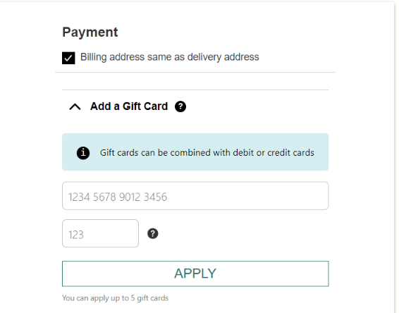
When a shopper places an order using split payment, the payment screen for the order in SFCC will appear as shown in screenshot
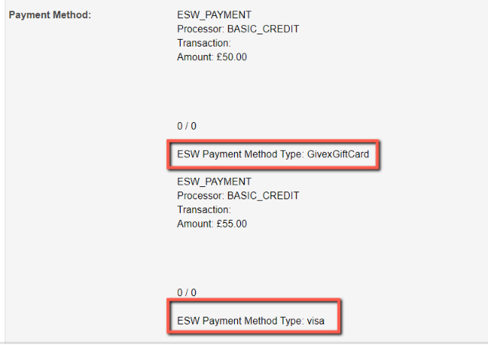
All the information will be store in SFCC order’s payment section after order confirmation.

Storefront

On the storefront, if a shopper paid using a split payment method, they can view all the information on the order detail page in their shopper currency, along with the payment methods.

On SFRA the payment method section on order detail will be shown as follows:
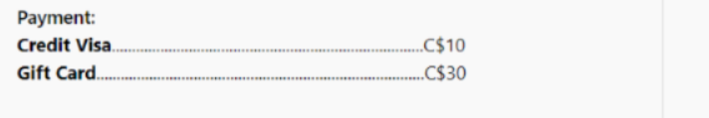
The above picture shows that shopper paid using C$ and payment methods used is “Credit Visa” and “Gift Card”. Please note that payment method name is subjected to what we get in the order conformation payload.

