


Version: 5.1.2
Published date: August 2026
Copyright © 2026 by ESW. All rights reserved. Information contained herein is subject to change without notice.

Split Shipment Integration
SFCC - ESW Cartridge
+
Contents
1 Split Shipment Support 4
1.1 eShopWorld Package Sync (SFCC => ESW) 4
1.2. Import meta 6
1.3. Package configuration 6
1.4. Workflow to sync package information from SFCC to ESW 7
2. Storefront 10
2.1. Order Detail (SFRA/PWA) 10
2.2. Order Detail (SiteGenesis) 10

Split Shipment Support
ESW SFCC Cartridge provides the capability to handle multiple shipment of an order. The relevant payload information is stored in SFCC custom order attributes which can be used to further synchronize with other downstream systems.
Note: As of the time this document was written, ESW does not support multiple shipments for shoppers. Therefore, it is the retailer’s responsibility to add multiple shipments to an order in SFCC when necessary.
  - eShopWorld Package Sync (SFCC => ESW)
The SFCC-ESW Cartridge flow allows retailers to sync package information generated through SFCC cartridge in the ESW. The high level process is demonstrated in the following diagram.

    - Import meta
To use this feature, retailer needs to make sure that he has custom attributes, services and the jobs are configured correctly in the BM. Make sure to import following from the cartridge:

System Objects:
\link_eshopworld\Metadata\meta\systemobjects.xml

The following configurations should be imported.

Order level attributes:

ID: eswPackageJson,
Name: ESW Package JSON,
Type: TEXT
Group: ESW Package Information

SitePreference attributes

ID: eswEnableSplitShipment
Title: Enable Multiple Shipment?
Type: Boolean
Default: false
Group: ESW General Configuration
    - Package configuration
- The feature will work If eswEnableSplitShipment === true, we will process multiple shipments so that current retailers are not affected with this change after updating the cartridge
- In case of eswEnableSplitShipment === false
  - BM Updates:
    - The current functionality will retain, see eShopWorld_Package_Integration.docx
    - Additionally, we will also store package information in eswPackageJSON attribute
  - StoreFront Updates:
    - If data is available in eswPackageJSON then we will show it from here
    - Otherwise, the related data will populate as per the current functionality
    - The storefront-related changes will take effect regardless of the functionality toggle, ensuring that orders stored during eswEnableSplitShipment === true will not be affected.
    - The following screenshot, demonstrate that how the store front will look like in SFRA 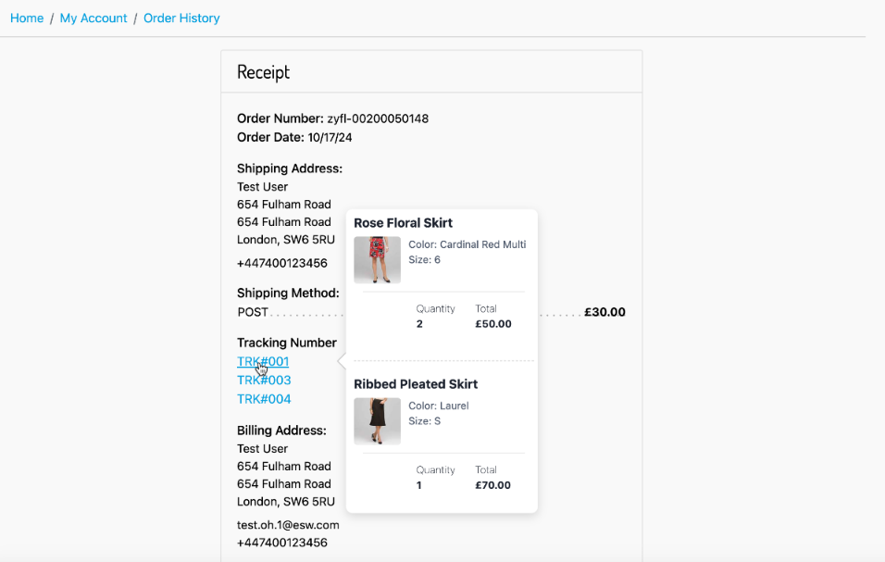
    - Workflow to sync package information from SFCC to ESW
The Job step “sendASNtoESW” in job ID “eswRetailerPackageFeed” can be configured to send the package information to ESW. This job can be set to get package information after each 24 hour.
After the job run the relevant order attribute eswPackageJson will be filled with the data as shown:
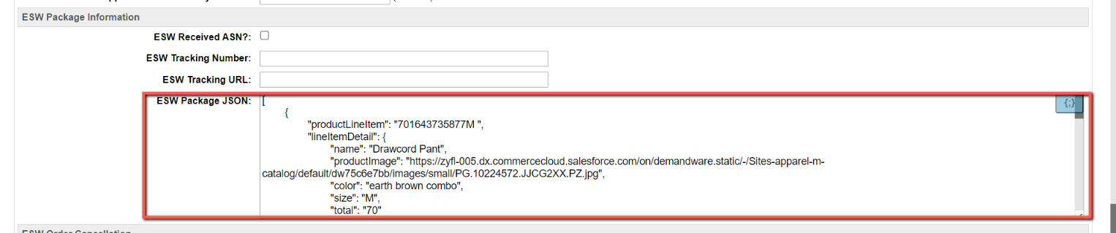
The sample JSON which will store in eswPackageJson is:

Storefront
  - Order Detail (SFRA/PWA)
On the storefront page of order detail, each tracking numbers will be displayed and upon hovering on the tracking number the lineitem detail will be displayed
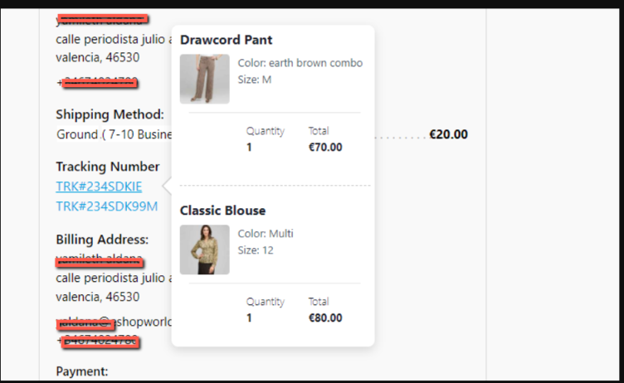
  - Order Detail (SiteGenesis)
On the storefront page of order detail, each tracking numbers will be displayed as per OOB site genesis behaviour as shown.

