


Version: 5.1.2
Published date: August 2026
Copyright © 2026 by ESW. All rights reserved. Information contained herein is subject to change without notice.

STOREFRONT COMPONENTS GUIDE

SFCC - ESW Cartridge
+
Contents
1 ESW Storefront Components 3
1.1 Welcome Mat 3
1.1.1 Welcome mat in SiteGenesis 3
1.1.2 Welcome mat in SFRA 4
1.1.3 Shopper Geo Location Alert 4
1.2 Header and Footer Widgets 5
1.2.1 Header 5
1.2.2 Footer 6
1.3 Country, Language, and Currency menus 7
1.3.1 Country 7
1.3.2 Language 7
1.3.3 Currency 8
1.3.4 Country Selection by URL Parameter 9
1.4 Order History Detail Page 9
2 ESW Storefront Components Configuration 10
2.1 Online Marketing > Content Slots 10
2.1.1 Verifying content slots 11
2.1.2 Configuring welcome message 11
2.1.3 Configuring Geo IP Alert Message 12
2.1.4 Configuring landing page content 13
2.2 ESW Retailer Display Configuration site preferences 14
2.3 ESW General Configuration site preferences 15

ESW Storefront Components

Welcome Mat
The welcome mat is a modal window that is displayed when shoppers visit your online store for the first time. Using the welcome mat, shoppers can change their shipping country, language, and currency. Clicking Continue Shopping saves all changes. Shoppers can easily change these details again by clicking the shopper selected country in the header as well as footer.
If the shopper has selected a country with a fixed pricing model, the currency selector will be disabled and the default currency from the ‘ESW Countries’ custom object will be automatically selected. If the shopper has selected a country with a calculated pricing model, the currency selector will be enabled and the default currency from the ‘ESW Countries’ custom object will be automatically selected.
If the geo-IP custom preference is enabled, then the welcome mat will not show up and the shopper’s country will be automatically selected based on the shopper’s geo location

Welcome mat in SiteGenesis

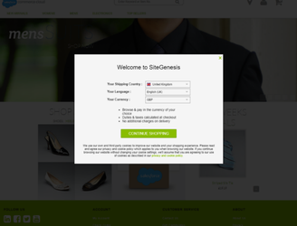

Welcome mat in SFRA
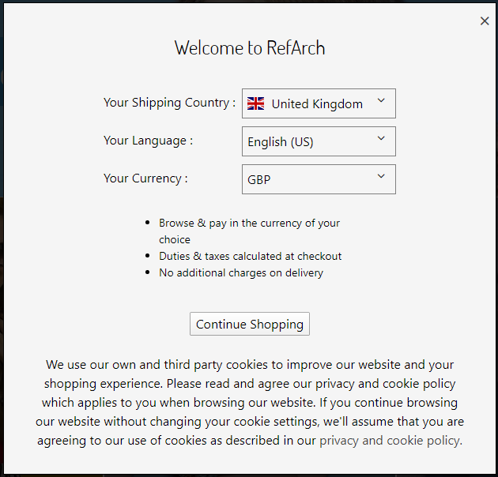

Shopper Geo Location Alert
If the custom preference value is set to true. The Welcome Mat will show an alert for returning shoppers when they are traveling or accessing the storefront from another country.
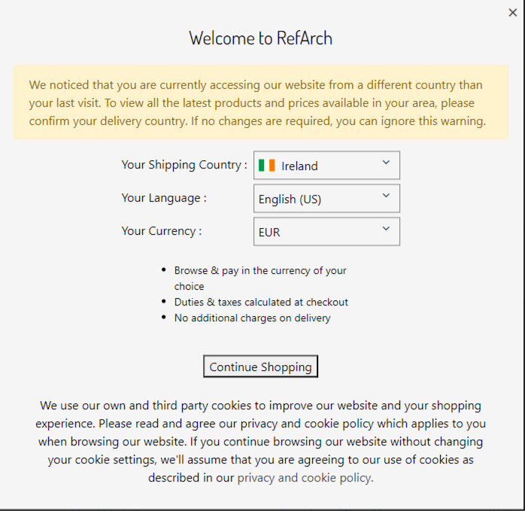

Header and Footer Widgets
The header and footer widgets include options that allow shoppers to change their preferences. The options include shipping country, language, and currency. These options are configurable from within the cartridge. When shoppers click the header or footer widget, the welcome mat appears again. The country, language, and currency preferences can then be updated via the welcome mat and applied to the storefront.

Header
The following image shows how the widgets are displayed in the header:
Header widgets in SiteGenesis
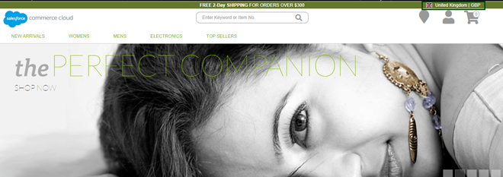
Header in SiteGenesis
Header widgets in SFRA
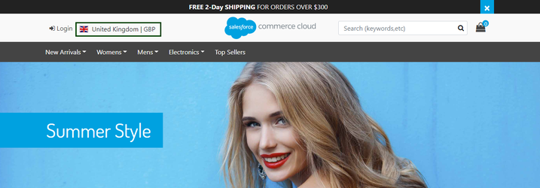
Header in SFRA

Footer
The following image shows how the widgets are displayed in the footer:
Footer widgets in SiteGenesis
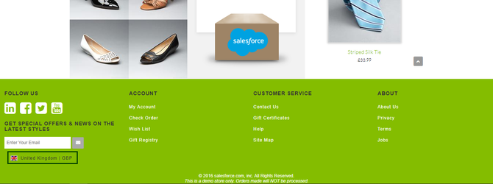
Footer in SiteGenesis
Footer widgets in SFRA
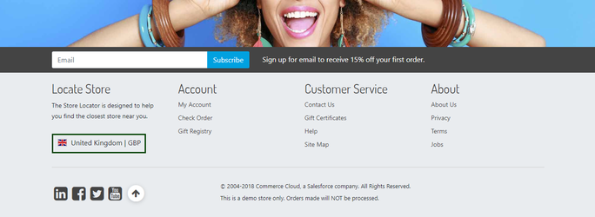
Footer in SFRA

Country, Language, and Currency menus
The currency and language details are updated based on the country selected by the shopper.

Country
- When a shopper selects a new country from the widget, the webpage is refreshed and the pricing logic for the new country is applied. The product prices are also updated on all pages, including the cart page.
- The cartridge supports the ESW-supported countries only. If the ESW-supported country is enabled for a site, all functionalities, such as welcome mat and header/footer widgets are displayed. If a non-supported country is selected, the cookies are updated but the prices are not.
- For ESW countries, the details load from the ESW Countries custom object. Each object has a flag (Is ESW Supported Country) to control if it is supported by the cartridge. You must update the custom objects ESW Countries and ESW Currencies for any new country or currency. You can implement a redirect to another site by customizing the EswHooks.js file.
- The Landing Page Enable or Disable option is provided for each site. You can also add countries that are within a site to the dropdown on the landing page, regardless of the country being supported or not supported by ESW. The currencies and languages on the landing page are updated along with the cookies. The welcome mat will be disabled if the user is using a URL parameter for country selection(See section 1.3.4 for details of URL parameter country selection)

Language
All languages/ locale must be enabled for the site that is selected in the configuration. The language/ locale that is configured and selected in ESW Allowed Languages custom site preference under ESW General Configuration group must be enabled in the SFCC Business Manager.
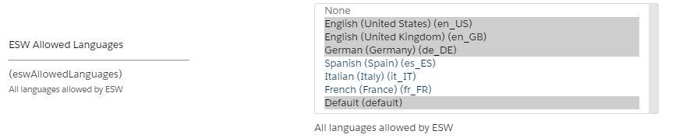
ESW Allowed Languages
To enable locales, go to SFCC Business Manager > Merchant Tools > Site Preferences > Locales, select locales and click Apply. If the locales are unavailable, add the required locales by navigating to SFCC Business Manager > Administration > Global Preferences > Locales.
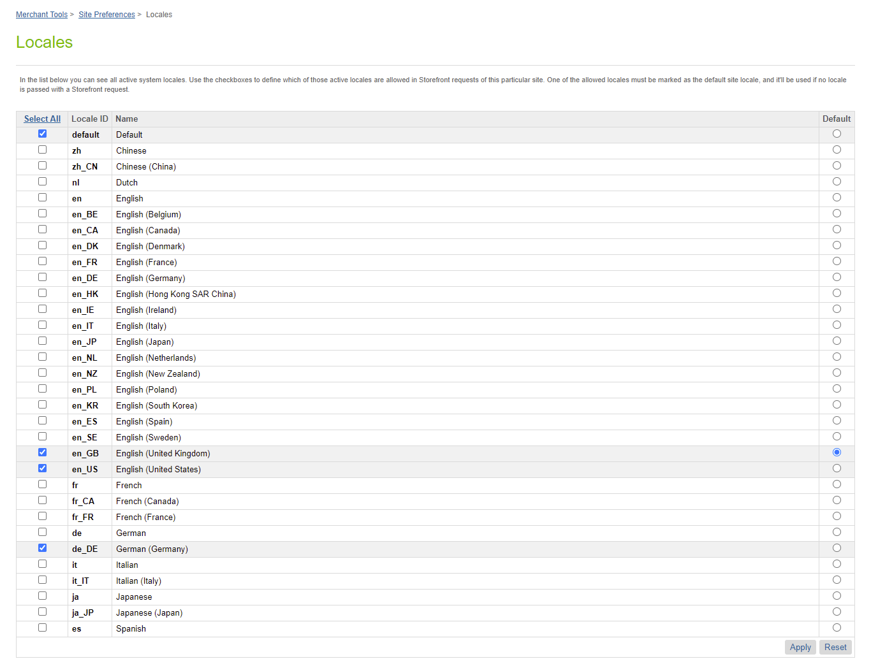
Locales

Currency
The base currency and any other currency for which you want to create the price book must be enabled for the site. To enable currencies, go to SFCC Business Manager > Merchant Tools > Site Preferences > Currencies, and then click Add.
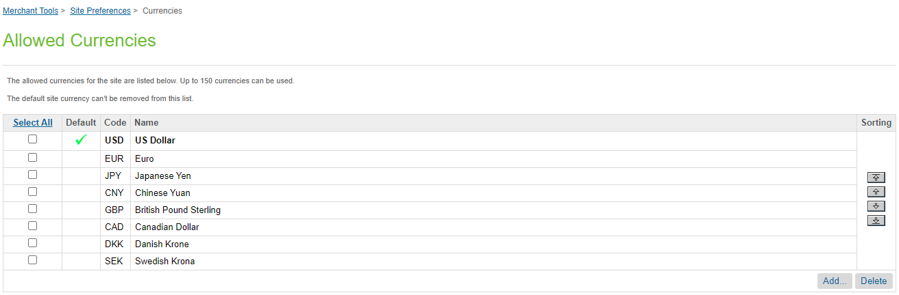
Allowed Currencies

Country Selection by URL Parameter

The ESW plugin allows country to be selected by using URL parameter. This feature is useful to check pricing in shopping feeds as well as help in the SEO ranking of the retailer’s storefront. To configure URL parameter name, navigate to the ESW General Configurations in the custom preferences and set a value for the parameter name in the preference ESW Country URL Parameter. The default value for this parameter name is country

ESW Country URL Parameter custom preference

For example, the retailer wants the pricing to be shown for Ireland, the parameter name can be given in URL with the value for the country code, IE. The URL will look like storefront.com?country=IE and prices will be shown in Euros.

Order History Detail Page
The eswEnableOrderDetail preference controls the display of shopper payment methods and order totals on the order history page. When set to true, the following features become available:
- Payment Method Display: The shopper's chosen payment method will be displayed alongside each order entry on the order history detail page.
- Currency Conversion: Order totals will be displayed in the shopper's local currency.
- Failed and Created Orders: Orders which are in failed or created state are not shown to the shopper.
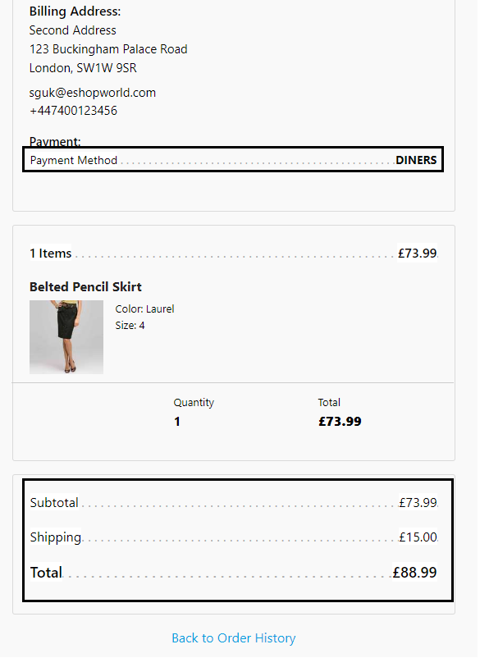
Order History Detail Page in SFRA

ESW Storefront Components Configuration

Online Marketing > Content Slots
After the site data import, two content slots are added. These content slots are for the welcome landing page and the landing page content.

Verifying content slots
You can verify the content slots using the following steps.
- Navigate to Merchant Tools > Online Marketing > Content Slots.
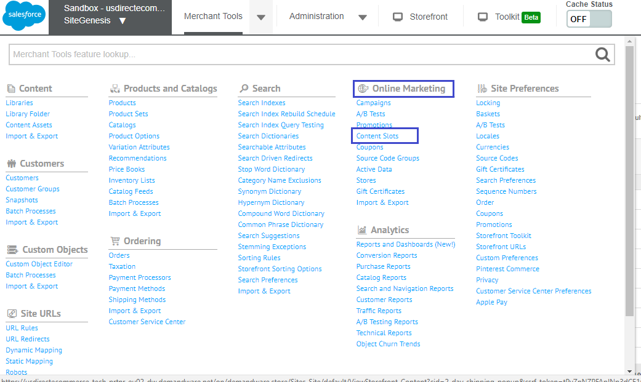
- Enter esw in the Search box. The content slots appear in the search result:
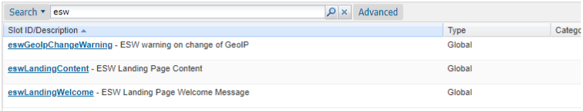

Configuring welcome message
You can configure the title by navigating to Merchant Tools > Online Marketing > Content Slots.
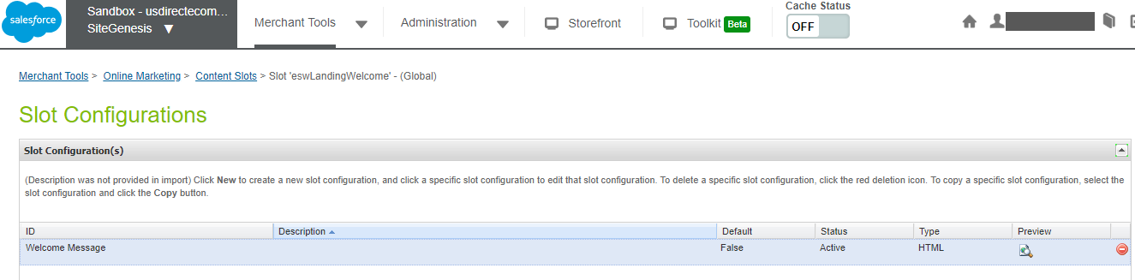
To configure a welcome message:
- Click the Welcome Message under ID.
- Add the title in the HTML attribute as shown in the following image:
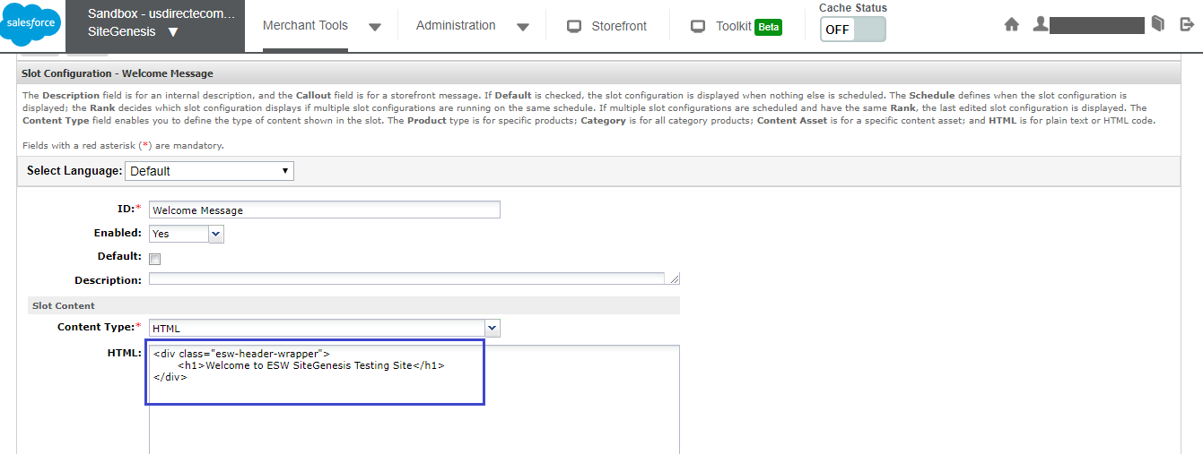
- Click Apply to apply the changes.

Configuring Geo IP Alert Message
Perform the following steps to configure the Geo IP Alert message content
- Click on the HTML Page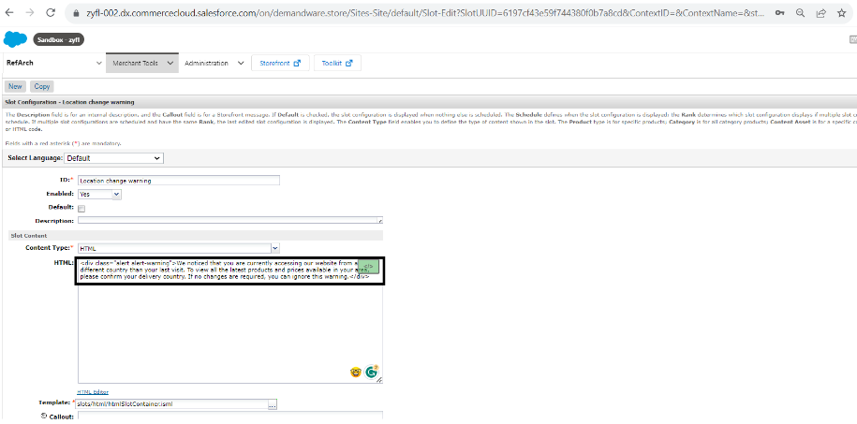
- Add the message in the div inside the HTML attribute as highlighted above
- Click on Apply to save and apply changes.

Configuring landing page content
Perform the following steps to configure the landing page content:
- Click the Landing Page Content ID
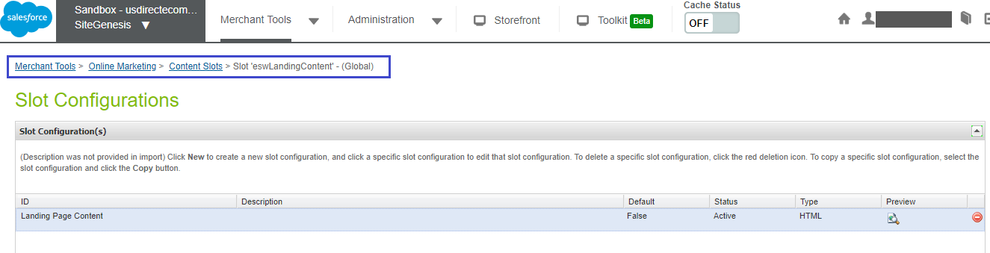
- Add the title in the HTML attribute under Slot Content:
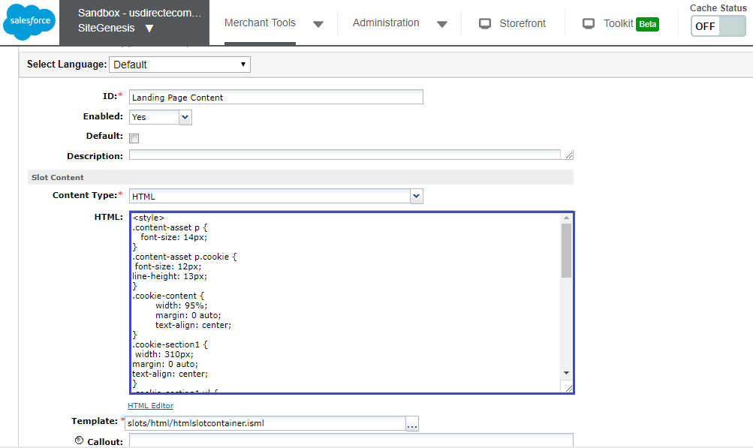
- Click Apply

ESW Retailer Display Configuration site preferences
You can use custom preferences to manage ESW retailer display configurations.
This group enables or disables the functionality at the site-level for the Landing, Header, and Footer pages. After adding or updating any value on the attributes, click Save to apply the changes.
- ESW Enable Landing Page: Select to show or hide the Welcome Landing page at the storefront end.
- ESW Enable Country Selector on Landing Page: Select to show or hide the Country dropdown.
- ESW Enable Currency Selector on Landing Page: Select to show or hide the Currency dropdown.
- ESW Enable Language Selector on Landing Page: Select to show or hide the Language dropdown.
- ESW Enable Bar on Landing Page: Select to show or hide the Landing page bar.
- ESW Enable Bar on Header Page: Select to show or hide the Header bar.
- ESW Enable Bar on Footer Page: Select to show or hide the Footer bar.
- ESW Enable Order Detail: If true ESW order attributes details will be displayed on Shopper’s order history page.
- ESW Hide Native Shipping: If true SFCC native shipping methods will be Hidden on cart page
- ESW AB Tasty Script Path: The script URL path for AB Tasty

ESW General Configuration site preferences
You can use custom preferences to manage ESW-specific configurations of the cartridge.
The following ESW General Configuration options are present:
- ESW Module Enabled: This is a mandatory attribute. It enables or disables the ESW Module at the site level.
- ESW Allowed Languages: The highlighted values represent languages to be considered as ESW Allowed Languages.
- ESW Base Currency: It sets the default/base currency at the site level.
- Enable Geo Lookup: This option enables or disables the geo IP lookup. If the geo lookup is enabled, the shopper’s current location is determined when they access the site for the first time. If disabled, the country selectors are preselected with the first options from the selectors.
- Enable Geo IP Alert: This option enables the Geo IP Alert for returning shoppers if the shopper’s IP country is different from the country value in the cookie.
- ESW Retailer Brand Code: This preference indicates the brand code of the current site.
- ESW Client ID for the Authorization Request: Indicates the client ID.
- ESW Client Secret for Authorization Request: Indicates the client secret.
- ESW Basic Auth Enabled: This option enables or disables basic authentication. For Sandbox instance, the option uses the storefront basic authentication. if the storefront is protected, then the storefront credentials (username and password) are used for authentication. For the Production instance, the username and password are provided by ESW.
- ESW Basic Authentication User: This option stores the basic authentication username.
- ESW Basic Authentication Password: This option stores the basic authentication password.
- ESW Instance Switcher:
  - If the Sandbox mode is selected, the
  - OrderConfirmationBase64EncodedAuth_TestOnlyand OrderConfirmationUri_TestOnly|EShopWorld-Notify metadata items fields are sent in the preorder call. These two values are used to perform the authentication during order confirmation in the Sandbox environment.
  - If the Production mode is selected, the mentioned metadata item fields are not sent to the preorder call. Also, this selection does not affect other metadata item fields that you might want to pass on to the preorder call.
- ESW Enable Return Prohibition: This option enables or disables the return prohibition feature for the current site.
- ESW Image Type: This option indicates the Image type to be displayed on checkout. By default, it is set to ‘small’ but retailer can customize as well.
- ESW Country URL Parameter: This value represents the optional parameter name for the country code parameter in the URL
- ESW Enable Tax Information: Tax information will be displayed in order history
- ESW Enable Multiple Shipment: Multiple shipments for the order feature will be enabled when toggle is set to “Yes”.
- ESW Order Status Updates: This value determines whether the retailer wants to synchronize order statuses with ESW.
- ESW SFCC OCAPI Client ID: SFCC OCAPI client ID to be used for basket and order related operations in case of embedded checkout

