


Version: 5.0.0
Published date: February 2026
Copyright © 2026 by ESW. All rights reserved. Information contained herein is subject to change without notice.

Mixed Cart Integration Guide

SFCC - ESW Cartridge
+
Table of Contents
1. Mixed Cart Overview 3
2. Mixed Cart Configurations 3
3. Testing Steps 4

Mixed Cart Overview

The ESW cartridge supports Mixed cart where retailer can combine physical and digital products into a single shopping cart streamlining the checkout process into a unified transaction. This elements the need for separate carts for different product types.

Mixed Cart Configurations
Import the custom attributes (systemobjects.xml) from link_eshopworld\Metadata\meta.

Product Level Attribute
SFCC does not natively support digital products type. To mark the product as a digital product, following custom attribute has been added at the product level.
.
- ESW Digital Product

Navigate to Merchant Tools > Products and Catalogs > Products >

Open the digital Product and update the attribute to true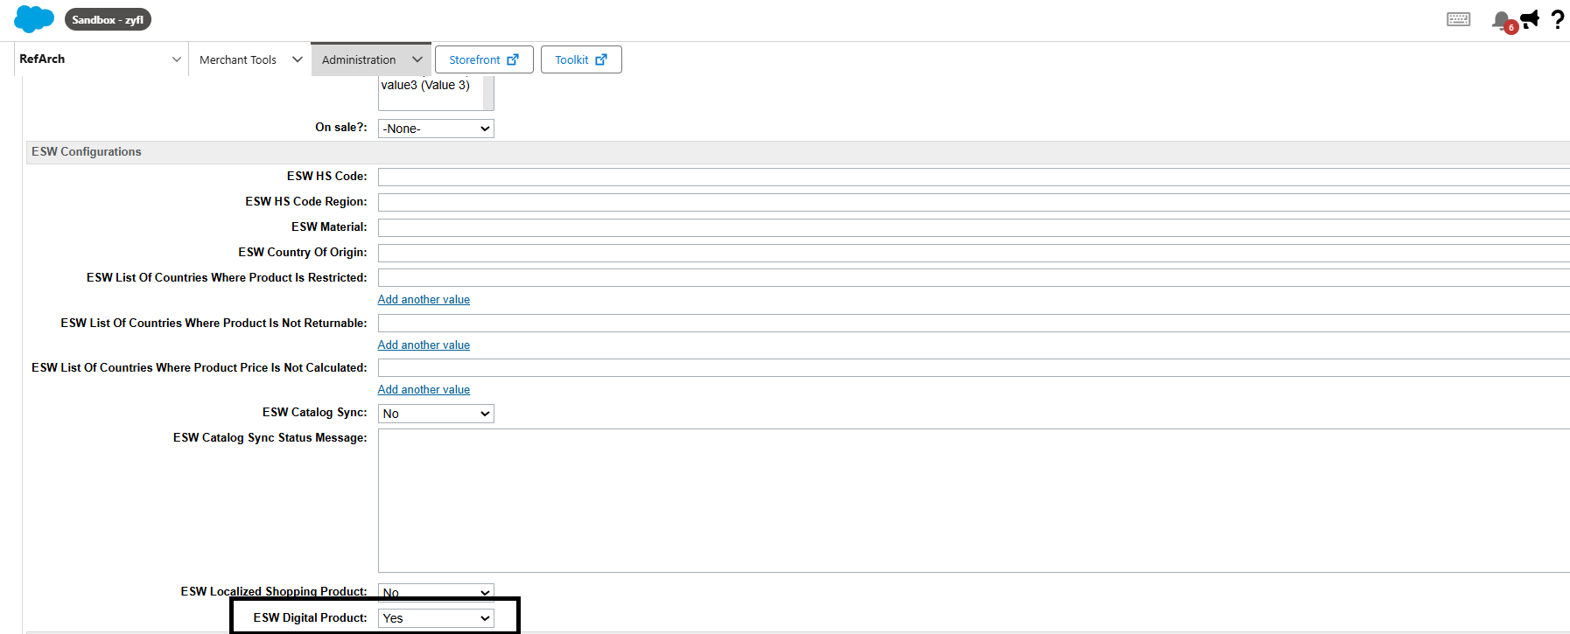

Marking the above attribute as true will ensure the ESW cartridge will consider this product as a digital product when navigating to the checkout.

The digital products can also be updated in bulk using SFCC bulk product updates. This can be achieved in two ways, Updating the attributes in the BM or using xml import.

To bulk update the attribute in the Business Manager
- Navigate to Business Manager > Merchant Tools > Products and Catalogs > Products.
- Locate the Product Search section and click the By ID tab.
- Locate List of IDs:, enter the product IDs, and click Find.
- Click Select all to select all products and then click Edit all/ Edit Selected.
- Select the Update/Delete Product Attributes action and then click on Next>>.
- Click Select attributes and select eswIsDigitalProduct
- Mark the value as true and click Finish or Go to Batch Process to complete the process.
To bulk update the attribute using XML import:
- Create an XML file with "eswIsDigitalProduct” value true under "custom-attribute" tag.
- Import the XML file in Business Manager by navigating to Merchant Tools > Products and Catalogs > Import & Export.
- Click Upload under Import and Export files to upload the XML file.
- Click the Import & Export module.
- Click Imports under Catalogs and then select the uploaded XML file.
- Click Next>> and then select the desired action (Merge or Replace).
- Click Finish.

Product Line Item
The following attribute is added on the lineitem level to identify the digital product
- eswIsDigitalProduct

Catalog

For catalog data, ensure that the category for any digital product is set to Digital. If you are using the ESW cartridge to transmit the catalog data, this is handled automatically and no additional steps are required. However, if you are not using the esw cartridge to export catalog data, you will need to manage this mapping manually.

Testing Steps
- Make sure the digital product’s attribute “ESW Digital Product” is set to Yes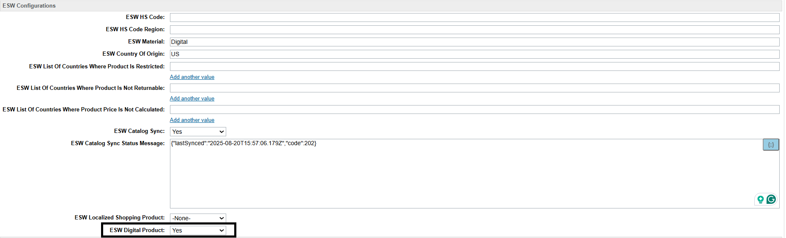
- Make sure the catalog is synced with ESW. For more information on catalog sync, please review the document eShopWorld_Catalog_Integration.docx
- Checkout
  - Add the product to the cart page and navigate to the checkout 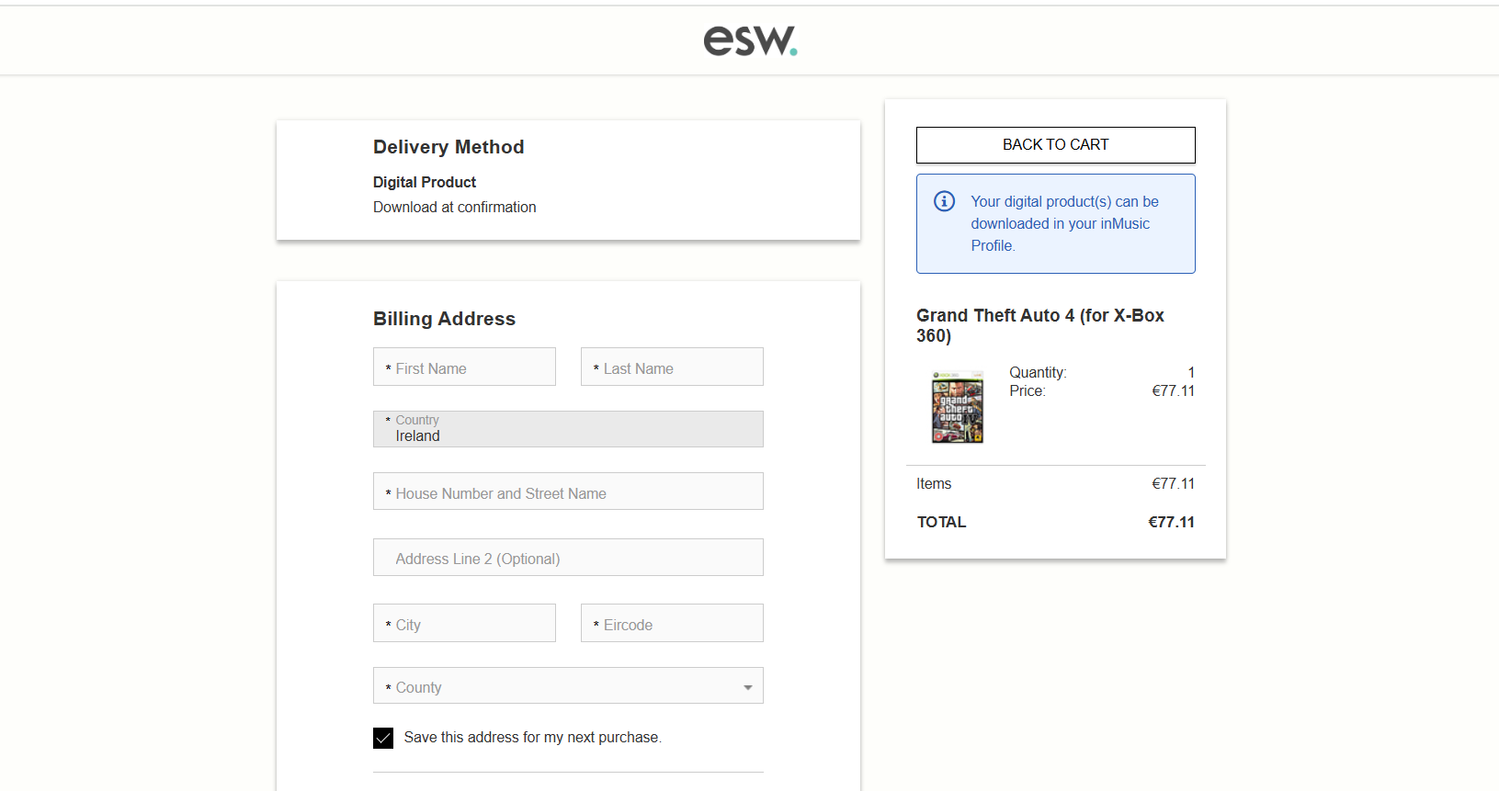
  - You can also combine the digital product with a physical product 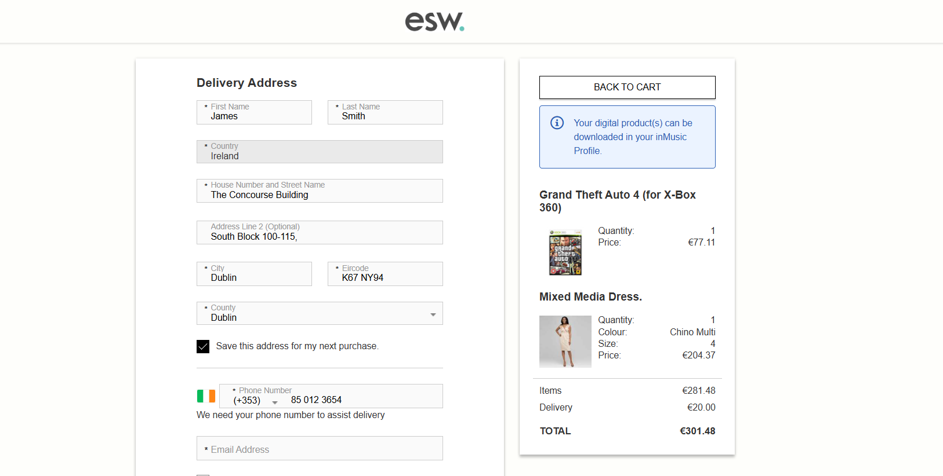
  - Place the order and verify the order confirmation attributes.

