


SFCC - ESW Cartridge

+
SFCC-PWA INTEGRATION GUIDE

Version: 5.1.0
Published date: May 2026
Copyright © 2026 by ESW. All rights reserved. Information contained herein is subject to change without notice.

Table of Contents
1. ESW PWA cartridges 3
1.1. Setup BM Cartridge 3
1.1.1. Setup cartridge path 3
1.1.2. Import site data 3
1.1.3. Configure PWA related custom preferences 3
2. Configure countries and locales 4
2.1. Configure countries custom object 4
2.2. Configure Locales 5
3. Code customization 6
3.1. Files to override to enable ESW functionalities: 6
3.2. Add ESW related configurations in default.js 6
3.3. ESW related configurations 7
3.4. Init ESW component 7
3.5. Override registration and login forms 8
3.6. Override Product Item component 10
3.7. Override Product view component 11
3.8. Override “useDerivedProduct” hook 12
3.9. Override “use-add-to-cart-modal” hook 14
3.10. Override site-utils.js 15
3.11. Override order detail page 16
3.12. Override Cart page 17
3.13. Shopper’s Timezone 19
3.14. Override Order Summary Page 19
3.15. Override product tile component 23
4. Update content slots and messages 23
4.1. Update geo ip alert message 23
4.2. Update return prohibit message 24
4.3. Update prices in callout messages and content 24
5. Custom attributes added in PWA 25
6. Custom Object Added in PWA 26
7. Order confirmation hooks 26

ESW PWA cartridges
The ESW PWA cartridge is developed to use with SFCC pwa-kit (https://github.com/SalesforceCommerceCloud/pwa-kit). To use this cartridge make sure you already have a working PWA environment.

Setup BM Cartridge

Setup cartridge path
- Add following cartridges to your cartridge path
  - int_eshopworld_headless
  - int_eshopworld_core
- The cartridge path should be looks like:
  - int_eshopworld_headless:int_eshopworld_core

Import site data
After setting up the cartridge path, you can import PWA related custom objects, preferences and content slots from following paths:
- To import system objects
  - link_eshopworld/sitesdata/meta/systemobjects.xml
  - link_eshopworld/sitesdata/meta/systemobjects_headless.xml
- To import custom objects
  - link_eshopworld/sitesdata/meta/customobjects.xml
  - link_eshopworld/sitesdata/meta/customobjects_headless.xml
- To import content assets
  - link_eshopworld/sitesdata/sites/RefArch/libraries.xml
  - link_eshopworld/sitesdata/sites/RefArch/content-assets.xml

Configure PWA
After importing site data you can configure custom preferences as follows:
- Please follow all steps outlined in eShopWorld_Cartridge_Configuration_Guide_Headless (OCAPI_SCAPI) and ensure that both SCAPI configuration and PWA Kit mapping are properly set up exactly as described in the document.
- Goto ` Merchant Tools > Site Preferences > Custom Site Preference Groups > ESW PWA Integration Configuration`
- Provide the “ESW PWA URL Expansion Pairs” as follows:
  - InventoryCheckFailurePageUrl|cart
  - BaseUrl|
  - ContinueShoppingUrl|Base url
  - BackToCartUrl|cart
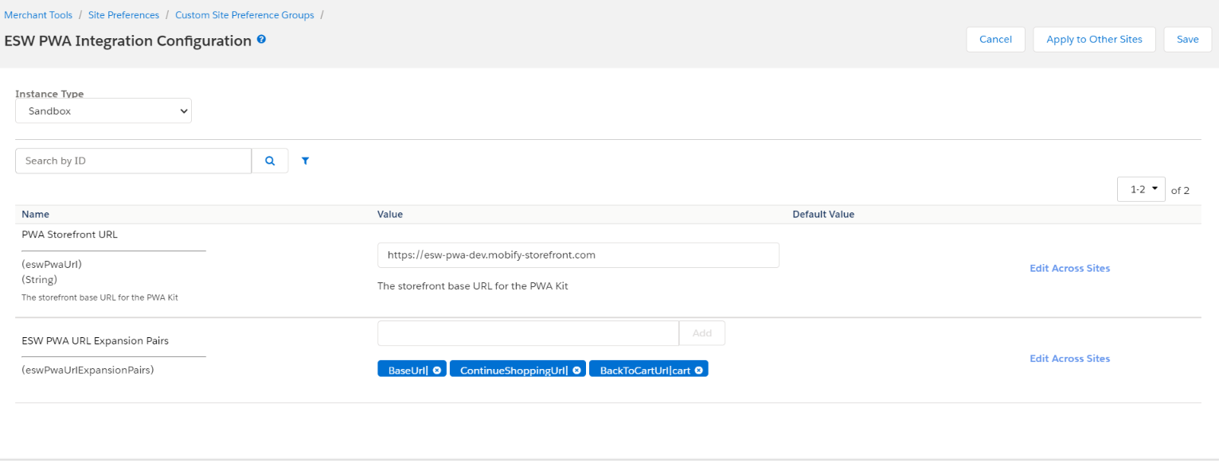

Configure countries and locales

Configure countries custom object
Countries should be configured in following way:
- Goto ` Merchant Tools > Custom Objects > Manage Custom Objects` and select ESW_COUNTRIES 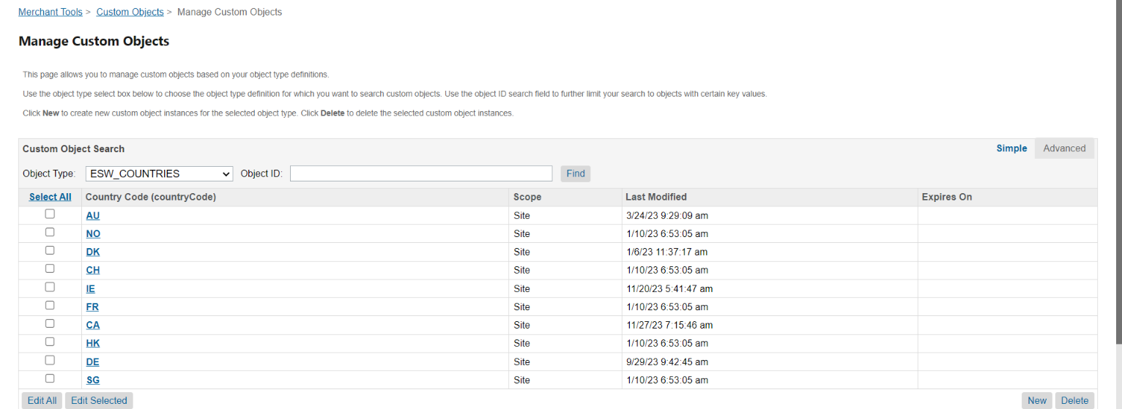
- Select country
- Add locale for the country as shown in screenshot 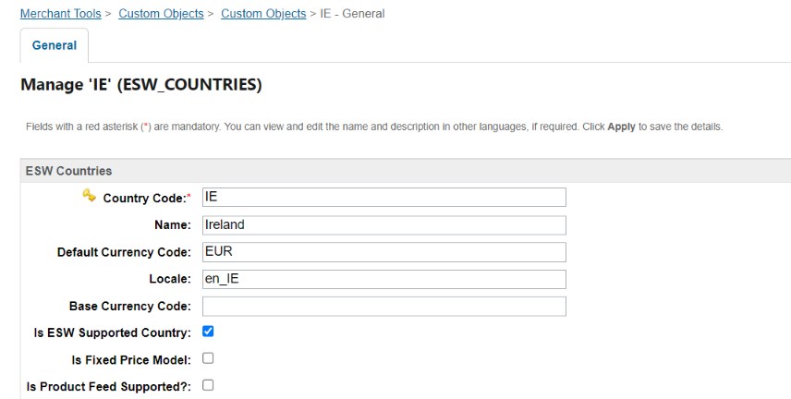
- The locale must be in the format of {lang_Country} e.g. en_IE, en_US, en_CA etc

Configure Locales
- Now go to “Merchant Tools > Site Preferences > Locales” and check if your given locale is present
- If yes then activate the locale (Mark the locale and press Apply button) 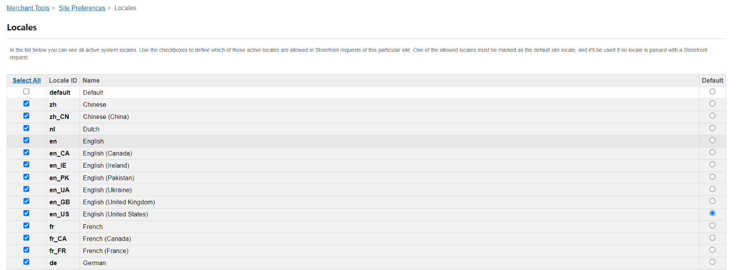
- If locale is not present then add locale from “Administration > Global Preferences > Locales > New Locale” 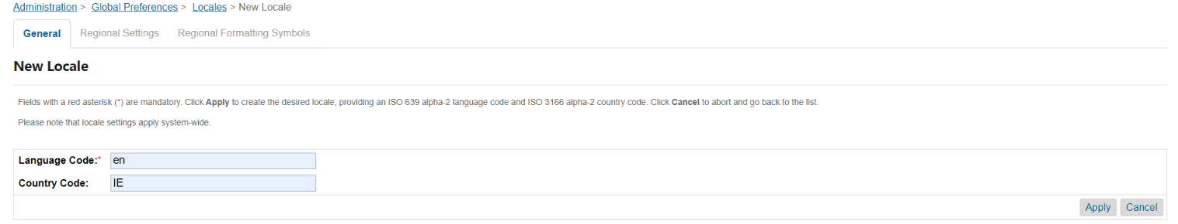
- This will generate locale in form of en_IE

Code customization
After setting up and running up the pwa kit successfully we can add ESW related changes in it.

Files to override to enable ESW functionalities:
Following files need to be placed in the relevant directories of pwa-kit to enabled ESW checkout:
- config/
  - default.js (To add ESW cartridge related URLs)
  - sites.js (Override this file so that add only one base country configs)
- override/
  - main.jsx (Add timezone cookie)
  - components/
    - footer/
      - index.js (To call esw init component)
    - forms/
      - login-fields.jsx (Prefilled login email for post checkout registration)
      - registration-fields.jsx (Prefilled registration fields for post checkout registration)
    - product-item/
      - index.jsx (Display return prohibit and restricted product message)
    - product-view/
      - index.jsx (Display return prohibit and restricted product message)
    - product-tile/
      - index.jsx (Force currency to be applied.++ from localStorage)
  - hooks/
    - use-derived-product.js (Setting return restricted product message)
    - use-add-to-cart-modal.js (Override checkout button in add to cart modal)
  - utils/
    - site-utils.js (Getting site.js configurations from the BM instead of site.js file)
  - pages
    - account/
      - order-detail.jsx (Display order tracking information from ESW)
  - cart/
    - partials/
      - cart-cta.jsx (override checkout button)
    - index.jsx
  - routes.jsx
- translations/
  - en-US.json (Add message for restricted products, retailer will need to update relevant translation file)

Add ESW related configurations in default.js
- Go to /configs folder
- Add esw-config.js file

ESW related configurations
Add the following configuration in default.js file in `app:
eswConfigs: {
ocapiProxyPath: '/mobify/proxy/ocapi',
siteUri: '/on/demandware.store/Sites-PWA-Site/default'
}
Make sure to add correct path for eswConfigs.
The sites.js file should have following content
module.exports = [
{
id: 'PWA',
l10n: {
supportedCurrencies: ['USD'], // Retailer's base currency
defaultCurrency: 'USD', // Retailer's base currency
defaultLocale: 'en-US', // Retailer's base country locale
supportedLocales: [
{
id: 'en-US', // Retailer's base country locale
alias: 'us', // country code in lowercase for URL
preferredCurrency: 'USD', // Retailer's base currency
supportedLocales: ['en-US'], // Retailer's base country locale
isFixedPriceModel: true,
isSupportedByESW: true,
actualCurrency: 'USD',
countryCode: 'US' // country code in uppercase for PWA cartridge use
}
]
}
}
]

Init ESW component
This component is responsible for the following:
- Update basket currency
- Getting ESW related configurations, for example: currency configurations, module enabled/disabled etc
- Display geo ip alert if user changes the location
- Cart rebuild when user come back to cart from the ESW checkout
To add this component please do the following:
- Go to /overrides/components/footer/index.jsx
  - Copy the file from pwa-kit if its not already there
- Import EswInit component
import {EswInit} from '../../esw/components/esw-init'

- Add EswInit component as shown in figure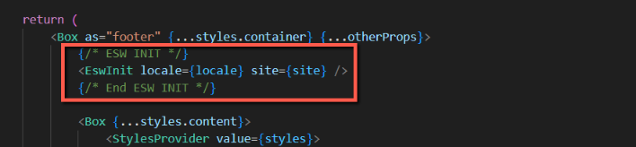
- EswInit component call APIs during initial rendering of the app

Override registration and login forms
This is require if you are using shopper registration (https://know.eshopworld.com/space/AE/848003073/Checkout+Shopper+Registration) feature of ESW. These forms are required to prefill the values of relevant fields in login and registration forms. Retailer can override these forms by following steps:
- Go to /overrides/components/forms
  - Create the folder if not already exist
- Copy and paste login-fields.jsx from ESW pwa cartridge
  - Add following codes in file 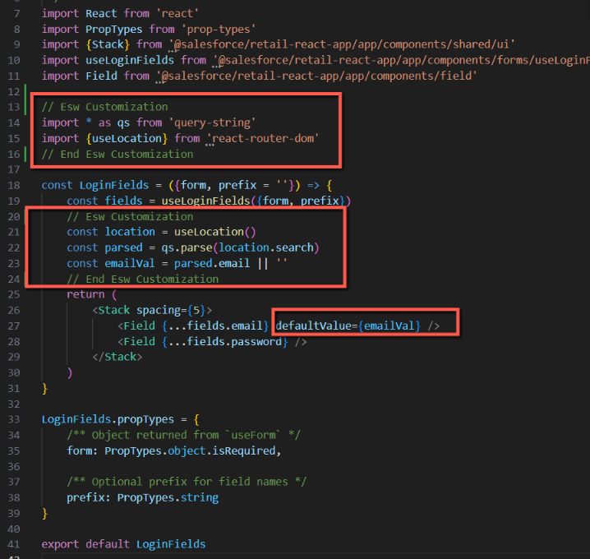
- Copy and paste registration-fields.jsx from ESW pwa cartridge
  - Add following codes in file 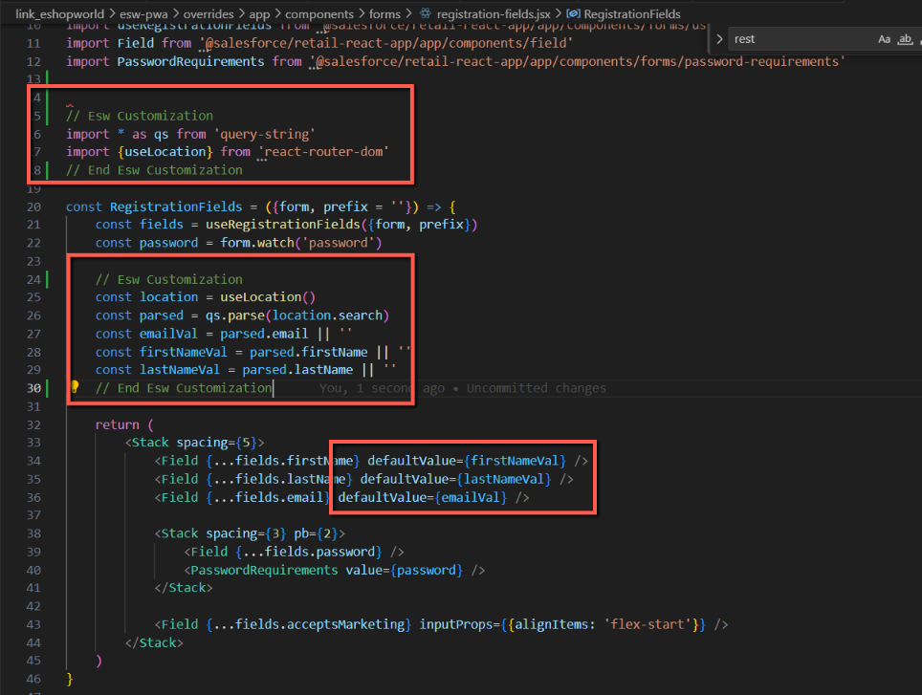

Override Product Item component
This is require if you are using Return prohibited (https://know.eshopworld.com/space/AE/255852638/Global+Product+Returns+Prohibition) feature of ESW. We will override this component by adding “EswReturnProhibitMsg” component. To add component follow these steps:
- Go to /overrides/components/product-item/index.jsx
  - If file is not there then get it from pwa cartridge
- Import the component
import {EswReturnProhibitMsg} from '../../esw/components/product-return-prohibit-msg'
- Call the component as shown 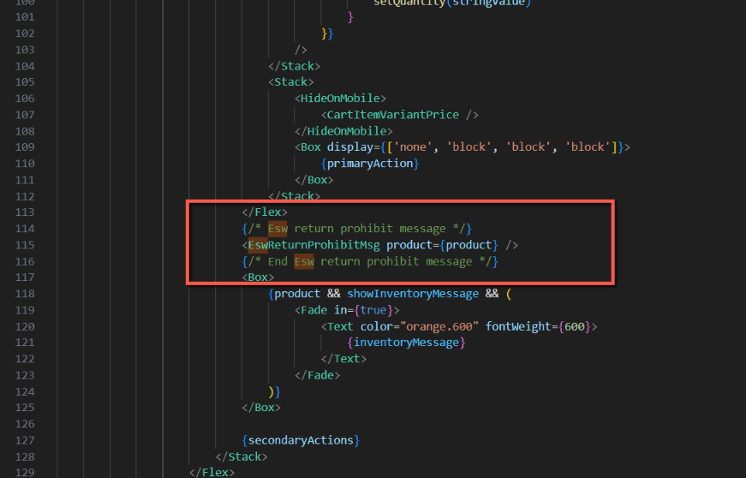
- We will call this component in /overrides/pages/cart/index.jsx in later steps

Override Product view component
This is require if you are using Return prohibited (https://know.eshopworld.com/space/AE/255852638/Global+Product+Returns+Prohibition) feature of ESW. We will override this component by adding “EswReturnProhibitMsg” component. To add component follow these steps:
- Go to /overrides/components/product-view/index.jsx
  - If file is not there then get it from pwa cartridge
- Import the component
import {EswReturnProhibitMsg} from '../../esw/components/product-return-prohibit-msg'
- Call the component as shown 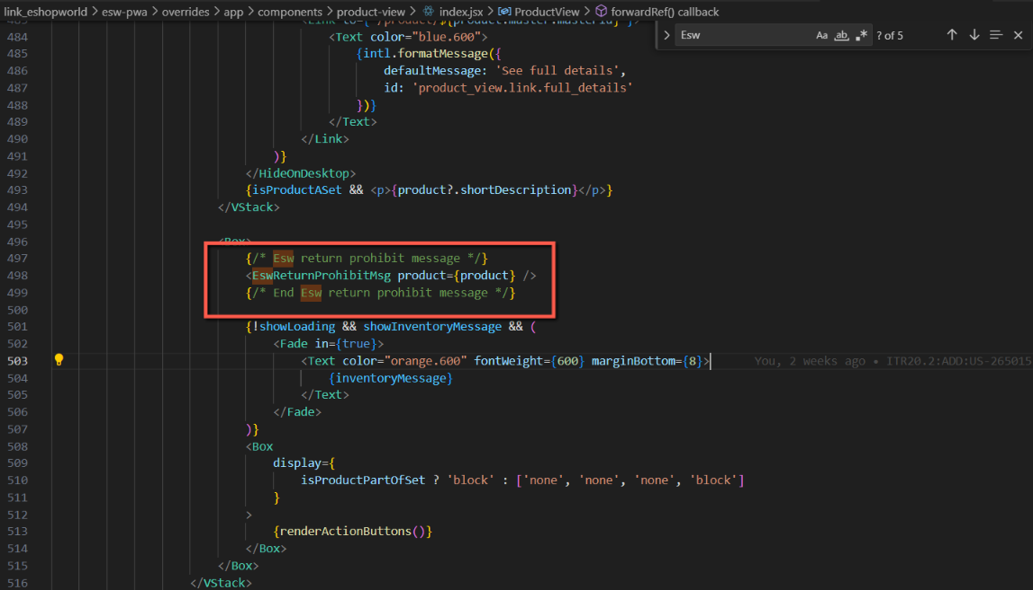

Override “useDerivedProduct” hook
This is require if you are using restricted product (https://know.eshopworld.com/space/AE/255557739/Global+Product+Restriction) feature of ESW. We will override this hook to add restrictions message. To override this hook please follow these steps:
- Go to /overrides/hooks/use-derived-product.js
  - If file is not there then get it from pwa cartridge
- Add following code as shown 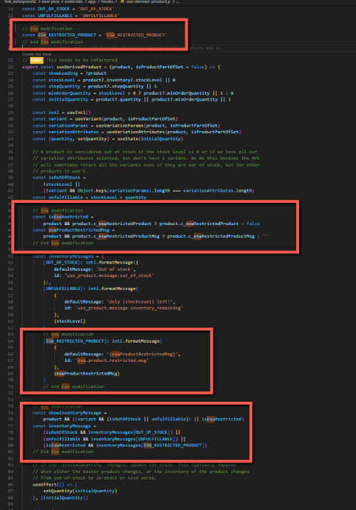
- Since we have updated hook which is using translation to show restricted product message. We also need to add the key in our translation file
  - Go to /translations/en-US.json
  - Add following code in the file
"esw.product.restricted.msg": {
"defaultMessage": "{eswProductRestrictedMsg}"
},
  - Retailer have to use specific translation file to add translation

Override “use-add-to-cart-modal” hook
This is require to implement ESW checkout on add to cart modal. To override the hook follow these steps:

- Go to /overrides/hooks/use-derived-product.js
  - If file is not there then get it from pwa cartridge
- Add code to add default shipment to basket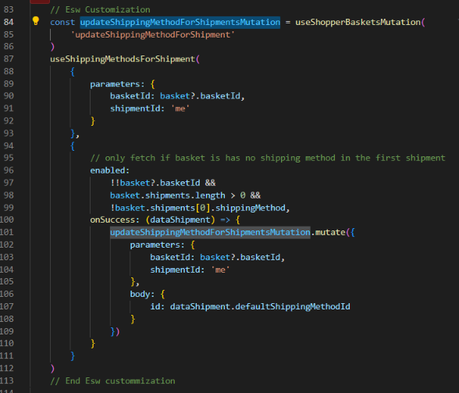
- Import required ESW modules
// Esw Customization
import { EswCheckoutBtn } from '../esw/components/checkout-btn'
import {
useShippingMethodsForShipment,
useShopperBasketsMutation
} from '@salesforce/commerce-sdk-react'
// end Esw Customization
- In place of checkout Button add following:
<EswCheckoutBtn
basketIdParam={basket.basketId}
variant="outline"
checkOrderAble={false}
/>
- As shown in screenshot 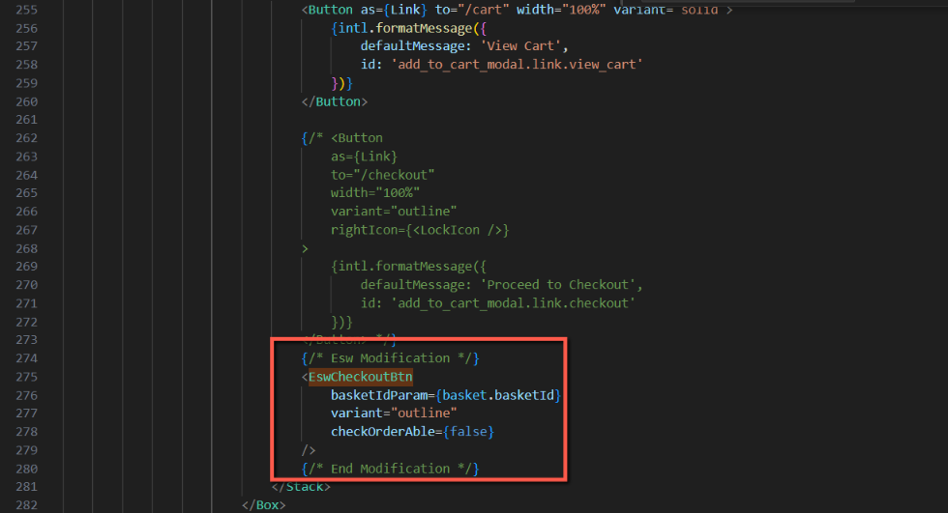
- Make sure to change it in two places (<ModalBody/> and <ModalFooter/>) components

Override site-utils.js
This is require to get countries from the BM configurations. To override this file please follow these steps:
- Go to /overrides/utils/site-utils.js
  - If file is not there then get it from pwa cartridge
- Import esw-services.js in the file
import {getSupportedCountries} from '../esw/esw-services'
- Update the function getSites()
/**
* ESW customized function to return the list of sites that has included their respective aliases
* @return {array} sites - list of sites including their aliases
*/
export const getSites = () => {
let sitesFromConfig = getConfig().app

// sites.js from the BM
getSupportedCountries()
.then((response) => response.json())
.then((data) => (sitesFromConfig.sites = data.allowedCountries))

let {sites = [], siteAliases = {}} = sitesFromConfig || {}

if (!sites.length) {
throw new Error("Can't find any sites from the config. Please check your configuration")
}

return sites.map((site) => {
const alias = siteAliases[site.id]
return {
...site,
...(alias ? {alias} : {})
}
})
}
- As shown in screenshot 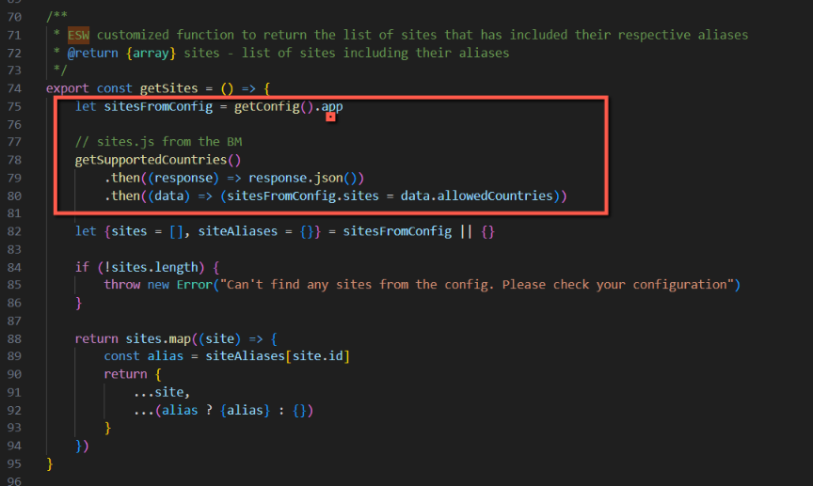

Override order detail page
This is require to display order tracking information from ESW. To override this file please follow these steps:
- Go to /overrides/pages/account/order-detail.jsx
  - If file is not there then get it from pwa cartridge
- Import EswOrderTracking component
import ESWOrderTracking from '../../esw/components/order-tracking/index'
- Call the component as shown in screenshot 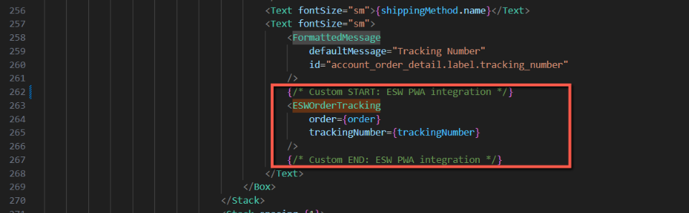

Override Cart page
This is require to override checkout functionality. So that if country is supported by ESW then it will redirect to esw checkout otherwise OOTB pwa checkout will work. To override this file please do the following:
- Go to /overrides/pages/cart/partials/cart-cta.jsx
  - If file is not there then get it from pwa cartridge
- Import EswCheckoutBtn component
import {EswCheckoutBtn} from '../../../esw/components/checkout-btn'
- Call the component as shown in screenshot 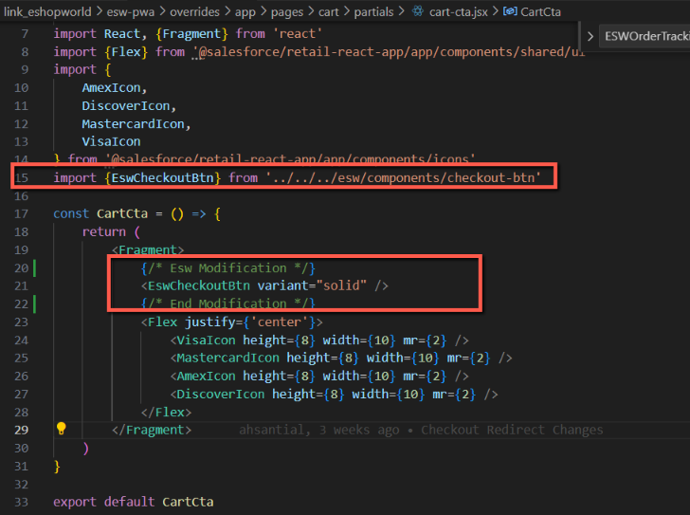
- After completing above step, call the component in cart page so that
  - Go to /overrides/pages/cart/index.jsx
  - Modify import of cart-cta as follows 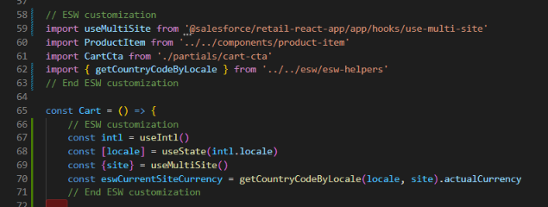
- Add condition on product item grid so that product price should not blink on page load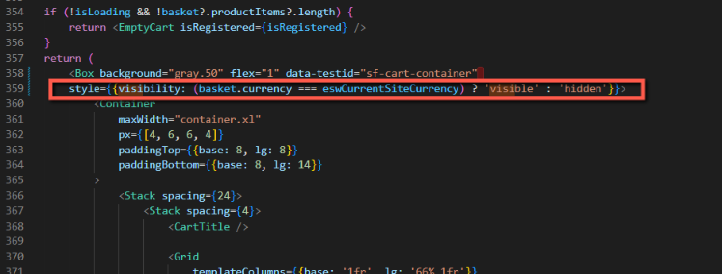
- Since we have updated page so we need to override routes too
  - Go to /overrides/routes.jsx
  - Import Cart
import Cart from './pages/cart'
  - Call this in routes as
{
path: '/cart',
component: Cart,
exact: true
}

Shopper’s Timezone
As MRT is not providing user’s country so we are getting it from the client timezone. For this reason we need to add “esw.shopperTimezone” cookie which we will get on the server to get the shopper country to show more accurate geo ip related results. To override this:
  - Go to /overrides/main.jsx
  - Add following piece of code in it
// Esw: Customization
document.cookie = "esw.shopperTimezone=" + Intl.DateTimeFormat().resolvedOptions().timeZone + ";secure"

Override Order Summary Page
This is required to display ESW override shipping methods on cart page. To override this file please follow these steps:
  - Go to overrides/app/components/order-summary/index.jsx
  - If file is not there then got it from PWA cartridge
  - Add the following piece of code as per screenshot
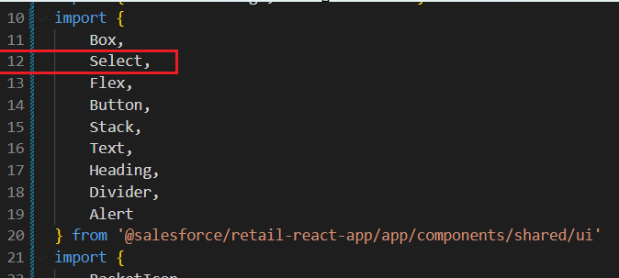
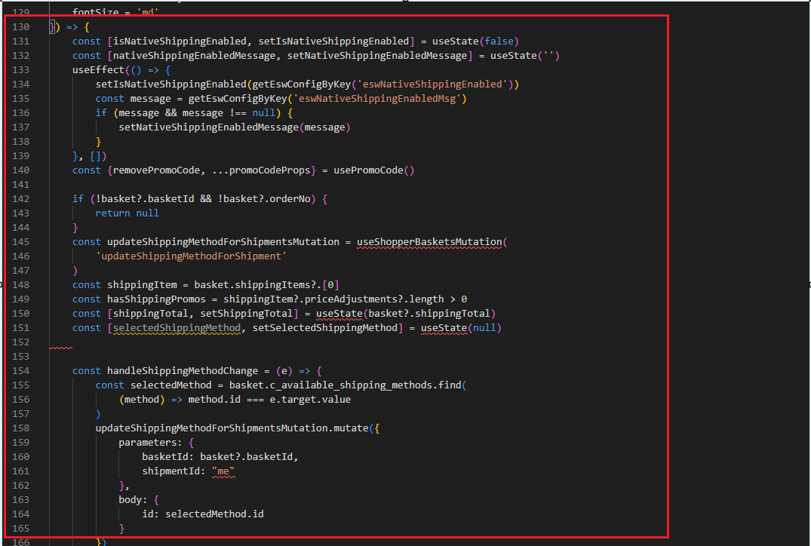
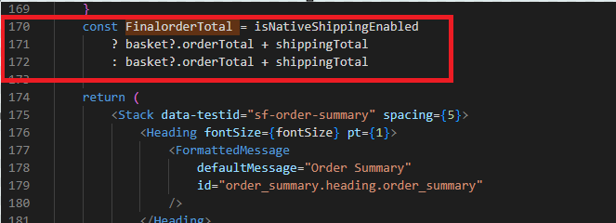
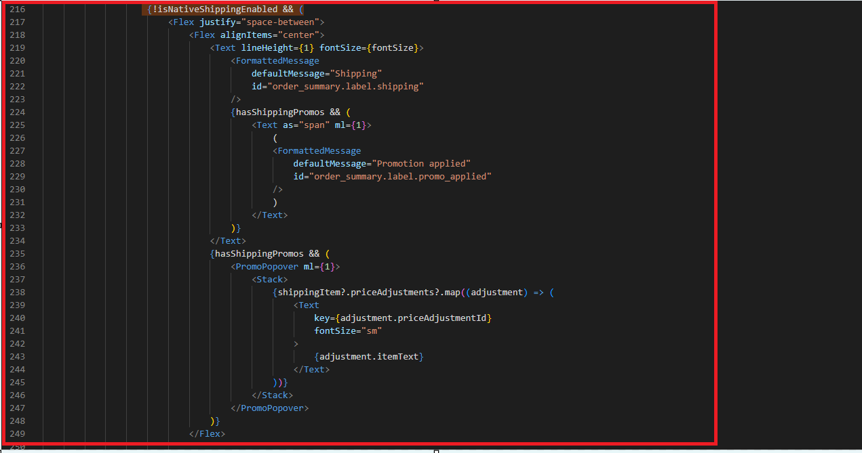
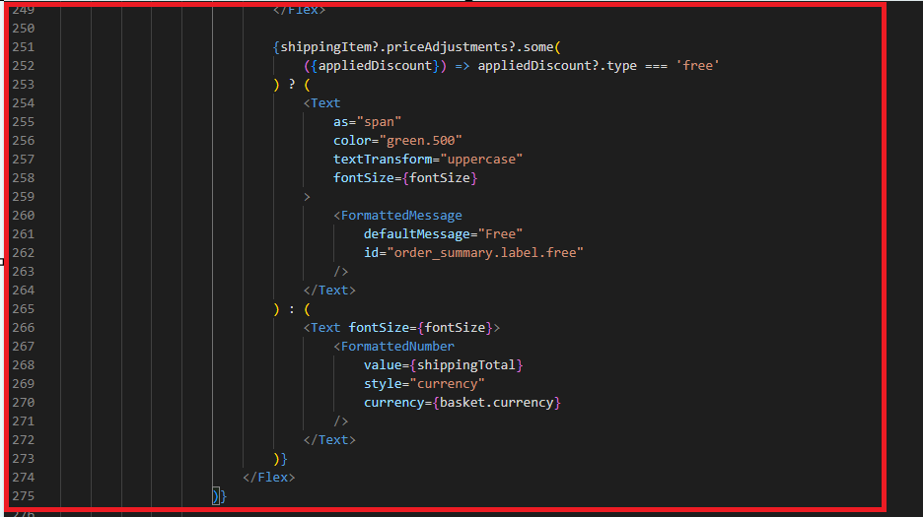
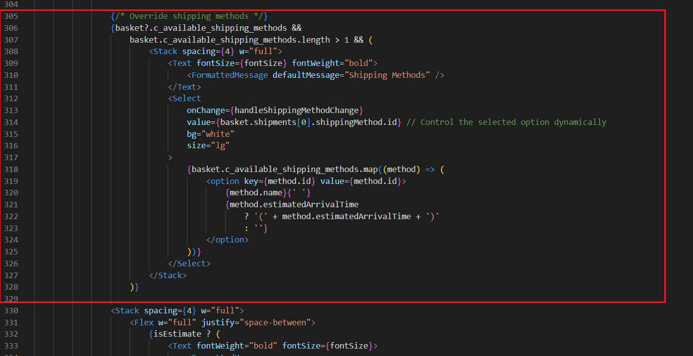
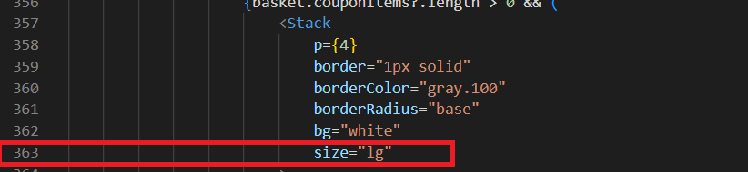

Override product tile component
This component has been overridden to allow manual setting of the product currency in cases of dynamic currency. By default, PWA sets the currency to the retailer’s base currency when dynamic currency is used. Therefore, we have updated this component and added the following customizations: 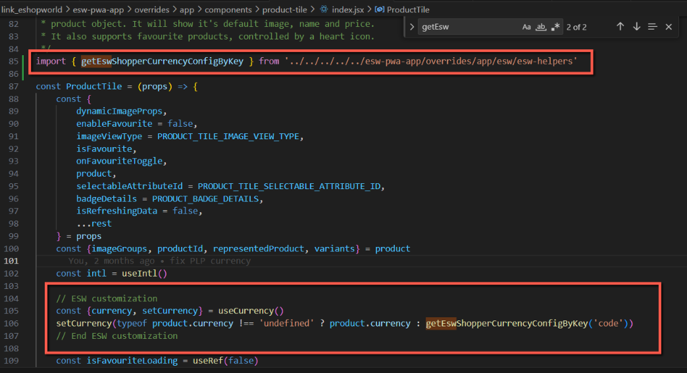

Update content slots and messages
This section describes how to update different messages we are getting from the BM

Update geo ip alert message
If retailer is using geo lookup (https://know.eshopworld.com/space/AE/255754260/ESW+Storefront+Components#ESW-General-Configuration-Site-Preferences) then its alert messages can be customized from content asset “eswGeoIpChangeWarning”. The title is the name of the content asset while the body of the content asset

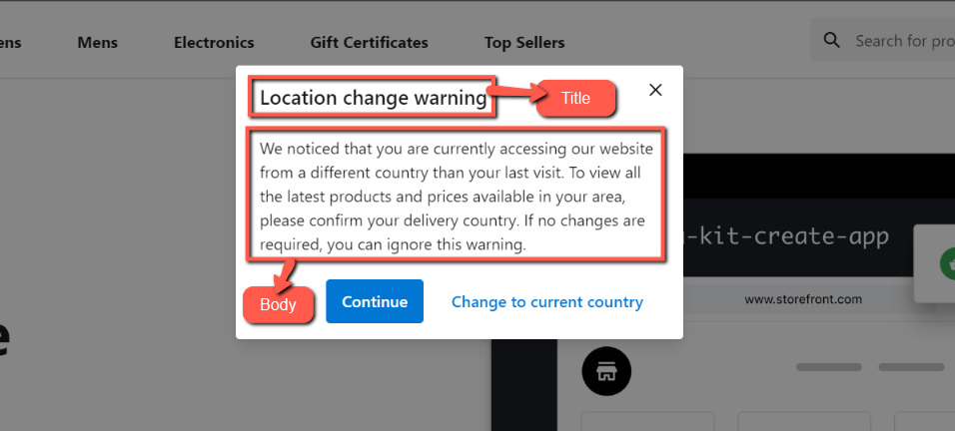

Update return prohibit message
If retailer is using return prohibit feature then its message can be updated from the body of content asset “esw-display-return-prohibited-message” 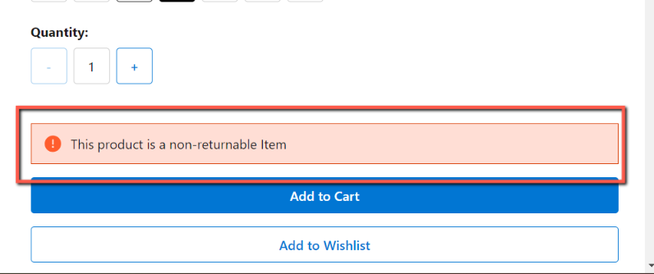

Update prices in callout messages and content
This is used to calculate prices from retailer’s currency to shopper currency. To enable this feature please follow (https://know.eshopworld.com/space/AE/475332611/Localized+Front-End+Prices). We then need to convert prices in shopper currency on the frontend. Please use convertPrice() function from esw-helpers to convert prices after getting in the DOM.

Working example can be found in ‘/overrides/pages/esw-example-content-details/index.jsx` and can be accessed via route `/content/esw-test-content` 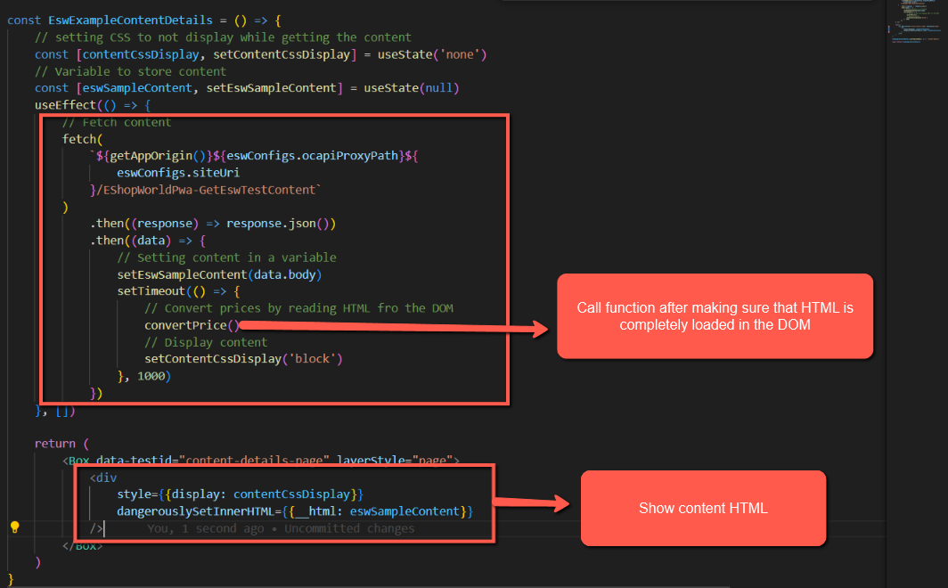

Custom attributes added in PWA
Product custom attributes
ESW Attribute | Data Type
c_eswReturnProhibited | Boolean - true/false if  product return is prohibited  in current shopper country.
c_eswReturnProhibitMsg | String - Message to show for return prohibit products
c_eswRestrictedProduct | Boolean - true/false if  product is restricted  in current shopper country.
c_eswRestrictedProductMsg | String - Message to show if product is restricted
Basket custom attributes
c_eswShopperCurrency | String - 2 Char ISO | -
Custom preferences attributes
eswPwaUrlExpansionPairs | Set of Strings: (URI configurations for different actions) | Values:  InventoryCheckFailurePageUrl|cart  BaseUrl|  ContinueShoppingUrl|Base url  BackToCartUrl|cart

Custom Object Added in PWA
The Following new custom object are added for PWA

ESW_PWA_ORDER_DATA:

No manual configuration is necessary for this custom object, as it's exclusively utilized by the cartridge to facilitate the post-registration feature for order number storage. The cartridge autonomously manages both the creation and destruction of this object, ensuring seamless functionality without any additional administrative overhead.

Order confirmation hooks
These hooks can be found and configured from related documentation. No special work requires for PWA

