


Version: 5.1.2
Published date: August 2026
Copyright © 2026 by ESW. All rights reserved. Information contained herein is subject to change without notice.

SiteGenesis - Code Customization guide

SFCC - ESW Cartridge
+

Table of Contents
Table of Contents 2
1 SiteGenesis 3
Customizing the code 3
1.1 Customizing the templates 3
1.1.1 header.isml 3
1.1.2 footer.isml 4
1.1.3 footer_UI.isml 4
1.1.4 cart.isml 5
1.1.5 minicart.isml 8
1.1.6 minilineitems.isml 9
1.1.7 orderdetails.isml 9
1.1.8 ordertotals.isml 11
1.1.9 pricing.isml 14
1.1.10 producttile.isml 15
1.1.11 productsearchbreadcrumbs.isml 17
1.1.12 productsearchrefinebar.isml 17
1.1.13 suggestions.isml 18
1.1.14 productcontent.isml 18
1.1.15 producttopcontentPS.isml 20
1.1.16 productsetproduct.isml 21
1.1.17 displayliproduct.isml 21
1.1.18 orders.isml 22
1.2 Customizing the controllers 22
1.2.1 Currency.js 22
1.2.2 Cart.js 25
1.2.3 COCustomer.js 25
1.3 Customizing the scripts and json 26
1.3.1 Resource.ds 26
1.3.2 OnRequest.js 27
1.3.3 validateCartForCheckout.js 28
1.3.4 calculate.js 29
1.3.5 hooks.json 30

1 SiteGenesis

Customizing the code
Important: The path for files listed in this section are based on the controller. Ensure that you add the code to the relevant cartridge.

1.1 Customizing the templates

1.1.1 header.isml
Path
SiteGenesis_core/cartridge/templates/default/components/header/header.isml

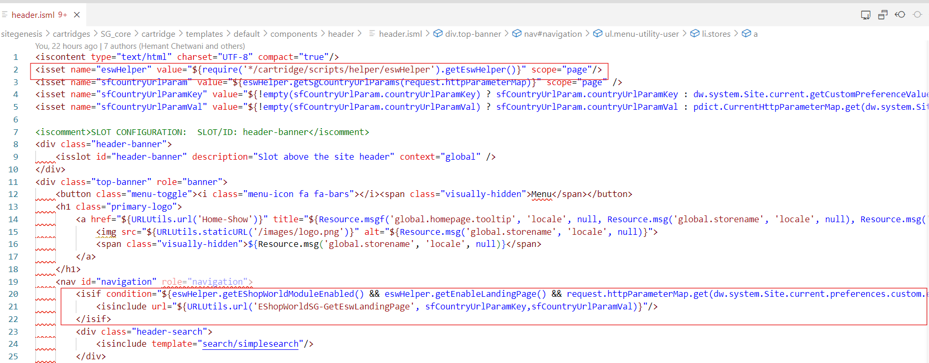
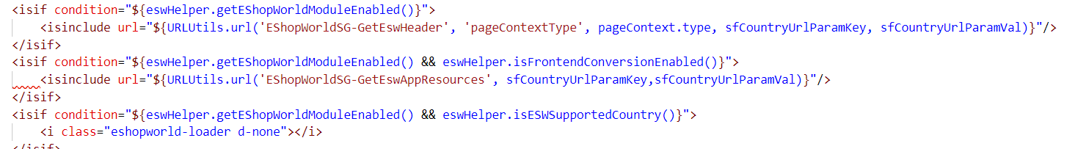
<isset name="eswHelper" value="${require('*/cartridge/scripts/helper/eswHelper').getEswHelper()}" scope="page"/>

<isif condition="${eswHelper.getEShopWorldModuleEnabled() && eswHelper.getEnableLandingPage() && request.httpParameterMap.get(dw.system.Site.current.preferences.custom.eswCountryUrlParam) == false}">
<isinclude url="${URLUtils.url('EShopWorldSG-GetEswLandingPage', dw.system.Site.current.getCustomPreferenceValue('eswCountryUrlParam'),pdict.CurrentHttpParameterMap.get(dw.system.Site.current.getCustomPreferenceValue('eswCountryUrlParam')))}"/>
</isif>

<isif condition="${eswHelper.getEShopWorldModuleEnabled()}">
<isinclude url="${URLUtils.url('EShopWorld-GetEswHeader', 'pageContextType', pageContext.type, dw.system.Site.current.getCustomPreferenceValue('eswCountryUrlParam'), pdict.CurrentHttpParameterMap.get(dw.system.Site.current.getCustomPreferenceValue('eswCountryUrlParam')))}"/></isif>
<isif condition="${eswHelper.getEShopWorldModuleEnabled() && eswHelper.isFrontendConversionEnabled()}">
<isinclude url="${URLUtils.url('EShopWorldSG-GetEswAppResources', dw.system.Site.current.getCustomPreferenceValue('eswCountryUrlParam'),pdict.CurrentHttpParameterMap.get(dw.system.Site.current.getCustomPreferenceValue('eswCountryUrlParam')))}"/>
</isif>
<isif condition="${eswHelper.getEShopWorldModuleEnabled() && eswHelper.isESWSupportedCountry()}">
<i class="eshopworld-loader d-none"></i>
</isif>

1.1.2 footer.isml
Path
SiteGenesis_core/cartridge/templates/default/components/footer/footer.isml
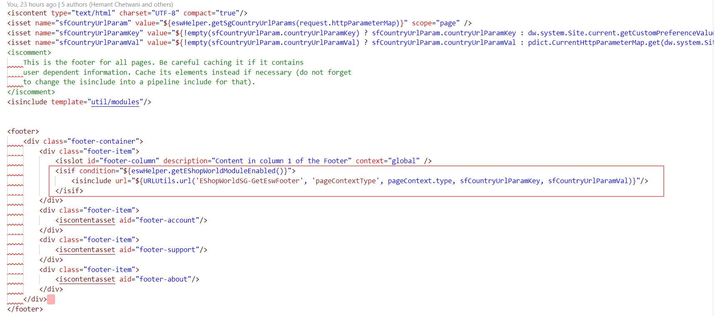
<isif condition="${eswHelper.getEShopWorldModuleEnabled()}">
<isinclude url="${URLUtils.url('EShopWorldSG-GetEswFooter', 'pageContextType', pageContext.type, dw.system.Site.current.getCustomPreferenceValue('eswCountryUrlParam'), pdict.CurrentHttpParameterMap.get(dw.system.Site.current.getCustomPreferenceValue('eswCountryUrlParam')))}"/>
</isif>

1.1.3 footer_UI.isml
Path
SiteGenesis_core/cartridge/templates/default/components/footer/footer_UI.isml

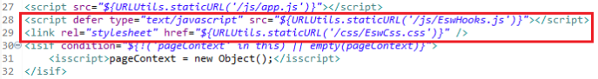
<script defer type="text/javascript" src="${URLUtils.staticURL('/js/EswHooks.js')}"></script>
<link rel="stylesheet" href="${URLUtils.staticURL('/css/EswCss.css')}" />

1.1.4 cart.isml
Path
SiteGenesis_core/cartridge/templates/default/checkout/cart/cart.isml

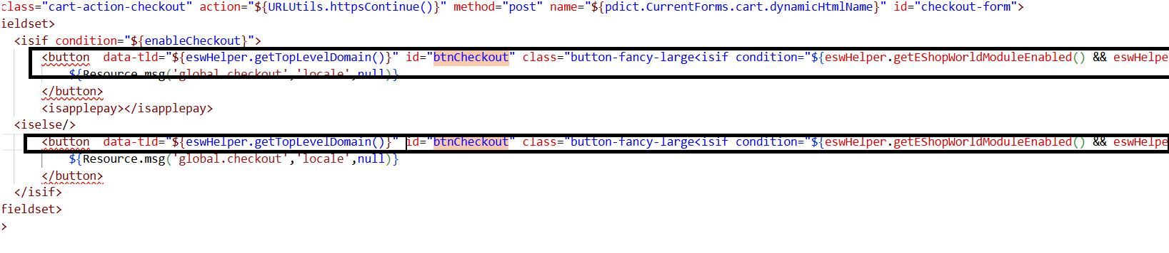
<button data-tld="${eswHelper.getTopLevelDomain()}" id="btnCheckout" class="button-fancy-large<isif condition="${eswHelper.getEShopWorldModuleEnabled() && eswHelper.isESWSupportedCountry()}"> btnCheckout</isif>" type="submit" value="${Resource.msg('global.checkout','locale',null)}" name="${pdict.CurrentForms.cart.checkoutCart.htmlName}">

<button data-tld="${eswHelper.getTopLevelDomain()}" id="btnCheckout" class="button-fancy-large<isif condition="${eswHelper.getEShopWorldModuleEnabled() && eswHelper.isESWSupportedCountry()}"> btnCheckout</isif>" disabled="disabled" type="submit" value="${Resource.msg('global.checkout','locale',null)}" name="${pdict.CurrentForms.cart.checkoutCart.htmlName}">

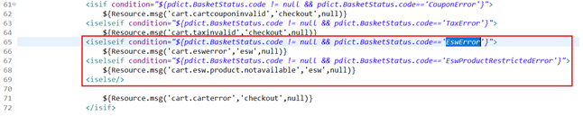

<iselseif condition="${pdict.BasketStatus.code != null && pdict.BasketStatus.code=='EswError'}">
${Resource.msg('cart.eswerror','esw',null)}
<iselseif condition="${pdict.BasketStatus.code != null && pdict.BasketStatus.code=='EswProductRestrictedError'}">
${Resource.msg('cart.esw.product.notavailable','esw',null)}
<iselse/>

Use the EShopWorldSG-GetConvertedPrice controller as shown to convert prices:
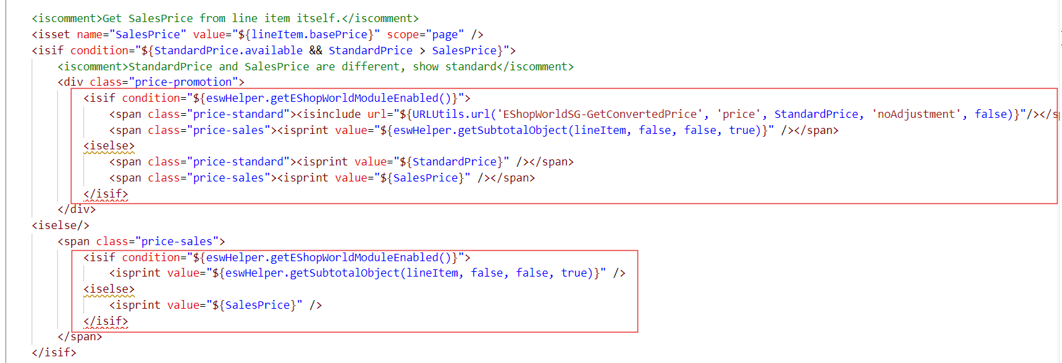
<isif condition="${eswHelper.getEShopWorldModuleEnabled()}">
<span class="price-standard"><isinclude url="${URLUtils.url('EShopWorldSG-GetConvertedPrice', 'price', StandardPrice, 'noAdjustment', false)}"/></span>
<span class="price-sales"><isprint value="${eswHelper.getSubtotalObject(lineItem, false, false, true)}" /></span>
<iselse>
<span class="price-standard"><isprint value="${StandardPrice}" /></span>
<span class="price-sales"><isprint value="${SalesPrice}" /></span>
</isif>
<isif condition="${eswHelper.getEShopWorldModuleEnabled()}">
<isprint value="${eswHelper.getSubtotalObject(lineItem, false, false, true)}" />
<iselse>
<isprint value="${SalesPrice}" />
</isif>

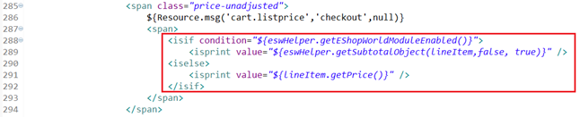

<isif condition="${eswHelper.getEShopWorldModuleEnabled()}">
<isprint value="${eswHelper.getSubtotalObject(lineItem,false, true)}" />
<iselse>
<isprint value="${lineItem.getPrice()}" />
</isif>

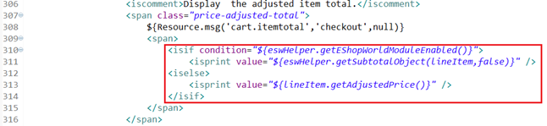
<isif condition="${eswHelper.getEShopWorldModuleEnabled()}">
<isprint value="${eswHelper.getSubtotalObject(lineItem,false)}" />
<iselse>
<isprint value="${lineItem.getAdjustedPrice()}" />
</isif>

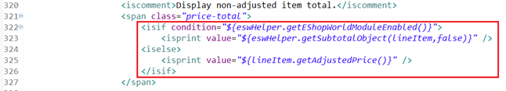
<isif condition="${eswHelper.getEShopWorldModuleEnabled()}">
<isprint value="${eswHelper.getSubtotalObject(lineItem,false)}" />
<iselse>
<isprint value="${lineItem.getAdjustedPrice()}" />
</isif>

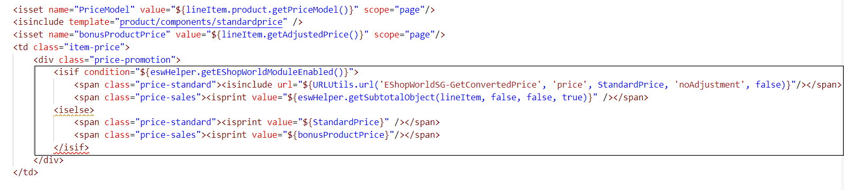
<isif condition="${eswHelper.getEShopWorldModuleEnabled()}">
<span class="price-standard"><isinclude url="${URLUtils.url('EShopWorldSG-GetConvertedPrice', 'price', StandardPrice, 'noAdjustment', false)}"/></span>
<span class="price-sales"><isprint value="${eswHelper.getSubtotalObject(lineItem, false, false, true)}" /></span>
<iselse>
<span class="price-standard"><isprint value="${StandardPrice}" /></span>
<span class="price-sales"><isprint value="${bonusProductPrice}"/></span>
</isif>

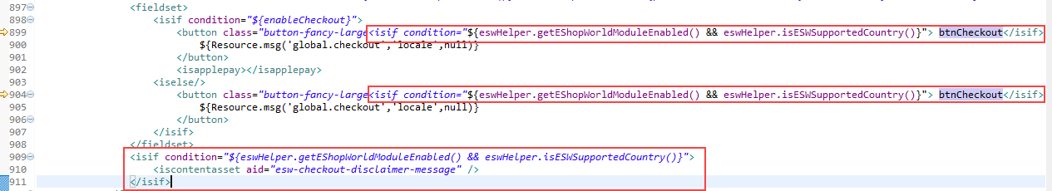
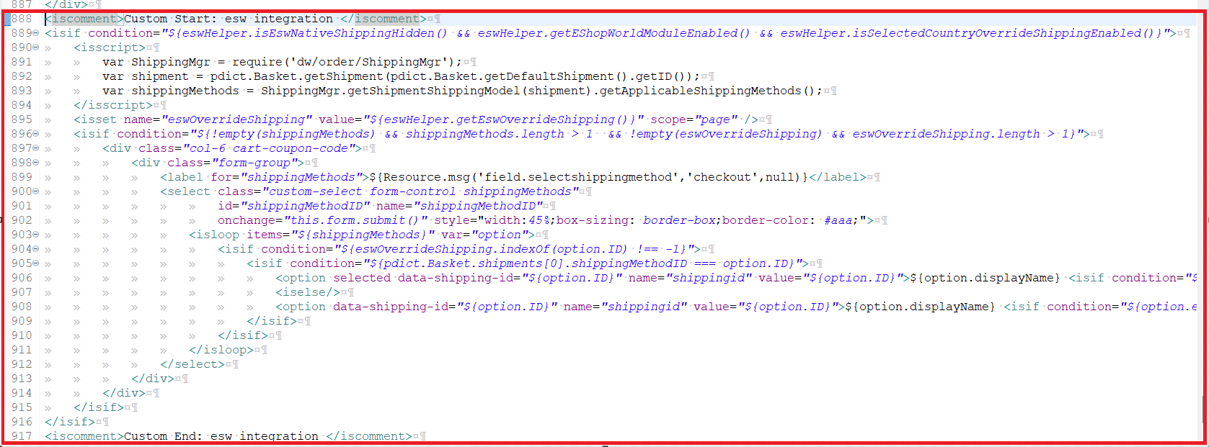
<iscomment>Custom Start: esw integration </iscomment>
<isif condition="${eswHelper.isEswNativeShippingHidden() && eswHelper.getEShopWorldModuleEnabled() && eswHelper.isSelectedCountryOverrideShippingEnabled()}">
<isscript>
var ShippingMgr = require('dw/order/ShippingMgr');
var shipment = pdict.Basket.getShipment(pdict.Basket.getDefaultShipment().getID());
var shippingMethods = ShippingMgr.getShipmentShippingModel(shipment).getApplicableShippingMethods();
</isscript>
<isset name="eswOverrideShipping" value="${eswHelper.getEswOverrideShipping()}" scope="page" />
<isif condition="${!empty(shippingMethods) && shippingMethods.length > 1 && !empty(eswOverrideShipping) && eswOverrideShipping.length > 1}">
<div class="col-6 cart-coupon-code">
<div class="form-group">
<label for="shippingMethods">${Resource.msg('field.selectshippingmethod','checkout',null)}</label>
<select class="custom-select form-control shippingMethods"
id="shippingMethodID" name="shippingMethodID"
onchange="this.form.submit()" style="width:45%;box-sizing: border-box;border-color: #aaa;">
<isloop items="${shippingMethods}" var="option">
<isif condition="${eswOverrideShipping.indexOf(option.ID) !== -1}">
<isif condition="${pdict.Basket.shipments[0].shippingMethodID === option.ID}">
<option selected data-shipping-id="${option.ID}" name="shippingid" value="${option.ID}">${option.displayName} <isif condition="${option.estimatedArrivalTime}">(${option.estimatedArrivalTime})</isif></option>
<iselse/>
<option data-shipping-id="${option.ID}" name="shippingid" value="${option.ID}">${option.displayName} <isif condition="${option.estimatedArrivalTime}">(${option.estimatedArrivalTime})</isif></option>
</isif>
</isif>
</isloop>
</select>
</div>
</div>
</isif>
</isif>
<iscomment>Custom End: esw integration </iscomment>

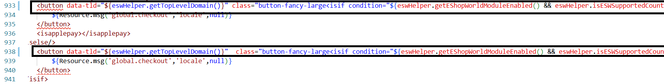
<button data-tld="${eswHelper.getTopLevelDomain()}"
class="button-fancy-large<isif condition="${eswHelper.getEShopWorldModuleEnabled() && eswHelper.isESWSupportedCountry()}"> btnCheckout</isif>" type="submit" value="${Resource.msg('global.checkout','locale',null)}" name="${pdict.CurrentForms.cart.checkoutCart.htmlName}">
${Resource.msg('global.checkout','locale',null)}
</button>

<button data-tld="${eswHelper.getTopLevelDomain()}"
class="button-fancy-large<isif condition="${eswHelper.getEShopWorldModuleEnabled() && eswHelper.isESWSupportedCountry()}"> btnCheckout</isif>" disabled="disabled" type="submit" value="${Resource.msg('global.checkout','locale',null)}" name="${pdict.CurrentForms.cart.checkoutCart.htmlName}">
${Resource.msg('global.checkout','locale',null)}
</button>
<isif condition="${eswHelper.getEShopWorldModuleEnabled() && eswHelper.isESWSupportedCountry()}">
<iscontentasset aid="esw-checkout-disclaimer-message" />
</isif>

1.1.5 minicart.isml
Path
SiteGenesis_core/cartridge/templates/default/checkout/cart/minicart.isml
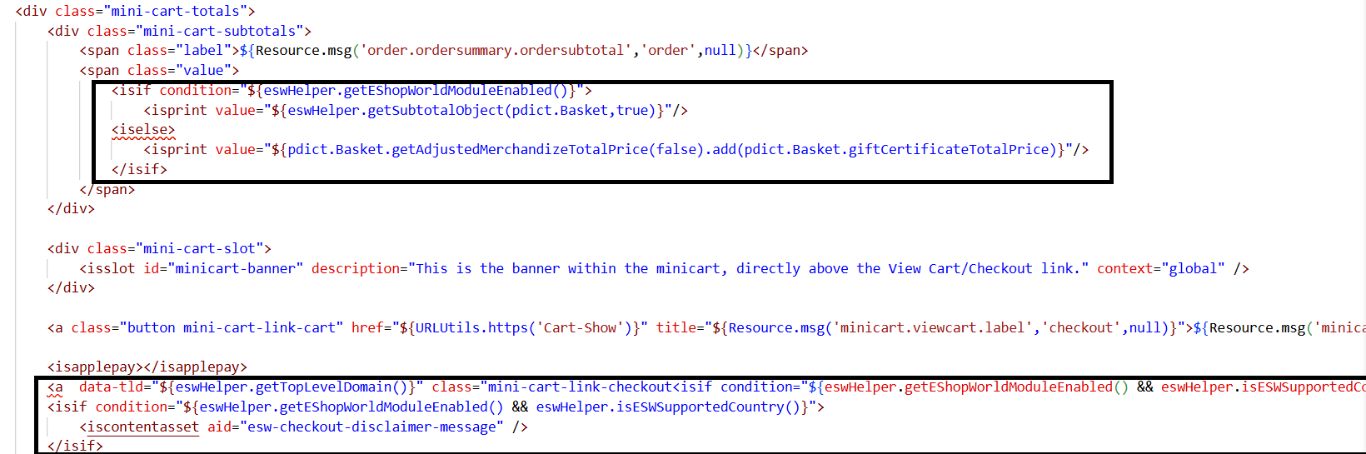

<isscript>
var eswHelper = require('*/cartridge/scripts/helper/eswHelper').getEswHelper();
</isscript>

<isif condition="${eswHelper.getEShopWorldModuleEnabled()}">
<isprint value="${eswHelper.getSubtotalObject(pdict.Basket,true)}"/>
<iselse>
<isprint value="${pdict.Basket.getAdjustedMerchandizeTotalPrice(false).add(pdict.Basket.giftCertificateTotalPrice)}"/>
</isif>

<a data-tld="${eswHelper.getTopLevelDomain()}"class="mini-cart-link-checkout<isif condition="${eswHelper.getEShopWorldModuleEnabled() && eswHelper.isESWSupportedCountry()}"> btnCheckout</isif>" href="${URLUtils.https('COCustomer-Start')}" title="${Resource.msg('minicart.directcheckout','checkout',null)}">${Resource.msg('minicart.directcheckout','checkout',null)} &raquo;</a>

<isif condition="${eswHelper.getEShopWorldModuleEnabled() && eswHelper.isESWSupportedCountry()}">
<iscontentasset aid="esw-checkout-disclaimer-message" />
</isif>
The ${eswSubtotalObject(pdict.Basket, true)} function calculates the order total by applying conversion rates and eShopWorld price adjustments.
The btnCheckout class redirects the shopper to the eShopWorld Checkout on clicking if ESW module is enabled and the shipping country exists in ESW supported countries.

1.1.6 minilineitems.isml
Path
SiteGenesis_core/cartridge/templates/default/checkout/components/minilineitems.isml
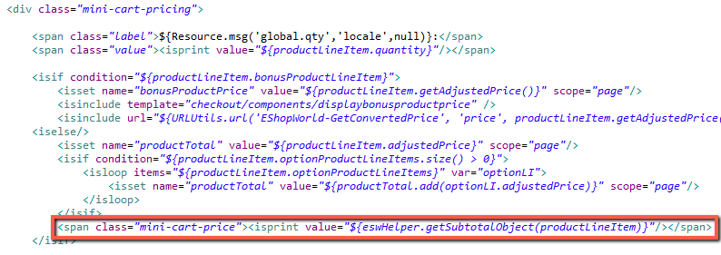
<span class="mini-cart-price"><isprint value="${eswHelper.getSubtotalObject(productLineItem)}"/></span>

1.1.7 orderdetails.isml
Path
SiteGenesis_core/cartridge/templates/default/components/order/orderdetails.isml

<isscript>
var eswHelper = require('*/cartridge/scripts/helper/eswHelper').getEswHelper();
var formatMoney = require('dw/util/StringUtils').formatMoney;
var eswOrderHistoryFlag = false;
var isOrderDetailEnabled = eswHelper.isOrderDetailEnabled();

var eswModuleEnabled = eswHelper.getEShopWorldModuleEnabled();
var isEswSupportedCountry = eswHelper.isESWSupportedCountry();
if (eswModuleEnabled) {
eswOrderHistoryFlag = eswHelper.isEswOrderHistory(Order);
}
var paymentMethod = !empty(Order.paymentTransaction.custom.eswPaymentMethodCardBrand) ? Order.paymentTransaction.custom.eswPaymentMethodCardBrand : Order.custom.eswPaymentMethod;

</isscript>

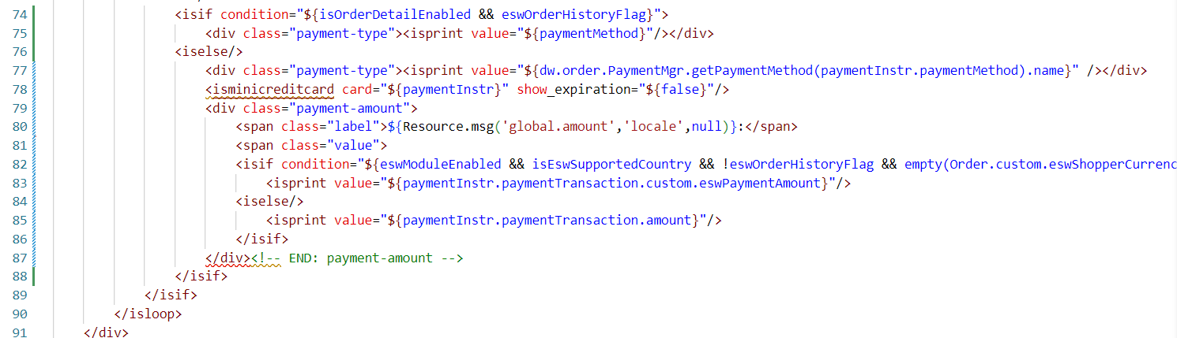
<isif condition="${isOrderDetailEnabled && eswOrderHistoryFlag}">
<div class="payment-type"><isprint value="${paymentMethod}"/></div>
<iselse/>
<div class="payment-type"><isprint value="${dw.order.PaymentMgr.getPaymentMethod(paymentInstr.paymentMethod).name}" /></div>
<isminicreditcard card="${paymentInstr}" show_expiration="${false}"/>
<div class="payment-amount">
<span class="label">${Resource.msg('global.amount','locale',null)}:</span>
<span class="value">
<isif condition="${eswModuleEnabled && isEswSupportedCountry && !eswOrderHistoryFlag && empty(Order.custom.eswShopperCurrencyCode)}" >
<isprint value="${paymentInstr.paymentTransaction.custom.eswPaymentAmount}"/>
<iselse/>
<isprint value="${paymentInstr.paymentTransaction.amount}"/>
</isif>
</div>
</isif>

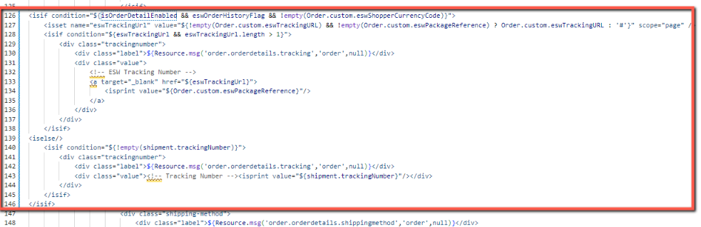
<isif condition="${isOrderDetailEnabled && eswOrderHistoryFlag && !empty(Order.custom.eswShopperCurrencyCode)}">
<isset name="eswTrackingUrl" value="${!empty(Order.custom.eswTrackingURL) && !empty(Order.custom.eswPackageReference) ? Order.custom.eswTrackingURL : '#'}" scope="page" />
<isif condition="${eswTrackingUrl && eswTrackingUrl.length > 1}">
<div class="trackingnumber">
<div class="label">${Resource.msg('order.orderdetails.tracking','order',null)}</div>
<div class="value">
<!-- ESW Tracking Number -->
<a target="_blank" href="${eswTrackingUrl}">
<isprint value="${Order.custom.eswPackageReference}"/>
</a>
</div>
</div>
</isif>
<iselse/>
<isif condition="${!empty(shipment.trackingNumber)}">
<div class="trackingnumber">
<div class="label">${Resource.msg('order.orderdetails.tracking','order',null)}</div>
<div class="value"><!-- Tracking Number --><isprint value="${shipment.trackingNumber}"/></div>
</div>
</isif>
</isif>
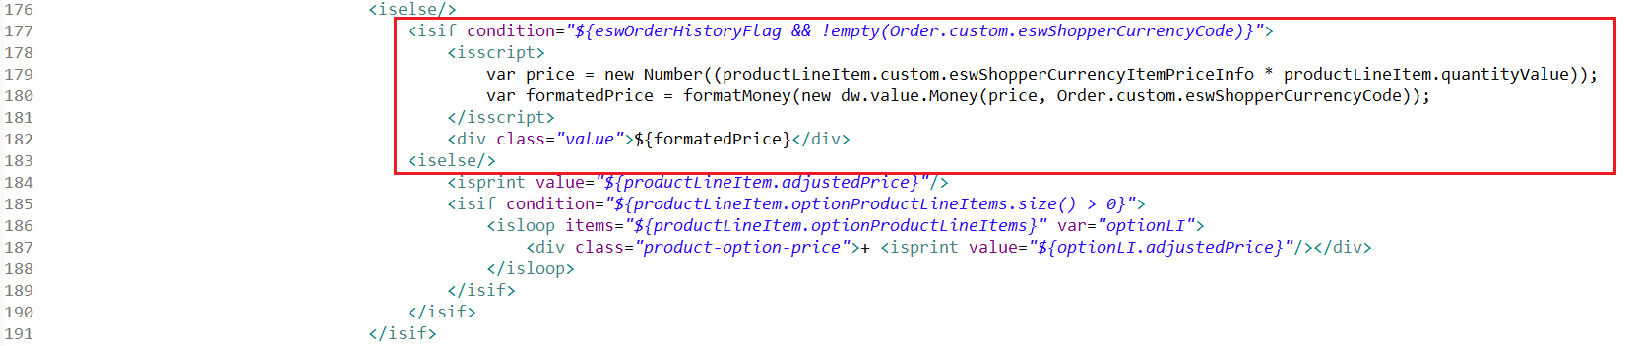
<isif condition="${eswOrderHistoryFlag && !empty(Order.custom.eswShopperCurrencyCode)}">
<isscript>
var price = new Number((productLineItem.custom.eswShopperCurrencyItemPriceInfo * productLineItem.quantityValue));
var formatedPrice = formatMoney(new dw.value.Money(price, Order.custom.eswShopperCurrencyCode));
</isscript>
<div class="value">${formatedPrice}</div>
<iselse/>

1.1.8 ordertotals.isml
Path
SiteGenesis_core/cartridge/templates/default/components/order/ordertotals.isml

<isscript>
var eswHelper = require('*/cartridge/scripts/helper/eswHelper').getEswHelper();
var eswOrderHistoryFlag = false;
var siteTaxationModel = eswHelper.getTaxationModel();
var eswModuleEnabled = eswHelper.getEShopWorldModuleEnabled();
var isEswSupportedCountry = eswHelper.isESWSupportedCountry();
if (eswModuleEnabled) {
eswOrderHistoryFlag = eswHelper.isEswOrderHistory(LineItemCtnr);
eswTaxInformationEnabled = eswHelper.getEShopWorldTaxInformationEnabled();
eswOrderDetailEnabled = eswHelper.isOrderDetailEnabled();
var getOrderTotals = require('*/cartridge/scripts/helper/orderHistoryTotals').orderTotals;
}
</isscript>

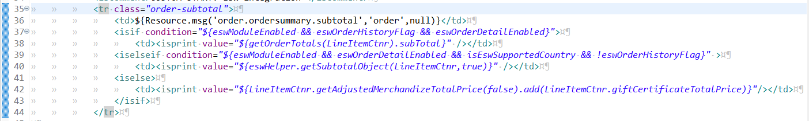

<tr class="order-subtotal">
<td>${Resource.msg('order.ordersummary.subtotal','order',null)}</td>
<isif condition="${eswModuleEnabled && eswOrderHistoryFlag && eswOrderDetailEnabled}">
<td><isprint value="${getOrderTotals(LineItemCtnr).subTotal}" /></td>
<iselseif condition="${eswModuleEnabled && eswOrderDetailEnabled && isEswSupportedCountry && !eswOrderHistoryFlag}" >
<td><isprint value="${eswHelper.getSubtotalObject(LineItemCtnr,true)}" /></td>
<iselse>
<td><isprint value="${LineItemCtnr.getAdjustedMerchandizeTotalPrice(false).add(LineItemCtnr.giftCertificateTotalPrice)}"/></td>
</isif>
</tr>

<<isif condition="${!empty(orderDiscount) && orderDiscount.value > 0.0}">
<tr class="order-discount discount">
<td>${Resource.msg('order.ordersummary.orderdiscount','order',null)}</td>
<td> - <isprint value="${(eswModuleEnabled && eswOrderDetailEnabled) ? eswHelper.getOrderDiscount(LineItemCtnr) : orderDiscount }" /></td>
</tr>
</isif>

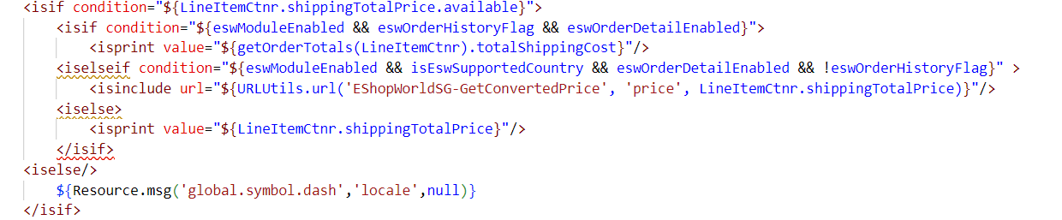
<isif condition="${eswModuleEnabled && eswOrderHistoryFlag && eswOrderDetailEnabled}">
<isprint value="${getOrderTotals(LineItemCtnr).totalShippingCost}"/>
<iselseif condition="${eswModuleEnabled && isEswSupportedCountry && eswOrderDetailEnabled && !eswOrderHistoryFlag}" >
<isinclude url="${URLUtils.url('EShopWorldSG-GetConvertedPrice', 'price', LineItemCtnr.shippingTotalPrice)}"/>
<iselse>
<isprint value="${LineItemCtnr.shippingTotalPrice}"/>
</isif>

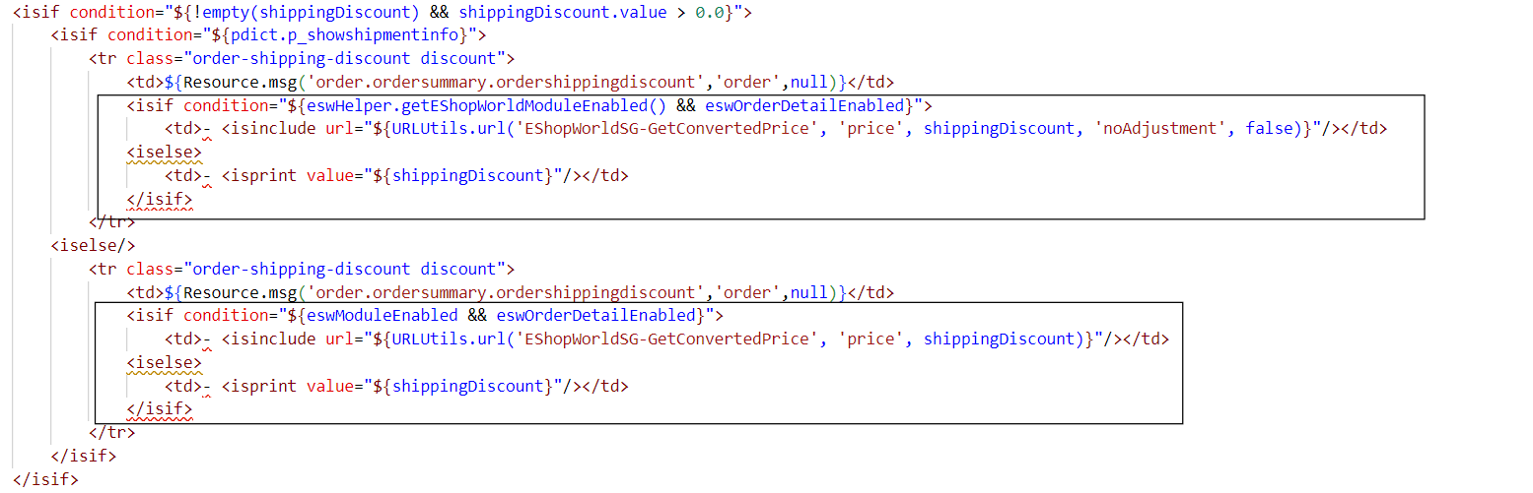

<isif condition="${eswHelper.getEShopWorldModuleEnabled() && eswOrderDetailEnabled}">
<td>- <isinclude url="${URLUtils.url('EShopWorldSG-GetConvertedPrice', 'price', shippingDiscount, 'noAdjustment', false)}"/></td>
<iselse>
<td>- <isprint value="${shippingDiscount}"/></td>
</isif>
<isif condition="${eswModuleEnabled && eswOrderDetailEnabled}">
<td>- <isinclude url="${URLUtils.url('EShopWorldSG-GetConvertedPrice', 'price', shippingDiscount)}"/></td>
<iselse>
<td>- <isprint value="${shippingDiscount}"/></td>
</isif>
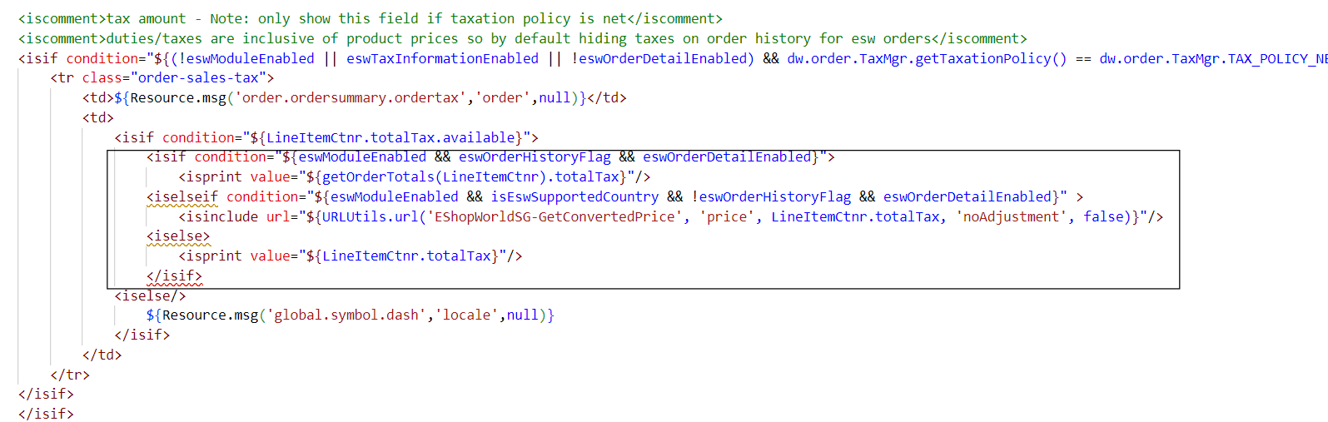

<isif condition="${(!eswModuleEnabled || eswTaxInformationEnabled || !eswOrderDetailEnabled) && dw.order.TaxMgr.getTaxationPolicy() == dw.order.TaxMgr.TAX_POLICY_NET}">
<tr class="order-sales-tax">
<td>${Resource.msg('order.ordersummary.ordertax','order',null)}</td>
<td>
<isif condition="${LineItemCtnr.totalTax.available}">
<isif condition="${eswModuleEnabled && eswOrderHistoryFlag && eswOrderDetailEnabled}">
<isprint value="${getOrderTotals(LineItemCtnr).totalTax}"/>
<iselseif condition="${eswModuleEnabled && isEswSupportedCountry && !eswOrderHistoryFlag && eswOrderDetailEnabled}" >
<isinclude url="${URLUtils.url('EShopWorldSG-GetConvertedPrice', 'price', LineItemCtnr.totalTax, 'noAdjustment', false)}"/>
<iselse>
<isprint value="${LineItemCtnr.totalTax}"/>
</isif>
<iselse/>
${Resource.msg('global.symbol.dash','locale',null)}
</isif>
</td>
</tr>
</isif>
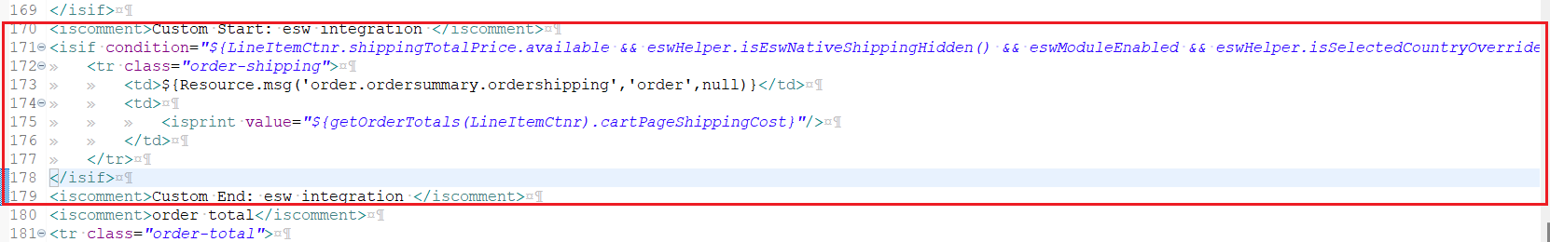
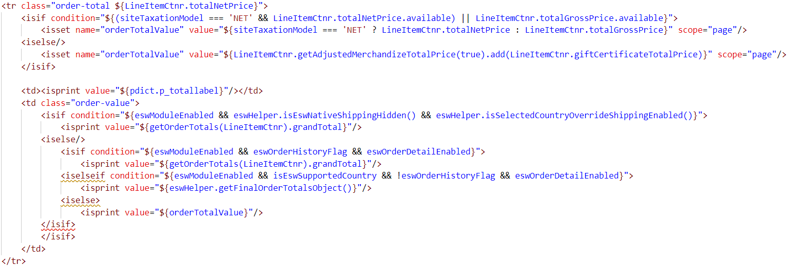
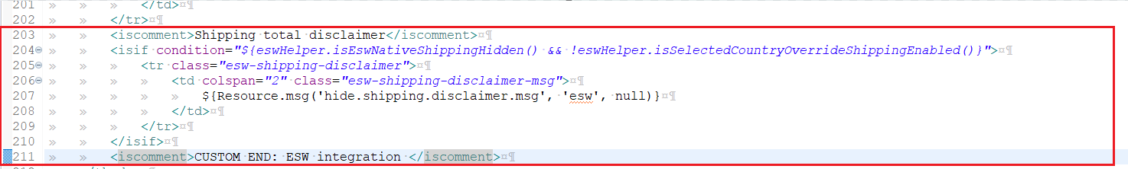
<iscomment>Custom Start: esw integration </iscomment>
<isif condition="${LineItemCtnr.shippingTotalPrice.available && eswHelper.isEswNativeShippingHidden() && eswModuleEnabled && eswHelper.isSelectedCountryOverrideShippingEnabled()}">
<tr class="order-shipping">
<td>${Resource.msg('order.ordersummary.ordershipping','order',null)}</td>
<td>
<isprint value="${getOrderTotals(LineItemCtnr).cartPageShippingCost}"/>
</td>
</tr>
</isif>
<iscomment>Custom End: esw integration </iscomment>
<tr class="order-total ${LineItemCtnr.totalNetPrice}">
<isif condition="${(siteTaxationModel === 'NET' && LineItemCtnr.totalNetPrice.available) || LineItemCtnr.totalGrossPrice.available}">
<isset name="orderTotalValue" value="${siteTaxationModel === 'NET' ? LineItemCtnr.totalNetPrice : LineItemCtnr.totalGrossPrice}" scope="page"/>
<iselse/>
<isset name="orderTotalValue" value="${LineItemCtnr.getAdjustedMerchandizeTotalPrice(true).add(LineItemCtnr.giftCertificateTotalPrice)}" scope="page"/>
</isif>

<td><isprint value="${pdict.p_totallabel}"/></td>
<td class="order-value">
<isif condition="${eswModuleEnabled && eswHelper.isEswNativeShippingHidden() && eswHelper.isSelectedCountryOverrideShippingEnabled()}">
<isprint value="${getOrderTotals(LineItemCtnr).grandTotal}"/>
<iselse/>
<isif condition="${eswModuleEnabled && eswOrderHistoryFlag && eswOrderDetailEnabled}">
<isprint value="${getOrderTotals(LineItemCtnr).grandTotal}"/>
<iselseif condition="${eswModuleEnabled && isEswSupportedCountry && !eswOrderHistoryFlag && eswOrderDetailEnabled}">
<isprint value="${eswHelper.getFinalOrderTotalsObject()}"/>
<iselse>
<isprint value="${orderTotalValue}"/>
</isif>
</isif>
</td>
</tr>

<iscomment>Shipping total disclaimer</iscomment>
<isif condition="${eswHelper.isEswNativeShippingHidden() && !eswHelper.isSelectedCountryOverrideShippingEnabled()}">
<tr class="esw-shipping-disclaimer">
<td colspan="2" class="esw-shipping-disclaimer-msg">
${Resource.msg('hide.shipping.disclaimer.msg', 'esw', null)}
</td>
</tr>
</isif>
<iscomment>CUSTOM END: ESW integration </iscomment>
This function calculates the final order total including discounts and price adjustments.

1.1.9 pricing.isml
Path
SiteGenesis_core/cartridge/templates/default/product/components/pricing.isml

<isscript>
var eswHelper = require('*/cartridge/scripts/helper/eswHelper').getEswHelper();
// for variation groups use the master, because all variants are available in detail page
if ( pdict.Product && pdict.Product.variationGroup )
{
pdict.Product = pdict.Product.masterProduct;
}
</isscript>

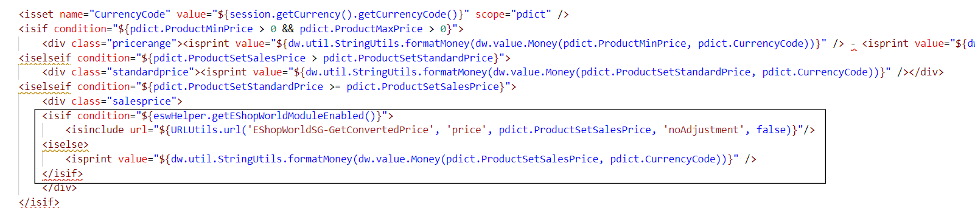
<isif condition="${eswHelper.getEShopWorldModuleEnabled()}">
<isinclude url="${URLUtils.url('EShopWorldSG-GetConvertedPrice', 'price', pdict.ProductSetSalesPrice, 'noAdjustment', false)}"/>
<iselse>
<isprint value="${dw.util.StringUtils.formatMoney(dw.value.Money(pdict.ProductSetSalesPrice, pdict.CurrencyCode))}" />
</isif>

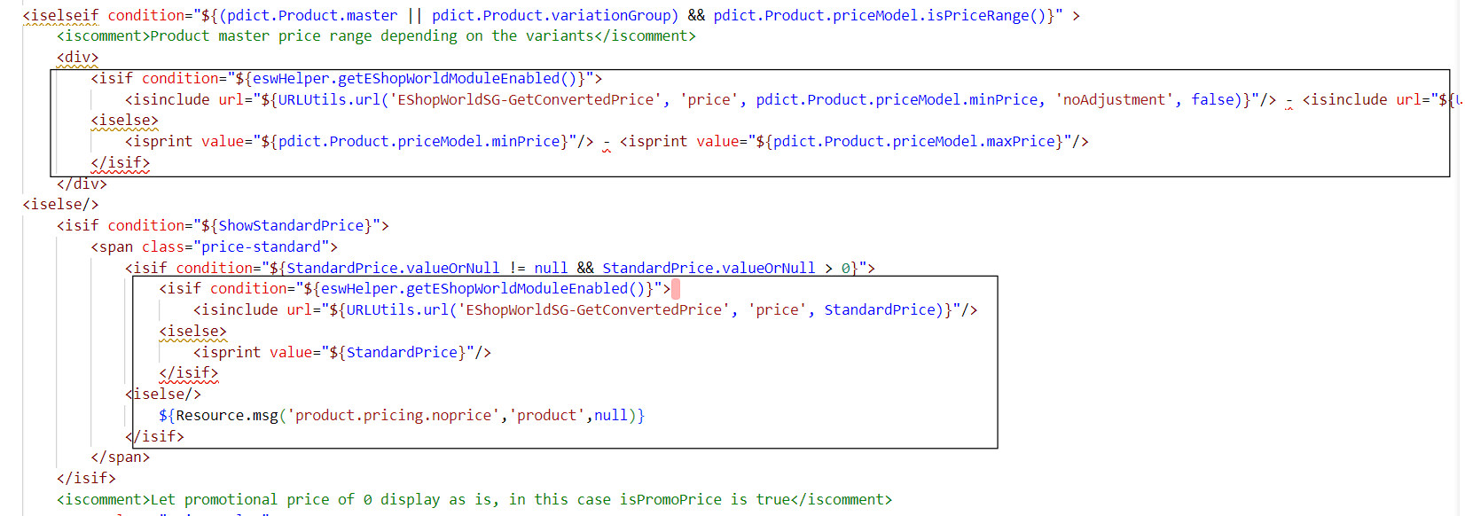
<isif condition="${eswHelper.getEShopWorldModuleEnabled()}">
<isinclude url="${URLUtils.url('EShopWorldSG-GetConvertedPrice', 'price', pdict.Product.priceModel.minPrice, 'noAdjustment', false)}"/> - <isinclude url="${URLUtils.url('EShopWorldSG-GetConvertedPrice', 'price', pdict.Product.priceModel.maxPrice)}"/>
<iselse>
<isprint value="${pdict.Product.priceModel.minPrice}"/> - <isprint value="${pdict.Product.priceModel.maxPrice}"/>
</isif>

<isif condition="${StandardPrice.valueOrNull != null && StandardPrice.valueOrNull > 0}">
<isif condition="${eswHelper.getEShopWorldModuleEnabled()}">
<isinclude url="${URLUtils.url('EShopWorldSG-GetConvertedPrice', 'price', StandardPrice)}"/>
<iselse>
<isprint value="${StandardPrice}"/>
</isif>
<iselse/>
${Resource.msg('product.pricing.noprice','product',null)}
</isif>

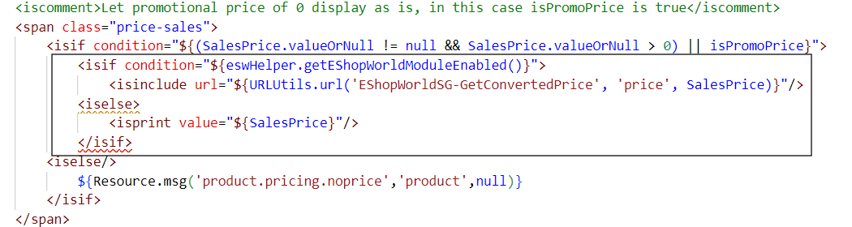
<isif condition="${eswHelper.getEShopWorldModuleEnabled()}">
<isinclude url="${URLUtils.url('EShopWorldSG-GetConvertedPrice', 'price', SalesPrice)}"/>
<iselse>
<isprint value="${SalesPrice}"/>
</isif>

1.1.10 producttile.isml
Path
SiteGenesis_core/cartridge/templates/default/product/producttile.isml

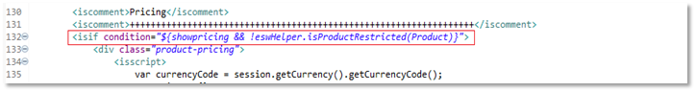
var eswHelper = require('*/cartridge/scripts/helper/eswHelper').getEswHelper();

<isif condition="${showpricing && !eswHelper.isProductRestricted(Product)}">

if (eswHelper.getEShopWorldModuleEnabled()) {
price.value = dw.value.Money(pdict.CurrentHttpParameterMap.minprice, currencyCode) + ' - ' + dw.value.Money(pdict.CurrentHttpParameterMap.maxprice, currencyCode);
} else {
price.value = dw.util.StringUtils.formatMoney(dw.value.Money(pdict.CurrentHttpParameterMap.minprice, currencyCode)) + ' - ' + dw.util.StringUtils.formatMoney(dw.value.Money(pdict.CurrentHttpParameterMap.maxprice, currencyCode));
}

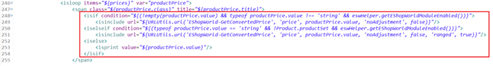
<isif condition="${(!empty(productPrice.value) && typeof productPrice.value !== 'string' && eswHelper.getEShopWorldModuleEnabled())}">
<isinclude url="${URLUtils.url('EShopWorldSG-GetConvertedPrice', 'price', productPrice.value, 'noAdjustment', false)}"/>
<iselseif condition="${(typeof productPrice.value == 'string' && !Product.productSet && eswHelper.getEShopWorldModuleEnabled())}">
<isinclude url="${URLUtils.url('EShopWorldSG-GetConvertedPrice', 'price', productPrice.value, 'noAdjustment', false, 'ranged', true)}"/>
<iselse>
<isprint value="${productPrice.value}"/>
</isif>

1.1.11 productsearchbreadcrumbs.isml
Path
SiteGenesis_core/cartridge/templates/default/search/components/productsearchbreadcrumbs.isml
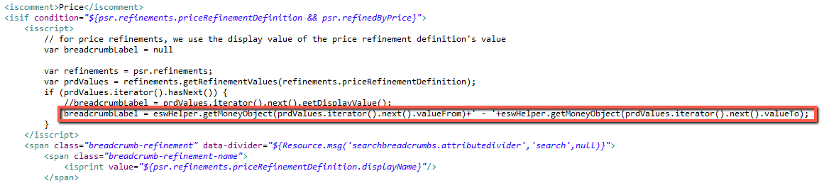

breadcrumbLabel = eswHelper.getMoneyObject(prdValues.iterator().next().valueFrom)+' - '+eswHelper.getMoneyObject(prdValues.iterator().next().valueTo);

1.1.12 productsearchrefinebar.isml
Path
SiteGenesis_core/cartridge/templates/default/search/components/productsearchrefinebar.isml
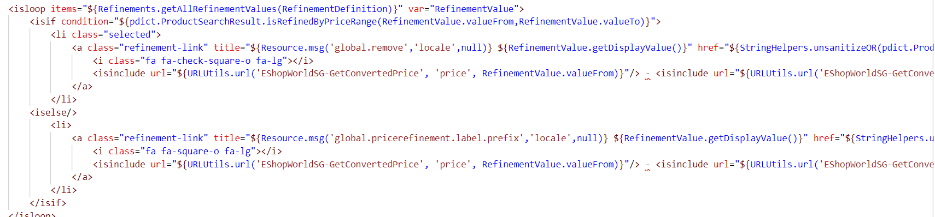

<a class="refinement-link" title="${Resource.msg('global.remove','locale',null)} ${RefinementValue.getDisplayValue()}" href="${StringHelpers.unsanitizeOR(pdict.ProductSearchResult.urlRelaxPrice('Search-Show'))}">
<i class="fa fa-check-square-o fa-lg"></i>
<isinclude url="${URLUtils.url('EShopWorldSG-GetConvertedPrice', 'price', RefinementValue.valueFrom)}"/> - <isinclude url="${URLUtils.url('EShopWorldSG-GetConvertedPrice', 'price', RefinementValue.valueTo)}"/>
</a>

<a class="refinement-link" title="${Resource.msg('global.pricerefinement.label.prefix','locale',null)} ${RefinementValue.getDisplayValue()}" href="${StringHelpers.unsanitizeOR(pdict.ProductSearchResult.urlRefinePrice('Search-Show',RefinementValue.getValueFrom(),RefinementValue.getValueTo()))}">
<i class="fa fa-square-o fa-lg"></i>
<isinclude url="${URLUtils.url('EShopWorldSG-GetConvertedPrice', 'price', RefinementValue.valueFrom)}"/> - <isinclude url="${URLUtils.url('EShopWorldSG-GetConvertedPrice', 'price', RefinementValue.valueTo)}"/>
</a>

1.1.13 suggestions.isml
Path
SiteGenesis_core/cartridge/templates/default/search/suggestions.isml
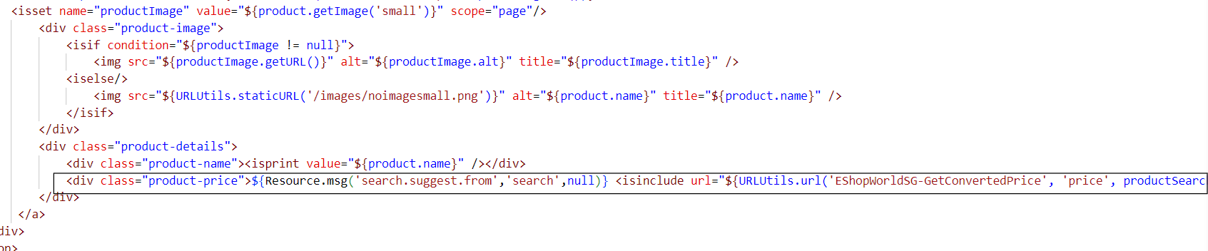
<div class="product-price">
${Resource.msg('search.suggest.from','search',null)}
<isinclude url="${URLUtils.url('EShopWorldSG-GetConvertedPrice', 'price', productSearchHit.getMinPrice())}"/>
</div>

1.1.14 productcontent.isml
Path
SiteGenesis_core/cartridge/templates/default/product/productcontent.isml
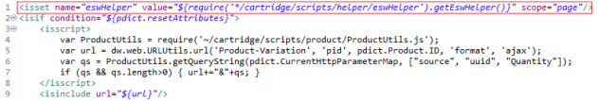
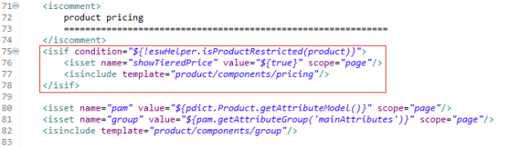
<isset name="eswHelper" value="${require('*/cartridge/scripts/helper/eswHelper').getEswHelper()}" scope="page"/>

<isif condition="${!eswHelper.isProductRestricted(product)}">
<isset name="showTieredPrice" value="${true}" scope="page"/>
<isinclude template="product/components/pricing"/>
</isif>

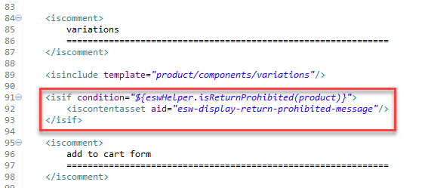
<isif condition="${eswHelper.isReturnProhibited(product)}">
<iscontentasset aid="esw-display-return-prohibited-message"/>
</isif>

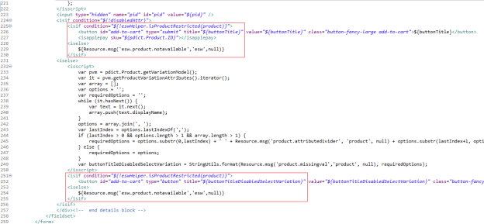
<isif condition="${!eswHelper.isProductRestricted(product)}">
<button id="add-to-cart" type="submit" title="${buttonTitle}" value="${buttonTitle}" class="button-fancy-large add-to-cart">${buttonTitle}</button>
<isapplepay sku="${pdict.Product.ID}"></isapplepay>
<iselse>
${Resource.msg('esw.product.notavailable','esw',null)}
</isif>

<isif condition="${!eswHelper.isProductRestricted(product)}">
<button id="add-to-cart" type="button" title="${buttonTitleDisabledSelectVariation}" value="${buttonTitleDisabledSelectVariation}" class="button-fancy-large add-to-cart-disabled"<isprint value="${disabledAttr}" encoding="off"/>>${buttonTitle}</button>
<iselse>
${Resource.msg('esw.product.notavailable','esw',null)}
</isif>

1.1.15 producttopcontentPS.isml
Path
SiteGenesis_core/cartridge/templates/default/product/producttopcontentPS.isml

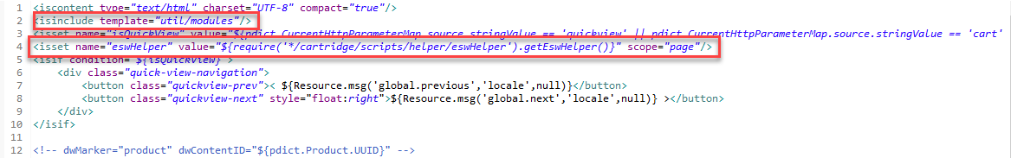
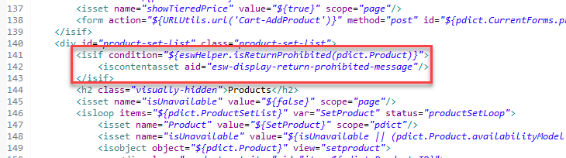
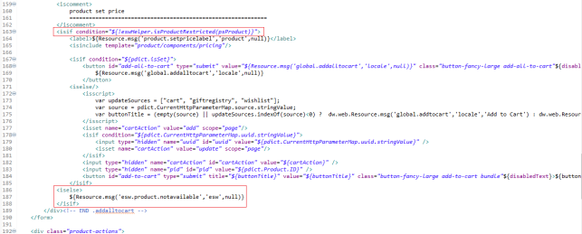
<isinclude template="util/modules"/>
<isset name="eswHelper" value="${require('*/cartridge/scripts/helper/eswHelper').getEswHelper()}" scope="page"/>

<isif condition="${eswHelper.isReturnProhibited(pdict.Product)}">
<iscontentasset aid="esw-display-return-prohibited-message"/>
</isif>
<isif condition="${!eswHelper.isProductRestricted(psProduct)}">

<iselse>
${Resource.msg('esw.product.notavailable','esw',null)}
</isif>

1.1.16 productsetproduct.isml
Path
SiteGenesis_core/cartridge/templates/default/product/components/productsetproduct.isml
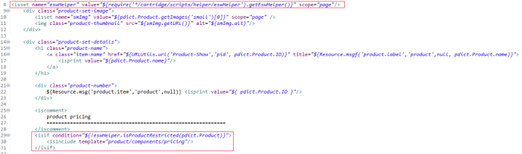
<isset name="eswHelper" value="${require('*/cartridge/scripts/helper/eswHelper').getEswHelper()}" scope="page"/>

<isif condition="${!eswHelper.isProductRestricted(pdict.Product)}">
<isinclude template="product/components/pricing"/>
</isif>

1.1.17 displayliproduct.isml
Path
SiteGenesis_core/cartridge/templates/default/product/components/displayliproduct.isml
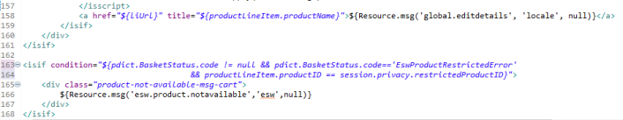
<isif condition="${pdict.BasketStatus.code != null && pdict.BasketStatus.code=='EswProductRestrictedError' && productLineItem.productID == session.privacy.restrictedProductID}">
<div class="product-not-available-msg-cart">
${Resource.msg('esw.product.notavailable','esw',null)}
</div>
</isif>

1.1.18 orders.isml
Path
SiteGenesis_core/cartridge/templates/default/account/orderhistory/orders.isml

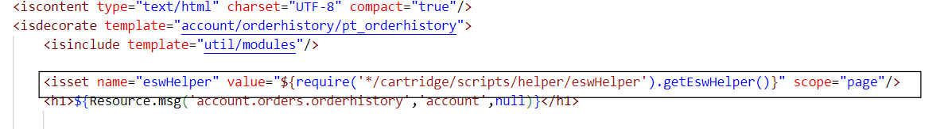
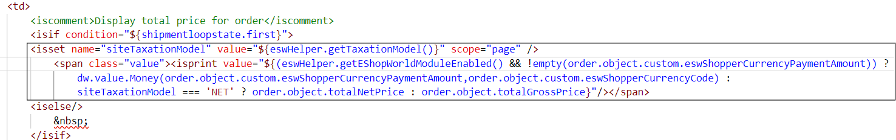
<isset name="eswHelper" value="${require('*/cartridge/scripts/helper/eswHelper').getEswHelper()}" scope="page"/>
<isset name="siteTaxationModel" value="${eswHelper.getTaxationModel()}" scope="page" />
<span class="value"><isprint value="${(eswHelper.getEShopWorldModuleEnabled() && !empty(order.object.custom.eswShopperCurrencyPaymentAmount)) ?
dw.value.Money(order.object.custom.eswShopperCurrencyPaymentAmount,order.object.custom.eswShopperCurrencyCode) :
siteTaxationModel === 'NET' ? order.object.totalNetPrice : order.object.totalGrossPrice}"/></span>

1.2 Customizing the controllers

1.2.1 Currency.js
Path
SiteGenesis_controllers/cartridge/controllers/Currency.js

'use strict';

/**
* This controller updates the current session currency.
*
* @module controllers/Currency
*/

/* API Includes */
var Currency = require('dw/util/Currency');
var Transaction = require('dw/system/Transaction');
var Site = require('dw/system/Site');

/* Script Modules */
var guard = require('~/cartridge/scripts/guard');
var Cart = require('~/cartridge/scripts/models/CartModel');

/**
* This controller is used in an AJAX call to set the session variable 'currency'.
*/
function setSessionCurrency() {
var eswHelper = require('*/cartridge/scripts/helper/eswHelper').getEswHelper();
var currencyMnemonic = request.httpParameterMap.currencyMnemonic.value;
var Response = require('~/cartridge/scripts/util/Response');
var Countries = require('*/cartridge/scripts/util/Countries');
var URLUtils = require('dw/web/URLUtils');
var redirect = null;

if (eswHelper.getEShopWorldModuleEnabled()) {
var selectedCountry;
var countryParam = request.httpParameterMap.get(Site.getCustomPreferenceValue('eswCountryUrlParam'));
if (empty(countryParam)) {
selectedCountry = countryParam;
} else {
selectedCountry = request.httpParameterMap.country.value;
}

var currencyCode = request.httpParameterMap.currency.value;
var language = request.httpParameterMap.language.value;

if(eswHelper.checkIsEswAllowedCountry(selectedCountry) != null) {
if (request.setLocale(language)) {
if (!eswHelper.overridePrice(selectedCountry)) {
eswHelper.setAllAvailablePriceBooks();
eswHelper.setBaseCurrencyPriceBook(eswHelper.getBaseCurrencyPreference());
}
}
eswHelper.selectCountry(selectedCountry, currencyCode, language);
} else {
delete session.privacy.fxRate;
var defaultCountryCurrencyMapping = eswHelper.getDefaultCountryCurrencyMapping();
if (defaultCountryCurrencyMapping.length > 0) {
eswHelper.createCookie('esw.location', selectedCountry, '/');
var siteCountries = JSON.parse(defaultCountryCurrencyMapping);
var foundCountry = siteCountries.filter(function(item) {
// Set Currency and Locale if esw not allowed country found
if(item.countryCode == selectedCountry) {
// Set cookies
eswHelper.createCookie('esw.currency', item.currencyCode, '/');
eswHelper.createCookie('esw.LanguageIsoCode', language, '/');

// Set Base currency Pricebook
eswHelper.setAllAvailablePriceBooks();
eswHelper.setBaseCurrencyPriceBook(item.currencyCode);

// Set locale
request.setLocale(language);
return true;
}
});

// Set Default Currency and Locale if esw not allowed country not found
if (empty(foundCountry)) {
eswHelper.setAllAvailablePriceBooks();
eswHelper.setBaseCurrencyPriceBook(eswHelper.getBaseCurrencyPreference());
eswHelper.createCookie('esw.currency', session.getCurrency(), '/');
eswHelper.createCookie('esw.LanguageIsoCode', dw.system.Site.getCurrent().getDefaultLocale(), '/');
request.setLocale(dw.system.Site.getCurrent().getDefaultLocale());
}
}
}
// redirect = eswHelper.getCurrent(request.getLocale());
} else {
if (currencyMnemonic) {
currency = Currency.getCurrency(currencyMnemonic);
if (currency) {
session.setCurrency(currency);
Transaction.wrap(function () {
var currentCart = Cart.get();
if (currentCart) {
currentCart.updateCurrency();
currentCart.calculate();
}
});
}
}
}

Response.renderJSON({
redirectUrl: (redirect != null) ? redirect.toString() : '',
success: true
});
}

function getAllowedCountry() {
var Response = require('~/cartridge/scripts/util/Response');
var eswHelper = require('*/cartridge/scripts/helper/eswHelper').getEswHelper()

var language = !empty(request.httpCookies['esw.LanguageIsoCode']) ? request.httpCookies['esw.LanguageIsoCode'].value : eswHelper.getAllowedLanguages()[0].value;
var currency = !empty(request.httpCookies['esw.currency']) ? request.httpCookies['esw.currency'].value : eswHelper.getDefaultCurrencyForCountry(eswHelper.getAvailableCountry());
var selectedCountry = request.httpParameterMap.country.value;
var flag = false;

if (eswHelper.getEShopWorldModuleEnabled() && eswHelper.checkIsEswAllowedCountry(selectedCountry)) {
flag = true;
}

Response.renderJSON({
success : flag,
country : selectedCountry,
language : language,
currency : currency
});
}

/*
* Module exports
*/

/*
* Web exposed methods
*/
/** @see module:controllers/Currency~setSessionCurrency */
exports.SetSessionCurrency = guard.ensure(['get'], setSessionCurrency);
exports.GetAllowedCountry = guard.ensure(['get'], getAllowedCountry);

1.2.2 Cart.js
Path
SiteGenesis_controllers/cartridge/controllers/Cart.js

/**
* Invalidates the login and shipment forms. Renders the checkout/cart/cart template.
*/
function show() {
var eswServiceHelper = require('*/cartridge/scripts/helper/serviceHelper');
var eswHelper = require('*/cartridge/scripts/helper/eswHelper').getEswHelper();
var BasketMgr = require('dw/order/BasketMgr');

if (eswHelper.getEShopWorldModuleEnabled() && eswHelper.isESWSupportedCountry()) {
if (BasketMgr.getCurrentBasket() === null) {
eswHelper.rebuildCart();
}
var cart = app.getModel('Cart').goc();
if (!empty(cart)) {
Transaction.wrap(function () {
let isShippingPriceAdjustmentAppliedOnCart = isShippingPriceAdjustmentApplied(cart);
if (!isShippingPriceAdjustmentAppliedOnCart) {
if (eswHelper.getShippingServiceType(cart.object) === 'POST') {
eswServiceHelper.applyShippingMethod(cart.object, 'POST', eswHelper.getAvailableCountry(), true);
} else {
eswServiceHelper.applyShippingMethod(cart.object, 'EXP2', eswHelper.getAvailableCountry(), true);
}
cart.calculate();
eswHelper.adjustThresholdDiscounts(cart.object);
eswHelper.removeThresholdPromo(cart.object);
}
});
}
}
var cartForm = app.getForm('cart');
app.getForm('login').invalidate();

cartForm.get('shipments').invalidate();

app.getView('Cart', {
cart: app.getModel('Cart').get(),
RegistrationStatus: false
}).render('checkout/cart/cart');

}

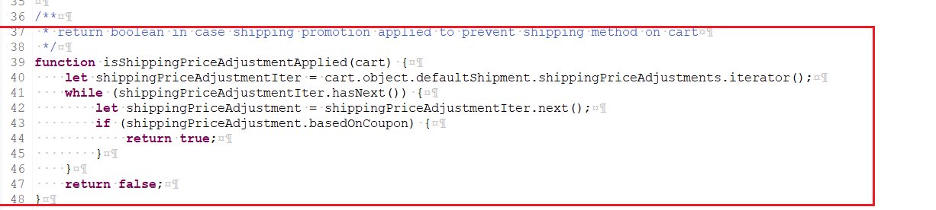

/**

* return boolean in case shipping promotion applied to prevent shipping method on cart

*/

function isShippingPriceAdjustmentApplied(cart) {

let shippingPriceAdjustmentIter = cart.object.defaultShipment.shippingPriceAdjustments.iterator();

while (shippingPriceAdjustmentIter.hasNext()) {

let shippingPriceAdjustment = shippingPriceAdjustmentIter.next();

if (shippingPriceAdjustment.basedOnCoupon) {

return true;

}

}

return false;}

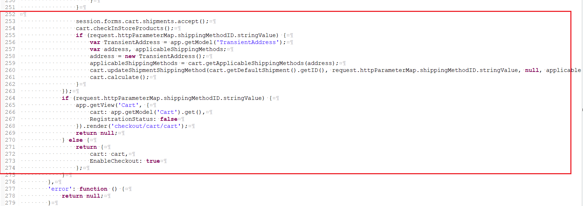

session.forms.cart.shipments.accept();

cart.checkInStoreProducts();

if (request.httpParameterMap.shippingMethodID.stringValue) {

var TransientAddress = app.getModel('TransientAddress');

var address, applicableShippingMethods;

address = new TransientAddress();

applicableShippingMethods = cart.getApplicableShippingMethods(address);

cart.updateShipmentShippingMethod(cart.getDefaultShipment().getID(), request.httpParameterMap.shippingMethodID.stringValue, null, applicableShippingMethods);

cart.calculate();

}

});

if (request.httpParameterMap.shippingMethodID.stringValue) {

app.getView('Cart', {

cart: app.getModel('Cart').get(),

RegistrationStatus: false

}).render('checkout/cart/cart');

return null;

} else {

return {

cart: cart,

EnableCheckout: true

};

}

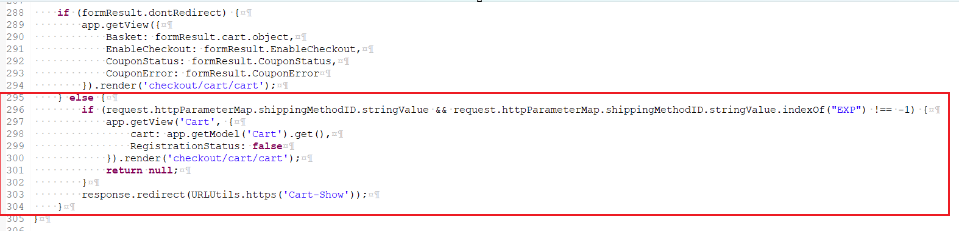

if (formResult) {

cartAsset = app.getModel('Content').get('cart');

pageMeta = require('~/cartridge/scripts/meta');

pageMeta.update(cartAsset);

if (formResult.dontRedirect) {

app.getView({

Basket: formResult.cart.object,

EnableCheckout: formResult.EnableCheckout,

CouponStatus: formResult.CouponStatus,

CouponError: formResult.CouponError

}).render('checkout/cart/cart');

} else {

if (request.httpParameterMap.shippingMethodID.stringValue && request.httpParameterMap.shippingMethodID.stringValue.indexOf("EXP") !== -1) {

app.getView('Cart', {

cart: app.getModel('Cart').get(),

RegistrationStatus: false

}).render('checkout/cart/cart');

return null;

}

response.redirect(URLUtils.https('Cart-Show'));

}

}
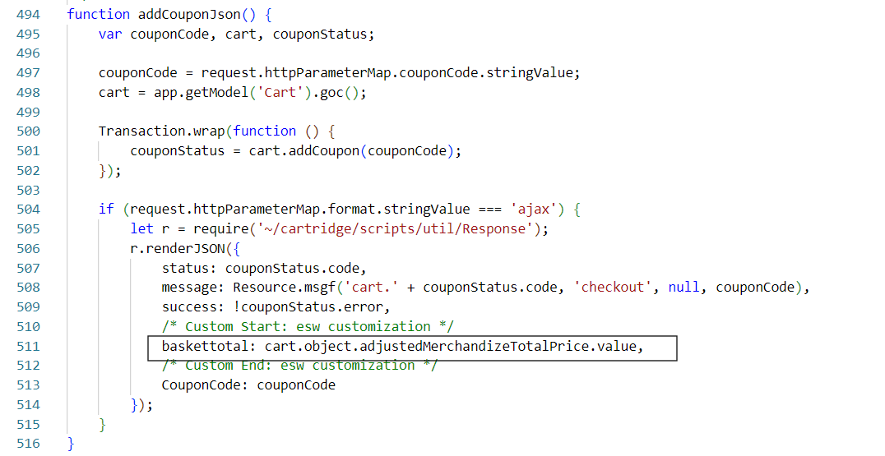
baskettotal: cart.object.adjustedMerchandizeTotalPrice.value,

1.2.3 Order.js
Path
SiteGenesis_controllers/cartridge/controllers/Order.js
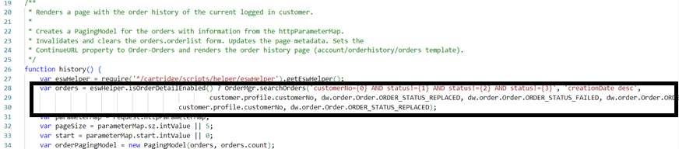

var orders = eswHelper.isOrderDetailEnabled() ? OrderMgr.searchOrders('customerNo={0} AND status!={1} AND status!={2} AND status!={3}', 'creationDate desc',
customer.profile.customerNo, dw.order.Order.ORDER_STATUS_REPLACED, dw.order.Order.ORDER_STATUS_FAILED, dw.order.Order.ORDER_STATUS_CREATED): OrderMgr.searchOrders('customerNo={0} AND status!={1}', 'creationDate desc',
customer.profile.customerNo, dw.order.Order.ORDER_STATUS_REPLACED);

1.2.3 CO Customer.js
Path
SiteGenesis_controllers/cartridge/controllers/COCustomer.js

/**
* Form handler for the login form. Handles the following actions:
* - __login__ - Calls the {@link module:controllers/Login~process|Login controller Process function}. If this returns successfully, calls
* the {@link module:controllers/COShipping~Start|COShipping controller Start function}.
* - __register__ - Calls the {@link module:controllers/Account~StartRegister|Account controller StartRegister function}.
* - __unregistered__ - Calls the {@link module:controllers/COShipping~Start|COShipping controller Start function}.
*/
function showLoginForm() {
var eswHelper = require('*/cartridge/scripts/helper/eswHelper').getEswHelper();
var loginForm = app.getForm('login');

session.custom.TargetLocation =URLUtils.https('COShipping-Start').toString();
if(eswHelper.getEShopWorldModuleEnabled() && eswHelper.checkIsEswAllowedCountry(request.httpCookies['esw.location'].value)) {
session.custom.TargetLocation = URLUtils.https('EShopWorldSG-PreOrderRequest').toString();
}
loginForm.handleAction({
login: function () {
app.getController('Login').LoginForm();
},
register: function () {
response.redirect(URLUtils.https('Account-StartRegister'));
},
unregistered: function () {
if(eswHelper.getEShopWorldModuleEnabled()) {
session.privacy.guestCheckout = true;
response.redirect(session.custom.TargetLocation);
}else{
response.redirect(URLUtils.https('COShipping-Start'));
}
}
});
}

1.3 Customizing the Pipelines
To enable ESW SFCC plugin, retailer’s technical team need to compare 1.2 Customizing the controllers section listed controllers with SG pipelines and make the required customizations/changes, as ESW does not support the siteGenesis pipelines version.
Sitegenesis custom controllers can be found on following path for comparison.
Path
SiteGenesis_controllers/cartridge/controllers/Cart.js
SiteGenesis_controllers/cartridge/controllers/Currency.js
SiteGenesis_controllers/cartridge/controllers/COCustomer.js

1.4 Customizing the scripts and json

1.4.1 Resource.ds
Path
SiteGenesis_core/cartridge/scripts/util/Resource.ds

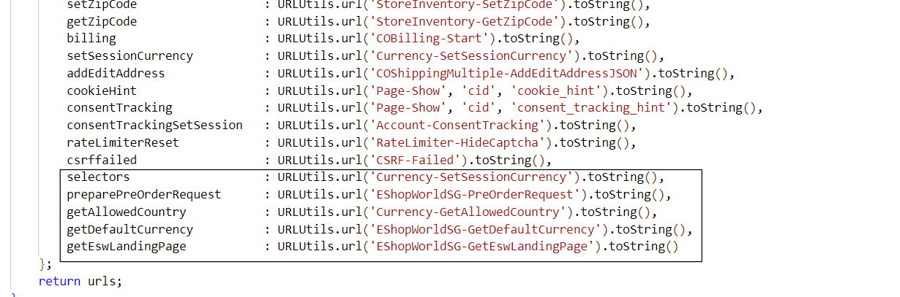

Selectors : URLUtils.url('Currency-SetSessionCurrency').toString(),
preparePreOrderRequest : URLUtils.url('EShopWorldSG-PreOrderRequest').toString(),
getAllowedCountry : URLUtils.url('Currency-GetAllowedCountry').toString(),
getDefaultCurrency: URLUtils.url('EShopWorldSG-GetDefaultCurrency').toString(),
getEswLandingPage : URLUtils.url('EShopWorldSG-GetEswLandingPage').toString()

1.4.2 OnRequest.js
Path
SiteGenesis_controllers/cartridge/scripts/request/OnRequest.js
onRequest is called with every top-level request in the site. The following function is used to redirect the site whenever locales are changed:
'use strict';

/**
* The onRequest hook is called with every top-level request in a site. This happens both for requests to cached and non-cached pages.
* For performance reasons the hook function should be kept short.
*
* @module request/OnRequest
*/

var Status = require('dw/system/Status');

/**
* The onRequest hook function.
*/
exports.onRequest = function () {
var eswHelper = require('*/cartridge/scripts/helper/eswHelper').getEswHelper(),
selectedFxRate = JSON.parse(session.privacy.fxRate);
if (eswHelper.getEShopWorldModuleEnabled()) {
if (!selectedFxRate && selectedFxRate !== null) {
var url = eswHelper.checkRedirect();
if (!empty(url) && request.httpMethod != 'POST'){
response.redirect(url);
}
} else {
var isAjax = Object.hasOwnProperty.call(request.httpHeaders, 'x-requested-with');
if (!isAjax && request.httpCookies['esw.LanguageIsoCode'] != null && request.getLocale() !== request.httpCookies['esw.LanguageIsoCode'].value) {
request.setLocale(request.httpCookies['esw.LanguageIsoCode'].value);
var url = eswHelper.getCurrent(request.httpCookies['esw.LanguageIsoCode'].value);
if (request.httpMethod != 'POST') {
response.redirect(url);
}
}
}
}

return new Status(Status.OK);
};

Declare the following variable at the top of your isml enclosed in <isscript> tags:
var eswHelper = require('int_eshopworld_controllers/cartridge/scripts/helper/eswHelper').getEswHelper();

1.4.3 validateCartForCheckout.js
Path
SiteGenesis_core/cartridge/scripts/cart/ValidateCartForCheckout.js

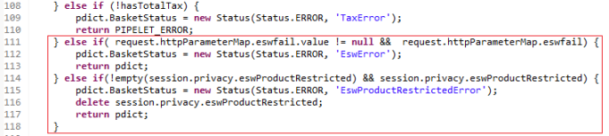
} else if(request.httpParameterMap.eswfail.value != null && request.httpParameterMap.eswfail) {
pdict.BasketStatus = new Status(Status.ERROR, 'EswError');
return pdict;
} else if(!empty(session.privacy.eswProductRestricted) && session.privacy.eswProductRestricted) {
pdict.BasketStatus = new Status(Status.ERROR, 'EswProductRestrictedError');
delete session.privacy.eswProductRestricted;
return pdict;
}

GetMoneyObject (price, noAdjustment, formatted, noRounding)
- price: This can be a number or a money object, for example, price.
- noAdjustment: Boolean value. If true, no adjustment will be applied.
- formatted: Boolean value. If true, it returns a string value with currency code, for example, $10.00. If false, it returns money object with the currency and the price.
- noRounding: Boolean value. If true, no rounding rule will be applied.
This function is a helper function that is used anywhere prices need to be calculated or displayed. It checks whether a country is a Fixed price country or an FX price country. It applies FX conversions when applicable. It also applies adjustments, duty, and tax where required.

1.4.4 calculate.js
Path
SG_core/cartridge/scripts/cart/calculate.js
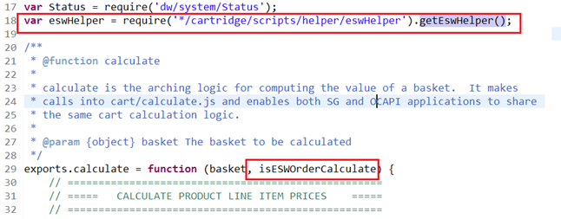

var eswHelper = require('*/cartridge/scripts/helper/eswHelper').getEswHelper();
exports.calculate = function (basket, isESWOrderCalculate) {

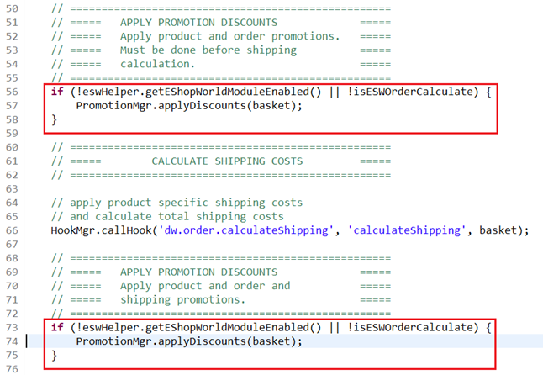
if (!eswHelper.getEShopWorldModuleEnabled() || !isESWOrderCalculate) {
PromotionMgr.applyDiscounts(basket);
}

if (!eswHelper.getEShopWorldModuleEnabled() || !isESWOrderCalculate) {
PromotionMgr.applyDiscounts(basket);
}

1.4.5 orderHistoryTotals.js
Path
/link_eshopworld/cartridges/int_eshopworld_controllers/cartridge/scripts/helper/orderHistoryTotals.js

1.4.6 hooks.json
Path
SG_core/cartridge/scripts/hooks.json
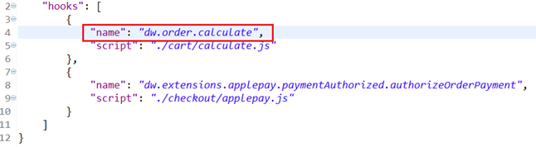
The default implementation calls the dw.ocapi.shop.basket.calculate hook. However, this hook is deprecated, and calling it creates entries in the deprecated API usage logs. You should override this function to use dw.order.calculate instead.

