


CATALOG INTEGRATION GUIDE

Version: 5.1.2
Published date: August 2026
Copyright © 2026 by ESW. All rights reserved. Information contained herein is subject to change without notice.

SFCC - ESW Cartridge
+
Contents
1 Catalog Integration 3
1.1 Catalog Feed Upload Via Service 3
1.1.1 Pre requisites 3
1.1.2 Automated Export 3
1.1.3 Manual Export 5
1.1.4 Dependencies 6
1.1.5 Testing in Sandbox 7
1.2 Catalog Feed Upload Via SFTP 8
1.2.1 Initial Full Catalog Upload 8
1.2.2 Delta Catalog Upload 9
2 Catalog Integration Configuration 10
2.1 ESW Catalog Integration Configuration site preferences 10
2.2 eswRetailerCatalogFeed job 12
2.3 ESWSFTP service 12
2.4 ESWCatalogService 12

Catalog Integration
ESW requires a product catalog from retailers to calculate correct duties and taxes
A product catalog includes data about the products that you want to sell internationally through the ESW Checkout and ship using the ESW logistics services. The data typically includes Product Code, Product Description, Country of Origin, Weight, HS Code, and so on. Sending the product catalog information is crucial as it allows ESW to accurately calculate the duties & taxes and ensure export compliance and customs clearance. Each time the product catalog is updated, for example, new products are added, the delta changes are required by ESW.
ESW cartridge supports the catalog synchronization
- via an API
- via Catalog Feed uploaded on SFTP.
If the Custom Preference isCatalogServiceEnabled is set to True and the Catalog service is configured then the Catalog Service will be used for catalog synchronization.

Catalog Feed Upload Via Service

Pre requisites
- Catalog Service should be imported in the SFCC Business Manager. For more details, please refer to Section 2.3
- The Preference isCatalogServiceEnabled must be set to True and the eswCatalogImportMethod Preference value should be set to "API”. For more details, Please refer to Section 2.1
- The ESW BM cartridge should be set in the cartridge path to view the Catalog Menu. The path in BM should be set as int_eshopworld_core:bm_eshopworld_core:bm_custom_plugin

Automated Export
For Automated export, the retailers can schedule a job according to their needs. This depends upon how often the catalog is updated. Once the Job eswRetailerCatalogFeed is run, If the job is run for the first time, all products' data will be synchronized otherwise the job will share the delta for the newly created/updated products since the last job execution.

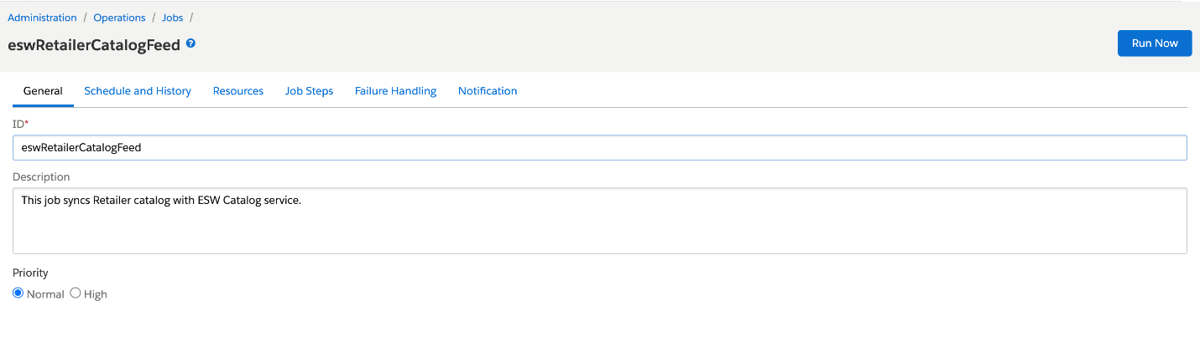
During the execution of the job, the catalog data will be exported. Once the Job is successfully executed, Navigate to Merchant Tools > ESW > Catalog
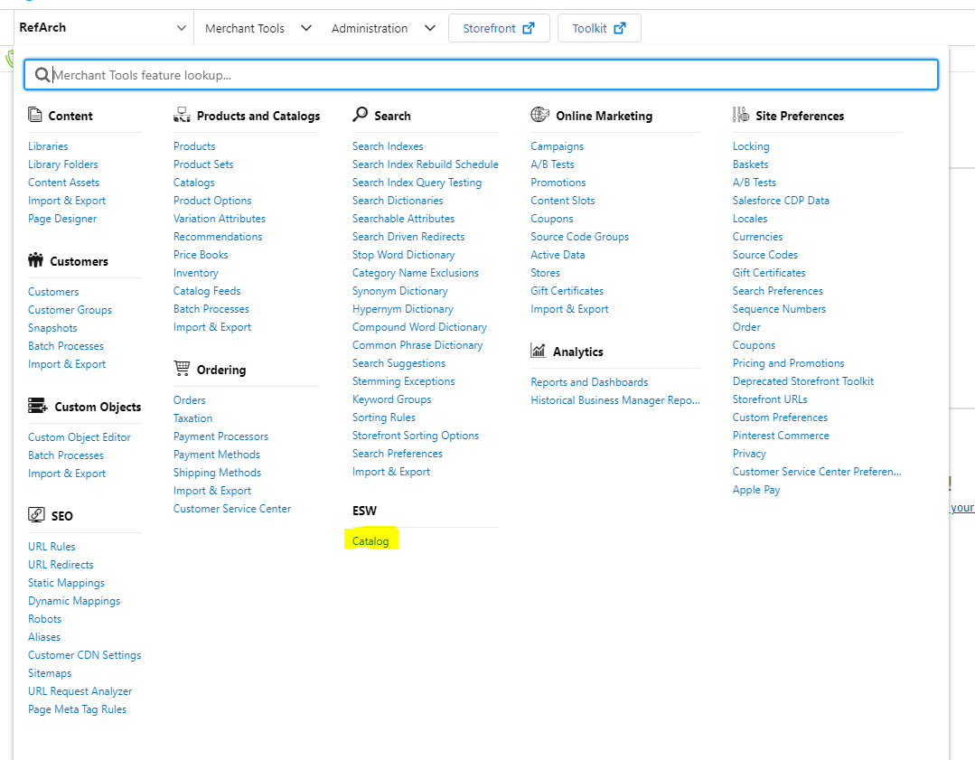

In the screen below, click on the Products tabs under Catalog Menu to view the product synchronization data.
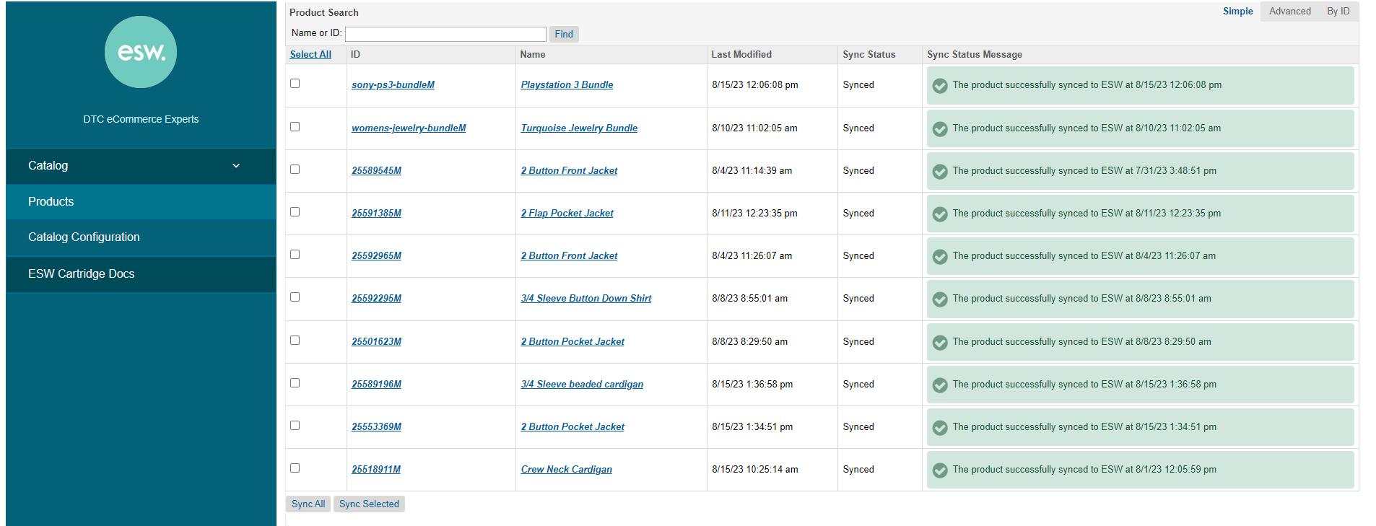The product synchronization data is available here. The details of the Sync Status and Sync Status Message are given below.

Field | Description | Status Values
Sync Status | This field indicates if the product is synched | - Unsynced(Default)- Indicates the product is not yet synchronized to ESW Catalog  - Synced - Indicates product is successfully synchronised to ESW catalog.
Sync Status Message | This field indicates the product’s sync status along with the error message or error details. | - Internal Validation Errors found - Indicates the internal validation error along with the details of missing attributes  - Product is internally validated- Indicates the product is successfully internally validated. This message is shown after internal validation. Now, the product is ready to be synchronized to ESW catalog.  - External Validation Error Found -This error status message displays any exception/error responses received during ESW Catalog API sync.  - The product successfully synced to ESW - Indicates the Product is successfully synchronized with ESW Catalog along with the timestamp of the synchronization
Retailers can manually synchronize products using the below method

Manual Export
Navigate to the SFCC Business Manager on the following path Merchant Tools > ESW > Catalog. The page is used to synchronize the catalog products manually.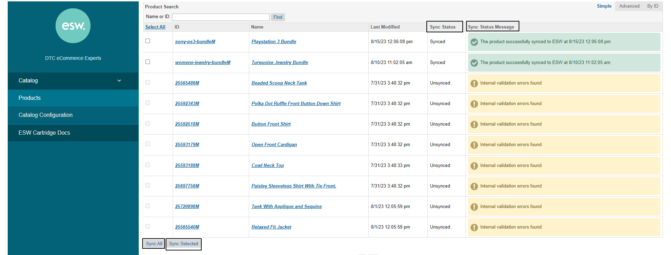
The Catalog Products

Selected products can be synchronized manually by selecting the Products and clicking Sync Selected. Here are the details, regarding the custom action and fields on the page

- Sync All - This button is used to synchronize All the candidate products
- Sync Selected - This button is used to synchronize the selected products
The validation steps described above will apply here as well. Sync Status will be updated along with the Sync Status Message. The error details of the internal validation can be viewed by hovering on the Error Status Message

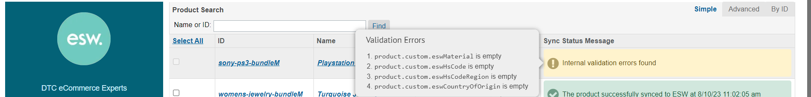
Internal Validation Errors Details

The Catalog Configurations can also be controlled from this BM Module. Clicking on Catalog Configuration will open up the configuration details. The Catalog Configuration page will show the configurations based on the Service URL set in the Catalog Service’s. If the Catalog Service’s URL is set, the page will show the API Configurations.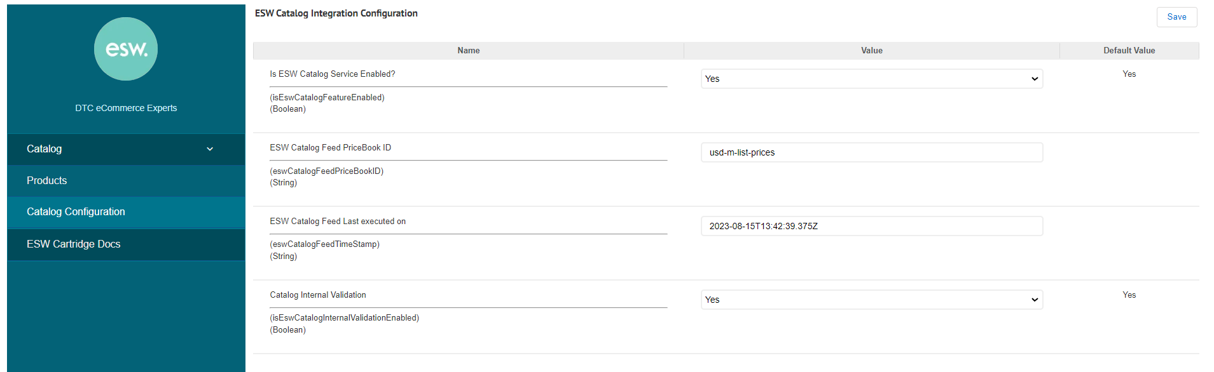
Catalog Service Preferences

If the Catalog Service doesn’t contain the service URL, SFTP configs will show up on the catalog configurations page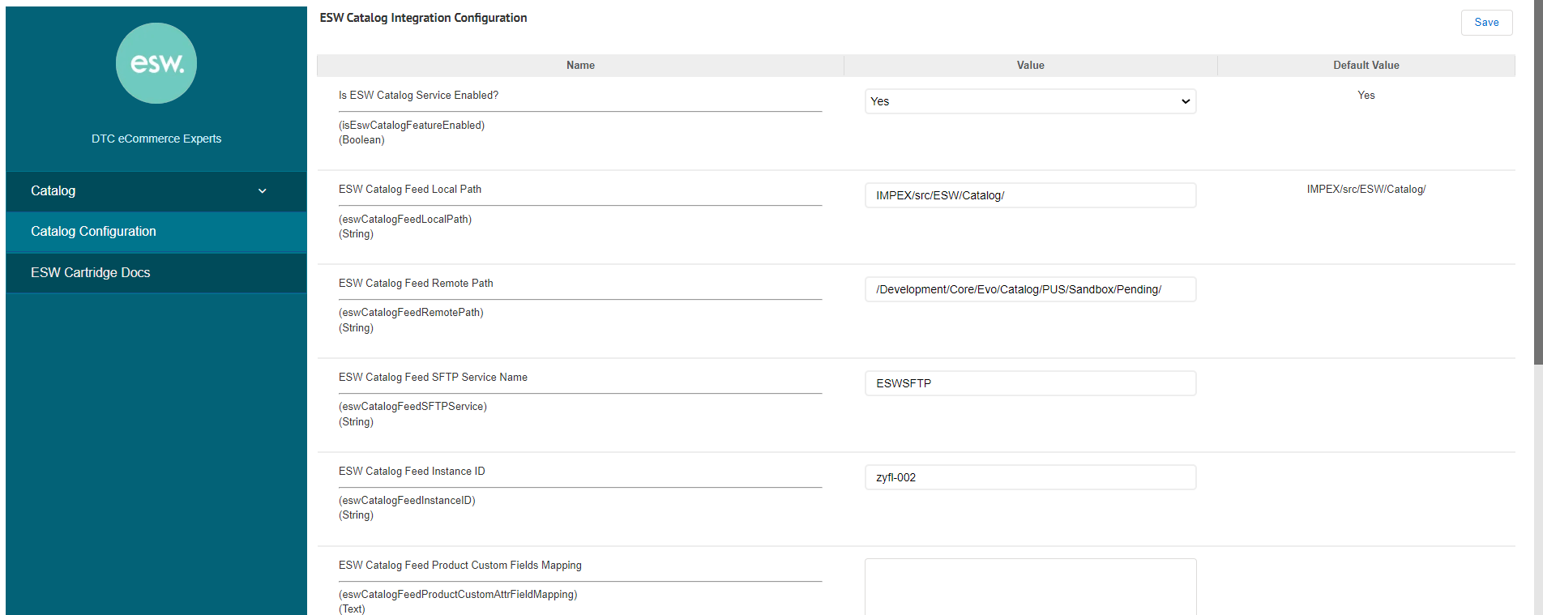
SFTP Preferences in Catalog Configurations

Dependencies
- The product should contain the minimum required attributes. The details of these required attributes can be viewed under the heading minimum required parameters

Testing in Sandbox
- Configure the API in SFCC
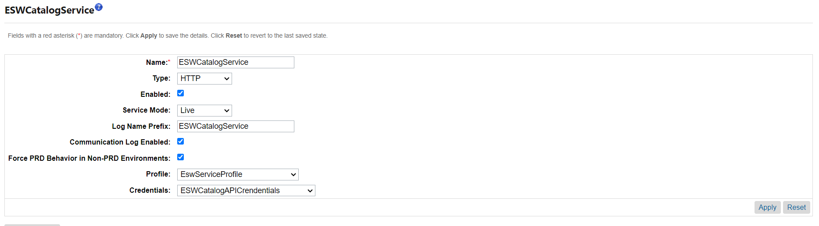

- Ensure that the products have the minimum required parameters. Products can be edited in Merchant Tools > Products & Catalog > Products
- Once the products have the required attributes. Execute the Job.
- Validate the Sync Status to ensure the product has been synched.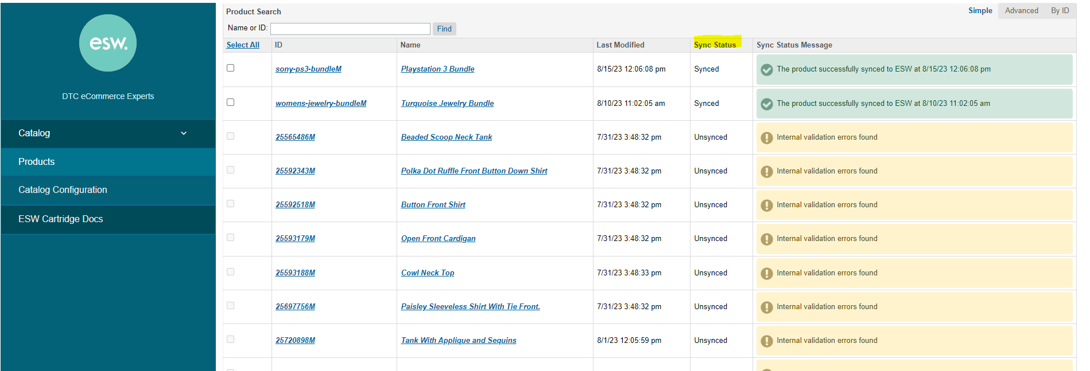
- For Manual Testing, select the product and Click Sync Selected and verify the status as shown in steps above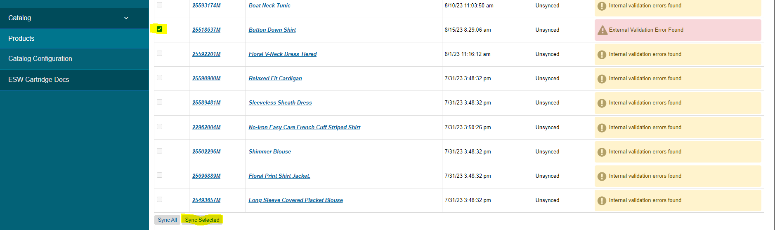

Catalog Feed Upload Via SFTP
The ESW Cartridge also provides option to send catalog file to ESW via SFTP. The eswRetailerCatalogFeed job configured within the cartridge runs at predefined intervals and performs the following operations automatically:
- Initial full catalog upload: Uploads the initial full catalog to the ESW catalog service.
- Delta catalog upload: Monitors the catalog in SFCC and auto-syncs the delta updates as soon as new products are added or existing products are modified.
For more information on the eswRetailerCatalogFeed job, see Operations > Job Schedules > eswRetailerCatalogFeed job.

Initial Full Catalog Upload
When the eswRetailerCatalogFeed job executes for the first time, a CSV file is generated. The file includes details of all products from the catalog:
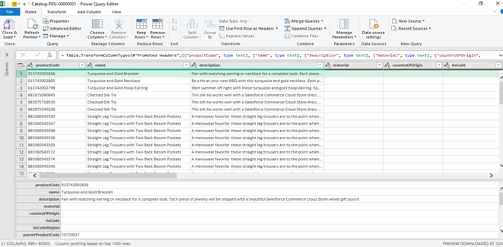
Full catalog upload
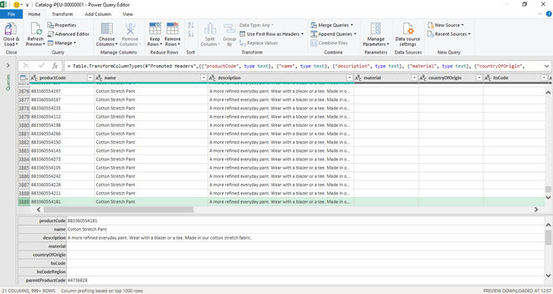
Full catalog upload continued

Delta Catalog Upload
When the eswRetailerCatalogFeed job executes after the initial full catalog upload, it searches for new products as well as products that are updated since the job was last executed. Once located, the delta product details are sent to the ESW Catalog service.
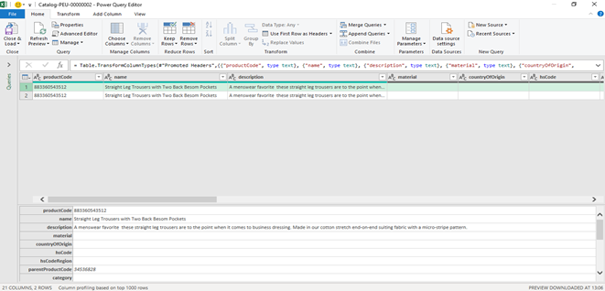
Delta catalog upload
The job uses custom preferences and the ESW SFTP service to transfer the file to the SFTP server. For information on the custom preferences and the ESW SFTP Service, see
ESW Catalog Integration Configuration and ESWSFTP service respectively.
For information on the Catalog File Specification, including the file format, naming conventions, and data, click here.
- The Catalog Feed covers these product types - Simple Product, Variation Product, Product part of Set, Product part of a Bundle, and Orderable Variation Master.
- Along with the ESW naming conventions, the cartridge allows you to store the Instance ID in the ESW Catalog Feed Instance ID site preference under ESW Catalog Integration Configuration. You can use the Instance ID in the file name to identify the catalog feed files of specific SFCC instances.
  - If the Instance ID exists in the site preference, the filename is generated as Catalog-nnn-[SFCCInstanceID]xxxxxxxx.
  - If the Instance ID is empty, the filename is generated as Catalog-nnn-xxxxxxxx.

Catalog Integration Configuration

ESW Catalog Integration Configuration site preferences
You can use Custom Preferences to manage ESW-specific configurations of the cartridge. You can access Custom Preferences by navigating to Merchant Tools > Site Preferences > Custom Preferences.
The following ESW Catalog Integration Configuration options are present:
- ESW Catalog Feed Local Path: This preference indicates the local path of the ESW Catalog Feed CSV file.
- ESW Catalog Feed Remote Path: This preference indicates the remote path of the ESW Catalog Feed CSV file in the SFTP location.
- ESW Catalog Feed SFTP Service Name: The preference indicates the SFTP service name that will be called when establishing the connection with SFTP.
- ESW Catalog Feed Instance ID: This preference indicates the SFCC instance from which the catalog feed is generated. The Instance ID is appended in the catalog feed filename, for example, Catalog-nnn-[instanceID]xxxxxxxx.csv. Note that the Instance ID should only contain an alphanumeric value.
- ESW Catalog Feed Product Custom Fields Mapping: This preference maps the product custom attributes IDs to the ESW Catalog Feed keys in the following pattern:
{
"EswKeyField1": "ProductCustomAttributeID1",
"EswKeyField2": "ProductCustomAttributeID2"
}
Based on this mapping, the script fetches the value of the mapped product custom attribute and sends it to the assigned ESW catalog feed key. For example, in the CSV file, the EswKeyField called hscode will be sent as a header column and the value of the productHSCode (Product level custom attribute) will be sent as a record in each product detail row, as shown in the following example:
{
"material":"productMaterialDescription",
"countryOfOrigin": "productManufacturerCountry",
"hsCode": "productHSCode",
"hsCodeRegion":"productHSCodeRegion",
"category": "",
"gender": "",
"ageGroup": "",
"weight": "",
"weightUnit":"",
"dangerousGoods": ""
}
- ESW Catalog Feed PriceBook ID: This preference indicates the pricebook ID from which the prices will be sent against the products in the catalog feed.
- ESW Catalog Feed Last Executed On: This preference indicates the last executed timestamp of the catalog feed job. You can trigger 'Full Catalog Upload' by clearing the 'ESW Catalog Feed Last executed on' preference value.
- ESW Catalog Feed Delimiter: This preference is to select the delimiter as a separator for catalog feed generated in response of catalog feed job execution. Default value for this preference would be pipe sign ‘|’ and comma ‘,’ can also be selected as delimiter value.
- Is Catalog Service Enabled: This preference is used to indicate if the catalog service will be used to send catalog related data to ESW

- Catalog Internal Validation: This option will allow to turn the catalog’s internal validation off or on while using the catalog service.

eswRetailerCatalogFeed job
The eswRetailerCatalogFeed job syncs the retailer catalog to the ESW Catalog Service by generating the required file in the specific file format. The file is generated in the IMPEX folder. The job also transfers the generated file to the ESW SFTP location using the SFTPClient service framework.

Services
The following services are being used for this functionality. The cartridge automatically generates the URL if they are not set already.
ESWSFTP: This service is used to make a call to the SFTP client and establish the connection to the remote ESW SFTP server. The service has its credentials that you can find under the Credentials tab.
For multiple sites using the common Sandbox, you can configure multiple services for sites that use the different ESW SFTP server. You can also add the service name to the ESW Catalog Feed SFTP Service Name custom preference.
ESW Cataog Service: This service is used to call the catalog API V2 and send the catalog data to ESW.

