


SFCC - ESW Cartridge
+
LIMITATIONS AND WORKAROUNDS GUIDE
Version: 5.1.2
Published date: August 2026
Copyright © 2026 by ESW. All rights reserved. Information contained herein is subject to change without notice.

Contents
1 Limitations and Workarounds 3
1.1 Promotions and Discounts Limitations 3
1.1.1 Maximum discount amount cannot be greater than the final product price. 3
1.1.2 Workaround 5
1.1.3 Promotion with the 'Without Qualifying Products' condition & Dynamic/Calculated Price Model 6
1.1.4 Workaround 7
1.1.5 The 'Buy X Get Y Free/Discounted' promotion cannot be mixed with the order-level promotion 7
1.1.6 Workaround 9
1.1.7 Customer group promotion 10
1.1.8 Workaround 10
1.1.9 Calculated Pricing Model Promotions 10
1.1.10 Workaround 10
1.1.11 Payment method specific Promotions 11
1.1.12 Workaround 11
1.2 Shipping Limitations 11
1.2.1 Shipping/delivery cost is based on the retailer’s default or price book currency 11
1.2.2 Workaround 16
1.2.3 Surcharges are ignored when calculating tiered shipping cost 16
1.2.4 Workaround 19

Limitations and Workarounds

Promotions and Discounts Limitations
This section contains certain limitations related to Order, Product, and Shipping. Click on a limitation to read the limitation scenario and workaround.

Maximum discount amount cannot be greater than the final product price
This means that the maximum Amount Off discount cannot be greater than the price of the product according to the price book.
For example, if the price of the product is 35.41 EUR in the price book.
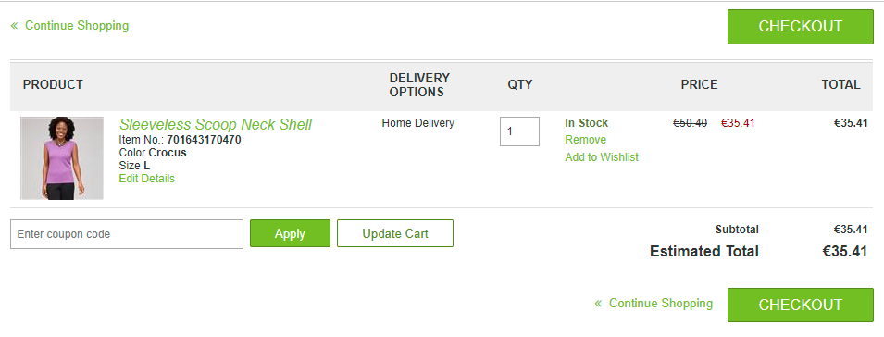
Configure promotion to offer a discount of 36 Amount Off, as shown in the following image:
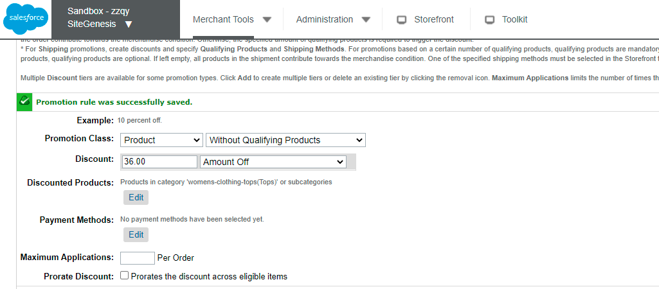
When the shopper applies 36 Amount Off discount in the shopping cart, only 35.41 EUR Amount Off discount will be displayed, as this is the price of the product from the price book.
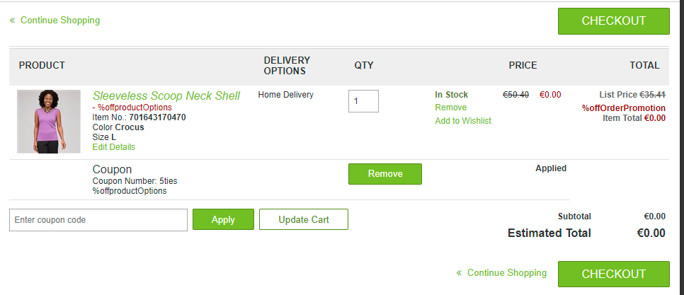
However, the ESW Checkout calculates the discount as configured in the Business Manager 36 EUR. The price of the item would go in negative in that case and Preorder checkout will throw an exception as can be seen in the following screenshot.
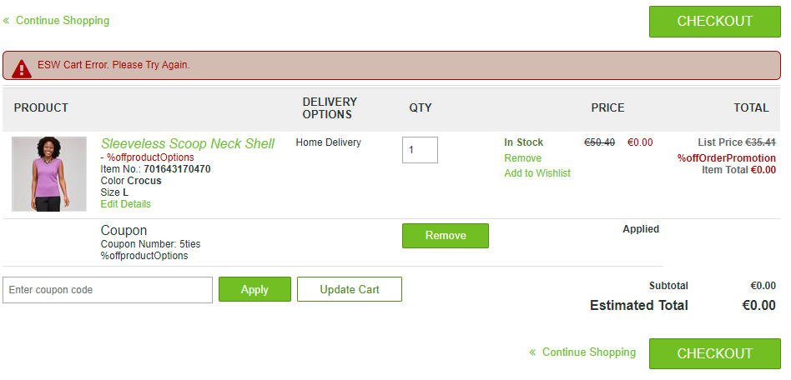

Workaround
- Ensure that the Amount Off discount is never higher than the price of the product from the price book.
- If you are offering a free product promotion, the discount must be set to 100 Percent Off.
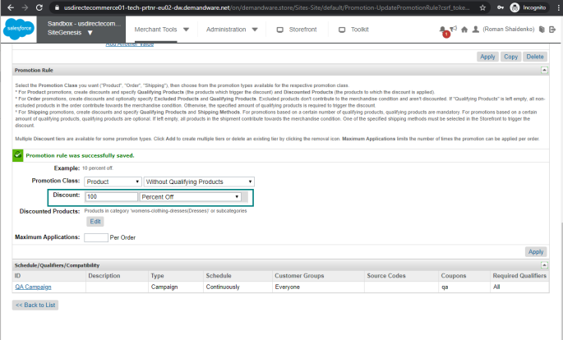
This allows the full total to be reduced to ‘0’, rather than a set amount being taken off.

Promotion with the 'Without Qualifying Products' condition & Dynamic/Calculated Price Model
This limitation only applies when the prices are being calculated on the fly. The final product prices after discount differ from those displayed on the product detail or listing (PDP/PLP) pages. This happens because of the way SFCC calculates the final prices on the PDP/PLP and Cart pages.
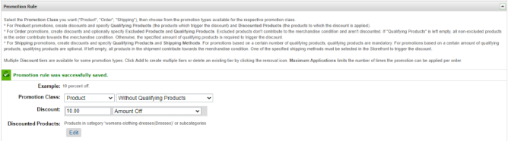
- On the PDP/PLP pages, the discount amount is subtracted from the product base price. For example, 40.99 USD -10, where 10 is the discount amount. The final price of 30.99 USD is then used to forward calculate the final price in the shopper currency.
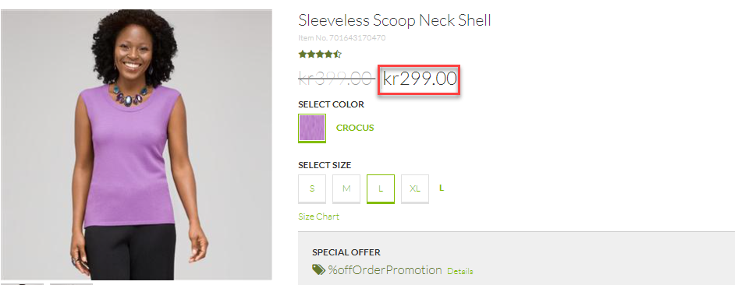
In this example, the price of 299.00 KR is converted on the fly from USD for Dynamic/Calculated pricing model country.
- On the Cart page, SFCC recalculates the prices first by converting 30.99 USD into shopper currency (399.00 KR) instead of 30.99 USD (as in the case of PDP). SFCC then converts the discount of 10 USD to shopper currency which is 101.62 and subtract from the converted amount (399.00 – 101.62 = 297.38 KR).
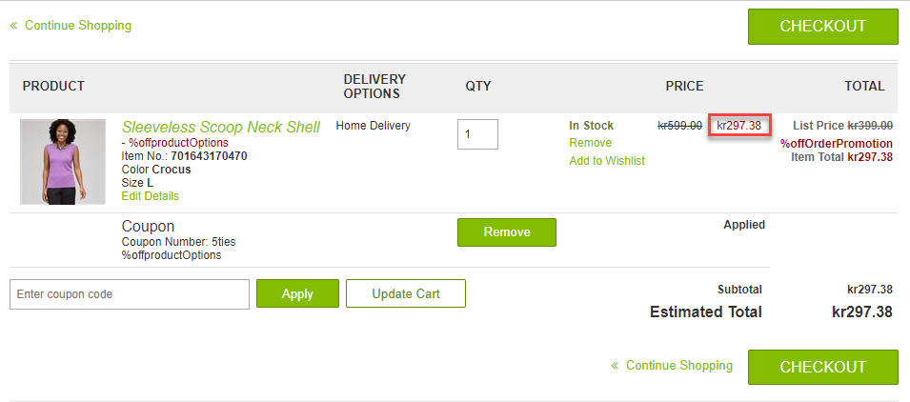
As a result, there is always a difference in the final prices displayed to the shopper. Hence, when using Dynamic/ Calculated Price Model shopper can experience mild visual discrepancies of prices between PLP/ PDP pages and Cart page.

Workaround
There is no workaround for this limitation.

The 'Buy X Get Y Free/Discounted' promotion cannot be mixed with the order-level promotion
The 'Buy X Get Y' product-level promotion, where X and Y are two different products should not be mixed with the order-level promotion for the same qualifying products.
For the product-level discount, the adjusted and prorated price is always the same, except for the 'Buy X Get Y' promotion where X and Y are two different products. With this promotion, the prorated price gets discounted as it does for the order-level promotion.
When the order-level promotion is applied to the same qualified product for the 'Buy X Get Y' promotion, the prorated price gets discounted for both promotions. Therefore, the order-level value in the cart and on the ESW checkout becomes incorrect due to the inclusion of the 'Buy X Get Y' promotion discount.
Discount = Order level discount + 'Buy X Get Y' rule prorated price difference
In the following example, the order-level prorated discount is £2. With the 'Buy X Get Y Free' promotion, the prorated price of the qualifying product becomes £8.60, which changes the order-level discount value to £10.60, which is incorrect.
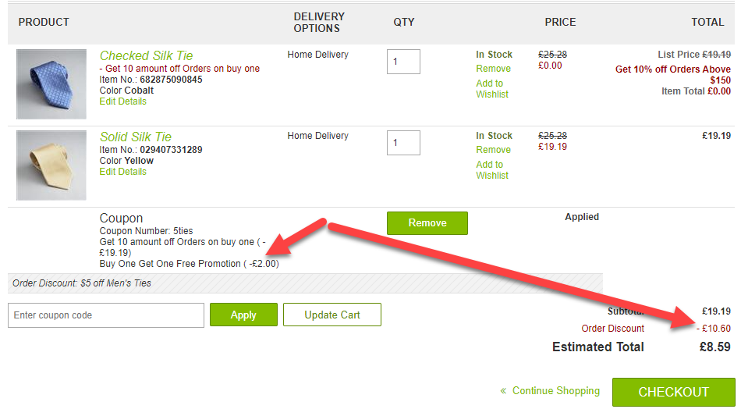
This limitation also impacts the values in the Checkout API call. In the following image, the qualified product shows the exact prorated price of the line item by deducting the order-level discount and half of the item price after applying the 'Buy X Get Y' promotion causing incorrect order totals.
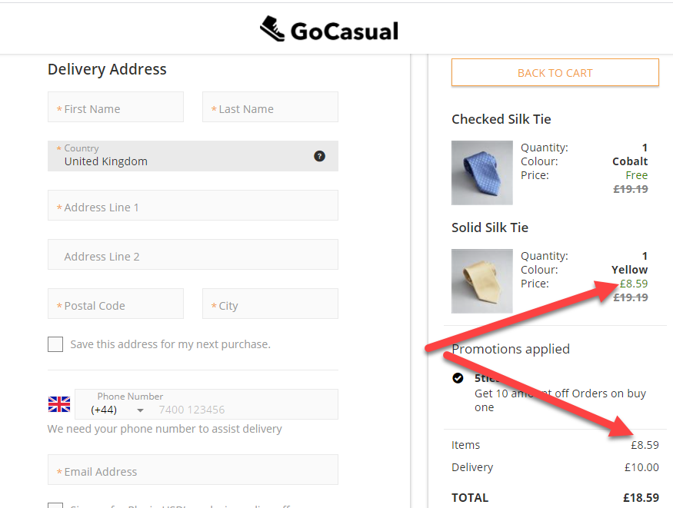

Workaround
Do not apply the order-level promotions and product-level promotions with the 'Buy X Get Y Discounted/Free' rule to the same qualifying product.
This can be achieved by setting the exclusivity global flag to Can’t be combined with any promotion for the Buy X Get Y promotion as can be seen in following screenshot.
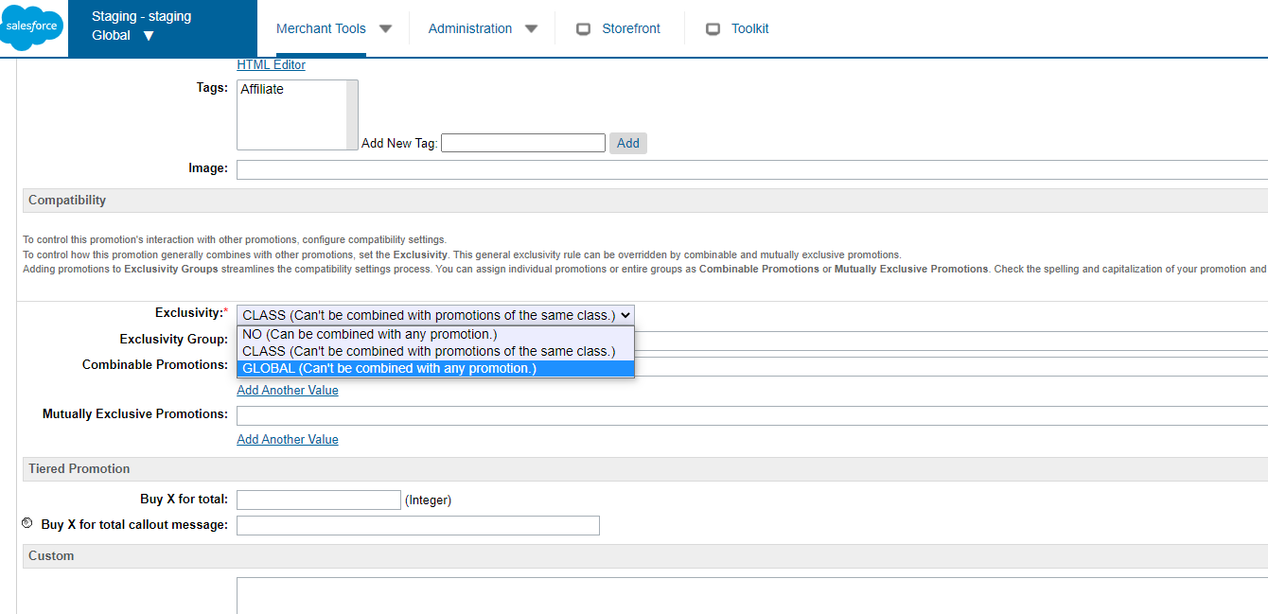

Customer group promotion
Promotions based on customer profile based customer groups are don’t remain applicable in Business Manager once order is confirmed. ESW doesn’t have access to the customer profile so the context is lost on server to server call between ESW tenant and retailer SFCC site while order confirmation webhook process. When the order is confirmed, the customer groups based on profile attributes don’t remain applicable and hence the promotion is not reflected in order confirmation

Workaround
Promotions based on Custom groups must be configured with custom session attributes not with the customer profile attributes. For example, when the customer logs in, a custom session attribute will be set. The promotion needs to be configured to trigger on the custom session attribute. This way the context won’t be lost and promotion won’t be removed from the order.

Calculated Pricing Model Promotions
Promotion on countries using calculated pricing model along with rounding rules might have minor differences in prices. Basically the discounts are calculated in base currency and then converted into the local currency. For example if there is $5 off discount for Canadian market then the price will be converted into C$ along with the rounding rule (6.81 C$ will be rounded off either to 6 or 7, depending upon the rounding rule). In some cases, if the customer is given 20%, it is possible that the customer will get either 21% or 19.5% off based on rounding rules. The exact discount value can’t be guaranteed with calculated pricing model since discounts are first calculated in base currency and then converted into storefront currency.

Workaround
There is no work around for this limitation the only solution is using fixed price model so that the discounts are calculated in the storefront currency.

Payment method specific Promotions
Promotions which are dependent on payment methods are not supported by the cartridge. Example is given below.
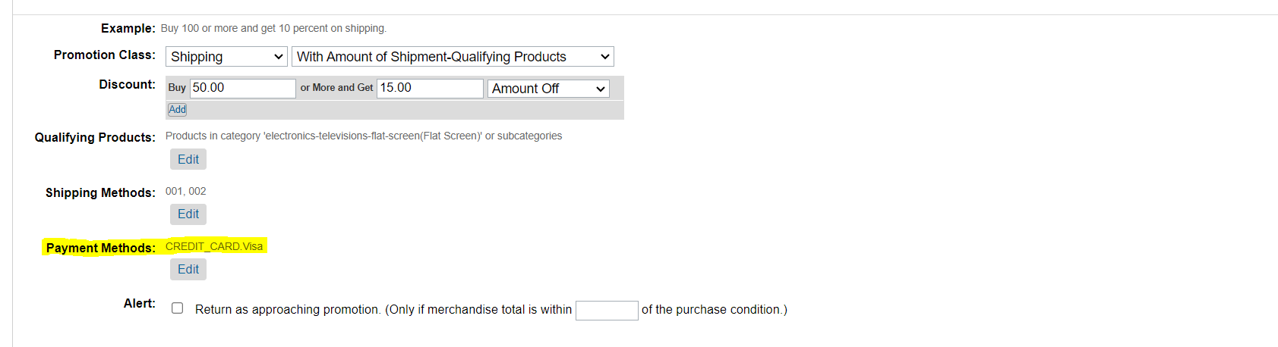

The reason is that payment methods are applied on ESW checkout and all promotions are calculated before the ESW checkout API call is made. Since payment methods are not available before the checkout is loaded hence this promotion type is not supported by the ESW Cartridge.

Workaround
There is no workaround for this limitation.

Shipping Limitations

Shipping/delivery cost is based on the retailer’s default or price book currency
When shipping is set as a percentage of the shipment value, by default, SFCC uses product prices from currency price books. As a result, SFCC calculates the shipping cost based on the actual product price in the price book and not the final calculated prices.
This applies only to the Calculated pricing model, where product prices are calculated on-the-fly using the rates fetched by ESW Pricing Advisor API.
For example:
Parameter | Value
Shipping country | Sweden
Shopper currency | SEK
Price of the product in the price book | EUR 92
Uplift | 3%
Duty | 7%
Tax | 20%

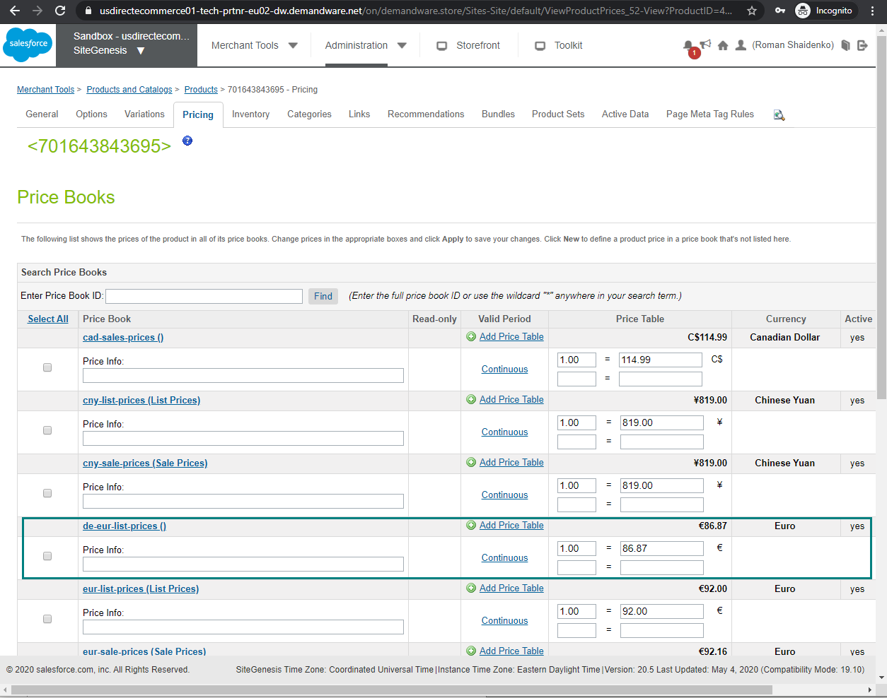

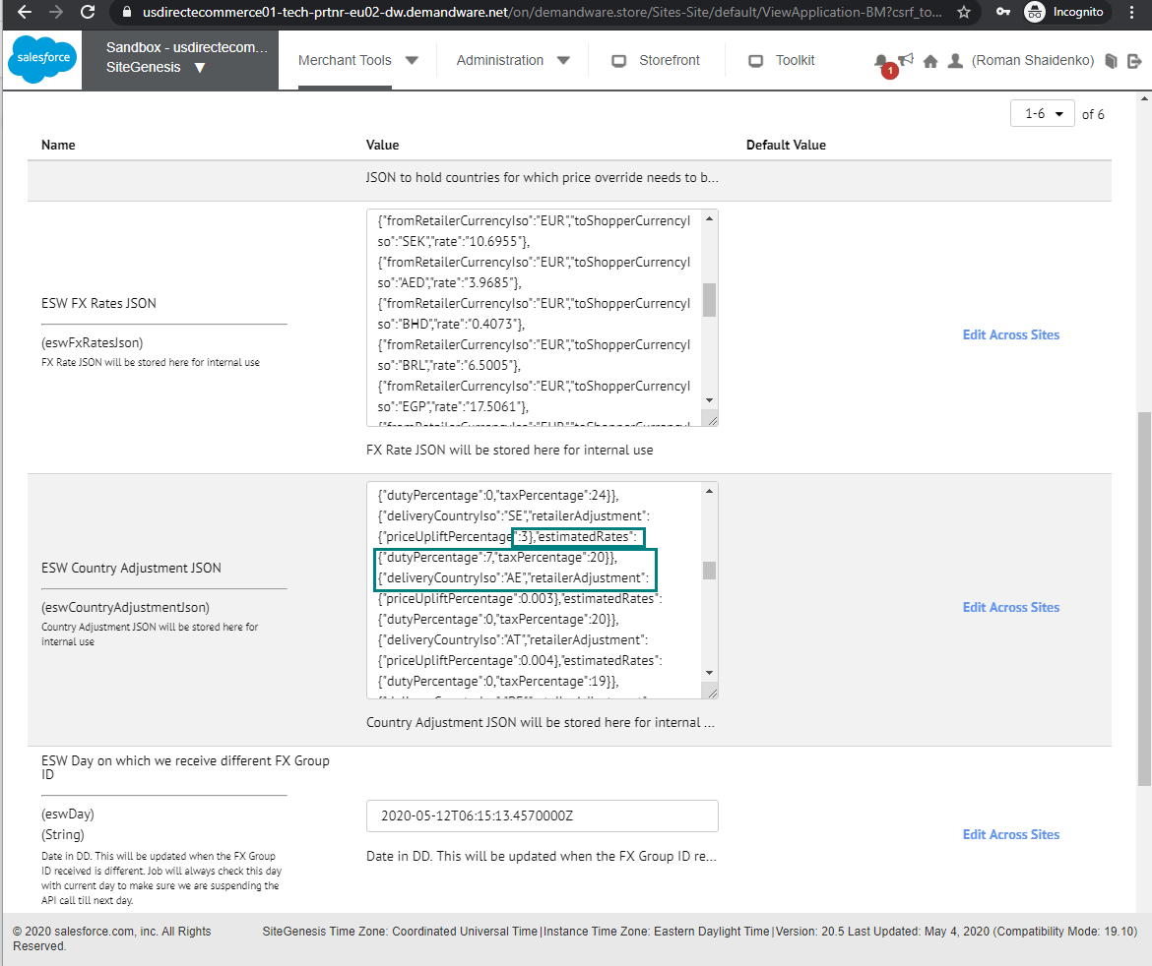
The price of the product on the storefront is calculated as SEK 1301.34:
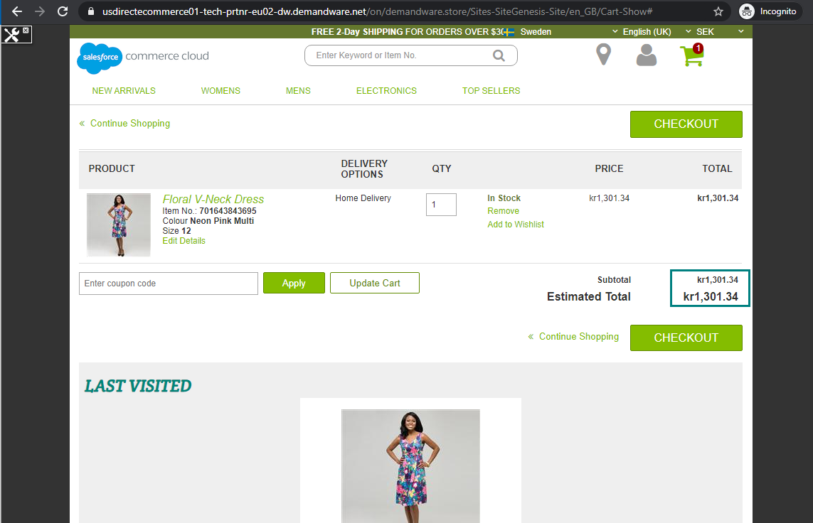
The Shipment Cost is set as 10 % of the shipment value in the Business Manager:
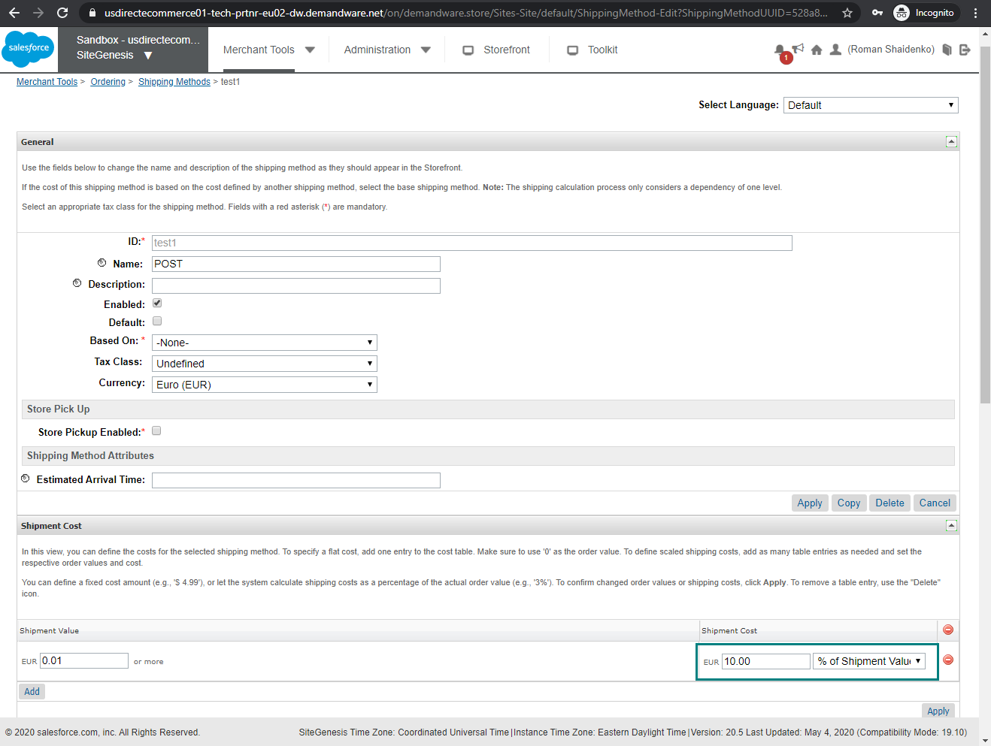
The actual Shipment Cost (as shown above) is calculated as 10 % of SEK 1301.34 = SEK 130.13
However, to the shoppers, the shipping cost will be displayed as SEK 98.4, as SFCC calculates the shipping cost using prices from the price book.
92 EUR x FX Rate -> 92 x 10.6955 = 983.986 (SEK)
10 % of 983.986 (SEK) = round (98.3986) = 98.4 (SEK).
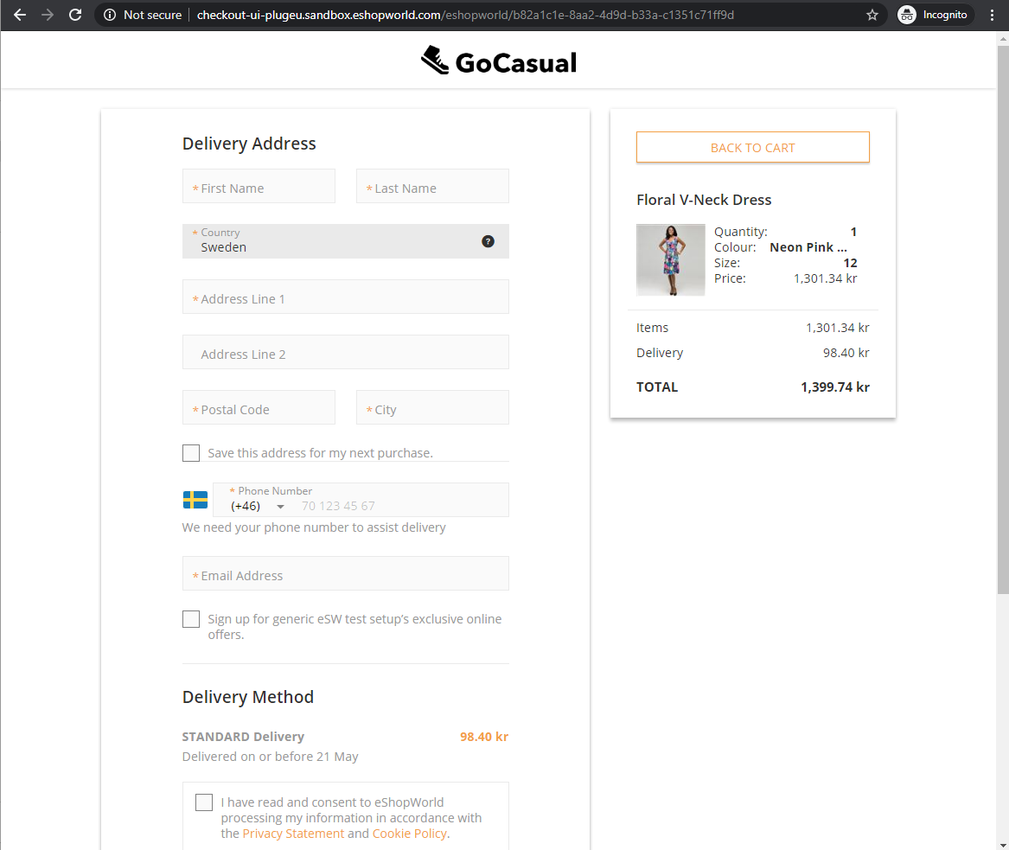

Workaround
You can set the Shipment Cost as Fixed Price instead of as % of the Shipment Value in the Business Manager.

Surcharges are ignored when calculating tiered shipping cost
Surcharges (uplift, tax, and duties) calculated as part of calculated pricing are ignored during tiered shipping cost calculation. This only applies to the Calculated pricing model. For example:
Parameter | Value
Shipping country | France
Shopper currency | GBP
Price of the product in the price book | EUR 92
Uplift | 3%
Duty | 7%
Tax | 20%
With these values and calculations, the price of the product on the storefront is displayed as EUR 121.67.
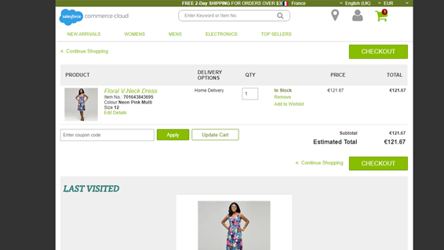
The following Shipment Value – Shipment Cost rules are set in SFCC Business Manager:
- Shipment Value: 0.01 – Shipment Cost: 10 EUR
- Shipment Value: 110 – Shipment Cost: 20 EUR
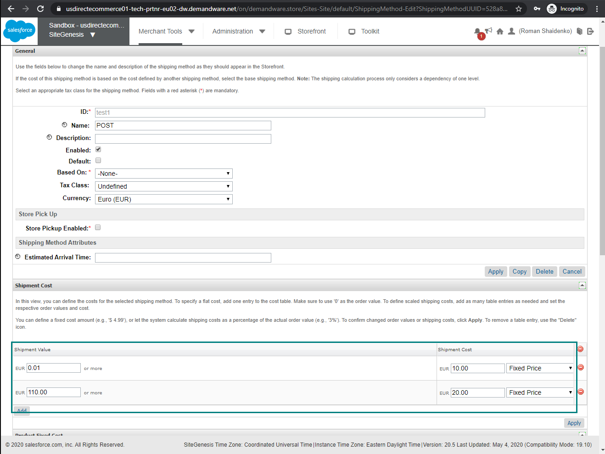
- Actual Result: Shopper sees EUR 10 as the Shipping Cost because SFCC calculates it based on the product price, which is EUR 92.
- Desired Result: Shoppers should see EUR 20 as the Shipping Cost because the cart total is more than EUR 110.
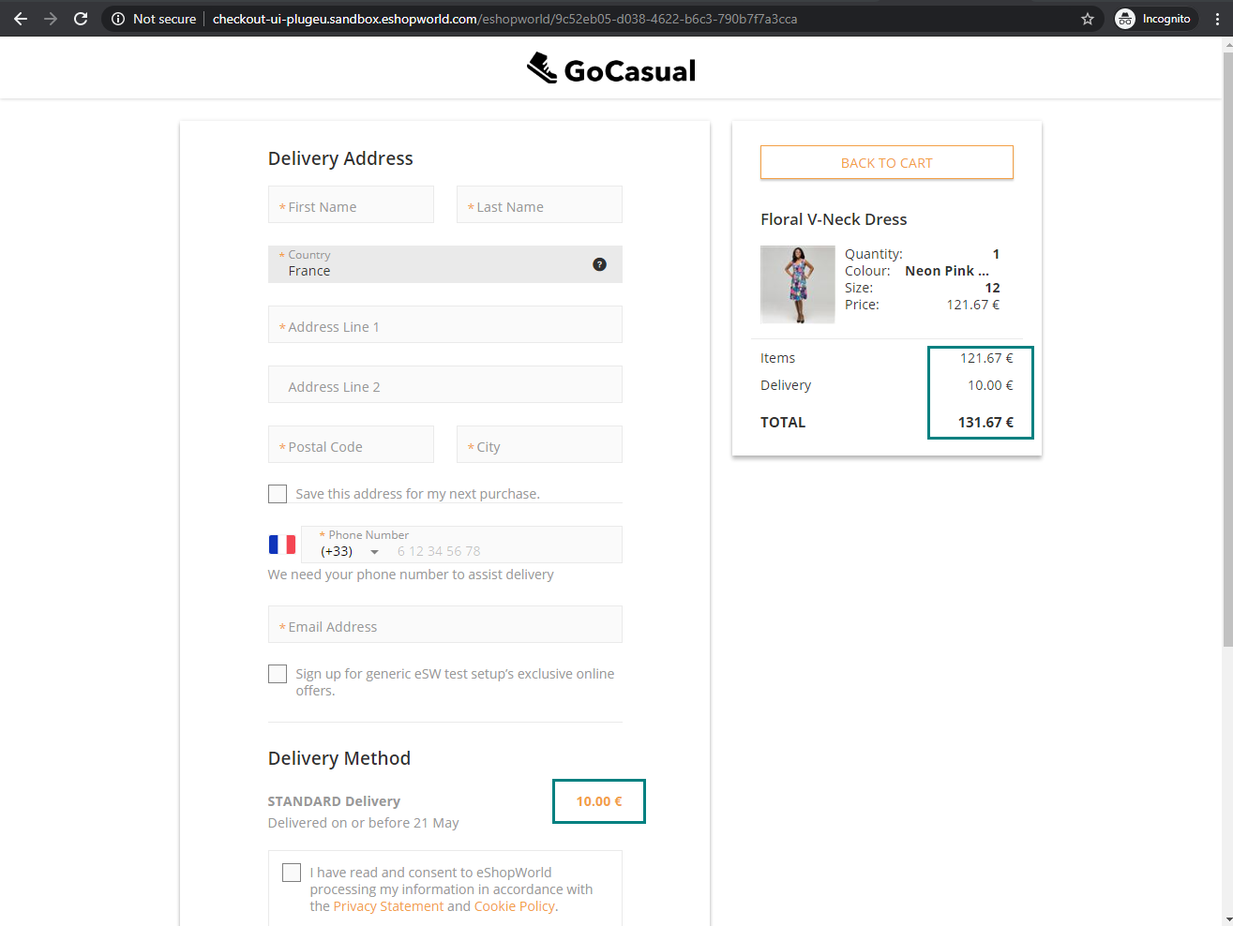

Workaround
There is no workaround for this limitation.

