


Version: 5.1.2
Published date: August 2026
Copyright © 2026 by ESW. All rights reserved. Information contained herein is subject to change without notice.

ORDER APPEASEMENT INTEGRATION GUIDE

SFCC - ESW Cartridge
+
Contents
1 Order Appeasement Integration 2
1.1 Workflow to Order Appeasement (SFCC => ESW) 3
1.2 Workflow to Order Appeasement Sync (ESW => SFCC) 3
1.2.1 ESW Webhooks Configuration 3
1.2.2 Workflow to Appeasement Order in SFCC 4
2 Order Appeasement Integration Configuration 4
2.1 Import Metadata 4

Order Appeasement Integration

Workflow to Order Appeasement (SFCC => ESW)
This flow is not available in the feature. A retailer can create appeasement only from the ESW panel.

Workflow to Order Appeasement Sync (ESW => SFCC)
If the order is appeased in ESW CSP. SFCC webhook endpoint will be called from CSP (EShopWorld-ProcessWebHooks) that will update appeasement custom attributes on specified order in request and mark the order as an appeased by changing the value for flag Is ESW Appeased Order? to true.
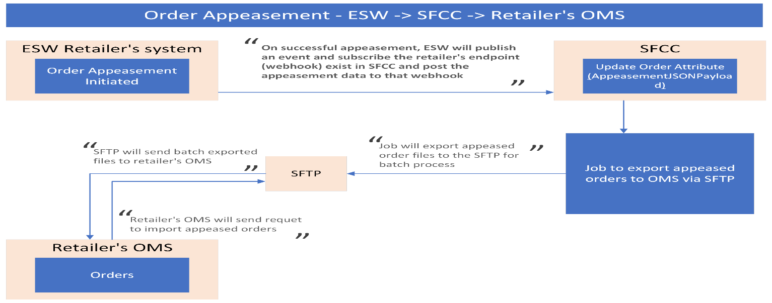
The endpoint will be configured on the ESW tenant side so retailers can subscribe to the event.

ESW Webhooks Configuration
Retailers need to subscribe SFCC API endpoint in ESW tenant configuration that will trigger on OrderAppeasementSucceedEvent. The ESW-SFCC cartridge provides the OOTB SFCC endpoint to subscribe to the ESW order appeasement webhook event. ESW integration engineer can help retailers subscribe to this endpoint.
SFCC Endpoint Example:
https://example.com/on/demandware.store/Sites-RefArch-Site/default/EShopWorld-ProccessWebHooks
Retailers can update example.com with their storefront domain.

Workflow to Appeasement Order in SFCC
The ESW-SFCC Cartridge would perform the following to appeasement order in SFCC If the order appeased from ESW CSP first to sync order status in SFCC.
- On successful order appeasement in ESW CSP, webhook will trigger the retailers provided subscribed SFCC endpoint (EShopWorld- ProcessWebHooks) with appeasement order detail in the request body.
- SFCC endpoint will park appeased order data in SFCC custom objects attributes. Set Order as appeased by marking attribute Is ESW Appeased Order as true.
- Park requests payload in Jason format to custom attribute appeasementJsonPayload.
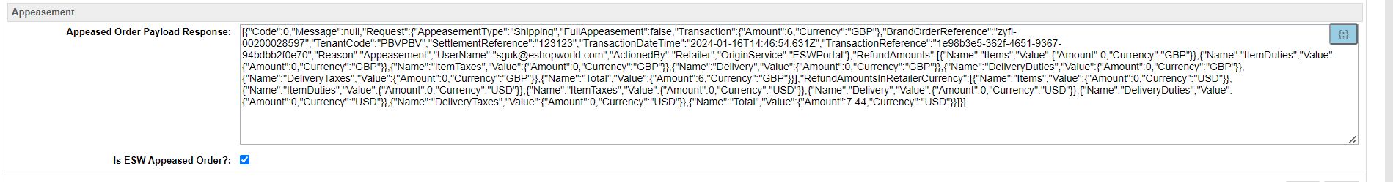

Order Appeasement Integration Configuration

Import Metadata
Import order-level custom attributes (systemobjects.xml) from link_eshopworld\sitesdata\meta.
The following ESW Order Appeasement custom attribute group will be present in Order Custom Attributes:
- Appeased Order Payload Response: This custom attribute will be filled with request JSON format if the order is successfully appeased in ESW, which will be in the ESW Order API response.
- Is ESW Appeased Order?: This will hold the Boolean status of appeasement on successfully updating the ESW Order API response.

