


Version: 5.1.2
Published date: August 2026
Copyright © 2026 by ESW. All rights reserved. Information contained herein is subject to change without notice.

ORDER CONFIRMATION INTEGRATION GUIDE

SFCC - ESW Cartridge
+
Contents
1 Order Confirmation Integration 3
1.1 Order Confirmation Request from ESW to SFCC 3
1.2 Order Confirmation in the SFCC Business Manager 3
1.3 Order Confirmation Attributes Mapping 6
1.3.1 Order Attributes 6
1.3.2 Order Item Attributes 10
2 Configuration 13
2.1 ESW Pricing Configuration 13
2.2 ESW Checkout Configuration site Preferences 17

Order Confirmation Integration
The Order Confirmation page is displayed after the order is placed. The screen displays the items that the shopper ordered, the total price they paid, and the delivery and payment addresses.
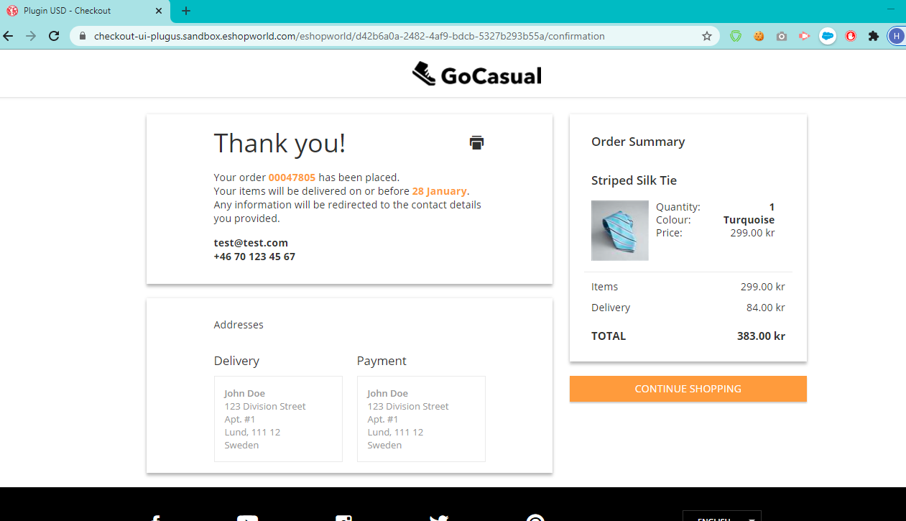

Order Confirmation Request from ESW to SFCC
When an order is placed successfully, the ESW console sends an order confirmation request to SFCC. The request is validated by SFCC and the selected shipping method is applied. If the request is not valid or there is an error, an error response is sent to the ESW console and the order fails.
- For order confirmation requests in SFRA, PWA and Headless the EShopWorld-Notify endpoint is used.
- For order confirmation requests in Headless (SG based) and SG, the EShopWorldSG-Notify endpoint is used.
- To change the endpoint, go to the ESW Metadata Items custom preference under ESW Checkout Configuration.
Note: The OrderConfirmationUri_TestOnly|EShopWorld-Notify and OrderConfirmationBase64EncodedAuth_TestOnly|1parameters are required for the Sandbox environments only.

Inventory Check Validation in SFCC
In case Enable ESW Inventory Check preference is enabled in checkout configurations, inventory validation will take place on order confirmation webhook before placing the order.
- If all line items inventory related to the order is available then order will be placed successfully and order confirmation page will be displayed on ESW checkout.
- If any/all line items inventory is not available then status of the order will be set to “Fail” and shopper will be redirected to cart or checkout page according to the configurations, with inventory error message.

Order Confirmation in the SFCC Business Manager
When the order is placed, the ESW Checkout pings back the SFCC instance and writes the additional order information to the Custom attributes of System Objects (Order & Product Line Item). If the incoming request is valid, then SFCC order statuses are updated accordingly.
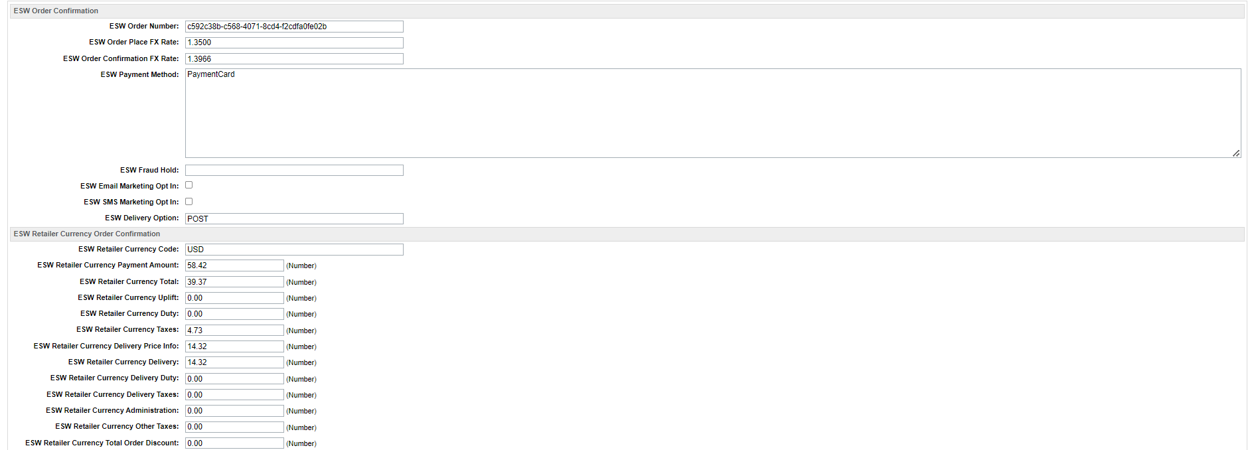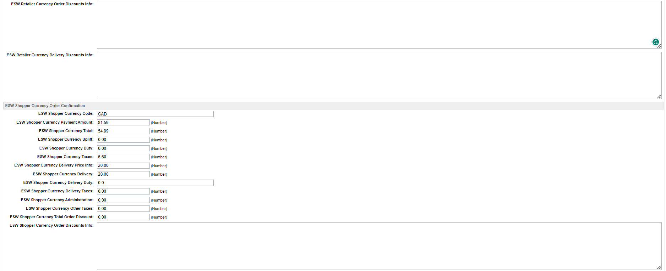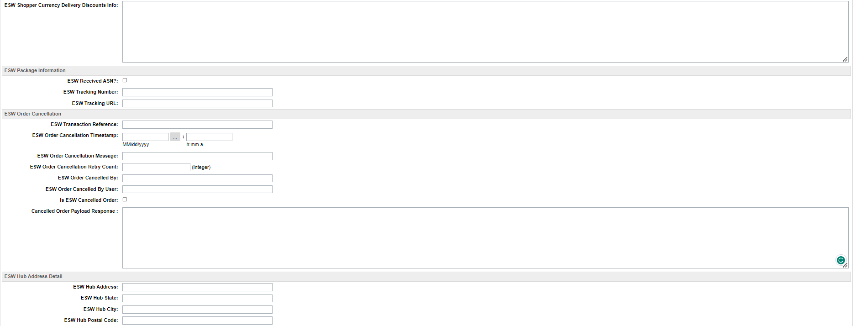
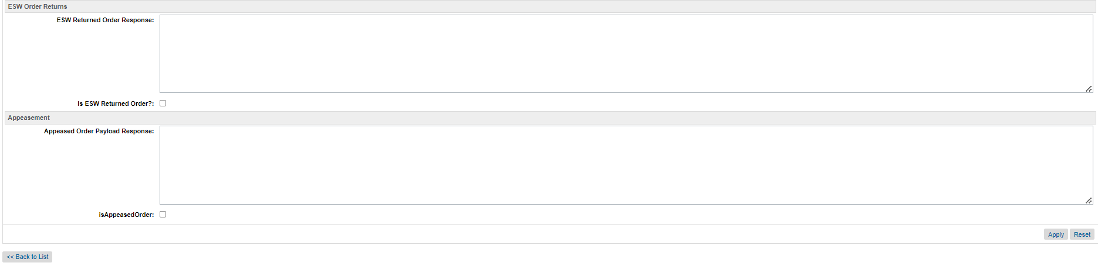

Order Level Custom Attributes
The detailed item information is also available in the SFCC Business Manager (SFCC Administration):
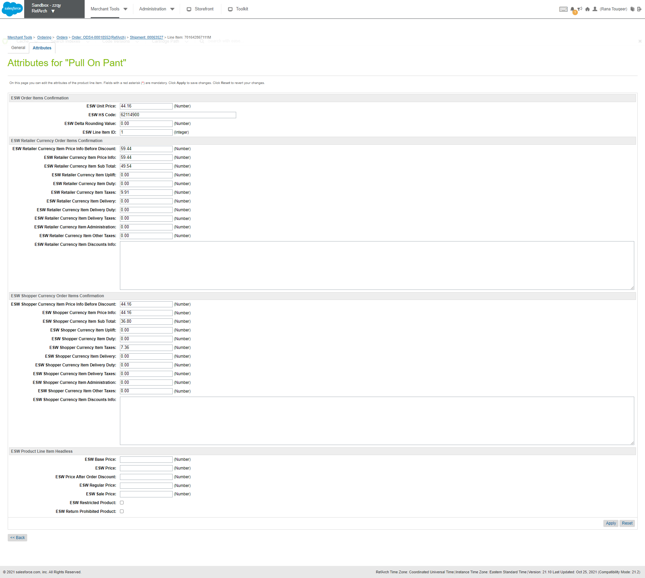
Order Item (Product Line Item) Level Custom Attributes
For more information on Order Confirmation Attributes, see Order Confirmation Attributes section.

  - Order Confirmation Attributes Mapping
This section describes the attributes in the ESW Order Confirmation request and how they are represented in SFCC.
    - Order Attributes
      - ESW Order Confirmation
SFCC Attribute | ESW Order Confirmation | Description
ESW Order Number | eShopWorld Order Number | ESW’s unique identifier for the order.  Example: bc8b3af0-470d-4425-9169-e701787aedd0
ESW Order Place FX Rate | SFCC BM Order Attribute, not coming from eSW order confirmation request. | The FX rate that was used during conversion from the retailer currency to the shopper currency on order placement.  Example: 0.8340
ESW Order Confirmation FX Rate | SFCC BM Order Attribute, not coming from eSW order confirmation request. | The FX rate that was used during conversion from the retailer currency to the shopper currency on the order confirmation.  Example: 0.8340 or 0.8341
ESW Payment Method | paymentMethod | The payment method selected by the shopper.
ESW Fraud Hold | SFCC BM Order Attribute, not coming from eSW order confirmation request. | Indicates if the fraud hold applies to the order.
ESW Email Marketing Opt-In | emailMarketingOptIn | Indicates if the shopper subscribed to email marketing. The options are Yes or No.
ESW SMS MarketingOpt-In | smsMarketingOptin | Indicates if the shopper subscribed to email marketing. The options are Yes or No.
ESW Delivery Option | deliveryOption | The preferred delivery option selected on the ESW Checkout. The options are POST and EXP2.
ESW Hub Address | SFCC BM Order Attribute, not coming from eSW order confirmation request. | The Hub Address for the delivery country stored in the country’s custom object in SFCC BM
ESW Hub State | SFCC BM Order Attribute, not coming from eSW order confirmation request. | The Hub Address State for the delivery country stored in the country’s custom object in SFCC BM
ESW Hub City | SFCC BM Order Attribute, not coming from eSW order confirmation request. | The Hub Address City for the delivery country stored in the country’s custom object in SFCC BM
ESW Hub Postal Code | SFCC BM Order Attribute, not coming from eSW order confirmation request. | The Hub Address Postal Code for the delivery country stored in the country’s custom object in SFCC BM
      - ESW Order Confirmation (Retailer Currency)
SFCC Attribute | ESW Order Confirmation (Retailer Currency) | Description
ESW Retailer Currency Code | SFCC BM Order Attribute, not coming from eSW order confirmation request. | The currency that was used by the retailer.  Example: USD
ESW Retailer Currency Payment Amount | retailerCurrencyPaymentAmount | The amount paid in the retailer currency. The amount includes the price of the product, delivery cost, uplift, duty, and taxes.  Example: 698.43
ESW Retailer Currency Total | retailerCurrencyTotal | The order merchandise charge in the retailer currency.  Example: 554.61
ESW Retailer Currency Uplift | retailerCurrencyUplift | The order uplift in the retailer currency.  Example: 0
ESW Retailer Currency Duty | retailerCurrencyDuty | The order duty charge in the retailer currency.  Example: 0
ESW Retailer Currency Taxes | retailerCurrencyTaxes | The order taxes charge in the retailer currency.  Example: 110.93
ESW Retailer Currency Delivery Price Info | retailerCurrencyDeliveryPriceInfo | The delivery override prices in the retailer currency. This attribute contains the full order delivery charge (including delivery duty and delivery taxes) in the retailer currency.  Example: 32.9  Either the retailerCurrencyOverridePriceInfo or shopperCurrencyOverridePriceInfo attribute is populated where ESW Use Delivery Contact Details for Paymentoverride is required.
ESW Retailer Currency Delivery | retailerCurrencyDelivery | The order delivery charge in the retailer currency.  Example: 27.4
ESW Retailer Currency Delivery Duty | retailerCurrencyDeliveryDuty | The order duty applicable to the delivery charge in the retailer currency.  Example: 0
ESW Retailer Currency Delivery Taxes | retailerCurrencyDeliveryTaxes | The order taxes applicable to the delivery charge in the retailer currency.  Example: 5.49
ESW Retailer Currency Administration | retailerCurrencyAdministration | Order administration charge in the retailer currency.  Example: 0
ESW Retailer Currency Other Taxes | retailerCurrencyOtherTaxes | Order other taxes in the retailer currency.  Example: 0
ESW Retailer Currency Total Order Discount | SFCC BM Order Attribute, not coming from ESW order confirmation request. | The total order-level discount in the retailer currency.
ESW Retailer Currency Order Discounts Info | retailerCurrencyOrderDiscount | The prorated order level discounts information in the retailer currency. This will hold JSON of all discounts.
ESW Retailer Currency Delivery Discounts Info | retailerCurrencyDelivery | The delivery discount information in the Shopper currency. This will hold JSON of all discounts.
ESW Retailer Cash on Delivery Fee Currency | orderCashOnDeliveryObj | The cash on delivery fee’s currency.
ESW Retailer Cash on Delivery Fee | orderCashOnDeliveryObj | The cash on delivery fee’s amount in retailer currency
      - ESW Order Confirmation (Shopper Currency)
SFCC Attribute | ESW Order Confirmation (Shopper Currency) | Description
ESW Shopper Currency Code | SFCC BM Order Attribute, not coming from eSW order confirmation request. | The currency in which the shopper paid for the order.  Example: GBP
ESW Shopper Currency Payment Amount | shopperCurrencyPaymentAmount | The amount paid in the shop-per currency. This amount includes the price of the product, delivery cost, uplift, duty, and taxes.  Example: 584.8
ESW Shopper Currency Total | shopperCurrencyTotal | The order merchandise charge in the shopper currency.  Example: 464.37
ESW Shopper Currency Uplift | shopperCurrencyUplift | The order uplift in the shopper currency.  Example: 0
ESW Shopper Currency Duty | shopperCurrencyDuty | The order duty amount in the shopper currency.  Example: 0
ESW Shopper Currency Taxes | shopperCurrencyTaxes | The order taxes charge in the shopper currency.  Example: 92.88
ESW Shopper Currency Delivery Price Info | shopperCurrencyDeliveryPriceInfo | The order full delivery charges (including delivery duty and delivery taxes) in the shopper currency.  Example: 27.55
ESW Shopper Currency Delivery | shopperCurrencyDelivery | The order delivery charge in the shopper currency. For example, 22.95.
ESW Shopper Currency Delivery Duty | shopperCurrencyDeliveryDuty | The order duty applicable to the delivery charge in the shopper currency.  Example: 0
ESW Shopper Currency Delivery Taxes | shopperCurrencyDeliveryTaxes | The order taxes on the delivery charge in the shopper currency.  Example: 4.6
ESW Shopper Currency Administration | shopperCurrencyAdministration | The order administration charge in the shopper currency.  Example: 0
ESW Shopper Currency Other Taxes | shopperCurrencyOtherTaxes | The other taxes in the shopper currency.  Example: 0
ESW Shopper Currency Total Order Discount | SFCC BM Order Attribute, not coming from eSW order confirmation request. | The total order-level discount in the shopper currency.
ESW Shopper Currency Order Discounts Info | shopperCurrencyOrderDiscountsInfo | The prorated order level discounts information in Shopper currency. This will hold JSON of all discounts.
ESW Shopper Currency Delivery Discounts Info | shopperCurrencyDeliveryDiscountsInfo | The delivery discount information in the Shopper currency. This will hold JSON of all discounts.
ESW Shopper Cash On Delivery Fee Currency | orderCashOnDeliveryObj | The cash on delivery fee currency
ESW Shopper Cash On Delivery Fee | orderCashOnDeliveryObj | The cash on delivery fee amount in shopper currency.
      - ESW Package Information
SFCC Attribute | ESW Package Information | Description
ESW Received ASN? | SFCC BM Order Attribute, not coming from eSW order confirmation request. | Indicates if ESW received an advanced ship-ping notice for the order.
eswPackageReference | eShopPackageReference | Package Reference Received from ESW in the package request
eswTrackingURL | trackingUrl | Tracking URL Received from ESW in the package request
eswPackageJSON | SFCC BM Order Attribute | The package JSON attribute is created based on the package JSON received from ESW

ESW Order Address

SFCC Attribute | ESW Attribute | Description
Native First Name | nativeFirstName | Native First name (Katakana) for Japanese shoppers
Native Last Name | nativeLastName | Native Last name (Katakana) for Japanese shoppers
    - Order Item Attributes
      - ESW Order Items Confirmation
SFCC Attribute | ESW Order Items Confirmation | Description
ESW Unit Price | SFCC BM Order Item Attribute, not coming from eSW order confirmation request. | The unit price of the product.
ESW HS Code | eswHSCode | The HS code of the product. The Harmonized Commodity Description and Coding System (HS code) of the tariff nomenclature is an international standardized system of names and numbers for the classification of commodities. The HS code system is based on a 6-digit nomenclature.
ESW Delta Rounding Value | SFCC BM Order Item Attribute, not coming from eSW order confirmation request. | The rounding values that are applied to the order line items when the order is placed.  To determine the delta rounding values, the cartridge uses the unit price of the item before and after the rounding is applied and saves the values at the order product line item level in the custom attribute.  ESW Delta Rounding Value = ESW Unit Price with Rounding-ESW Unit Price without Rounding.  When using the Calculated pricing model, this attribute provides visibility on the rounding values.
ESW Line Item ID | lineItemId | Order item id
ESW Return Prohibited Product | eswReturnProhibited | This will be checked if Item is on final sales. This attribute will be updated based on order confirmation response attribute isReturnProhibited.
ESW Article Charges | articles | This attribute stores the article (product unit level) charges
ESW Digital Product | category | This attributes identifies if the product is a digital product. Value is true if the category is digital
      - ESW Order Items Confirmation (Retailer Currency)
SFCC Attribute | ESW Order Items Confirmation (Retailer Currency) | Description
ESW Retailer Currency Item Price Info Before Discount | retailerCurrencyProductPriceInfo - 'beforeDiscount' | The price of the item with the uplift, duties, and tax included before the discount was applied in the retailer currency.
ESW Retailer Currency Item Price Info | retailerCurrencyProductPriceInfo -'price' | The price of the item with the uplift, duties, and tax included after the discount was applied in the retailer currency.
ESW Retailer Currency Item Sub Total | retailerCurrencyItemSubTotal | The item merchandise charge in the retailer currency.
ESW Retailer Currency Item Uplift | retailerCurrencyItemUplift | The item uplift in the retailer currency.
ESW Retailer Currency Item Duty | retailerCurrencyItemDuty | The item duty charge in the retailer currency.
ESW Retailer Currency Item Taxes | retailerCurrencyItemTaxes | The item taxes charge in the retailer currency.
ESW Retailer Currency Item Delivery | retailerCurrencyItemDelivery | The item delivery charge in the retailer currency.
ESW Retailer Currency Item Delivery Duty | retailerCurrencyItemDeliveryDuty | The item duty on delivery charge in the retailer currency.
ESW Retailer Currency Item Delivery Taxes | retailerCurrencyItemDeliveryTaxes | The item taxes on delivery charge in the retailer currency.
ESW Retailer Currency Item Administration | retailerCurrencyItemAdministration | The item administration charge in the retailer currency.
ESW Retailer Currency Item Other Taxes | retailerCurrencyItemOtherTaxes | The item other taxes charge in the retailer currency.
ESW Retailer Currency Item Discounts Info | retailerCurrencyItemDiscountsInfo | Item level discount in the retailer currency
ESW Retailer Cash On Delivery Item Fee Currency | itemCashOnDeliveryObj | Item level cash on delivery fee currency
ESW Retailer Cash On Delivery Item Fee | itemCashOnDeliveryObj | Item level cash on delivery fee amount in Retailer currency
      - ESW Order Items Confirmation (Shopper Currency)
SFCC Attribute | ESW Order Items Confirmation (Shopper Currency) | Description
ESW Shopper Currency Item Price Info Before Discount | shopperCurrencyProductPriceInfo - 'beforeDiscount' | The ESW shopper currency item price info before discount.
ESW Shopper Currency Item Price Info | shopperCurrencyProductPriceInfo -'price' | The price of the item with the uplift, duties, and tax included after the discount was applied in the shopper currency.
ESW Shopper Currency Item Sub Total | shopperCurrencyItemSubTotal | The item merchandise charge in the shopper currency.
ESW Shopper Currency Item Uplift | shopperCurrencyItemUplift | The item uplift in the shopper currency.
ESW Shopper Currency Item Duty | shopperCurrencyItemDuty | The item duty charge in the shopper currency.
ESW Shopper Currency Item Taxes | shopperCurrencyItemTaxes | The item taxes charge in the shopper currency.
ESW Shopper Currency Item Delivery | shopperCurrencyItemDelivery | The item delivery charge in the shopper currency.
ESW Shopper Currency Item Delivery Duty | shopperCurrencyItemDeliveryDuty | The item duty on delivery charge in the shopper currency.
ESW Shopper Currency Item Delivery Taxes | shopperCurrencyItemDeliveryTaxes | Item taxes on delivery charge in the shopper currency.
ESW Shopper Currency Item Administration | shopperCurrencyItemAdministration | Item administration charge in the shopper currency.
ESW Shopper Currency Item Other Taxes | shopperCurrencyItemOtherTaxes | Item other taxes charge in the shopper currency.
ESW Shopper Currency Item Discounts Info | shopperCurrencyItemDiscountsInfo | Item level discount in the shopper currency
ESW Shopper Cash On Delivery Item Fee Currency | itemCashOnDeliveryObj | Item level cash on delivery fee currency
ESW Shopper Cash On Delivery Item Fee | itemCashOnDeliveryObj | Item level cash on delivery fee amount in shopper currency

      - Data Transformations for OMS/Downstream Processing
ESW provide these custom attributes and data for retailers financial reconciliation and other downstream processing. Typically retailer would export these attributes as-is with the orders exporrts into OMS without requiring any further data transformation, however there are occasions where further data transformations might be required.
Following are some examples:
- For instance, eswShopperCurrencyTotal holds order subtotal after discounts and without duty/taxes.
- With following logic we can get pre-discount order subtotal without duty/ taxes
  - Formula to calculate pre-discount order subtotal: you need to iterate over line items and add each item’s (ESW Shopper Currency Item Price Info Before Discount * item quantity) – duty/ taxes

Configuration

ESW Pricing Configuration
You can use the following Custom Preferences and Custom Objects to manage ESW-specific configurations of the cartridge.
The following ESW Pricing Configuration options are present:

Custom Objects:

- ESW Pricing Advisor Data: The Retailer Pricing feed job fetches Pricing advisor data into the ESW_PA_DATA custom objects. ESW recommends this job to be configured nightly before ESW Retailer Auto Configurator job. The pricing advisor data contains the FX Rates, country adjustments and rounding rules for the ESW Supported countries.
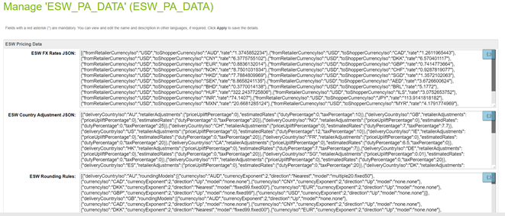

- ESW Fixed Price Model Countries: When the ESW Retailer Auto configurator job is executed the ESW supported countries’ custom object are instantiated. For Fixed price model country the ‘is Fixed Price Model’ needs to be checked manually, by default country will be created with dynamic/calculated pricing model
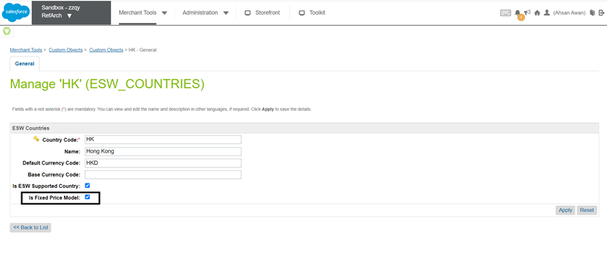

Custom Preferences:
- ESW Fixed List PriceBook Pattern This site preference sets the list price books Id pattern for fixed price model countries. i.e. {countryCode}-list-price-book. Pattern must have {countryCode} string part in this value.
- ESW Fixed Sale PriceBook Pattern This site preference sets the sale price books Id pattern for fixed price model countries. i.e. {countryCode}-sale-price-book. Pattern must have {countryCode} string part in this value.
For Currency Overrides, you must configure the related Shipping Method with the appropriate currency at the SFCC end.
- ESW Enable Multiple FX Rates: Enables or disables the Multiple FX Rates feature for the current site.
- ESW Enable Roundings: Enables or disables the rounding on the prices across all applicable countries for the current site. If the option is enabled, the appropriate rounding models are applied to the prices in the applicable countries.
- ESW Enable Frontend Prices Conversion: Enables or disables the Localized Front-end Prices feature across storefront.
- ESW Price Feed Instance Switcher: Indicates the Price Feed mode for the current site. If you select Production, the Price Feed job uses the Production Price Feed service called EswPriceFeedV3Service.PROD.
- ESW Production Client Secret for Price Feed Authorization Request: Indicates the Production Client Secret key for the Price Feed authorization request. If the ESW Price Feed Instance Switcher is selected as Production, the Price Feed job uses the production client secret while making a call to the ESW Pricing Advisor API.
- ESW Localized Pricing Countries: Indicates the shopper country, currency, and local price books for which local prices are required. This preference also defines the base price book from where the prices, country adjustment, and rounding rules can be used.
[
{
"localizeCountryObj": {
"countryCode": "FR",
"currencyCode": "EUR",
"localListPriceBook": "eur-m-list-prices",
"localSalePriceBook": "eur-m-sale-prices"
},
"baseListPriceBook": "usd-m-list-prices",
"baseSalePriceBook": "usd-m-sale-prices",
"applyCountryAdjustments": "true",
"applyRoundingModel": "true"
}
]
The following table describes these parameters:
Parameter | Description
countryCode | (Required) The two-letter ISO code of the shopper country.
currencyCode | (Required) The three-letter ISO code of the shopper's local currency.
localListPriceBook | (Required) The price book ID of the local list price.
localSalePriceBook | (Optional) The price book ID of the local sale price.
baseListPriceBook | (Required) The price book ID of the base list price. The price book currency must match the tenant base currency.
baseSalePriceBook | (Required if 'localSalePriceBook' is provided) The price book ID of the base sale price. The price book currency must match the tenant base currency.
applyCountryAdjustments | (Required) Indicates if you want to apply country adjustments while calculating the local price. The values are True or False.
applyRoundingModel | (Required) Indicates if you want to apply the rounding model while calculating the local price. The values are True or False.
- ESW Localized Promotions: A JSON object containing single or multiple base promotion configurations, which can be used to generate localized promotions.
[
{
"basePromoId":"10%offordersover150",
"campaignId":"",
"excludeCurrencies":[
"GBP",
"SEK"
]
},
{
"basePromoId":"Buy5for50",
"campaignId":"Automation",
"excludeCurrencies":""
}
]
Each promotion object contains the following attributes:
Parameter | Description
basePromoId | (Required) The ID of the base promotion configuration.
campaignId | (Optional) The ID of the campaign.  This parameter can be left blank if you want to assign the same ID as the base promotion. However, if you want to assign localized promotions as a separate campaign, you must provide the new campaign ID.  You must also ensure that the campaign ID provided in this parameter is already created because the job only generates localized promotions, not campaigns.
excludeCurrencies | (Optional) The currencies for which you do not want to generate localized promotions.  If no value is provided, localized promotions are generated for all allowed currencies.

ESW Checkout Configuration site Preferences
You can use Custom Preferences to manage ESW-specific checkout configurations of the cartridge.
The following ESW Checkout Configuration options are present:
- ESW Checkout Service Name: The name of the service that is associated with the Checkout. The value in this field is used for the current site. The service name is set by default once the ESW Auto Configurator Job is executed successfully. For more information, see Services.
- ESW URL Expansion Pairs: This option sets the URL that ESW will redirect to. The following URLs must be set in the Name of URL|Name of Controller format:
  - ContinueShoppingUrl
  - BaseUrl
  - BackToCartUrl
  - InventoryCheckFailurePageUrl
The above values are set by default once the job ESW Retailer Auto Configurator is executed successfully.

Format | Example
Name of URL|url | ContinueShoppingUrl|Home page URL
Additionally, the ContinueShoppingUrl (URL of the home page) and BackToCartUrl (URL of the Cart page) attributes must be sent with all requests:
- ESW Metadata Items: This option stores the basic authentication URL and the default value. The default value of 1 is stored in the OrderConfirmationBase64EncodedAuth_TestOnly parameter for when basic authentication is not enabled.
The OrderConfirmationUri_TestOnly|EShopWorld-Notify and OrderConfirmationBase64EncodedAuth_TestOnly|1 parameters are required for the Sandbox environments only.
The above values are set by default once the job ESW Retailer Auto Configurator is executed successfully.
- ESW Product Line Metadata Items: This option is used for display purposes only and it stores the product line metadata items information that you want to send in the Checkout request. Options include loyalty points, engraving, debossing, gift message, and so on. The information must be stored in the following format:
Format | Example
EswKeyField|ProductLineItemCustomAttributeID | Gift Message|GiftWrapMessage
In the following example, the Gift Messageattribute is sent with name in the metadataItems object. For the GiftWrapMessage product line custom attribute, the value is sent with value in the metadataItems object. The metadataItems are sent under Product JSON in the Checkout request.
"cartItems": [ {
………………
………………
“product”: {
…………………………
…………………………
"metadataItems": [ {
"name": "Gift Message",
"value": "Congratulations!"
} ]
},
…………………
…………………
}]
If you want to send any product information under metadataItems in the Checkout request, you can do so by copying the product information in the product line item and by configuring that productLineItem custom attribute ID in this configuration.
- ESW Redirect: This preference indicates from where the shopper (Guest User) will be redirected to ESW Checkout Page. The options are Cart and Login. When the shopper is logged in, the ESW Checkout Redirect will be from the Cart page. The preference selection is ignored.
  - If the Cart option is selected, the ESW Checkout Redirect will happen from the Cart page, and the preorder request will be sent.
  - If the Login option is selected, the ESW Checkout Redirect will happen from the Login page, and the pre order request will be sent. The login value is set by default once the ESW Retailer Auto Configurator Job is executed successfully.
- ESW Override Shipping: This option sets the shipping override for specific countries. It allows you to override the shipping prices for a shipping method. In the following example, ID represents the shipping method IDs. 001 is the POST shipping method and 002 is the EXP2 shipping method. Shipping methods are sent as per the order in ID array.
  - For the UK, the EXP2 shipping method is sent first and then POST.
  - For the US, the POST shipping method is sent first and then EXP2.
  - For NL, only the POST shipping method is sent.
[
{
"countryCode": "GB",
"shippingMethod": {
"ID": ["002", "001"]
}
},
{
"countryCode": "US",
"shippingMethod": {
"ID": ["001","002"]
}
},
{
"countryCode": "NL",
"shippingMethod": {
"ID": ["001"]
}
}
]
- The shipping method names must be POST or EXP2. This naming rule is required by ESW. However, the ID can be any value.
- If ESW Override Pricebook under ESW Pricing Configuration is configured for a country, then the shipping methods matching the override pricebook currency must be configured in ESW Override Shipping.
- ESW Use Delivery Contact Details for Payment: This option allows you to select the default behavior of the Billing address same as delivery address field on the ESW Checkout.
- ESW Update Order Payment Status to Paid After Successful Order Confirmation: This option allows you to change the order payment status to Paid after successful order confirmation.
- ESW Russian Data Storage Url: This option allows retailers to process and store the Russian shoppers pre-order and checkout data via a dedicated endpoint. This endpoint route and store the Russian shoppers data via Russian hosted servers to ensure the Russian data compliance. This Url value will be provided by ESW onboarding team.
- ESW Checkout Session Timeout: This allows retailers to control the session time out duration on the ESW checkout. Retailers can set the session time out value in minutes in this preference and on ESW checkout page session will be alive for this duration in minutes.
- ESW Top Level Domain: This allows retailers to configure top level domain for Stored Card feature. ESW plugin will created shopper access token cookie on this site preference value.
- Enable ESW Inventory Check: This allows retailers to enable/disable inventory check feature during the order confirmation webhook call before placing the order.
- Enable ESW Checkout Shoppers Registration: To configure if ESW checkout shopper's registration is enabled or not

ESW Hub Address Configuration
ESW Hub Address for the specific country can be configured in the country’s custom object.

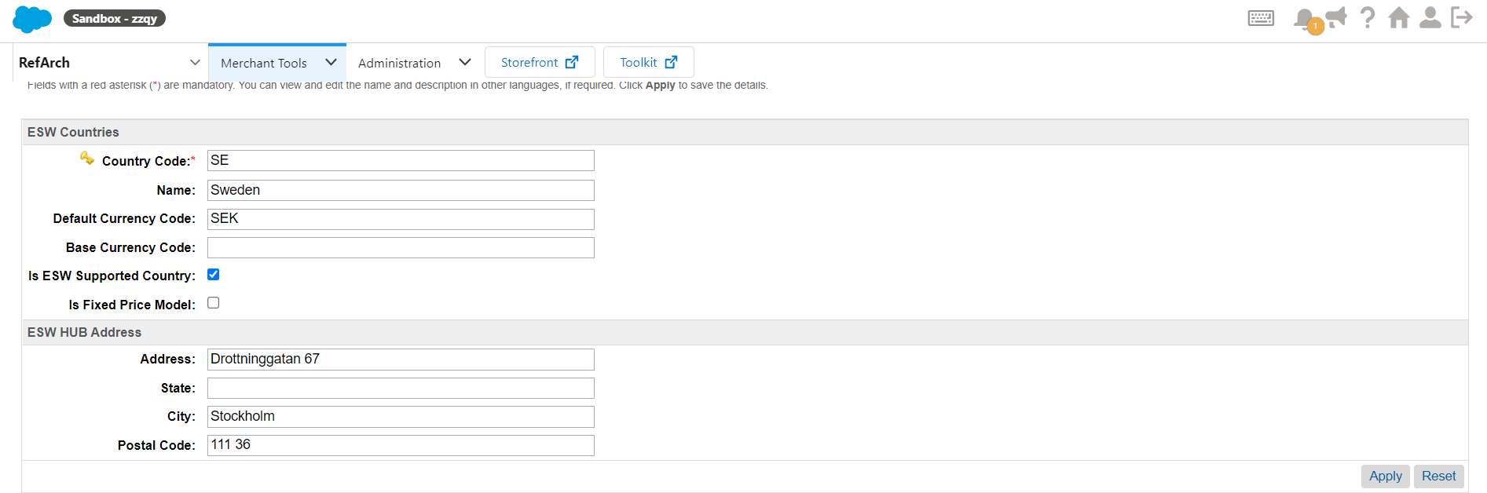
ESW Countries Custom Object for SE

If the Hub Address is stored in the delivery country’s custom object, it is stored in the order confirmation attribute for the order placed with respective country.

