


Version: 5.1.2
Published date: August 2026
Copyright © 2026 by ESW. All rights reserved. Information contained herein is subject to change without notice.

PRICING INTEGRATION GUIDE

SFCC - ESW Cartridge
+
Contents
1 Pricing Integration 3
1.1 Pricing Models 3
1.1.1 Fixed Pricing Model 3
1.1.2 Fixed pricing model examples 3
1.1.3 Calculated Pricing Model 6
1.1.4 Calculated pricing model examples 7
1.2 Rounding Prices 9
1.2.1 Model Rules 11
1.2.2 Rounding rules and examples 12
1.2.3 ESW Rounding Rules Matrix 21
1.3 Product Prices 21
1.4 Multiple FX Rates Pricing 24
1.5 Localized Pricebooks 24
1.5.1 Exclude or Freeze Product Prices from Localized PriceBooks 26
1.5.2 Configure ESW Production Pricing Advisor API on SFCC Staging Instance 28
1.6 Localized Promotions 30
1.6.1 Localized Promotion Configuration 30
1.6.2 Generating Localized Promotions 31
1.7 Localized Front-end Prices 35
1.8 Promotional Price Books 37
2 Pricing Integration Configuration 38
2.1 ESW Pricing Configuration 38
2.2 eswRetailerLocalizedPricing job 42
2.3 eswRetailerLocalizedPromotions job 42
2.4 eswRetailerPricingFeed job 42
2.5 Services 43

Pricing Integration

Pricing Models
The cartridge supports two pricing models offered by ESW - Fixed Pricing and Calculated Pricing. You can configure these pricing models per country through the SFCC Business Manager.

Fixed Pricing Model
Fixed Model Price is the localized price which won't be converted dynamically but will be used as is from Salesforce B2C Commerce standard price books, if it's configured in ESW Pricing Configurations Site Preferences ("ESW Fixed List PriceBook Pattern" and "ESW Fixed Sale PriceBook Pattern"), the Fixed Price Books exist (matched with any price book Id pattern) and they have valid product price assignments (definitions). If there is only one Fixed Price in one of the Fixed Price Book (list or sale), or only one Fixed Price Book is configured in ESW Site Preferences (with valid product price assignment), only one Fixed Price will be shown.
If there is not any Fixed Price Book price assigned to the product - null (or N/A) will be shown.
The Fixed pricing model sets in-country prices through price books in the Currency setup. For this model, you must add additional currencies that are not your default currencies to the Salesforce Commerce Cloud. Once the currency is added, the orders are saved in the new currency set. Also, for fixed pricing model countries, currency selection is disabled on the welcome mat and default currency (from 'ESW Countries' custom object) is selected. To use this price model, Is Fixed Price Model option must be enabled in ESW Countries custom object.

Fixed pricing model examples

Fixed price country with price book exist and without FX rate
The following example shows how the final price is calculated in the Fixed pricing model. In this example, price book exist and the price in the price book is GBP 201.6. The other values are as follows:
Parameter | Value
Shipping country | United Kingdom
Base currency | USD
Price book currency | GBP
Shopper currency | GBP
Based on these values, the final price that is displayed to the shopper is GBP 201.6. No calculation is performed in this case and the price is taken from the GBP price book as it is.
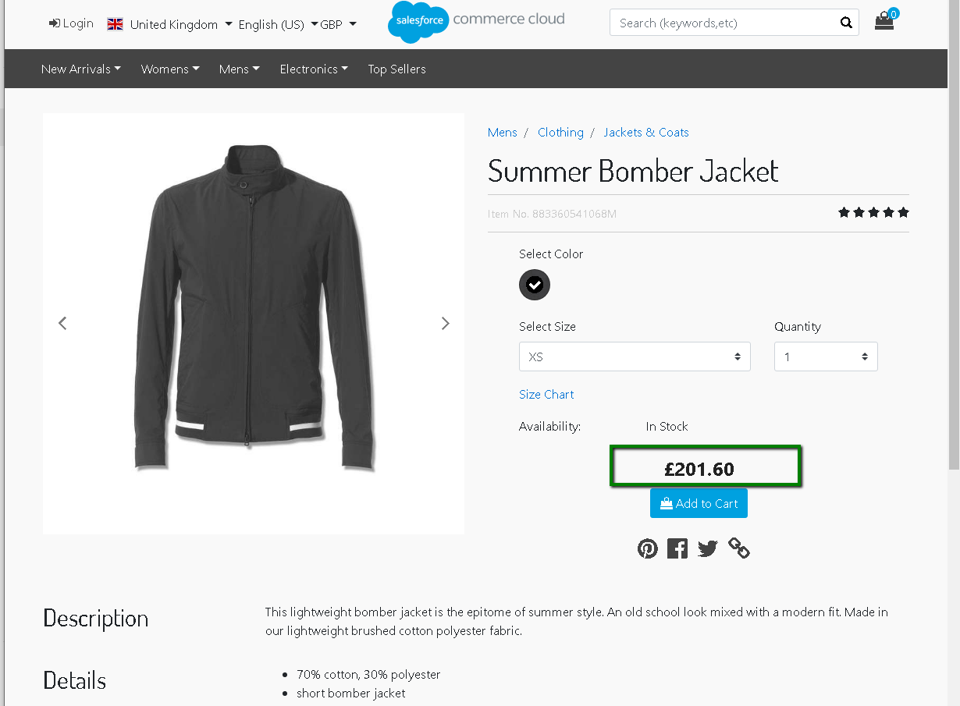

Fixed price country without price book and with FX rate
The following example shows how the final price is calculated in the Fixed pricing model. In this example, the price in the price book is EUR 92. The other values are as follows:
Parameter | Value
Shipping country | Poland
Base currency | EUR
Price book currency | EUR
Shopper currency | PLN
Product price in the price book | EUR 92
FX Rate (EUR – PLN) | 4.2191
Based on these values, the final price that is displayed to the shopper is PLN 388.16. This is calculated as (Price of product in price book x FX rate, that is, EUR 92 * 4.2191 = PLN 388.16).
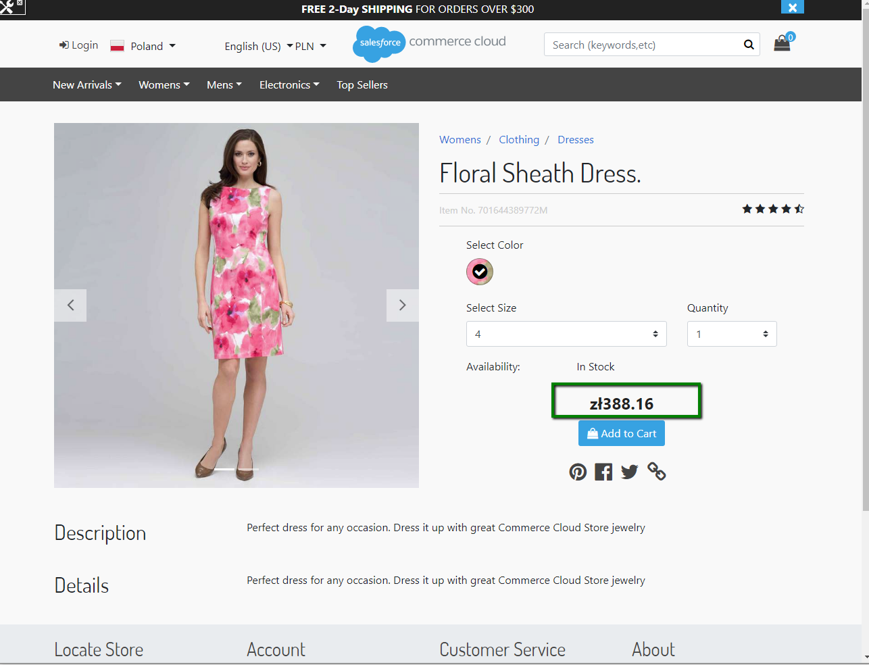

Calculated Pricing Model
This model uses a retailer’s default price book and converts this to prices for specific countries using the following formula:
(((Product base price x (1 + priceUpliftPercentage)) x (1 + dutyPercentage)) x (1 + taxPercentage)) x fxRate = Price in the shopper currency → apply rounding = Final product price.
The exchange rate, retailer uplift, estimated duties and taxes, and rounding rules are taken from the ESW Pricing Advisor API v3.0. The API is configured within the cartridge. The following diagram shows the process:
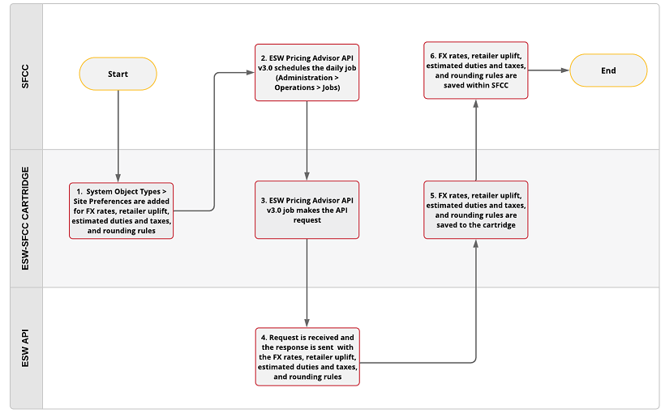
The following attributes are agreed in advance with the retailer:
- Retailer uplift per country: Percentage uplift from the default price book for the country. For example, if you want to increase the prices for the U.K by 10%.
- Estimated taxes per country: Estimated tax percentage is set for each shipping country based on the mix of products in specific categories. The value might change based on the order total including shipping, and therefore must be an estimated value.
- Estimated duties per country: An estimated duty percentage is set for each shipping country based on the mix of products in specific categories. The value might change based on the order total including shipping, and therefore must be an estimate.
- Exchange rate: Source data for the exchange rate and the frequency of updates.
- Rounding rules: Rounding rules are defined and applied to the product prices on the storefront, shopping cart, and the ESW Checkout.
These agreed values are synchronized daily with SFCC using the job configured within the cartridge. When the API call is made, ESW responds with the exchange rate, retailer uplift, estimated taxes and duties, and rounding rules. The values are stored under Merchant Tools > Site Preferences > Custom Site Preference Groups > eShopWorld Configuration Pricing.

Calculated pricing model examples
The following example shows how the final price is calculated in the Calculated pricing model. In this example, the price in the price book is EUR 92:
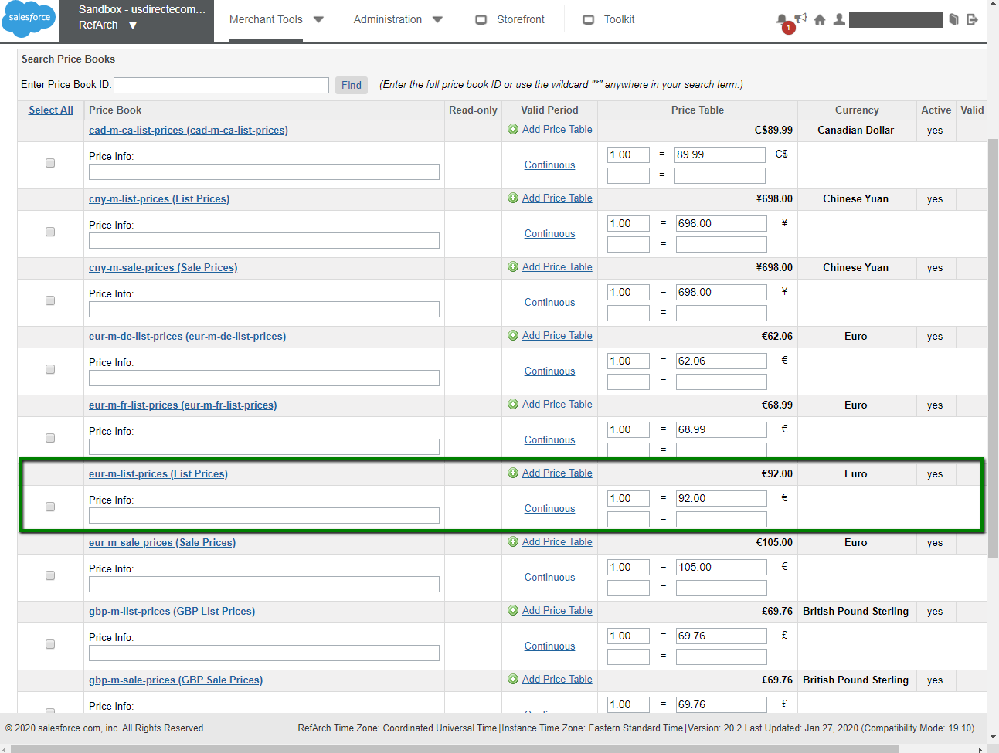
The other values are as follows:
Parameter | Value
Shipping country | Denmark
Base currency | EUR
Price book currency | EUR
Shopper currency | Danish Krona
Product price in the price book | EUR 92
Uplift | 3%
Duty | 7%
Tax | 23%
FX Rate (EUR – DKK) | 4.2191
Based on the values, the final price that will be displayed to the shopper is DKK 526.18. This is calculated as (((Product base price (1 + priceUpliftPercentage)) x (1 + dutyPercentage)) x (1 + taxPercentage)) FX Rate.
(((92 x (1 + 0.03)) x (1 + 0.07)) x (1 +0.23)) x 4.2191 = (((92 x 1.03) x 1.07) x 1.23) x 4.2191 = round (526.1793016476) = DKK 526.18).
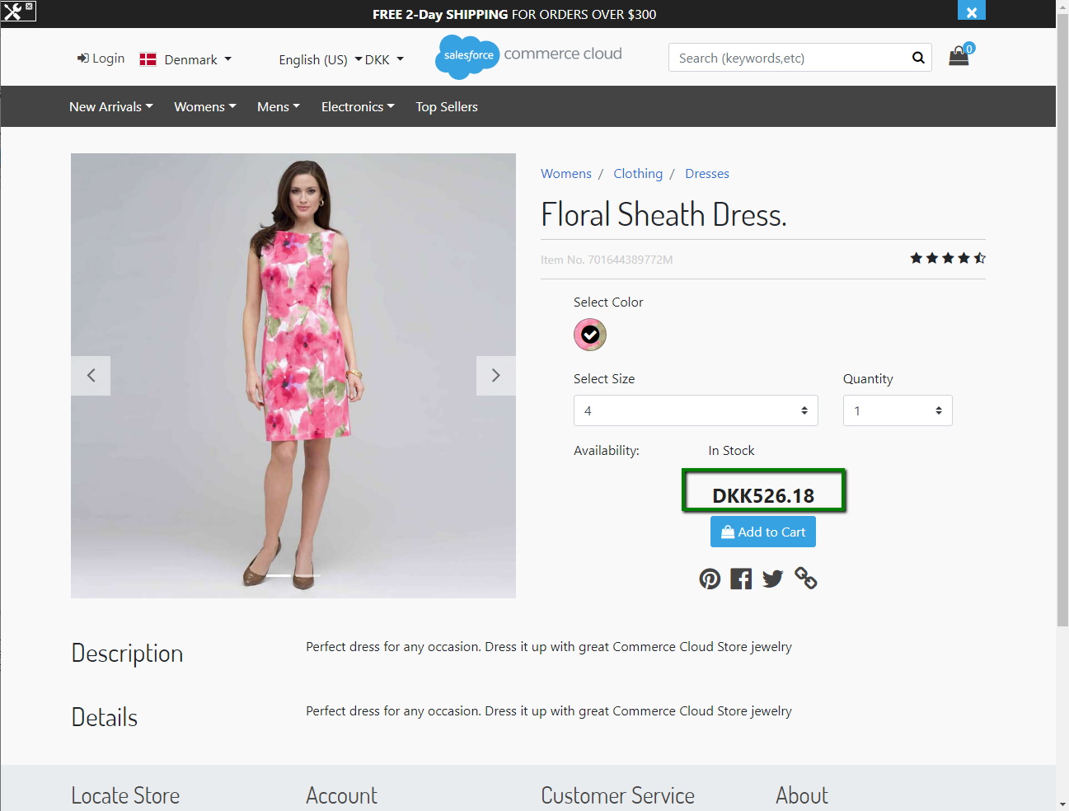

Rounding Prices
The ESW-SFCC cartridge allows you to specify how you want to display prices on the storefront, shopping cart, and ESW Checkout. This is done using the ESW Rounding Rules option. Note that this option applies to the country and currency selected for the Calculated pricing model only.
You can implement rounding by setting the rounding rules in the SFCC Business Manager. To set up rounding rules, navigate to Merchant Tools > Custom Objects > Custom Object Editor > ESW _PA_DATA> ESW Rounding Rules.
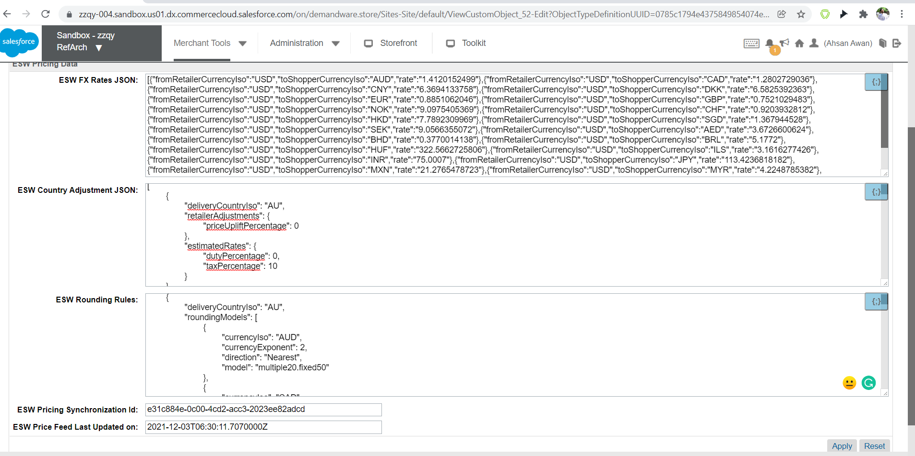

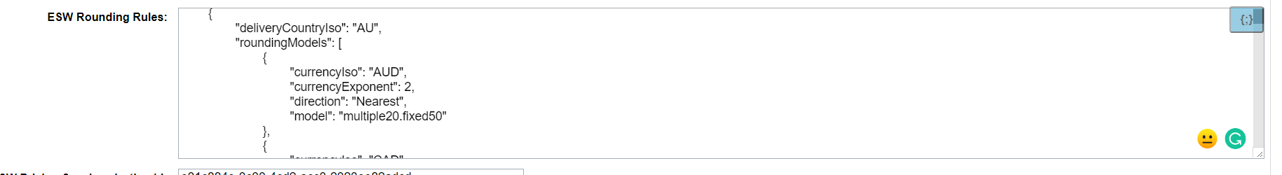
ESW Rounding Rules
The ESW Rounding Rules are applied to the particular country and currency after the eswRetailerPricingFeed job completes:
{
"deliveryCountryIso":"GB",
"roundingModels":[
{
"currencyIso":"GBP",
"currencyExponent":2,
"direction":"Up",
"model":"none.fixed99"
}
]
},
{
"deliveryCountryIso":"JP",
"roundingModels":[
{
"currencyIso":"JPY",
"currencyExponent":0,
"direction":"Nearest",
"model":"multiple1000.none"
}
]
}
You can also set the ESW Rounding Rules for several currencies within one country, as shown in the following example:
{
"deliveryCountryIso":"FR",
"roundingModels":[
{
"currencyIso":"EUR",
"currencyExponent":2,
"direction":"Up",
"model":"none.none"
},
{
"currencyIso":"GBP",
"currencyExponent":2,
"direction":"Down",
"model":"none.fixed99"
}
]
}
- delieveryCountryIso: Indicates the country to which the ESW Rounding Rule is applied. In this example, the ISO code of the delivery country is GB.
- currencyIso: Indicates the currency to which the ESW Rounding Rule will be applied. In this example, the currency is GBP.
- currencyExponent: Indicates the number of symbols after the decimal point that will be displayed in the product’s price. The value in this example is 2.
- direction: Indicates the rounding direction that will be applied to product price within the ESW Rounding Rule. The values are Up, Down, and Nearest. The value in this example is Up.
- model: Indicates the rounding model that will be applied to product price within ESW Rounding Methods. The values are Fixed, Multiple, and None. For the 'multiple1000.none' or 'none.fixed99' rounding models, the rounding methods are 'Fixed', 'Multiple' and 'None', while '1000' and '99' are the rounding targets.

Model Rules
The following model rules apply:
- Truncate: The number of digits in the model if the number of exponents is less than the digits in the model type.
- Extend: The number of digits with zeros if the exponents are more than the number of digits in the model type.
For example:
Parameter | Value
Shipping country | France
Base currency | EUR
Price book currency | EUR
Shopper currency | GBP
Product price in the pricebook | EUR 100
Uplift | 3%
Duty | 7%
Tax | 20%
FX rate (EUR – GBP) | 0.8313
Based on these values, the calculated price will be 109.9410876 GBP.
This is calculated as: Price of product in price book x Uplift x Duty x Tax x FX rate = 100 x 1.03 x 1.07 x 1.2 x 0.8313 = 109.9410876.
ESW rounding rules apply to the calculated price.

Rounding rules and examples

Rounding Method: 'none'
{"currencyIso":"GBP","currencyExponent":2,"direction":"Up","model":"none.none"}
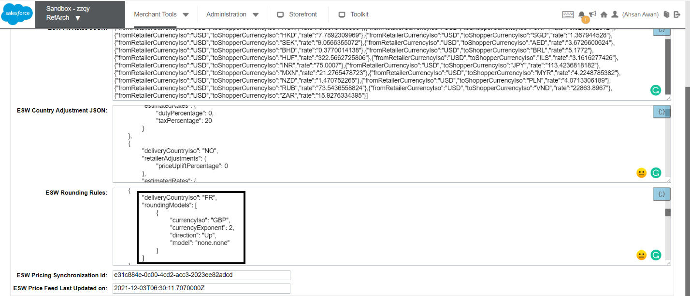
Based on this, 109.9410876 GBP is displayed as 109.94 GBP on the storefront.
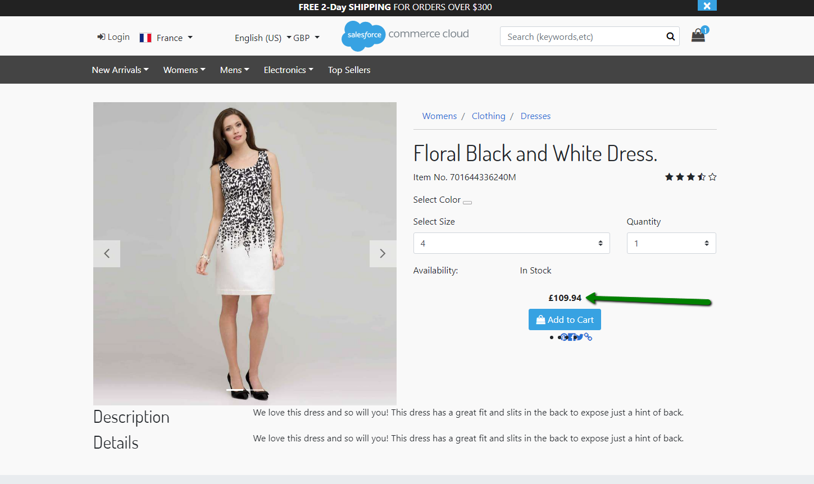
Product page
The following image shows how the price is displayed in the cart:
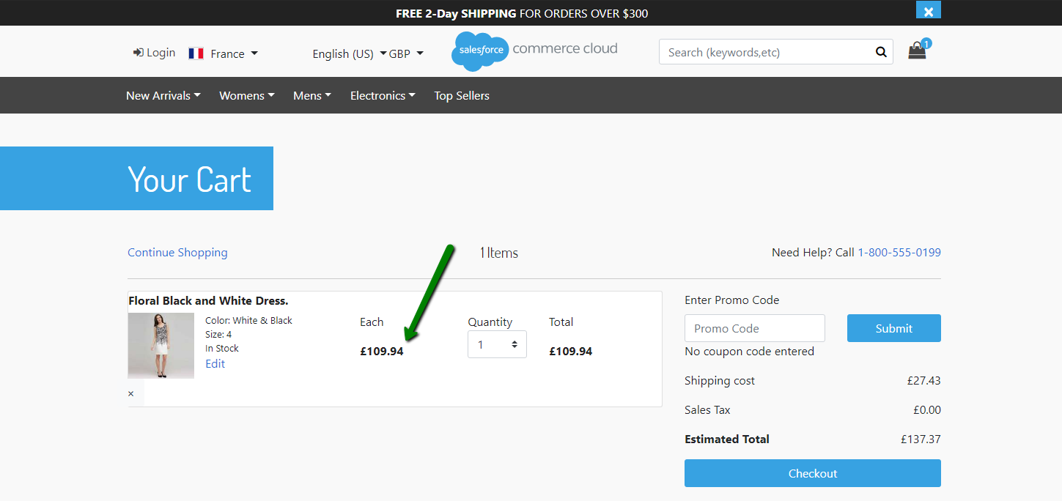
Cart page
The following image shows how the price is displayed on the checkout:
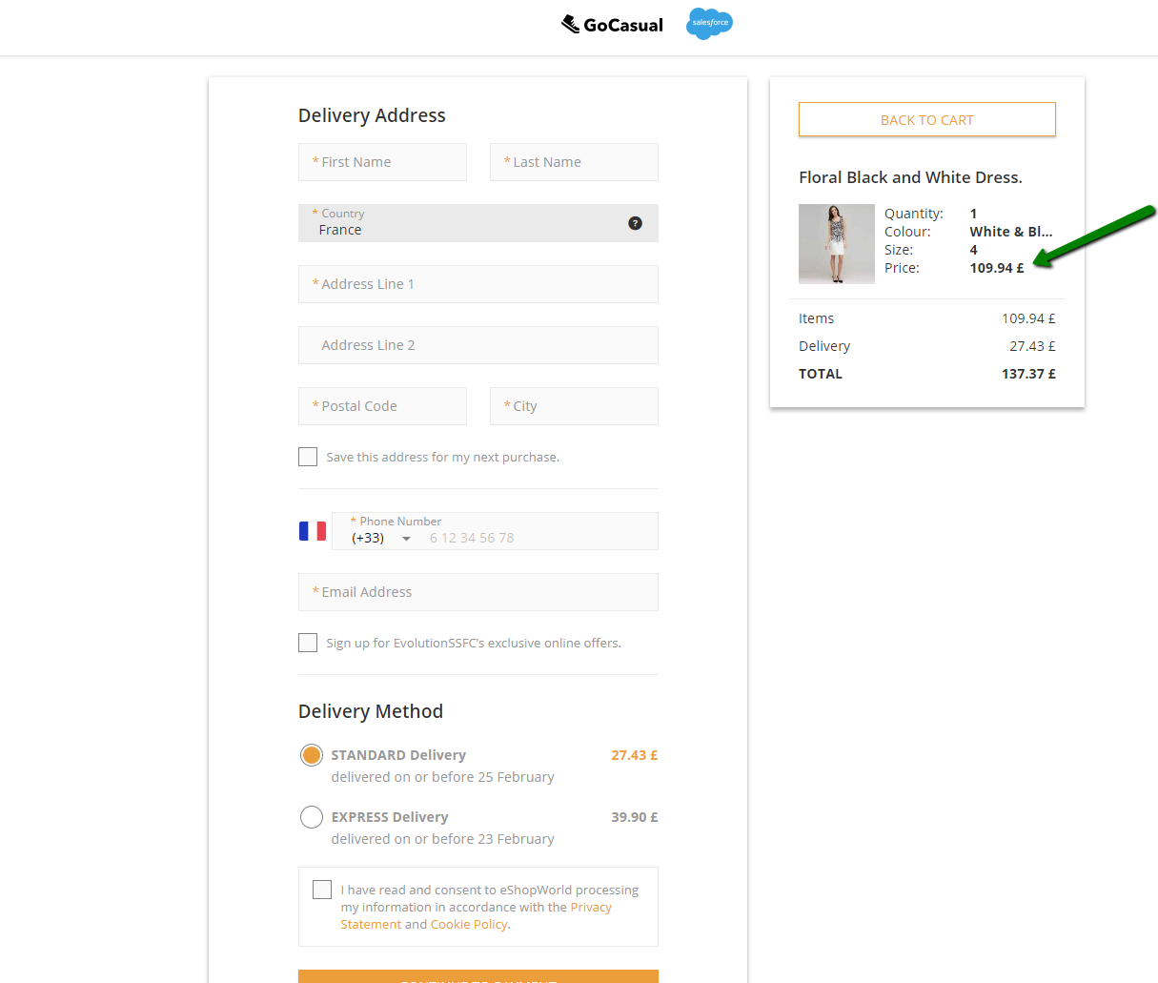
ESW Checkout

Rounding Method: 'fixed'
{"currencyIso":"GBP", "currencyExponent":2, "direction":"Up", "model":"none.fixed25"}
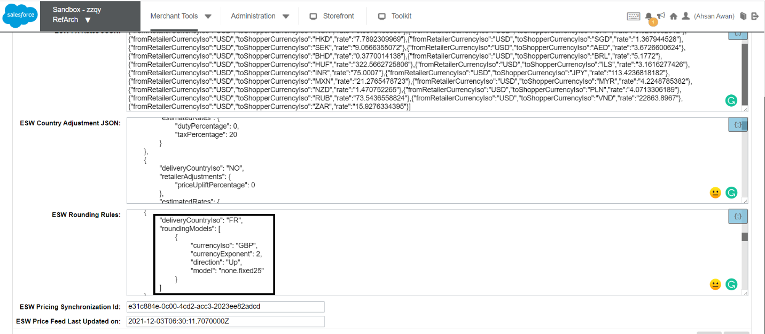
Based on this, 109.9410876 GBP is displayed as 110.25 GBP on the storefront, and the shipping cost 27.49 is displayed as 28.25 GBP in the cart.
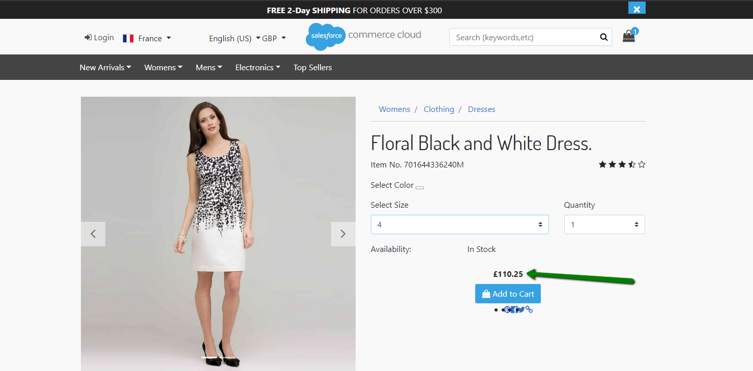
The following image shows how the product price and shipping cost is displayed in the cart:
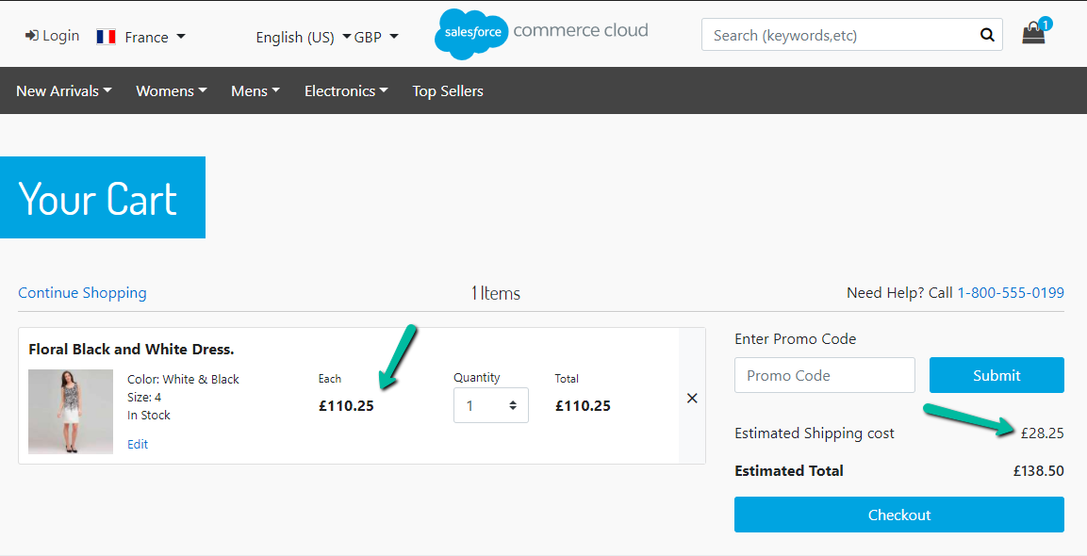
The following image shows how the product price and shipping cost is displayed on the checkout:
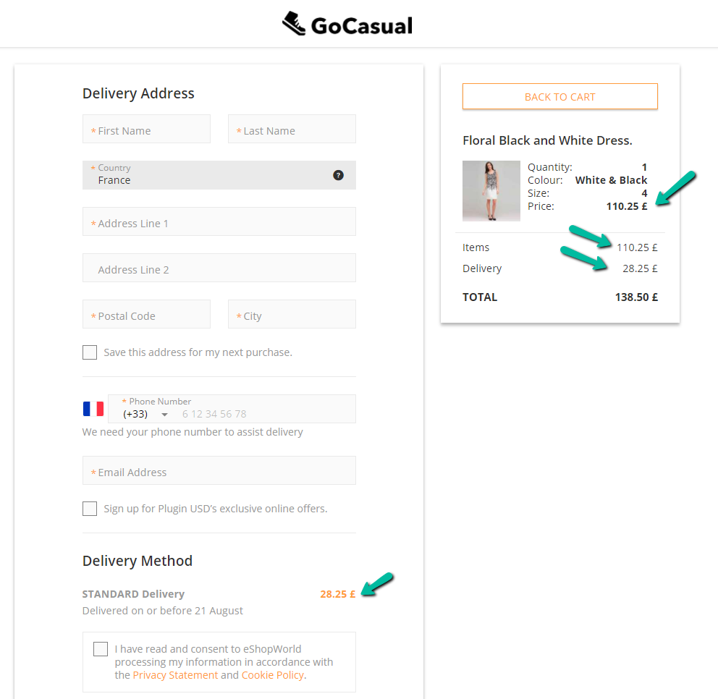

Rounding Method: 'multiple'
{"currencyIso":"JPY","currencyExponent":0,"direction":"Nearest","model":"multiple1000.none"}
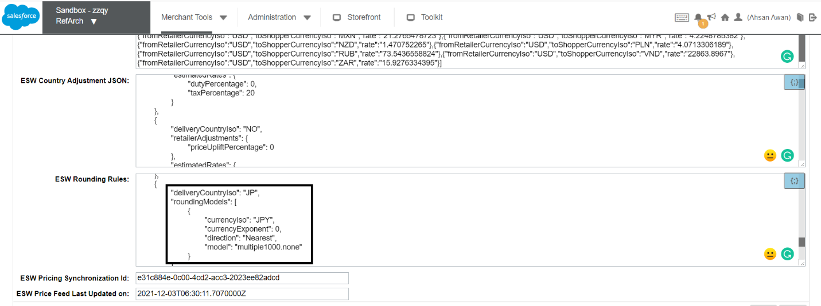
In this example, the converted price for JP before rounding is 14713 JPY.
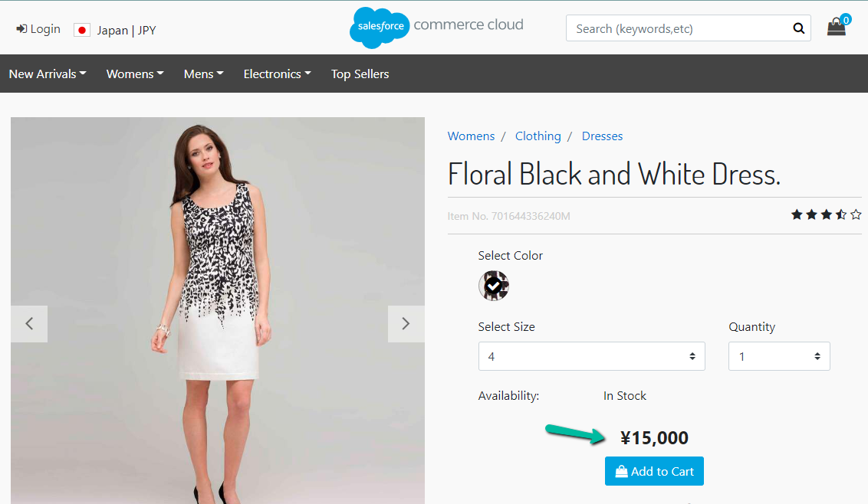
When the 'multiple1000' rounding logic is applied, 14713/1000 = 14.7 > Nearest > 15 > 15 x 1000 = 15000.
The following image shows how the price is displayed in the cart:
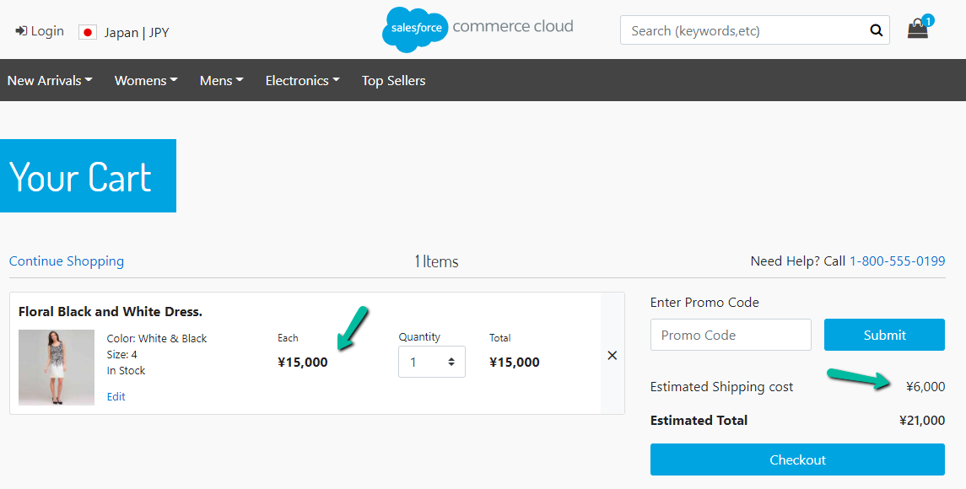
The following image shows how the price is displayed on the checkout:
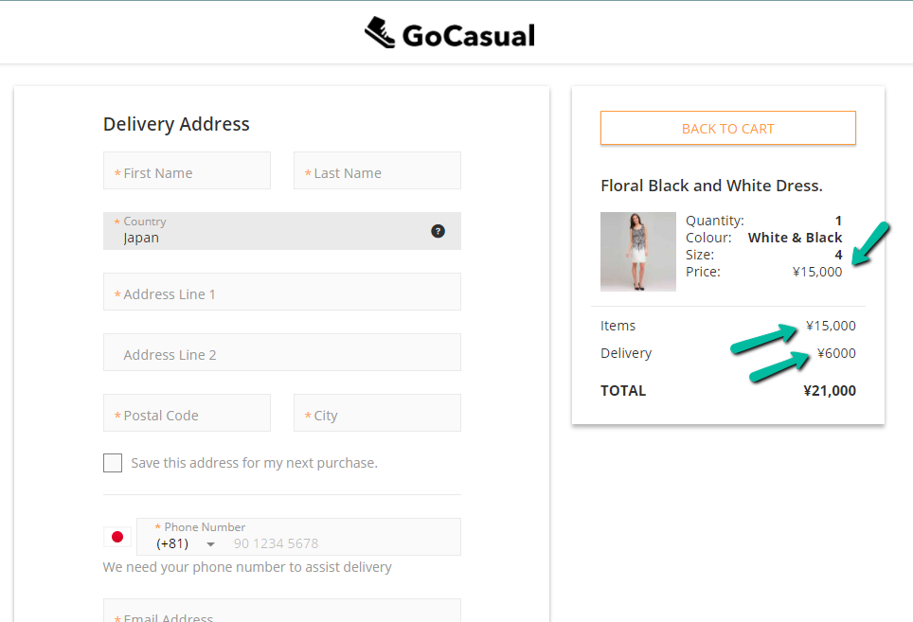
The difference between the product prices before and after the rounding model is applied is saved at the order product line item level as ESW Delta Rounding Values.

ESW Rounding Rules Matrix
Currency Exponent | Direction | Exponent rounding method (Fixed) | Exponent rounding method (Multiple) | Exponent rounding method (None) | Whole number rounding method (Fixed) | Whole number rounding method (Multiple) | Whole number rounding method (None)
0 | Up | N/A | N/A | N/A | Supported | Supported | Supported
0 | Down | N/A | N/A | N/A | Supported | Supported | Supported
0 | Nearest | N/A | N/A | N/A | Supported | Supported | Supported
2 | Up | Supported | Supported | Supported | Supported | Supported | Supported
2 | Down | Supported | Supported | Supported | Supported | Supported | Supported
2 | Nearest | Supported | Supported | Supported | Supported | Supported | Supported

Product Prices
The ESW-SFCC cartridge displays correct localized product prices throughout the SFCC site, as shown in the following images:
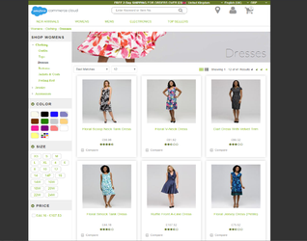

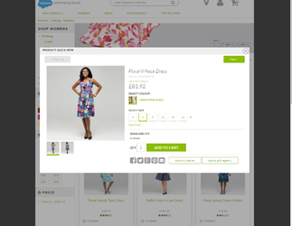

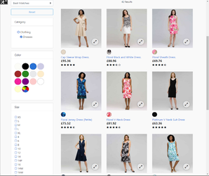
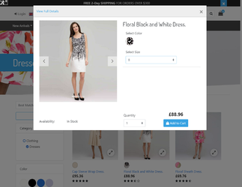

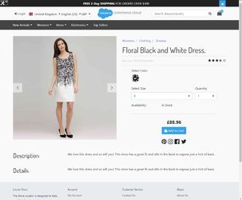
Cart Page
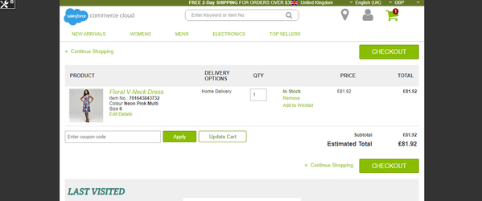
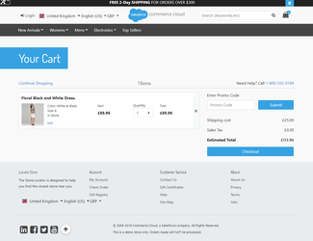

Multiple FX Rates Pricing
The Multiple FX Rates Pricing feature provides country-level control over pricing conversions, allowing you to set up multiple base and settlement currencies.
Depending on the shopper or the billing country, the cartridge picks the base currency and applies the FX rate to convert the product price. For example, if you want to convert prices for Germany from GBP to EUR, instead of default base currency USD, you can set 'GBP' as the baseCurrency for Germany.
To use this feature, the following points must be considered:
- Ensure that the ESW Enable Multiple FX Rates custom site preference under ESW Pricing Configuration is set to Yes. This will enable the Multiple FX Rates Pricing feature.
- Ensure that the base/settlement currency for the required country is set against the baseCurrency attribute in the ESW Countries custom object.
- Ensure that the base currency price book is online, available, and assigned to the site.
- Verify that the base currency exists under Allowed Currencies. You can verify this by navigating to Merchant Tools > Site Preferences > Currencies.

Localized Pricebooks
This feature allows you to generate localized pricebooks using the FX rates, uplifts, duties, taxes, and rounding rules from the ESW Pricing Advisor.
After a localized pricebook is generated, the final product prices are included in the pricebooks, which you can easily export to external marketplaces. This increases conversion and allows you to offer a range of shipping options and promotions to international shoppers.
The eswRetailerLocalizedPricing job converts the product prices to localized prices. In addition to converting prices, this job also exports the local price book in the XML format to the IMPEX directory. From IMPEX, you can import the pricebook to the SFCC Business Manager. The eswRetailerLocalizedPricing job works in conjunction with the ESW Localized Pricing Countries custom preference to complete the following tasks:
- Assign a converted price to the local price book and generate localized pricebooks:
- If a local price book exists, the eswRetailerLocalizedPricing job converts all prices that exist in the base pricebook to the local prices using the FX rate, country adjustments, and rounding rules. The converted/updated price is then assigned to the existing local pricebook.
- If a local pricebook does not exist, the eswRetailerLocalizedPricing job converts all prices that exist in the base pricebook to the local prices using the FX rate, country adjustments, and rounding rules. The converted price is then assigned to the newly created local pricebook.
- Export the local price books. The localized prices are assigned to the price book using the Price Book XML schema. For each local pricebook, the eswRetailerLocalizedPricing job generates an XML schema file and exports the file to the IMPEX directory specified in the impexDirPath parameter.
- Import the local price books. The ImportPriceBook job imports all local pricebooks from the IMPEX directory to the SFCC Business Manager.
- Assign the pricebook to the site.
Note:
- As per the SFCC standard and the overall cartridge design, the code uses ProductSearchModel to retrieve product data. This search model only uses products that are searchable and can be ordered. Any customization on retrieving the product data needs to be handled from the retailer's end.
- For scalability ESW recommends the pricebooks to be generated in the PIM and then imported into SFCC as read-only pricebooks. This will reduce the import time and save any bottle necks due to huge catalog with millions of products. Reference documentation for read only pricebooks usage can be found in SFCC documentation.
https://documentation.b2c.commercecloud.salesforce.com/DOC3/index.jsp?topic=%2Fcom.demandware.dochel[…]2Fpricebooks%2Fb2c_optimized_price_books.html

Exclude or Freeze Product Prices from Localized PriceBooks
This feature also allows retailers to exclude product prices while generating new localized price books for specific localize country or freeze product prices from existing localized price books while updating product prices using latest pricing advisor data:
- Navigate to Merchant Tools > Product and Catalogs > Products and click a product.
- Enter the product ID to find the product.
- Open and lock the listed product.
- Locate “List of countries where product price is not calculated” under ESW Configurations.
- Enter the ISO code of the country where don’t want to calculate the product prices. If you want to exclude / freeze product prices for all localized price books, enter All. To add multiple values, click Add another value.
- Click Apply.
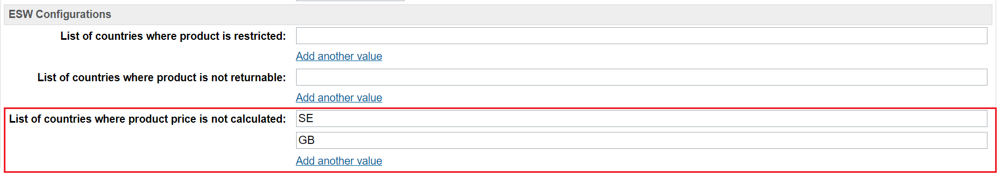
After this configuration, this product will not qualify for prices calculation in localized price book for configured localize countries.

ESW Skip Localized Product Flag
The flag eswSkipFlaggedLocalPrice determines how freeze prices are incorporated into localized pricebooks.
eswSkipFlaggedLocalPrice set to "No" (default):
- If a localized pricebook already exists for the country:
  - Prices for products with a freeze product price are retained from the previous localized pricebook. They are not recalculated based on PA data.
  - Prices for products without a freeze product price are calculated based on their corresponding PA data.
- If there is no existing localized pricebook for the country:
  - Prices for products with a freeze product price are omitted from the generated pricebook.
  - Prices for products without a freeze product price are calculated based on their corresponding PA data.
eswSkipFlaggedLocalPrice set to "Yes"
- Prices for products with a freeze price are copied from the base pricebook into the localized pricebook. Only the currency is converted to match the localized currency.
- Prices for products without a freeze price are calculated based on their corresponding PA data.

Bulk Products Restriction Management
You can update, delete, or change the countries value for multiple products using any of the two methods - Bulk Update via Attributes in Business Manager or Bulk update via XML Import.
Bulk update via the attributes in Business Manager
- Navigate to Business Manager > Merchant Tools > Products and Catalogs > Products.
- Locate the Product Search section and click the By ID tab.
- Locate List of IDs:, enter the product IDs, and click Find.
- Click Select all to select all products and then click Edit all/ Edit Selected.
- Select the Update/Delete Product Attributes action and then click on Next>>.
- Click Select attributes and select eswProductPriceFreezeCountries.
- Enter Country ISO codes and click Finish or Go to Batch Process to complete the process.
Bulk update via XML import
- Create an XML file with "Catalog-id", "product-id" and values for "Country ISO" under "custom-attribute" tag.
- Import the XML file in Business Manager by navigating to Merchant Tools > Products and Catalogs > Import & Export.
- Click Upload under Import and Export files to upload the XML file.
- Click the Import & Export module.
- Click Imports under Catalogs and then select the uploaded XML file.
- Click Next>> and then select the desired action (Merge or Replace).
- Click Finish.
Sample XML File
<?xml version="1.0" encoding="UTF-8"?>
<catalog xmlns="http://www.demandware.com/xml/impex/catalog/2006-10-31" catalog-id="apparel-catalog">
<product product-id="701642853695">
<custom-attributes>
<custom-attribute attribute-id=" eswProductPriceFreezeCountries">
<value>FR</value>
<value>GB</value>
</custom-attribute>
</custom-attributes>
</product>
<product product-id="701642853718">
<custom-attributes>
<custom-attribute attribute-id=" eswProductPriceFreezeCountries">
<value>FR</value>
<value>DE</value>
<value>SE</value>
</custom-attribute>
</custom-attributes>
</product>
</catalog>

Configure ESW Production Pricing Advisor API on SFCC Staging Instance
If you are using the Localized Pricebooks feature, ESW recommends connecting the SFCC staging instance to the ESW Production Pricing Advisor API. The best practice is to generate pricebooks on the Staging instance and then replicate them to the Production.
To connect to the Production API:
- Create a new production Price Feed OAuth service with the service name EswPriceFeedOAuthService.PROD and configure it with the ESW Production OAuth API URL.
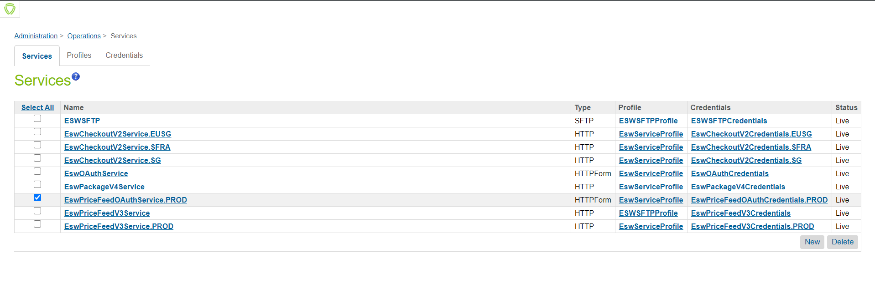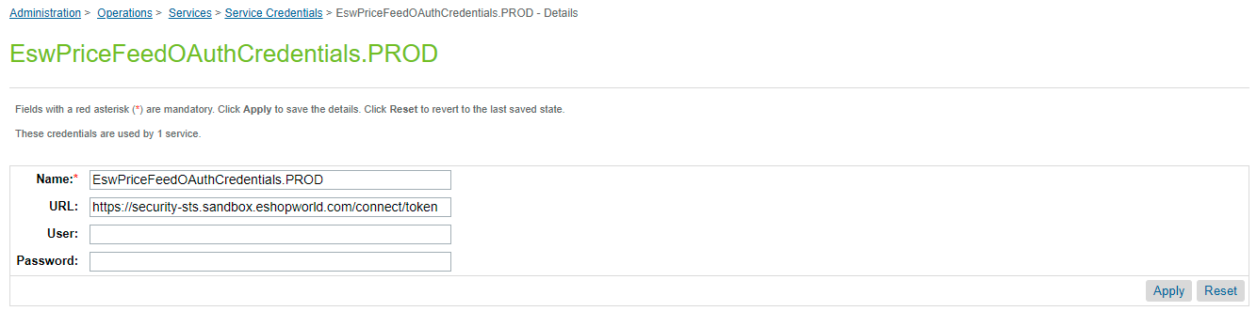
- Create a new production Price Feed service with the name EswPriceFeedV3Service.PROD and configure it with the production Pricing Advisor API URL. For more information on how to create services in SFCC business manager, see the official Salesforce Documentation.
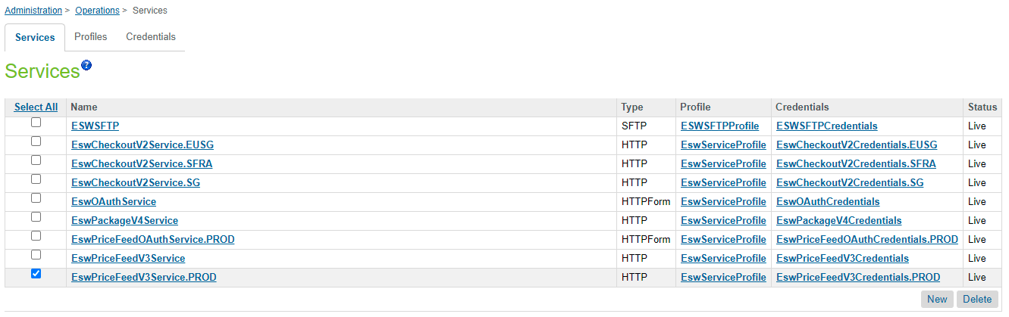
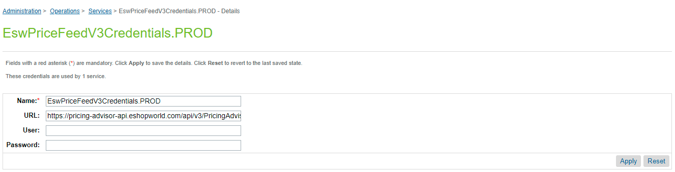
- After the production services are created, navigate to Site Preferences > Custom Preferences > ESW Pricing Configuration and do the following:
  - Select Production in ESW Price Feed Instance Switcher.
  - Configure the production client secret in the ESW Production Client Secret for Price Feed Authorization Request site preference.

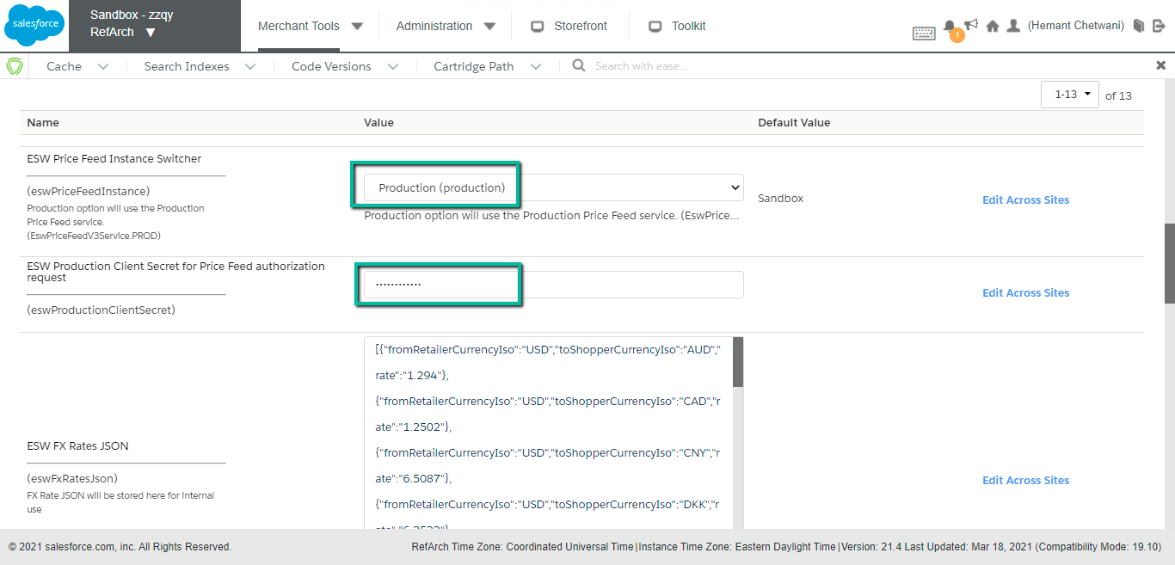

Localized Promotions
The Localized Promotions feature is an effective way of creating international promotions for countries that use the ESW Fixed Pricing model. It allows you to generate localized promotions using the FX rates and reduces the manual effort involved in creating and maintaining promotions. The Localized Promotions feature supports the 'With Amount of Qualifying Products', 'Amount Off', and 'Fixed Price discount types.

Localized Promotion Configuration
The Localized Promotions feature uses the eswRetailerLocalizedPromotions job and the base_promotions.xml file. Before exporting the XML file, ensure that the base currency is selected in the base promotions.
In the following example, USD is the base promotion currency. For localized promotions, other localized currencies such as EUR, GBP, and SEK are set. This means that when EUR is selected at the storefront, the localized promotion with EUR is applied to the qualified products. Similarly, if GBP is selected at the storefront, the localized promotion with GBP is applied to the qualified products.
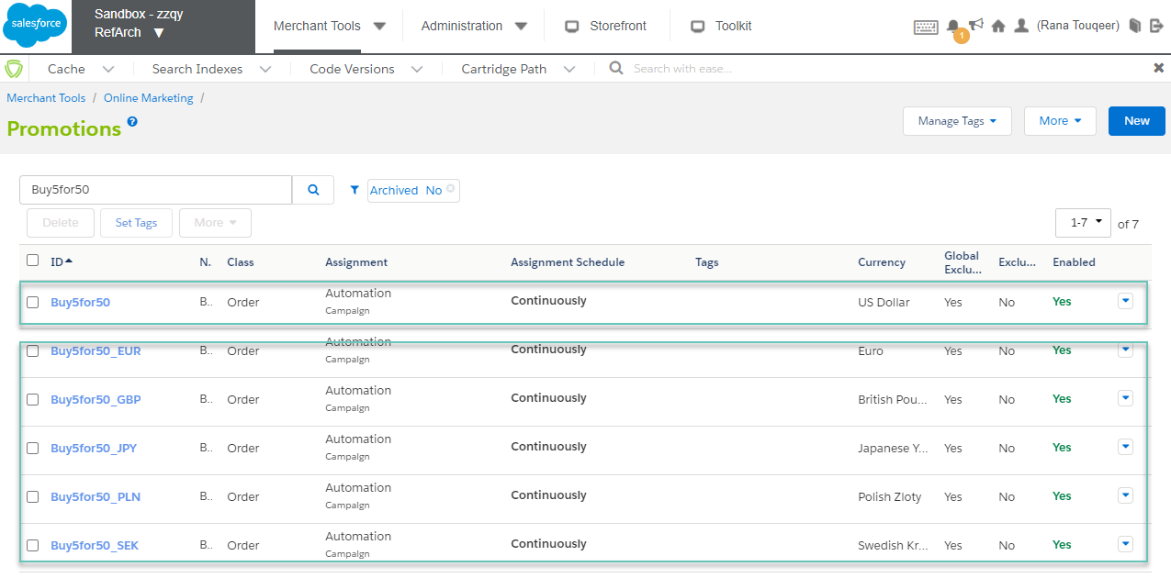

Generating Localized Promotions
To generate localized promotions, perform the following steps:
- Navigate to Merchant Tools > Online Marketing > Import & Export, select the promotion for which you want to generate localized promotions, and then click Next >>.
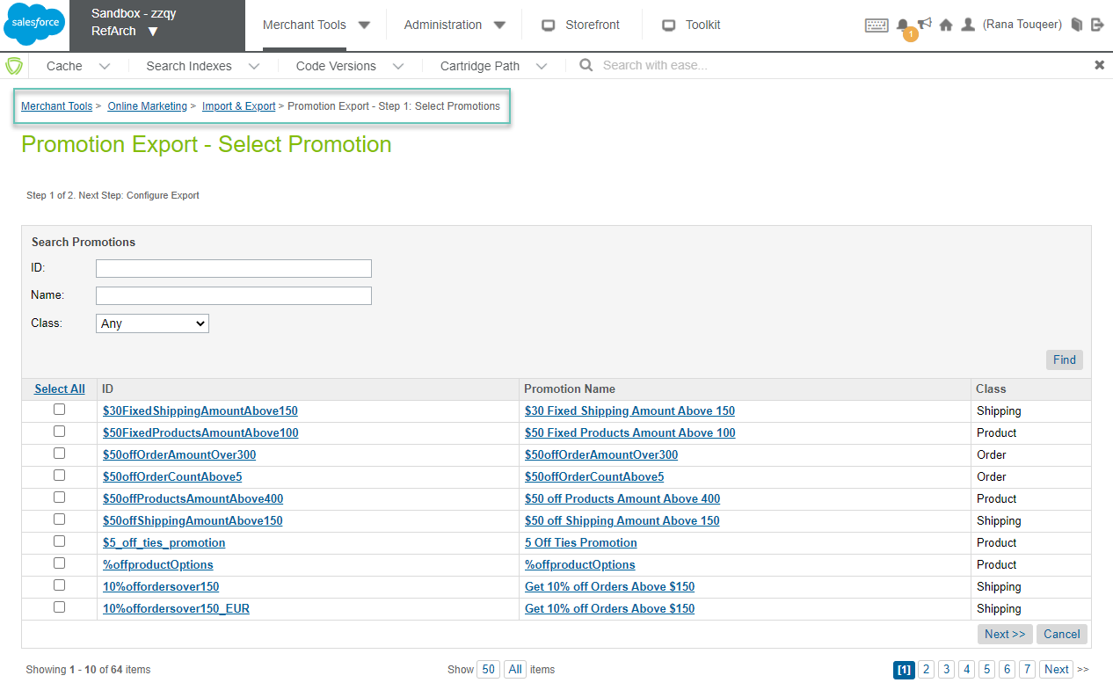
- Enter the file name as base_promotions in the Export file field, and then click Export.
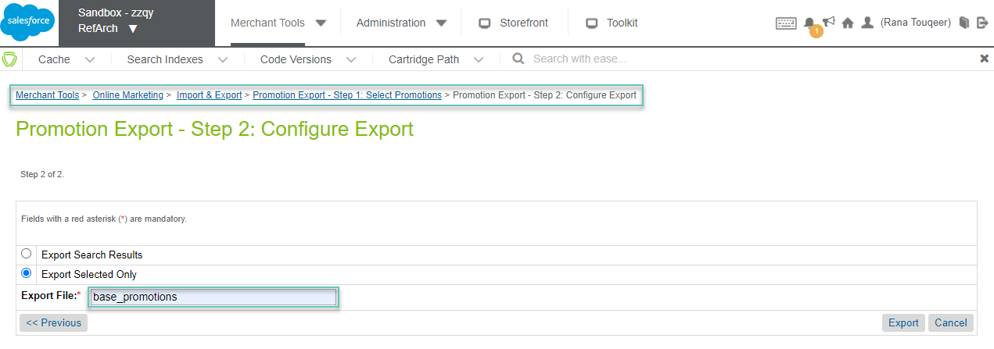
- When the base_promotions.xml file is generated, download the XML file and then upload it to the IMPEX folder under the /RefArch site ID.
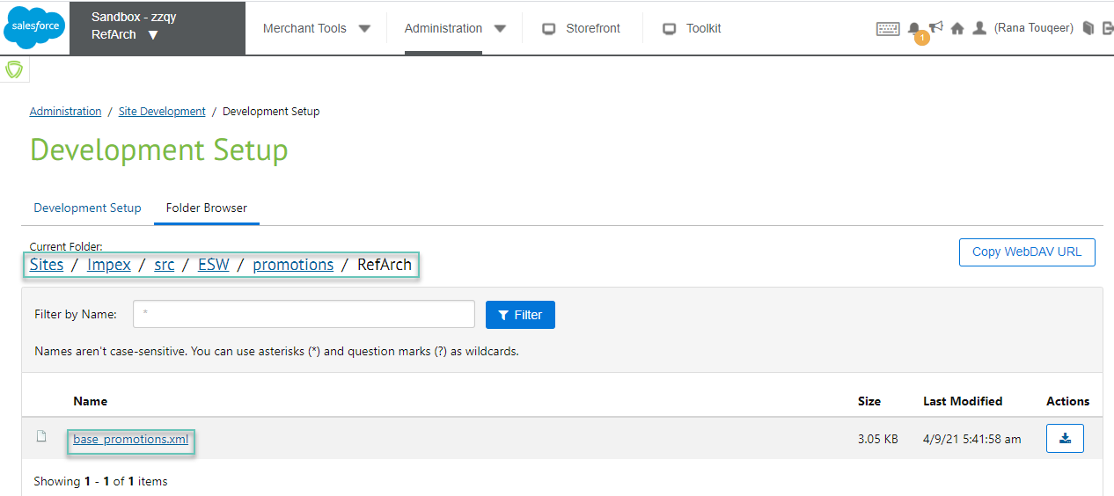
4. Configure the ESW Localized Promotions preference under ESW Pricing Configuration. This preference contains the base promotion configuration, which is required to generate localized promotions.
5. Execute the eswRetailerLocalizedPromotions job.
- You can import the eswRetailerLocalizedPromotions job from the Jobs XML file available at salesforce-plugin\link_eshopworld\sitesdata.
- After the job is imported to Administration > Jobs > eswInternationalPromotions, the name of the exported promotions XML file should be set to base_promotions in the related site folder under the promotions directory in Impex. This filename is used in the job script to generate localized promotions. The configuration should look like Impex/src/ESW/promotions/RefArch/base_promotions.xml.
6. Verify that the job is executed successfully by ensuring that the newly generated localized promotions are displayed under Business Manager > Online Marketing > Promotions. In the following image, 'Buy5for50' is the base promotion and 'Buy5for50_EUR' is the localized promotion.
Note that the localized promotions are a replica of the base promotion uploaded to the IMPEX folder as base_promotions.xml. For example, for the 'Buy5for50' promotion:

Field | Base Promotion | Localized Promotion
Promotion ID | Buy5for50 | Buy5for50_EUR
Currency | USD | EUR
Threshold Amount | 100 USD | 83.59 EUR
Discount | 15 USD | 12.54 EUR

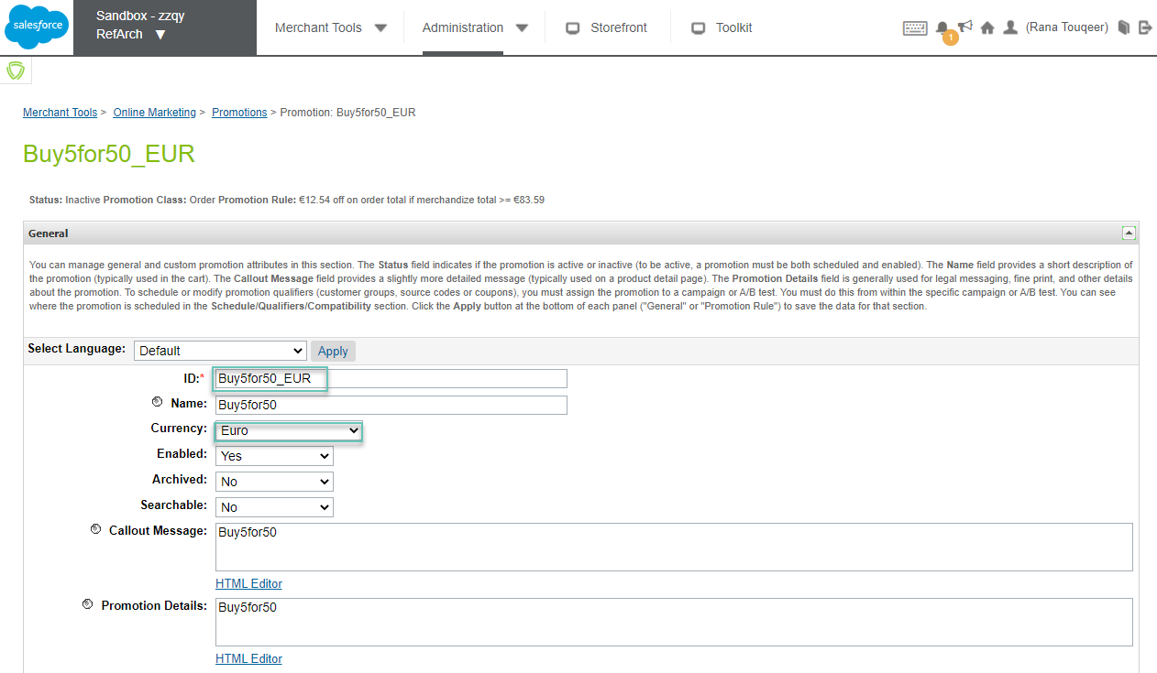

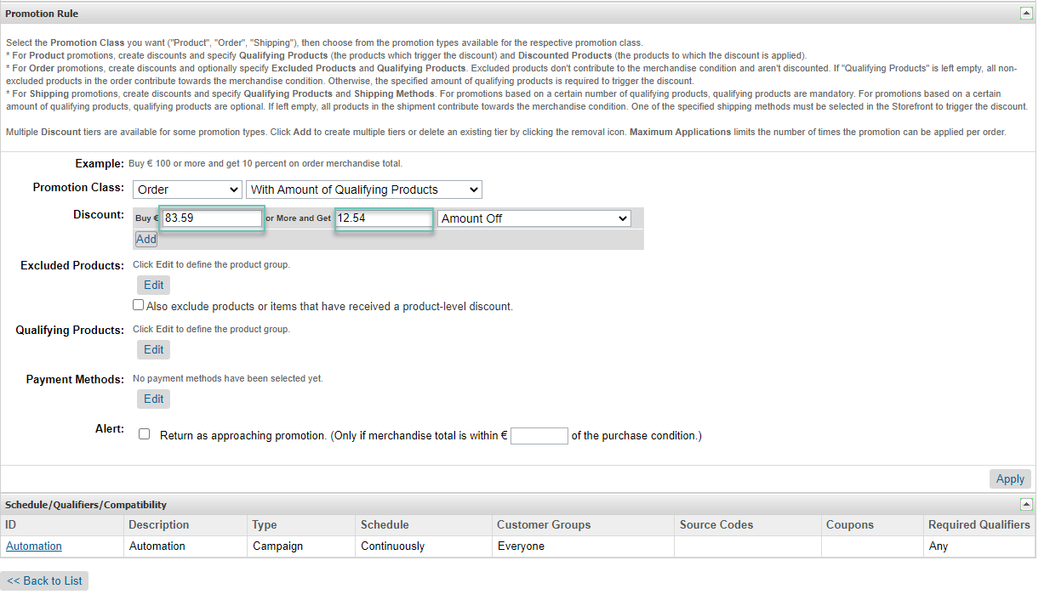
For the Campaign Assignment, if the campaign ID provided in the custom preference differs from the base promotion, then the custom preference for the given campaign is assigned to the localized promotion.
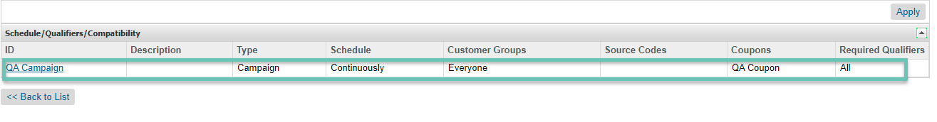

Localized Front-end Prices
The Localized Front-end Prices feature used to enhance shopper’s localized experience by converting front-end prices configured in Content Slots/ Assets & Promotional Call-out Messages.
With this feature retailers will gain access to additional feature, where their merchandising team will be able to display fully localized promotional call out & homepage banner messages on storefront. These messages will help shoppers to make use of ongoing promotions and see actual result in more international orders.
As ESW SFCC plugin will automatically convert these static prices to localized messages, therefore this will remove the operational overheads from retailer's merchandising team to configure separate promotions & content assets for every localize ESW supported shipping country.
To use this feature, the following points must be considered:
- Ensure that the ESW Enable Frontend Prices Conversion custom site preference under ESW Pricing Configuration is set to Yes. This will enable the Localized Front-end Prices feature.
- Ensure following HTML mark-up to configure Front-end prices in Promotional Call-out Messages and content assets. Any HTML selector can be used with “esw-price” class i.e. <div>, <span>, <p>.
<div class="esw-price">$100</div>
With additional optional data attributes
<div data-disable-adjustments="true" data-disable-rounding="false" class="esw-price">$100</div>
By default Rounding and Country Adjustments will apply while converting $100 (as mentioned in above example) into local currency using ESW Pricing Advisor data but if retailer don’t want to apply country adjustments or rounding model, can achieve this by using optional data attributes data-disable-adjustments & data-disable-rounding with “true” value.
Once price gets converted in static content “esw-price-converted” class will be added to the price element which can be used for post conversion styling/events. The final HTML/Markup will look like this after the conversion.
<div data-disable-adjustments="true" data-disable-rounding="false" class="esw-price esw-price-converted ">$100</div>

Note: In ESW SFCC Plugin while country shipping method cost country adjustments are not applying, so retailers can easily achieve this for shipping promotion call-out messages and shipping related content assets.
- Ensure that the prices must be configured in Base Currency.
- For Dynamic/ Calculated pricing countries, price will be converted from base currency to localize currency using ESW Pricing Advisor data and for Fixed Pricing, ESW Non-Supported countries Prices will remain same but with localize currency symbol.
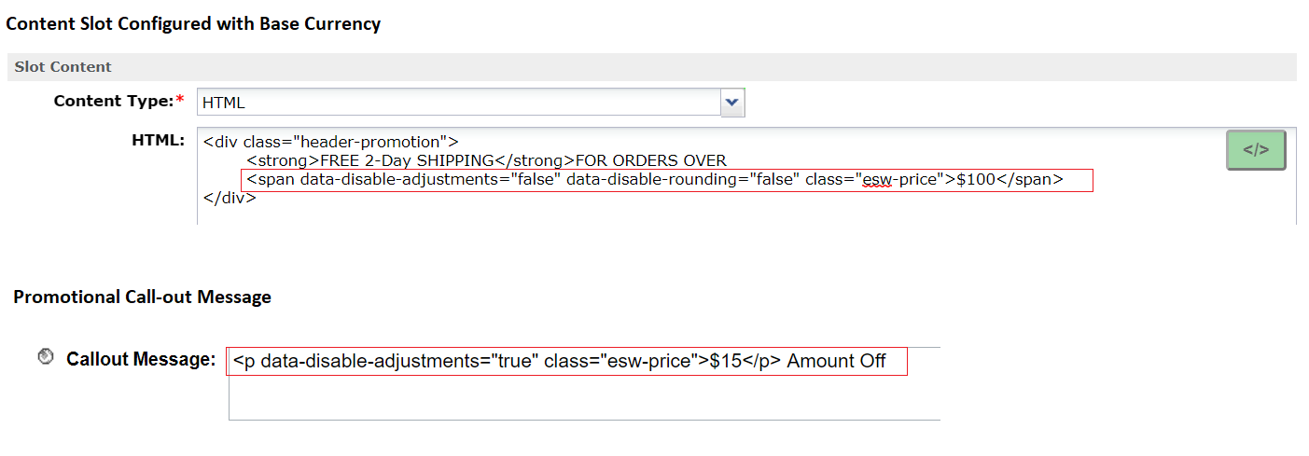
No Conversion for Fixed Model Pricing & ESW Non-Supported Countries:
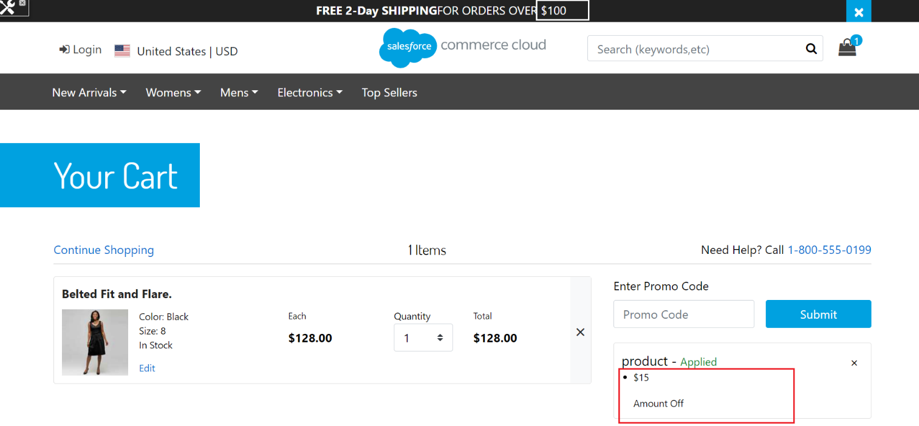
Prices Converted for Dynamic/ Calculated Pricing Countries:
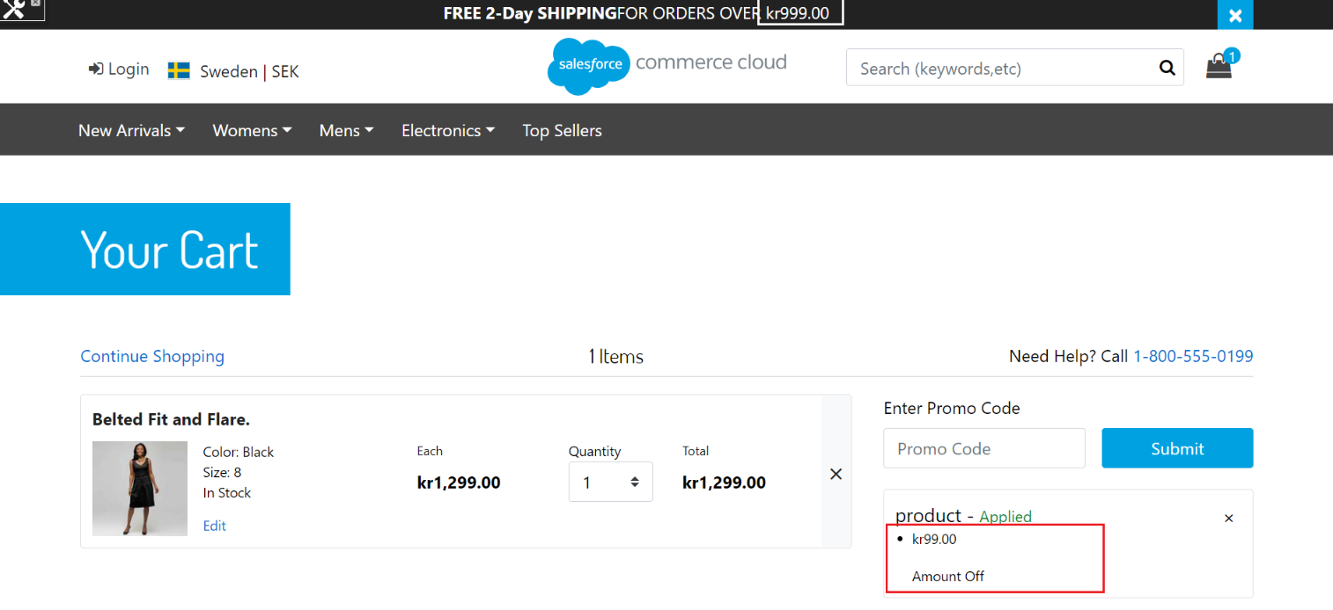

1.8 Promotional Price Books
ESW cartridge provides the ability to use promotional price books for specific customers using appropriate customer groups, retailers have the flexibility to show special prices by combination of ESW cartridge and SFCC’s native promotion engine. To use this feature, create customer group with the required rules. ESW cartridge also offers custom session variable which can be used in creating a customer group for a specific country, currency or pricing model.

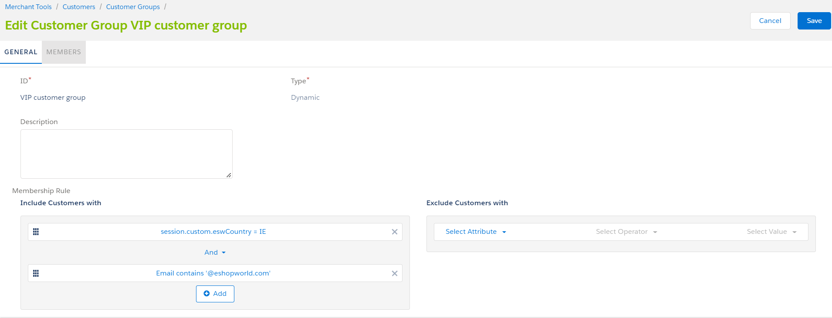

Customer group for customers from Ireland with email @eshopworld

Assign the customer group to a campaign. After this step, assign a promotion to the campaign. The promotion should be a product type with discount value of price from pricebook
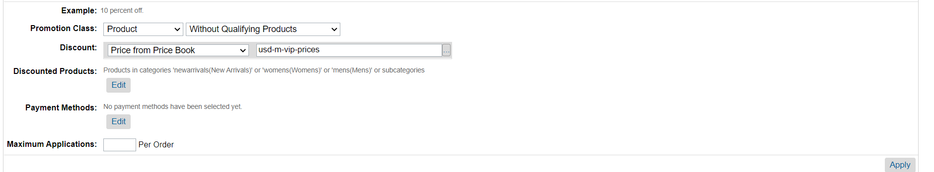
Price from Pricebook

You can find demo customer groups meta in the meta folder.

Pricing Integration Configuration

ESW Pricing Configuration
You can use the following Custom Preferences and Custom Objects to manage ESW-specific configurations of the cartridge.
The following ESW Pricing Configuration options are present:

Custom Objects:

- ESW Pricing Advisor Data: The Retailer Pricing feed job fetches Pricing advisor data into the ESW_PA_DATA custom objects. ESW recommends this job to be configured nightly before ESW Retailer Auto Configurator job. The pricing advisor data contains the FX Rates, country adjustments and rounding rules for the ESW Supported countries.
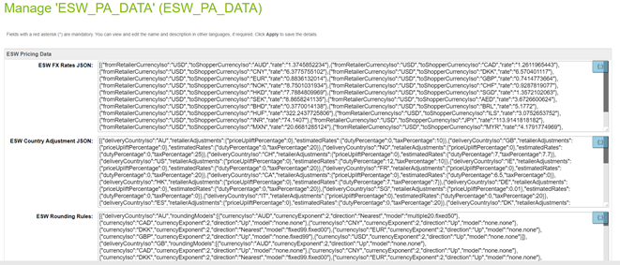

- ESW Fixed Price Model Countries: When the ESW Retailer Auto configurator job is executed the ESW supported countries’ custom object are instantiated. For Fixed price model country the ‘is Fixed Price Model’ needs to be checked manually, by default country will be created with dynamic/calculated pricing model
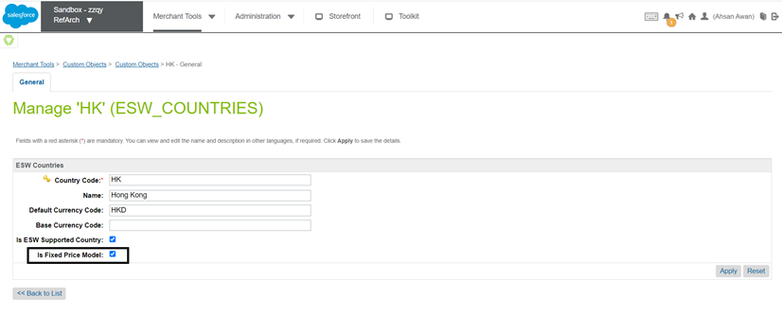

Custom Preferences:
- ESW Fixed List PriceBook Pattern This site preference sets the list price books Id pattern for fixed price model countries. i.e. {countryCode}-list-price-book. Pattern must have {countryCode} string part in this value.
- ESW Fixed Sale PriceBook Pattern This site preference sets the sale price books Id pattern for fixed price model countries. i.e. {countryCode}-sale-price-book. Pattern must have {countryCode} string part in this value.
For fixed price model counties, must configure the related Shipping Method with the appropriate currency at the SFCC end.
- ESW Enable Multiple FX Rates: Enables or disables the Multiple FX Rates feature for the current site.
- ESW Enable Roundings: Enables or disables the rounding on the prices across all applicable countries for the current site. If the option is enabled, the appropriate rounding models are applied to the prices in the applicable countries.
- ESW Enable Frontend Prices Conversion: Enables or disables the Localized Front-end Prices feature across storefront.
- ESW Price Feed Instance Switcher: Indicates the Price Feed mode for the current site. If you select Production, the Price Feed job uses the Production Price Feed service called EswPriceFeedV3Service.PROD.
- ESW Production Client Secret for Price Feed Authorization Request: Indicates the Production Client Secret key for the Price Feed authorization request. If the ESW Price Feed Instance Switcher is selected as Production, the Price Feed job uses the production client secret while making a call to the ESW Pricing Advisor API.
- ESW Localized Pricing Countries: Indicates the shopper country, currency, and local price books for which local prices are required. This preference also defines the base price book from where the prices, country adjustment, and rounding rules can be used.
[
{
"localizeCountryObj": {
"countryCode": "FR",
"currencyCode": "EUR",
"localListPriceBook": "eur-m-list-prices",
"localSalePriceBook": "eur-m-sale-prices"
},
"baseListPriceBook": "usd-m-list-prices",
"baseSalePriceBook": "usd-m-sale-prices",
"applyCountryAdjustments": "true",
"applyRoundingModel": "true"
}
]
The following table describes these parameters:
Parameter | Description
countryCode | (Required) The two-letter ISO code of the shopper country.
currencyCode | (Required) The three-letter ISO code of the shopper's local currency.
localListPriceBook | (Required) The price book ID of the local list price.
localSalePriceBook | (Optional) The price book ID of the local sale price.
baseListPriceBook | (Required) The price book ID of the base list price. The price book currency must match the tenant base currency.
baseSalePriceBook | (Required if 'localSalePriceBook' is provided) The price book ID of the base sale price. The price book currency must match the tenant base currency.
applyCountryAdjustments | (Required) Indicates if you want to apply country adjustments while calculating the local price. The values are True or False.
applyRoundingModel | (Required) Indicates if you want to apply the rounding model while calculating the local price. The values are True or False.
- ESW Localized Promotions: A JSON object containing single or multiple base promotion configurations, which can be used to generate localized promotions.
[
{
"basePromoId":"10%offordersover150",
"campaignId":"",
"excludeCurrencies":[
"GBP",
"SEK"
]
},
{
"basePromoId":"Buy5for50",
"campaignId":"Automation",
"excludeCurrencies":""
}
]
Each promotion object contains the following attributes:
Parameter | Description
basePromoId | (Required) The ID of the base promotion configuration.
campaignId | (Optional) The ID of the campaign.  This parameter can be left blank if you want to assign the same ID as the base promotion. However, if you want to assign localized promotions as a separate campaign, you must provide the new campaign ID.  You must also ensure that the campaign ID provided in this parameter is already created because the job only generates localized promotions, not campaigns.
excludeCurrencies | (Optional) The currencies for which you do not want to generate localized promotions.  If no value is provided, localized promotions are generated for all allowed currencies.
- ESW Skip Flagged Product: This flag indicates the inclusion of flagged products' localized prices in the localized pricebook generation. When a product is marked as price freeze, and this option is enabled, the base price will be included in the localized pricebook. If this option is disabled, the prices for price freeze products will be retained as they are.

eswRetailerLocalizedPricing job
The eswRetailerLocalizedPricing job generates new localized price books. It also assigns the generated localized prices for the missing products to the existing localized price books. Additionally, the job imports the localized price books to the SFCC Business Manager.

eswRetailerLocalizedPromotions job
The eswRetailerLocalizedPromotions job uses the base promotions export XML file to generate localized promotions. Localized promotions are used to apply the discount amounts to the qualified products according to the selected allowed currencies.

eswRetailerPricingFeed job
The eswRetailerPricingFeed job makes API calls to the retailer pricing feed and stores relevant data in the custom object. The data includes JSON values for FX rates, country adjustments, duties and taxes for the countries. The API call will not be made if the day listed in the preference is the current day. This means that the ESW_PA_DATA custom object will be updated only once a day. No API calls will be made for the rest of the day.

Services
The following services are being used for this functionality. The cartridge automatically generates the URL if they are not set already.
ESWOAuthService: This service is used to get the authentication token from ESW. This token is used by other ESW services and APIs, such as Price Feed, Checkout, and Package.
EswPriceFeedV3Service: This service is used for pricing feed to get the current currency FX Rates, Country Adjustments, and Rounding Rules.

