


PROMOTIONS INTEGRATION GUIDE

Version: 5.1.2
Published date: August 2026
Copyright © 2026 by ESW. All rights reserved. Information contained herein is subject to change without notice.

SFCC - ESW Cartridge
+
Contents
1 Shipping Threshold Promotion 3
1.1 Benefits 3
1.2 Using the ESW Shipping Threshold 3
1.3 Examples 5
2 Order Threshold Promotion 6
2.1 Using the ESW Order Threshold 6
2.2 Examples 6
3 ESW Customer Groups 7
3.1 Configuring the Customer groups 7
3.2 Examples 7

Shipping Threshold Promotion

Benefits
Native SFCC promotion engine threshold amount does not work with dynamic pricing. When dynamic price model is in use, localized prices are calculated on the fly in templates and SFCC backend engine does not see them. Since SFCC backend only works with the base or price-book currency, therefore there are some promotions limitations when prices are dynamically calculated.

This is where ESW cartridge comes into the play. The cartridge:
- Allows retailers to unlock native SFCC promotion limitation for international markets.
- Increase AOV by allowing promotion threshold in shopper's currency.
- Remove error prone manual work required to manage promotions for international markets.

Using the ESW Shipping Threshold
The Shipping threshold feature works with countries having shipping over-ride enabled. It Involves following steps:
- Open SFCC BM, go to Merchant Tools -> Online Marketing -> Promotions and open the newly created required promotion. If the promotion doesn’t exists then need to create new promotion. Moreover, sample for promotion meta can be found in Metadata/demo. As selected country is using dynamic price model, so promotion will be configure either with base currency or All.

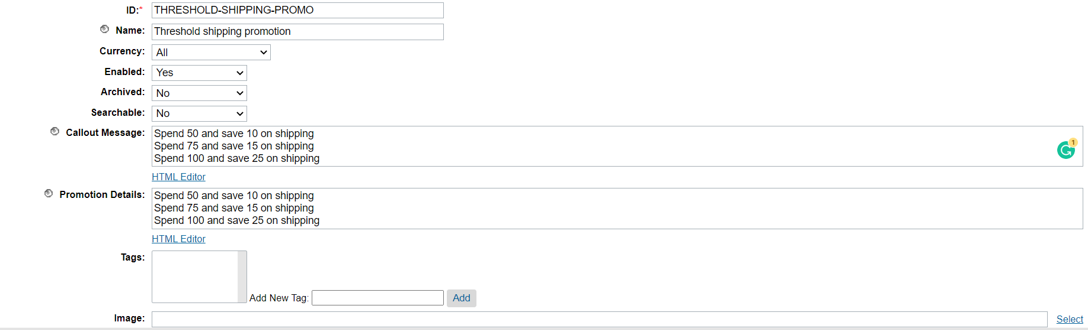

The promotion contains following configurations:
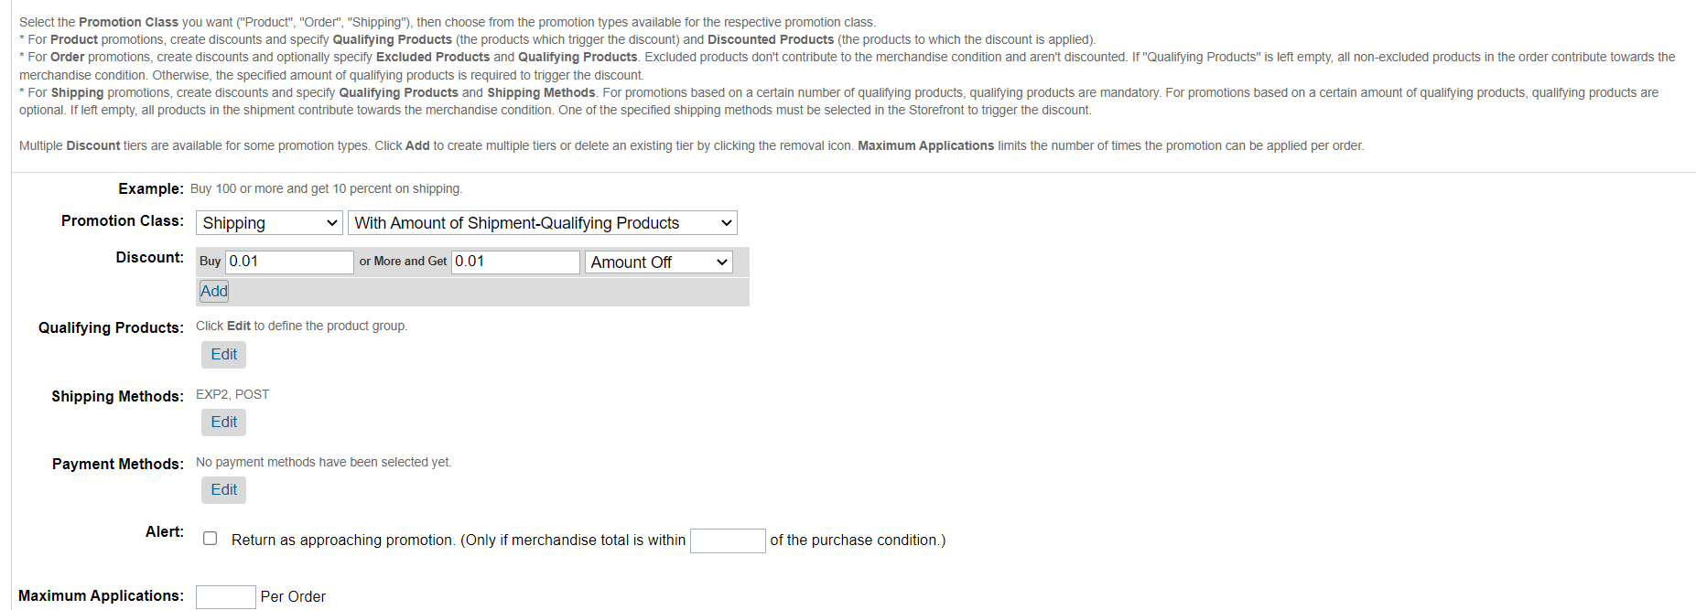
Threshold Promotion
Note that the Shipping Methods must be the override shipping methods configured for the specific country in the custom preferences. The qualifying products will be empty so this promotion will be applied on all products.

- Set the Attributes for Discount type and threshold values in the custom attributes for the promotion. 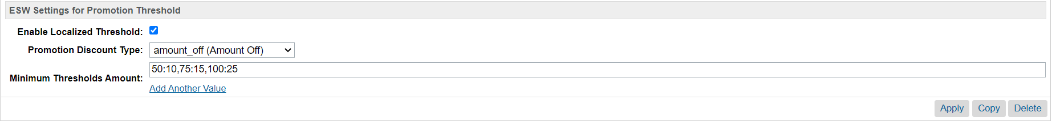
Threshold Promotion: Attributes
The Detail of custom attributes are as follows:

Parameter | Type | Description
Enable Localized Threshold | Boolean | Flag to control this feature
Promotion Discount Type | Dropdown | Type of discounts, values can be Amount Off, Percentage or Free
Minimum Thresholds Amount | Set Of Strings | The key value pair for [threshold amount]:[discount]. For example 50:10, 75:15, 100:25

Given the above configurations, retailer will get 10 amount off discount if the order total is greater than 50, 15 amount off Discount if the order total is greater than 75 and 25 Discount off if the order total is greater than 100. Moreover, retailers can also mix amount off discount with free shipping for large value order by giving ‘0’ as discount value, for example 200:0.

In the below example, The estimated shipping cost was 500 and we are getting 25 discount because order total is greater than 100.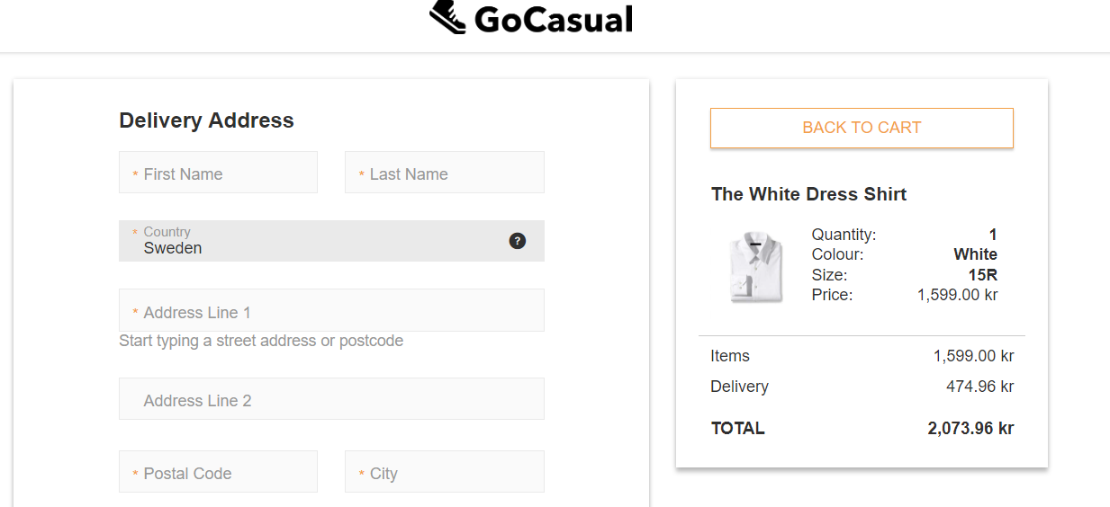
ESW Checkout page with shipping discount based on threshold value

Supported Discount types for Shipping promotion are Free, Amount off and Percentage Off

Examples

Here are some scenarios to better understand how the feature works:
Scenario 1: If Threshold 1000:0, Promotion Discount Type(Amount Off)
If order total is greater than or equal to 1000 in localize currency then apply Free Shipping.
In this case, shipping cost will zero/ Free.
Scenario 2: if Threshold 800:100, Promotion Discount Type Amount Off
If order total is greater than or equal to 800 & less than 1000 in localize currency then save 100 SEK in shipping cost. In this case, there will be 100 amount off discount on shipping
Scenario 3: If Threshold 800:10, Promotion Discount Type Percentage
If order total is greater than or equal to 800, in localize currency then save 10% shipping cost. In this case, there will be 10% off on shipping cost.
Scenario 4: : if Threshold 800:100, Promotion Discount Type (Free)
If order total is greater than or equal to 100 in local currency then there will be free shipping. Since the discount type is free so there will be free shipping discount.

Order Threshold Promotion

Using the ESW Order Threshold
Using the order threshold feature Involves following steps:
- Open SFCC BM, go to Merchant Tools -> Online Marketing -> Promotions and open the newly created promotion. If the promotion doesn’t exists then need to create new promotion. Moreover, sample for promotion meta can be found in Metadata/demo. As selected country is using dynamic price model, so promotion will be configure either with base currency or All.
- The promotion contains following configurations:
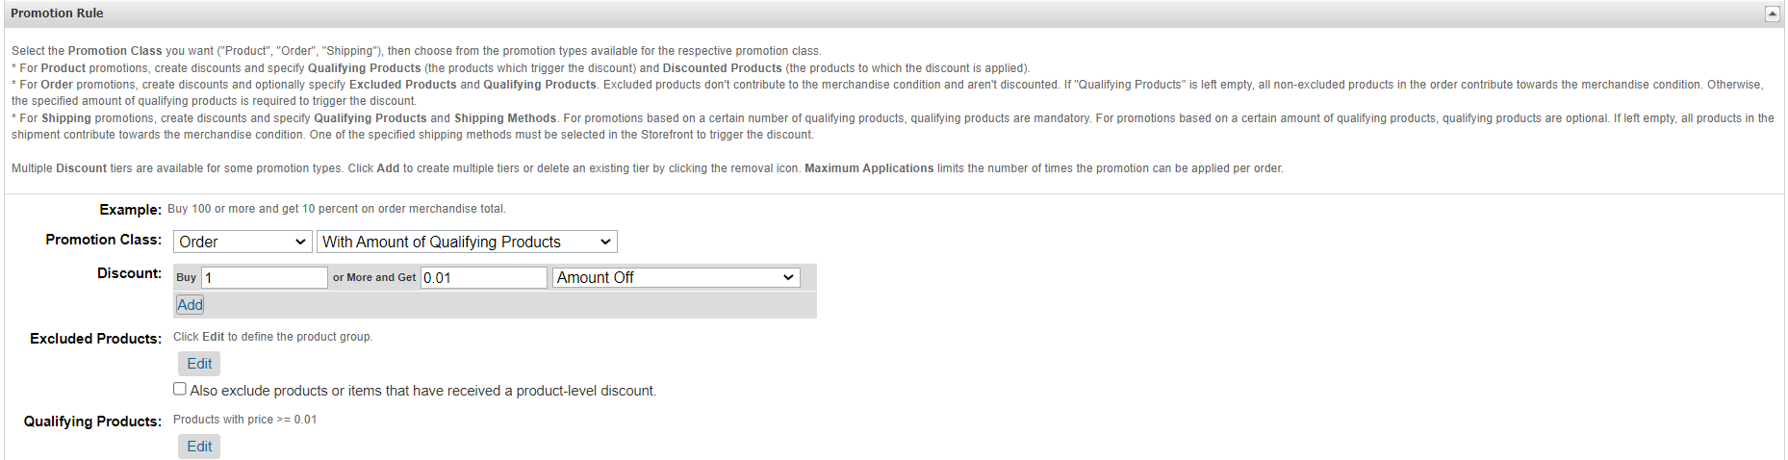
- Set the Attributes for Discount type and threshold values in the custom attributes for the promotion.
The Detail of custom attributes are as follows:

Parameter | Type | Description
Enable Localized Threshold | Boolean | Flag to control this feature
Promotion Discount Type | Dropdown | Type of discounts, values can be Amount Off or Percentage OFF
Minimum Thresholds Amount | Set Of Strings | The key value pair for [threshold amount]:[discount]. For example 50:10, 75:15, 100:25

Given the above configurations, retailer will get 10 amount off discount if the order total is greater than 50, 15 amount off Discount if the order total is greater than 75 and 25 Discount off if the order total is greater than 100.

Supported Discount types for Order Threshold promotion are Amount off and Percentage Off.

Examples
Here are some scenarios to better understand how the feature works:
Scenario 1: if Threshold 800:100, Promotion Discount Type Amount Off
If order total is greater than or equal to 800 & less than 1000 in localize currency then save 100 SEK. In this case, there will be 100 amount off discount on order totals
Scenario 2: If Threshold 800:10, Promotion Discount Type Percentage
If order total is greater than or equal to 800, in localize currency then save 10% of the order total. In this case, there will be 10% off order discount.

ESW Customer Groups

ESW cartridge exposes several session custom attributes which retailer can use while configuring Dynamic Customer Group. Retailer can use then the Customer Group in Content Slots, Promotion Campaigns, etc. This enables retailers to have more granular level control on the international promotions.

Configuring the Customer groups
ESW cartridge exposes the following session variables.
- eswEnabled: Indicates if ESW functionality is enabled.
- eswCountry: Indicates the country
- eswOperatedCountry: Indicates if the country is supported by ESW
- eswSupportsFixedPrices: Indicates if the pricing model is fixed pricing model
- eswCurrency: Indicates the currency
Using the above custom session variables, customer groups can be configured using SFCC native customer group functionality.
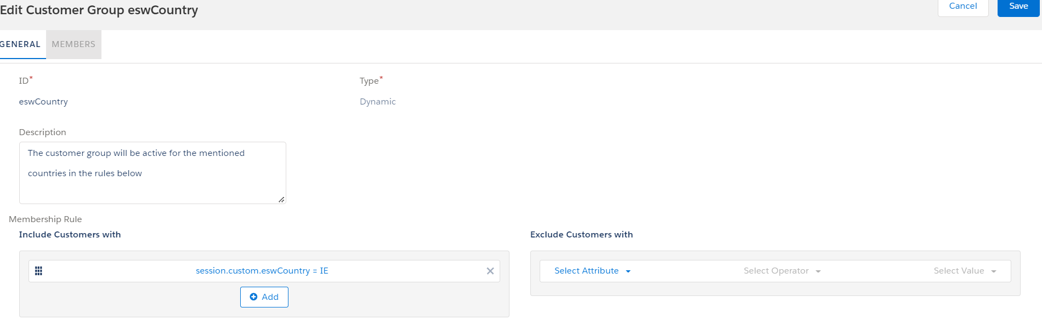
ESW Customer group

Examples
Scenario 1: Retailer wants the promotion/content slot to appear only for customers shopping in Euro. Retailer can make a customer group with rule session.custom.eswCurrency = EUR

Scenario 2: Retailer wants the promotion/content slot to appear only for customers from Ireland. Retailer can make a customer group with rule session.custom.eswCountry equals IE

Sample customer groups meta can be found in the sites data/demo folder.

