


Version: 5.1.2
Published date: August 2026
Copyright © 2026 by ESW. All rights reserved. Information contained herein is subject to change without notice.

TESTING GUIDE

SFCC - ESW Cartridge
+
Contents
1. About this document 3
1.1. Overview 3
1.2. What is basically should be tested 3
1.3. Testing preparation 3
2. Basic tests when the user starts shopping journey 3
2.1. How to check Fixed pricing model country 6
2.2. How to check Calculated / Dymanic pricing model country 14
2.3. How to check ESW non supported Country 18

About this document
This document describes how to perform basically tests of ESW Cartridge, based on SFRA storefront.

Overview
The Salesforce Commerce Cloud (SFCC) - ESW cartridge allows you to integrate with the ESW services, such as hosted checkout, local payment methods, and international logistics network. The cartridge also enables developers to self-manage site configuration, including the welcome mat configuration, landing page, country & currency widgets and product prices. For more information, please refer to eShopWorld_SFCC_Integration_Guide_v24.7.0.docx.

What is basically should be tested
- Price on storefront for ESW supported (Fixed and Calculated / Dynamic pricing models)
- Price on storefront for ESW non supported countries
- Price on ESW checkout (Fixed and Calculated / Dynamic pricing models)
- Price on Native checkout
- Successfully placed order on ESW Checkout (Fixed and Calculated / Dynamic pricing models)
- Successfully placed order on Native checkout.
Note: Please perform appropriate specific tests according to the tested feature.

Testing preparation
Check that the Storefront (SiteGenesis/SFRA) is working fine and configured properly as following:
- Master Product Catalog is uploaded, configured and has products.
- Storefront Catalog is configured and assigned to the Site.
- At least one Pricebook, assigned to the Site and has product records.
- At least one Inventory list exists, assigned to the Site and has inventory records (or "Default In-Stock" is checked).
- At least one orderable product, defined in Master Catalog, assigned to some category in Storefront Catalog, has records in Pricebook and Inventory list.
- At least one locale and Currency configured and assigned to the Site.
- The Services, Jobs other metadata for ESW have been imported without errors (please see eShopWorld_SFCC_Integration_Guide_v24.7.0.docx).
- The ‘eswRetailerPricingFeed’ job must be executed successfully at least one time in SFCC BM.
- The ESW Site Preferences have been configured properly (please see eShopWorld_SFCC_Integration_Guide_v24.7.0.docx).
- ESW cartridge is enabled in the ESW General Configuration custom site preferences.
- Appropriate Code Version is updated and activated.
- All Search Indexes are rebuilt successfully.
- The Cache for the Site has been cleared.

Basic tests when the user starts shopping journey
Once the shopper opens SFCC storefront the first time the Welcome mat appears with ability to view / update Shipping country, Language and Currency.
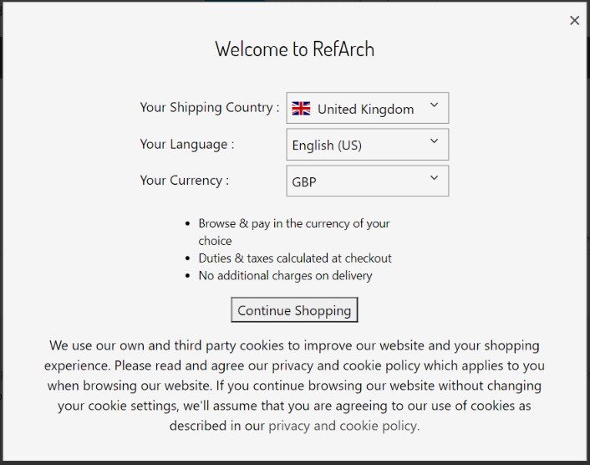

After the shopper clicked on the ‘Continue Shopping’ button, welcome mate should disappear and selected Country | Currency menu should be displayed on the Header and Footer. Appropriate Cookies should be set in the dev tools:
- esw.location for selected Country
- esw.LanguageIsoCode for selected language
- esw.currency for selected Currency
- esw.InternationalUser: true should be set for ESW supported country and false for ESW non supported country.

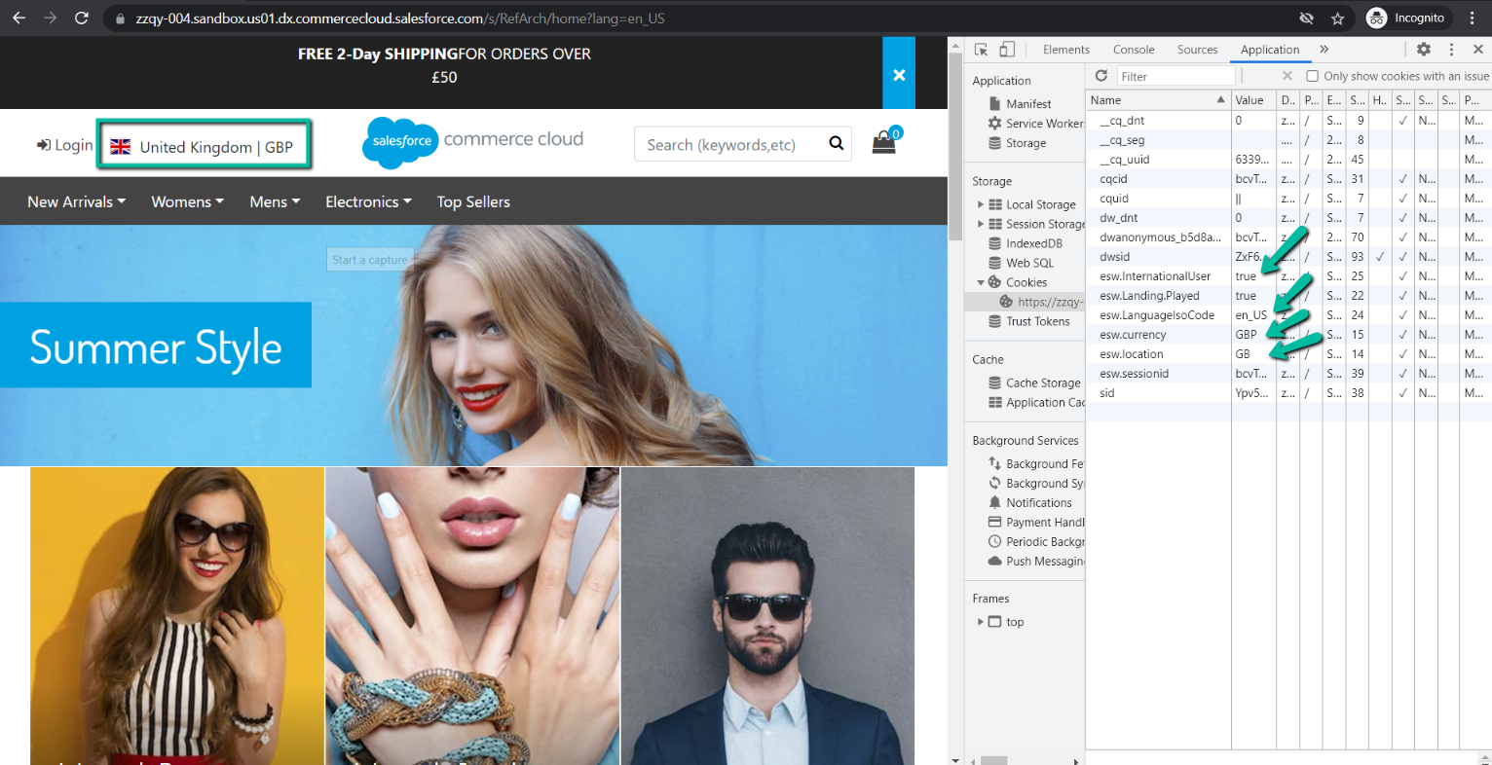

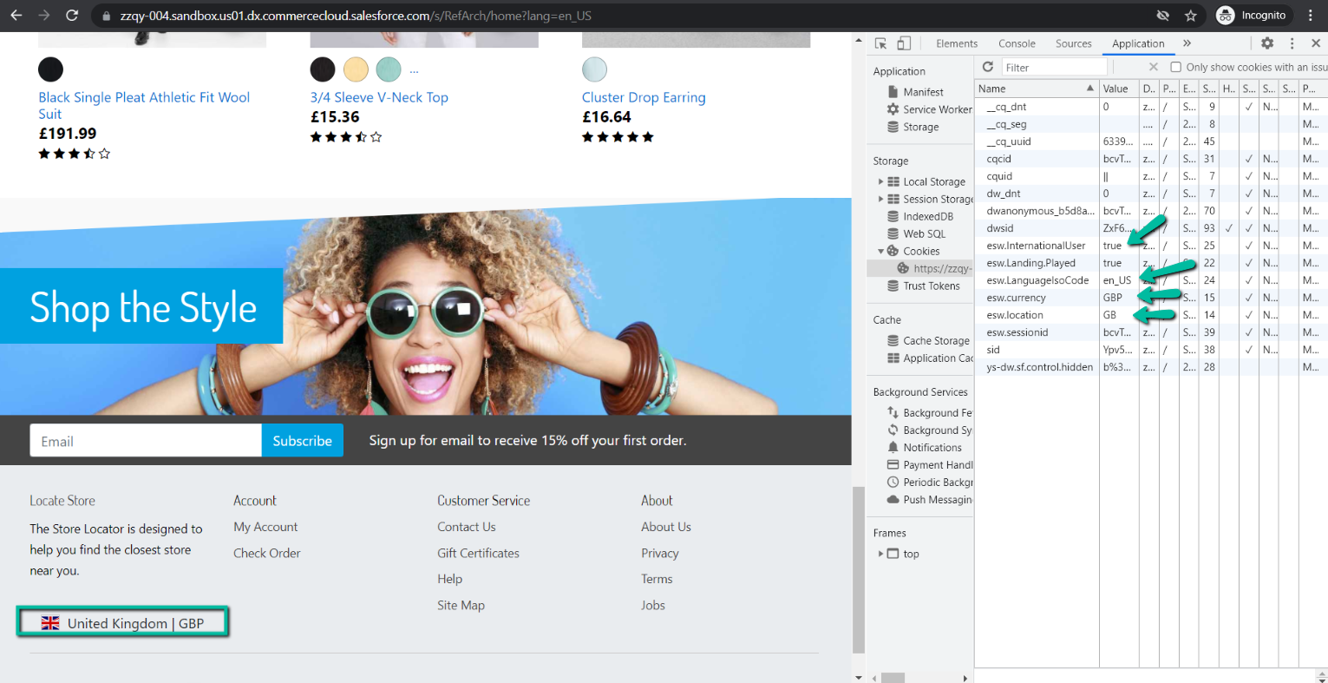

Also, product prices should be displayed in the selected currency: GBP.

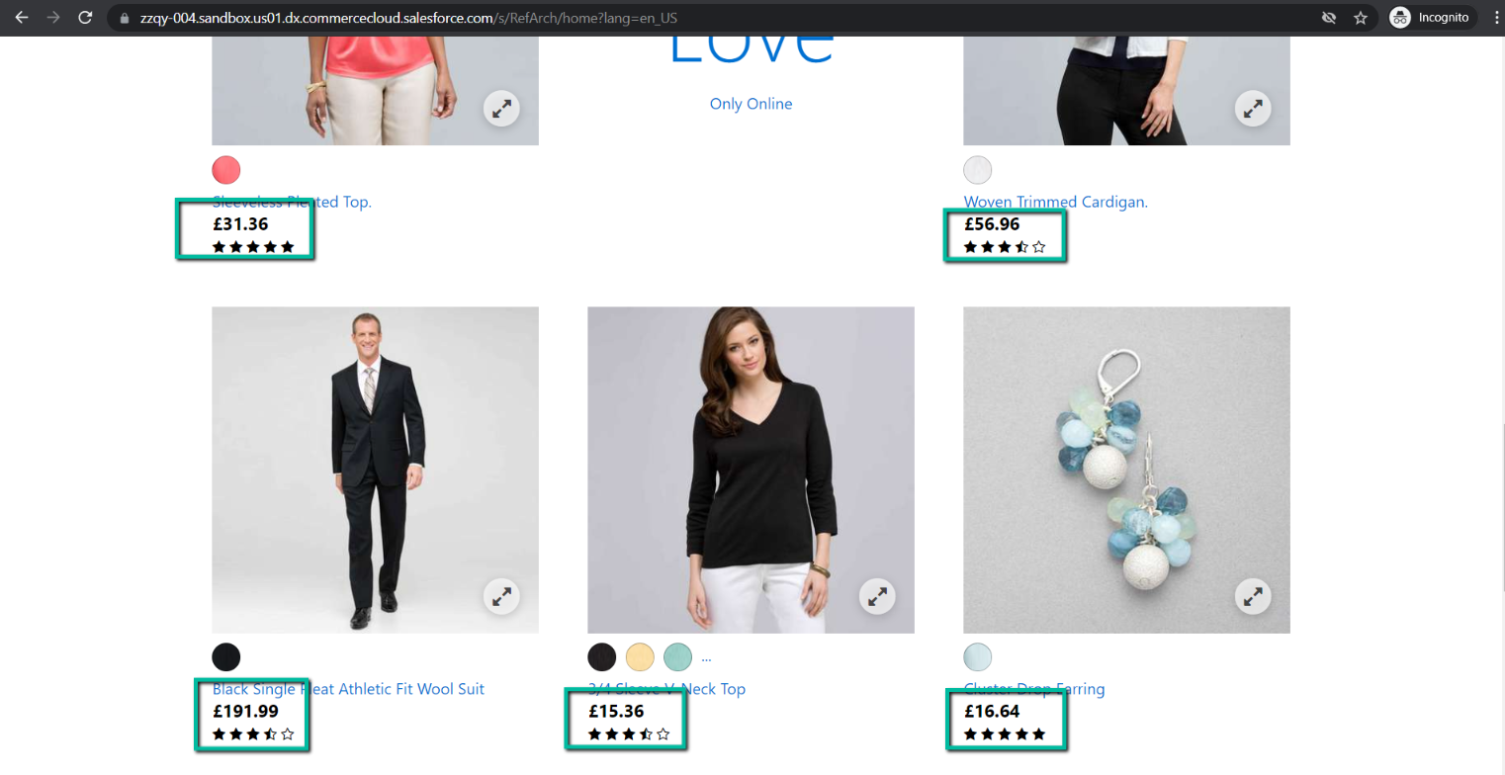
Shopper should have an ability to easy update Country, Language and Currency in the Welcome Mat. It should be opened by clicking on the Country | Currency menu in the Header or Footer.

How to check Fixed pricing model country
To test the Fixed pricing model country, ensure that:
- Tested country’s custom object of type ‘ESW Countries’ exists and the flag ‘is ESW Supported Country’ is enabled.
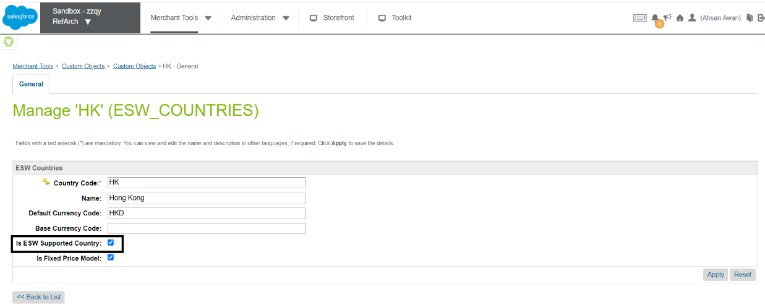
- Tested country has override price book set in the ‘ESW Override Price Book’ setting in the ‘ESW Pricing Configuration’ group.

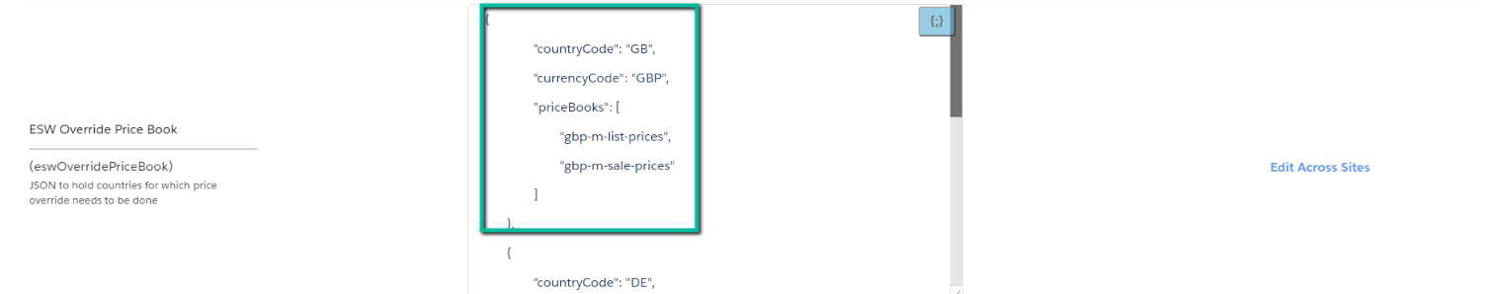

Price of product on the storefront for Fixed pricing model country should be the same as in the price book assigned to the country.
Price of product in price book is 99.2 GBP.
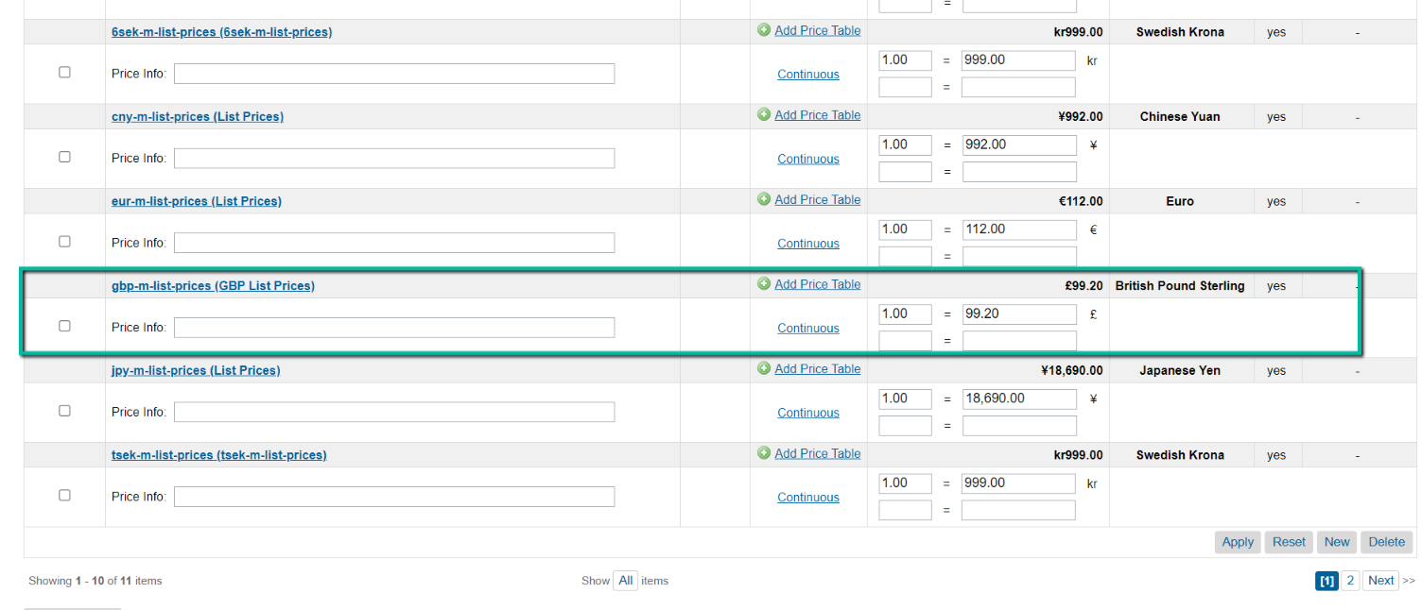

The same 99.2 GBP price should be on the PLP, Quick view page, PDP.

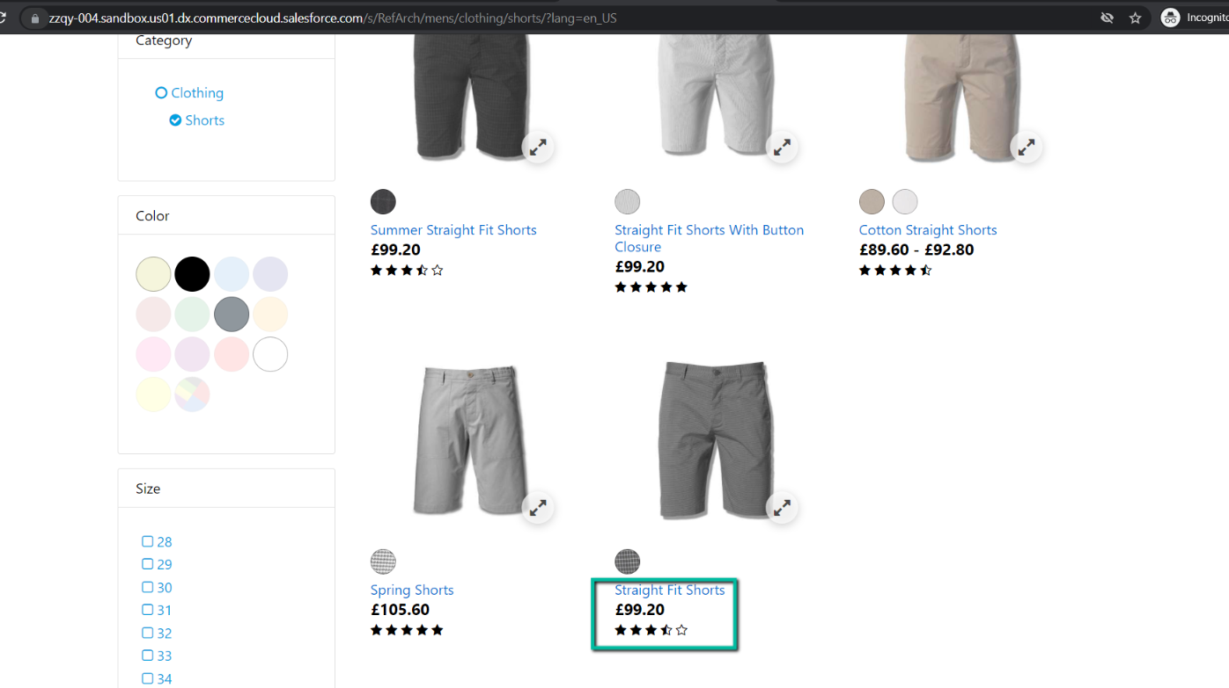
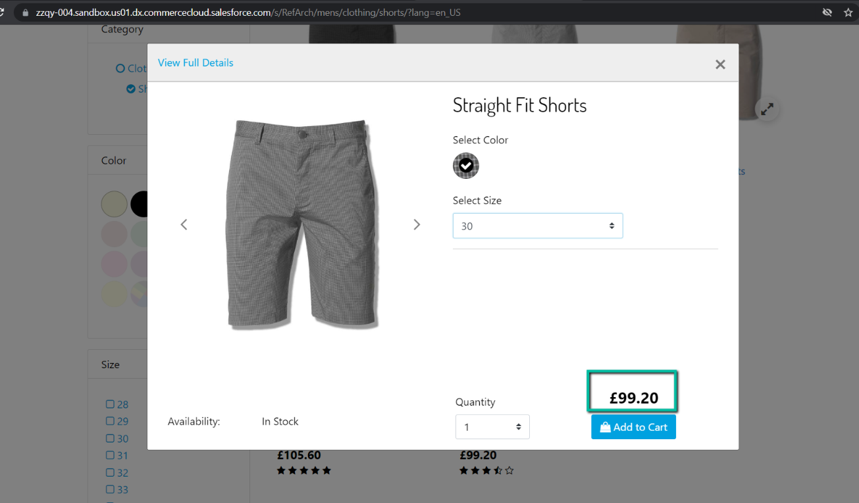
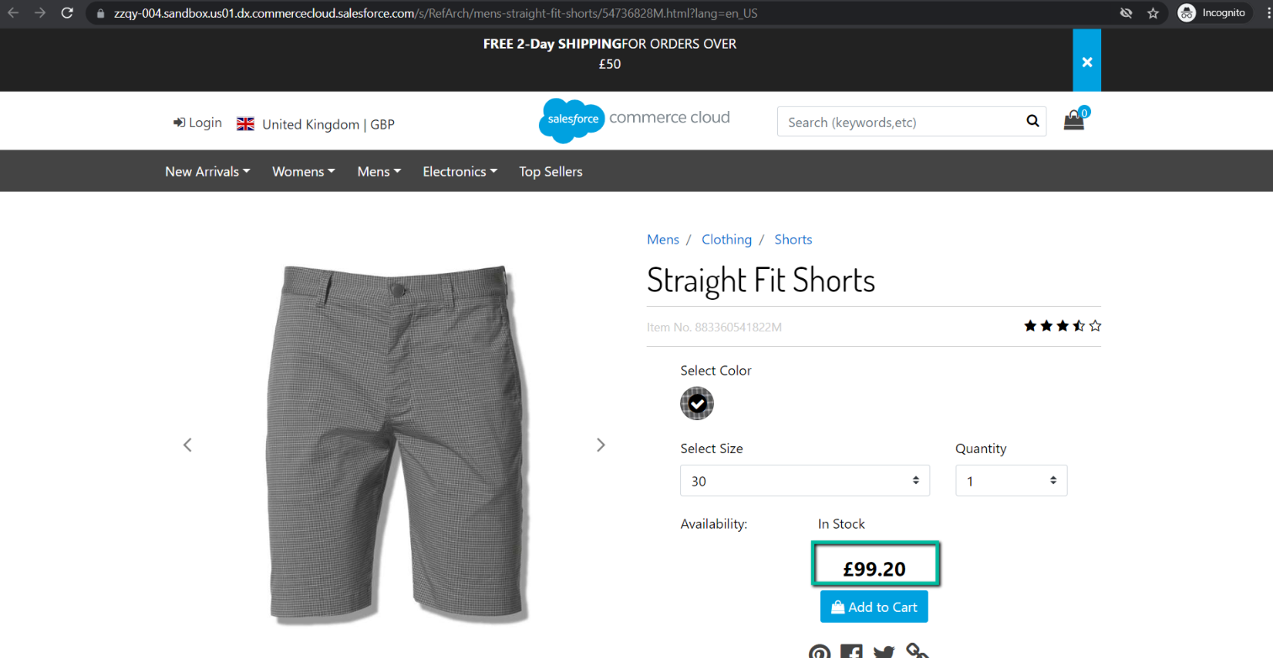
Add product to the shopping cart and ensure that the same price is displayed in the mini cart and shopping cart: 99.20 GBP.
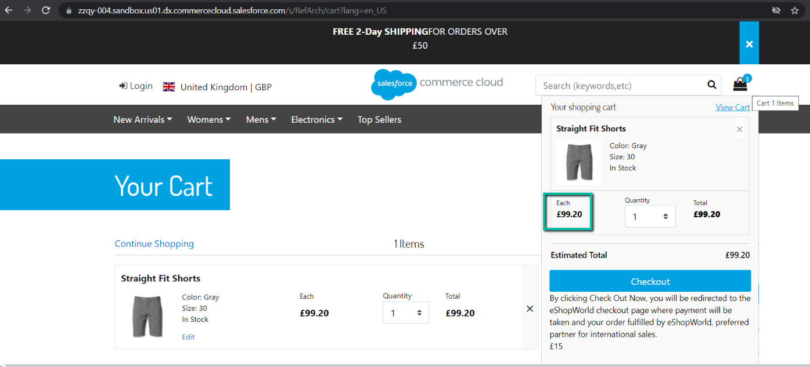
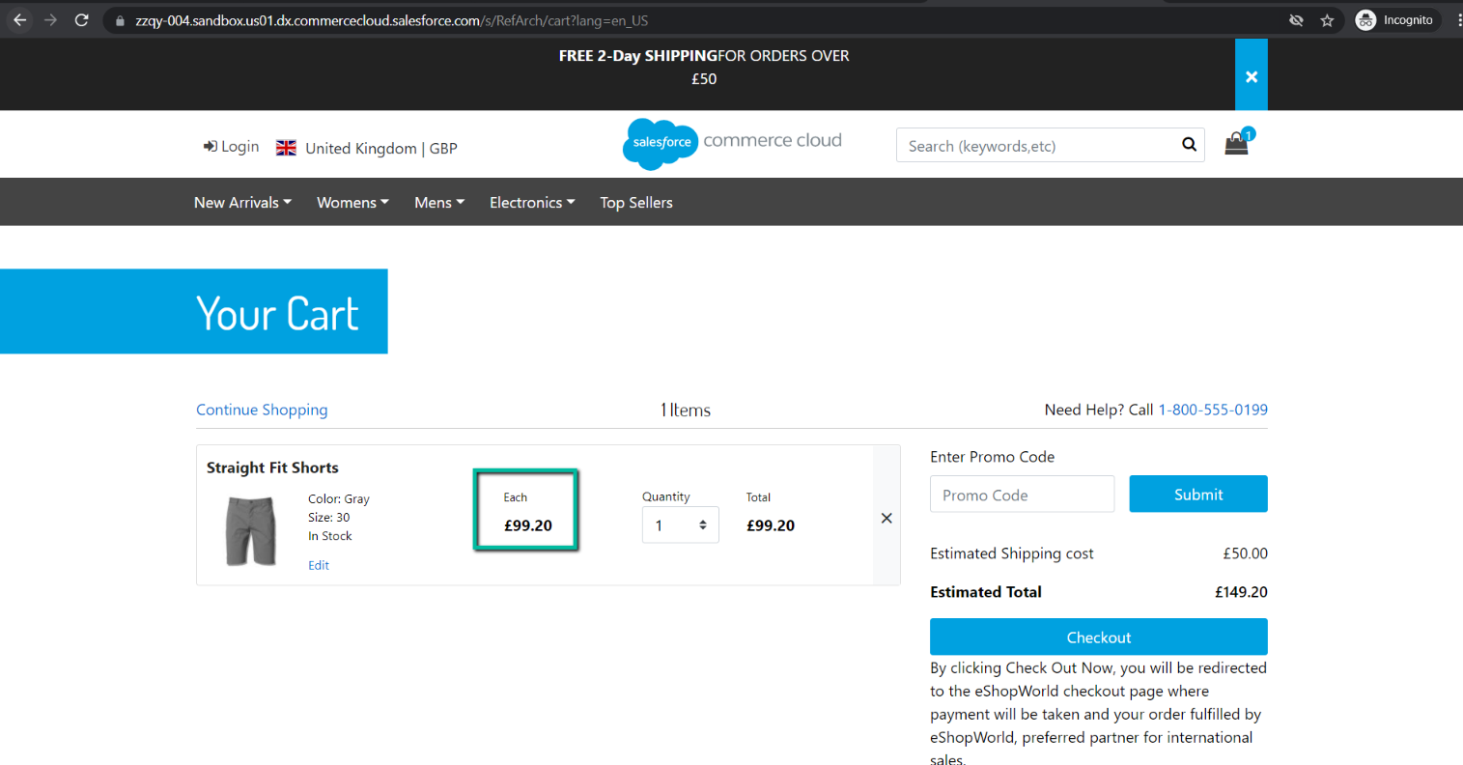
Navigate to ESW checkout and ensure that product price is the same as on the storefront: 99.2 GBP.
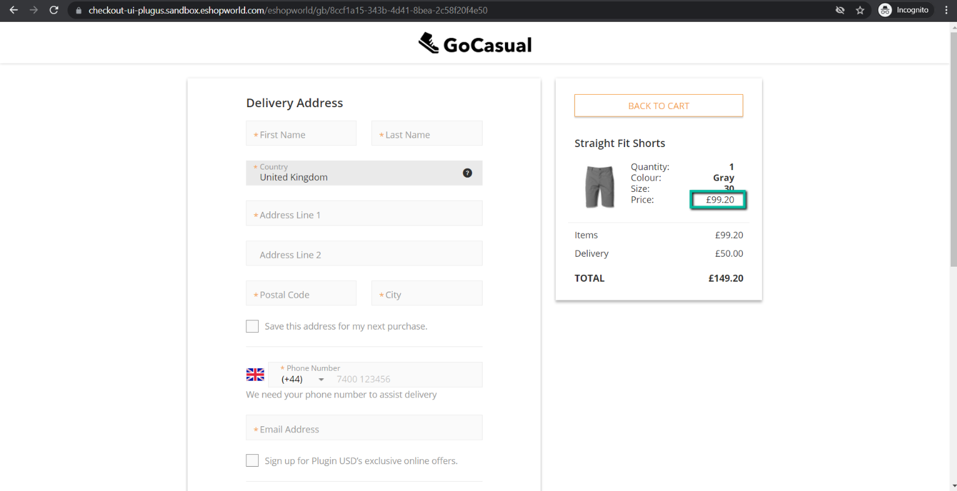
Order should be in Created state in SFCC BM (Merchant Tools > Ordering > Orders).
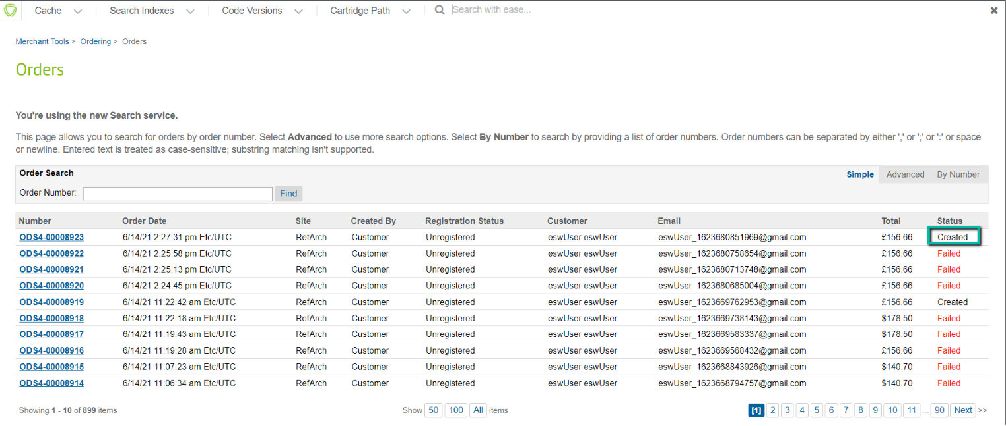
Enter Delivery / Payment information, card details, pay an order and ensure that the order is placed successfully.
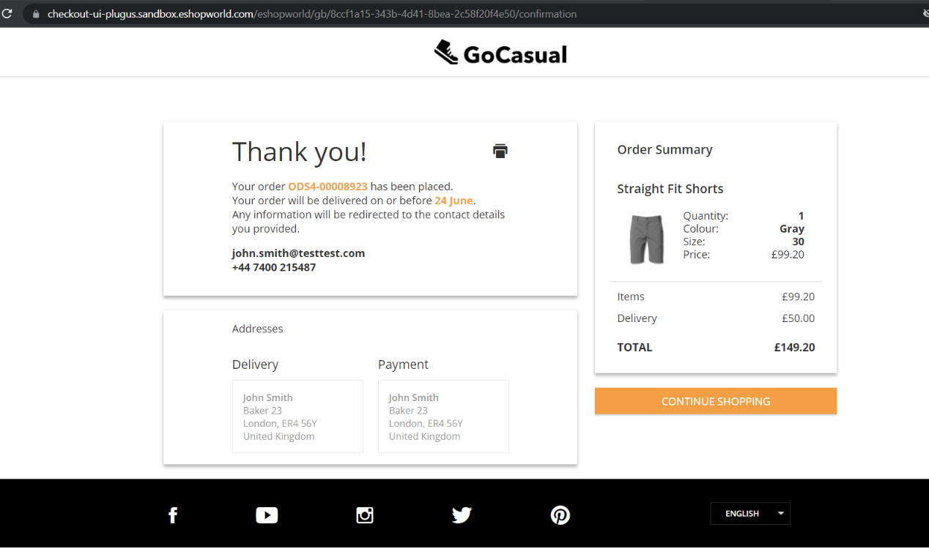
Check that order status is changed to New after it was placed successfully.
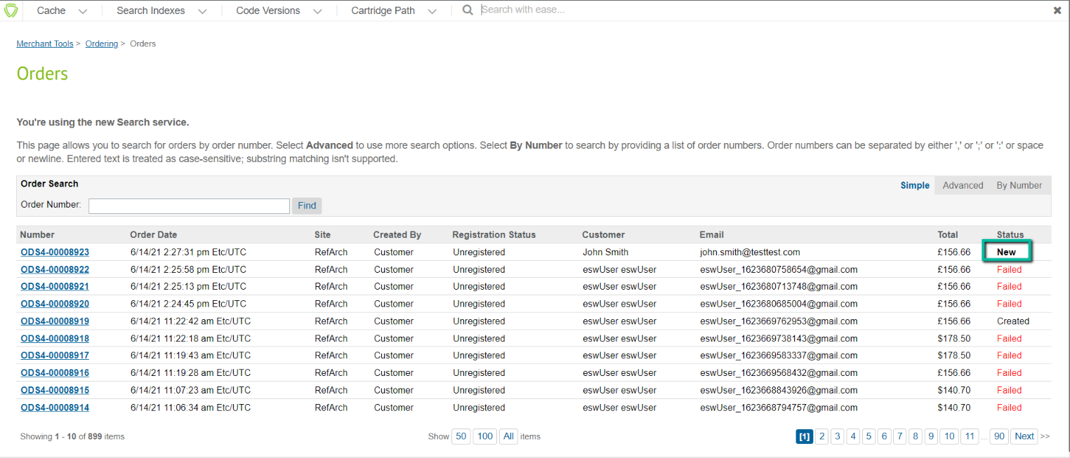
Open order and ensure that Order Attributes (Merchant Tools > Ordering > Orders > Order: ODS4-00008923(RefArch)) are correct (compare with order confirmation payload).
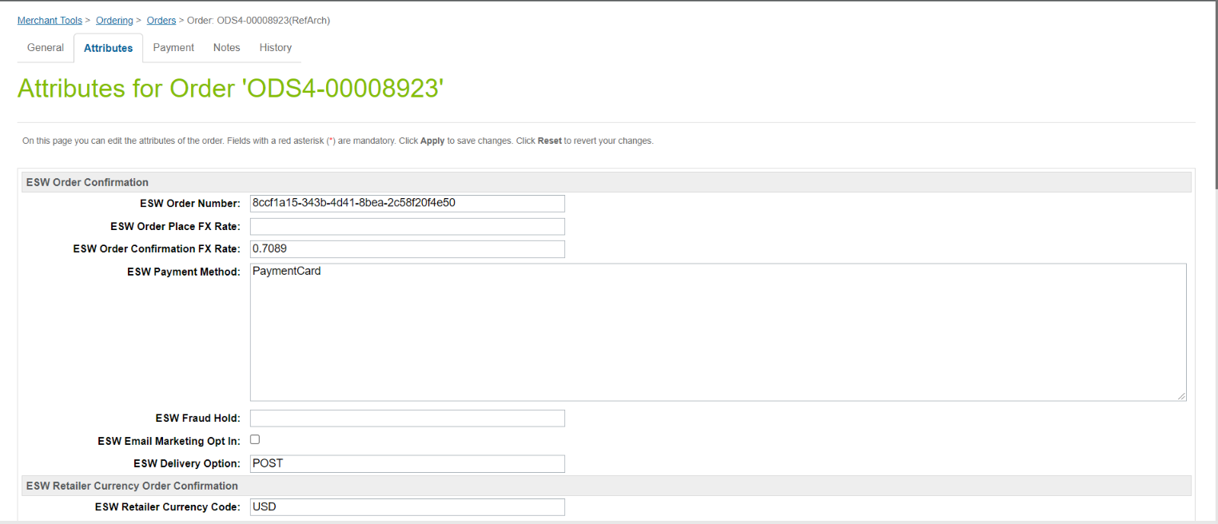
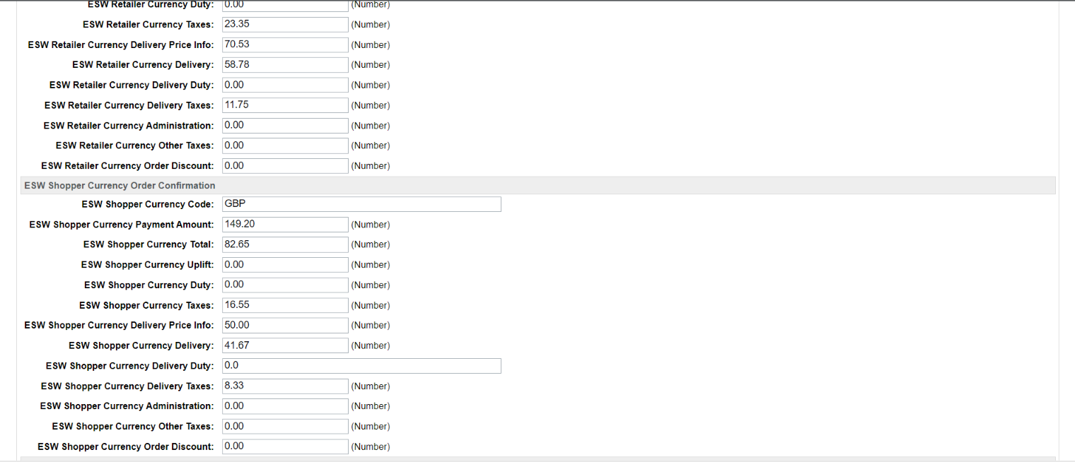
Open order and ensure that Order Items Attributes (Merchant Tools > Ordering > Orders > Order: ODS4-00008923(RefArch) > Shipment: 00030001 > Line Item: 883360541822M) are correct (compare with order confirmation payload).

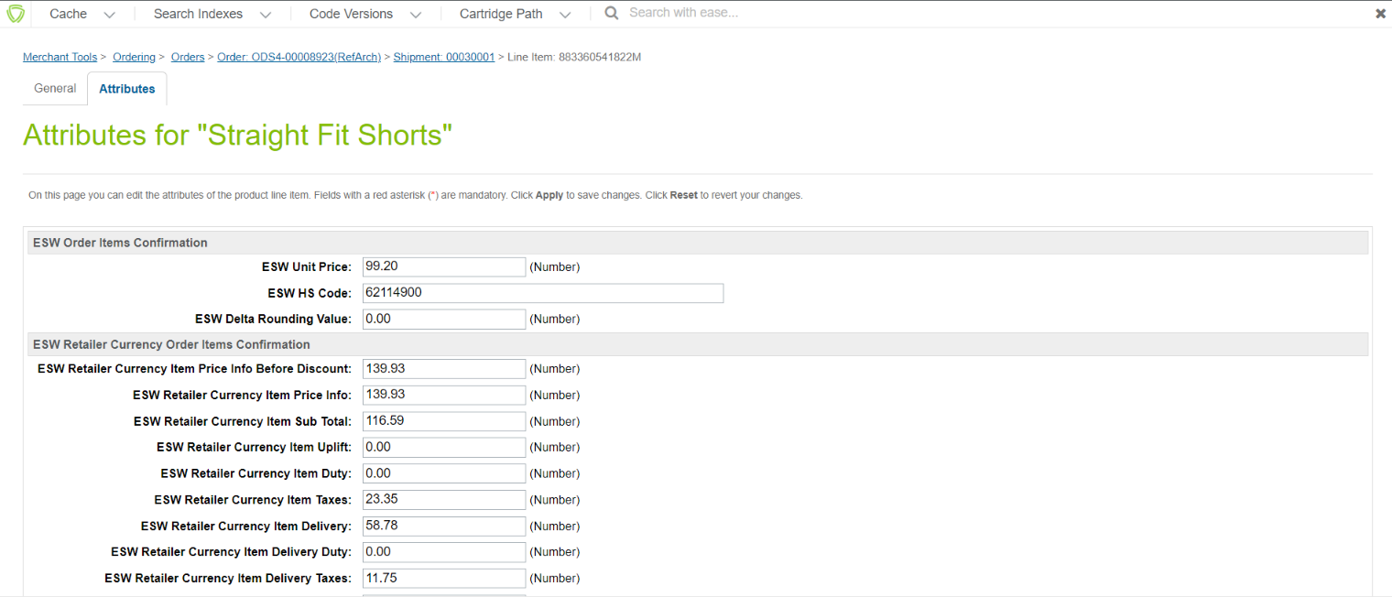
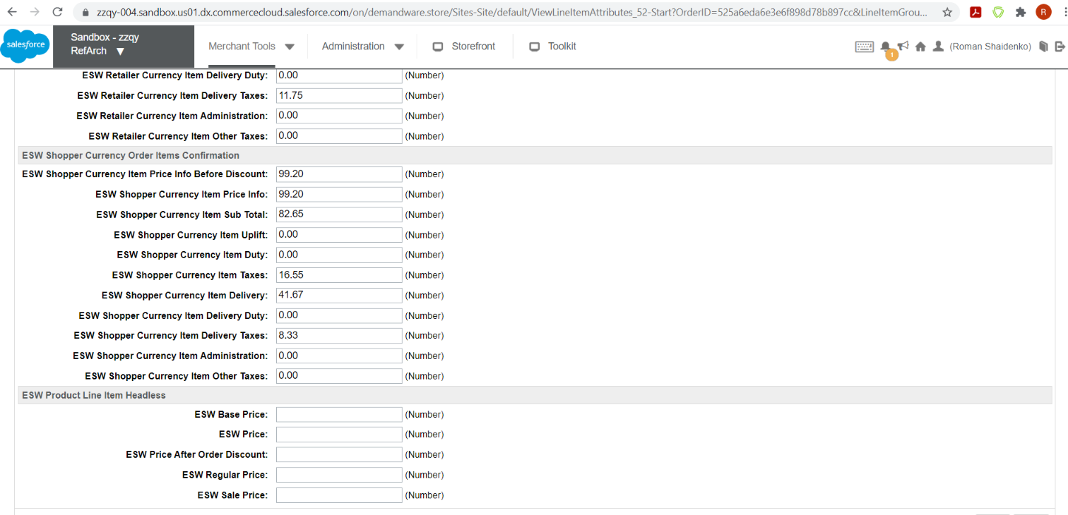

How to check Calculated / Dymanic pricing model country
To test the Calculated / Dynamic pricing model country, ensure that:
- The flag ‘is Fixed Price Model’ in the Tested country’s custom object is disabled.
- Tested country does not have override price book set in the ‘ESW Override Price Book’ setting in the ‘ESW Pricing Configuration’ group.

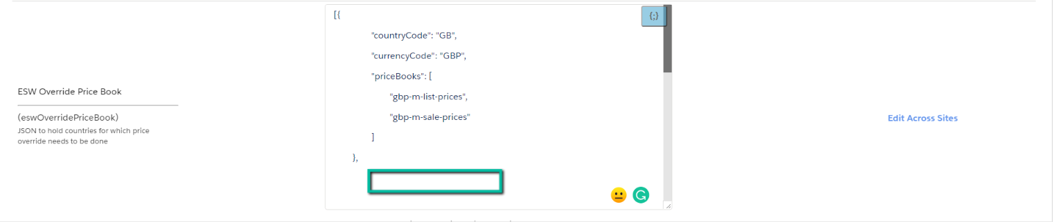
This model uses a retailer’s default price book and converts this to prices for specific countries using the following formula:
(((Product base price x (1 + priceUpliftPercentage)) x (1 + dutyPercentage)) x (1 + taxPercentage)) x fxRate = Price in the shopper currency → apply rounding = Final product price.

Price in in the default price book | 155 USD
Uplift | 3%
Duty | 7%
Tax | 20%
FX Rate USD - SEK | 8.32
ESW Rounding Rule | {"currencyIso":"SEK","currencyExponent":2,"direction":"Up","model":"fixed99.fixed00"}
155 USD * 1.03 * 1.07 * 1.2 * 8.32 = 1705.52 SEK – product price without ESW rounding rule.
Final product price = 1799.00 SEK (after ESW rounding was applied).
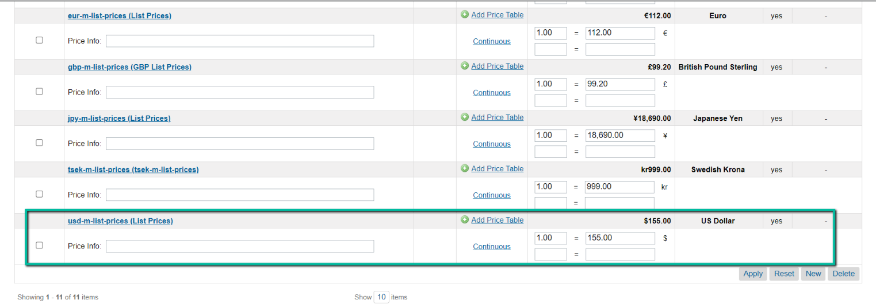
1799.00 SEK price should be on the PLP, Quick view page, PDP.
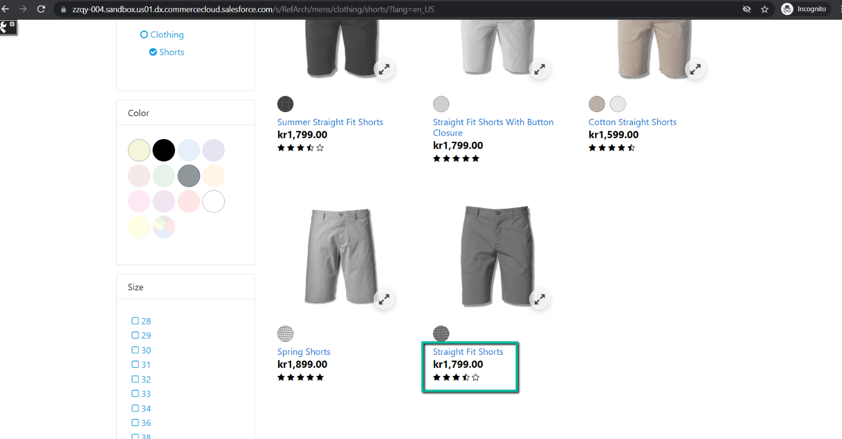
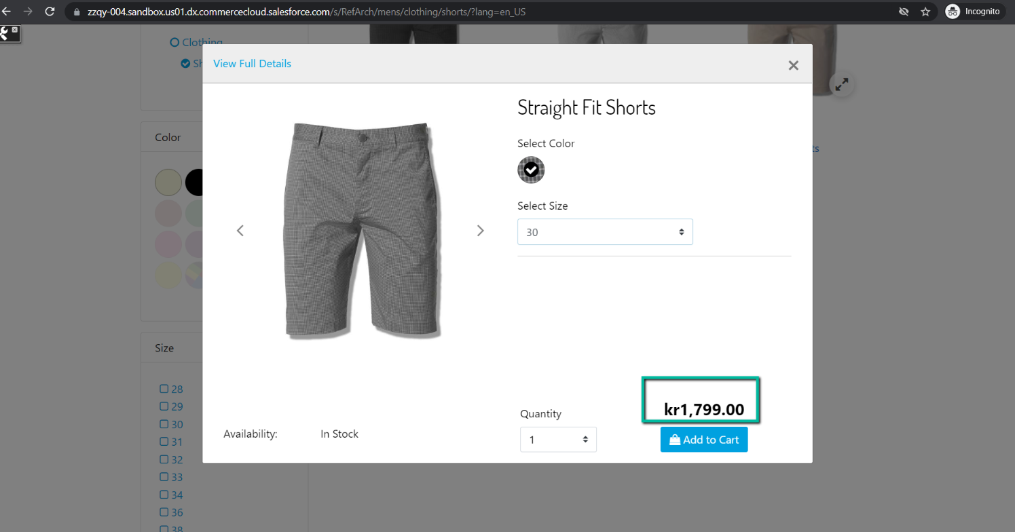
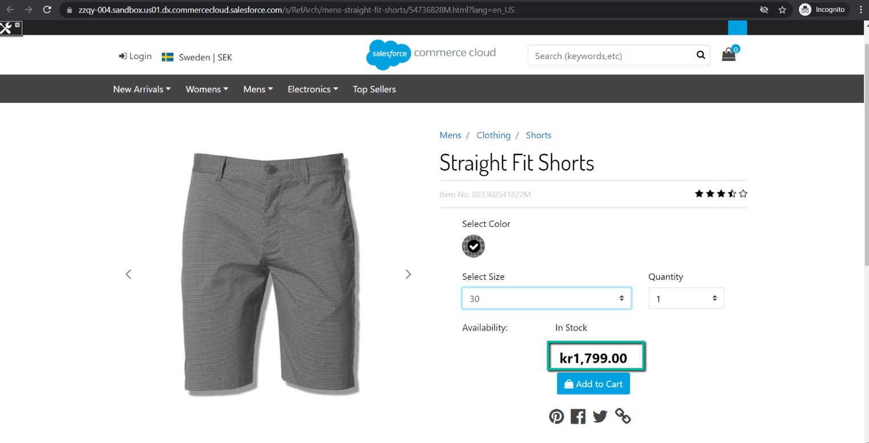
Add product to the shopping cart and ensure that the same price is displayed in the mini cart and shopping cart: 1799.00 SEK.
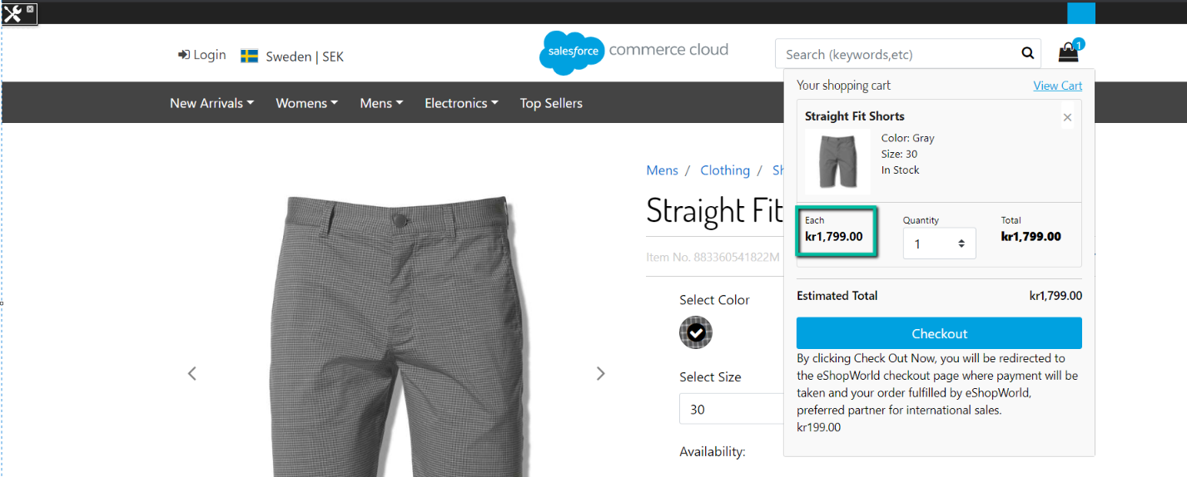

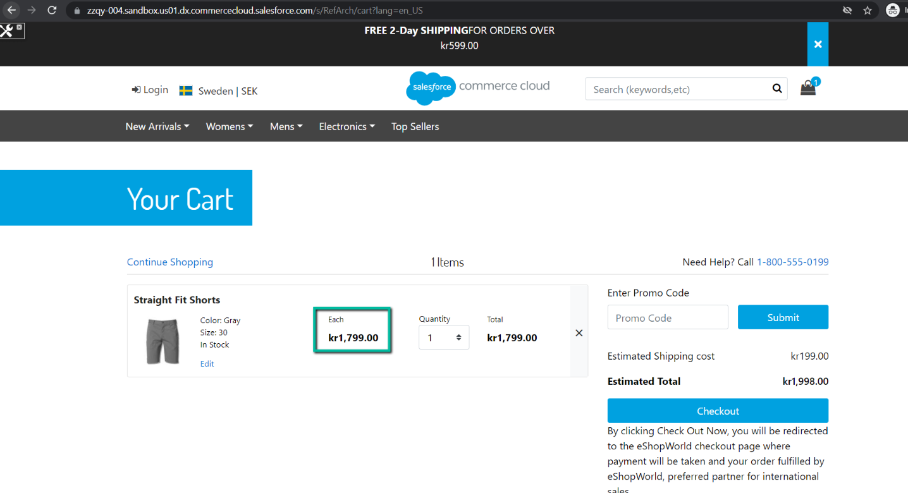
Navigate to ESW checkout and ensure that product price is the same as on the storefront: 1799.00 SEK.
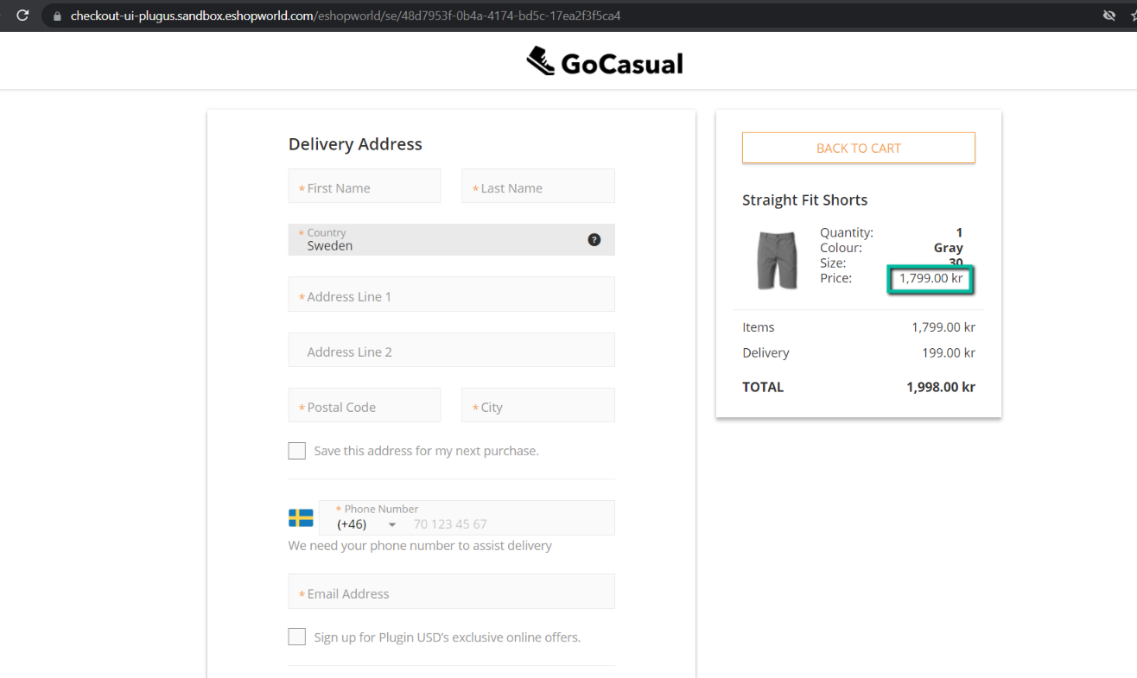
The further testing of order placement, order status, Order Attributes, Order Item Attribute is the same as for the Fixed pricing model country described above.

How to check ESW non supported Country
To test the ESW non supported country, ensure that the flag "is ESW Supported Country" in the country’s custom object is disabled.
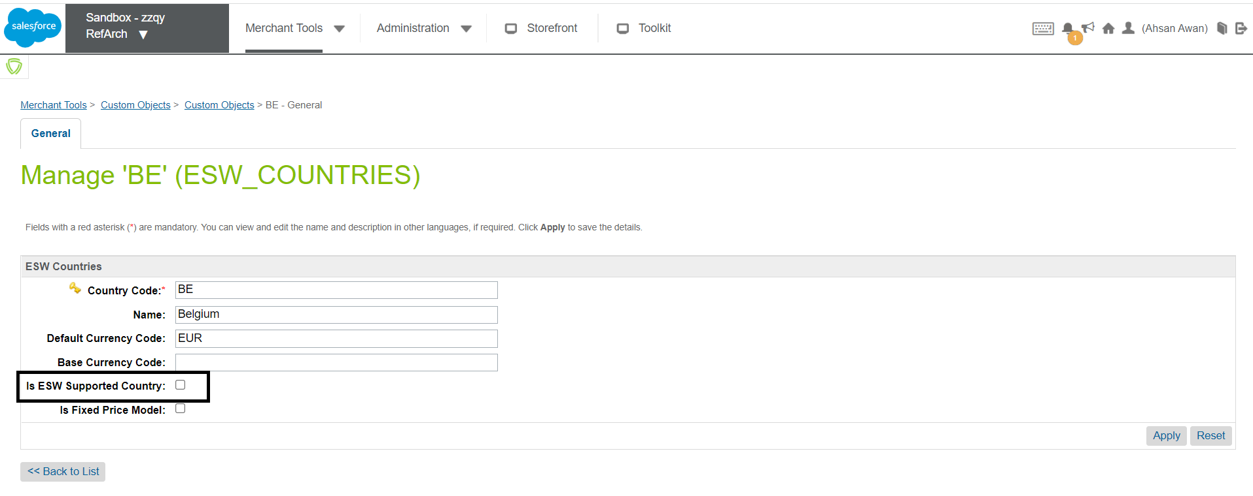

Price of product on the storefront for ESW non supported country should be the same as in the shopper currency price book.

Price of product in price book is 155 USD.

The same 155 USD price should be on the PLP, Quick view page, PDP.
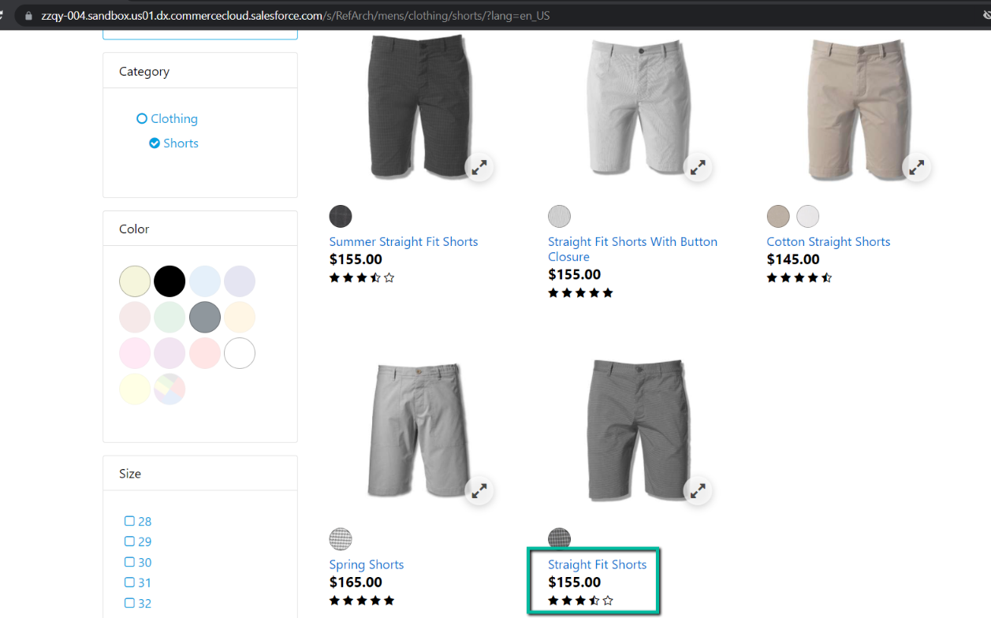
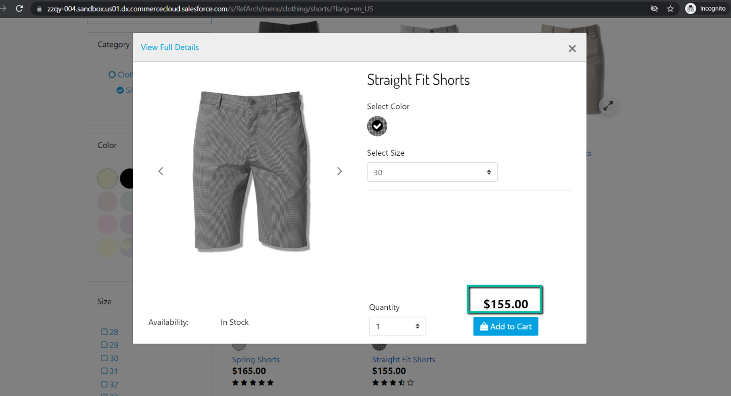
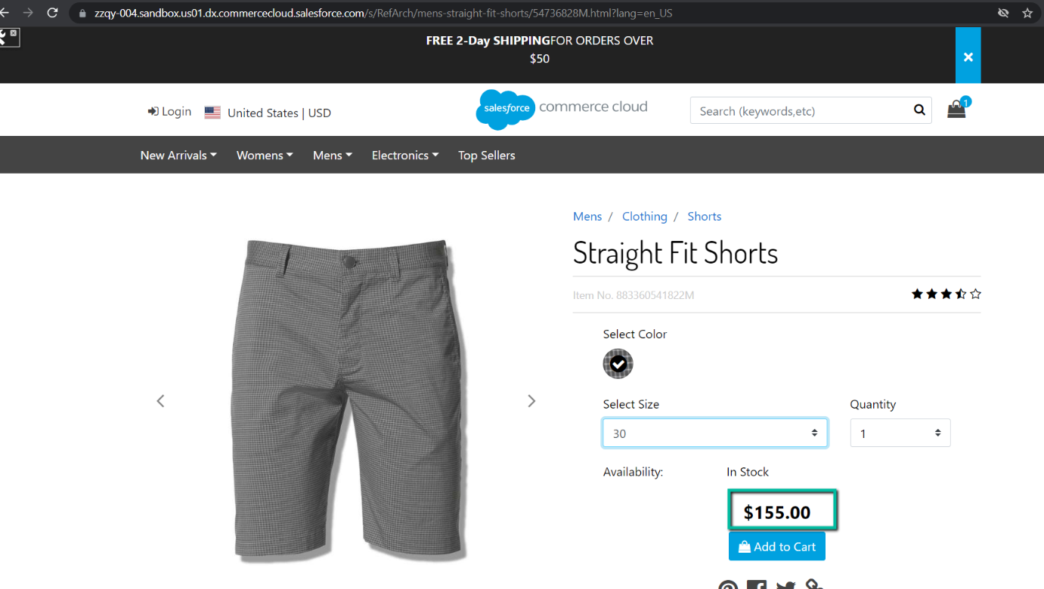
Add product to the shopping cart and ensure that the same price is displayed in the mini cart and shopping cart: 155 USD.
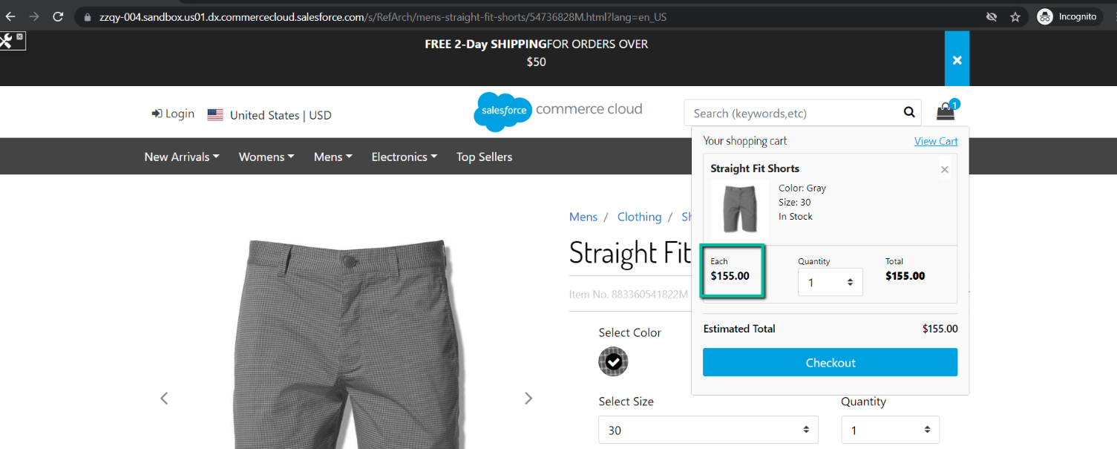
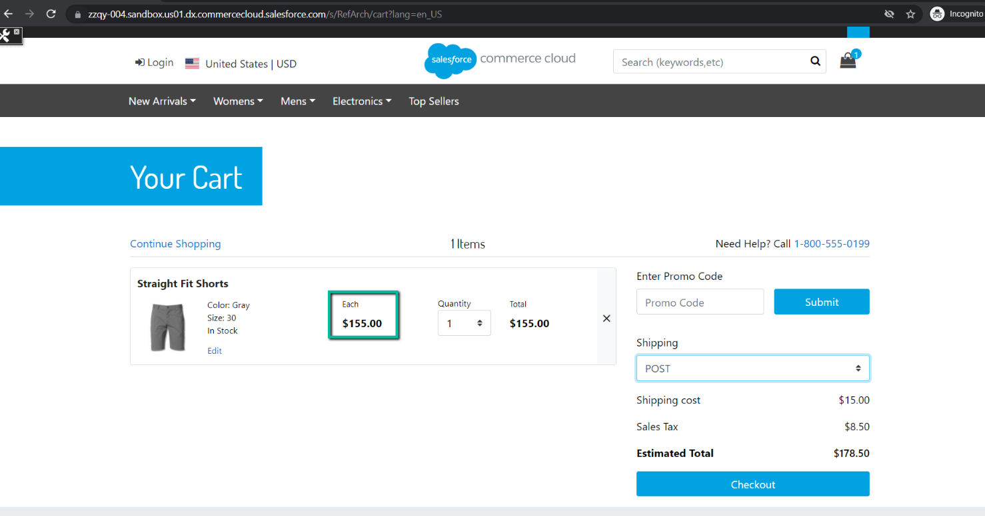
Navigate to Native checkout and ensure that product price is the same as on the storefront: 155 USD. Native order is not created in SFCC BM (Merchant Tools > Ordering > Orders).
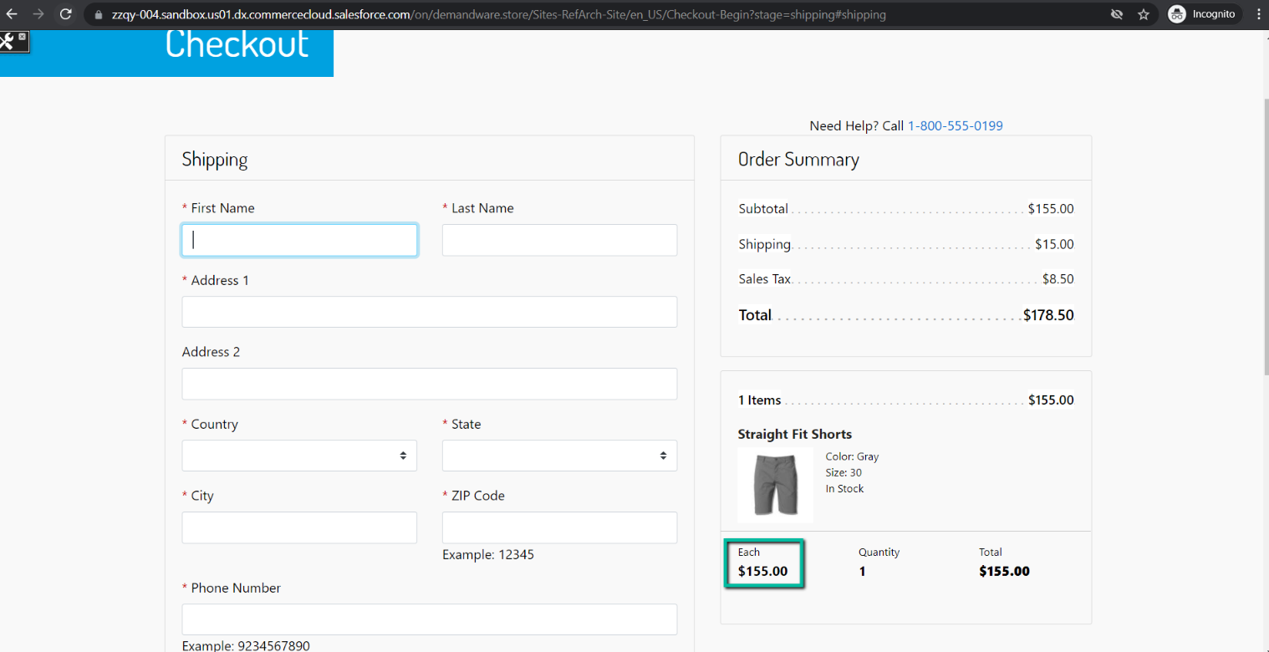
Enter Delivery / Payment information, card details, pay an order and ensure that the order is placed successfully.
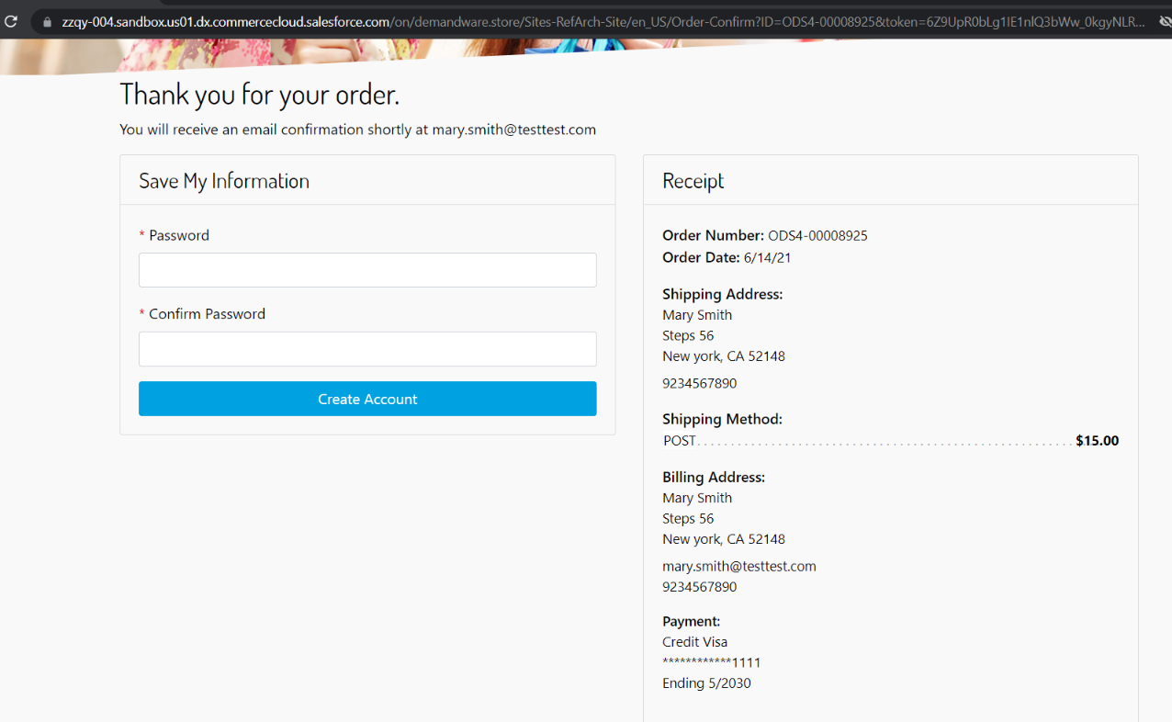
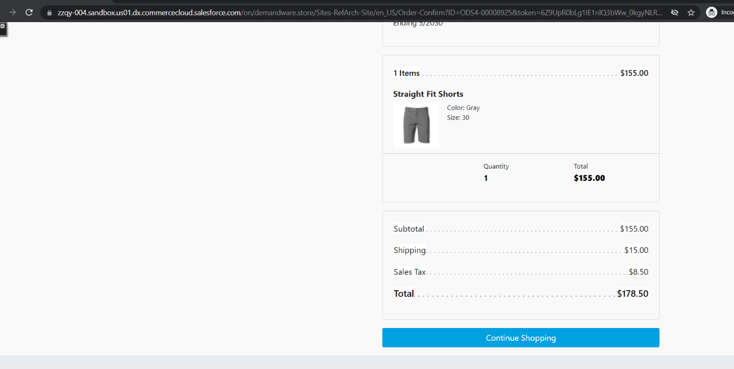
Check that order appears with New state in SFCC BM after it was placed successfully.
