


Version: 5.1.2
Published date: August 2026
Copyright © 2026 by ESW. All rights reserved. Information contained herein is subject to change without notice.

ESW- Share Marketing Opt-In
INTEGRATION GUIDE

SFCC - ESW Cartridge
+
Contents
1 ESW Marketing Opt-Ins 3
1.1 Benefits 3
1.2 ESW Marketing Opt-in Configuration 7
1.3 First-time Experience- New shoppers without any opt-in selection to ESW checkout 8
1.4 Repeat Opt-in selected Shoppers Experience- Returning Shoppers are presented with the Email Marketing opt-in & SMS Marketing opt-in selected on ESW checkout 9
1.5 Testing Sandbox/Staging Environment 10

ESW Marketing Opt-Ins
  - Benefits
Following are some benefits of using the ESW marketing opt-in feature.
- This ESW opt-in allows retailers to create separate newsletters or intimidation emails for ESW opted-in shoppers. The ESW cartridge also supports SMS opt in, Phone & Post opt-in
- Registered Shoppers stored opt-in preference value can be passed to the pre-order payload, which will turn on opt-in preference on ESW checkout for already opted-in shoppers.
- The registered shoppers will be able to opt-out by unchecking opt-in preference on ESW checkout.
In addition to checkout shoppers’ registration, Retailers can store opt-in shoppers’ lists on the marketing cloud, i.e. (SFMC, Bronto).
How does this work?
Enabling the Opt-Ins
ESW cartridge supports the below
- Email Marketing Opt-in
- SMS Marketing Opt-in
- Phone Marketing Opt-in
- Post Marketing Opt-in
These are controllable on the site level as well as the country level within SFCC.
To enable the opt-in on Site Level navigate to Merchant Tools > Site Preferences > Custom Site Preferences Group > ESW Checkout Configuration
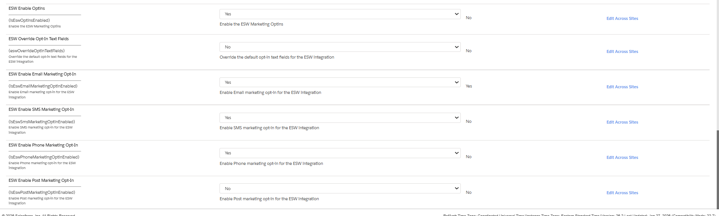
The feature is controllable via a custom preference ESW Enable Optins. Enabling this preference unlocks the granular control on the country opt-ins and allows retailers to enable/disable each opt-in type.
If the preference is disabled by default Email & SMS optin are enabled in the preorder request.
To enable additional opt-ins or to disable Email/SMS opt-in, toggle the ESW Enable Optin custom preference value to “Yes” And then you can control the opt-ins using the corresponding custom preference.
The cartridge also provides flexibility to manage opt-ins at the country level. For example, if SMS opt-in is enabled globally but needs to be hidden for specific countries, this can be configured through the cartridge.
To hide an opt-in for a specific country:
- Go to Merchant Tools > Custom Objects > Manage Custom Objects.
- Open the custom object for the desired country.
- Update the opt-in settings as needed.
.
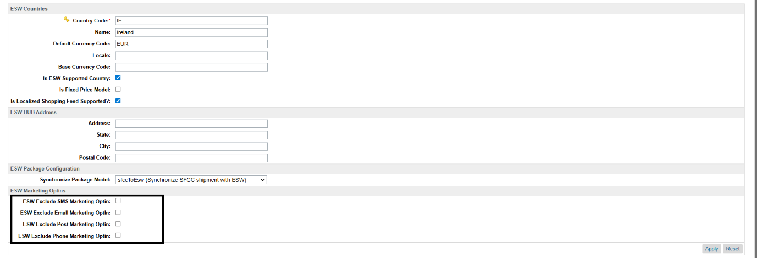
To hide one or more opt-ins for a specific country, select the corresponding checkbox. If the custom preference is enabled, all opt-ins will appear at checkout by default. For example, to hide the Post opt-in for Ireland (IE) only, check the ESW Exclude Post Marketing Opt-in option.
. 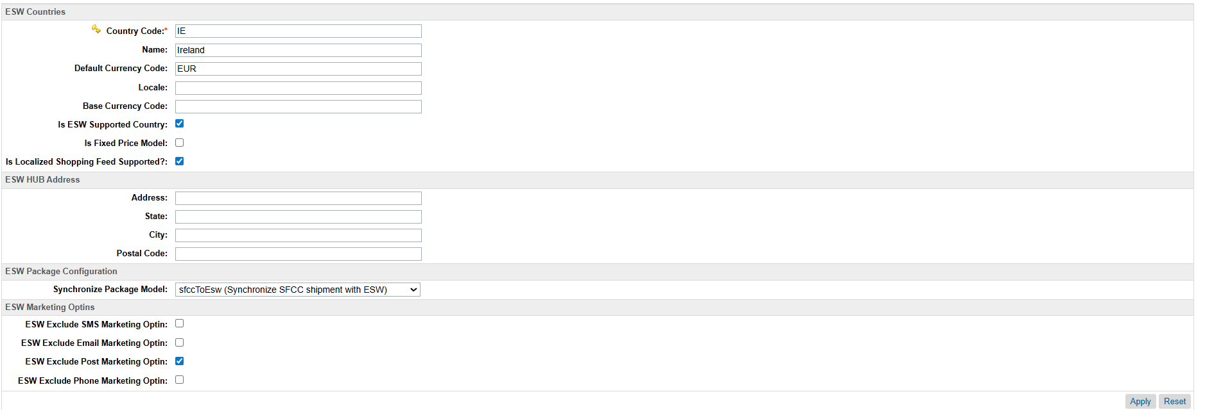

ESW Email Marketing Opt-in:
The following flow depicts how marketing opt-in works. Please note the retailer needs to enable the email marketing opt-in on the custom preference level and ensure that it is not excluded on the country’s custom object level as described above.
Flow is divided into two steps according to customers.
- Customer checks out

When the shopper adds an item to their cart and clicks Checkout, the following steps occur:

  - If the customer is logged in and has checked the opt-in custom profile preference, the email meta field is added to the marketingOptins in the pre-order request with the isSelected attribute value of true. This will cause the customer to be opted in to marketing emails on the ESW checkout page.

  - If the shopper is a first time shopper, a guest customer or has unchecked the opt-in custom profile preference, the email meta field is added to the marketingOptins in the pre-order request with the isSelected attribute value of false. This will cause the customer to be opted out of marketing emails on the ESW checkout page.

- ESW updates the order configuration in SFCC.
Once the shopper has checked out and the order has been placed successfully, ESW order confirmation webhook calls SFCC endpoint to update the order attributes in SFCC.

  - If the customer checked the marketing opt-in preference on the ESW checkout page, ESW will update the customer's eswMaretingOptIn profile preference in SFCC to true.

  - If the customer unchecked the opt-in preference on the ESW checkout page, ESW will update the customer's eswMaretingOptIn profile preference in SFCC to false.

ESW SMS Marketing Opt-in:
The following flow depicts how SMS marketing opt-in works Please note the retailer needs to enable the SMS marketing opt-in on the custom preference level and ensure that it is not excluded on the country’s custom object level.
The flow is divided into two steps:
- Customer checks out

When the shopper adds an item to their cart and clicks Checkout, the following steps occur:

  - If the customer is logged in and has checked the SMS marketing opt-in custom profile preference, then the Sms meta field is added to the marketingOptins in the pre-order request with the isSelected attribute value of true. This will cause the customer to be opted in to SMS marketing on the ESW checkout page.

  - If the shopper is a first time shopper, a guest customer or has unchecked the SMS opt-in custom profile preference, the email meta field is added to the marketingOptins in the pre-order request with the isSelected attribute value of false. This will cause the customer to be opted out of SMS marketing on the ESW checkout page.

- ESW updates the order configuration in SFCC.
Once the shopper has checked out and the order has been placed successfully, ESW order confirmation webhook calls SFCC endpoint to update the order attributes in SFCC.

  - If the customer checked the SMS opt-in preference on the ESW checkout page, ESW will update the customer's eswSMSMarketingOptin profile preference in SFCC to true.

  - If a registered customer unchecked the SMS opt-in preference on the ESW checkout page, ESW will update the customer's eswSMSMarketingOptin profile preference in SFCC to false.

  - For guest shoppers, if a profile is found with the email used in order then the profile attribute will be updated only if the shopper checked the SMS marketing optin. This means that if the customer did not check the SMS marketing optin checkbox on ESW checkout, there would be no change in the profile attribute

  - Guest shoppers who register after placing an order using the post-registration feature will have their SMS opt-in value populated on their newly created profile.

ESW Phone Marketing Opt-in:
The following flow depicts how Phone marketing opt-in works. Please note the retailer needs to enable the Phone marketing opt-in on the custom preference level and ensure that it is not excluded on the country’s custom object level.
The flow is divided into two steps:
- Customer checks out

When the shopper adds an item to their cart and clicks Checkout, the following steps occur:

  - If the customer is logged in and has checked the Phone marketing opt-in custom profile preference, then the Phone meta field is added to the marketingOptins in the pre-order request with the isSelected attribute value of true. This will cause the customer to be opted in to Phone marketing on the ESW checkout page.

  - If the shopper is a first time shopper, a guest customer or has unchecked the Phone opt-in custom profile preference, then the Phone meta field is added to the marketingOptins in the pre-order request with the isSelected attribute value of true.. This will cause the customer to be opted out of SMS marketing on the ESW checkout page.

- ESW updates the order configuration in SFCC.
Once the shopper has checked out and the order has been placed successfully, ESW order confirmation webhook calls SFCC endpoint to update the order attributes in SFCC.

  - If the customer checked the Phone opt-in preference on the ESW checkout page, ESW will update the customer's eswPhoneMarketingOptIn profile preference in SFCC to true.

  - If a registered customer unchecked the Phone opt-in preference on the ESW checkout page, ESW will update the customer's eswPhoneMarketingOptIn profile preference in SFCC to false.

  - For guest shoppers, if a profile is found with the email used in order then the profile attribute will be updated only if the shopper checked the Phone marketing optin. This means that if the customer did not check the Phone marketing optin checkbox on ESW checkout, there would be no change in the profile attribute

  - Guest shoppers who register after placing an order using the post-registration feature will have their Phone opt-in value populated on their newly created profile.

ESW Post Marketing Opt-in:
The following flow depicts how Post marketing opt-in works. Please note the retailer needs to enable the Post marketing opt-in on the custom preference level and ensure that it is not excluded on the country’s custom object level.
The flow is divided into two steps:
- Customer checks out

When the shopper adds an item to their cart and clicks Checkout, the following steps occur:

  - If the customer is logged in and has checked the Post marketing opt-in custom profile preference, then the Post meta field is added to the marketingOptins in the pre-order request with the isSelected attribute value of true. This will cause the customer to be opted in to Post marketing on the ESW checkout page.

  - If the shopper is a first time shopper, a guest customer or has unchecked the SMS opt-in custom profile preference, then the Post meta field is added to the marketingOptins in the pre-order request with the isSelected attribute value of true. This will cause the customer to be opted out of Post marketing on the ESW checkout page.

- ESW updates the order configuration in SFCC.
Once the shopper has checked out and the order has been placed successfully, ESW order confirmation webhook calls SFCC endpoint to update the order attributes in SFCC.

  - If the customer checked the Post opt-in preference on the ESW checkout page, ESW will update the customer's eswPostMarketingOptIn profile preference in SFCC to true.

  - If a registered customer unchecked the Post opt-in preference on the ESW checkout page, ESW will update the customer's eswPostMarketingOptIn profile preference in SFCC to false.

  - For guest shoppers, if a profile is found with the email used in order then the profile attribute will be updated only if the shopper checked the Post marketing optin. This means that if the customer did not check the Post marketing optin checkbox on ESW checkout, there would be no change in the profile attribute

  - Guest shoppers who register after placing an order using the post-registration feature will have their Post opt-in value populated on their newly created profile.
Note: If any third party is used to manage marketing optin, the ESW cartridge’s functions can be customized to meet the to meet the requirements for both the order confirmation and checkout API endpoints.
  - ESW Marketing Opt-in Configuration
ESW Marketing Opt-ins Custom Preference
The following custom preference in the group ESW Checkout Configuration is added
- ESW Enable Optins: When enabled, this preferences unlocks the granular level control for the marketing opt-ins (Email,SMS,Phone & Post). When disabled, the flow falls back to default behaviour which is Email & SMS opt-in. By Default, this preference will be disabled.
- ESW Override Opt-In Text Fields: This value dictates if the default Opt-in legal hint text will be overridden on the ESW checkout. To override the default legal hint text, the retailers can turn the above preference on and edit the marketing sign text in the file esw.properties. This toggle will only take place if ESW Enable Optins is enabled
- ESW Enable Email Marketing Opt-In: This preference enables/disables the email marketing optin on Site level. By default, it is enabled. This toggle will only take place if ESW Enable Optins is enabled
- ESW Enable SMS Marketing Opt-In : This preference enables/disables the sms marketing optin on Site level. By default, it is disabled. This toggle will only take place if ESW Enable Optins is enabled
- ESW Enable Phone Marketing Opt-In: : This preference enables/disables the Phone marketing optin on Site level. By default, it is disabled. This toggle will only take place if ESW Enable Optins is enabled
- ESW Enable Post Marketing Opt-In: : This preference enables/disables the Post marketing optin on Site level. By default, it is disabled. This toggle will only take place if ESW Enable Optins is enabled
ESW Marketing Opt-ins Attributes on country’s custom object level
The country’s custom object can be used to enable/disable the opt-ins. The cartridge gives the flexibility to control the opt-ins based on different markets. The following attributes are added on the country custom object level
- ESW Exclude SMS Marketing Optin: If marked as true, the SMS opt-in marketing will be will be excluded from the preorder request and will not be visible on the checkout
- ESW Exclude Email Marketing Optin: If marked as true, the Email marketing opt-in will be excluded from the preorder request and will not be visible on the checkout
- ESW Exclude Post Marketing Optin: If marked as true, the Post marketing opt-in will be excluded from the preorder request and will not be visible on the checkout
- ESW Exclude Phone Marketing Optin: If marked as true, the Phone marketing opt-in will be excluded from the preorder request and will not be visible on the checkout
ESW Marketing Opt-ins Attributes on customer profile level
Customer profiles can be used to manage ESW opt-in, allowing merchants to create separate newsletters for opted-in shoppers. To access customer profiles, navigate to Merchant Tools > Customers > Customer Profile.
Each customer profile will include the following attributes:
- ESW Email Marketing Optin: This attribute determines whether the customer is opted in to ESW marketing emails.
- ESW SMS Marketing Optin: This attribute determines whether the customer is opted in to ESW SMS marketing.
- ESW Phone Marketing Optin: This attribute determines whether the customer is opted in to ESW Phone marketing
- ESW Post Marketing Optin: This attribute determines whether the customer is opted in to ESW Post marketing
Merchants can use these attributes to filter their customer list and send targeted marketing messages.
  - First-time Experience- New shoppers without any opt-in selection to ESW checkout
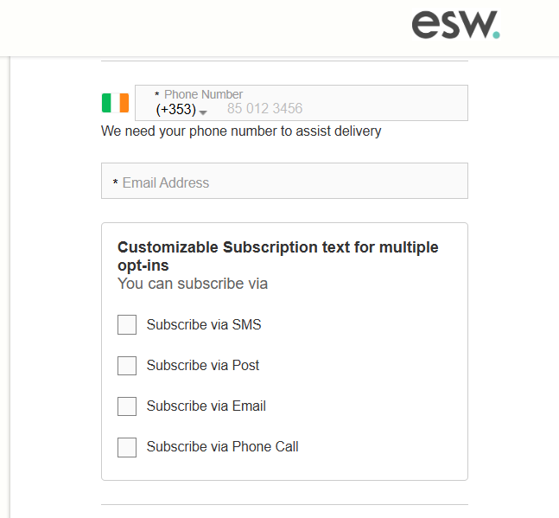
Once the order is placed with the above checkboxes checked. The information is updated in SFCC as well.

  - Repeat Opt-in selected Shoppers Experience- Returning Shoppers are presented with the Email Marketing opt-in & SMS Marketing opt-in selected on ESW checkout
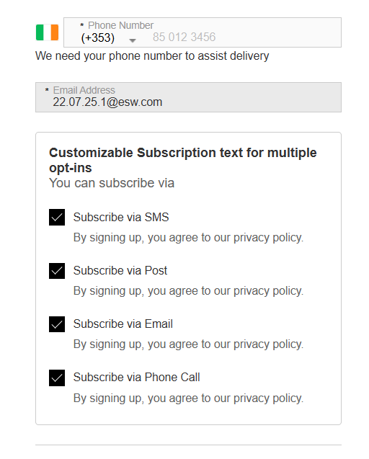

  - Testing Sandbox/Staging Environment
There are two options to test this feature in a sandbox/staging environment.
- Create an order with a newly registered customer following the ESW checkout flow.
- Ensure that the required opt-ins are enabled on the custom preference level 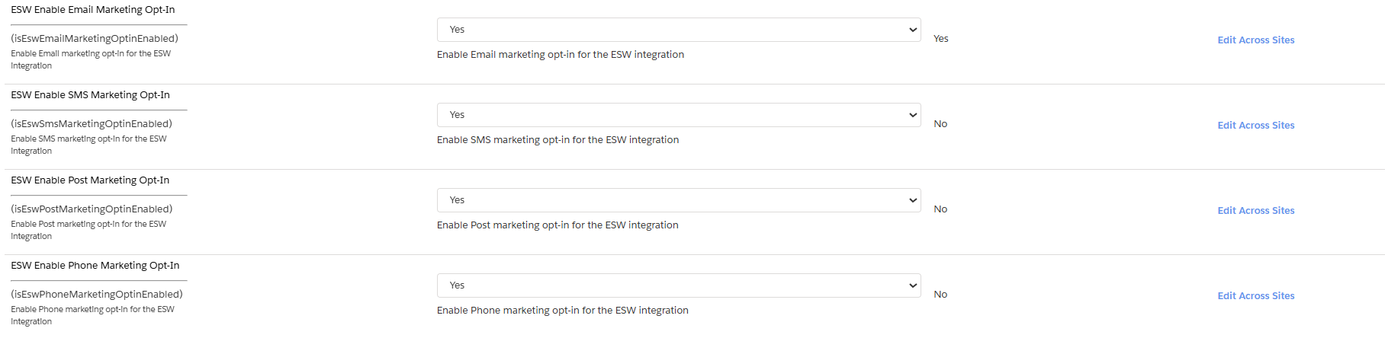
- Ensure that the required opt-ins are not marked as hidden on the country level custom object 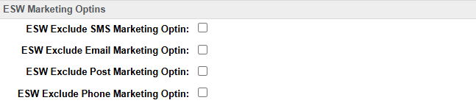
- Review that the registered customer profile custom attributes is set to false.
- On ESW checkout, select the Email marketing opt-in or SMS marketing opt-in checkbox to be true and place the order.

- Check customer’s profile custom attributes is set to true.

- Place an order with the existing account and opted-in for customer preference.
- Review that the registered customer profile custom attributes are set to true
- On ESW checkout, confirm and deselect the Email marketing opt-in & SMS marketing opt-in checkbox to true and place the order.

- Preview the customer’s profile to confirm if the Email marketing opt-in & SMS marketing opt-in reverted to false.

