

SFRA - Code Customization guide

Version: 4.0

Published date: Septemeber 2023

Copyright © 2023 by ESW. All rights reserved. Information contained herein is subject to change without notice.



**SFCC - ESW Cartridge**

+

Table of Contents

Table of Contents 2

1 Storefront Reference Architecture 4

Customizing the code 4

1.1 Customizing the template 4

1.1.1 page.isml 4

1.1.2 pageHeader.isml 4

1.1.3 pageFooterESW.isml 5

1.1.4 htmlHead.isml 6

1.1.5 cart.isml 6

1.1.6 cartTotals.isml 7

1.1.7 cartCouponDisplay.isml 8

1.1.8 checkoutButtons.isml 8

1.1.9 main.isml 8

1.1.10 default.isml 9

1.1.11 setPrice.isml 10

1.1.12 productTiles.isml 11

1.1.13 homePageProductSlot.isml 11

1.1.14 cartProductCardProductPrice.isml 12

1.1.15 shippingSummary.isml 13

1.1.16 addToCartGlobal.isml 13

1.1.17 addToCartProduct.isml 14

1.1.18 updateCartProduct.isml 14

1.1.19 productCardProductTotalPrice.isml 15

1.1.20 mobileCountrySelector.isml 16

1.1.21 bundleDetails.isml 17

1.1.22 setDetails.isml 17

1.2 Customizing the controllers 18

1.2.1 Page.js 18

1.2.2 Cart.js 18

1.2.3 Checkout.js 20

1.2.4 CheckoutServices.js 20

1.2.5 Tile.js 20

1.3 Customizing the models 21

1.3.1 priceTotal.js 21

1.3.2 searchPrice.js 22

1.3.3 base.js 24

1.3.4 fullProduct.js 24

1.4 Customizing the scripts and json 24

1.4.1 taxes.js 24

1.4.2 validateBasket.js 25

1.4.3 calculate.js 25

1.4.4 detail.js 27

1.4.5 quickView.js 27

1 Storefront Reference Architecture

Customizing the code

1.1 Customizing the template

1.1.1 page.isml

| Path |
| --- |
| int_eshopworld_sfra/cartridge/templates/default/common/layout/page.isml |

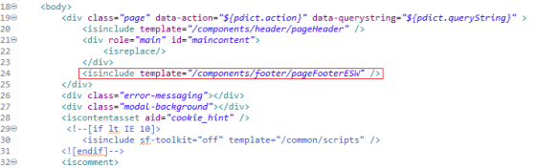

|  |
| --- |
| <isinclude template=*"/components/footer/pageFooterESW"* /> |

1.1.2 pageHeader.isml

| Path |
| --- |
| int_eshopworld_sfra/cartridge/templates/default/components/header/pageHeader.isml |

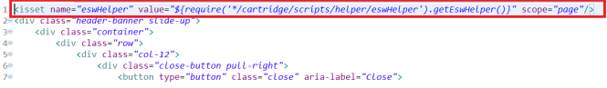

|  |
| --- |
| <isset name=*"eswHelper"* value=*"${require('*/cartridge/scripts/helper/eswHelper').getEswHelper()}"* scope=*"page"*/> |



|  |
| --- |
| <isif condition="${isEswEnabled && eswHelper.getEnableLandingPage() && request.httpParameterMap.get(dw.system.Site.current.preferences.custom.eswCountryUrlParam) == false}">      <isinclude url="${URLUtils.url('EShopWorld-GetEswLandingPage',dw.system.Site.current.getCustomPreferenceValue('eswCountryUrlParam'), pdict.CurrentHttpParameterMap.get(dw.system.Site.current.getCustomPreferenceValue('eswCountryUrlParam')))}"/>  </isif> |
| <isif condition="${isEswEnabled}">      <isinclude url="${URLUtils.url('EShopWorld-GetEswHeader', dw.system.Site.current.getCustomPreferenceValue('eswCountryUrlParam'),pdict.CurrentHttpParameterMap.get(dw.system.Site.current.getCustomPreferenceValue('eswCountryUrlParam')))}"/>  </isif>  <isif condition="${isEswEnabled && eswHelper.isFrontendConversionEnabled()}">      <isinclude url="${URLUtils.url('EShopWorld-GetEswAppResources', dw.system.Site.current.getCustomPreferenceValue('eswCountryUrlParam'),pdict.CurrentHttpParameterMap.get(dw.system.Site.current.getCustomPreferenceValue('eswCountryUrlParam')))}"/>  </isif>  <isif condition="${isEswEnabled && eswHelper.isESWSupportedCountry()}">      <i class="eshopworld-loader d-none"></i>  </isif> |

1.1.3 pageFooterESW.isml

| Path |
| --- |
| int_eshopworld_sfra/cartridge/templates/default/components/footer/pageFooterESW.isml |

|  |
| --- |
| <isif condition="${eswHelper.getEShopWorldModuleEnabled()}">      <isinclude url="${URLUtils.url('EShopWorld-GetEswFooter',dw.system.Site.current.getCustomPreferenceValue('eswCountryUrlParam'), pdict.CurrentHttpParameterMap.get(dw.system.Site.current.getCustomPreferenceValue('eswCountryUrlParam')))}"/>  </isif> |

1.1.4 htmlHead.isml

| Path |
| --- |
| int_eshopworld_sfra/cartridge/templates/default/common/htmlHead.isml |

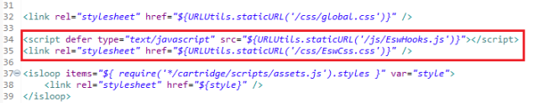

|  |
| --- |
| <script defer type=*"text/javascript"* src=*"${URLUtils.staticURL('/js/EswHooks.js')}"*></script>  <link rel=*"stylesheet"* href=*"${URLUtils.staticURL('/css/EswCss.css')}"* /> |

1.1.5 cart.isml

| Path |
| --- |
| int_eshopworld_sfra/cartridge/templates/default/cart/cart.isml |

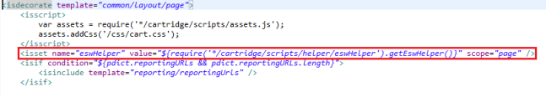

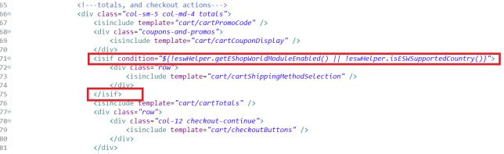

|  |
| --- |
| <isset name=*"eswHelper"* value=*"${require('*/cartridge/scripts/helper/eswHelper').getEswHelper()}"* scope=*"page"* /> |
| <isif condition=*"${!eswHelper.getEShopWorldModuleEnabled() || !eswHelper.isESWSupportedCountry()}"*>  <div class=*"row"*>  <isinclude template=*"cart/cartShippingMethodSelection"* />  </div>  </isif> |

1.1.6 cartTotals.isml

| Path |
| --- |
| int_eshopworld_sfra/cartridge/templates/default/cart/cartTotals.isml |

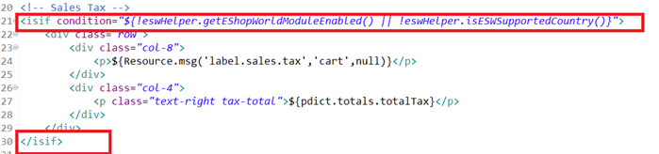

|  |
| --- |
| <isif condition=*"${!eswHelper.getEShopWorldModuleEnabled() || !eswHelper.isESWSupportedCountry()}"*>  <div class=*"row"*>  <div class=*"col-8"*>  <p>${Resource.msg('label.sales.tax','cart',null)}</p>  </div>  <div class=*"col-4"*>  <p class=*"text-right tax-total"*>${pdict.totals.totalTax}</p>  </div>  </div>  </isif> |

1.1.7 cartCouponDisplay.isml

| Path |
| --- |
| /int_eshopworld_sfra/cartridge/templates/default/cart/cartCouponDisplay.isml |

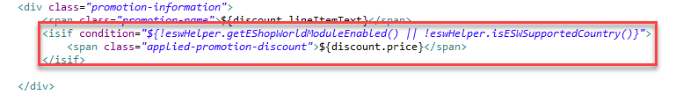

|  |
| --- |
| <isif condition=*"${!eswHelper.getEShopWorldModuleEnabled() || !eswHelper.isESWSupportedCountry()}"*>  <span class=*"applied-promotion-discount"*>${discount.price}</span>  </isif> |

1.1.8 checkoutButtons.isml

| Path |
| --- |
| int_eshopworld_sfra/cartridge/templates/default/cart/checkoutButtons.isml |

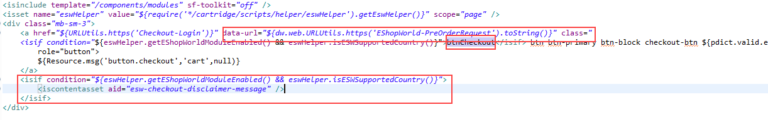

|  |
| --- |
| <a href=*"${URLUtils.https('Checkout-Login')}"* data-url=*"${dw.web.URLUtils.https('EShopWorld-PreOrderRequest').toString()}"* class=*"*  *<isif condition="*${eswHelper.getEShopWorldModuleEnabled() && !!eswHelper.checkIsEswAllowedCountry(request.httpCookies['esw.location'].value)}">btnCheckout</isif> btn btn-primary btn-block checkout-btn ${pdict.valid.error ? 'disabled' : ''}" role="button"> |
| <isif condition=*"${eswHelper.getEShopWorldModuleEnabled() && eswHelper.isESWSupportedCountry()}"*>  <iscontentasset aid=*"esw-checkout-disclaimer-message"* />  </isif> |

1.1.9 main.isml

| Path |
| --- |
| int_eshopworld_sfra/cartridge/templates/default/product/components/pricing/main.isml |

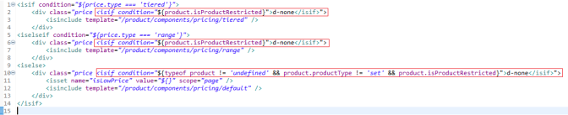

|  |
| --- |
| <div class=*"price <isif condition="*${product.isProductRestricted}">d-none</isif>"> |
| <div class=*"price <isif condition="*${product.isProductRestricted}">d-none</isif>"> |
| <div class=*"price <isif condition="*${typeof product != *'undefined'* && product.productType != *'set'* && product.isProductRestricted}">d-none</isif>"> |

1.1.10 default.isml

| Path |
| --- |
| int_eshopworld_sfra/cartridge/templates/default/product/components/pricing/default.isml |

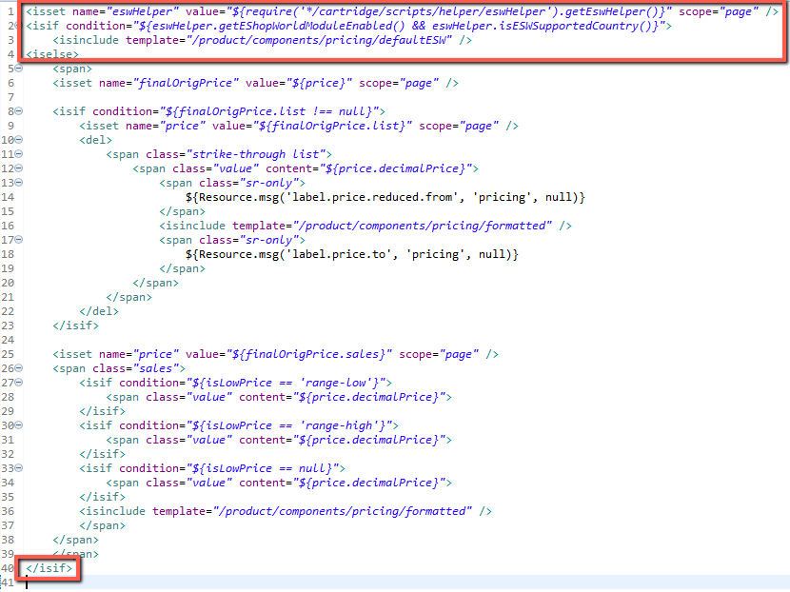

|  |
| --- |
| <isset name=*"eswHelper"* value=*"${require('*/cartridge/scripts/helper/eswHelper').getEswHelper()}"* scope=*"page"* />  <isif condition=*"${eswHelper.getEShopWorldModuleEnabled() && eswHelper.isESWSupportedCountry()}"*>  <isinclude template=*"/product/components/pricing/defaultESW"* />  <iselse>  ... |
| ...  </isif> |

1.1.11 setPrice.isml

| Path |
| --- |
| int_eshopworld_sfra/cartridge/templates/default/product/components/pricing/setPrice.isml |

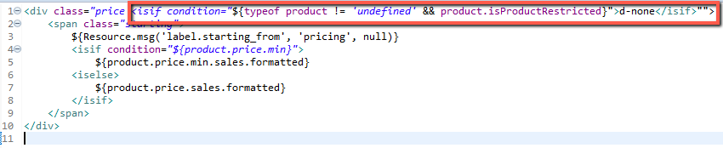

|  |
| --- |
| <div class=*"price <isif condition="*${typeof product != *'undefined'* && product.isProductRestricted}">d-none</isif>"">  <span class=*"starting"*>  ${Resource.msg('label.starting_from', 'pricing', null)}  <isif condition=*"${product.price.min}"*>  ${product.price.min.sales.formatted}  <iselse>  ${product.price.sales.formatted}  </isif>  </span>  </div> |

1.1.12 productTiles.isml

| Path |
| --- |
| int_eshopworld_sfra/cartridge/templates/default/search/components/productTiles.isml |

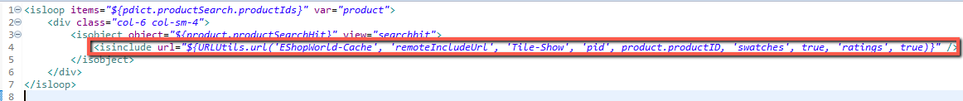

|  |
| --- |
| <isinclude url=*"${URLUtils.url('EShopWorld-Cache', 'remoteIncludeUrl', 'Tile-Show', 'pid', product.productID, 'swatches', true, 'ratings', true)}"* /> |

1.1.13 homePageProductSlot.isml

| Path |
| --- |
| int_eshopworld_sfra/cartridge/templates/default/slots/product/homePageProductSlot.isml |

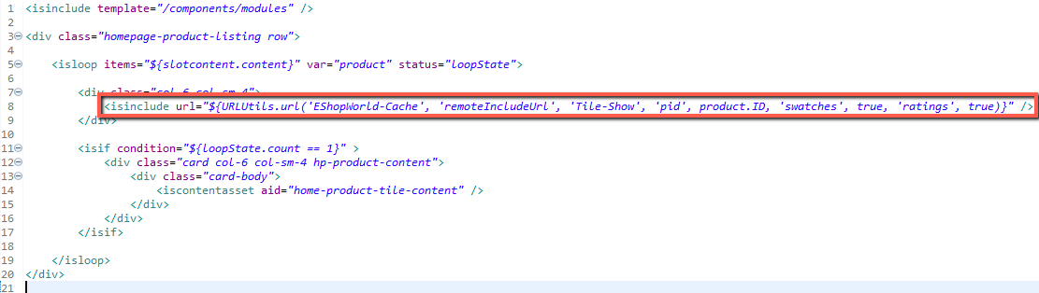

|  |
| --- |
| <isinclude url=*"${URLUtils.url('EShopWorld-Cache', 'remoteIncludeUrl', 'Tile-Show', 'pid', product.ID, 'swatches', true, 'ratings', true)}"* /> |

1.1.14 cartProductCardProductPrice.isml

| Path |
| --- |
| int_eshopworld_sfra/cartridge/templates/default/cart/productCard/cartProductCardProductPrice.isml |

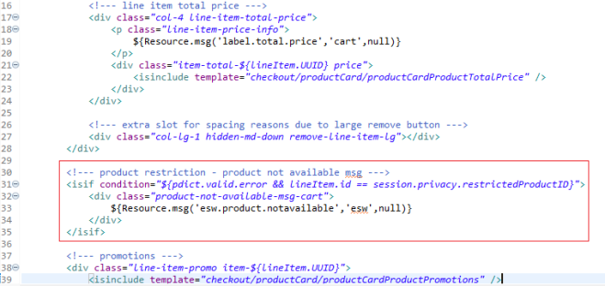

|  |
| --- |
| <!--- product restriction - product not available msg --->  <isif condition=*"${pdict.valid.error && lineItem.id == session.privacy.restrictedProductID}"*>  <div class=*"product-not-available-msg-cart"*>  ${Resource.msg('esw.product.notavailable','esw',null)}  </div>  </isif> |

1.1.15 shippingSummary.isml

| Path |
| --- |
| int_eshopworld_sfra/cartridge/templates/default/checkout/shipping/shippingSummary.isml |

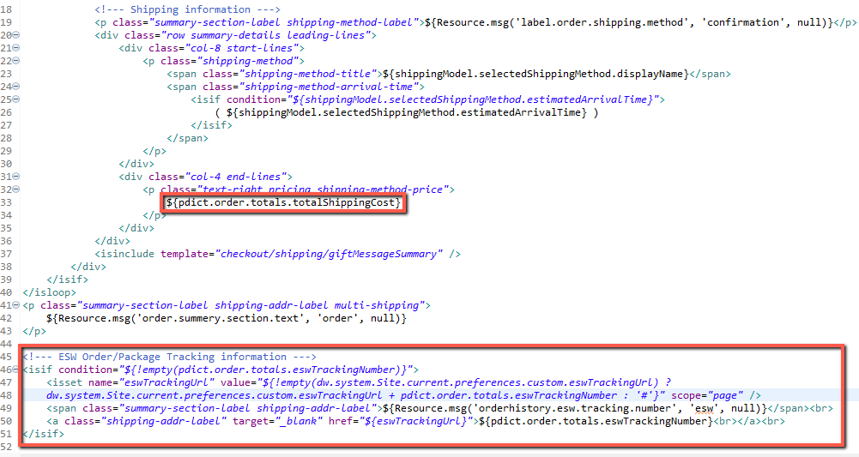

|  |
| --- |
| ${pdict.order.totals.totalShippingCost} |
| <!--- ESW Order/Package Tracking information --->  <isif condition=*"${!empty(pdict.order.totals.eswTrackingNumber)}"*>  <isset name=*"eswTrackingUrl"* value=*"${!empty(dw.system.Site.current.preferences.custom.eswTrackingUrl) ? dw.system.Site.current.preferences.custom.eswTrackingUrl + pdict.order.totals.eswTrackingNumber : '#'}"* scope=*"page"* />  <span class=*"summary-section-label shipping-addr-label"*>${Resource.msg('orderhistory.esw.tracking.number', 'esw', null)}</span><br>  <a class=*"shipping-addr-label"* target=*"_blank"* href=*"${eswTrackingUrl}"*>${pdict.order.totals.eswTrackingNumber}<br></a><br>  </isif> |

1.1.16 addToCartGlobal.isml

| Path |
| --- |
| int_eshopworld_sfra/cartridge/templates/default/product/components/addToCartGlobal.isml |

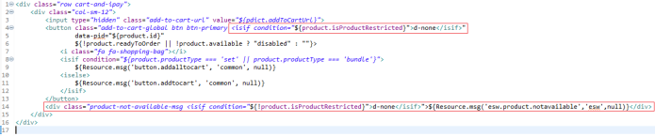

|  |
| --- |
| <button class=*"add-to-cart-global btn btn-primary <isif condition="*${product.isProductRestricted}">d-none</isif>" |
| <div class=*"product-not-available-msg <isif condition="*${!product.isProductRestricted}">d-none</isif>">${Resource.msg('esw.product.notavailable','esw',null)}</div> |

1.1.17 addToCartProduct.isml

| Path |
| --- |
| int_eshopworld_sfra/cartridge/templates/default/product/components/addToCartProduct.isml |

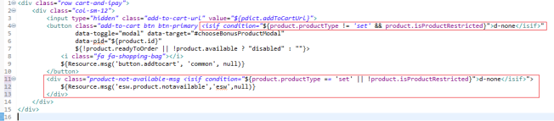

|  |
| --- |
| <button class=*"add-to-cart btn btn-primary <isif condition="*${product.productType != *'set'* && product.isProductRestricted}">d-none</isif>" |
| <div class=*"product-not-available-msg <isif condition="*${product.productType =*=* 'set' || !product.isProductRestricted}">d-none</isif>">${Resource.msg('esw.product.notavailable','esw',null)}</div> |

1.1.18 updateCartProduct.isml

| Path |
| --- |
| int_eshopworld_sfra/cartridge/templates/default/product/components/updateCartProduct.isml |

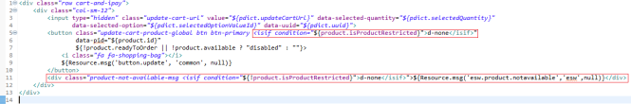

|  |
| --- |
| <button class=*"update-cart-product-global btn btn-primary <isif condition="*${product.isProductRestricted}">d-none</isif>" |
| <div class=*"product-not-available-msg <isif condition="*${!product.isProductRestricted}">d-none</isif>">${Resource.msg('esw.product.notavailable','esw',null)}</div> |

1.1.19 productCardProductTotalPrice.isml

| Path |
| --- |
| int_eshopworld_sfra/cartridge/templates/default/checkout/productCard/productCardProductTotalPrice.isml |

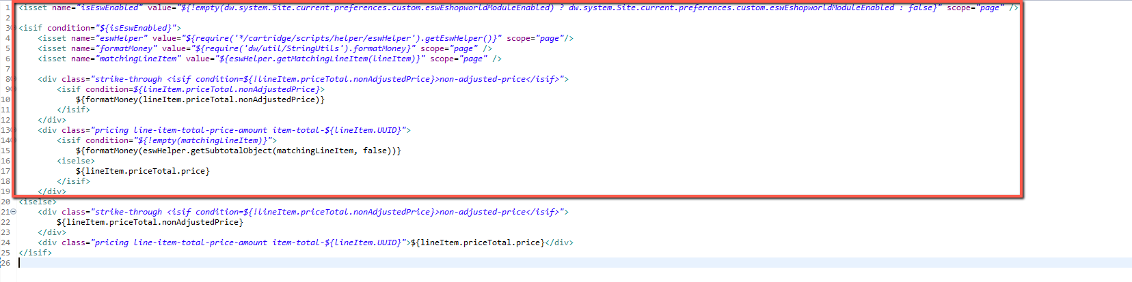

|  |
| --- |
| <isset name=*"isEswEnabled"* value=*"${!empty(dw.system.Site.current.preferences.custom.eswEshopworldModuleEnabled) ? dw.system.Site.current.preferences.custom.eswEshopworldModuleEnabled : false}"* scope=*"page"* />  <isif condition=*"${isEswEnabled}"*>  <isset name=*"eswHelper"* value=*"${require('*/cartridge/scripts/helper/eswHelper').getEswHelper()}"* scope=*"page"*/>  <isset name=*"formatMoney"* value=*"${require('dw/util/StringUtils').formatMoney}"* scope=*"page"* />  <isset name=*"matchingLineItem"* value=*"${eswHelper.getMatchingLineItem(lineItem)}"* scope=*"page"* />    <div class=*"strike-through <isif condition=${!lineItem.priceTotal.nonAdjustedPrice}>non-adjusted-price</isif>"*>  <isif condition=*${lineItem.priceTotal.nonAdjustedPrice}*>  ${formatMoney(lineItem.priceTotal.nonAdjustedPrice)}  </isif>  </div>  <div class=*"pricing line-item-total-price-amount item-total-${lineItem.UUID}"*>  <isif condition=*"${!empty(matchingLineItem)}"*>  ${formatMoney(eswHelper.getSubtotalObject(matchingLineItem, false))}  <iselse>  ${lineItem.priceTotal.price}  </isif>  </div>  <iselse>  <div class=*"strike-through <isif condition=${!lineItem.priceTotal.nonAdjustedPrice}>non-adjusted-price</isif>"*>  ${lineItem.priceTotal.nonAdjustedPrice}  </div>  <div class=*"pricing line-item-total-price-amount item-total-${lineItem.UUID}"*>${lineItem.priceTotal.price}</div>  </isif> |

1.1.20 mobileCountrySelector.isml

| Path |
| --- |
| int_eshopworld_sfra/cartridge/templates/default/components/header/mobileCountrySelector.isml |

|  |
| --- |
| <isset name=*”isEswEnabled”* value=*”${!empty(dw.system.Site.current.preferences.custom.eswEshopworldModuleEnabled) ? dw.system.Site.current.preferences.custom.eswEshopworldModuleEnabled : false}”* scope=*”page”* />  <isif condition=*”${isEswEnabled}”*>  <isset name=*”eswHelper”* value=*”${require(‘*/cartridge/scripts/helper/eswHelper’).getEswHelper()}”* scope=*”page”*/>  </isif>  <isif condition=*”${!isEswEnabled && pdict.localeModel.locale.localeLinks.length > 0}”*>  <li class=*”menu-item dropdown country-selector d-md-none”* data-url=*”${URLUtils.url(‘Page-SetLocale’)}”*>  <span class=*”btn dropdown-toggle”* id=*”dropdownCountrySelector”* data-toggle=*”dropdown”* aria-haspopup=*”true”* aria-expanded=*”false”*>  <I class=*”flag-icon flag-icon-${pdict.localeModel.locale.countryCode.toLowerCase()}”*></i>  ${pdict.localeModel.locale.displayName}  </span>  <div class=*”dropdown-menu dropdown-country-selector”* aria-labelledby=*”dropdownCountrySelector”*>  <isloop items=*”${pdict.localeModel.locale.localeLinks}”* var=*”localeLink”*>  <a class=*”dropdown-item”* href=*”${‘#’}”* data-locale=*”${localeLink.localID}”* data-currencyCode=*”${localeLink.currencyCode}”* >  <I class=*”flag-icon flag-icon-${localeLink.country.toLowerCase()}”*></i>  ${localeLink.displayName}  </a>  </isloop>  </div>  </li>  </isif>  <isif condition=*”${isEswEnabled && eswHelper.getEnableHeaderBar()}”*>  <li class=*”menu-item dropdown country-selector d-md-none”*>  <isinclude url=*”${URLUtils.url(‘EshopWorld-GetEswHeader’)}”*/>  </li>  </isif> |

1.1.21 bundleDetails.isml

| Path |
| --- |
| /int_eshopworld_sfra/cartridge/templates/default/product/bundleDetails.isml |

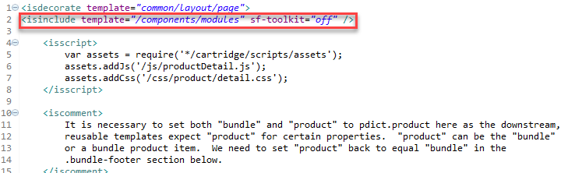

|  |
| --- |
| <isinclude template=*"/components/modules"* sf-toolkit=*"off"* /> |

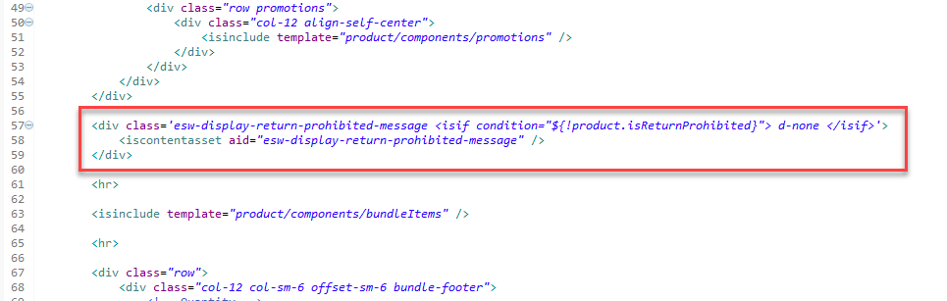

|  |
| --- |
| <div class=*'esw-display-return-prohibited-message <isif condition="${!product.isReturnProhibited}"> d-none </isif>'*>  <iscontentasset aid=*"esw-display-return-prohibited-message"* />  </div> |

1.1.22 setDetails.isml

| Path |
| --- |
| /int_eshopworld_sfra/cartridge/templates/default/product/setDetails.isml |

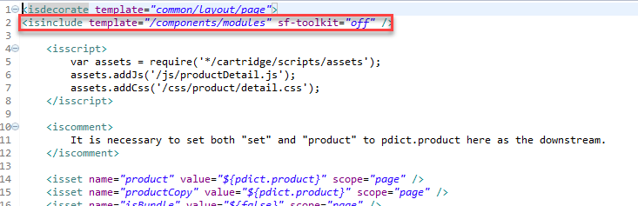

|  |
| --- |
| <isinclude template=*"/components/modules"* sf-toolkit=*"off"* /> |

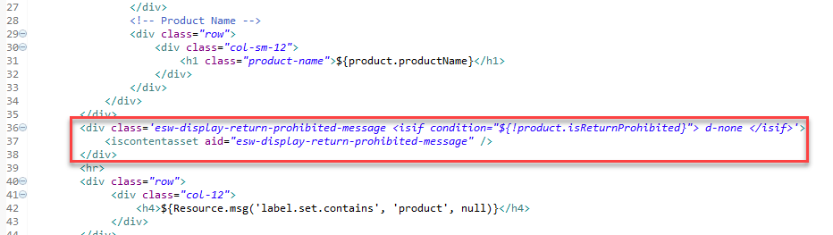

|  |
| --- |
| <div class=*'esw-display-return-prohibited-message <isif condition="${!product.isReturnProhibited}"> d-none </isif>'*>  <iscontentasset aid=*"esw-display-return-prohibited-message"* />  </div> |

1.2 Customizing the controllers

1.2.1 Page.js

| Path |
| --- |
| int_eshopworld_sfra/cartridge/controllers/Page.js |

1.2.2 Cart.js

| Path |
| --- |
| int_eshopworld_sfra/cartridge/controllers/Cart.js |
| app_storefront_base\cartridge\controllers\Cart.js  In the base Cart.js, need to make following changes highlighted below in Cart-Show controller. |

Also need to make changes in the Cart-UpdateQuantity controller in the base SFRA cartridge.

1.2.3 Checkout.js

| Path |
| --- |
| int_eshopworld_sfra/cartridge/controllers/Checkout.js |

1.2.4 CheckoutServices.js

| Path |
| --- |
| int_eshopworld_sfra/cartridge/controllers/CheckoutServices.js |

1.2.5 Tile.js

| Path |
| --- |
| int_eshopworld_sfra/cartridge/controllers/Tile.js |

1.2.6: Calcu

1.3 Customizing the models

1.3.1 priceTotal.js

| Path |
| --- |
| int_eshopworld_sfra/cartridge/models/productLineItem/decorators/priceTotal.js |

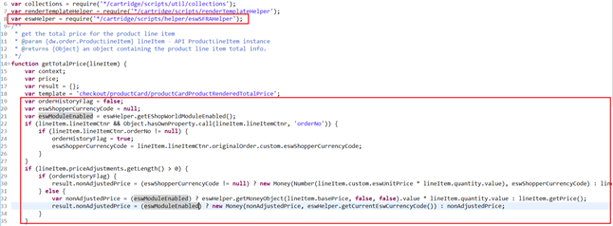

|  |
| --- |
| **var** eswHelper = require('*/cartridge/scripts/helper/eswSFRAHelper'); |
| **var** orderHistoryFlag = **false**;  **var** eswShopperCurrencyCode = **null**;  **var** eswModuleEnabled = eswHelper.getEShopWorldModuleEnabled();  **if** (lineItem.lineItemCtnr && Object.hasOwnProperty.call(lineItem.lineItemCtnr, 'orderNo')) {  **if** (lineItem.lineItemCtnr.orderNo != **null**) {  orderHistoryFlag = **true**;  eswShopperCurrencyCode = lineItem.lineItemCtnr.originalOrder.custom.eswShopperCurrencyCode;  }  }  **if** (lineItem.priceAdjustments.getLength() > 0) {  **if** (orderHistoryFlag) {  result.nonAdjustedPrice = (eswShopperCurrencyCode != **null**) ? **new** Money(Number(lineItem.custom.eswUnitPrice * lineItem.quantity.value), eswShopperCurrencyCode) : lineItem.getPrice();  } **else** {  **var** nonAdjustedPrice = (eswModuleEnabled) ? eswHelper.getMoneyObject(lineItem.basePrice, **false**, **false**).value * lineItem.quantity.value : lineItem.getPrice();  result.nonAdjustedPrice = (eswModuleEnabled) ? **new** Money(nonAdjustedPrice, eswHelper.getCurrentEswCurrencyCode()) : nonAdjustedPrice;  }  } |

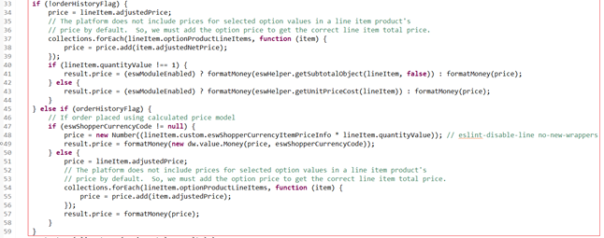

|  |
| --- |
| **if** (!orderHistoryFlag) {  price = lineItem.adjustedPrice;  // The platform does not include prices for selected option values in a line item product's  // price by default. So, we must add the option price to get the correct line item total price.  collections.forEach(lineItem.optionProductLineItems, **function** (item) {  price = price.add(item.adjustedNetPrice);  });  **if** (lineItem.quantityValue !== 1) {  result.price = (eswModuleEnabled) ? formatMoney(eswHelper.getSubtotalObject(lineItem, **false**)) : formatMoney(price);  } **else** {  result.price = (eswModuleEnabled) ? formatMoney(eswHelper.getUnitPriceCost(lineItem)) : formatMoney(price);  }  } **else** **if** (orderHistoryFlag) {  // If order placed using calculated price model  **if** (eswShopperCurrencyCode != **null**) {  price = **new** Number((lineItem.custom.eswShopperCurrencyItemPriceInfo * lineItem.quantityValue)); // eslint-disable-line no-new-wrappers  result.price = formatMoney(**new** dw.value.Money(price, eswShopperCurrencyCode));  } **else** {  price = lineItem.adjustedPrice;  // The platform does not include prices for selected option values in a line item product's  // price by default. So, we must add the option price to get the correct line item total price.  collections.forEach(lineItem.optionProductLineItems, **function** (item) {  price = price.add(item.adjustedPrice);  });  result.price = formatMoney(price);  }  } |

1.3.2 searchPrice.js

| Path |
| --- |
| int_eshopworld_sfra/cartridge/models/product/decorators/searchPrice.js |

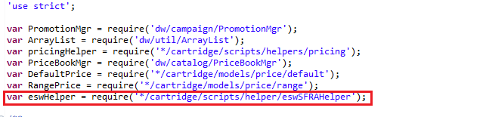

|  |
| --- |
| **var** eswHelper = require('*/cartridge/scripts/helper/eswSFRAHelper'); |

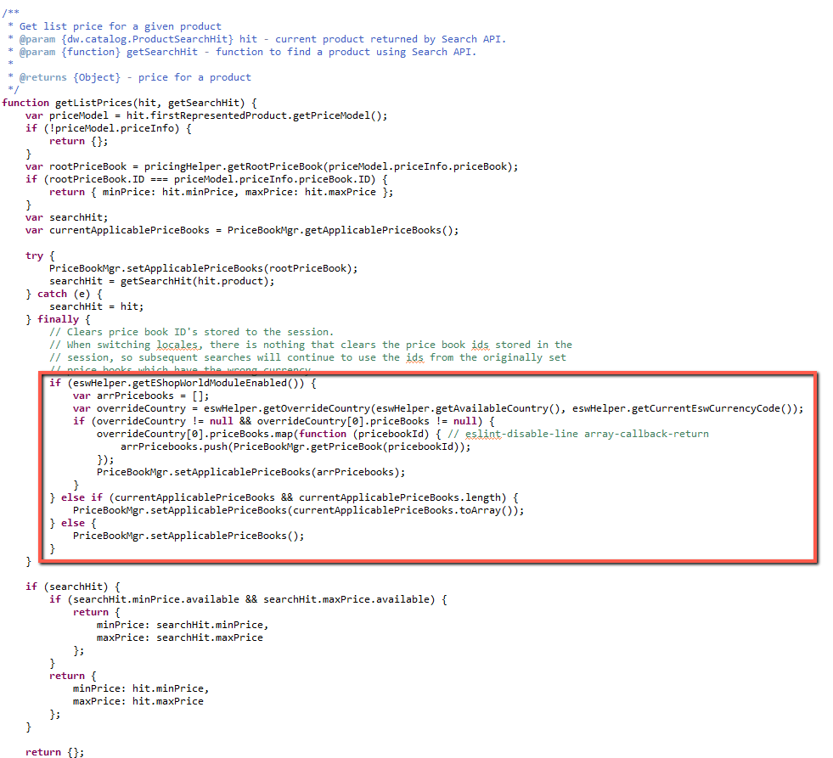

|  |
| --- |
| **if** (eswHelper.getEShopWorldModuleEnabled()) {  **var** arrPricebooks = [];  **var** overrideCountry = eswHelper.getOverrideCountry(eswHelper.getAvailableCountry(), eswHelper.getCurrentEswCurrencyCode());  **if** (overrideCountry != **null** && overrideCountry[0].priceBooks != **null**) {  overrideCountry[0].priceBooks.map(**function** (pricebookId) { // eslint-disable-line array-callback-return  arrPricebooks.push(PriceBookMgr.getPriceBook(pricebookId));  });  PriceBookMgr.setApplicablePriceBooks(arrPricebooks);  }  } **else** **if** (currentApplicablePriceBooks && currentApplicablePriceBooks.length) {  PriceBookMgr.setApplicablePriceBooks(currentApplicablePriceBooks.toArray());  } **else** {  PriceBookMgr.setApplicablePriceBooks();  } |

1.3.3 base.js

| Path |
| --- |
| int_eshopworld_sfra/cartridge/models/product/decorators/base.js |

1.3.4 fullProduct.js

| Path |
| --- |
| int_eshopworld_sfra/cartridge/models/product/decorators/fullProduct.js |

1.4 Customizing the scripts and json

1.4.1 taxes.js

| Path |
| --- |
| int_eshopworld_sfra/cartridge/scripts/hooks/taxes.js |

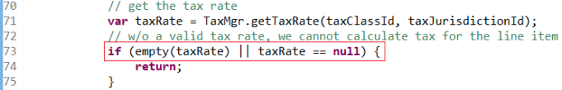

|  |
| --- |
| Important: You must include this file in your hooks.json file. |

1.4.2 validateBasket.js

| Path |
| --- |
| int_eshopworld_sfra/cartridge/scripts/hooks/validateBasket.js |

|  |
| --- |
| Important: You must include this file in your hooks.json file. |

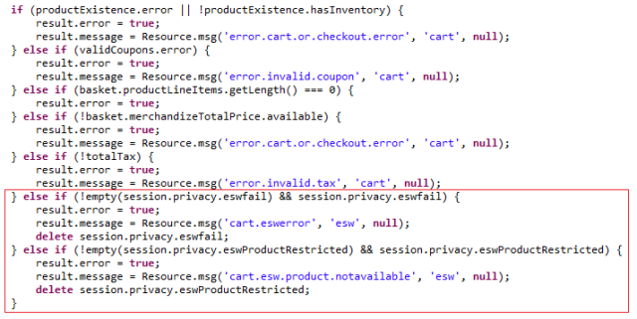

|  |
| --- |
| } **else** **if** (!empty(session.privacy.eswfail) && session.privacy.eswfail) {  result.error = **true**;  result.message = Resource.msg('cart.eswerror', 'esw', **null**);  **delete** session.privacy.eswfail;  } **else** **if** (!empty(session.privacy.eswProductRestricted) && session.privacy.eswProductRestricted) {  result.error = **true**;  result.message = Resource.msg('cart.esw.product.notavailable', 'esw', **null**);  **delete** session.privacy.eswProductRestricted;  } |

1.4.3 calculate.js

| Path |
| --- |
| int_eshopworld_sfra/cartridge/scripts/hooks/cart/calculate.js |

|  |
| --- |
| You must include this file in your hooks.json file. |



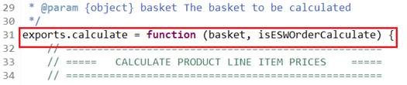

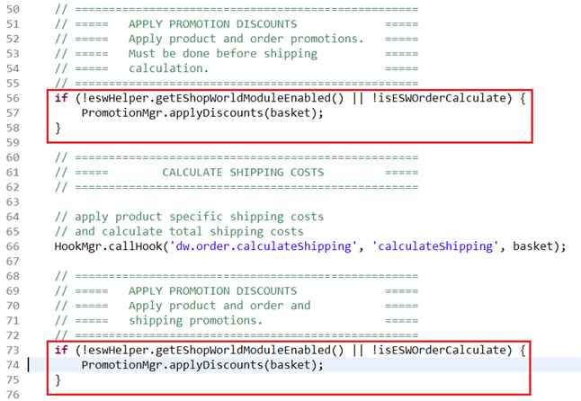

|  |
| --- |
| **var** eswHelper = require('*/cartridge/scripts/helper/eswHelper').getEswHelper(); |
| exports.calculate = **function** (basket, isESWOrderCalculate) { |
| **if** (!eswHelper.getEShopWorldModuleEnabled() || !isESWOrderCalculate) {  PromotionMgr.applyDiscounts(basket);  } |
| **if** (!eswHelper.getEShopWorldModuleEnabled() || !isESWOrderCalculate) {  PromotionMgr.applyDiscounts(basket);  } |

1.4.4 detail.js

| Path |
| --- |
| int_eshopworld_sfra/cartridge/client/default/js/product/detail.js |

1.4.5 quickView.js

| Path |
| --- |
| int_eshopworld_sfra/cartridge/client/default/js/product/quickView.js |

|  |
| --- |
| Note: Customization to the following models is extended: fullProduct.js, productTile.js, productSet.js, productBundle.js, detail.js, quickView.js, default.js and total.js |