

CHECKOUT METADATA INTEGRATION GUIDE

Version: 4.1.0

Published date: October 2023

Copyright © 2023 by ESW. All rights reserved. Information contained herein is subject to change without notice.



**SFCC - ESW Cartridge**

+

Contents

**1** **Checkout Metadata Integration** 3

1.1 **Problem Statement** 3

1.2 Benefits 3

1.3 Pre-requisite...…………………………………………………………………………………………… 3

**2** **Checkout Metadata Integration Configuration** 3

2.1 Checkout metadata Integration Configuration site preferences 3

2.2 Testing/Sandbox Staging Environment.….………………….….…………………………….………….3

# **Checkout Metadata Integration**

Problem Statement

# Previously, retailers could only configure product/line-item level metadata in our SFCC plugin. We have seen increased requests to add customer and shopper experience level metadata to be mapped in the data layer on ESW checkout. These metadata can be used for various tag managers such as GTM, Tealium, etc. By allowing the option to configure such metadata attributes directly in SFCC to minimize the retailer’s specific code customizations.

Benefits

* Less integration effort is needed to send these metadata attributes in preOrder requests
* Easy to configure all levels of metadata attributes in the SFCC plugin
* Better retailer experience

Pre-requisite

For customer-level metadata, shoppers must be registered and logged in before redirecting to checkout.

# **Checkout Metadata Integration Configuration**

## **Checkout metadata Integration Configuration site preferences**

You can use **Custom Preferences** to manage ESW-specific configurations of the cartridge. You can access Custom Preferences by navigating to **Merchant Tools** > **Site Preferences** > **Custom Preferences > ESW Checkout Configuration.** The following option is present ESW Checkout Configuration group.

# **ESW Customer Meta Data**: This preference indicates the key|value pairs for esw customer metadata.

# **ESW Basket Meta Data**: The preference indicates the key|value for esw basket metadata.

## **Testing Sandbox/Staging Environment**

## The recommended approach is to test this feature for **basket-level** and **Customer level** custom attributes.

Customer-Level Metadata

* In the business manager, add the metadata custom attributes at the customer profile level.
* In the following snapshot can see the similarities.

* For customer metadata items, in the business manager, add the customer metadata preference under ESW in the checkout configuration group with values in key|value format for the metadata custom attributes.

1. Similar is configured for product line item metadata in the checkout preference group.

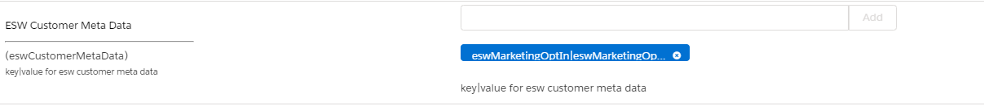

1. Validate customer-level data items in the preOrder being passed to EWS checkout under the **contactDetails**.

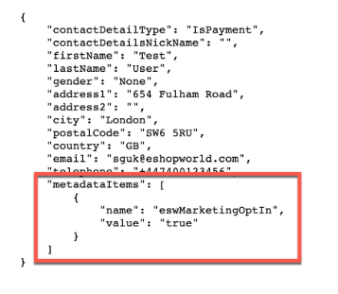

**Note: To validate customer metadata, it’s needed to be logged in.**

Basket-Level Metadata

* In the business manager, add the metadata custom attributes at the basket level custom attributes.
* For Basket level metadata items, in the business manager, add the basket metadata preference under the ESW checkout configuration group with values in key|value format for the metadata custom attributes.
  1. Similar is configured for product line item metadata in the checkout preference group.

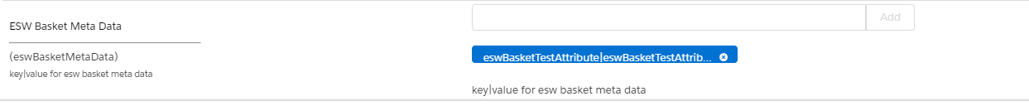

* 1. Validate basket level metadata items in the preOrder being passed to EWS checkout under the **shopperCheckoutExperience**.

