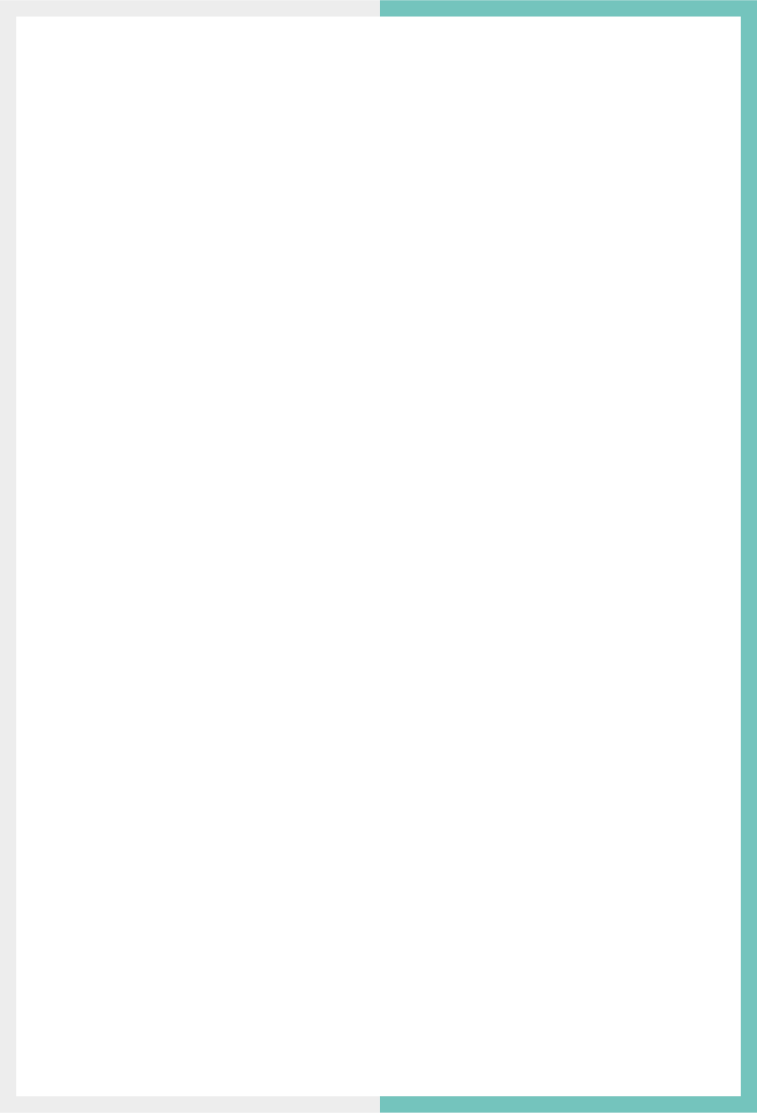

GLOBAL PRODUCT RESTRICTION GUIDE

Version: 4.7

Published date: April 2025

Copyright © 2025 by ESW. All rights reserved. Information contained herein is subject to change without notice.



**SFCC - ESW Cartridge**

+

Contents

**1** **Global Product Restriction** 3

1.1 Restricting Products 3

1.2 Bulk Products Restriction Management 6

1.2.1 Bulk update via the attributes in Business Manager 6

1.2.2 Bulk update via XML import 6

1.2.3 Sample XML File 7

# **Global Product Restriction**

Considering different needs and availability of products over the global market, if you want to sell a product in a few targeted countries and not all, you can do so using the **ESW Custom Product Level** attribute. Using this attribute, you restrict the product from being sold in the countries that you specify within the cartridge.

Restricting Products

To restrict the product in selected countries, perform the following steps:

1. Navigate to **Merchant Tools** > **Product and Catalogs** > **Products**and click a product.
2. Enter the product ID to find the product.
3. Open and lock the listed product.
4. Locate **List of countries where product is restricted**” under **ESW Configurations**.
5. Enter the ISO code of the country where you want to restrict the product. To add multiple values, click **Add another value**.
6. Click **Apply**.

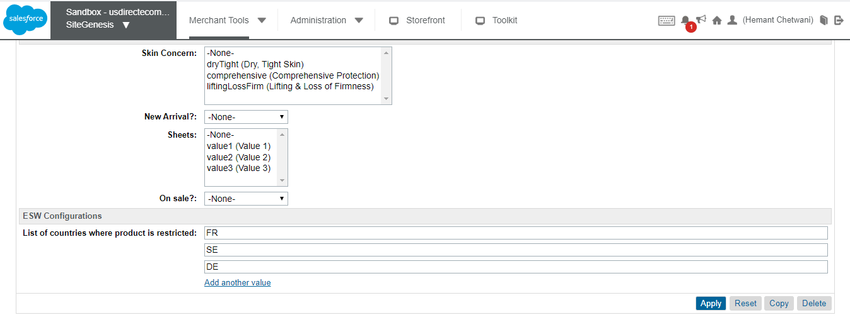

After the product is restricted, the This product is not available in your country message is displayed to the shopper. The price information is hidden and the **Add to cart** button is unavailable.

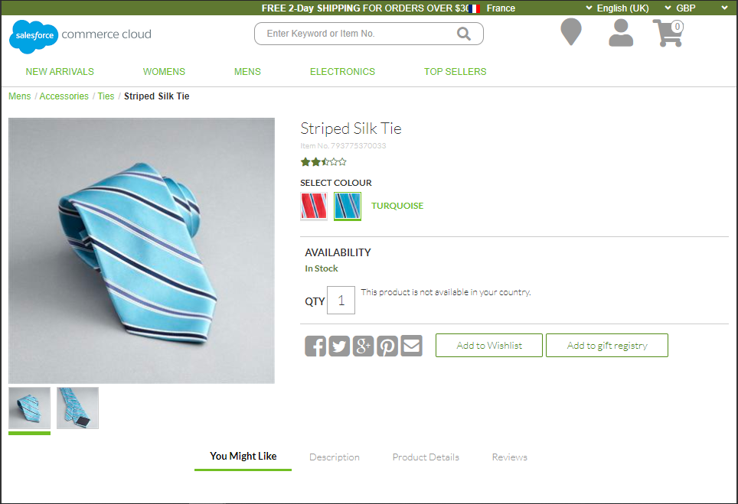

The following image shows the same message in SFRA:

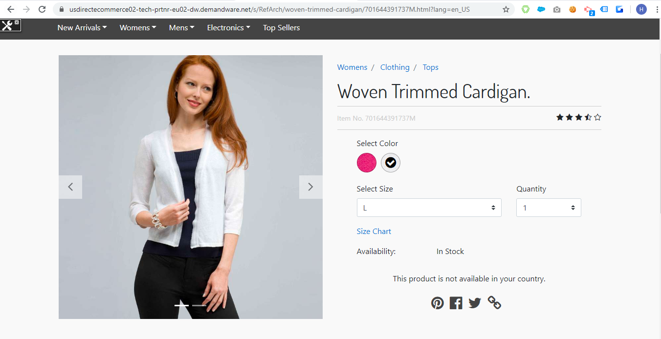

Product not available

After adding the restricted product to their cart, if a shopper changes the country from the cart, the The cart consists of items that are not salable in your country message is displayed:

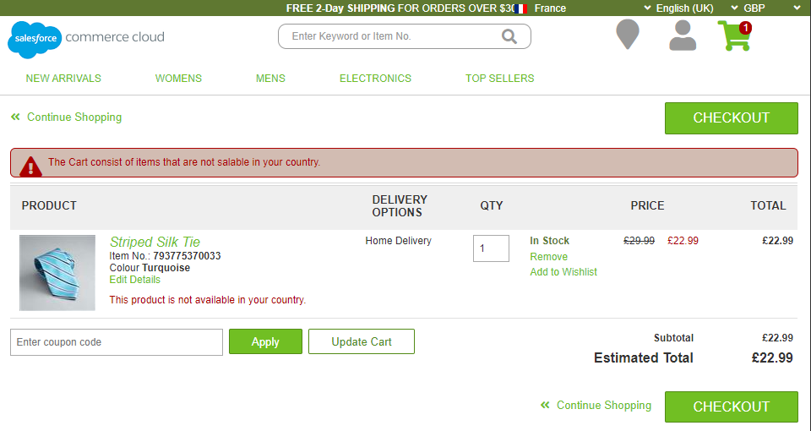

The following image shows the same message in SFRA:

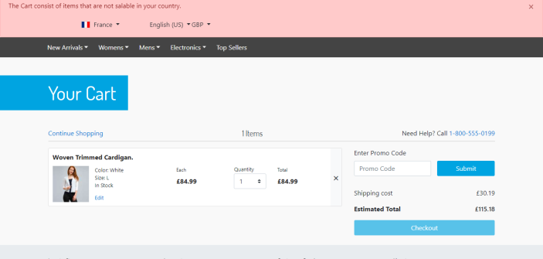

Notes:

* Product restriction applies to all types of products - Standard, Variation Product, Variation Master, Product Set, and Product Bundle. If a restricted product is part of any product set, then you must manually restrict the product sets.
* When a product is restricted, it is still visible on the storefront. Note that hiding products from the storefront might impact the overall SEO performance of the website. Additionally, restricting products from being displayed on the storefront requires post-processing of the Product Search Results. This can lead to result-handling issues, such as pagination, caching, verifying results on Ajax load, and direct hit through URL. SFCC does not recommend post-processing on Product Search Results. Also, other approaches like creating Search Refinements do not work well with the current ESW plugin architecture.

Bulk Products Restriction Management

You can update, delete, or change the restricted countries value for multiple products using any of the two methods - Bulk Update via Attributes in Business Manager or Bulk update via XML Import.

Bulk update via the attributes in Business Manager

1. Navigate to **Business Manager** > **Merchant Tools** > **Products and Catalogs** > **Products**.
2. Locate the Product Search section and click the **By ID** tab.
3. Locate **List of IDs:**, enter the product IDs, and click **Find**.
4. Click **Select all** to select all products and then click **Edit all**/ **Edit Selected**.
5. Select the **Update/Delete Product Attributes** action and then click on **Next>>**.
6. Click **Select attributes** and select **eswProductRestrictedCountries**.
7. Enter Country ISO codes and click **Finish** or **Go to Batch Process** to complete the process.

Bulk update via XML import

1. Create an XML file with "Catalog-id", "product-id" and values for "Country ISO" under "custom-attribute" tag.
2. Import the XML file in Business Manager by navigating to **Merchant Tools** > **Products and Catalogs** > **Import & Export**.
3. Click **Upload**under **Import and Export files** to upload the XML file.
4. Click the **Import & Export** module.
5. Click **Imports** under **Catalogs** and then select the uploaded XML file.
6. Click **Next**>> and then select the desired action (**Merge** or **Replace**).
7. Click **Finish**.

Sample XML File

<?xml version="1.0" encoding="UTF-8"?>

<catalog xmlns="http://www.demandware.com/xml/impex/catalog/2006-10-31" catalog-id="apparel-catalog">

<product product-id="701642853695">

<custom-attributes>

<custom-attribute attribute-id="eswProductRestrictedCountries">

<value>FR</value>

<value>GB</value>

</custom-attribute>

</custom-attributes>

</product>

<product product-id="701642853718">

<custom-attributes>

<custom-attribute attribute-id="eswProductRestrictedCountries">

<value>FR</value>

<value>DE</value>

<value>SE</value>

</custom-attribute>

</custom-attributes>

</product>

</catalog>