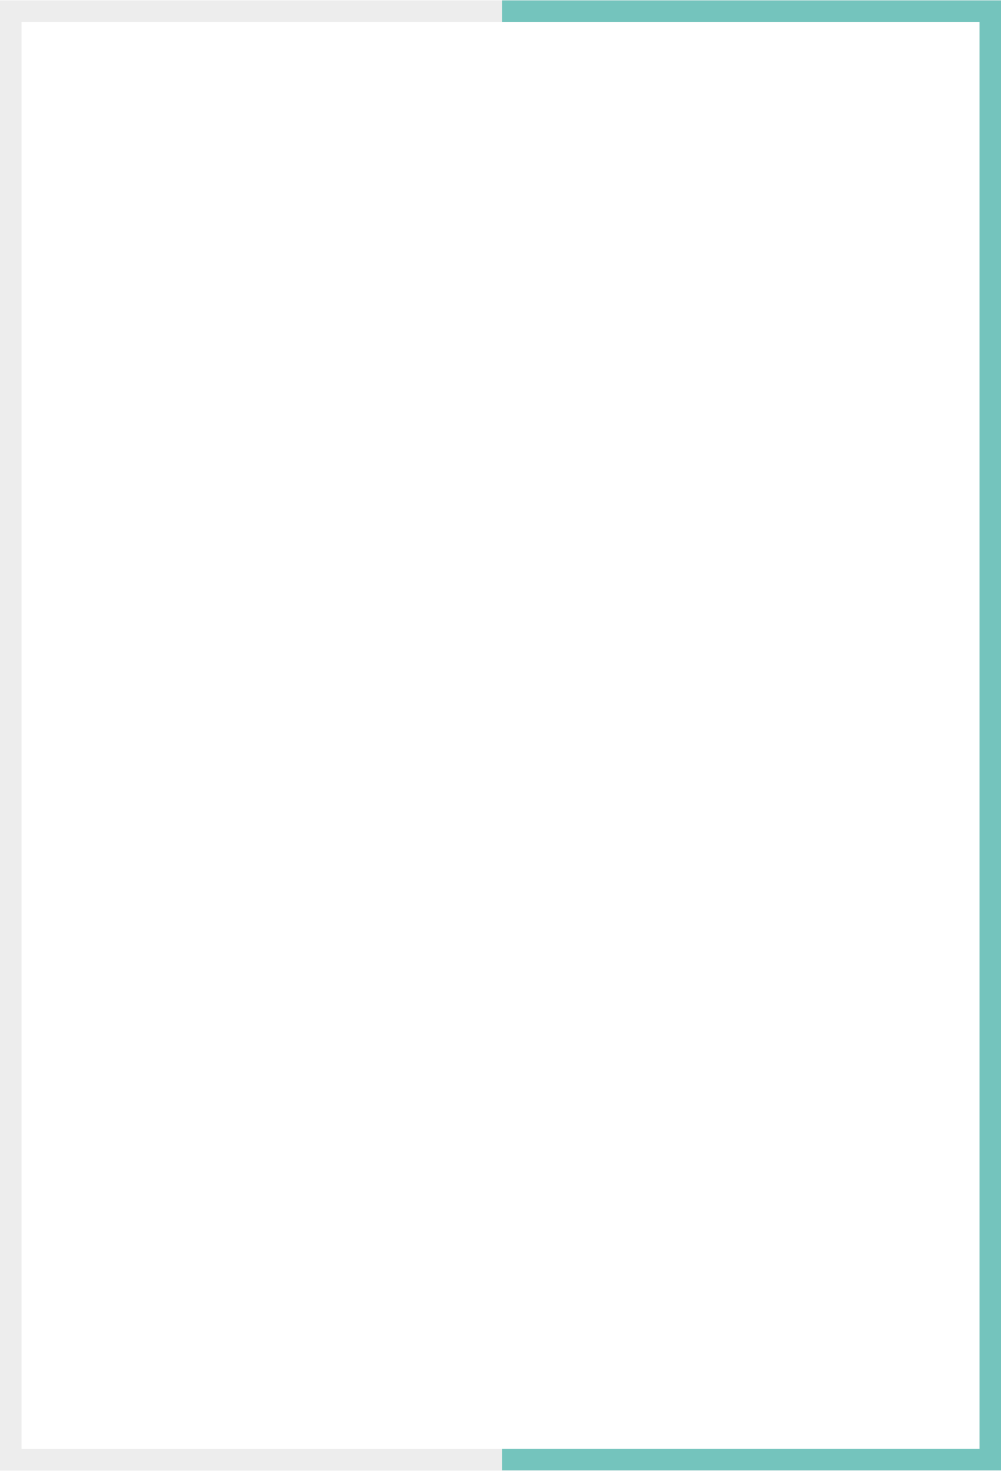

GLOBAL PRODUCT RETURNS PROHIBITION GUIDE

Version: 4.2.1

Published date: March 2024

Copyright © 2024 by ESW. All rights reserved. Information contained herein is subject to change without notice.



**SFCC - ESW Cartridge**

+

Contents

**1** **Global Product Returns Prohibition** 3

1.1 Restricting Product Returns 3

1.2 Bulk Products Return Prohibition Management 7

1.2.1 Bulk update via the attributes in Business Manager 7

1.2.2 Bulk update via XML import 8

1.2.3 Sample XML File 8

# **Global Product Returns Prohibition**

Considering different needs and availability of products over the global market, if you want to prohibit a product return in a few targeted or all countries, you can do so using the **ESW Custom Product Level** attribute. Using this attribute, you restrict the product from being returned in the countries that you specify within the cartridge.

Restricting Product Returns

To display the return prohibition message on the product in selected or all countries:

1. Navigate to **Merchant Tools** > **Custom Preferences** > **ESW General Configuration** and enable the **ESW Enable Return Prohibition** preference.

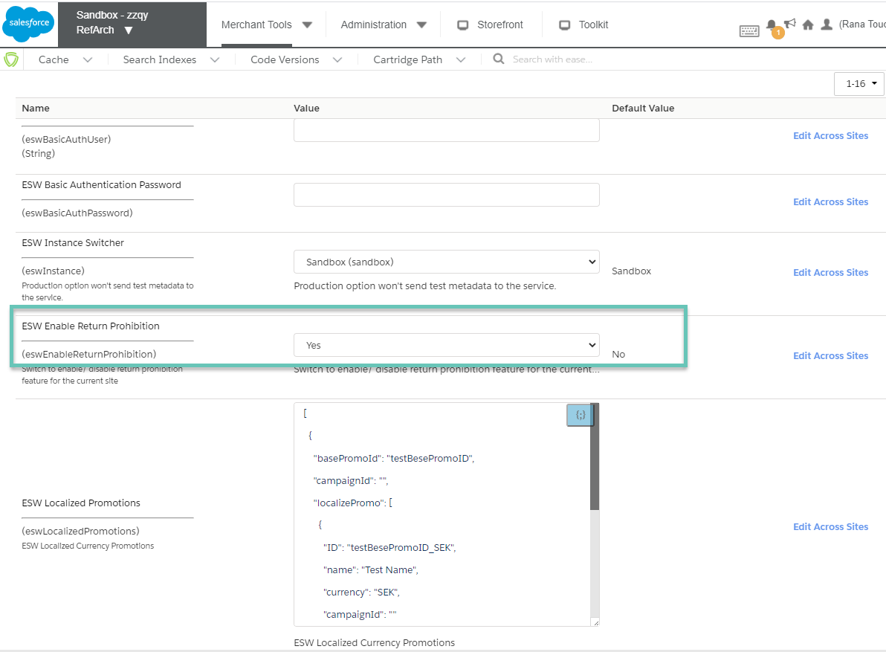

1. Navigate to **Merchant Tools** > **Product and Catalogs**> **Products** and click a product.
2. Enter the product ID to find the product.
3. Open and lock the listed product.
4. Under **ESW Configurations**, locate **List of countries where product is not returnable** and enter the ISO code of the country where you want to restrict the product. If you want to prohibit the product in all countries, enter **All**. To add multiple values, click **Add another value**.

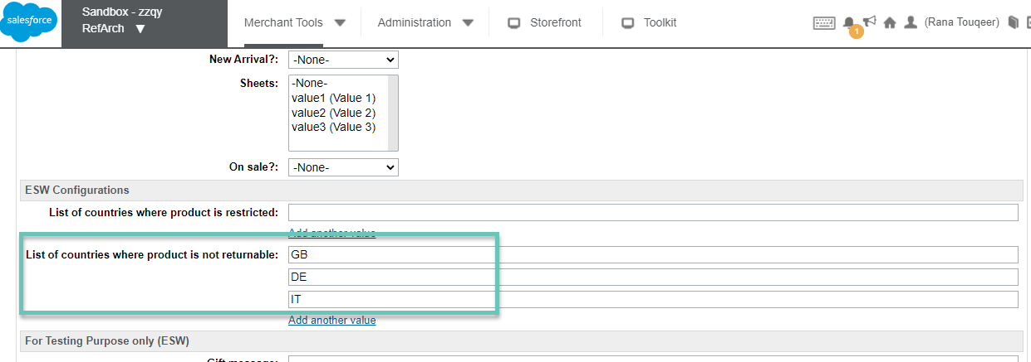

1. Click **Apply**.
2. Configure the Content asset with the ID available in the site metadata with ID esw-display-return-prohibited-message.

You can enable or disable the return prohibited message through this Content asset. If the asset is enabled, the return prohibited message is displayed. If disabled, the message will not be displayed against the selected product on the Product Detail and Cart pages.

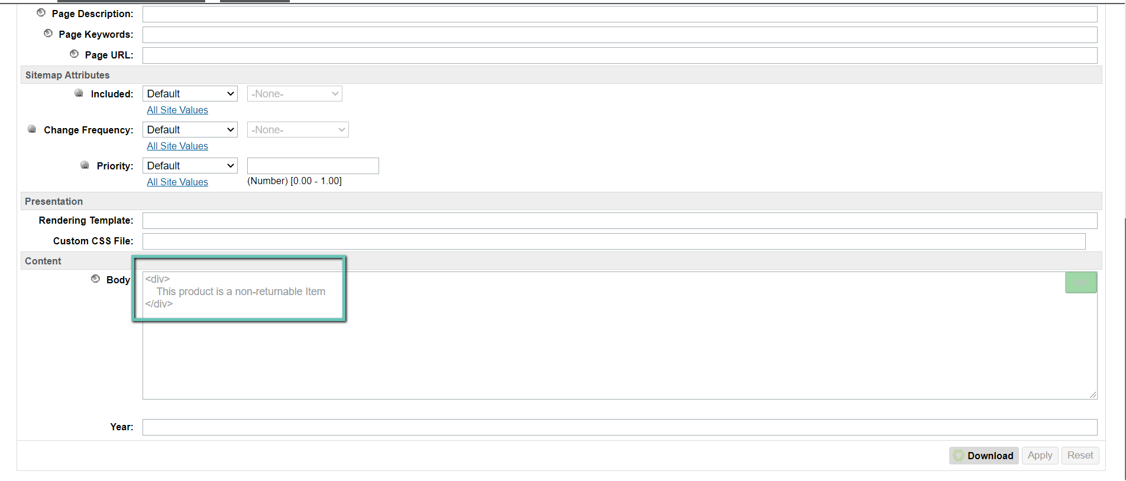

After the product is prohibited for return, the Content asset message is displayed to the shopper on product detail and cart pages.

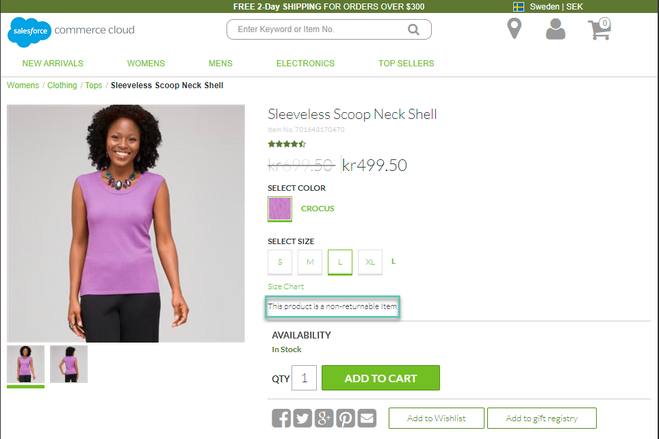

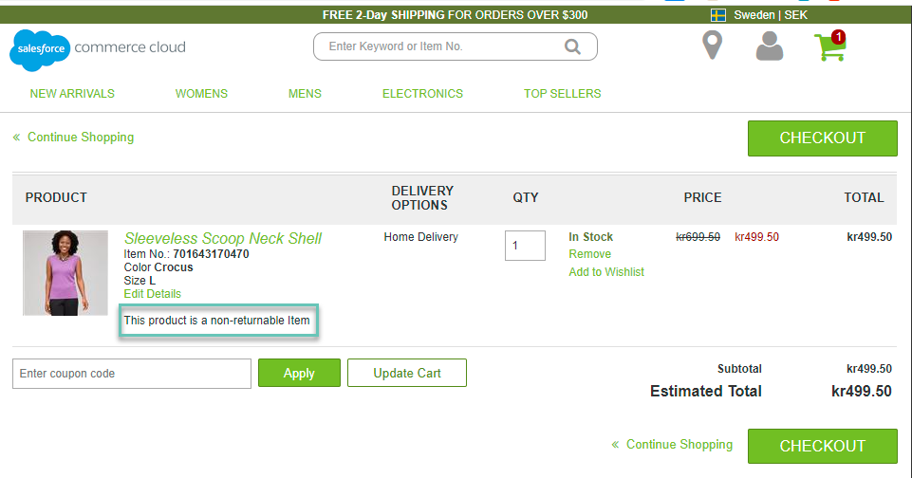

The following images show the same message in SFRA:

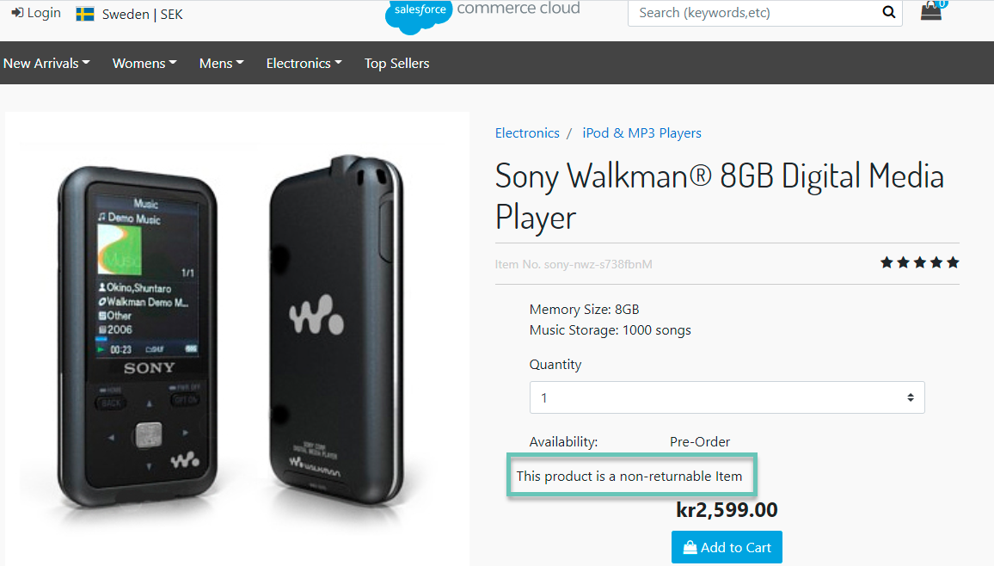

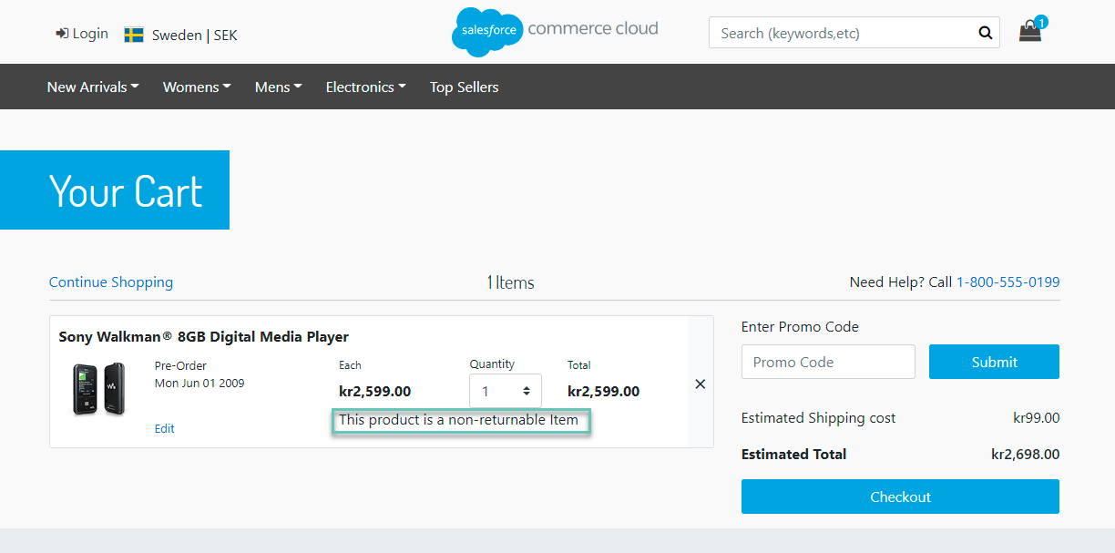

After adding the non-returnable product to their cart, when the shopper redirects to the ESW checkout, the isReturnProhibited attribute is sent in the preorder checkout object against the related line items, as shown in the following example:

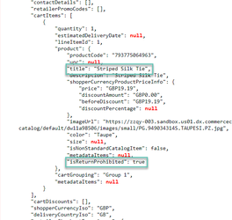

In this example, the striped silk tie is a return prohibited product line item, and isReturnProhibited value for this product line item is true in the preorder service object.

**Note:** The Product Return Prohibit feature applies to all types of products - Standard, Variation Product, Variation Master, Product Set, and Product Bundle. If a restricted product is part of any product set, you must manually configure the return prohibition country in the product set configuration.

Bulk Products Return Prohibition Management

You can update, delete, or change the return prohibited countries value for multiple products using any of the two methods - Bulk Update via Attributes in Business Manager or Bulk update via XML Import.

Bulk update via the attributes in Business Manager

1. Navigate to **Business Manager** > **Merchant Tools** > **Products and Catalogs** > **Products**.
2. Locate the Product Search section and click the **By ID** tab.
3. Locate **List of IDs:**, enter the product IDs, and click **Find**.
4. Click **Select all** to select all products and then click **Edit all**/ **Edit Selected**.
5. Select the **Update/Delete Product Attributes** action and then click on **Next>>**.
6. Click **Select attributes** and select **eswProductReturnProhibitedCountries**.
7. Enter Country ISO codes and click **Finish** or **Go to Batch Process** to complete the process.

Bulk update via XML import

1. Create an XML file with "Catalog-id", "product-id" and **All** value or values for "Country ISO" under "custom-attribute" tag.
2. Import the XML file in Business Manager by navigating to **Merchant Tools** > **Products and Catalogs** > **Import & Export**.
3. Click **Upload**under **Import and Export files** to upload the XML file.
4. Click the **Import & Export** module.
5. Click **Imports** under **Catalogs** and then select the uploaded XML file.
6. Click **Next**>> and then select the desired action (**Merge** or **Replace**).
7. Click **Finish**.

Sample XML File

<?xml version="1.0" encoding="UTF-8"?>

<catalog xmlns="http://www.demandware.com/xml/impex/catalog/2006-10-31" catalog-id="apparel-catalog">

<product product-id="701642853695">

<custom-attributes>

<custom-attribute attribute-id="eswProductReturnProhibitedCountries">

<value>FR</value>

<value>GB</value>

</custom-attribute>

</custom-attributes>

</product>

<product product-id="701642853718">

<custom-attributes>

<custom-attribute attribute-id="eswProductReturnProhibitedCountries">

<value>All</value>

</custom-attribute>

</custom-attributes>

</product>

</catalog>