

Version: 4.5

Published date: October 2024

Copyright © 2024 by ESW. All rights reserved. Information contained herein is subject to change without notice.

ESW INTEGRATION MONITORING GUIDE



**SFCC - ESW Cartridge**

+

# Contents

1. ESW Integration Monitoring 3
   1. ESW Integration Monitoring Menu**………………….………………………………………....……….**3
   2. ESW Integration Monitoring Report Fields**………...………………………………………….…...….**5

1. ESW Integration Monitoring Configuration 6
   1. ESW Integration Monitoring Menu**………………….………………………………………………….**6
   2. Cartridge Path**……………………………………………………………………………………………**6

## ESW Integration Monitoring

The ESW Integration Monitoring module provides a comprehensive configuration analysis report for plugins within Salesforce Commerce Cloud (SFCC). This report serves as a valuable resource for identifying and troubleshooting potential issues stemming from misconfigurations. By leveraging the generated report, users gain the ability to:

**Proactively Identify Misconfigurations**: The report highlights deviations from

recommended or expected plugin configuration settings. This proactive approach

helps to prevent unexpected behaviour or functionality issues within the plugins.

**Expedite Troubleshooting**: The detailed report streamlines the troubleshooting

process by pinpointing potential configuration errors that might be causing problems.

This allows users to focus their efforts on resolving the root cause of the issue more

efficiently.

The Plugin Integration Monitoring tool, through its configuration analysis report,

empowers users to maintain optimal plugin functionality and performance within their

SFCC environment.

* 1. **ESW Integration Monitoring Menu**

ESW cartridge allows to manage the Integration Monitoring from the Business Manager.

Navigate to *Merchant Tools > ESW > Integration Monitoring*

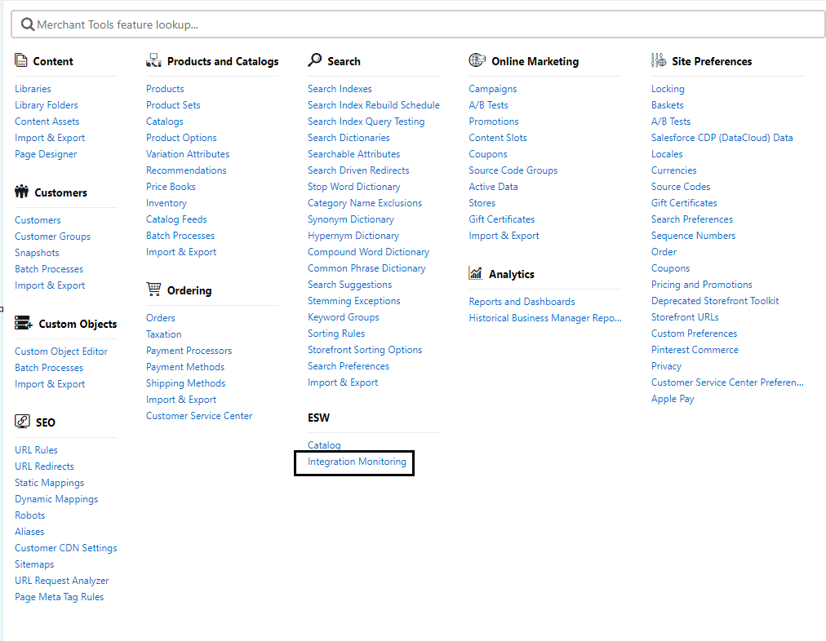

Upon navigation, the following screen will be displayed, showcasing the PIM Report.

The integration monitoring report contain the System Configurations, Site Preferences, and custom object related data in JSON format.

* **Export**:This button is used to export/download the report.

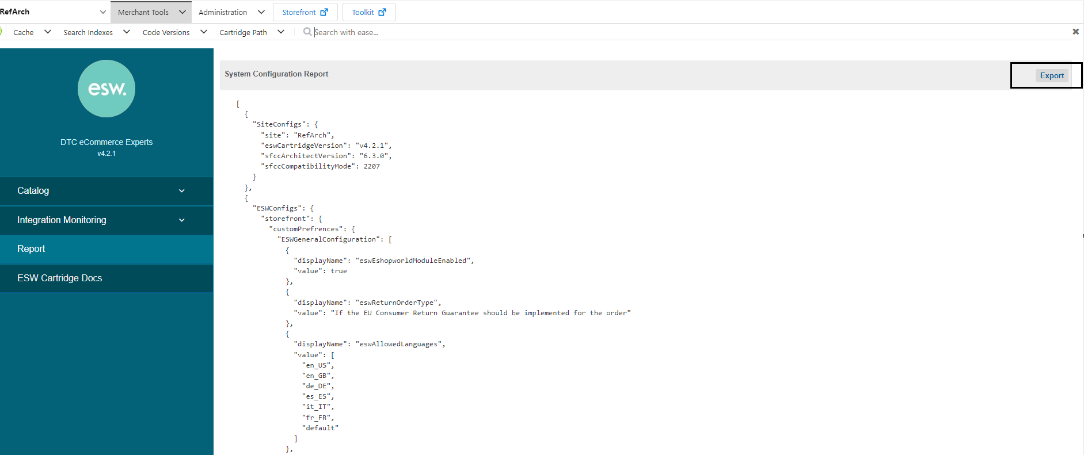

* 1. **ESW Integration Monitoring Report Fields**

|  |  |
| --- | --- |
| **Component** | **Included Fields** |
| **SiteConfigs** | **Site:** site ID  **eswCartridgeVersion:** Esw Cartridge Version number  **sfccArchitectVersion:** SFCC Architect Version  **sfccCompatibilityMode:** SFCC Sandbox Compatibility Mode |
| **ESWConfigs** | Contains all information that is related to the Esw configs |
| **ESWGeneralConfiguration** | Contains ESW General Configuration Group related configs on the site |
| **ESWRetailerDisplayConfiguration** | Contains ESW Retailer Display Configuration Group related configs on the site |
| **pricing** | **ESW Pricing Configuration: C**ontains ESW Pricing Configuration Group related configs on the site.  **Service URL: C**ontains **EswPriceFeedService** service URL |
| **Catalog** | **ESW Catalog Configuration:** Contains the ESW Catalog Configuration group related configs on site.  **Service URL:** Contains **ESWCatalogService** and **ESWSFTP** services URLs |
| **Package** | **ESW Package Integration Configuration:** It contains ESW Package integration Configuration Group related configs on the site  **Service URL:** Contains **EswPackageV4Service** service URL |
| **Checkout** | **ESW Checkout Configuration:** It contains ESW Checkout Configuration Group related configs on the site.  **Service URL:** Contains **EswCheckoutV3Service** or **EswCheckoutV2Service** services URLs |
| **customObjects** | Contains ESW related custom objects details  **ESWCountries:** Contains Esw countries related configurations in custom objects.  **ESWCurrencies:** Contains Esw currencies related configurations in custom objects  **ESWPAData:** Contains Esw fxRates, countryAdjustment, roundingModels, eswPricingSynchronizationId and eswPriceFeedLastUpdated related configurations in custom objects |
| **GlobalConfigs** | Contains Global Configurations  **allowedLocales:** Contains allowed locales data on site.  **allowedCurrencies:** Contains allowed Currencies data on site.  **ShippingMethods:** Contains Shipping method related configs i.e.ID, Name, Status and Currency  **OrderConfigs:** Contains order level configs in global configs I.e. failedOrderRetention, AutoFailOrders, LimitStoreFrontOrderAccess, and FilterStorefrontOrdersByCustomerSession related config |

Top of Form

# **ESW Integration Monitoring Configuration**

## Import Metadata

Import Custom Object (customobjects.xml) from **link_eshopworld\sitesdata\meta.**

The following **ESW_INTEGRATION_MONITORING** custom Object will be present in Custom Objects:

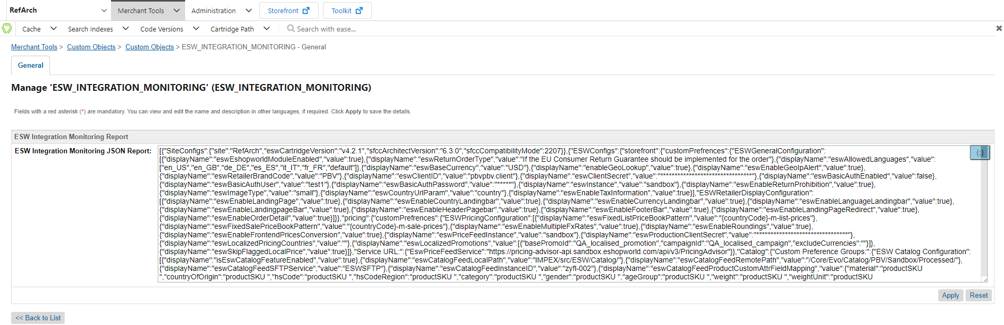

* 1. Cartridge Path

The ESW BM cartridge should be set in the cartridge path to view the Integration Monitoring menu. The path in BM should be set as

 int_eshopworld_core:int_eshopworld_sfra:bm_eshopworld_core:bm_custom_plugin

Note: For the Business Manager (BM) user to successfully export a report that includes shipping methods, they must have access to the Shipping Module within the BM. Without this access, shipping information will not be retrievable and consequently, will not be included in the report