

Version: 4.4.2

Published date: June 2024

Copyright © 2024 by ESW. All rights reserved. Information contained herein is subject to change without notice.

KONBINI PAYMENT METHOD  
INTEGRATION GUIDE



**SFCC - ESW Cartridge**

+

Contents

1. Konbini Payment Method Integration 3

2. Konbini Payment Method Integration Configuration 3

3. Workflow to get Konbnin payment information in SFCC 3

**3.1** **Order Confirmation flow** 3

3.2 Order Settlement Flow 4

4. SFCC Endpoint Example 5

1. Konbini Payment Method Integration

Konbini is a payment method that allows consumers to order goods online and pay for them over the counter in a convenience store. ESW cartridge allow shopper to use new payment method to simplify the shopping experience. So that on the checkout screen shopper can see the Konbini as payment methods.

# Konbini Payment Method Integration Configuration

**2.1 Konbini Payment Method Integration Order Level Custom Attribute**

* **Esw Konbini Payload Json (eswKonbiniPayloadJson):** This custom attribute used to store the Konbini related payloads and append the data from webhook and order confirmation in Json format

1. Workflow to get Konbnin payment information in SFCC

## **Order Confirmation flow**

The workflow is quit straight forward. Retailers need to make sure that Konbini payment integration feature is enabled on ESP and new event eshopworld.platform.events.oms.orderholdstatusupdatedevent is added. If Konbini payment is enabled on SFCC for the tenant, then shopper will see the Konbini payment method on payment panel. When a shopper places an order using Konbini payment method, then in SFCC BM order looks like:

* The payment screen for the order in SFCC will appear as shown in screenshot with payment status not Paid:

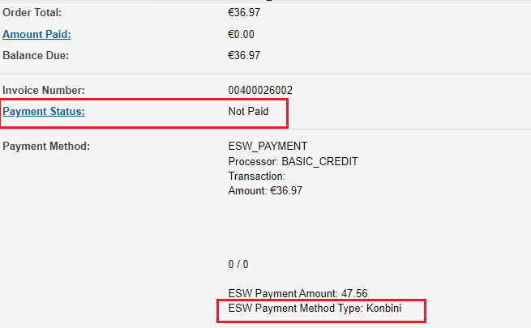

* **Please be aware that the ESW Payment Method Type value will correspond to what we receive in the order confirmation payload.**
* The general screen for the order in SFCC will appear as shown in screenshot with confirmation status Not Confirmed and Export Status Not Exported:



* All the order confirmation related info will be stored in Esw Konbini Payload Json (order level custom attribute).

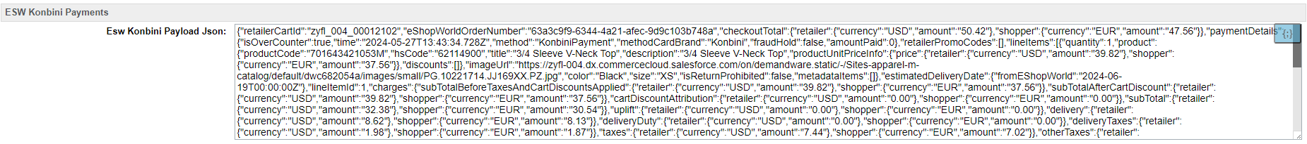

The flow diagram can be seen as follows:

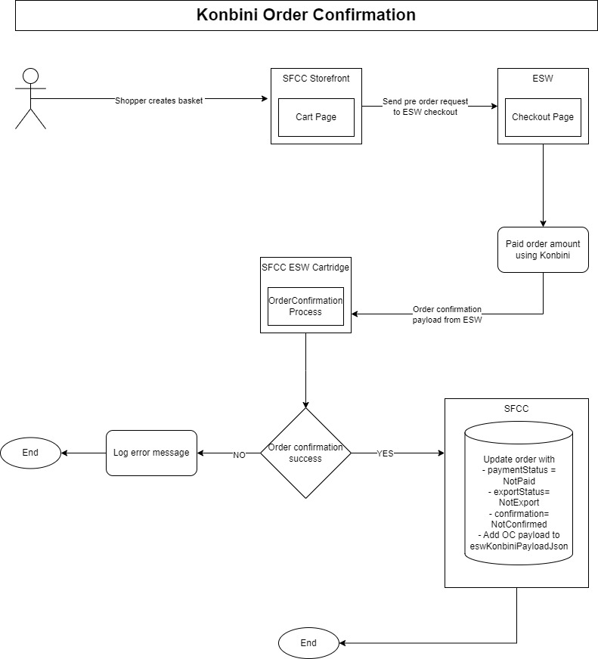

## Order Settlement Flow

After order has been placed via Konbini Payment Method once change in the payment Status The Konbini webhook will publish event to SFCC EswHL-ProcessWebHooks endpoint. This endpoint will be responsible for the following:

If order is available in the SFCC And payment **HoldStatus** status is **NoHold** in the webhook payload

* Then it will update the order’s payment status to PAID

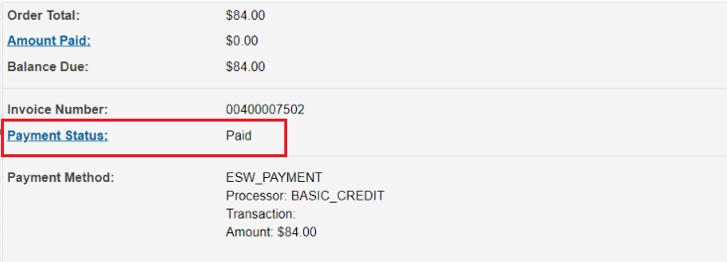

* Order’s Export status will be Ready to Export and Confirmation status will be Confirmed.



* All the webhook related info will be append in Esw Konbini Payload Json (order level custom attribute) with order confirmation payload.

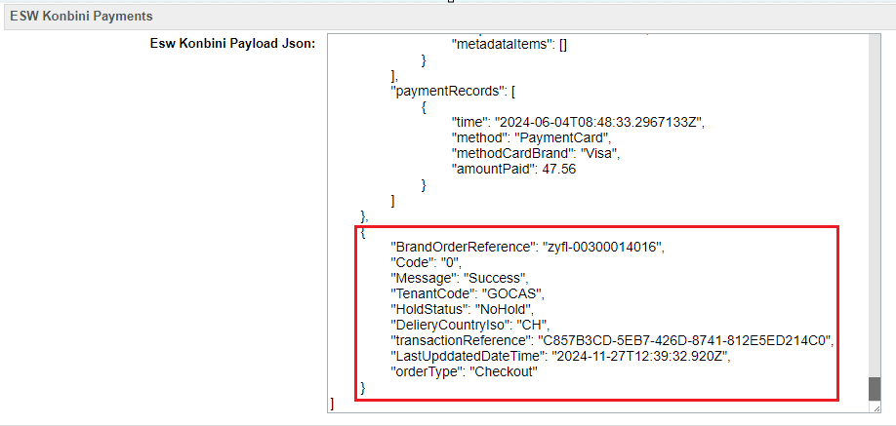

# SFCC Endpoint Example

* The endpoint and event will be configured on the ESW tenant side so retailers can subscribe to the event
* [https://example.com/on/demandware.store/Sites-RefArch-Site/default/ EswRefArchHL-ProccessWebHooks](https://example.com/on/demandware.store/Sites-RefArch-Site/default/%20EswRefArchHL-ProccessWebHooks)
* can update the ‘example’ domain in https://example.com URL with your storefront’s domain.