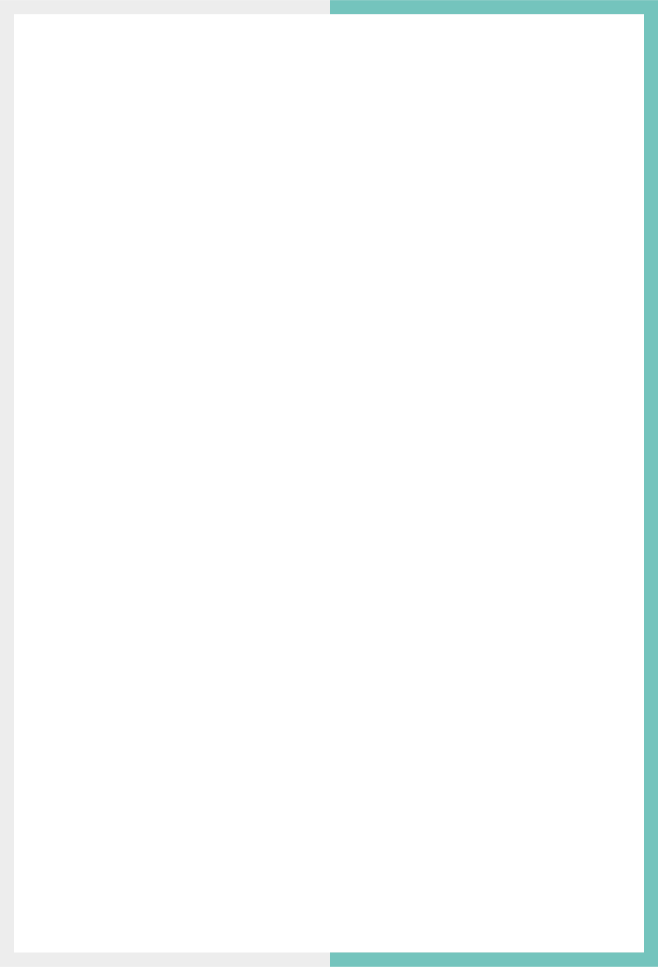

ESW Localized Shopping Feed INTEGRATION GUIDE

Version: 4.8

Published date: September 2025

Copyright © 2025 by ESW. All rights reserved. Information contained herein is subject to change without notice.



**SFCC - ESW Cartridge**

+

**Contents**

1. ESW Localized Shopping Feed Integration 3

**1.1** **Pre-requisite** 3

**1.2** **End to End Flow** 3

2. ESW Localized Shopping Feed Integration Configuration 3

**2.1** **ESW Localized Shopping Feed product level custom attribute** 3

**2.2** **ESW Localized Shopping Feed Custom Object Configuration** 3

**2.3** **eswLocalizedShoppingFeed job** 4

# **ESW Localized Shopping Feed Integration**

* 1. Pre-requisite
* Country’s and Products must be marked for the localized shopping feed.
* The system objects metadata must be imported in the BM.

## **End to End Flow**

* **The country’s custom object will contain the flag Is Localized Shopping Feed Supported?**
* **The job will be executed. The job will create the shopping feed for the products that have the flag ESW Localized Shopping Product** true. The feed will be generated on the impex on the path configured in the job.
* Retailers can customize from this point to export the Feed to any system as per their requirement.

# **ESW Localized Shopping Feed Integration Configuration**

ESW Localized Shopping Feed Configuration site preferences

* **ESW Localized Shopping Feed Delimiter**: This preference is to select the delimiter as a separator for the localized shopping feed generated. The default value for this preference would be pipe sign **‘|’** and comma **‘,’** can also be selected as delimiter value.
* **ESW Shopping Feed Product Custom Fields Mapping:** This preference is used to Map Product custom attributes IDs to ESW Shopping Feed keys. Example: { "EswKeyField1": "ProductCustomAttributeID1", "EswKeyField2": "ProductCustomAttributeID2"}

## **ESW Localized Shopping Feed product level custom attribute**

**ESW Localized Shopping Product:** This custom attribute indicates if the product is to be included in the localized shopping feed. Only the marked products will be included in the feed.

## **ESW Localized Shopping Feed Custom Object Configuration**

* Add attribute **Is Localized Shopping Feed Supported?** type Boolean under custom object **ESW_COUNTRIES** (value, if true, will be used to populate the feed for related country/market)
* Use **countryCode** as the country key from the custom object **ESW_COUNTRIES** to set the country.

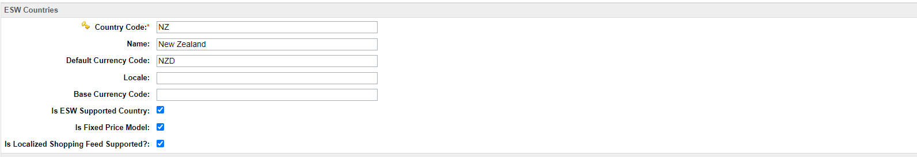

## **eswLocalizedShoppingFeed job**

The **eswLocalizedShoppingFeed** job creates a shopping feed based on **ESW Localized Shopping Product** flag. The file is generated with the delimiter defined in the preference ESW Localized Shopping Feed Delimiter. The file is generated in the IMPEX folder (the Impex path could be set up under the impexDirPath of job custom steps). Retailer can customize from this point to export the feed to external systems.