

MAMENTA INTEGRATION GUIDE

Version: 4.0.0

Published date: September 2023

Copyright © 2023 by ESW. All rights reserved. Information contained herein is subject to change without notice.



**SFCC - ESW Cartridge**

+

**Contents**

1. Mamenta Integration 2

**1.1** Problem Statement 3

1.2 Benefits 3

1.3 Pre-requisite 3

**2.** **Architecture Analysis & High-Level Design (HLD)** 3

**2.1** End to End order Workflow Diagram 3

3. Mamenta Integration Configuration 4

**3.1** ESW General configuration site preferences 4

**3.2** ESW Mamenta Integration Configuration product level custom attribute 5

**3.3** ESW Mamenta Integration Configuration order level custom attribute group 5

**3.4** ESW Mamenta Integration Configuration LineItem level custom attribute group 5

**3.5** ESW Mamenta Integration Configuration Custom object 6

**3.6** eswLocalizedProductFeed job 6

**3.7** eswInventoryFeed job 6

3.8 eswExportMarketPlaceOrders job 6

3.9 EswMamentaSftp service 6

3.10 EswOAuth service 7

3.11 EswOrderAPIV2 service 7

# **Mamenta Integration**

### **Problem Statement**

* **There were couple of limitations that Retailers were facing before mamenta integration.**
* The retailers cannot create product feeds from the catalog to reflect localized product prices for specific international markets (i.e., Australia and Canada). This is needed to produce product feeds for 3rd party marketplaces such as Amazon, Google, Facebook, etc.
* Due to the limitation of Order API sync with Mamenta (missing retailerID). Now, the mamenta orders will flow from SFCC to ESW. These orders need to be updated in SFCC so that retailers can sync them with their downstream systems.
  1. Benefits
* Shoppers from 3rd party marketplaces could see the localized product prices based on their country.
* Retailers will be able to create localized product feeds for international markets.
* Post-order processing sync for Marketplace orders
* Support for Order events such as Returns, cancellations, etc.
* Retailer downstream systems sync
* Better shopper experience
* Increased customer traffic/sales
  1. Pre-requisite
* The retailer must configure the country key custom preference in the business manager to be a URL attribute key for localized countries.
* The retailers have configured the SFTP credentials to transfer the generated feeds to ESW.
* The retailers must import the metadata in BM.

## **Architecture Analysis & High-Level Design (HLD)**

## **End to End order Workflow Diagram**

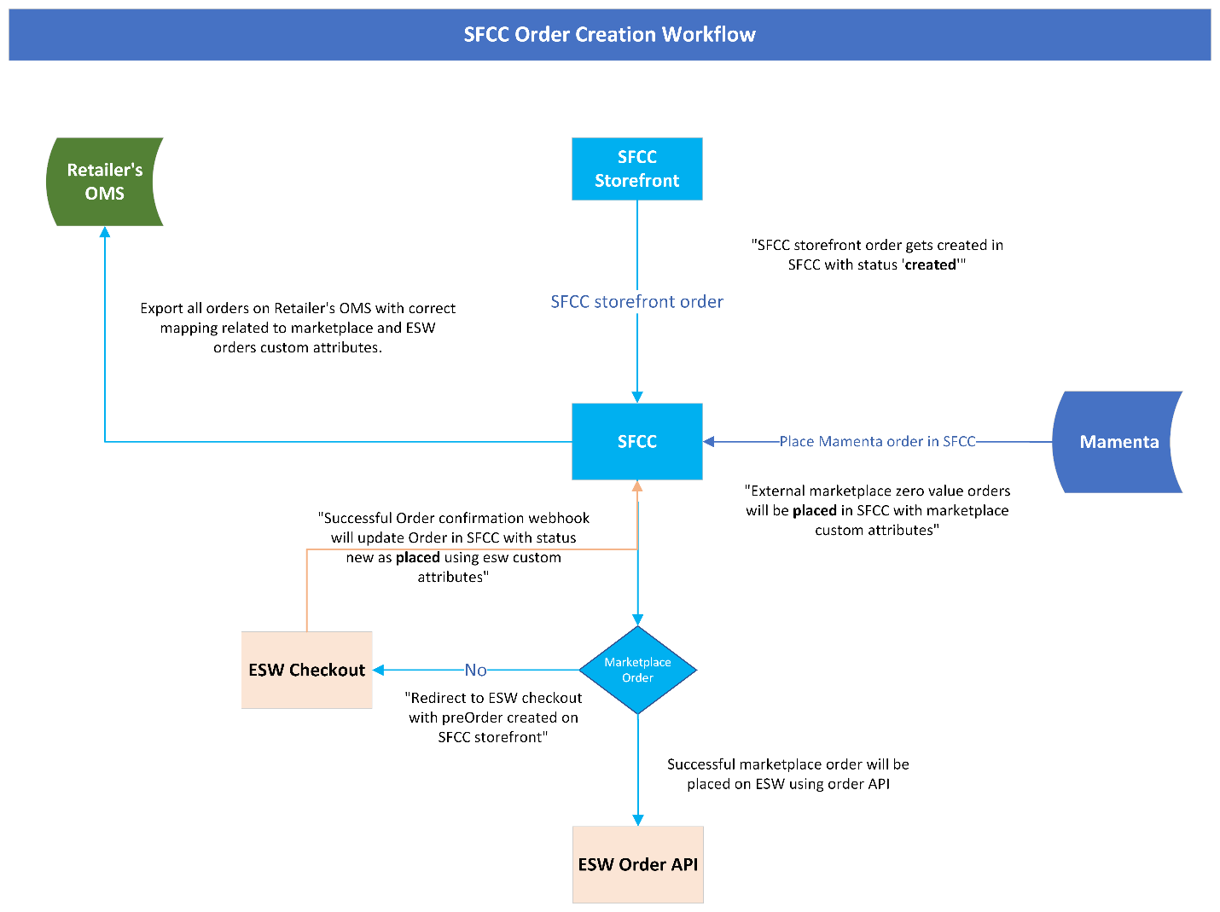

# **Mamenta Integration Configuration**

ESW Mamenta Integration Configuration site preferences

The ESW Mamenta Integration Configuration options are present:

* **ESW Mamenta Inventory Feed Remote Path**: This preference indicates the remote path of the ESW Mamenta inventory Feed CSV file in the SFTP location.
* **ESW Mamenta Catalog Feed Remote Path**: This preference indicates the remote path of the ESW Mamenta catalog Feed CSV file in the SFTP location.
* **ESW Mamenta Feed SFTP Service Name**: The preference indicates the SFTP service name that will be called when establishing the connection with SFTP.
* **ESW Mamenta Feed Delimiter**: This preference is to select the delimiter as a separator for the mamenta feed generated in response to the moment feed job execution. The default value for this preference would be pipe sign **‘|’** and comma**, ‘’** can also be selected as delimiter value.

## **ESW General configuration site preferences**

* **ESW Basic Auth Enabled:** This preference indicated that basic auth is enable or disable to place marketplace order in SFCC.
* **ESW Basic Authentication User:** This preference indicates the basic auth client ID.
* **ESW Basic Authentication Password:** This preference indicates the basic auth client secret.

## **ESW Mamenta Integration Configuration product level custom attribute**

* **Market Place Product:** This custom attribute is for marketplace products. It's a Boolean type that indicates if the product is a marketplace product or not. If the flag is true, catalog and inventory feed will be generated for the product.

## **ESW Mamenta Integration Configuration order level custom attribute group**

* **Marketplace order attributes:** This group contains several order custom attributes. Which keeps the order’s request payload information.

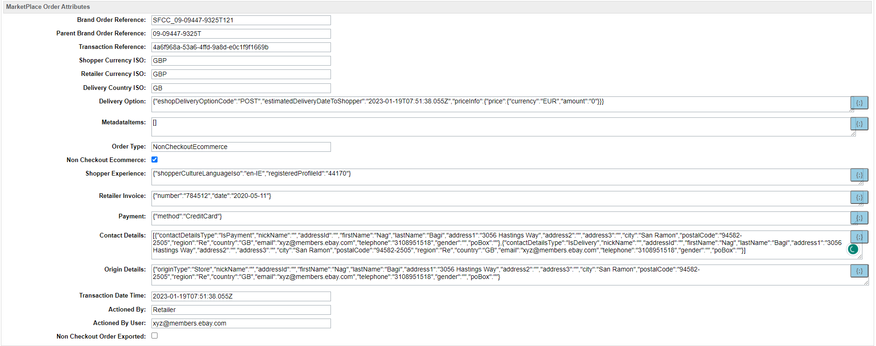

## **ESW Mamenta Integration Configuration LineItem level custom attribute group**

**ESW Marketplace Items:** This group contains several lineitem custom attributes. Which keeps the lineitem level information in request payload.

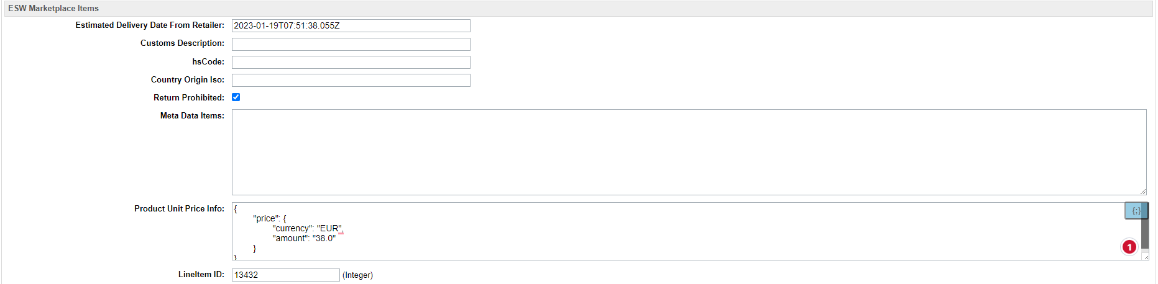

## **ESW Mamenta Integration Configuration Custom object**

* Add attribute **isProductFeedSupported** type Boolean under custom object **ESW_COUNTRIES** (value, if true, will be used to populate the feed for related country/market)
* Use **countryCode** as the country key from the custom object **ESW_COUNTRIES** to set the country.

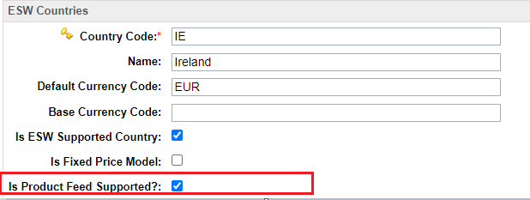

## **eswLocalizedProductFeed job**

The **eswLocalizedProductFeed** job syncs the retailer catalog to the ESW Catalog Service by generating the required file in a specific format based on **Market Place Product** flag. The file is generated in the IMPEX folder (the Impex path could be set up under the impexDirPath of job custom steps). The job also transfers the generated file to the Mamenta SFTP location using the SFTPClient service framework.

## **eswInventoryFeed job**

The **eswInventoryFeed** job syncs the retailer inventory to the ESW Catalog Service by generating the required file in a specific format based on **Market Place Product** flag. The file is generated in the IMPEX folder (Impex path could be set-up under the impexDirPath of job custom steps). The job also transfers the generated file to the Mamenta SFTP location using the SFTPClient service framework.

* 1. eswExportMarketPlaceOrders job

The **eswExportMarketPlaceOrders** job will use the order API V2 to export market place orders to ESW. If the **Non Checkout Ecommerce** (order level custom) flag is set, **eswExportMarketPlaceOrders** will export the order to ESW. When an order is successfully exported, the ESW **Non Checkout Order Exported** (order level custom attribute) flag is set to true to prevent order exports from being duplicated when the job is executed the next time.

* 1. EswMamentaSftp service

This service is used to make a call to the SFTP client and establish the connection to the remote MAMENTA SFTP server. The service has its credentials that you can find under the **Credentials**tab.

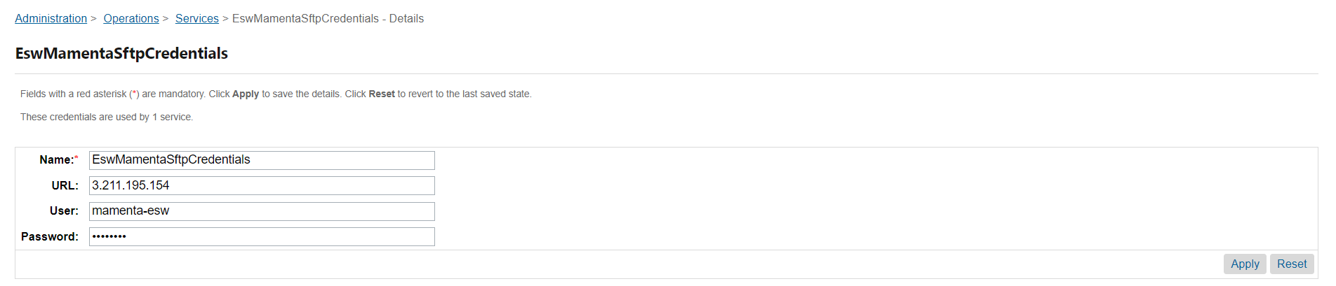

* For multiple sites using the common Sandbox, you can configure multiple services for sites that use the different MAMENTA SFTP servers. You can also add the service name to the **ESW Mamenta Feed SFTP Service Name** custom preference. Examples of the service names are EswMamentaSftp.SG and EswMamentaSftp.SFRA.
  1. EswOAuth service
* This service is used to get the authentication token from ESW. This token is used by other ESW services and APIs, such as Price Feed, Checkout, and Package.
* Services can Import service from **link_eshopworld\sitesdata\services.xml**

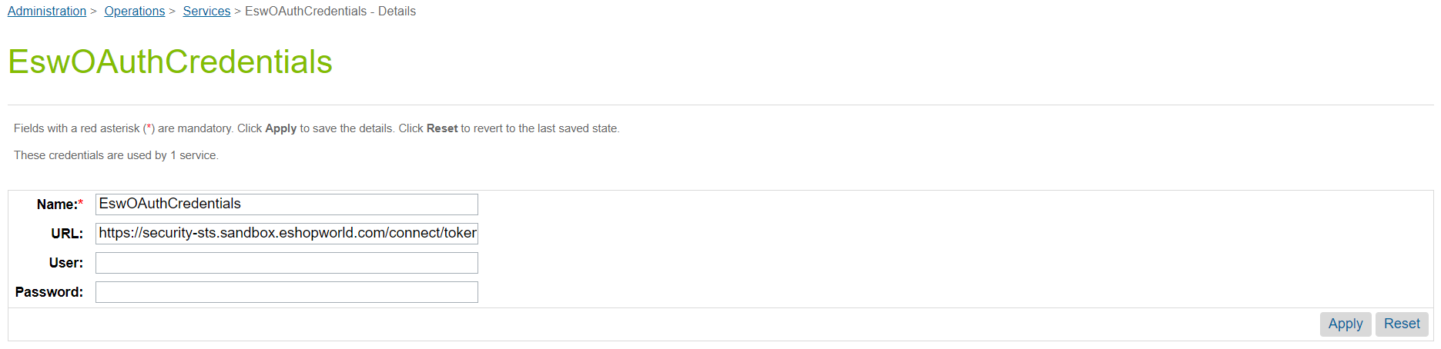

*ESW OAuth Credentials*

* 1. EswOrderAPIV2 service
* This service is used to make a call to the ESW Order API v2.0 and create order in ESW CSP. Import service from **link_eshopworld\sitesdata\services.xml**

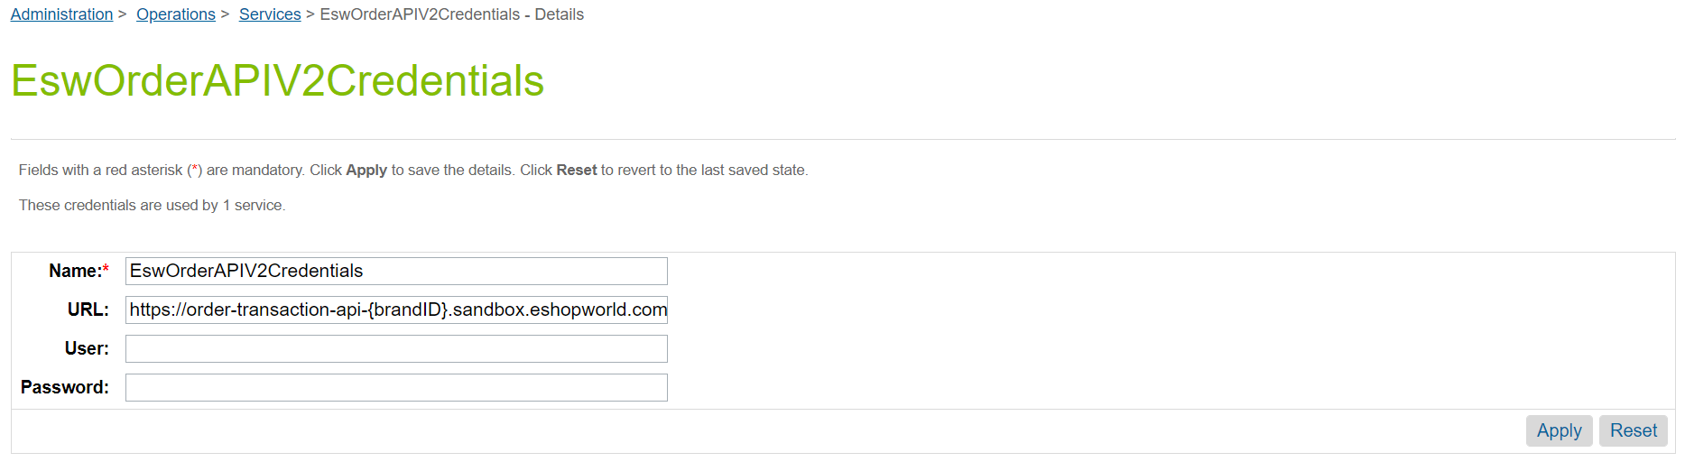EswOrderAPIV2Service

1. **Testing Sandbox/Staging Environment**

* Follow the below steps to test end to end order flow using postman and sandbox
  1. Trigger the endpoint [**https://zyfl-002.dx.commercecloud.salesforce.com/on/demandware.store/Sites-RefArch-Site/en_US/EShopWorld-ProcessExternalOrder**](https://zyfl-002.dx.commercecloud.salesforce.com/on/demandware.store/Sites-RefArch-Site/en_US/EShopWorld-ProcessExternalOrder)with basic auth and request body payload(see the below sample payload) to sync the marketplace order with SFCC. Zero value order will be placed on SFCC, and retailer will get an order number with success response.
  2. Once a zero value order is successfully placed in SFCC and order payload information is stored in relevant custom attributes. Execute the **eswExportMarketPlaceOrders** Job.
  3. Once Job is successfully executed order will be exported in ESW. Order can be verified on CSP panel <https://uatrc-csp.eshopworld.net/CustomerService/Order/Search> by using order number.
* **Important note:**
* **brandOrderReference** value will be SFCC order number.
* **parentBrandOrderReference** value will be marketplace order ID.
* **transactionReference** should be unique for every order.
* **lineItemId** should be max limit integer values 10

**Sample payload:**

{

    "brandOrderReference": "SFCC_09-09447-9325T121",

    "weight": {

        "weightTotal": 2,

        "weightUnit": "KG"

    },

    "orderType": "NonCheckoutEcommerce",

    " parentBrandOrderReference ": "09-09447-9325T",

    "transactionReference": "*{{$guid}}*",

    "transactionDateTime": "2023-01-19T07:51:38.055Z",

    "actionedBy": "Retailer",

    "actionedByUser": "",

    "shopperCurrencyIso": "GBP",

    "retailerCurrencyIso": "GBP",

    "deliveryCountryIso": "GB",

    "shopperExperience": {

        "shopperCultureLanguageIso": "en-IE",

        "registeredProfileId": "44170"

    },

    "contactDetails": [

        {

            "contactDetailsType": "IsPayment",

            "nickName": "",

            "addressId": "",

            "firstName": "Nag",

            "lastName": "Bagi",

            "address1": "3056 Hastings Way",

            "address2": "",

            "address3": "",

            "city": "San Ramon",

            "postalCode": "94582-2505",

            "region": "Re",

            "country": "GB",

            "email": "xyz@members.ebay.com",

            "telephone": "3108951518",

            "gender": "",

            "poBox": ""

        },

        {

            "contactDetailsType": "IsDelivery",

            "nickName": "",

            "addressId": "",

            "firstName": "Nag",

            "lastName": "Bagi",

            "address1": "3056 Hastings Way",

            "address2": "",

            "address3": "",

            "city": "San Ramon",

            "postalCode": "94582-2505",

            "region": "Re",

            "country": "GB",

            "email": "xyz@members.ebay.com",

            "telephone": "3108951518",

            "gender": "",

            "poBox": ""

        }

    ],

    "lineItems": [

        {

            "quantity": 5,

            "estimatedDeliveryDateFromRetailer": "2023-01-19T07:51:38.055Z",

            "lineItemId": "125477",

            "product": {

                "productCode": "013742002836M",

                "title": "Turquoise and Gold Bracelet",

                "description": "Turquoise and Gold Bracelet",

                "productUnitPriceInfo": {

                    "price": {

                        "currency": "EUR",

                        "amount": "38.00"

                    }

                },

                "customsDescription": "",

                "hsCode": "",

                "countryOfOriginIso": "",

                "imageUrl": "",

                "color": "Gold",

                "size": "",

                "metadataItems": {},

                "isReturnProhibited": **true**

            }

        }

    ],

    "deliveryOption": {

        "eshopDeliveryOptionCode": "POST",

        "estimatedDeliveryDateToShopper": "2023-01-19T07:51:38.055Z",

        "priceInfo": {

            "price": {

                "currency": "EUR",

                "amount": "0"

            }

        }

    },

    "retailerInvoice": {

        "number": "784512",

        "date": "2020-05-11"

    },

    "payment": {

        "method": "CreditCard"

    },

    "originDetails": {

        "originType": "Store",

        "nickName": "",

        "addressId": "",

        "firstName": "Nag",

        "lastName": "Bagi",

        "address1": "3056 Hastings Way",

        "address2": "",

        "address3": "",

        "city": "San Ramon",

        "postalCode": "94582-2505",

        "region": "Re",

        "country": "GB",

        "email": "xyz@members.ebay.com",

        "telephone": "3108951518",

        "gender": "",

        "poBox": ""

    },

    "metadataItems": []

}