

Version: 4.8

Published date: September 2025

Copyright © 2025 by ESW. All rights reserved. Information contained herein is subject to change without notice.

ORDER APPEASEMENT INTEGRATION GUIDE



**SFCC - ESW Cartridge**

+

Contents

**1** **Order Appeasement Integration** 3

1.1 Benefits 3

1.2 Workflow to Order Appeasement (SFCC => ESW) 3

1.3 Workflow to Order Appeasement Sync (ESW => SFCC) 3

1.3.1 ESW Webhooks Configuration 4

1.3.2 Workflow to Appeasement Order in SFCC 4

**2** **Order Appeasement Integration Configuration** 5

2.1 Import Metadata 5

# **Order Appeasement Integration**

# Previously, retailers had to directly integrate their OMS/WMS/financial systems with ESW for appeasement information/details as SFCC doesn’t support ESW Appeasement API.

# The following issues will be resolved:

* Increase the integration effort the retailers need to integrate their OMS/WMS/financial systems with ESW.
* Retailers are not able to extend their integration with SFCC to access the appeasement information.

Benefits

* Appeasement integration with SFCC will allow the retailer to access the appeasement information directly through SFCC and send them to their respective OMS/WMS/financial systems.
* Retailers will be able to sync them to their ERP/finance with critical financial data retailer and shopper currencies.
* Retailer will be able to see the correct breakdown of tax/duty information
* Reduces integration effort

Workflow to Order Appeasement (SFCC => ESW)

This flow is not available in the feature. A retailer can create appeasement only from the ESW panel.

Workflow to Order Appeasement Sync (ESW => SFCC)

If the order is appeased in ESW CSP. SFCC webhook endpoint will be called from CSP (EShopWorld-ProcessWebHooks) that will update appeasement custom attributes on specified order in request and mark the order as an appeased by changing the value for flag **Is ESW Appeased Order?** to true.

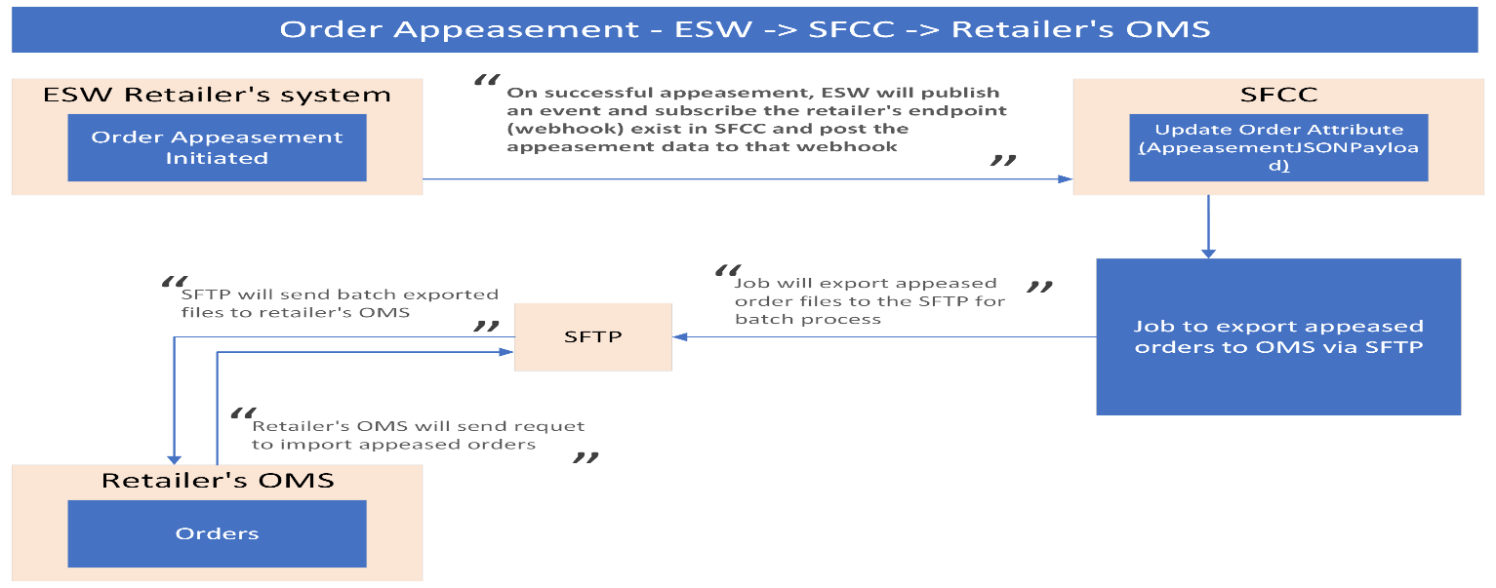

The endpoint will be configured on the ESW tenant side so retailers can subscribe to the event.

ESW Webhooks Configuration

Retailers need to subscribe SFCC API endpoint in ESW tenant configuration that will trigger on OrderAppeasementSucceedEvent. The ESW-SFCC cartridge provides the OOTB SFCC endpoint to subscribe to the ESW order appeasement webhook event. ESW integration engineer can help retailers subscribe to this endpoint.

**SFCC Endpoint Example:**

[https://example.com/on/demandware.store/Sites-RefArch-Site/default/EShopWorld-ProccessWebHook](https://example.com/on/demandware.store/Sites-RefArch-Site/default/EShopWorld-CancelOrder)s

Retailers can update example.com with their storefront domain.

Workflow to Appeasement Order in SFCC

The ESW-SFCC Cartridge would perform the following to appeasement order in SFCC If the order appeased from ESW CSP first to sync order status in SFCC.

* On successful order appeasement in ESW CSP, webhook will trigger the retailers provided subscribed SFCC endpoint (EShopWorld- ProcessWebHooks) with appeasement order detail in the request body.
* SFCC endpoint will park appeased order data in SFCC custom objects attributes. Set Order as appeased by marking attribute **Is ESW Appeased Order** as true**.**
* Park requests payload in Jason format to custom attribute **appeasementJsonPayload.**

# **Order Appeasement Integration Configuration**

Import Metadata

Import order-level custom attributes (systemobjects.xml) from **link_eshopworld\sitesdata\meta.**

The following **ESW Order Appeasement** custom attributegroup will be present in Order Custom Attributes:

* **Appeased Order Payload Response**: This custom attribute will be filled with request JSON format if the order is successfully appeased in ESW, which will be in the ESW Order API response.
* **Is ESW Appeased Order?**: This will hold the Boolean status of appeasement on successfully updating the ESW Order API response.