

Version: 4.6.2

Published date: April 2025

Copyright © 2025 by ESW. All rights reserved. Information contained herein is subject to change without notice.

ORDER CANCELLATION INTEGRATION GUIDE



**SFCC - ESW Cartridge**

+

Contents

**1** **Order Cancellation Integration** 3

1.1 Retailers OMS Order Cancellation (SFCC => ESW) 3

1.1.1 Workflow to Cancel Order in ESW using Order API 3

1.2 eShopWorld Order Cancellation (ESW => SFCC) 4

1.2.1 ESW Webhooks Configuration 4

1.2.2 Workflow to Cancel Order in SFCC 5

**2** **Order Cancellation Integration Configuration** 5

2.1 Import Metadata 5

2.2 eswRetailerOrderStatus Job 6

2.2.1 Job Frequency 7

2.3 EswOAuthService 7

2.4 EswOrderAPIV2Service 7

# **Order Cancellation Integration**

ESW plugin allows retailers to synchronize cancelled orders status between SFCC & ESW regardless of where order cancellation triggered first, whether in SFCC or ESW.

The ESW-SFCC cartridge allows retailers to synchronize cancelled order status in both ways ESW => SFCC and SFCC => ESW.

eShopWorld Order Cancellation (ESW => SFCC)

The ESW-SFCC Cartridge allows retailers to cancel orders in SFCC if order cancelled via ESW CSP first.

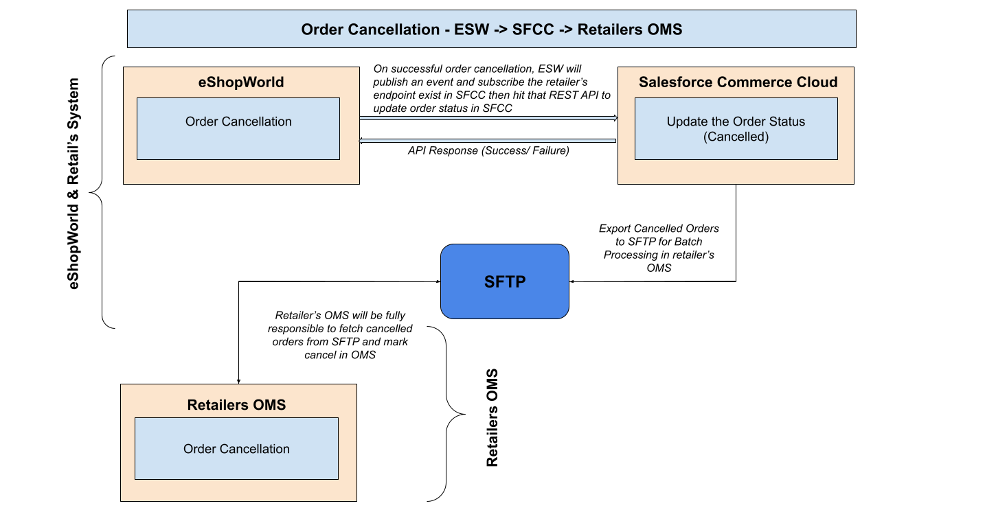

ESW Webhooks Configuration

Retailers need to subscribe SFCC API endpoint in ESW tenant configuration that will trigger on OrderCancelSucceedEvent. The ESW-SFCC cartridge provides the OOTB SFCC endpoint to subscribe with ESW order cancellation webhook event. ESW integration engineer can help retailers to subscribe this endpoint.

**SFCC Endpoint Example:**

[https://example.com/on/demandware.store/Sites-RefArch-Site/default/EShopWorld-ProcessWebHooks](https://example.com/on/demandware.store/Sites-RefArch-Site/default/EShopWorld-CancelOrder)

Retailers can update example.com with their storefront domain.

Workflow to Cancel Order in SFCC

The ESW-SFCC Cartridge perform the following to cancel order in SFCC If order cancelled from ESW CSP first to sync order status in both systems.

* On successful order cancellation in ESW CSP, webhook will trigger the retailers provided subscribed SFCC endpoint (EShopWorld-ProcessWebhook) with cancelled order detail in request body.
* SFCC endpoint will park cancelled order data in SFCC custom objects **eswCancelledOrders** temporarily for further processing like below.

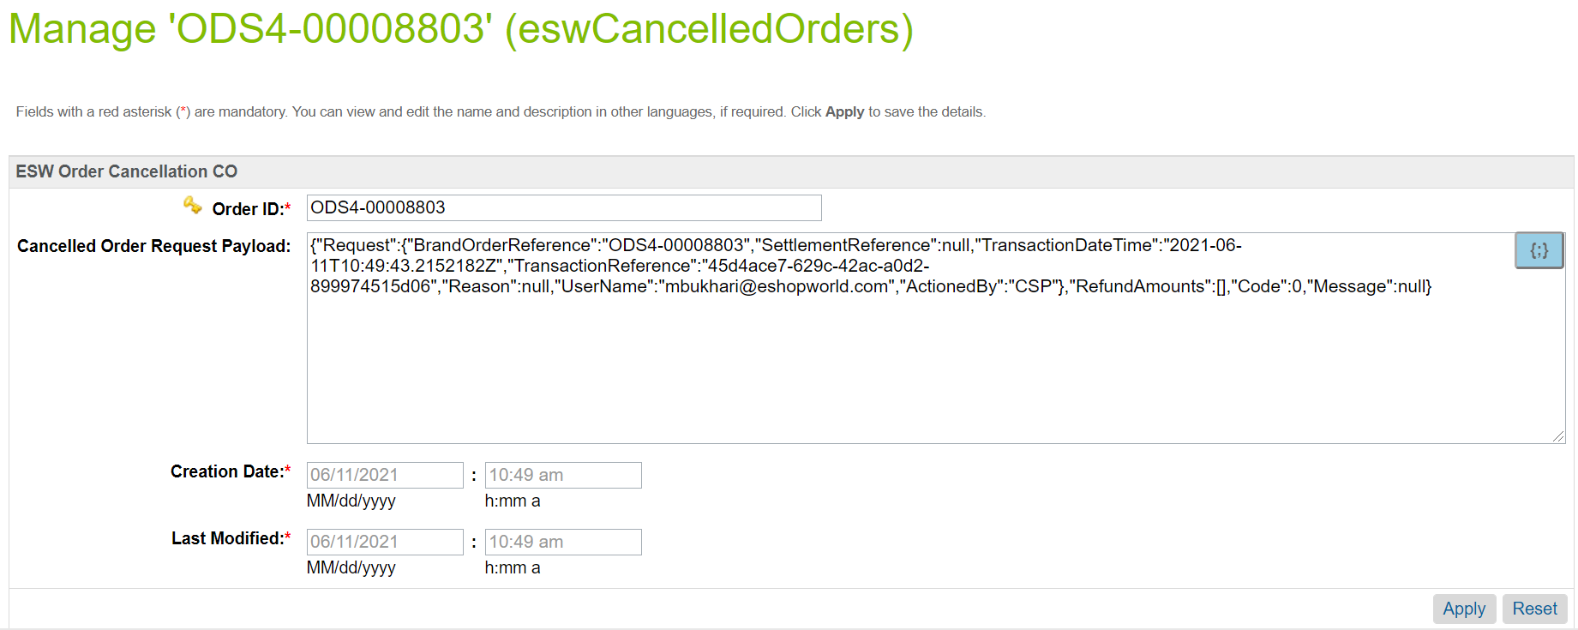

* ESW scheduled SFCC Job eswRetailerOrderStatus will iterate over orders exist in custom objects and mark as cancelled in SFCC. Job step **eswToSfccOrderCancellation** perform this ESW to SFCC cancellation activity.
* Retailers is responsible to sync cancelled orders between SFCC and external Retailers OMS.

# **Order Cancellation Integration Configuration**

Import Metadata

Import order level custom attributes (systemobjects.xml) and custom objects (customobjects.xml) from **link_eshopworld\sitesdata\meta.**

The following **ESW Order Cancellation** custom attributegroup will be present in Order Custom Attributes:

* **ESW Transaction Reference**: This custom attribute will be filled with transaction reference if order successfully cancelled in ESW and this will be in ESW Order API response.
* **ESW Order Cancellation Timestamp**: This will hold the timestamp that when order cancellation happened.
* **ESW Order Cancellation Message**: This attribute will hold the Success Message or Error Message coming in ESW Order API response.
* **ESW Order Cancellation Retry Count**: This attribute will hold the number of tries to cancel order in ESW using Order API. SFCC Job will try max three times to cancel order in ESW.
* **ESW Order Cancelled By**: This attribute will hold the value that who perform this cancellation action, Retailer/ Shopper or CSP. In case of order cancellation from SFCC to ESW, this value will be Retailer.
* **ESW Order Cancelled By User**: This attribute will hold the email of the user whole triggered the cancellation.

**Custom Object eswCancelledOrders will be present in SFCC Custom Objects.**

eswRetailerOrderStatus Job

The **eswRetailerOrderStatus**job syncs the cancelled orders status between SFCC & ESW via the ESW Order API v2.0. Import job from **link_eshopworld\sitesdata\jobs.xml**

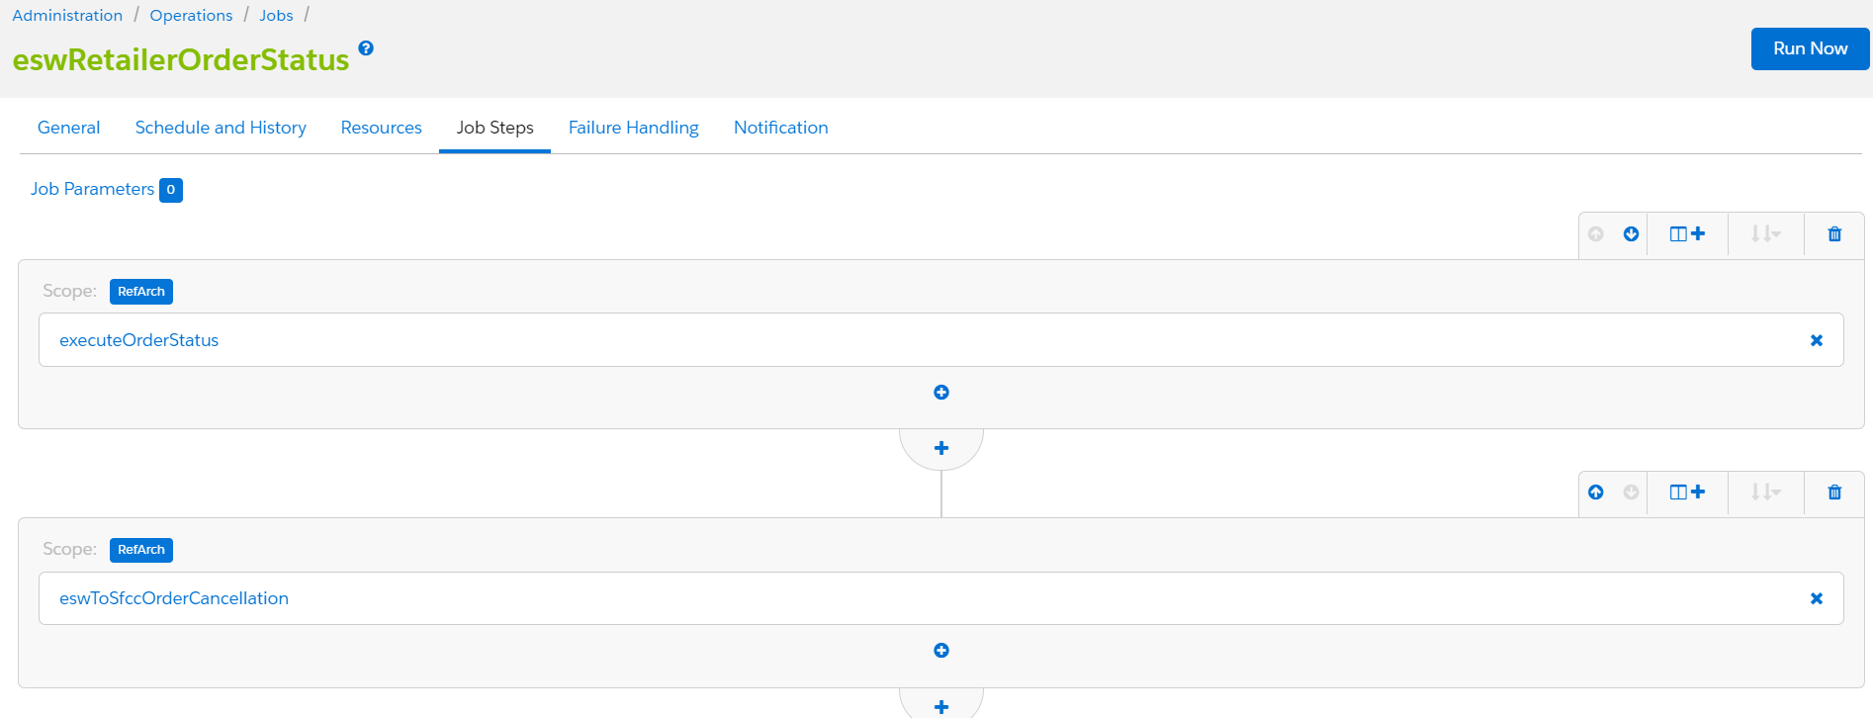

**eswRetailerOrderStatus** job contains two job steps as below:

**executeOrderStatus:** This job step cancel order in ESW CSP using Order API if order cancelled in SFCC. Retailers needs to add some parameters in this job.

* actionBy [Retailer, CSP] – In SFCC value should be Retailer because order cancelled first in SFCC.
* actionByUserEmail – Email of the user who is going to run this job.

**eswToSfccOrderCancellation:** This job step cancel order in SFCC if order cancelled by ESW CSP.

Job Frequency

Schedule this job to run after every hour. Retailers can schedule according to cancelled orders frequency.

EswOAuthService

This service is used to get the authentication token from ESW. This token is used by other ESW services and APIs, such as Price Feed, Checkout, and Package.

Services can Import service from **link_eshopworld\sitesdata\services.xml**

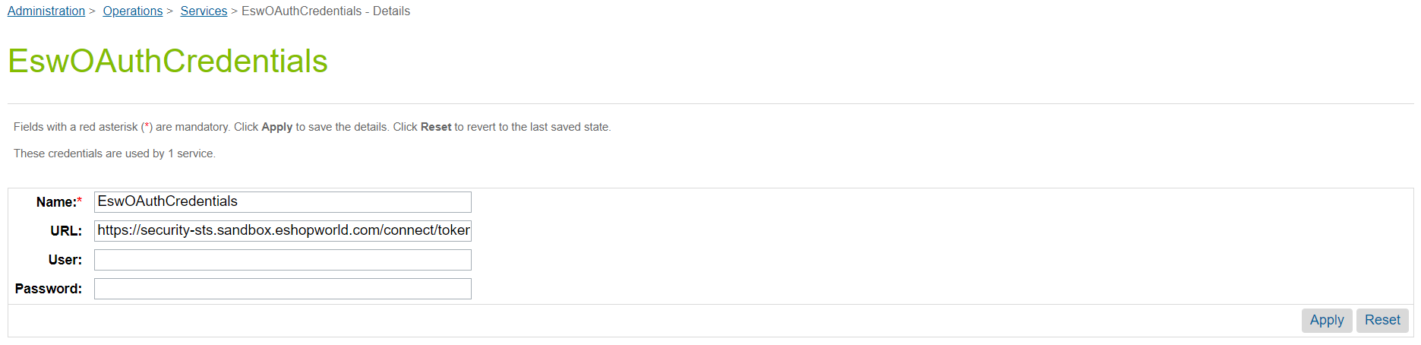

*ESW OAuth Credentials*

EswOrderAPIV2Service

This service is used to make a call to the ESW Order API v2.0 and cancel order in ESW CSP. Import service from **link_eshopworld\sitesdata\services.xml**

While adding service URL please replace client/brand ID and Order number like below:

https://order-transaction-api-**{brandID}**.sandbox.eshopworld.com/api/v2/Order/**{brandOrderReference}**/OrderActivity

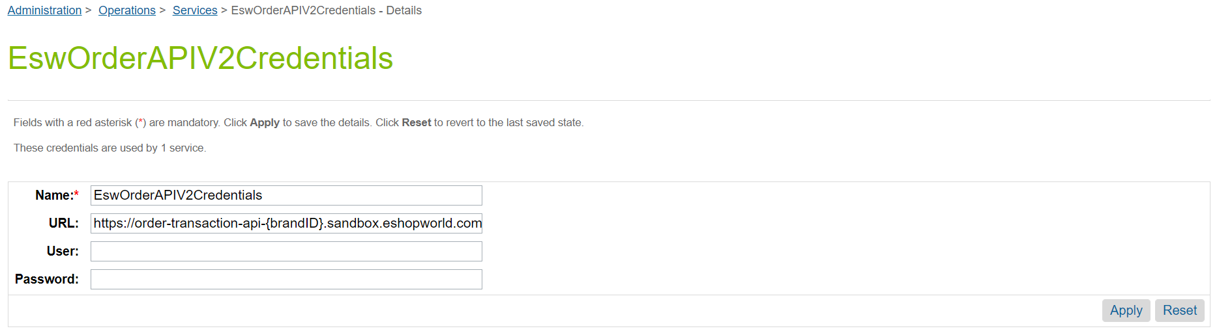EswOrderAPIV2Service