

Version: 4.8

Published date: September 2025

Copyright © 2025 by ESW. All rights reserved. Information contained herein is subject to change without notice.

Order Status Updates from ESW to SFCC



**SFCC - ESW Cartridge**

+

Contents

1. Payment status updates from ESW to SFCC 2

2. Prerequisites 3

3. Configurations in SFCC Business Manager 3

3.1. Import Metadata 3

3.2. Enable the feature toggle 4

3.3. Understanding the order mapping with ESW payment status 4

4. Testing Steps 5

# **Order Payment status updates from ESW to SFCC**

This feature synchronizes payment statuses from ESW directly into the SFCC Business Manager, providing real-time visibility into the order's financial lifecycle. An order's confirmation and export status are directly tied to the payment settlement. Until a payment is marked as "Settled" in ESW, the order will remain “not confirmed” and will not be ready for export. Once settled, the order status will updated to “confirmed” and becomes ready for export to fulfilment systems.

**Why is this important?**

* **Enhanced Order Visibility:** Understand the exact payment state of any ESW order without leaving the SFCC Business Manager.
* **Improved Automation:** SFCC order confirmation and export statuses are now automatically updated based on real-time payment events from ESW, reducing manual work and potential errors.
* **Accurate Status Mapping:** Ensures that order data in SFCC accurately reflects the payment processing and settlement events occurring in ESW.

# **Prerequisites**

**ESW Webhook Configuration:** Retailers need to subscribe SFCC API endpoint in ESW tenant configuration that will trigger on **Test-fromVirtualEvent-order-order**. This webhook is responsible for sending the payment updates to SFCC instance. The ESW-SFCC cartridge provides the OOTB SFCC endpoint to subscribe with ESW webhook event. ESW integration engineer can help retailers to subscribe this endpoint.

**SFCC Endpoint Example:**

For SiteGenesis implementations, the endpoint [https://example.com/on/demandware.store/Sites-{siteId}-Site/default/EShopWorldSG-ProcessWebHooks](https://example.com/on/demandware.store/Sites-%7bsiteId%7d-Site/default/EShopWorldSG-ProcessWebHooks) must be used.

For all other architectures, the endpoint [https://example.com/on/demandware.store/Sites-{siteId}-Site/default/EShopWorld-ProcessWebHooks](https://example.com/on/demandware.store/Sites-%7bsiteId%7d-Site/default/EShopWorld-ProcessWebHooks) can be used.

Retailers should replace example.com with their storefront domain and {siteId} with their site ID, for example RefArch.

# **Configurations in SFCC Business Manager**

Activating this feature requires a one time configuration in the Business Manager Site Preferences.

# **Import Metadata**

Import system level attributes (**systemobjects.xml**) from **link_eshopworld\Metadata\meta.**

The following custom attributewill be present at site level custom preferences under **ESW General Configuration** group:

* **ESW Order Status Updates**: This feature is controlled by this site level preference that acts as a master switch to on or off the feature. 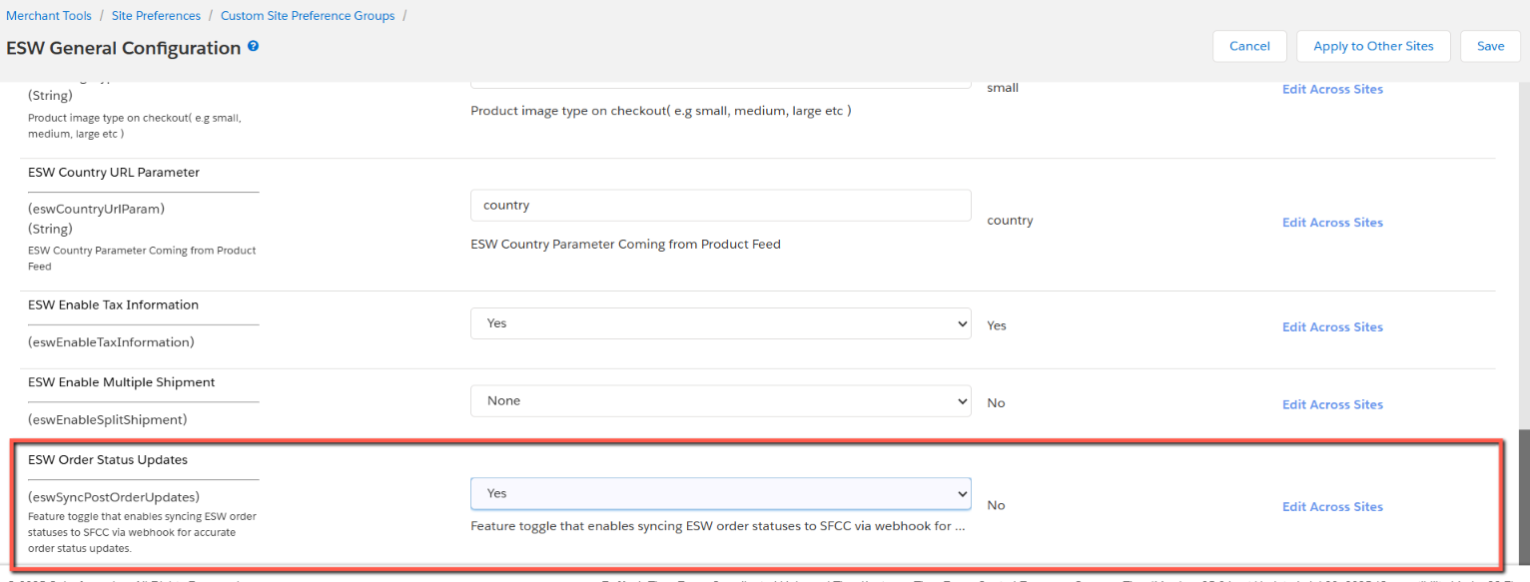

The following custom attributewill be present at order’s payment level.

* **ESW Payment Status:** This attribute shows one of the below status of order payment.
  + **Settled:** The payment has been fully captured and confirmed by ESW.
  + **Authorized:** The payment is authorized by the provider but is still waiting to be settled/captured.
  + **Not Authorized:** The payment has not yet been authorized or settled.

# **Enable the feature toggle**

* Navigate to **Merchant Tools > Site Preferences > Custom Preferences**.
* Select the preference group **ESW General Configuration**.
* Locate the custom preference ESW sync post order updates.
* Set its value to **Yes** to enable the feature.

# **Understanding the order mapping with ESW payment status**

Once the feature is enabled, the SFCC will listen for webhook **Test-fromVirtualEvent-order-order** messages from ESW and automatically update the SFCC order and payment statuses. Here is the logic that will be applied:

|  |  |  |  |
| --- | --- | --- | --- |
| **ESW Payment Status** | **SFCC’s Order Payment Status** | **SFCC’s Order Export Status** | **SFCC’s Order Confirmation Status** |
| Settled | Paid | Confirmed | Ready to Export |
| Authorized | Not Paid | Not Confirmed | Not Exported |
| Not Authorized | Not Paid | Not Confirmed | Not Exported |

# **Testing Steps**

To check if the feature is working correctly:

1. Place a test order through your ESW enabled SFCC storefront.
2. In Business Manager, find the order you just created.
3. Check the **Order Status**, **Confirmation Status**, and **Export Status** on the main order page.
4. Navigate to the **Payment** section of the order.
5. Verify that the **ESW Payment Status** custom attribute displays the expected value (e.g., "Authorized", "Not Authorized" or "Settled") based on the payment event **Test-fromVirtualEvent-order-order**.