

OVER THE COUNTER PAYMENT METHOD  
INTEGRATION GUIDE

Version: 4.5

Published date: October 2024

Copyright © 2024 by ESW. All rights reserved. Information contained herein is subject to change without notice.



**SFCC - ESW Cartridge**

+

Contents

1. Over the Counter Payment Method Integration 3

2. Over the Counter Payment Method Integration Configuration 3

3. Workflow to get Over the Counter Payment method information in SFCC 3

3.1 Order Confirmation flow 3

3.2 Order Settlement flow 4

3.3 Order Expiration/Cancellation flow 5

4. SFCC Endpoint Example 6

1. Over the Counter Payment Method Integration

Over the Counter is a payment method that allows consumers to order goods online and pay for them over the counter in a convenience store. ESW cartridge allow shopper to use new payment method to simplify the shopping experience. So that on the checkout screen shopper can see the over the counter as payment methods.

# **Over the Counter Payment Method Integration Configuration**

**2.1 Over the Counter Payment Method Integration Order Level Custom Attribute**

* **Esw Over the Counter Payload Json (eswOverTheCounterPayloadJson):** This custom attribute is used to store the over the counter related payloads and append the data from webhook and order confirmation in Json format

1. Workflow to get Over the Counter payment information in SFCC

## **Order Confirmation flow**

The workflow is quite straight forward. Retailers need to make sure that Over the Counter payment integration feature is enabled on ESP and new event eshopworld.platform.events.oms.orderholdstatusupdatedevent is added. If Over the Counter payment is enabled on SFCC for the tenant, then shopper will see the Over the Counter payment method on payment panel. When a shopper places an order using Over the Counter payment method, then in SFCC BM order looks like:

* The payment screen for the order in SFCC will appear as shown in screenshot with payment status not Paid:

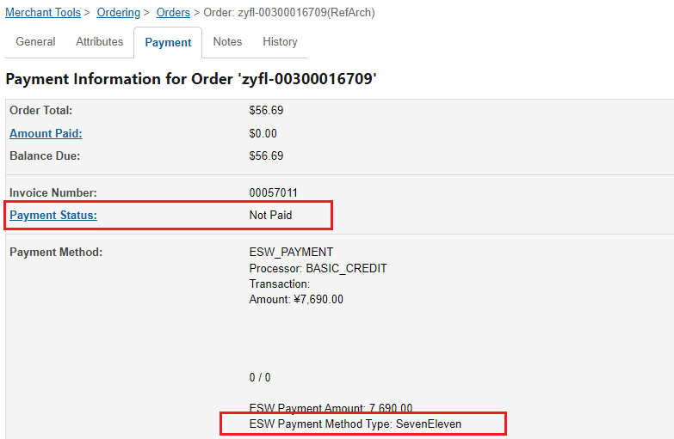

* **Please be aware that the ESW Payment Method Type value will correspond to what we receive in the order confirmation payload.**
* The general screen for the order in SFCC will appear as shown in screenshot with confirmation status Not Confirmed and Export Status Not Exported:



* All the order confirmation related info will be stored in Esw Over the Counter Payload Json (order level custom attribute).

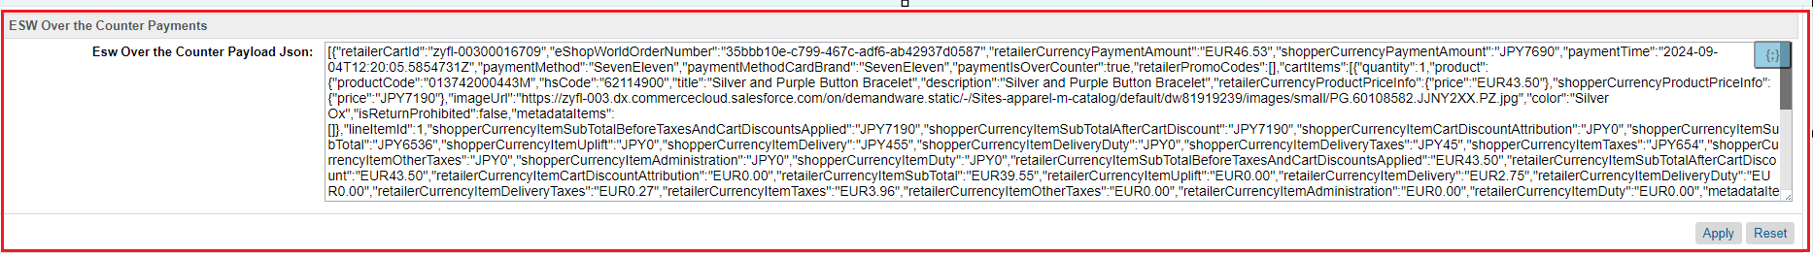

The flow diagram can be seen as follows:

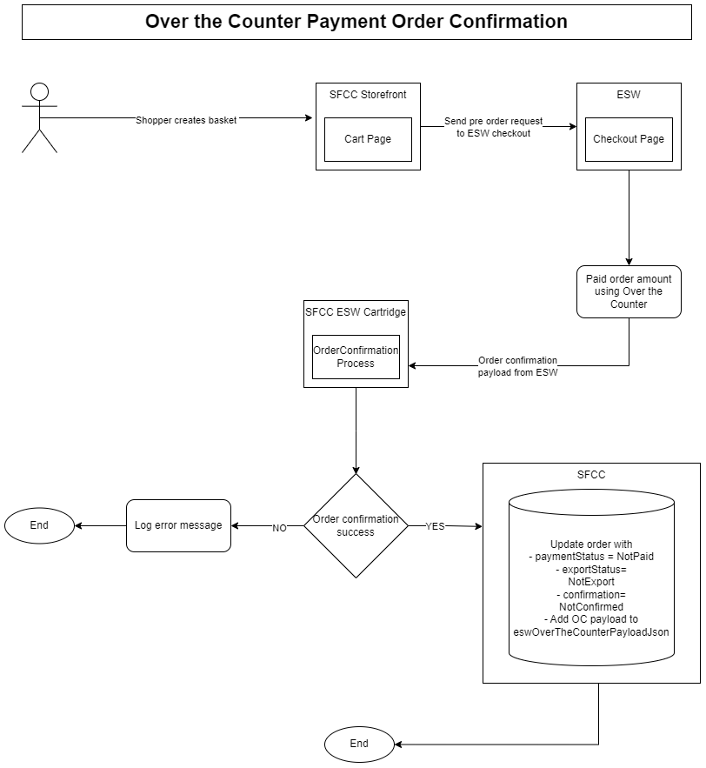

## **Order Settlement Flow**

After order has been placed via Over the Counter payment Payment Method once change in the payment Status The Order webhook will publish event to SFCC EShopWorld-ProcessWebHooks endpoint. This endpoint will be responsible for the following:

If order is available in the SFCC And payment **HoldStatus** status is **NoHold** in the webhook payload

* Then it will update the order’s payment status to PAID

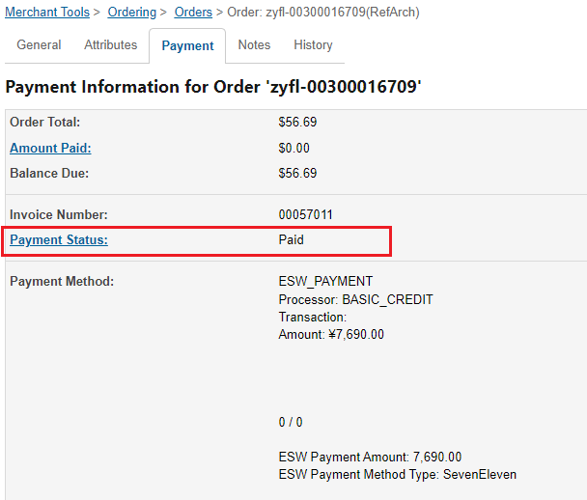

* Order’s Export status will be Ready to Export and Confirmation status will be Confirmed.



* All the webhook related info will be append in Esw Over the Counter payment Payload Json (order level custom attribute) with order confirmation payload.

## **Order Expiration/Cancellation flow**

Over the Counter payment orders have an expiration limit. This limit defines how many days shopper has to pay for the order over the counter. This limit is configurable on ESW side. Once the Over the Counter payment order is expired, ESW activates cancellation process for this order. SFCC cartridge will receive a webhook event for Over the Counter payment order cancellation which you can find more information [here](https://know.eshopworld.com/space/AE/580812939/Order+Cancellation+Integration).  
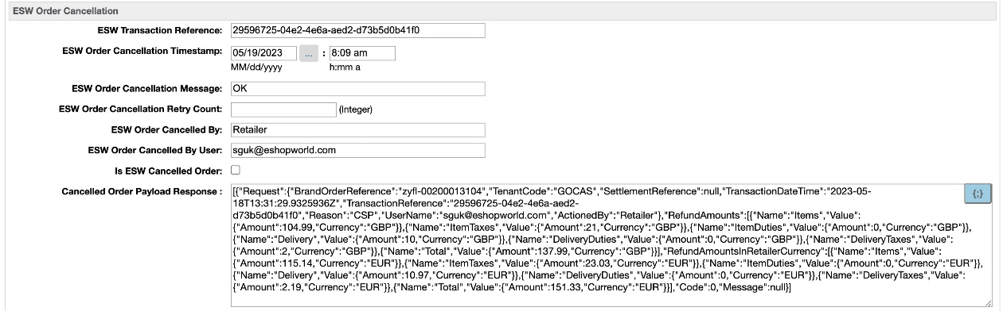

# **SFCC Endpoint Example**

* The endpoint and event will be configured on the ESW tenant side so retailers can subscribe to the event
* [https://example.com/on/demandware.store/siteID /default/EShopWorld-ProccessWebHooks](https://example.com/on/demandware.store/siteID%20/default/EShopWorld-ProccessWebHooks) (For SFRA SG and PWA)
* [https://example.com/on/demandware.store/siteID/default/ EswRefArchHL-ProccessWebHooks](https://example.com/on/demandware.store/siteID/default/%20EswRefArchHL-ProccessWebHooks) (For Headless SFRA based architect)
* [https://example.com/on/demandware.store/siteID/default/ EswHL-ProccessWebHooks](https://example.com/on/demandware.store/siteID/default/%20EswHL-ProccessWebHooks) (For Headless Site Genesis based architect)
* can update the ‘example’ domain in https://example.com URL with your storefront’s domain.