

Version: 4.6.1

Published date: January 2025

Copyright © 2025 by ESW. All rights reserved. Information contained herein is subject to change without notice.

PACKAGE INTEGRATION GUIDE



**SFCC - ESW Cartridge**

+

Contents

**1** **Package Integration** 2

1.1 Hub Model 3

1.1.1 Sending an ASN to ESW 3

1.1.2 Viewing ESW Tracking Number 3

1.1.3 ESW Tracking Portal 5

**2** **Package Integration Configuration** 5

2.1 eswRetailerPackageFeed job 5

2.2 EswOAuthService 5

2.3 EswPackageV4Service 6

# **Package Integration**

ESW provides a range of models, such as Hub and Ship from Store (Hubless) for retailers to fulfill the orders. Each model has a different order process flow.

The ESW-SFCC cartridge allows retailers to synchronize their shipment/package data with the ESW Package Service through the Hub model.

Hub Model

The Hub model is used when a retailer ships goods to the ESW distribution hub. And then the goods are shipped to the shopper from the ESW distribution hub. To use the Hub model, retailers must send an advance shipping notification (ASN) of their packages to ESW. The ASN is required in advance of the packages physically arriving at the hub.

Sending an ASN to ESW

Retailers can send an advance shipping notification (ASN) to ESW using the eswRetailerPackageFeedjob within SFCC.

This job synchronizes the package data and syncs the package information to the ESW package service called EswPackageV4Service. All packages that are shipped from the retailer hub and have real-time data, such as the tracking number or package reference, are included in the advance shipment notice and sent to ESW.

When the ASN is received successfully for each package, ESW sends the ESW Package Reference in the response and the SFCC job saves the ESW Package Reference at the order-level as ESW Tracking Number. The order is also marked as **True** under the **ESW Received ASN?** attribute.

Viewing ESW Tracking Number

After the ESW Package Reference is stored under the Order Custom Attribute as ESW Tracking Number, registered users can track their order or package from their account order history:

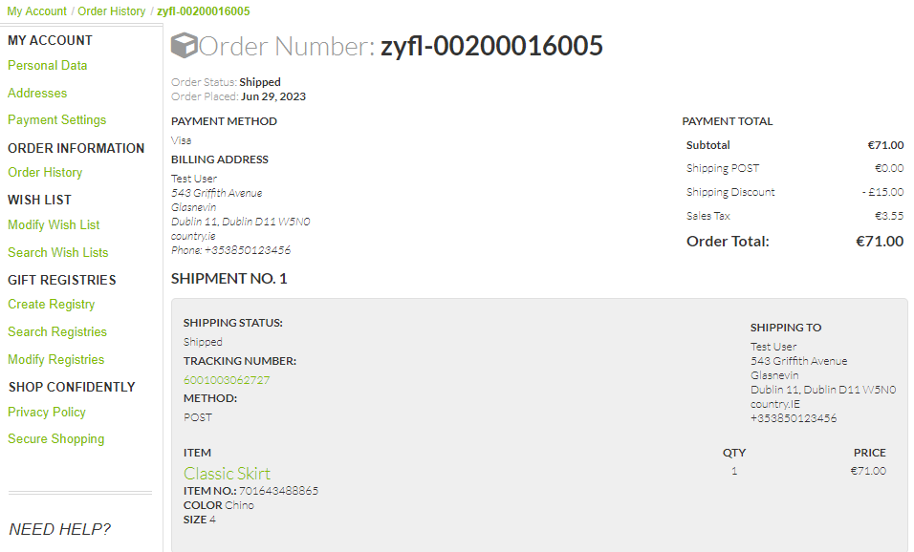

Tracking number in My Account > Order History

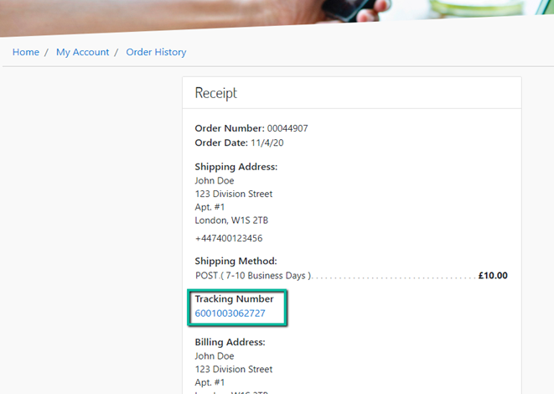

Tracking number in My Account > Order History

ESW Tracking Portal

Clicking the tracking number brings the shopper to the retailer-specific ESW Tracking portal. On the Tracking portal, shoppers can find more information on their order shipment.

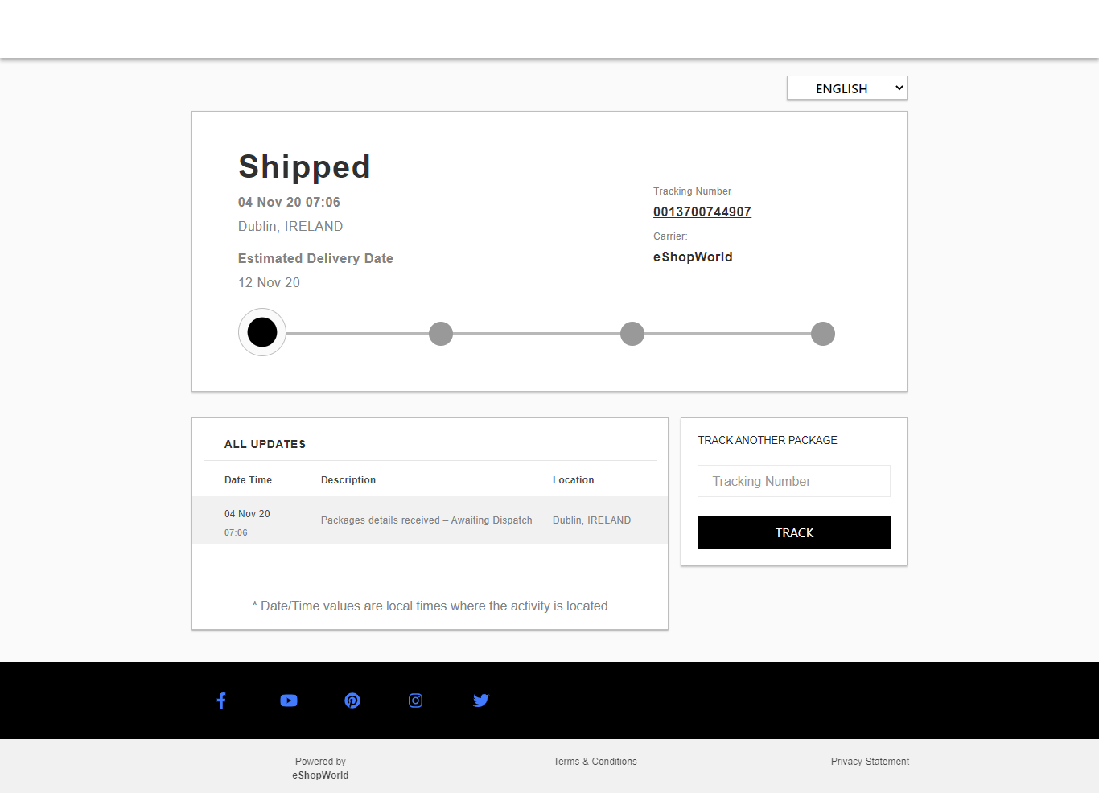

# **Package Integration Configuration**

eswRetailerPackageFeed job

The **eswRetailerPackageFeed**job syncs the retailer's package information with the ESW Package Service. The job composes the API request and sends an advanced shipping notice to ESW via the Package API v4.0.

EswOAuthService

This service is used to get the authentication token from ESW. This token is used by other ESW services and APIs, such as Price Feed, Checkout, and Package.

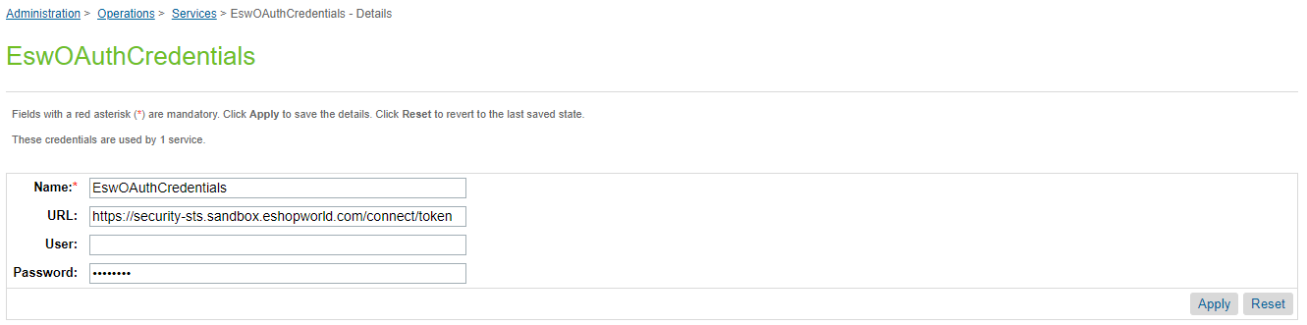

*ESW OAuth Credentials*

EswPackageV4Service

This service is used to make a call to the ESW Package API v4.0 and send an advanced shipping notification to ESW (Hub model only).

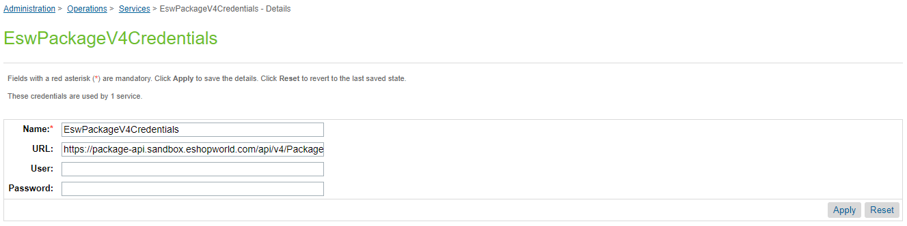

EswPackageV4Service