

Version: 4.7

Published date: April 2025

Copyright © 2025 by ESW. All rights reserved. Information contained herein is subject to change without notice.

PAGE DESIGNER

INTEGRATION GUIDE



**SFCC - ESW Cartridge**

+

Contents

1. Page Designer 3

2. ESW Cartridge setup with SFCC Page Designer 3

2.1. Setup with SiteGenesis 3

2.2. Setup with SFRA 4

2.3. Import ESW sample pages 4

2.4. Setup Page using Page Designer 5

# Page Designer

This feature enhances the capabilities of Salesforce Commerce Cloud (SFCC) by allowing retailers to create dynamic and localized front-end experiences for their shoppers. Here’s a breakdown of the key points:

* The Esw cartridge seamlessly integrates with the Page Designer module within SFCC.
* This integration enables retailers to design and customize their storefront pages with ease, enhancing the overall shopping experience for customers.
* By leveraging the ESW cartridge, retailers gain access to additional features and functionalities that go beyond the out-of-the-box capabilities of SFCC.

[**Localized Front-End Prices**](https://know.eshopworld.com/space/AE/475332611/Localized+Front-End+Prices)**:**

* The primary benefit of this integration lies in the ability to display localized front-end prices.
* Retailers can create dynamic pricing displays that cater to different regions, currencies, and languages.
* When designing pages using the Page Designer, retailers can add components specifically for showing prices in the shopper’s preferred currency.
* These localized prices are automatically converted based on exchange rates or other business rules.
* For example, if a shopper from Japan views a product, the ESW cartridge can dynamically convert the base price to Japanese Yen (JPY) and display it on the page.
* In summary, the ESW cartridge bridges the gap between the Page Designer and localized pricing, allowing retailers to enhance their storefronts and provide a personalized shopping experience for their customers. Whether on SFRA or SiteGenesis, this integration empowers retailers to showcase accurate and relevant prices to shoppers worldwide.

# ESW Cartridge setup with SFCC Page Designer

## Setup with SiteGenesis

Retailers can enable page designer support for site genesis using following:

* Make sure to upload following cartridges for storefront cartridge path
  + app_pagedesigner_sg
  + module_pagedesigner
* Add `bm_pagedesigner` to the cartridge path of the Business Manager site.
* For a SiteGenesis site, the cartridge path would look like this:
  + app_pagedesigner_sg:int_eshopworld_core:int_eshopworld_controllers:SG_core:SG_controllers:module_pagedesigner
* To support ESW cartridge following code changes are required if retailer already have enabled Page Designer support for SiteGenesis
  + In file “sg-pagedesigner\cartridges\app_pagedesigner_sg\cartridge\controllers\Page.js” Add following code in show() function 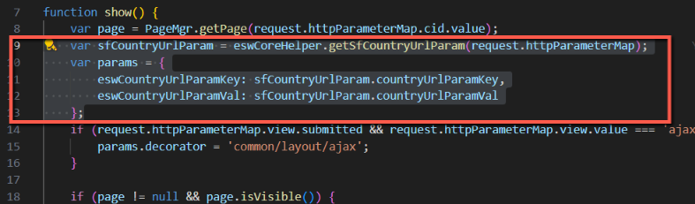
  + In file “sg-pagedesigner\cartridges\app_pagedesigner_sg\cartridge\scripts\util\Resource.ds” add highlighted code in function “ResourceHelper.getUrls” 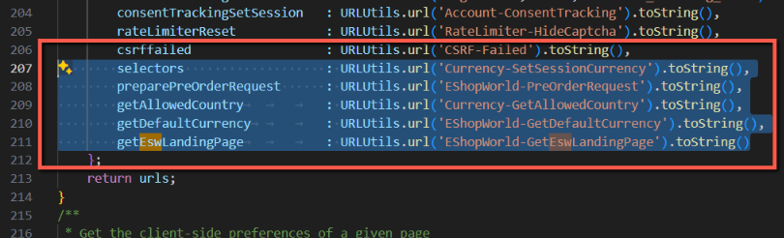
* Now you can use page designer feature with Site Genesis

## Setup with SFRA

Page designer support for SFRA is enabled by default. Retailer needs to make sure that ESW cartridge version supports page designer.

## Import ESW sample pages

ESW cartridge provides sample pages so that retailer can import and see the use of components in page designer module.

* Sample page designer for SFRA can be found at:
  + \Metadata\sites\RefArch\esw-page-designer-example-sfra.xml
* Sample page designer for SG can be found at:
  + \Metadata\sites\SiteGenesis\esw-page-designer-example-sg.xml
* Now go to “Merchant Tools > Content > Import & Export > Library Import Step 1 - Select File” and import the required page designer fileA screenshot of a computer

  Description automatically generated

## Setup Page using Page Designer

Retailer can use following steps to use ESW cartridge with page designer.

1. Make sure the ESW cartridge is uploaded
2. Go to “Merchant Tools -> Content -> Page Designer”
3. Select or create a new page
4. In the page designer select component “ESW HTML Content” component under “esw_components” 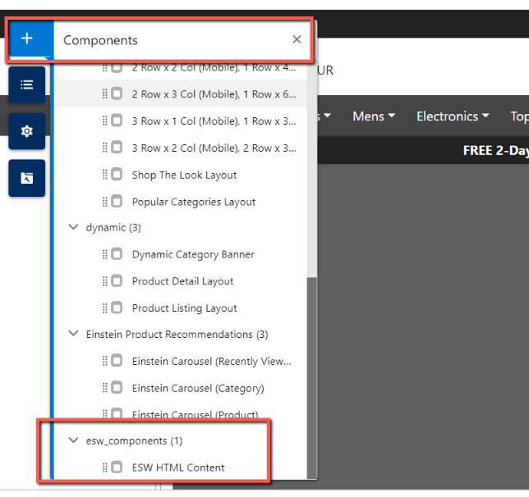
5. From this component retailer can add raw HTML 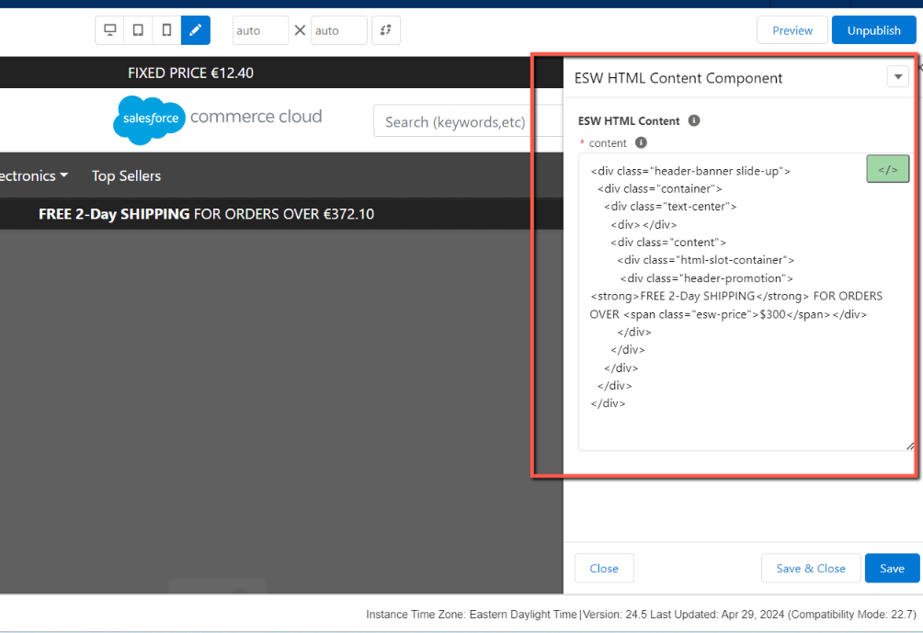
6. This HTML can be seen in the storefront with converted prices A screenshot of a computer

   Description automatically generated