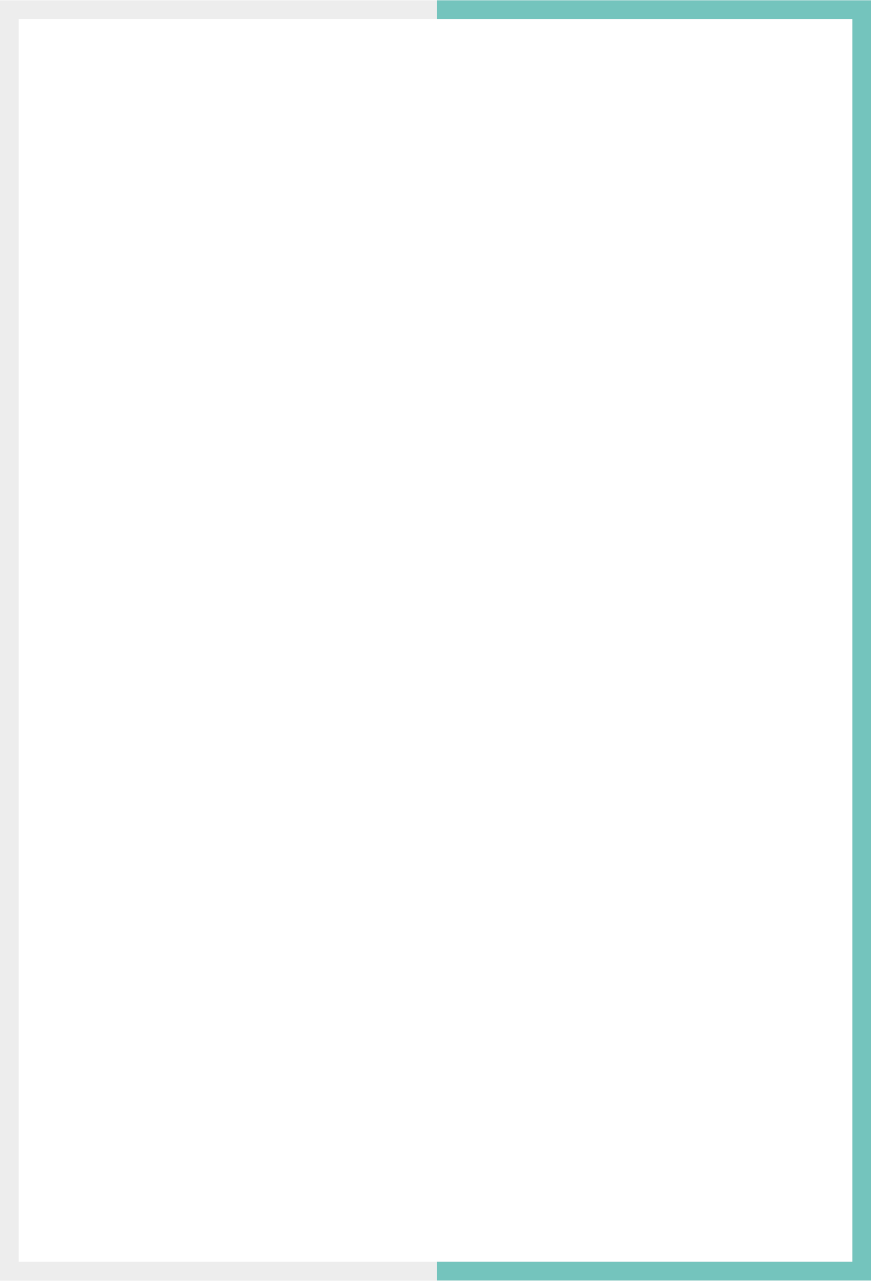

Version: 4.6.2

Published date: April 2025

Copyright © 2025 by ESW. All rights reserved. Information contained herein is subject to change without notice.

Synchronize Package from ESW



**SFCC - ESW Cartridge**

+

Contents

**1** **Get package information from ESP** 2

1.1 eShopWorld Package Sync (ESW => SFCC) 2

1.2. Import meta 4

1.3. Package configuration 5

1.4. Workflow to sync package information from ESW 7

**2.** **Storefront** 9

2.1. Order Detail (SFRA/PWA) 9

2.2. Order Detail (SiteGenesis) 9

# **Get package information from ESP**

ESW SFCC Cartridge provides the capability to synchronize the packages initiated on ESW portal/center. When an order or a lineitem is marked as shipped on ESW portal/centre, relevant payload information is stored in SFCC custom order attributes which can be used to further synchronize with other downstream systems.

* 1. eShopWorld Package Sync (ESW => SFCC)

The ESW-SFCC Cartridge allows retailers to sync package information generated through ESW in the SFCC cartridge. The high level process is demonstrated in the following diagram.

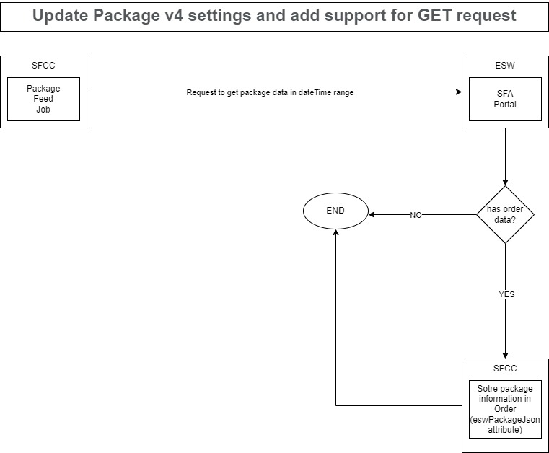

Retailer can get information about Ship From Anywhere (SFA) from [Ship From Anywhere - Manage - ESW Knowledge Centre](https://know.esw.com/space/TE/1234174142/Ship+From+Anywhere)

* 1. Import meta

To use this feature, retailer needs to make sure that he has custom attributes, services and the jobs are configured correctly in the BM. Make sure to import following from the cartridge:

**System Objects:**

* \link_eshopworld\Metadata\meta\systemobjects.xml

**Custom Objects:**

* \link_eshopworld\Metadata\meta\customobjects.xml

**Jobs**:

* \link_eshopworld\Metadata\jobs.xml

**Services:**

* \link_eshopworld\Metadata\services.xml

The following configurations should be imported.

**Job configurations**

* Add a new job step getAsnFromEsw in eswRetailerPackageFeed job
* Job params for start and end date to manually set the date range
* This will have the priority over job date range.

**Order level attributes**

Add following attribute on Order level:

* **ID**: eswPackageJson,
* **Name**: ESW Package JSON,
* **Type:** TEXT
* **Group:** ESW Package Information

**Custom object attribute**

Add following attribute in ESW_COUNTRIES

* **Name:** Synchronize Package Model
* **ID:** eswSynchronizePkgModel
* **Type:** ENUM OF STRINGS
* **Values**
  + **ID**: eswToSfcc, **Display Value**: Synchronize SFCC shipment with ESW
  + **ID:** sfccToEsw, **Display Value:** Synchronize SFCC with ESW Package/ASN

**SitePreference attributes**

* **ID**: eswPkgAsnType
* **Title**: ESW Package ASN Type
* **Type**: Enum of strings
* **Values**
  + **Title:** Synchronize SFCC shipment with ESW, **ID**: sfccToEsw. (default value)
  + **Title:** Synchronize ESW Package/ASN with SFCC, **ID:** eswToSfcc
  + **Title:** Mixed - Specific field for country level, **ID:** mixed
* **Group**: ESW Package Configurations

**Service:**

* **ID**: EswGetAsnPackage
* **Creds**: EswGetAsnPackageCredentials
  1. Package configuration

There are two basic type of package configurations supported in ESW SFCC cartridge. Which are:

* Synchronize SFCC shipment with ESW (SFCC to ESW) – Can be seen [Package Integration - Developer Resources - ESW Knowledge Centre](https://know.esw.com/space/TDR/1234636478/Package+Integration)
* Synchronize ESW Package/ASN with SFCC (ESW to SFCC) – This document will discuss this behaviour

Another Mix configuration can also be used from the BM cartridge so that retailer can select individual package configuration for each country. Please note that one country can only have one package model.

**This document will only describe to implement Synchronize ESW Package/ASN with SFCC (ESW to SFCC).**

The retailer can configure packages for each country from ESW BM cartridge by following the below steps:

* Goto Merchant Tools -> ESW -> Packages
* Select the package model as per your requirement:
  + **Synchronize SFCC shipment with ESW (sfccToEsw):** If retailer require package sync from SFCC to ESW for all countries. This is default cartridge behaviour as our current retailers are using this package model. The detail can be seen at [Package Integration - Developer Resources - ESW Knowledge Centre](https://know.esw.com/space/TDR/1234636478/Package+Integration)
  + **Synchronize ESW Package/ASN with SFCC (eswToSfcc):** If retailer require package sync from ESW to SFCC for all countries
  + **Mixed:** If retailer want to use different package model for difference countries. Please note that in this case if no package model is selected for the country then **Synchronize SFCC shipment with ESW (sfccToEsw)** will be considered.

The following screenshot is demonstrating how to update package configurations. 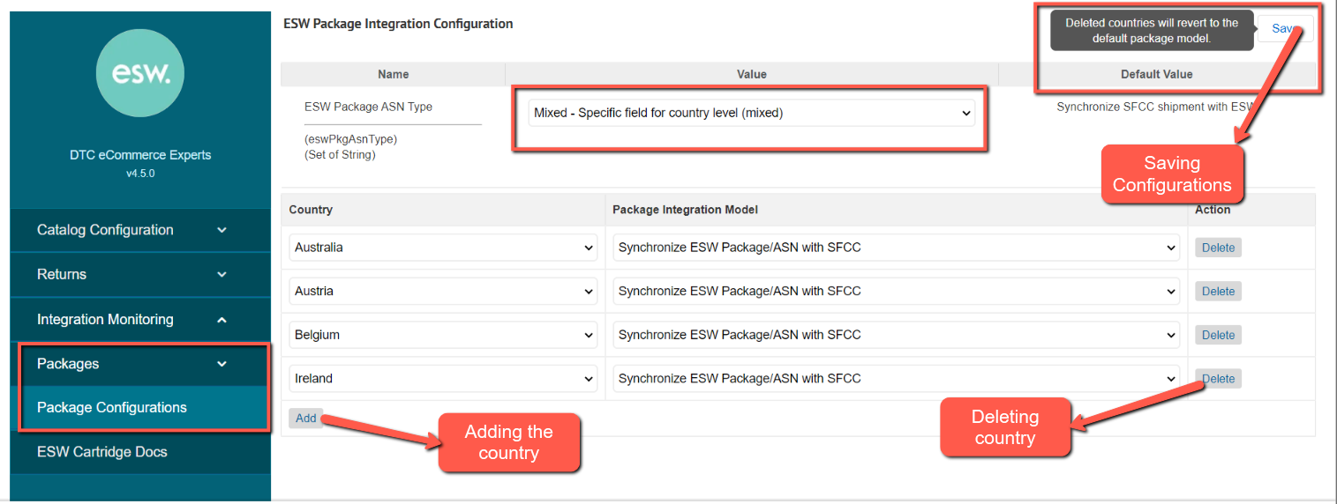

* 1. Workflow to sync package information from ESW

The Job step “getASNFromESW” in job ID “eswRetailerPackageFeed” can be configured to get the package information. This job can be set to get package information after each 24 hour. However retailer can also set the date interval to get the package information from ESW in a given date range.

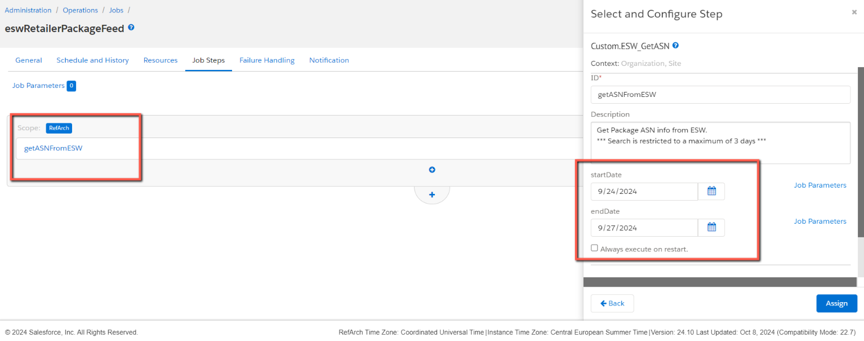

**Please note that the date range cannot exceed 3 days.**

After the job run the relevant order attribute eswPackageJson will be filled with the response data as shown:

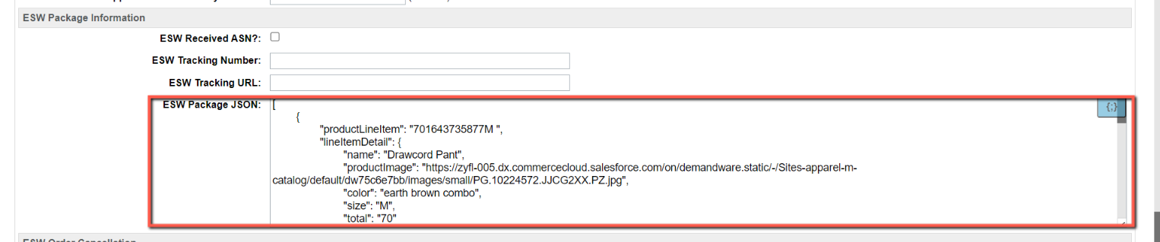

The **sample JSON** which will store in eswPackageJson is:

[

    {

        "productLineItem": "701643735877M ",

        "lineItemDetail": {

            "name": "Drawcord Pant",

            "productImage": "https://zyfl-005.dx.commercecloud.salesforce.com/on/demandware.static/-/Sites-apparel-m-catalog/default/dw75c6e7bb/images/small/PG.10224572.JJCG2XX.PZ.jpg",

            "color": "earth brown combo",

            "size": "M",

            "total": "70"

        },

        "carriedReference": "UCS",

        "trackingUrl": "http://trackingURl.com",

        "qty": "1",

        "trackingNumber": "TRK#234SDKUI"

    },

    {

        "productLineItem": "701644058586M ",

        "lineItemDetail": {

            "name": "Long Tiered Skirt.",

            "productImage": "https://zyfl-005.dx.commercecloud.salesforce.com/on/demandware.static/-/Sites-apparel-m-catalog/default/dw54c7bf97/images/small/PG.10230296.JJI15XX.PZ.jpg",

            "color": "Admiral Navy",

            "size": "6",

            "total": 120

        },

        "carriedReference": "UCS",

        "trackingUrl": "http://trackingURl.com",

        "qty": "1",

        "trackingNumber": "TRK#33466"

    },

    {

        "productLineItem": "701642884880M ",

        "lineItemDetail": {

            "name": "Classic Blouse.",

            "productImage": "https://zyfl-005.dx.commercecloud.salesforce.com/on/demandware.static/-/Sites-apparel-m-catalog/default/dwe21bf267/images/small/PG.10208973.JJZ01XX.PZ.jpg",

            "color": "Multi",

            "size": "12",

            "total": "80"

        },

        "carriedReference": "UCS",

        "trackingUrl": "http://trackingURl.com",

        "qty": "1",

        "trackingNumber": "TRK#234SDKUI"

    }

]



# **Storefront**

* 1. Order Detail (SFRA/PWA)

On the storefront page of order detail, each tracking numbers will be displayed and upon hovering on the tracking number the lineitem detail will be displayed

* 1. Order Detail (SiteGenesis)

On the storefront page of order detail, each tracking numbers will be displayed as per OOB site genesis behaviour as shown.

