TEST 01: Diode Testing
- Please observe the diode in the image below:
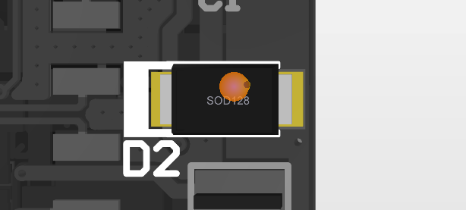
- The diode needs to be removed from the PCB carefully so that the pads do not get scrapped. This can be done by applying heat on both sides of the diode one by one until it starts to move and then gently apply pressure from side to lift the diode and remove it.
- Once removed, the region will appear as below:
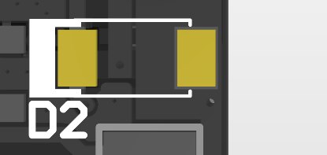
- Solder the newly arrived diode. First cut the pins of the new diode enough to adjust that on to the PCB. Once pins are cut, observe the diode physically for marking as shown in screenshot below:
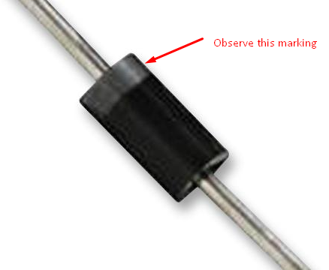
- This marking side of the diode should be placed on the side of D2 that also has elongated marking as shown below:
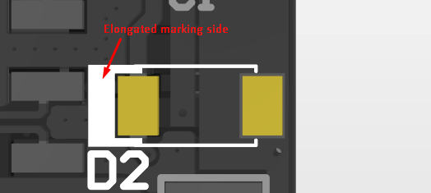
- Solder the other pin in similar manner and the PCB should be ready for testing.
TEST 02: Fuse Testing
- The fuse testing is done to ensure excess current doesn’t flow through and burn the PCB. For this, we will use a fuse holder. A basic wiring diagram is shown below
