Frankever Dimmer

DPID (Packet Info):
First Byte | Second Byte | Third Byte | Fourth Byte | Fifth Byte
0xAA (Header) | 0x00 (++ till 0xFF) | - 0x00 (Off)  - 0x01 (On) | 0x00 to 0x64  (Value Byte) | Checksum Byte  (Add 2nd to 4th Byte values)

FEATURES:
- Power button to manually On & Off the bulb.
- Increase/Decrease Intensity Button to increase/decrease the intensity of the bulb manually.
- Long press the power button for atleast 20 seconds to run factory reset.
- All above indications are controllable through ezlo cloud.

OBSERVATIONS:
- Bulb is On -> Red LED
- Bulb is Off -> Blue LED
- Wifi Disconnection -> Green LED
Note: Only one indication at a time will be visible.

DAIS:
Devices:

{
"_id": "10364000",
"deviceTypeId": "ezlopi",
"parentDeviceId": "",
"category": "dimmable_light",
"subcategory": "dimmable_bulb",
"gatewayId": "457a5069",
"batteryPowered": false,
"name": "Frankever Dimmer",
"type": "dimmer.outlet",
"reachable": true,
"persistent": false,
"serviceNotification": false,
"armed": false,
"roomId": "",
"security": "no",
"ready": true,
"status": "idle",
"parentRoom": true,
"protectConfig": "default"
}

Items:

{
"_id": "20364000",
"deviceId": "10364000",
"hasGetter": true,
"hasSetter": true,
"name": "dimmer",
"show": true,
"valueType": "int",
"value": 0,
"valueFormatted": "0",
"status": "idle"
},
{
"_id": "20364001",
"deviceId": "10364000",
"hasGetter": true,
"hasSetter": true,
"name": "switch",
"show": true,
"valueType": "bool",
"value": false,
"valueFormatted": "false",
"status": "idle"
}

Pictures:
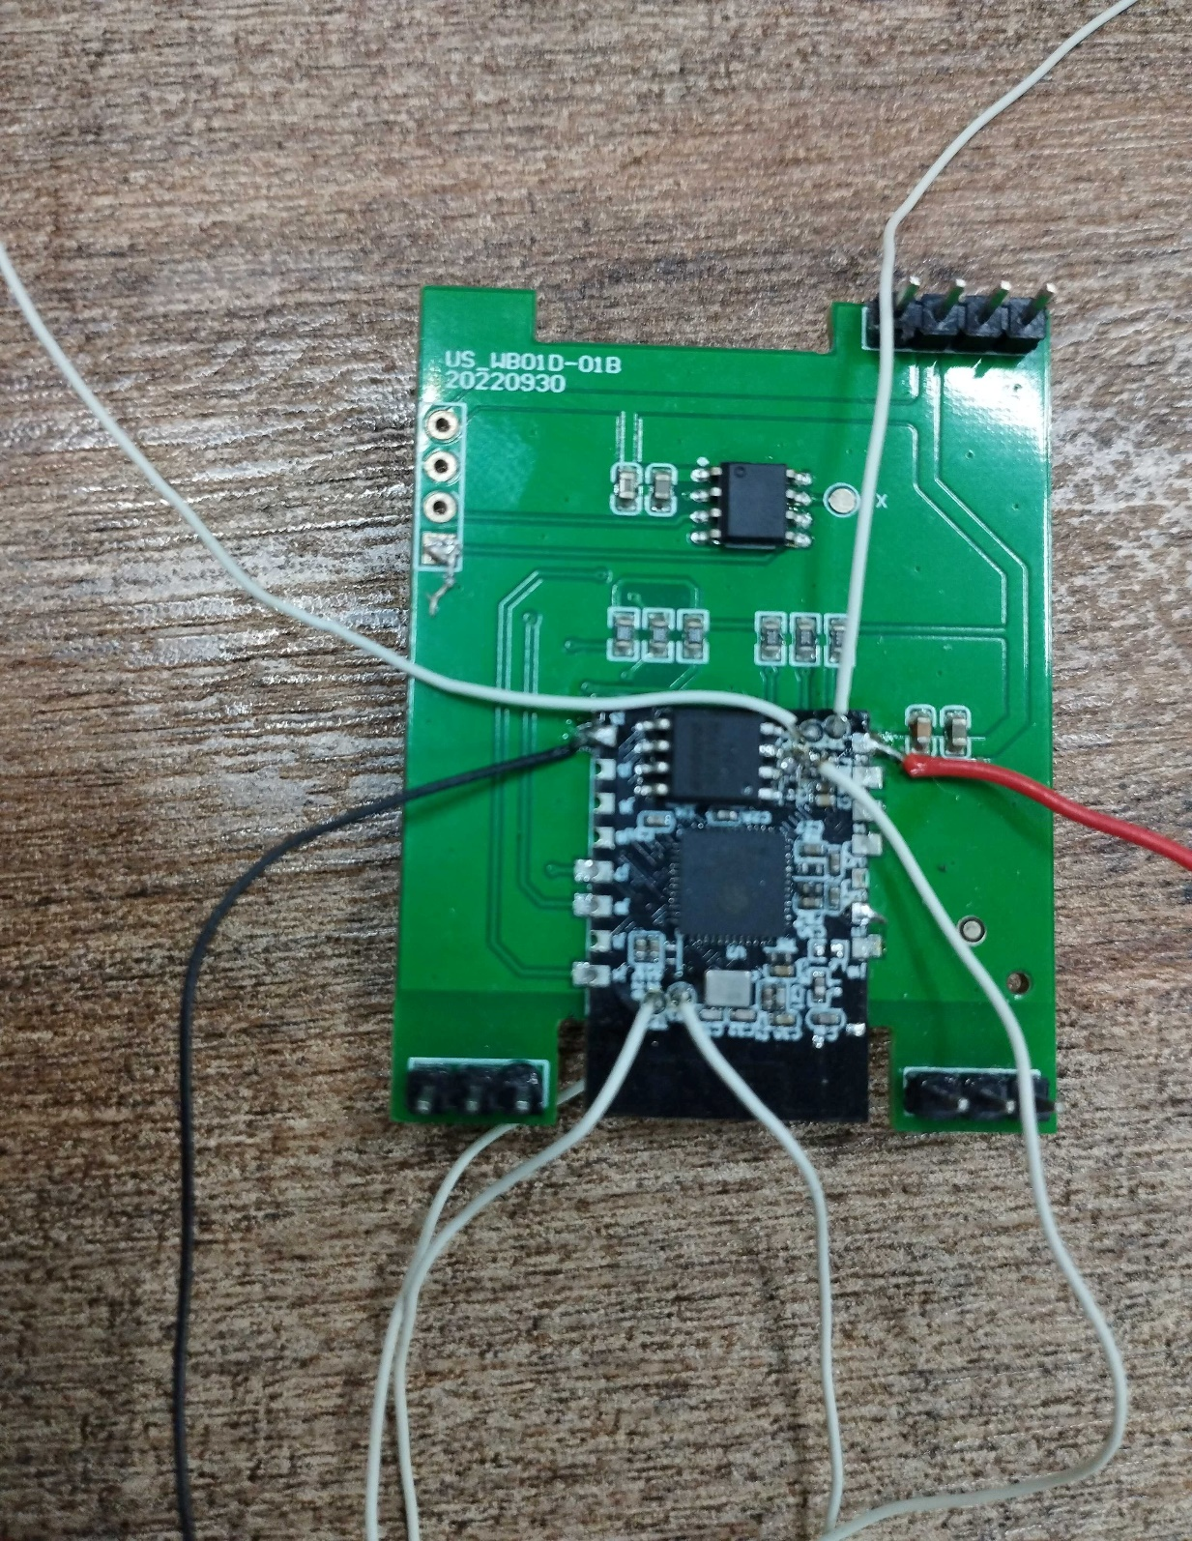
PCB1 Backside
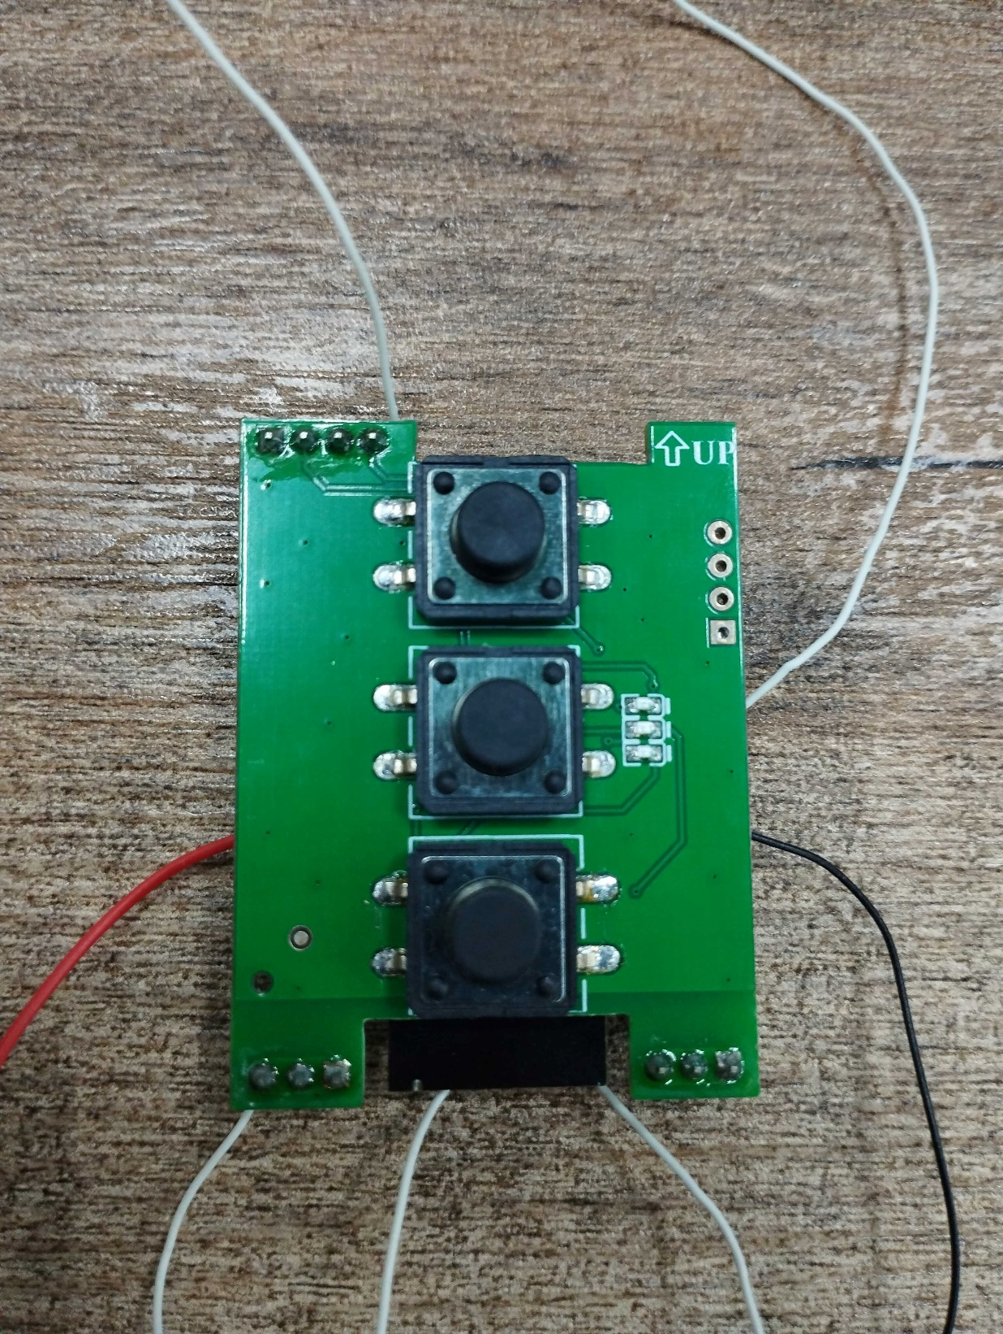
PCB1 Frontside
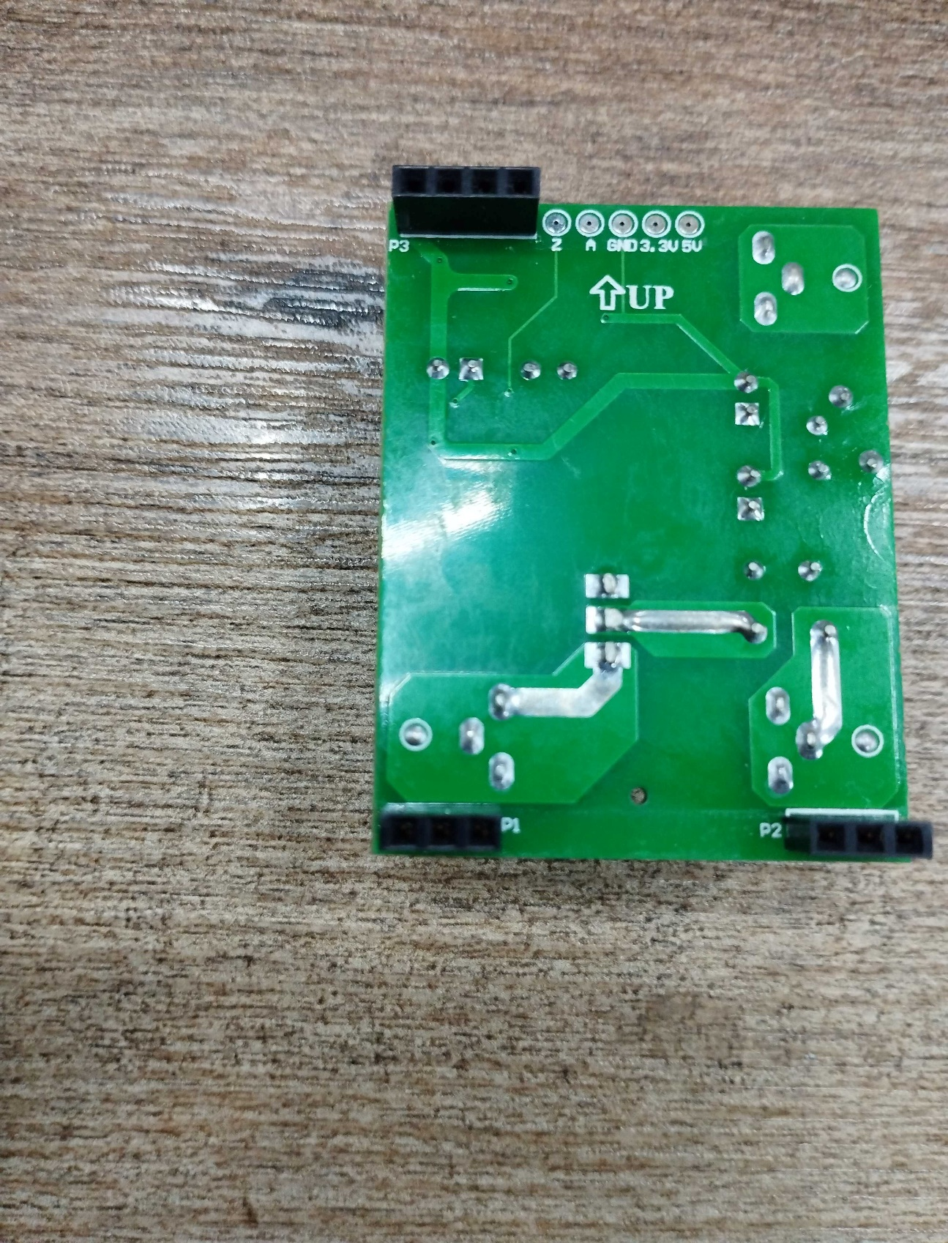
PCB2 Backside
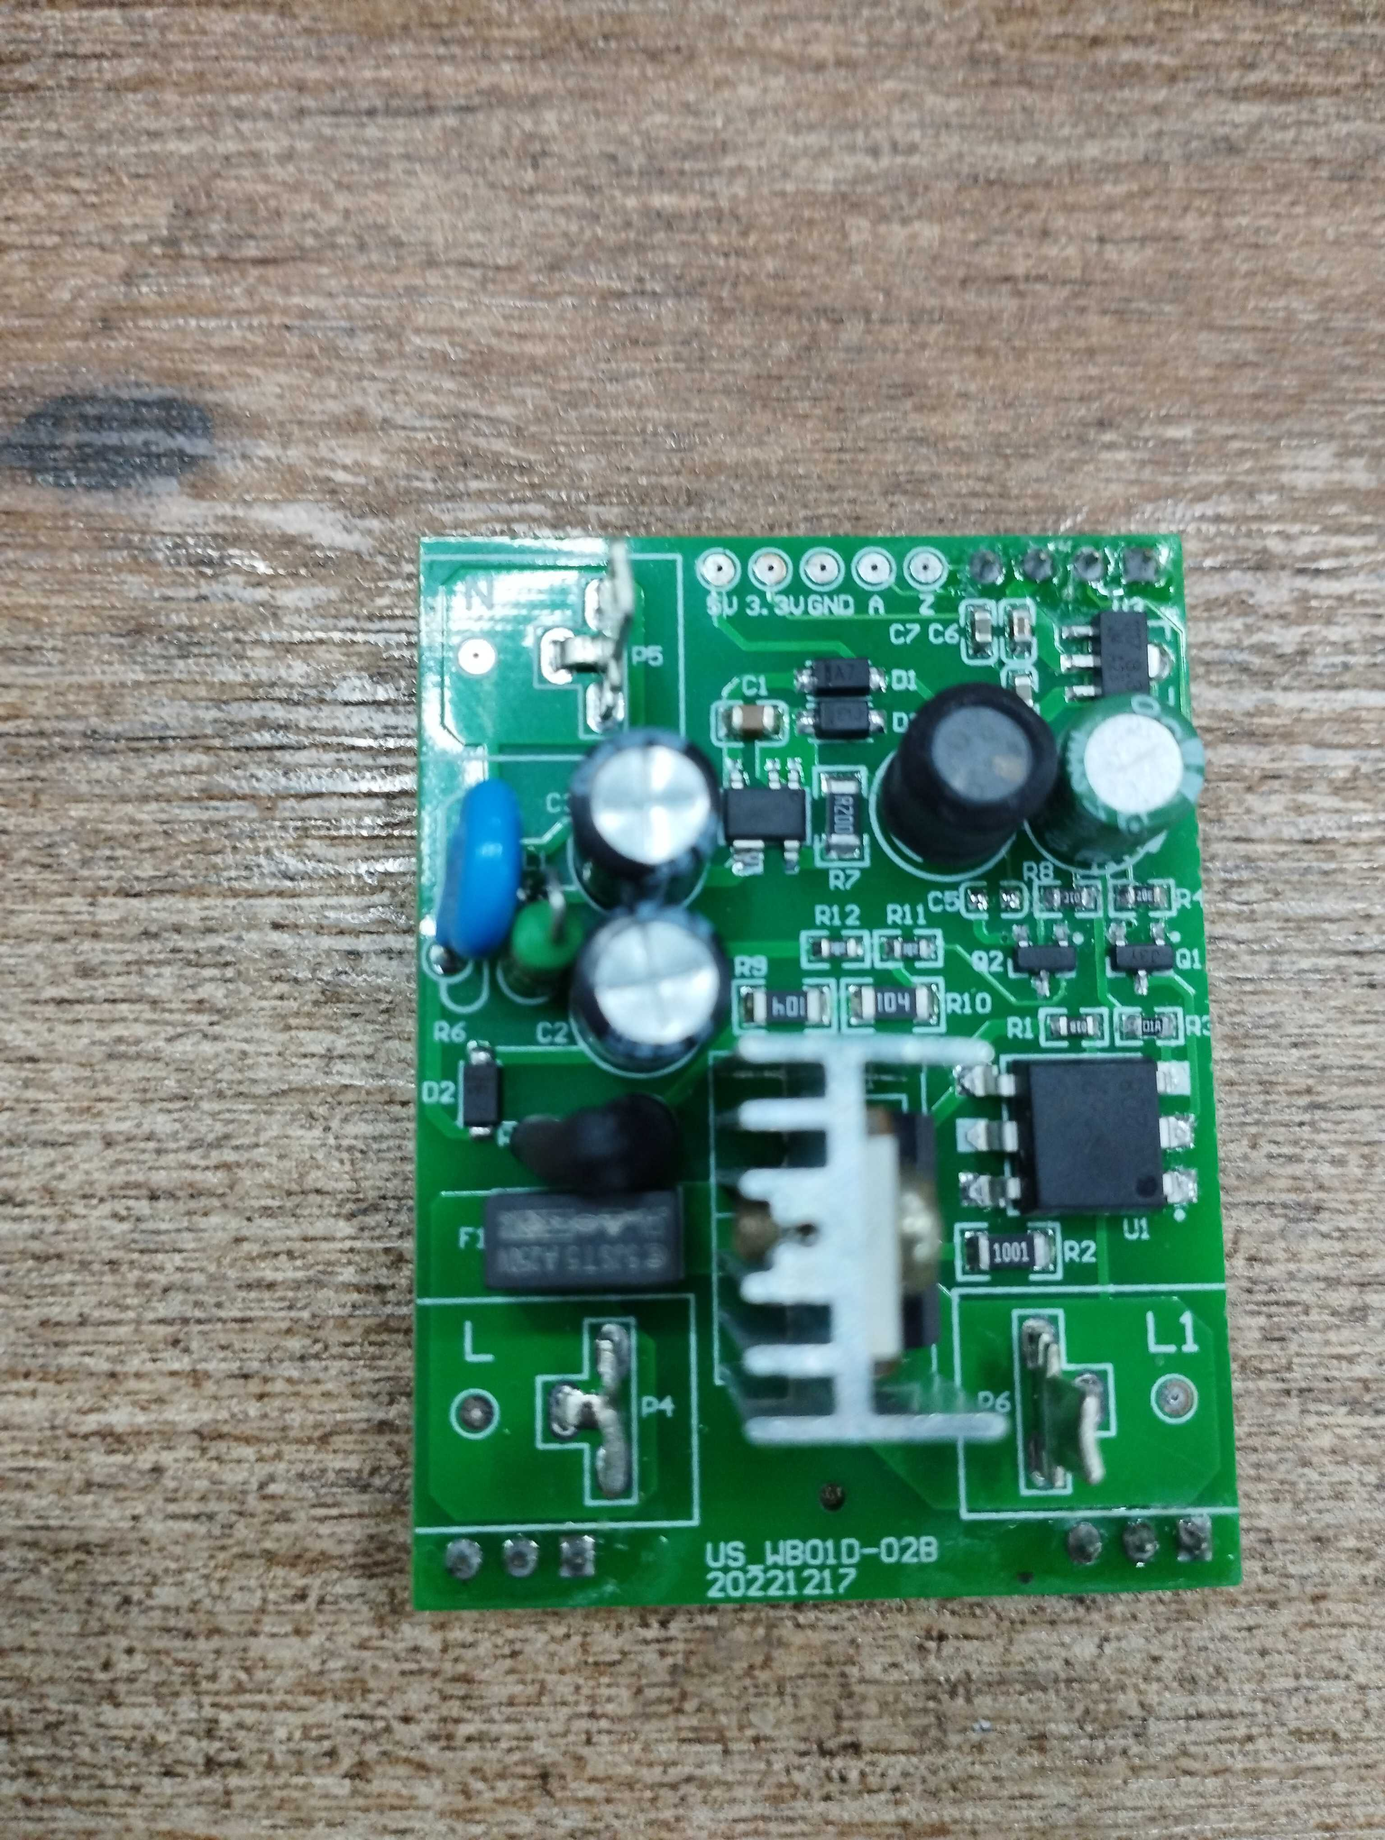
PCB2 Frontside

Schematic:
