Sep 23rd

Missing items
- Altitude Data Transmission
  - TX Board currently does not transmit altitude. Implement altitude tracking on the relay board, base station, and app
  - Could we review the while((!gps.gnssSignalReceived) and make it to have a 3D fix or altitude data? For example the condition could be if altitude is different from 0.0 meters. This will help to get a more accurate coordinate given that GNSS module will be able to lock signal into more satellites. App.cpp line 245
  - 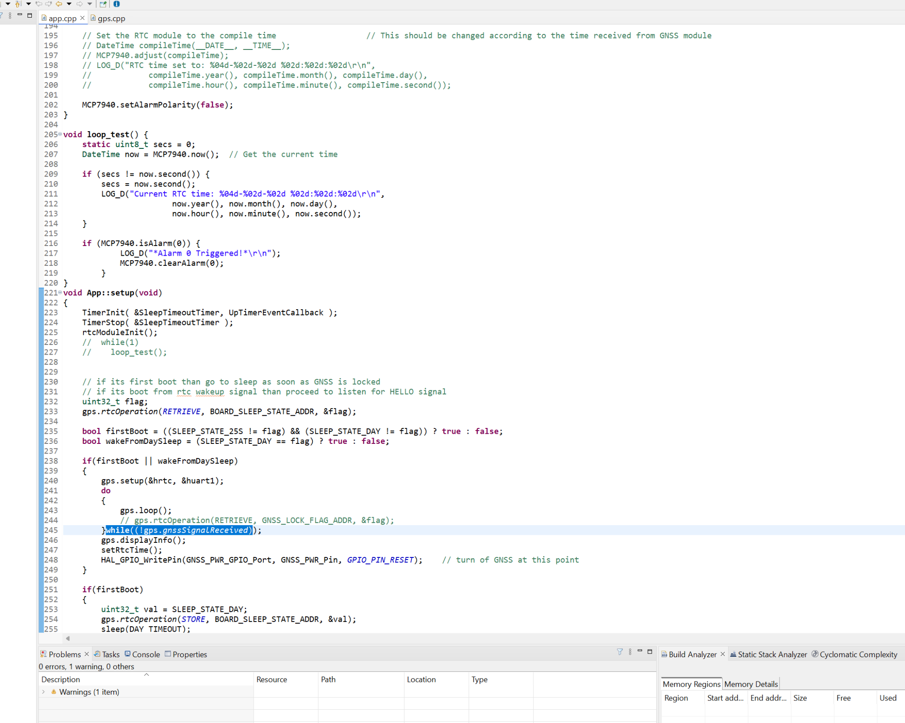
- I’ve identified the bug. The TX board sends an invalid signal when attempting to read the GNSS location from memory of the MCU. I confirmed this by debugging the relay board and reviewing the contents of the received messages.
The first message sent by the TX board works correctly. However, if the TX board is running between 8:00 and 10:00 AM and I power on the relay board at 8:05 for example, the received message contains coordinates (0, 0).
Solution 1 fix the bug and check why the coordinates aren’t stored in the memory;
THIS ONE Solution 2 instead of storing data in memory which can be complicated, when the TX board receives the Hello signal, it powers the GNSS module, obtains a valid signal and the sends the coordinates to the Relay board.
Make sure future boards have
TX board to Relay: 915 MHz SF 12 BW= 125 kHz
Relay to Base Station: 918 MHz SF 10, increase BW 250 kHz
- 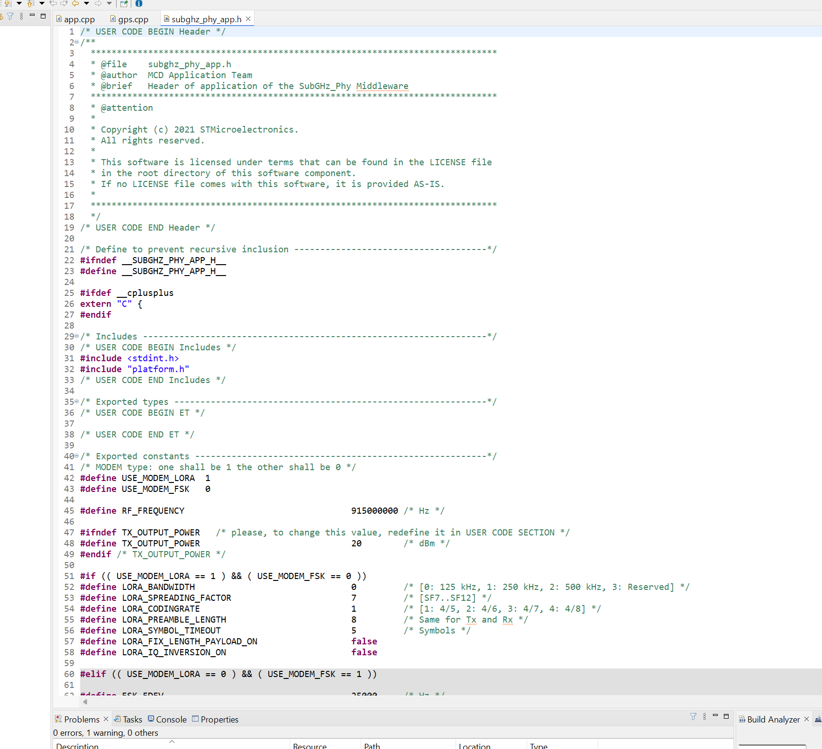
- Properly store the data on the app [We can choose whether download the file into a CSV or upload to the cloud or send an email]. Explore different options to extract the data from the phone.
NEW ITEMS
- Enhance communication protocol. There’s need to be better timing within the Relay board when signals are being transmitted to avoid collisions. If one MCU is transmitting the other one should stay silent.
Solution: once MCU1 transmits data to MCU2, MCU1 will wait for 5 seconds to send a new Hello.
- TX Board Scheduling
  - Currently, TX board run daily from 8 AM to 10 AM, wasting energy
  - Implement custom scheduling in the app so customers can define on/off times
  - This is a complex feature but necessary for battery conservation
  - Could we update the calendar on when to wake while the the GNSS locks onto signal? The calendar update would be up to 4 digit x 30 days = 120 Bytes, plus headers. How can the code update the timers? The system knows the current date; it needs to calculate the following time to wake. Operating hours will remain the same. We need to make sure the string doesn’t have errors.
We need to design the calendar system so it is simple to manage and ensures smooth operation without any risk of collisions.
System Flow:
- Power Sequence:
  - The customer must power on the base station, then the relay board, and finally the app.
- Calendar Setup on the App:
  - The app should allow the customer to select the days when the TX boards should be on or off.
  - After selecting the schedule, the customer will press a "Transmit to Base Station" button.
  - If the relay board loses power this operation will have to be repeated. All data is volatile and non stored on memory.
- Data Transmission Flow:
  - The base station transmits the schedule to the relay board.
  - The relay board updates its data accordingly.
  - Once the operation completes successfully, all data will be erased by power cycle.
- Power & Transmission Considerations:
  - Communication from the relay board to the TX Board can use as much energy as needed.
  - Communication from the TX Board to the relay board should be energy-efficient. We may need acknowledgement signals, but transmissions should be limited to save power limited to 3 transmissions
- Additional Features on the App:

  - A battery status indicator for the transmitter board so its charge level can also be transmitted.

