Proof of Concept (PoC) Custom Setup
This document provides the wiring and pin mappings for a PoC setup using an ESP32-S3-N16R8 microcontroller, MAX98357A audio amplifier, INMP441 microphone, and a speaker.
---

Wiring Diagram
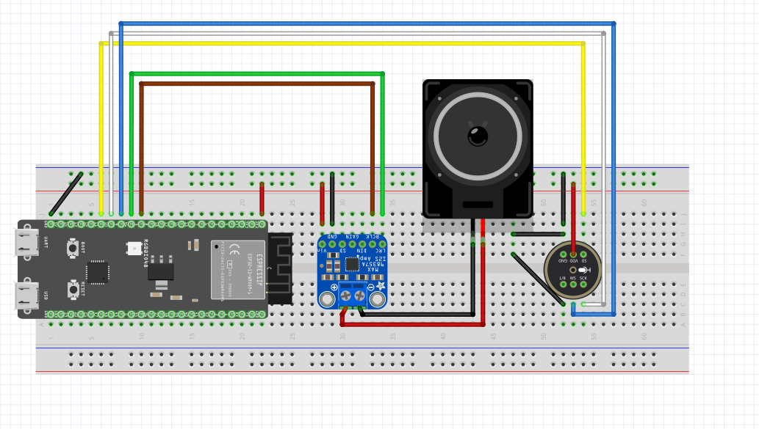---

Pin Mappings

MAX98357A to ESP32-S3-N16R8
MAX98357A Pin | ESP32-S3-N16R8 Pin
VIN | 3V3
GND | GND
LRC | D46
BCLK | D3
DIN | NC
GAIN | NC
SD | NC
---

INMP441 to ESP32-S3-N16R8
INMP441 Pin | ESP32-S3-N16R8 Pin
VIN | 3V3
GND | GND
SD | D11
SCK | D10
WS | D9
L/R | GND
---

Speaker to MAX98357A
Speaker Pin | MAX98357A Pin
OUT+ | +SPK_VE
OUT- | -SPK_VE
---
Ensure all connections are secure before powering the setup. For any queries or troubleshooting, refer to the wiring diagram and pin mappings above.

Fritzing File
[Konstantin-FZ-issue-1.zip](https://github.com/user-attachments/files/17922775/Konstantin-FZ-issue-1.zip)

Flashing Binaries
Binaries can be extracted from Binaries.zip provided and addresses can be verified from flasher_args.json file if required
BIN FILE ADDRESS OFFSET
bootloader.bin 0x0
test-skainet.bin 0x10000
partition-table.bin 0x8000
srmodels.bin 0x281000

