FLASHING INSTRUCTION FOR NRF52840

There are 2 ways to do this either using J link flash software or nrf connect vscode.

1. USING J-FLASH: (J LINK ADAPTER):
- download segger J-Link from https://www.segger.com/downloads/jlink/
- Connect the nrf52840 through the J-link adapter to your PC .

J-Link Pin | Signal Name | nRF52840 Pin
1 (VTref) | VCC (Target Voltage) | VDD (3.3V)
4 (GND) | Ground | GND
7 (SWDIO) | SWD Data | SWDIO
9 (SWCLK) | SWD Clock | SWDCL
15 (nRESET) [Optional] | Reset | P0.18 (RESET)

- Open J-Link Flash and create a new project
- A prompt will open asking for target device , select nrf52480 as target device and leave the other setting as it is.
- now drag the merged.hex file from the (flashing_guide->bin) folder to the box asking for hex file or you can also select it from file->Open data file
- now navigate to target-> and press Connect
- now navigate to target->manual programming-> program and verify
- if it shows target programmed and verify successfully ,you can run the application by target->manual programming-> Start Application
Note: if the flashing fails , try to erase the chip by navigating and selecting target->manual programming-> Erase chip and then reprogramming it again.

2. USING NRF CONNECT SDK (VSCODE):

1 - Setup NRF connect SDK on VS Code
- VS Code Installation
  - Download the Visual Studio Code installer for Windows.
  - Once it is downloaded, run the installer (VSCodeUserSetup-{version}.exe). This will only take a minute.
  - Open VS Code.
- Add NRF Connect SDK extension in VS Code.
  - Add both the nrf connect sdk extensions.
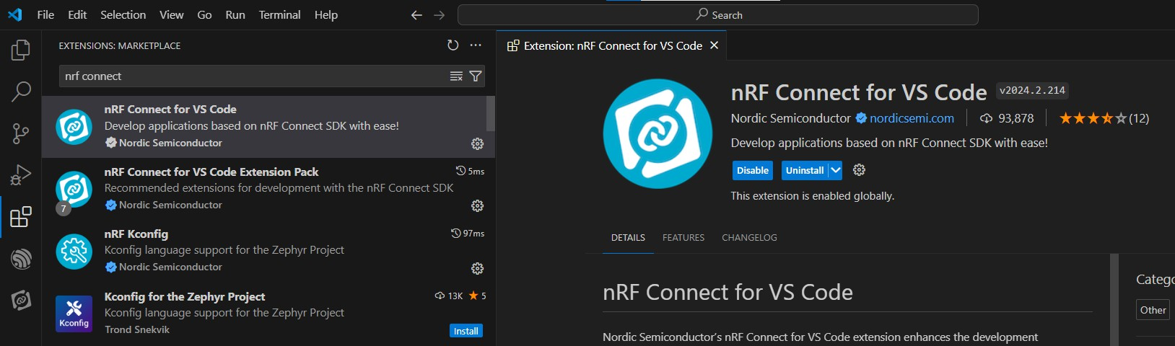
  - After installing the extensions nrf connect extension icon will appear on the left bar.
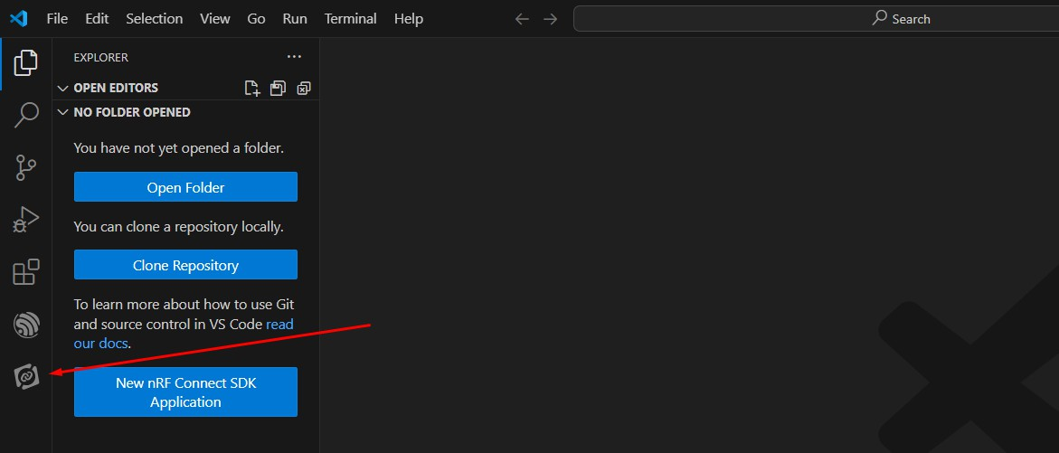

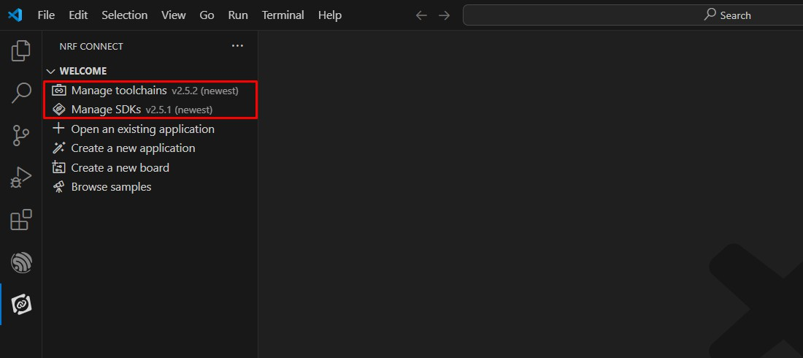
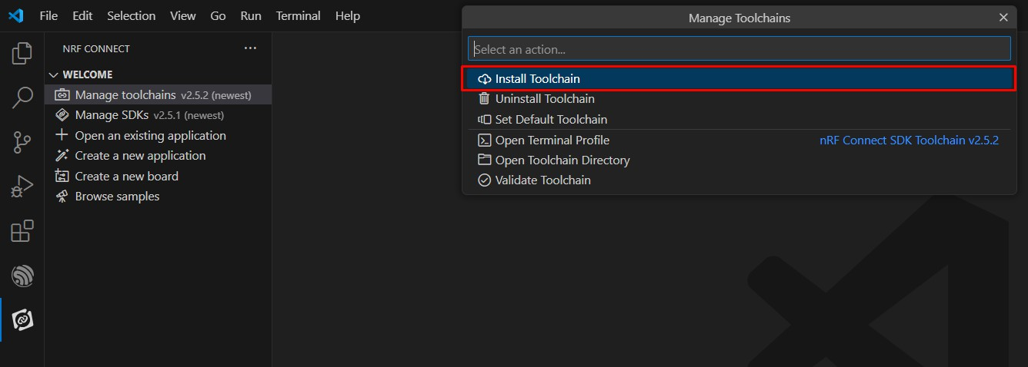
Install Toolchain- lick on Manage toolchain, then install the nRF Connect SDK Toolchain v2.7.0.

-Install SDK
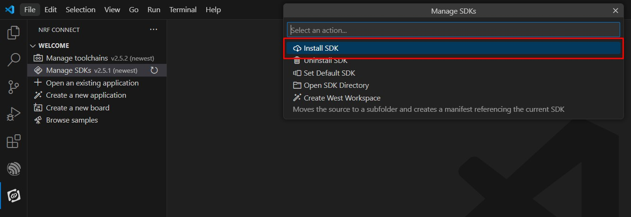
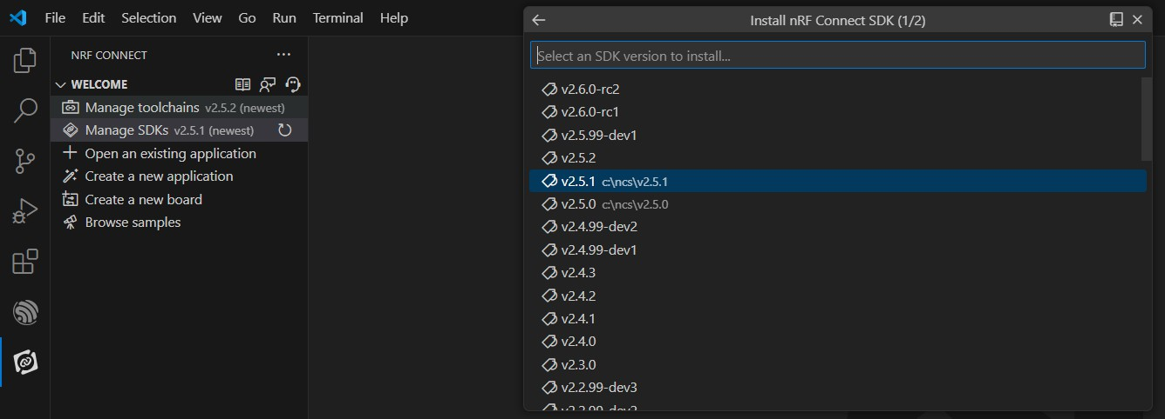
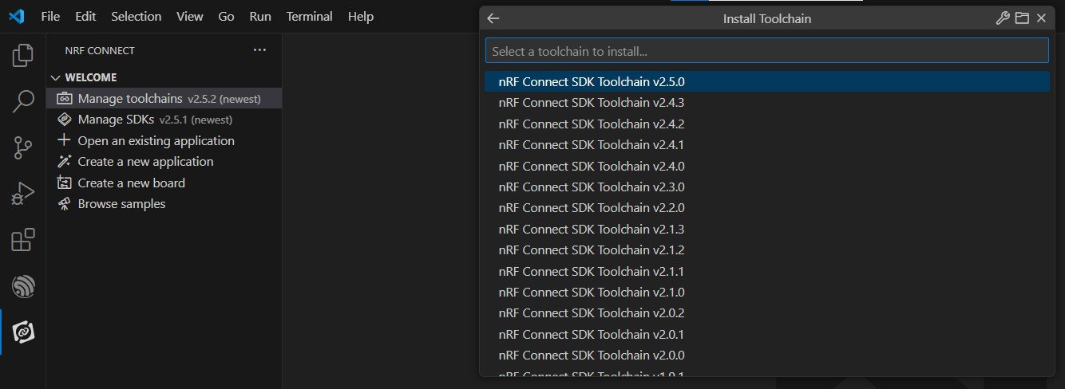
Then do the same for Manage SDKs, install v2.7.0

2 - Install J-Link tools
Download J-Link tools from here We used v7.94e. Download the latest from this link for the tools here
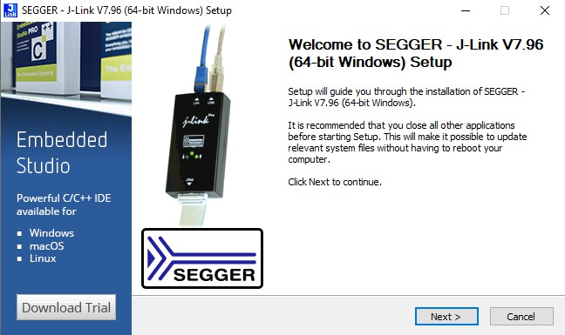
- Follow the installation guide and install

3 - Flashing the Device

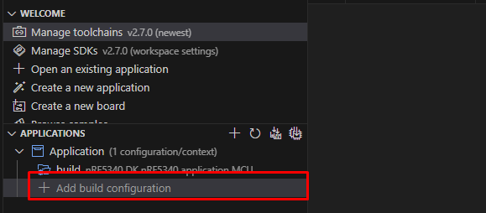
- Go to NRF Connect Extention Tab. Select “Add Build Configuration”.
- Select “prj.conf” as Base configuration files and “application.overlay” as Base Devicetree overlay.
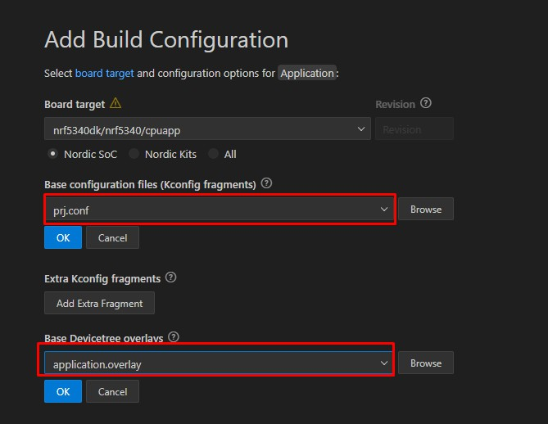
- Click Build Configuration.

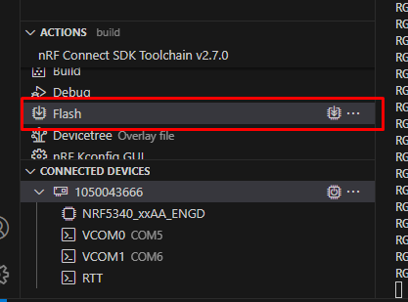
- Once build, the device can be flashed from the Actions section.

MONITORING LOGS FOR NRF52840

USING UART TO USB BRIDGE/ADAPTER (CP210X):
- install the CP210x driver using this link
- now plugin the adapter to your pc
- connect the txd pin of the adapter to the TRACE DATA 2 pin (p0.11)
- connect the rxd pin of the adapter to the TRACE DATA 1 pin (p0.12)
- now go to device manager->ports and see if the device is detected , if its already there then its okay if not then update driver and select the CP210x.zip file downloaded previously
- you will be able to monitor logs using any serial monitor and selecting the COM port at which Silicon Labs Cp210x is present and setting the baud rate to 115200 .
- Logs will only appear after the merged.hex file is flashed and the NRF52840 is powered on.
On successfull setup following logs will be printed :(Note: if the logs are not showing press reset the nrf and do it while monitoring)
Scanning I2C0 bus...
Sensor detected at 0x76 Bus:I2C0
I2C0 scan complete.
Scanning I2C1 bus...
I2C1 scan complete.
ICM45686 found
Initializing ICM45686
Successfully data read from WHO_AM_I register
WHO_AM_I: 0x0
Buffer: 100000008000
Successfull data fetch from ACCEL_REG
Buffer2: 000000800000
Successfull data fetch from GYRO_REG
Accel: X=4096, Y=0, Z=-32768
Gyro: X=0, Y=128, Z=0
Buffer: 100000008000
Successfull data fetch from ACCEL_REG
Buffer2: 000000800000
Successfull data fetch from GYRO_REG
Accel: X=4096, Y=0, Z=-32768
Gyro: X=0, Y=128, Z=0

if the sensor fails to detect:
Scanning I2C0 bus...
Sensor detected at 0x76 Bus:I2C0
I2C0 scan complete.
Scanning I2C1 bus...
I2C1 scan complete.
ICM not found....

