MSM Device Firmware Validation
SCM Board
- On successful flashing, the LEDs labelled as D101-D104 will show a pattern on each power reset i.e. on every reboot of ATSAM.
If it doesn’t show a pattern it indicates that it hasn’t been flashed successfully.
- Below is the snapshot of jlink commander showing a successful flash logs.
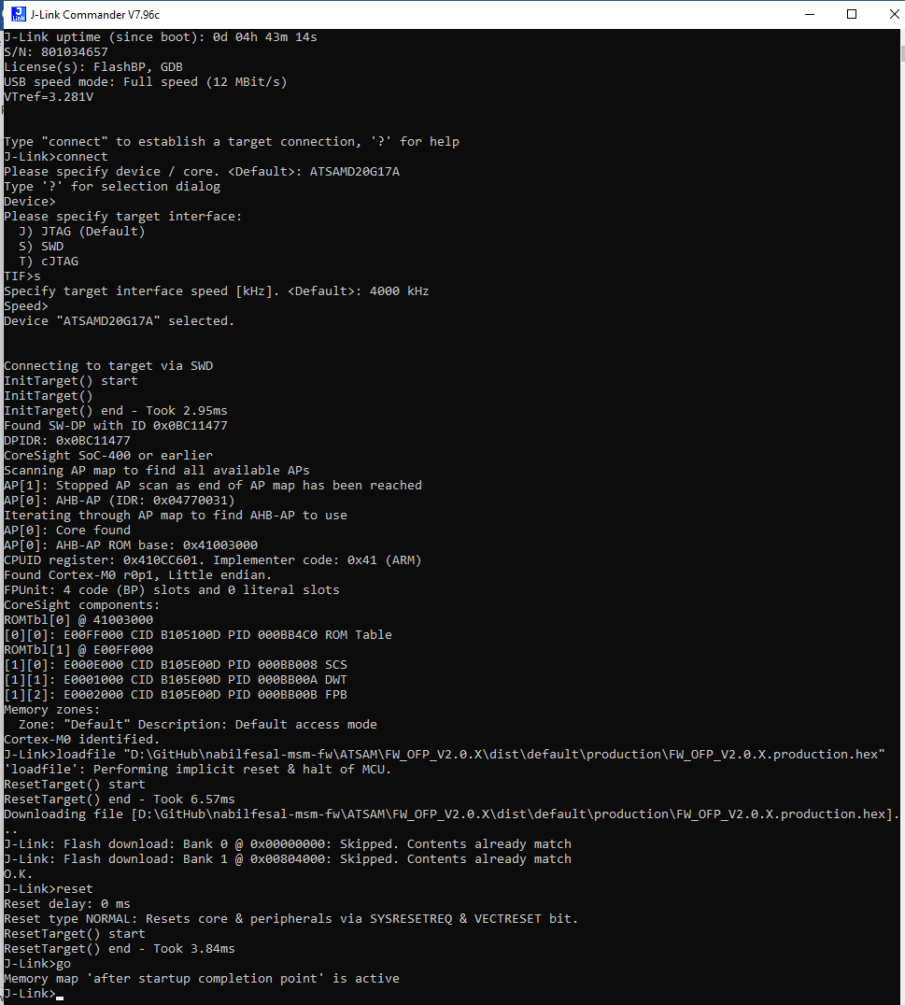
MCM Board
- Once the SD Card has been flashed successfully and is being attached inside the MCM board.
- Power up the MCM board, the LCD should turn on with the advertisement screen of EIN, after that a loader will appear and will be completed. A screen of UID will be appeared to you.
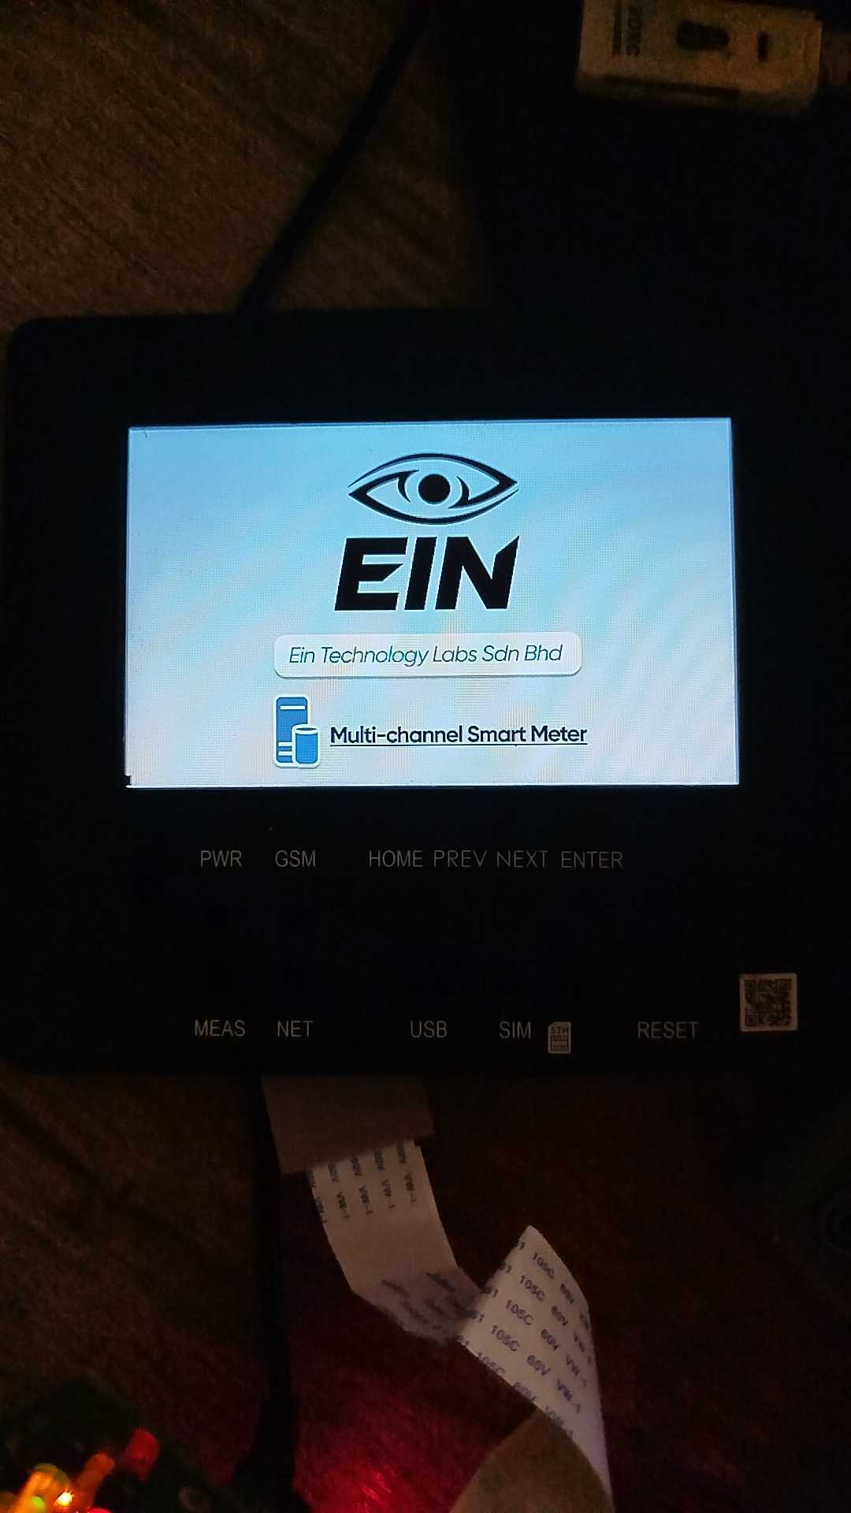
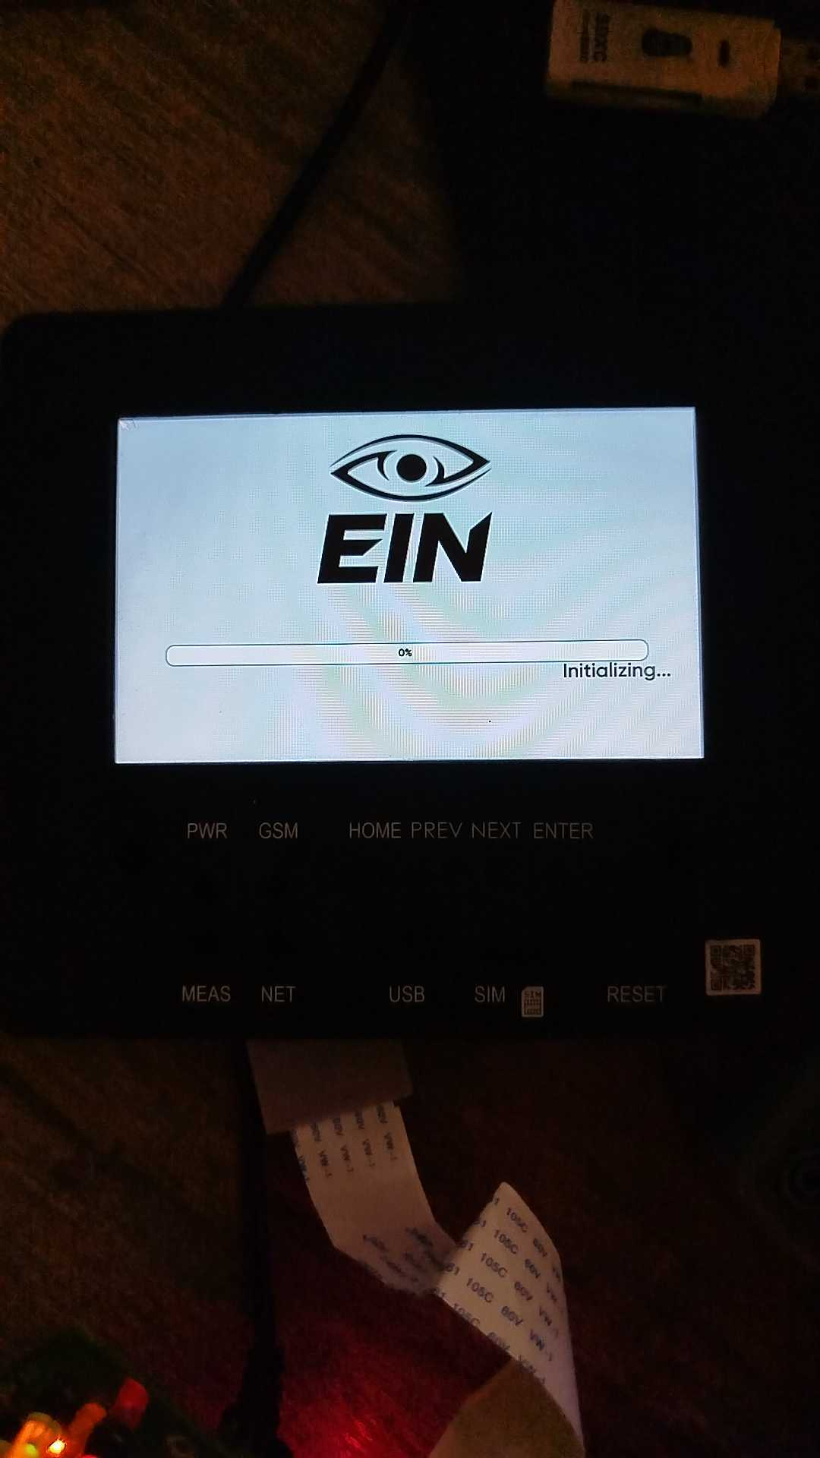
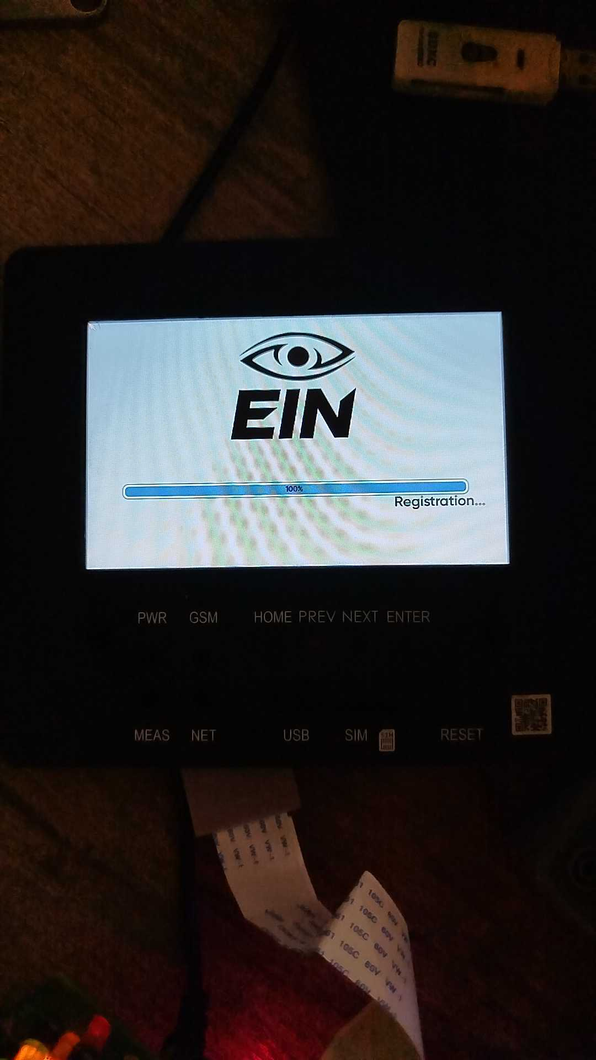
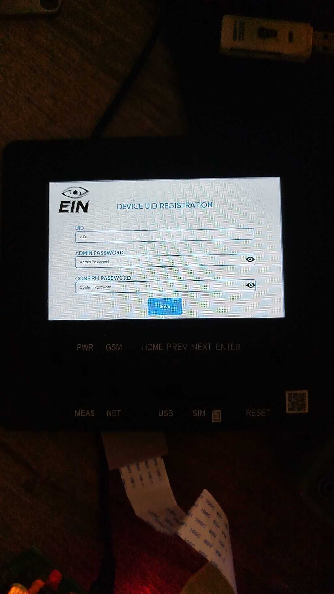
- Just to ensure that the touch of the LCD is working, tap on the UID box and type anything. If typing is successful, it ensures that the LCD touch is working fine.
MSM Device
- 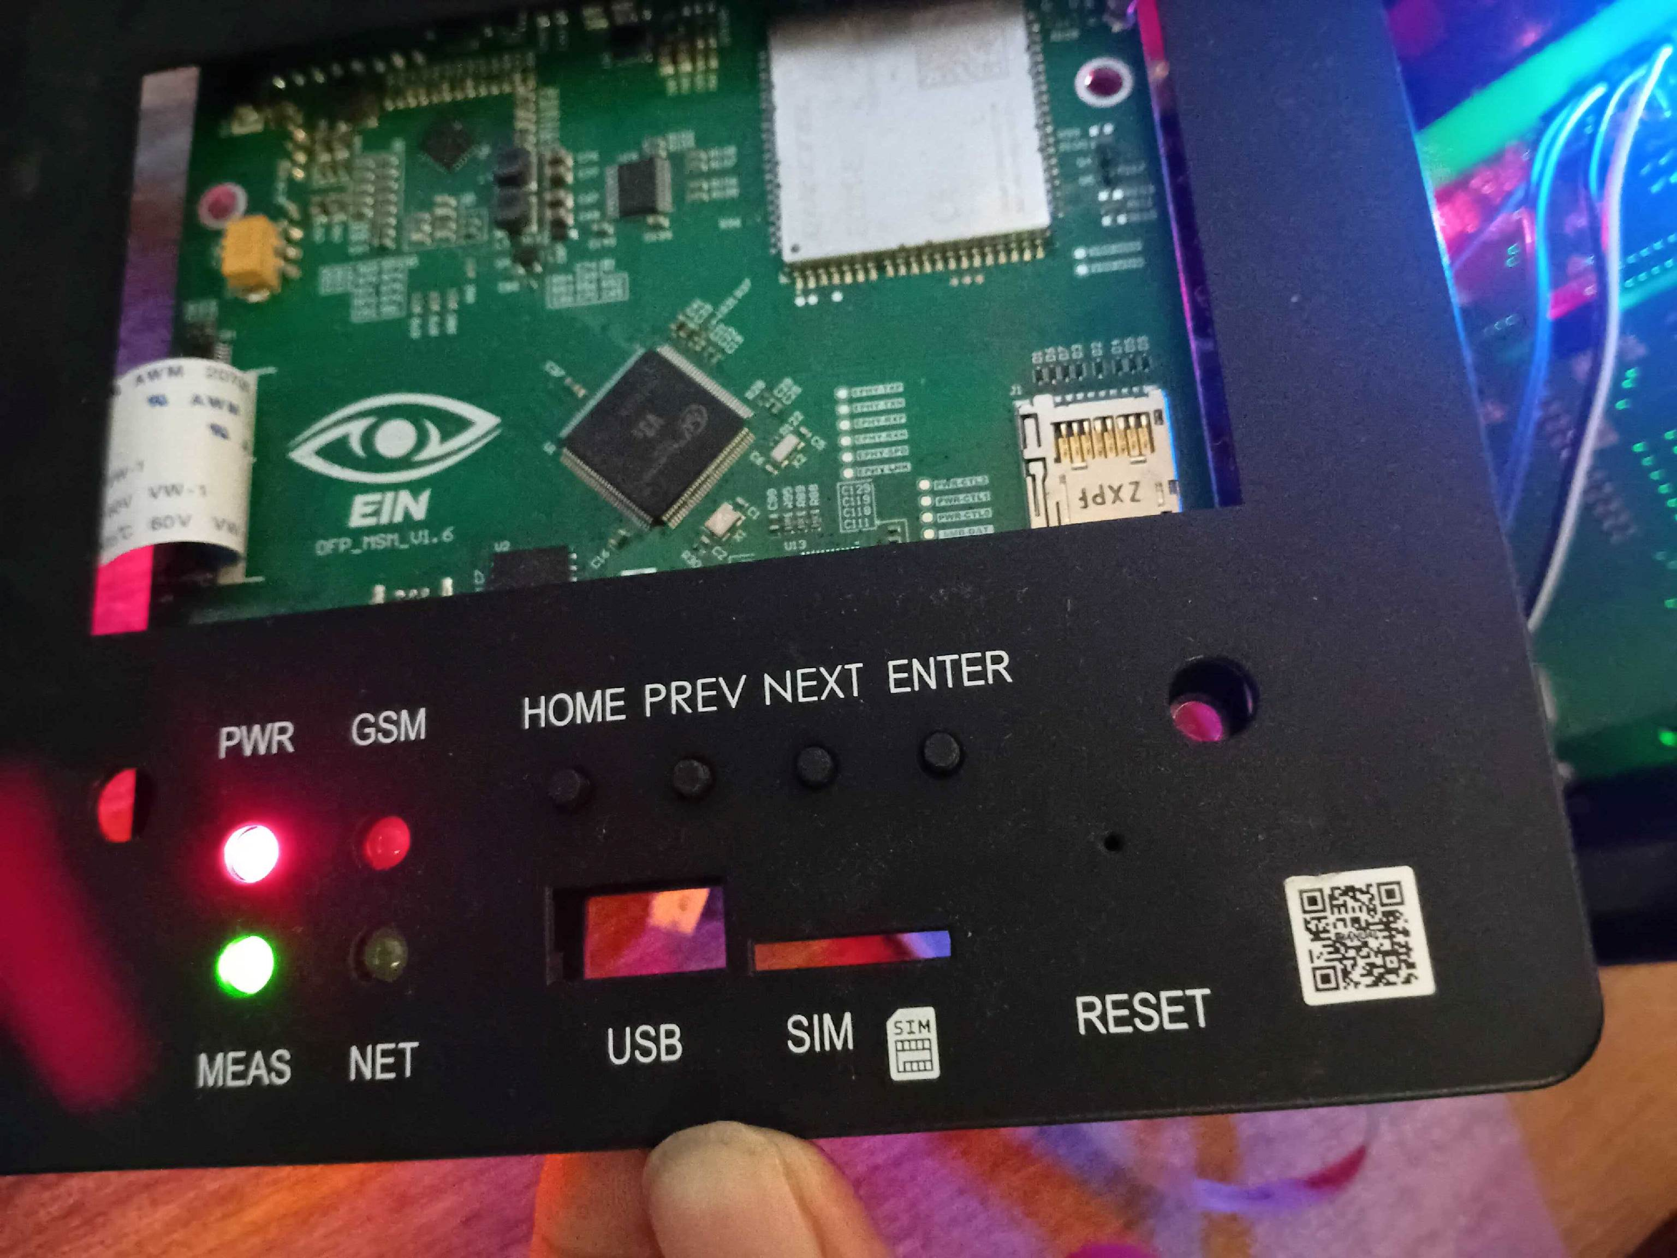Once the device has been assembled, check the power LED and meas LED. Both should be working.

