MSM Device Calibration Procedures

CT-Ratio
- Login into factory settings using the factory password & navigate to CT-Ratio Screen.
- Tap the channel for which you want to set the ct-ratio.
- A keypad will open, enter the ct-ratio depending upon your CT requirement and press Enter, like if your CT is of 500:5A then you will be entering 100.
- Once set, hit save button and wait for the response.
- Once response is success, you’re good to go! Else try again!

V-Calibration
- Login into factory settings using the factory password and navigate to V-Calibration Screen.
- Tap the phase for which you want to perform calibration. Make sure that three phase are connected in the VIM board and CIM boards are connected.
- A keypad will open, enter the voltage value that is being injected and press Enter.
- Once set, hit save button and wait for the response.
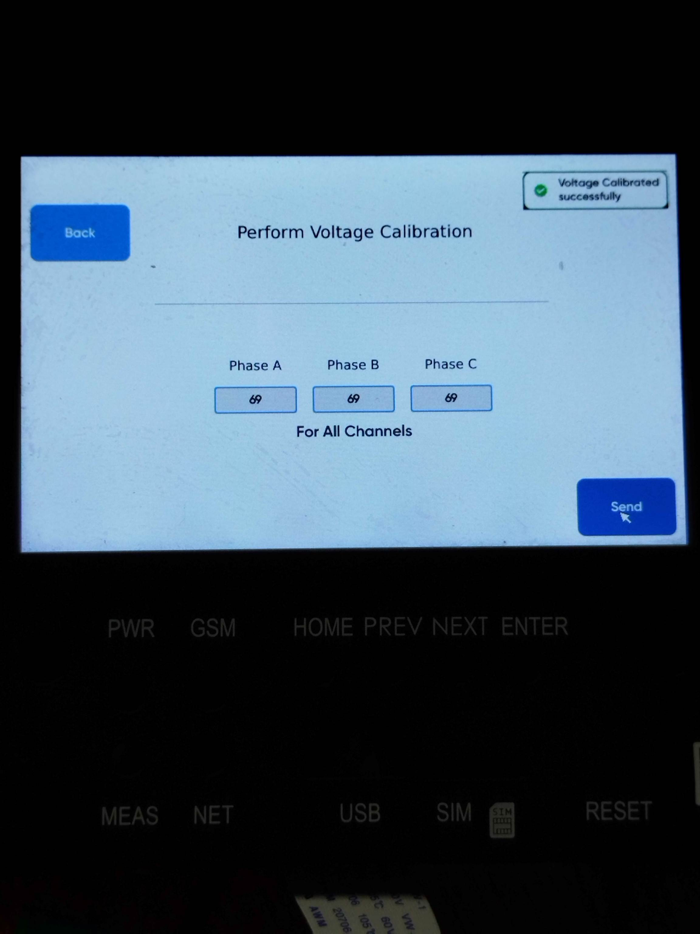
- Once response is success, you’re good to go! Else try again!

I-Calibration
- Login into factory settings using the factory password and navigate to I-Calibration Screen.
- Tap the phase for which you want to perform calibration. Make sure that all three phases are connected in the VIM board and CTs on the CIM boards are connected as well.
- A keypad will open, enter the current value that is being injected and press Enter.
- Once set, hit save button and wait for the response.
- Once response is success, you’re good to go! Else try again!

V-Offset
- Login into factory settings using the factory password and navigate to V-Offset Screen.
- Tap the phase for which you want to perform offset. Make sure that all three phases are connected in the VIM.
- A keypad will open, enter the offset value you want (can be +ve/-ve) and press Enter.
- Once set, hit save button and wait for the response.
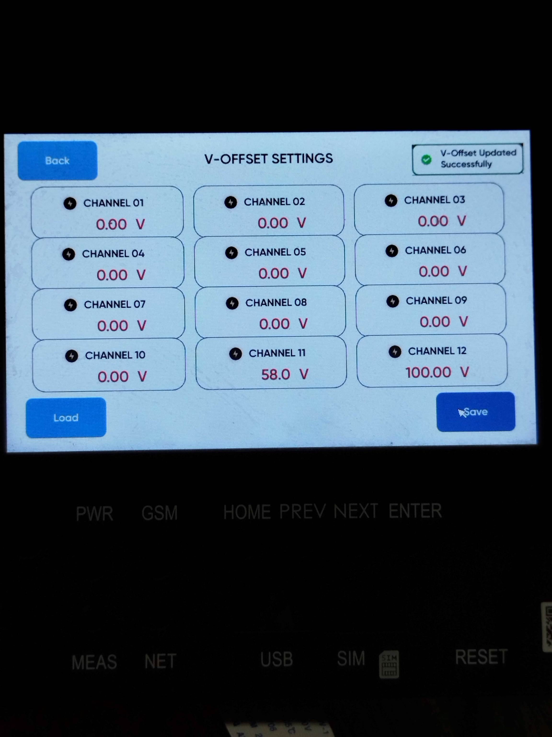
- Once response is success, you’re good to go! Else try again!

I-Offset
- Login into factory settings using the factory password and navigate to I-Offset Screen.
- Tap the phase for which you want to perform offset. Make sure that all CTs on the CIM boards are connected as well.
- A keypad will open, enter the offset value you want (can be +ve/-ve) and press Enter.
- Once set, hit save button and wait for the response.
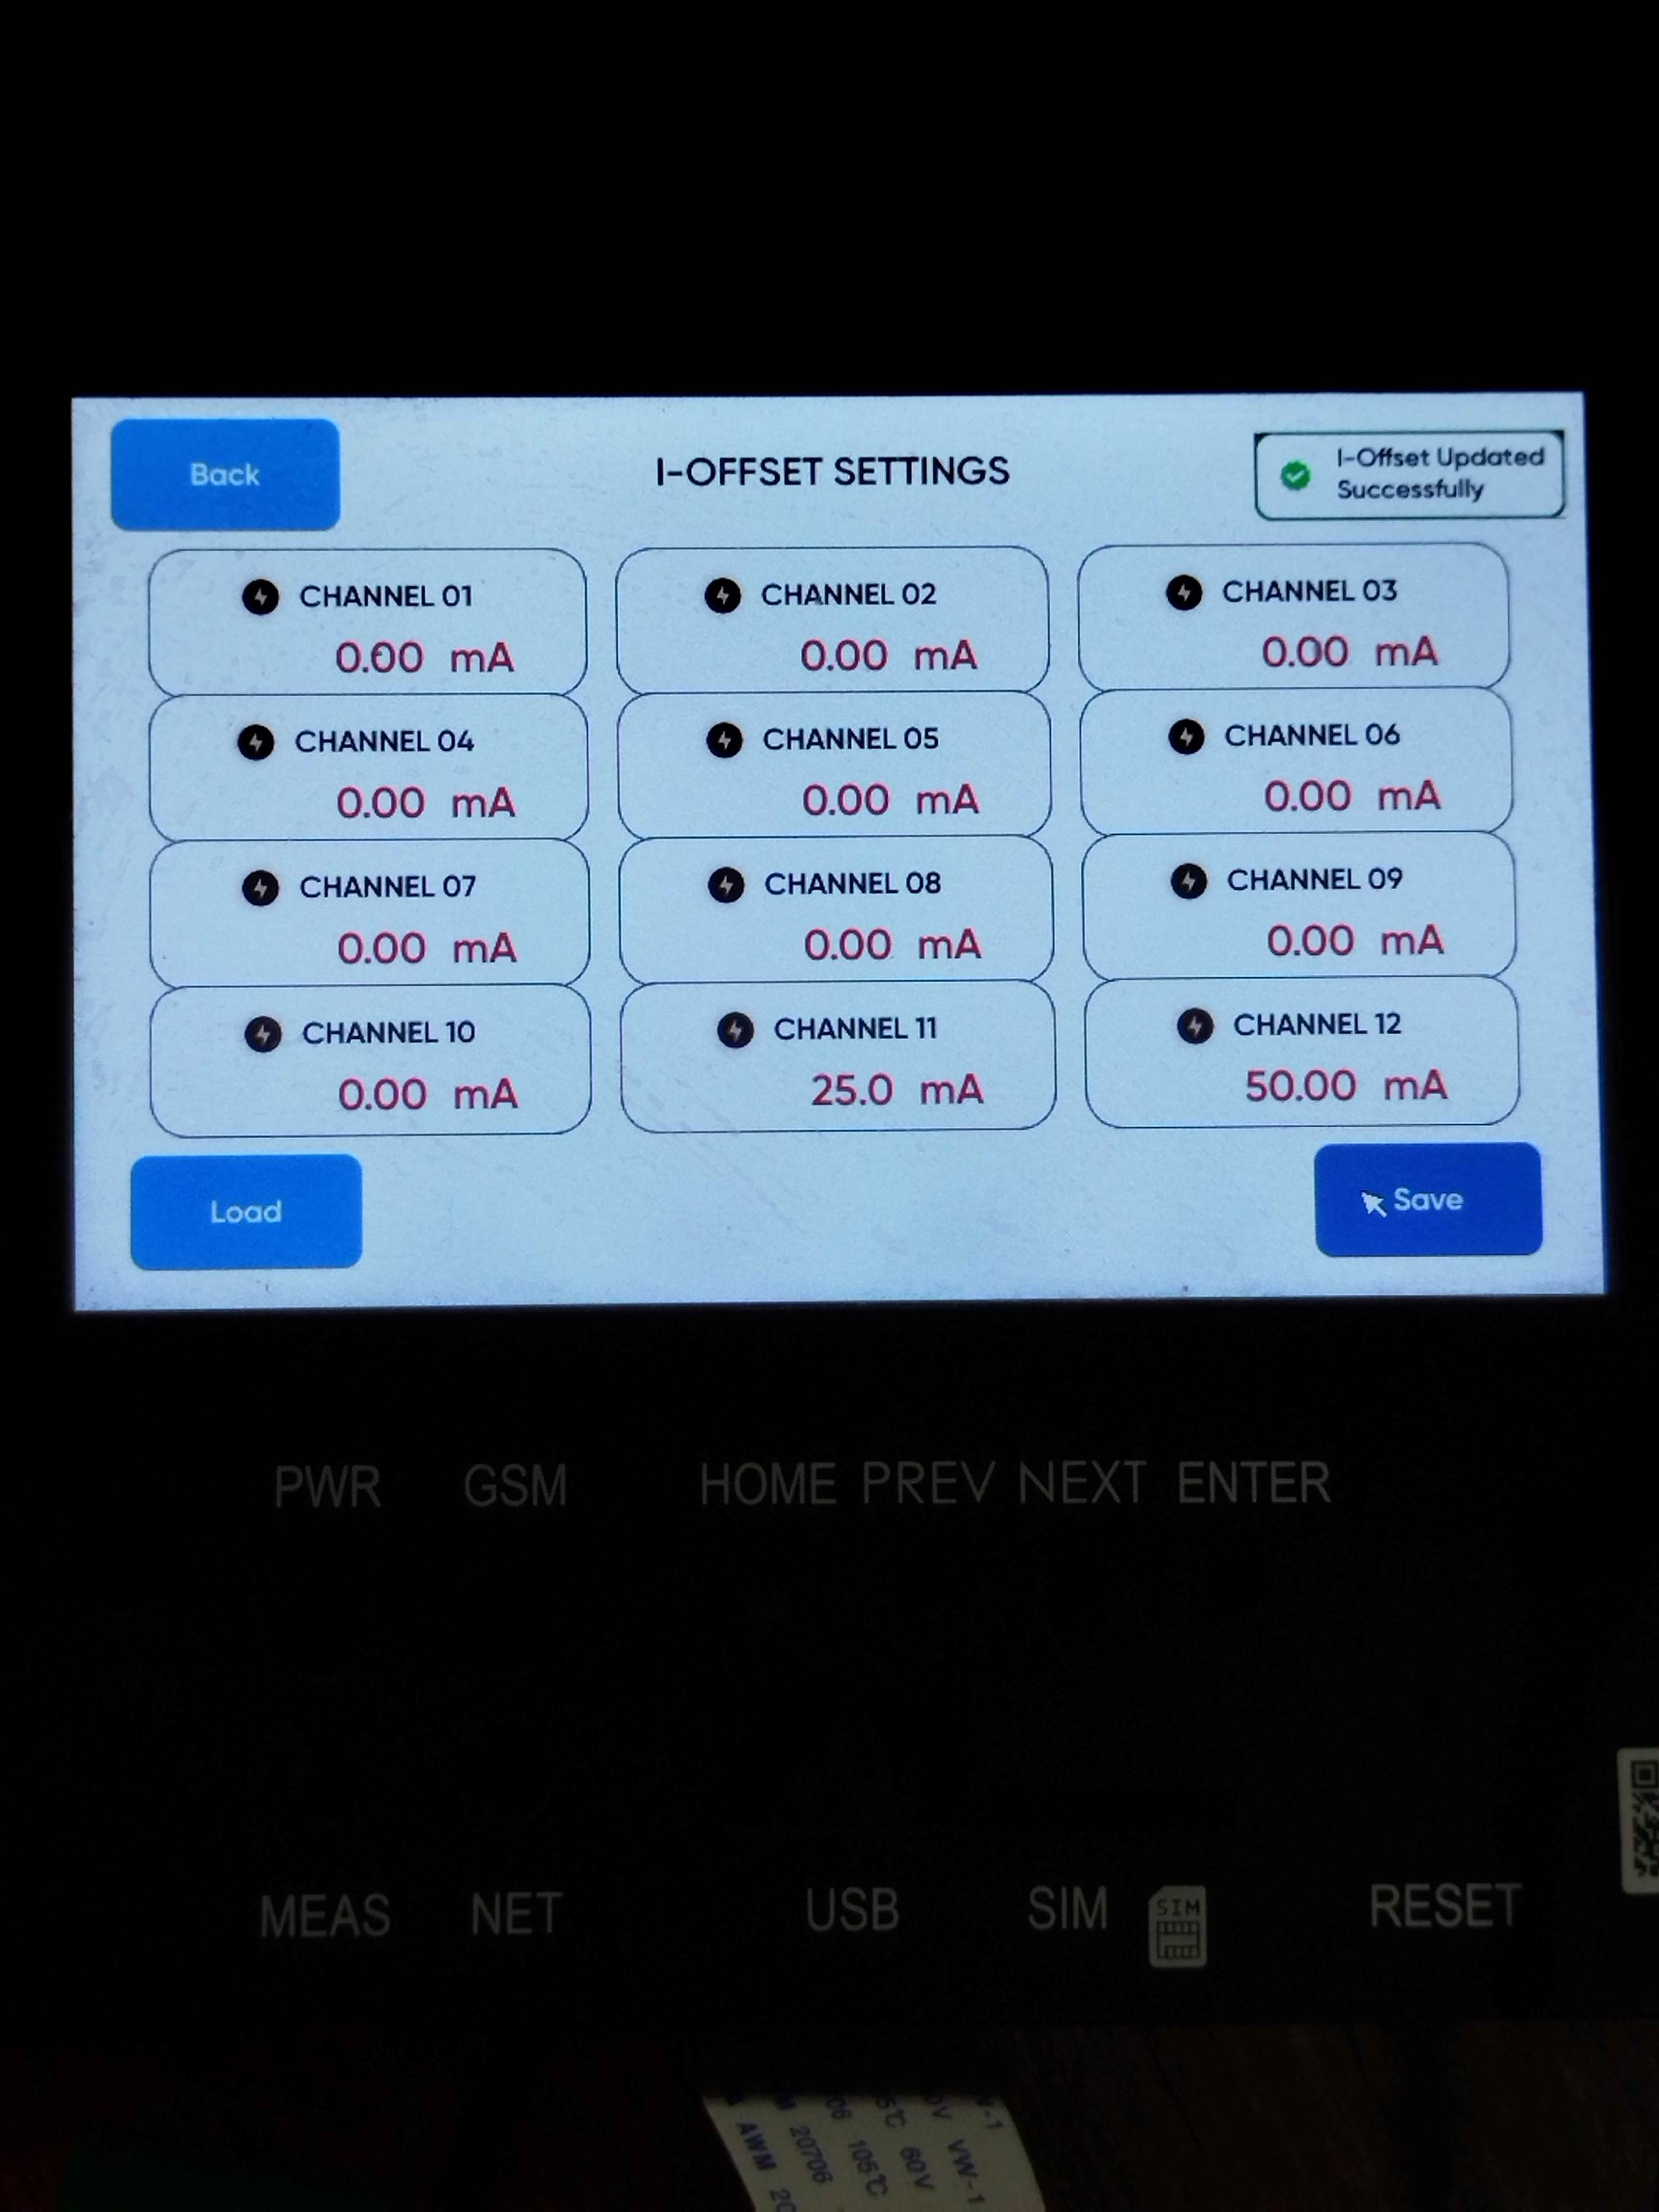
- Once response is success, you’re good to go! Else try again!

