Centre LED
- Not shown in the image, the centre "0" LED will be RED Colour.
- When the device Start, this ‘0’ LED will glow (Fade In / Fade Out pattern).
- Time Duration will be 5 Sec for Fade In / Fade Out pattern, after that it will continuous Glow.
RTC IC Testing
- RTC IC will be tested; External Crystal is already placed but we can also drive its clock from uController. Which will be better option for us?
- Can we use uController timer as a reliable RTC? If yes, it will definitely save cost.
- If we are using uController times as a RTC, we should use External Crystal to power uController or we can go for internal Clock?
LED Rings
- Fade in and Fade out pattern will be followed.
- As One loop is Fading out, the Second loop should fade in, in parallel.
- The cycle (Fade in and Fade out) will start from First LED Ring and continued till last Fifth LED Ring.
- This cycle will again start from First LED Ring (Fade IN) when Fifth LED Ring was Fading Out.
- The LED Rings Cycle will be continued for Two Minutes (Testing Purpose, actual timing is One Hour).
- After Two Minutes, all LED Rings will be coloured RED and start Toggling (On/Off Scheme) until we switched it off.
Buzzer
- The Buzzing will start after One Hour, in our case (testing purpose), we will buzz after Two Minutes. This Buzzing will be continued until we switched it off.

Colour Scheme
- Colour pattern will be same as in shared image below.
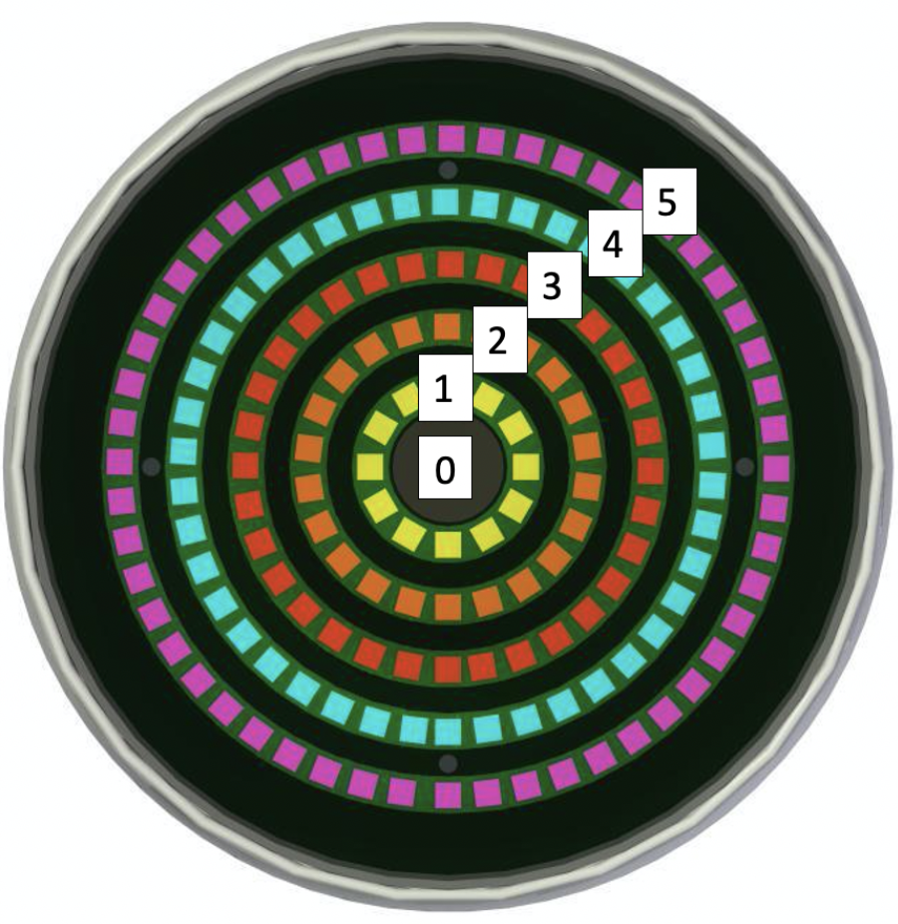

Further, I will share working video of Abbas so that it will be more clear. If I failed to guide you properly.

