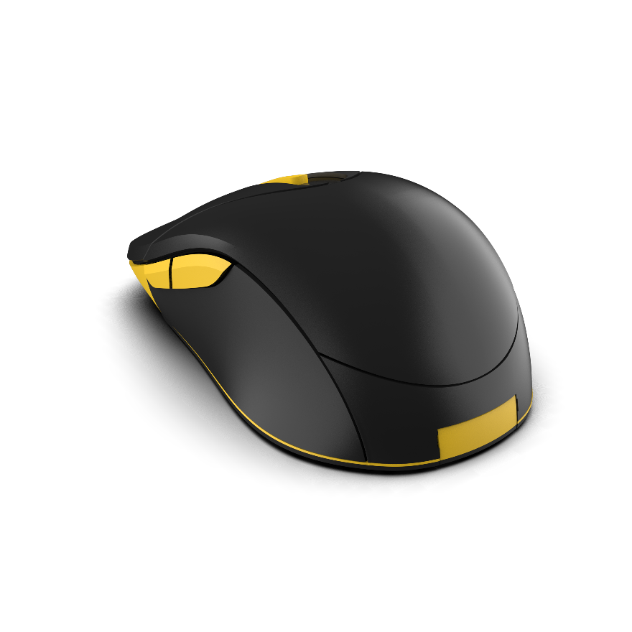
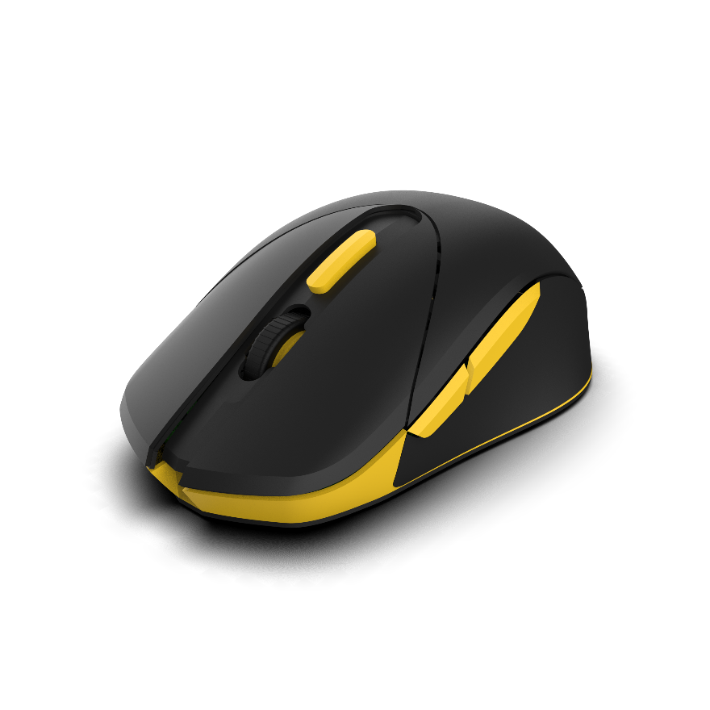
Design Documentation for the Manufacturing
of the Era 1 Gaming Mouse

1- Product Overview

The Era 1 gaming mouse is a wireless gaming peripheral meticulously designed for precision, durability, and ergonomic comfort. With a strategically positioned sensor, instant battery swap capabilities, and a revolutionary CPI indicator, the Era 1 represents the future of gaming. Please specify that the mouse is designed for right-handed users focusing on a palm/claw grip style. - Also, note that the mouse will utilize proprietary 2.4 GHz wireless technology.

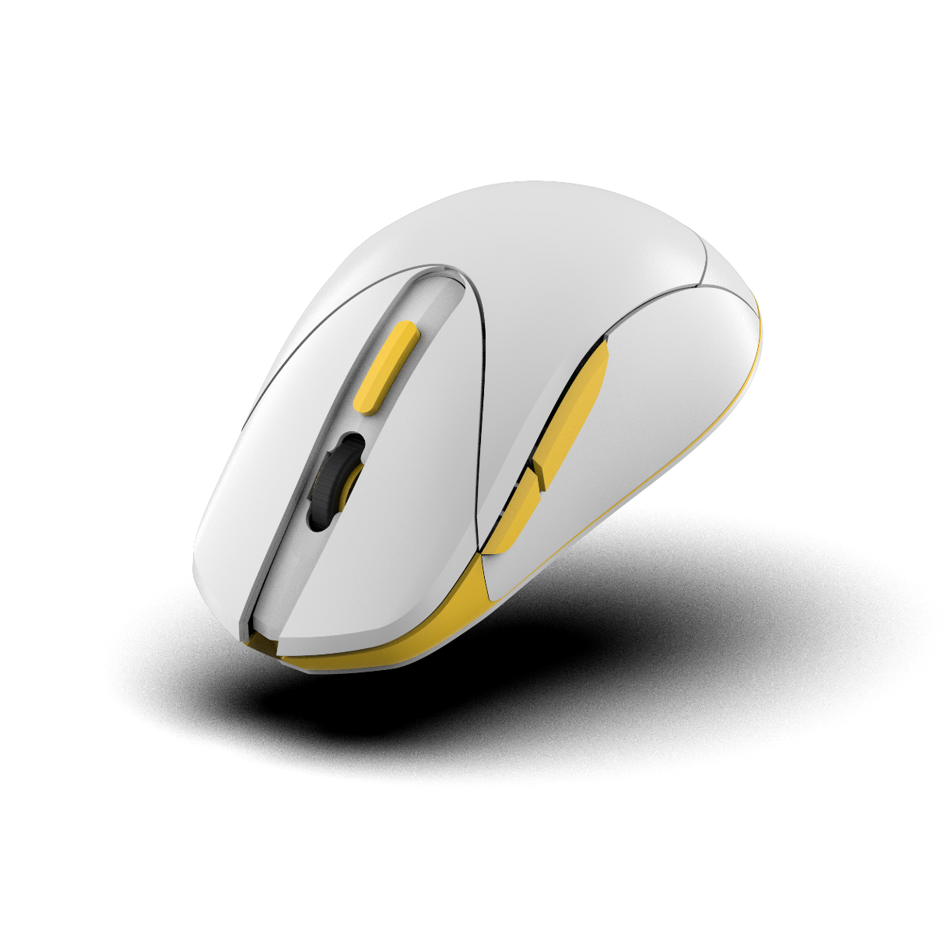
- Components: Sensor:PAW3395 upto 26,000 CPI resolution, 650 IPS tracking speed, and 2mm lift-off distance., switches:Kailh GM8.0 Mousewheel encoder: TTC Gold 60mm TTC Gold switches featuring a 65g actuation force and a lifespan of 80 million clicks. Including Rotary mouse wheel encoder with 12PPR. PCB, battery module, Specify the use of a 200mAh Li-poly battery with up to 14 hours of continuous use.casing materials. - Casing:A plastic chosen for durability and lightweight design. - For casing, state that we are using PBT plastic with a rubberized grip and UV coating. - Part numbers, quantities, and suppliers: - Handling: Special attention to the battery module for swift and efficient battery swaps.

2- Bill of Materials (BOM)

3- 3D Models and 2D Drawings
- CAD files available for each component. - Detailed annotations focusing on the unique placement of the sensor and battery module. Tolerance levels of ±0.1mm for plastic parts and ±0.05mm for metal parts.
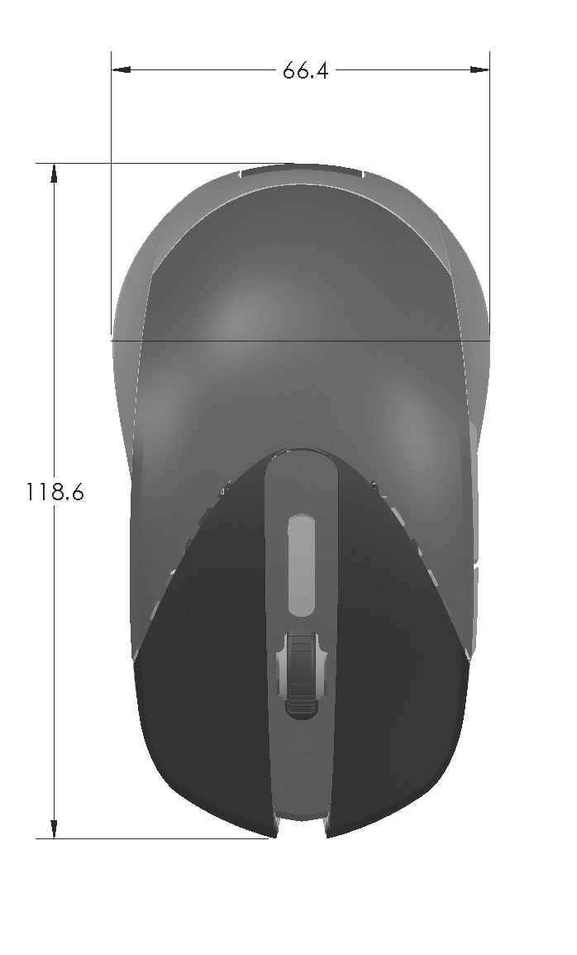

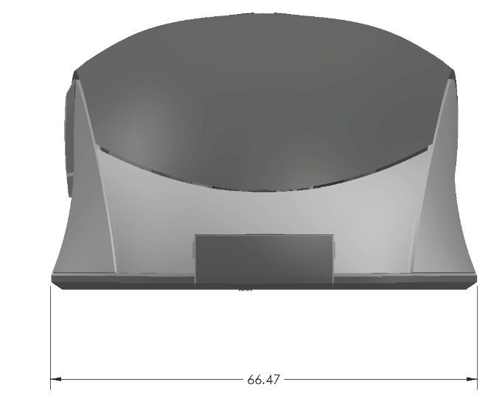
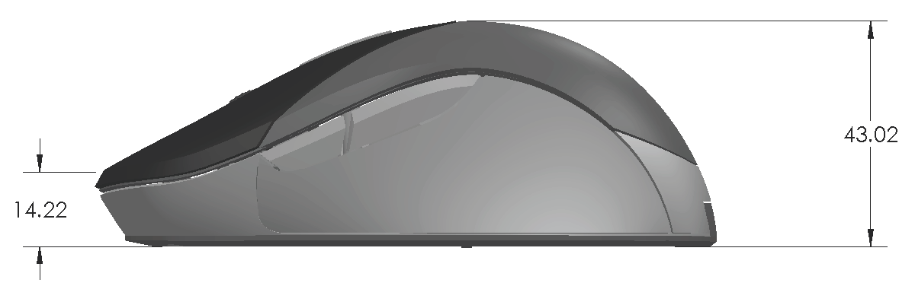
4- Assembly Instructions
-Emphasis on correct sensor placement for optimal performance. - Detailed instructions for battery module placement ensuring easy swap functionality. -Critical checkpoints to ensure sensor and battery module integrity. - Introduce a Quality Control Procedures section outlining the tests for button durability, scroll wheel durability, and latency. Specifications for packaging and firmware details.

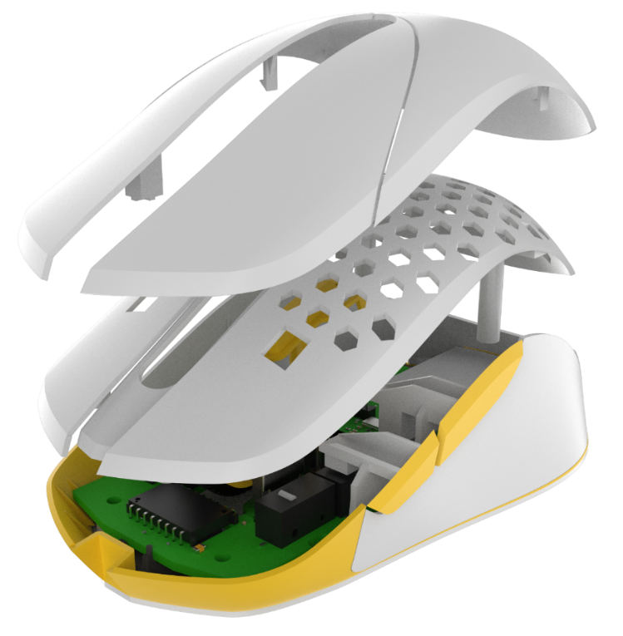

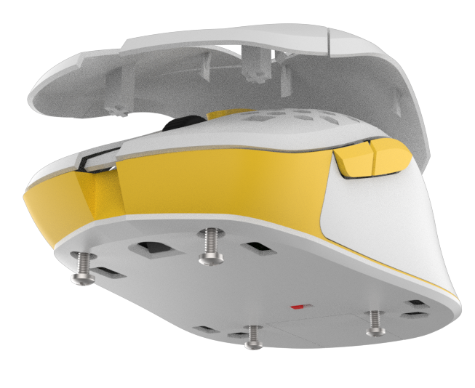

Screw

5. PCB Design Files and Schematics
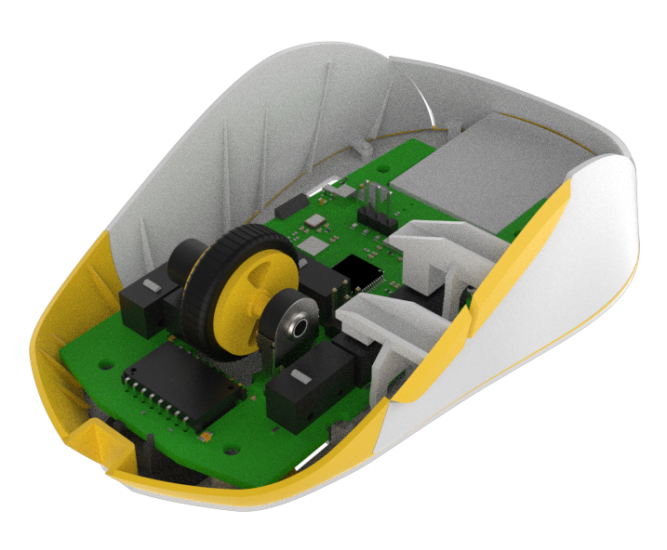

- Focus on integration of the 8000Hz polling rate.- Highlighted pathways for the CPI indicator functionalit. - Note that the CPI indicator will feature an RGB LED with a color spectrum of 16.8 million colors. - Power Management: - Auto-Awake: The mouse will remain in a low-power state until touched, at which point it will automatically wake up. This can be achieved using capacitive touch sensors. - Connection-Based Shutdown: The mouse will automatically turn off if it loses connection with the base station or if the base station is unplugged from the PC. - Inactivity Timeout: The mouse will enter a deep sleep mode after 15 minutes of inactivity to conserve battery life.

- Purpose of Coating: The coating for the Era 1 gaming mouse is intended to provide a premium feel to the user, ensuring a non-slip grip during intense gaming sessions while also resisting common wear and tear. This coating should additionally aid in maintaining the aesthetic integrity of the mouse over prolonged usage. - Desired Finish: We are seeking a finish that is matte in appearance, yet smooth to the touch. It should minimize fingerprints and not become sticky or degrade with exposure to sweat or hand oils. - Durability: The coating should be durable enough to resist common scratches, abrasions, and resist fading or discoloring from UV light exposure. - Feel: While the visual appeal is crucial, the tactile feel is equally essential. The coating should be cool and comfortable against the skin, ensuring that users can comfortably grip the mouse even during extended usage. - Environmental and Health Concerns: Any coatings considered should be environmentally friendly and should not contain substances that might be harmful to users or the manufacturing staff. Compliance with regulations such as RoHS (Restriction of Hazardous Substances) is mandatory. - Application Process: Provide details on how the coating should be applied, cured, or treated. If this is unknown, manufacturers can often advise on best practices based on the chosen material and desired finish. - Sample Validation: Before full-scale production, we'd like to validate the chosen coating on a sample batch to test for wear, grip, look, and feel. - Alternatives: If the manufacturer has expertise in this domain, we are open to suggestions on coatings that match or exceed our described criteria. Samples or case studies of previously manufactured products using proposed coatings would be highly beneficial.

- Instructions for achieving the desired matte finish.

6. Coating and Finishing Specifications

7. Testing Procedures

- Tests to validate the 8000Hz polling rate. - Functional testing for battery swap efficiency. - Quality tests focusing on the optimal sensor position and wireless functionality.
- Automated Testing: Add a test scenario to validate the auto-awake and auto-shutdown features. Ensure the mouse wakes up within 200 milliseconds of being touched and shuts down within 5 seconds of losing connection with the base station.
- Functional Testing: - Sensor Accuracy: Ensure that the sensor, especially given its unique positioning, captures movement accurately and without latency. - Battery Swap Efficiency: Test the ease and speed of swapping out the battery module without glitches. - Button Response: Each button, including the main buttons, side buttons, and the scroll wheel, should register clicks consistently. - Wireless Functionality: Test for range, interference, and general consistency in connection. - DPI Indicator Verification: Confirm that the DPI indicator correctly reflects the DPI settings. - Durability and Lifespan Testing: - Click Lifecycle: Simulate prolonged use by repeatedly pressing each button to ensure they can withstand millions of clicks without failure. - Wear and Tear: Simulate the mouse's usage over time to check how it stands up to scratches, abrasion, and general wear. - Drop Test: Check the mouse's resilience to accidental drops from a standard desk height. - Ergonomics and User Comfort: -Grip and Feel: Get feedback from testers on how comfortable the mouse feels during prolonged gaming sessions. Ensure that the shape and coating do not lead to hand fatigue. - Weight Balance: Verify that the mouse feels balanced in hand and isn't too front or back-heavy. - Performance under Extreme Conditions: - Temperature Tests: Ensure that the mouse operates optimally under a range of temperatures, especially considering varying room temperatures gamers might experience. - Humidity Test: Test the mouse's functionality in high and low humidity conditions. - Quality Assurance: - Visual Inspection: Ensure that each mouse meets the aesthetic standards, with no defects in coating, no misalignment in assembly, and no visible irregularities. - Software Integration: Ensure that the mouse software, if any, integrates seamlessly with the mouse, allowing users to customize settings as intended. - Feedback Loop: - Create a mechanism for testers to provide detailed feedback on any defects or areas of improvement they identify.

- All regulatory information pertinent to wireless devices and gaming peripherals.
- CE Marking (for European Market): - Ensure the mouse conforms to European standards for health, safety, and environmental protection. - Complete the necessary self-declaration or get the product assessed by an authorized third-party body, as applicable. - FCC Certification (for U.S. Market): - Given the wireless functionality of the mouse, secure certification from the Federal Communications Commission, ensuring that it doesn't cause harmful interference and can operate without being interfered with. - RoHS Compliance: - Confirm that the mouse meets the Restriction of Hazardous Substances (RoHS) directive, ensuring that it does not contain prohibited hazardous materials. - WEEE Directive: - For sales in the European Union, ensure adherence to the Waste Electrical and Electronic Equipment (WEEE) directive, which aims at reducing electronic waste. - Battery Certifications: - Given the inclusion of a battery module, ensure the mouse meets safety and transportation regulations for batteries. This includes the UN38.3 Transportation Test for batteries. - Wireless Standards: - Validate that the mouse adheres to wireless transmission standards, especially if it uses a particular frequency band. This can vary by country. - ISO Standards: - While not always mandatory, attaining ISO certifications like ISO 9001 (for quality management) can enhance credibility. - Country-Specific Regulations: - Depending on the markets you're targeting, there may be country-specific electronic and wireless device regulations to adhere to. Make sure to research each target market's specific requirements. - Environmental Certifications: - Achieve certifications like ENERGY STAR or equivalents to demonstrate that the mouse is energy-efficient. - User Safety & Information: - Ensure that the user manual provides necessary safety precautions, information about potential hazards, and proper usage guidelines. - Recycling & Disposal Information: - Offer guidelines on how users should responsibly dispose of the mouse at the end of its lifespan, especially the battery. - Record-Keeping: - Maintain records of all tests and certifications as proof of compliance. This is especially crucial if a regulatory body asks for them.

8. Compliance and Regulatory Information

9. Packaging Instructions


- Emphasis on packaging that showcases the DPI indicator and informs about the unique sensor position.
- Primary Packaging Structure: - Material: Eco-friendly materials such as recyclable cardboard or molded pulp to provide a blend of sturdiness and sustainability. - Dimensions: - Box: 140mm x 90mm x 60mm (This allows a cushion of space around the mouse's dimensions of 118.5 x 66.5 x 44mm.) - Ensure the depth allows for the mouse and potential protective layers or compartments. - Internal Protective Layer: - Consider molded pulp or foam cutouts to securely cradle the mouse, preventing movement and potential damage from shocks during transit. - Accessories Compartment: - A designated section for including accessories like the charging cable. This could be a separate compartment or a pouch. - Consider small cardboard compartments or mesh pockets attached to the box's inner roof. - Seal: Implement a tamper-evident seal to ensure the product remains untouched until it reaches the consumer. - Documentation Placement: - Include a slit or pocket on the inner side of the box lid for the user manual and any supplementary documentation. - Labeling & Information: - Inside Lid: Consider printing a quick setup guide or diagram to assist users immediately upon opening. - Bottom: Include a space for regulatory labels, battery safety and disposal instructions, and a unique serial number. - Box Opening Experience: - Design the box to open with a front flap or lid to provide a direct view of the mouse, enhancing the unboxing experience. - If feasible, incorporate a magnetic closure for a premium feel. - Secondary Packaging (If required): - Use a protective sleeve or outer box with padding for added protection during shipping. - Quality Assurance: - Protection Test: Ensure the mouse remains immobile when the box is shaken. - Durability Test: Examine the box's resistance to wear and tear, especially at corners and edges. - Box Integrity Test: Test the box under various conditions, ensuring it remains sealed and its contents protected. - Charger Base LEDs: - Green LED: Indicates the battery is fully charged. - Red LED: Activates when the battery level drops to 15% or lower. - White LED: Lights up during all other times. - Battery Preservation: The charger base should utilize trickle charging to extend battery lifespan once the mouse reaches full charge. This approach shifts the base to a maintenance charging mode, which reduces the stress on the battery. Eco-friendly packaging to align with sustainability goals. To meet the 60-gram target, let's add this section to detail material choices and design optimizations aimed at weight reduction. New Section: Weight Management Material: Utilize lightweight polycarbonate for the shell. Design: Implement honeycomb design on non-critical grip areas to reduce weight.

10. Special Considerations for Innovations

- Detailed guidelines on showcasing the lightweight design, prominent DPI indicator light, and instant battery swap capabilities. - Specific instructions for handling the innovative sensor positioning.- Lightweight Design: - Assembly Precaution: Ensure the lightweight materials, especially the polypropylene casing, are handled with care to prevent deformation or damage. - Testing: Conduct weight measurement tests on the final product during the QA process to confirm it's within the target weight range. - Documentation: Highlight the advantages of a lightweight mouse in user manuals, focusing on its ergonomics and comfort over prolonged use. - Prominent DPI Indicator Light: - Assembly Instruction: Prioritize the correct placement and connection of the DPI indicator LEDs to the PCB. Ensure they align perfectly with the external casing indicators. - Testing: Activate the DPI switch in various settings to ensure clear visibility of the indicator light in both dim and brightly lit conditions. - Documentation: Include a section in the user manual explaining the function of the DPI indicator, guiding users on how to interpret the light signals and adjust settings as per their preference. - Instant Battery Swap Capabilities: - Assembly Instruction: Ensure the battery compartment is easily accessible and designed for quick battery replacement without needing any tools. - User Experience: Make sure that the battery compartment latch or cover is intuitive to use, providing tactile feedback when securely closed. - Testing: Conduct repeated battery swap tests to validate the ease of use and the durability of the compartment. - Documentation: Incorporate a detailed guide in the user manual illustrating the steps to perform a battery swap, complete with images and safety precautions. - Innovative Sensor Positioning: - Assembly Instruction: Use jigs or templates during the assembly process to ensure the sensor's consistent and precise positioning. - Testing: Validate the sensor's performance, ensuring it tracks accurately and doesn't experience any glitches due to its unique positioning. - Documentation: In the user manual, emphasize the benefits of the unique sensor position, perhaps highlighting better tracking performance and ergonomics. - 8000Hz Polling Rate: - Testing: Run the mouse through rigorous testing environments to ensure the 8000Hz polling rate delivers ultra-smooth cursor movements without any lag or jitter. - Documentation: Emphasize this feature's importance in the user manual, explaining its advantages for high-paced gaming scenarios and how users can adjust or make the most of this high polling rate.
11. Revision Control and Change Management
- Regular updates to maintain the currency of the documentation.

12. Contact Information

- For any questions or clarifications, please contact us at jexi@periphs.com

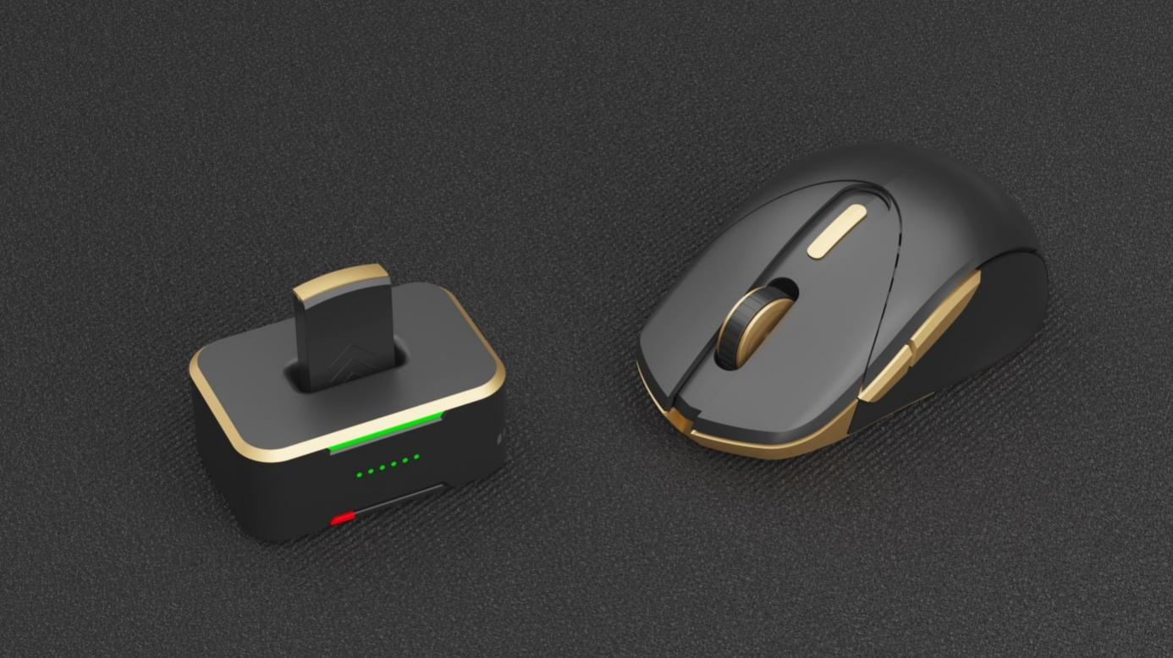
Mouse Parameters
Model No.
Type BT 2.4G
Number of keys 6
Resolution 26000CPI
Maximal tracking speed 30IPS
Maximum polling rate 2.4G-1000hz BT-133hz
Battery specification 200mA
Dimensions 118.5 x 66.5 x 44
Weight 60g ± 3
System compatibility Windows 11 / Vista /Mac

