FLASHING AND MONITORING INSTRUCTIONS FOR Real-tek BW16 (Main controller board)

USING VOLT-LINK and ARDUINO IDE: (recommended)

- Download and install Arduino IDE, go to file->preferences.
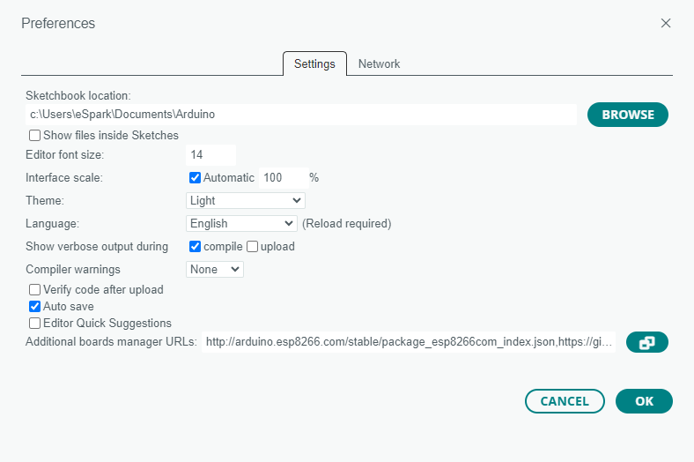

- Add the following URL in the additional boards manager:
https://sandeepmistry.github.io/arduino-nRF5/package_nRF5_boards_index.json
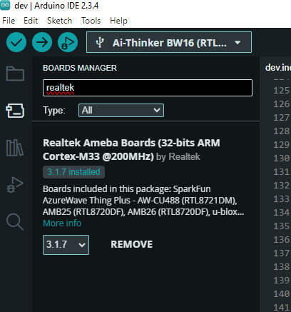
- Go to the tools->boards->boards manager and install the following board:

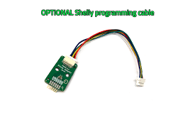
- Now connect your volt-link to your pc via type c cable. And connect the volt link to the main controller boards J3 port using the connector wire :

- Make sure you have CP210x driver installed , if not download using this link: https://www.silabs.com/documents/public/software/CP210x_Universal_Windows_Driver.zip

- Now go to device manager->ports and see if the device is detected , if its already there then its okay if not then update driver and select the CP210x.zip file downloaded using the link previously.

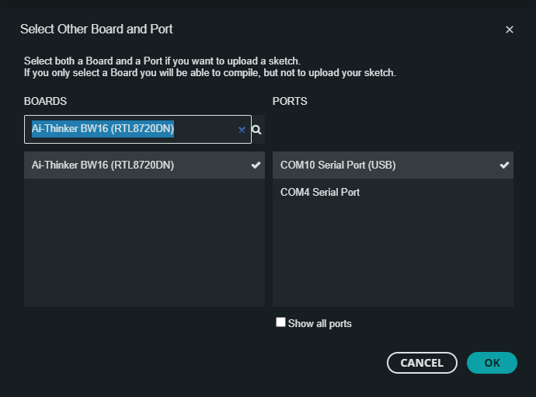
- Now feel free to upload the source code to a New Sketch in Arduino IDE and make sure to select the correct COM PORT and the correct board:

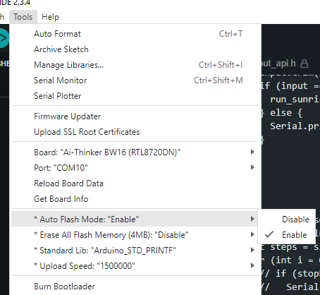
- Make sure that the auto flash mode is enabled:

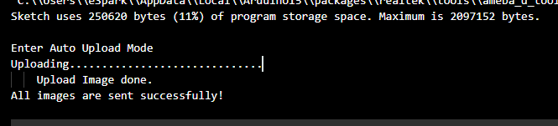
- Compile and upload the code (make sure the board is given supply i.e. 24V else code will not be uploaded). You will observe the following logs on a successful flash:

- To monitor logs open a serial monitor in the Arduino ide by navigating to tools->serial monitor , set the baud rate to 115200

- In order for the sunrise animation to begin give a serial command using the serial monitor , the command is “sunrise”. After pressing enter the animation should begin , which will last upto 60 seconds approx..

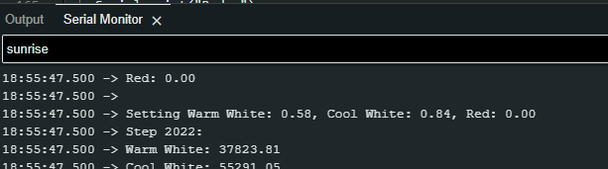

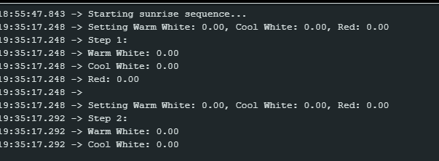
Following logs should be observed after running the animation:

