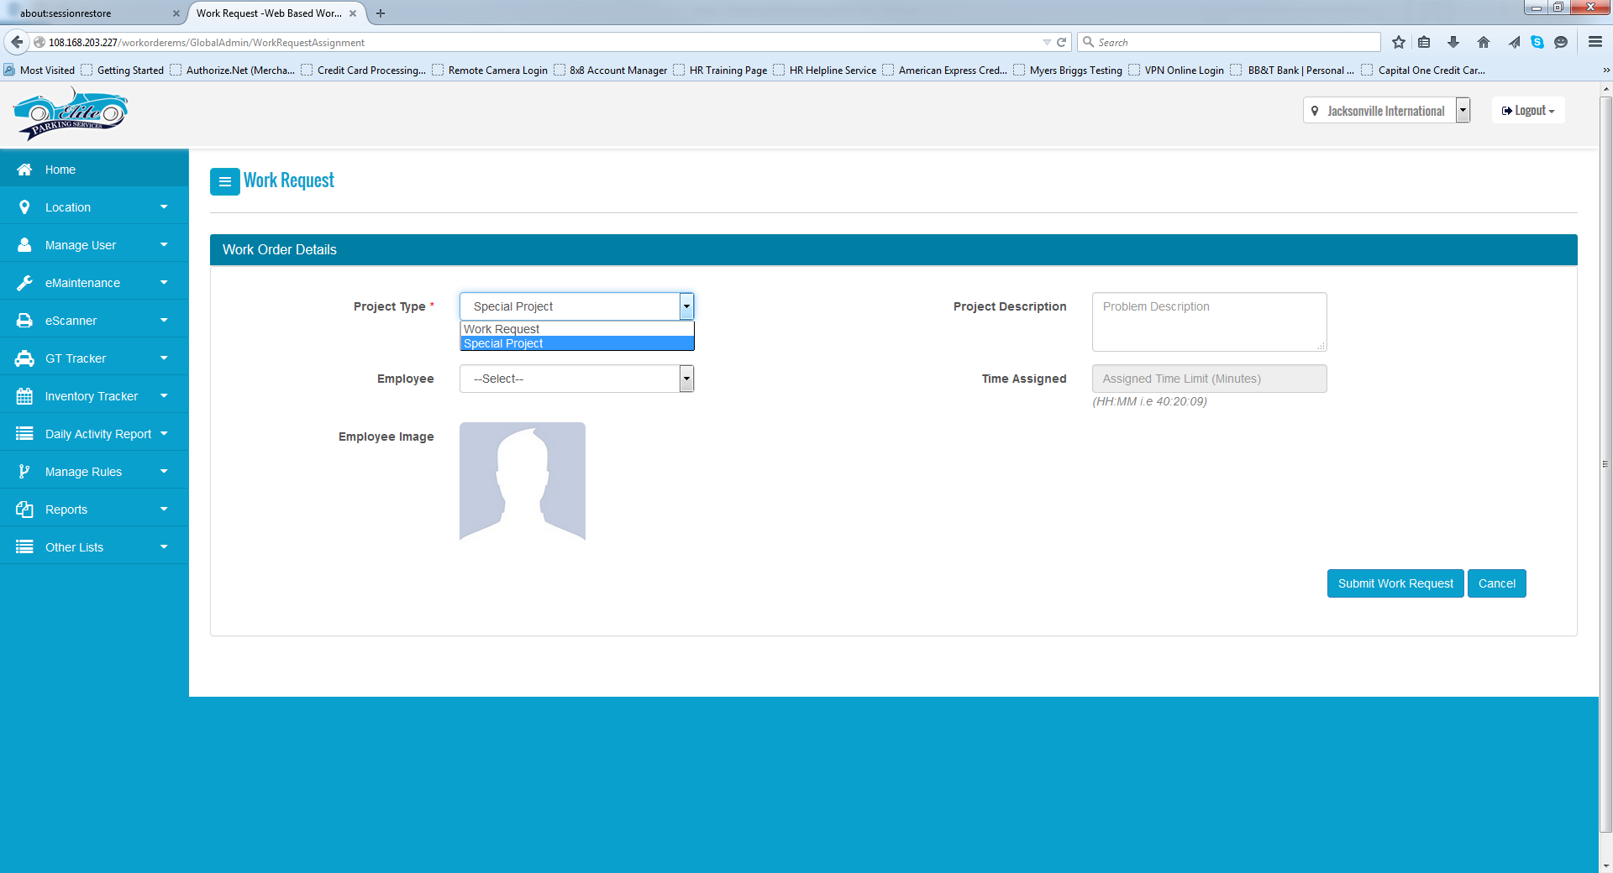

Need to add one more drop down button that’s called facility request

It should then have a drop down that request each of the prior coded functions:

* Customer Vehicle Locate
* Customer Jump Start
* Customer Tire Inflation
* Customer Assistance
  + This section should have a dialog box open up so that information can be inputted as to what need the customer request is.

Additional Boxes:

* Customer Name:
* Address:
* Vehicle Make:
* Vehicle Model:
* Vehicle Year:
* Vehicle Color:
* Current Location:
* Contact Number: (can we make this a number that the employee is unable to see, but from the mobile application side if they press on it, it sends the call out through the phone?)
* Driver’s License Number:
* Should be able to submit the time of request to accept the call
* *Should have a section where it automatically populates the name of the person logged in and submitting the information.*

Once submitted it should time stamp and notify all employees having access to e-Maintenance. The facility request should populate on application dashboard where the employee can accept the request.

Once the employee clicks on accept the timer should be running

***The employee should be able to see the following information in the mobile application once they accept the call:***

* ***Customer Name,***
* ***Vehicle Make,***
* ***Vehicle Model,***
* ***Vehicle Year,***
* ***Vehicle Color,***
* ***Current Location,***
* ***Contact Customer Button- If they press this is should be documented in the DAR that the customer was called and the time the customer was called.***

***There should be a button at the bottom of the information that says disclaimer form and another that says cancel***

If cancel is clicked it should verify if they are sure. Then it should state that request was canceled by employee information should be sent back to users logged into web application and stored in DAR. If disclaimer form is clicked then it should begin calculating the time disclaimer form was populated onto the screen to the time the form was signed and entered into the system.

Once the employee clicks on the disclaimer form it should produce the following on the form:



1

4

3

2

Items above should automatically populate into the form. The numbers denote where the information should derive from:

1. Location Name populated into the system, Name given at time of setup
2. Current date and time information submitted from the web application
3. Information submitted from the web application (willing to look at separating line if necessary)
4. This should be based on the “facility request” selected which are the following listed below:
   1. Customer Vehicle Locate
   2. Customer Jump Start
   3. Customer Tire Inflation
   4. Customer Assistance

7

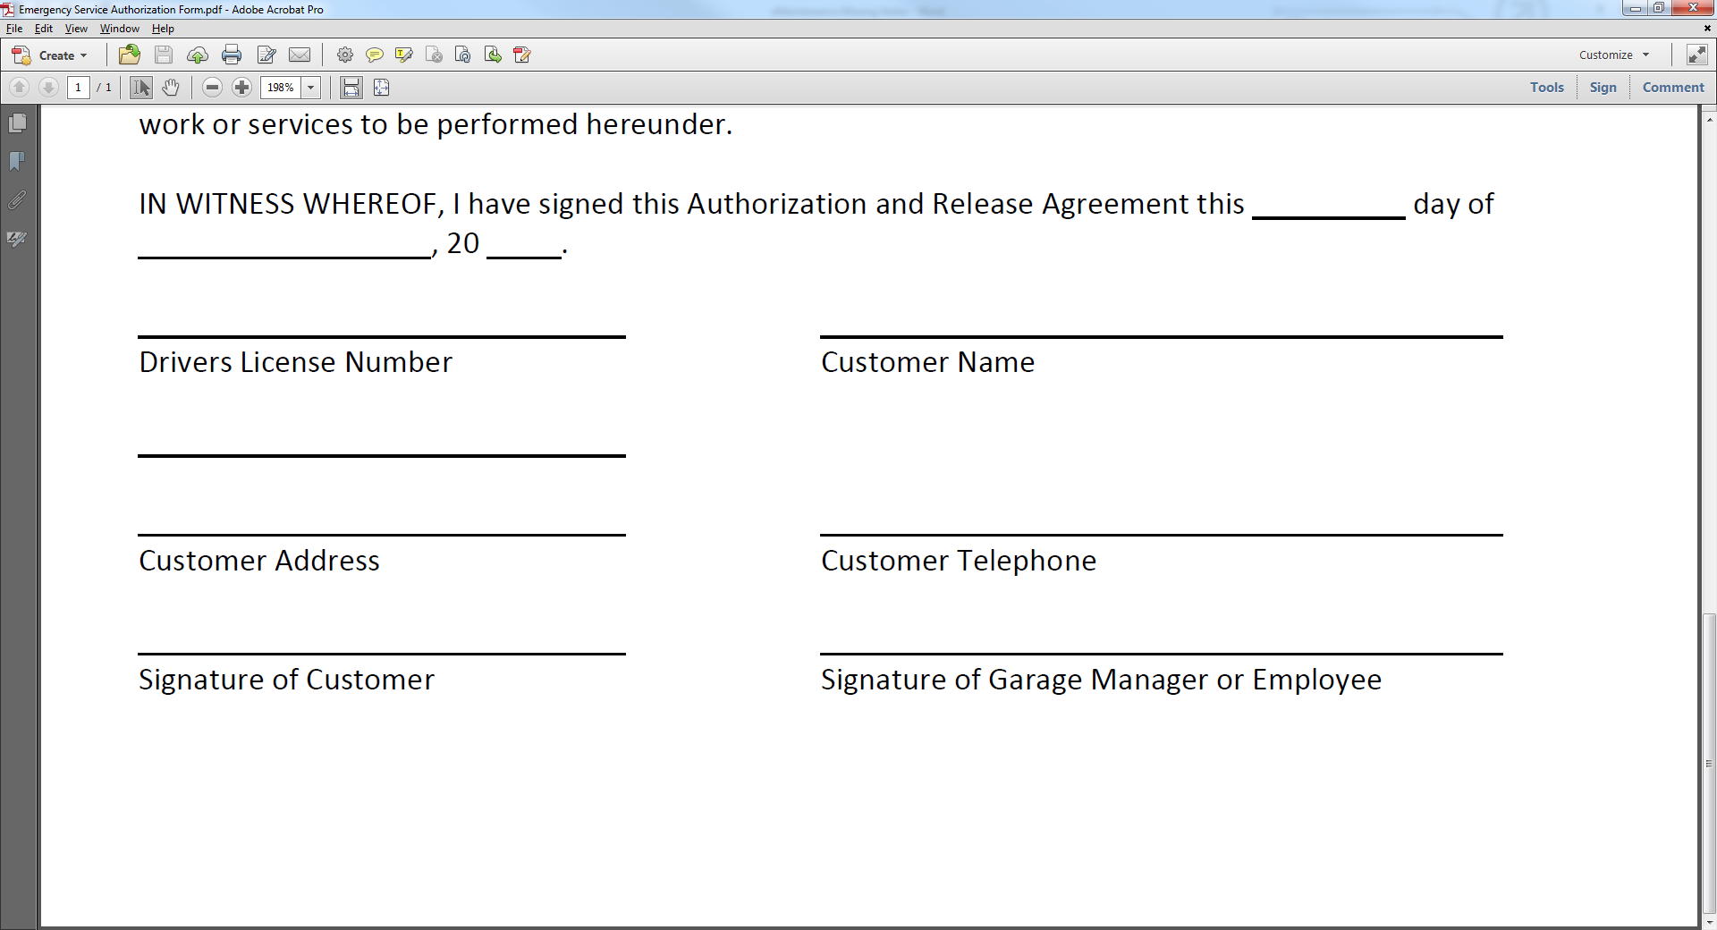

6

5

4

3

2

1

1. This should take date, by putting the date in the first slot, month in the next, and year in the following
2. Customers Driver’s License Number- Information come from the facilities request section on the web application
3. Customers name should come from the facility request section on the web application
4. Customer information should derive from the web application
5. Customer information should derive from the web application
6. Should take the employee accepting the call name and document it in the section.
7. Once customer gets to signature section (***listed information below***) customer signature should populate on this area of the form.

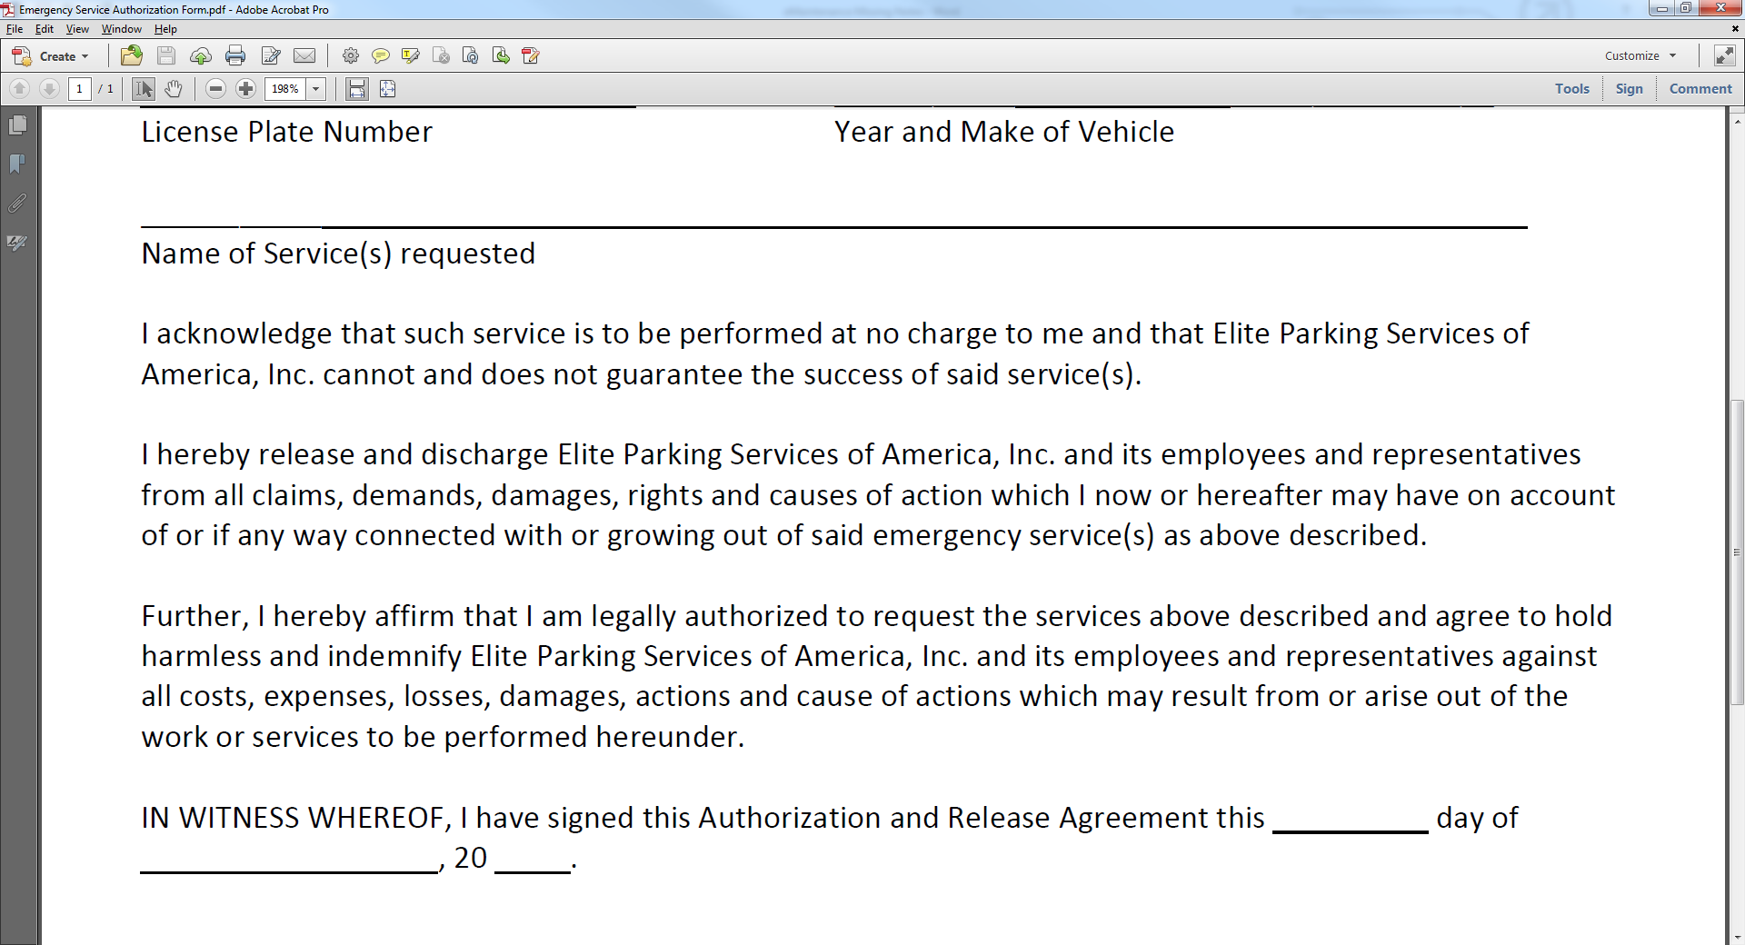

Disclaimer should populate on the screen of the mobile app for the customer to see and read. There should be a section that allows them to scroll to the bottom and click a button that states accept service and decline service. Decline service should state are you sure with yes or no. If they click on this response should populate that customer declined service. Should be documented on all employees involved DAR that they declined the service. Should still keep the customers information submitted into the system regardless. Once they click accept service a signature box should appear for them to sign inside of the box and click ok or cancel. If cancel should ask are you sure with yes or no selection choice, if yes is selected it should report to the necessary DAR. If signed and ok is clicked it should move to below. ***Signature should populate in the line on the form once signed by the customer.***

Once signed by the individual and ok is pressed it should ask them if they would like to take a survey on the service they’ve received, this should be in the form of a yes/no dialog box. If they click yes it should request their email address. They enter their email address and then we email them a 6 question survey that they are able to email back to us. This should work just like the American Express Dialog sent out.

Survey Questions Needs to ask

1. Did the attendant introduce themselves when initially meeting you?
   1. Yes or no selection
2. Did the attendant help you accomplish your goal for requesting the service?
   1. Yes or no selection.
      1. If no selected allow comment box on the bottom for them to actually make a statement, “Please Explain”
3. On a scale of 1 to 5, 5 being extremely fast and 1 extremely slow how would rate the time it took the attendant to get to you after you disconnected the call?
   1. If 1 is selected open up a dialog box that says “Please Explain”
4. On a Scale of 1 to 5, 5 being extremely helpful and 1 not helpful, how would you rate the attendants level of helpfulness during the service?
   1. If 1 is selected open up a dialog box that says “Please Explain”
5. On a scale of 1-5, 5 being extremely satisfied and 1 being extremely dissatisfied how would you rate the overall service and experience you received while utilizing our facility?
   1. Leave area for comments
6. Would you like to be contacted by a member of management to discuss the service you received?
   1. Yes or no selection

Results of survey should be emailed to the manager. Surveys should have an area where they are stored where we can pull them up at any point in the process to review. Surveys requesting a call back from the customers should be emailed to the General Manager and the administrator as well.

There should be an area in the system that stores the form as well as the information regarding the call in a grid. Grid should give the ability to download the disclaimer form and the survey. It should also outline the individual submitting the request, the individual accepting, service requested, times submitted, accepted, and completed. Action buttons should be located there as well.