

Metadata Services Toolkit
Installation Manual
Table of Contents

1. Install external software 3
1.1. Install Java SE Development kit (JDK) 3
1.2. Install Tomcat 6
1.3. Install MySQL server 8
2. Installing the Metadata Services Toolkit in Windows 9
2.1. Download the Metadata Services Toolkit 9
2.2. Setup database 10
2.3. Customize configuration files 12
2.3.1. MetadataServicesToolkit_config.xml 12
2.3.2. Log4j.config.txt 13
2.3.3. SolrConfig.xml 14
2.4. Service configuration folder 15
2.5. Deploy WAR file 16
2.6. Start Server 16
3. Installing the Metadata Services Toolkit in Unix 20
3.1. Download Metadata Services Toolkit 20
3.2. Setup database 21
3.3. Customize configuration files 21
3.3.1. MetadataServicesToolkit_config.xml 21
3.3.2. Log4j.config.txt 22
3.3.3. SolrConfig.xml 24
3.4. Service configuration folder 25
3.5. Deploy the WAR file 25
3.6. Start server 26
4. Browse and setup the Metadata Services Toolkit 26
4.1. Login 26
4.2. My account 27
4.3. Email setup 28
5. Uninstalling the MST and Installing a New Version from Scratch 29
6. Upgrading the Metadata Services Toolkit 29

Install external software

Install Java SE Development kit (JDK)
The Java SE Development kit 6 (JDK) can be downloaded from:
http://java.sun.com/javase/downloads/index.jsp
Under the heading “Java SE Development Kit (JDK)” -> JDK 6 update x (x = update number; currently it is JDK 6 update 14. Choose the latest version), click on the Download button. In the next screen, choose the “windows” platform, check the “I agree” box and click on the Continue button. In the next screen, click on the EXE file to download and run the .EXE file.
The release notes to guide the installation can be found at:
http://java.sun.com/javase/6/webnotes/install/
Choose from the manuals under the JDK column and select the appropriate platform used, e.g. Solaris/Linux/Windows. Also make sure to select the type of OS (either 32 bit or 64 bit). The manual for 64 bit OS is labeled specifically.
Steps to set JAVA_HOME environment variable
The JAVA_HOME environment variable holds the location of the root directory of a java install. You must set this environment variable if any one of the following is true
- Operating System is Unix
- Operating System is Windows but Tomcat software (described in the next section of this document) is not installed using the Windows Service Installer. (We recommend installing Tomcat using the Windows Service Installer, which is described in the next section of this document. If you plan to follow those instructions, you may skip this section )
The sole purpose of setting up this environment variable is to let Tomcat know about the Java installed on the server machine.
Unix:
Before setting up the environment variable, make sure you have the path to the correct version of java.
In Unix, all environment variables are stored in a file named “.profile”, which is usually stored in the root directory of the user. It is a hidden file so it would not be visible with a command to list files (e.g. ls -lrt). You would use the following command
ls -lart
Once you have located the file, use a familiar editor to create the environment variable. The following screen shots show it using the vi editor.

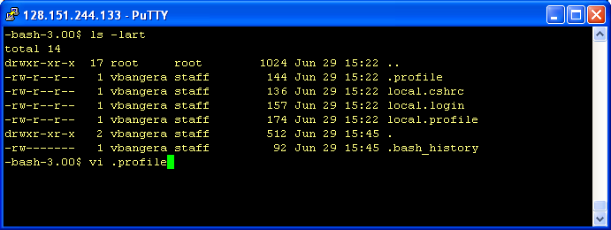
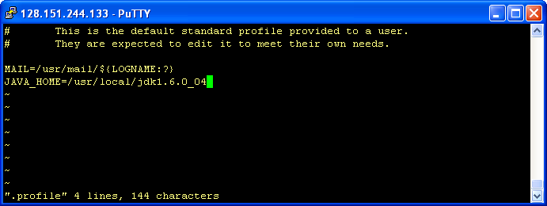
Save the changes to the file and start a new terminal so that the changes take effect. To check if the environment variable has been set up, key in the following command to verify
echo $JAVA_HOME
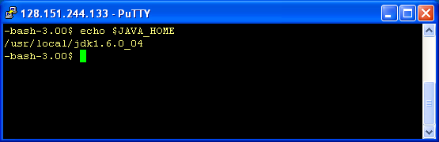

Windows:
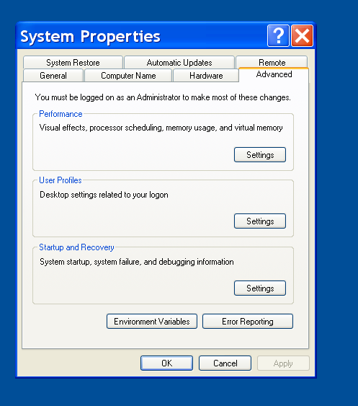
Go to Start Menu -> right click on My Computer and select properties.
Select the Advanced tab and click on the Environment variables button.

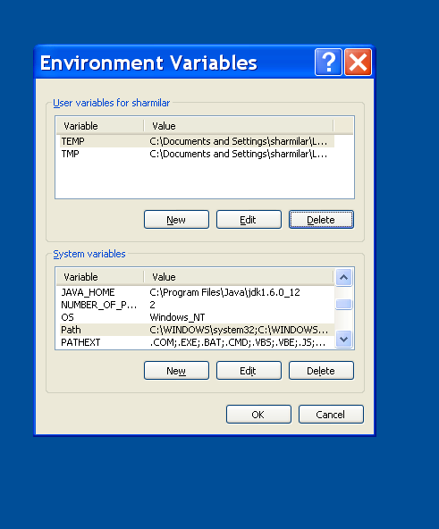
Add a new System variable
Variable name : JAVA_HOME
Variable value: <Path where JDK is installed>
For example: C:\Program Files\Java\jdk1.6.0_12
Click Ok.
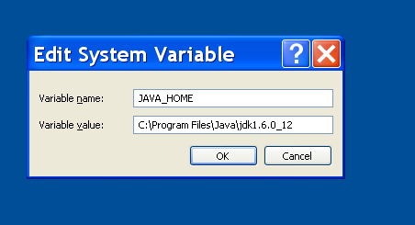

Install Tomcat
Tomcat 6.0.x can be downloaded from http://tomcat.apache.org/download-60.cgi
The three modes of distribution of Tomcat are the zip, tar.gz, windows installer files. The first two (zip and tar.gz ) files are self-extracting files. Installing tomcat using one of these two files is as easy as extracting the files. The third option is applicable only for the Windows platform server.

Steps to install in Unix
Download the tar.gz file or the zip file onto a directory on the server. If you are using the .zip file, execute the following command to extract the contents.
unzip <zipFilename>
OR
If you are using the .tar.gz file, use the following commands in sequence
gunzip <.tar.gzFilename>
This command will create a file with just the .tar file extension (would strip off the .gz). Using the following command will complete the extract process:
tar –xvf <.gzFilename>
The above two methods will extract the tomcat files on the server. In order to start the server, follow the steps below:

- Navigate to the bin dir under the root dir extracted from the above process. View the contents of the folder by executing the following command
ls –lrt
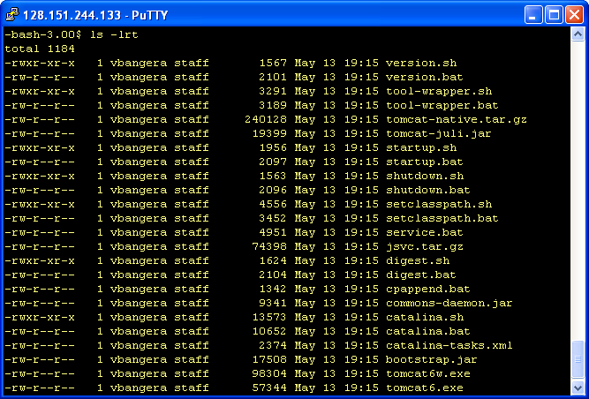
The above screenshot shows the list of files in the bin directory.
- Run the following command
./catalina.sh run
If you want to run the command in the background (for e.g if you want to let tomcat run on the server even after you close the terminal window) use the following command

./catalina.sh run &
In order to increase the amount of memory used by tomcat, use the following step to set up the memory used by tomcat.

- Navigate to bin dir under the tomcat root directory.
- Open the file catalina.sh in any editor of choice
- Locate the section with the heading “# Java Heap settings”
- Use the following text under that section
export JAVA_OPTS="-Xms128m –Xmx1356m"
The screenshot below shows the changes.
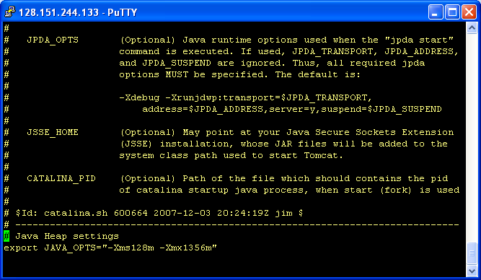

Steps to install in Windows
A simple way to install Tomcat is by downloading and running the “Windows service Installer” under Binary distributions, core.
Note: JDK (Java Development Kit) should be installed before installing Tomcat. In a step ‘Please select path of a J2SE 5.0 JRE installed on your system’, select the path where JDK is installed.
After installing Tomcat, increase its heap size to 1356 MB. This can be done using the Configure Tomcat application. In the start menu select All Programs -> Apache Tomcat -> Configure Tomcat.
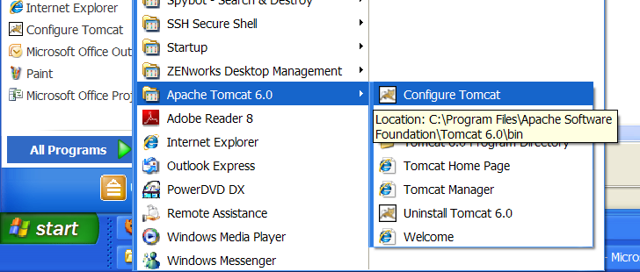
When the application opens navigate to the Java tab and enter 1356 in the Initial memory pool and Maximum memory pool sections.
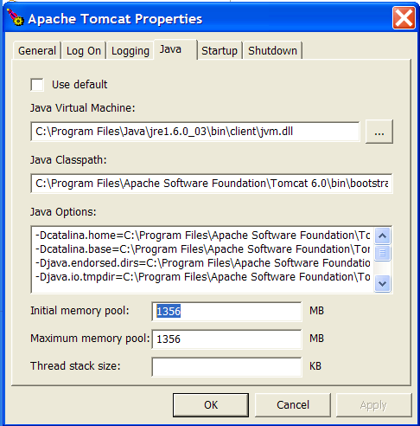
Note: Tomcat cannot be running when the Configure Tomcat application is opened. Section 4.1 of this document explains how to stop and start Tomcat.

Install MySQL server
Download and install MySQL Server 5.x from:
http://dev.mysql.com/downloads/
The documentation for installation can be found at
http://dev.mysql.com/doc/
Make sure you download the ‘MySQL Community Server’.
Installing MySQL on Unix
This section uses the tar packages for installing MySQL on Solaris. Download the tar.gz file or the zip file onto a directory on the server. Use the following commands in sequence:

gunzip <.tar.gzFilename>
This command would create a file with just the .tar file extension (would strip off the .gz). Use the following command to complete the extract process:

tar –xvf <.gzFilename>

The above two methods would extract the tomcat files on the server. In order to install the server, follow the steps in the following link
http://dev.mysql.com/doc/refman/5.0/en/installing-binary.html

Installing MySQL on Windows
The steps below are intended to assist users who are new to installing MySQL server. Advanced users can install according to their needs.
Setup type: Typical
Configure MySQL server now: select the box and click ‘Finish’ button
Configuration type: Detailed configuration
Server type: Choose ‘Developer machine’ if you are just trying out the MST. Choose ‘Server machine’ if you want to run a production MST and the machine you are installing MySQL server is a web/application server. Choose ‘Dedicated MySQL server machine’ if the machine you are installing MySQL server on is dedicated only for MySQL and has no other servers running on it.
Database usage: Multifunctional database
Approximate number of concurrent connections to server: Decision support
Networking options
Enable TCP/IP networking: select the box.
Port number: 3306. (By default it is 3306. Choose another port number if 3306 is in use)
Enable restrict mode: select box
Default Character Set: Select ‘Manual selected default character set/collation’ option box and set character set to ‘UTF8’.
Install as windows service: select the box
Include bin directory in windows PATH: select the box
Security options: The installation requires you to create a database user name (by default it is ‘root’, but can be changed) and password. Please make a note of the user name and password which is later needed to connect to the database!

Installing the Metadata Services Toolkit in Windows

Download the Metadata Services Toolkit
Download the MetadataServicesToolkit.zip from http://code.google.com/p/xcmetadataservicestoolkit/downloads/list
Step 1: Unzip and extract the contents into the <tomcat_working_dir>.
What is the <tomcat_working_dir>?
The location of this directory differs depending upon the way Tomcat is installed. On Windows, if you use the Windows installer to install Tomcat, by default the root directory of the installation (e.g. C:\Program Files\Apache Software Foundation\Tomcat 6.0) is your <tomcat_working_dir>. Otherwise, if a zip file is used to install Tomcat then <tomcat_folder_path>\bin is your <tomcat_working_dir>. To change/view the Tomcat working directory (for the Windows installer) go to Windows Start -> Apache tomcat 6.0 -> Configure tomcat. Choose the ‘startup’ tab and change the ‘Working path’.
In this document we are assuming that the MST is installed on Windows and a Windows installer is used to install Tomcat. In this case, the <tomcat_working_dir> is C:\Program Files\Apache Software Foundation\Tomcat 6.0, which is the location suggested by the installer, unless a different path is chosen.
Following is a screen shot of the tomcat_working_dir with the MST release zip file extracted into it.
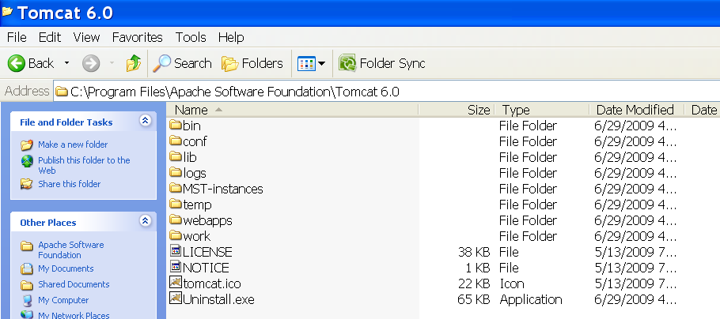

This will create a folder called ‘MST-instances’ inside the tomcat_working_dir. ‘MST-instances’ will contain an instance folder for each MST installation. The instance folder name should match the WAR file name. The path for the instance folder will be <tomcat_working_dir>\MST-instances\<war_file_name>.

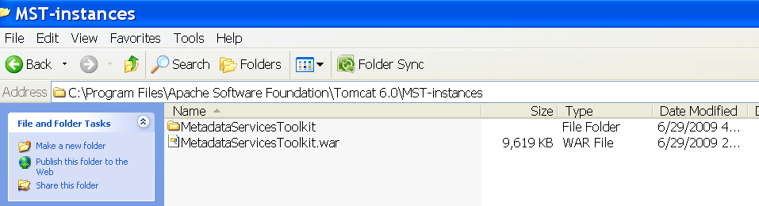
By default, the war file is called MetadataServicesToolkit.war, so the instance folder name is ‘MetatdataServicesToolkit’. In this document the default path of the default instance would be: <tomcat_working_dir>\MST-instances\MetadataServicesToolkit. This is where all configuration files and folders for that instance of the MetadataServicesToolkit (MST) are located.
Changing the Default WAR File name and Instance Folder Name to Enable Multiple Installations of the MST
Extract the zip file to <tomcat_working_dir> and change the WAR file name to say MetadataServicesToolkit_ production.war. Next, change the instance folder name to <tomcat_working_dir>\MST-instances\MetadataServicesToolkit_production to match the WAR file name.
There will be a need to change the default WAR file name and instance folder (<tomcat_working_dir>\MST-instances\MetadataServicesToolkit) name in case of multiple installation where <tomcat_working_dir>\ MST-instances\MetadataServicesToolkit already exists and contains configuration details of the MetadataServicesToolkit.

Setup database
Open the MySQL command line client by going to Start -> Program Files -> MySQL -> MySQL Server x.x ->MySQL command line client.

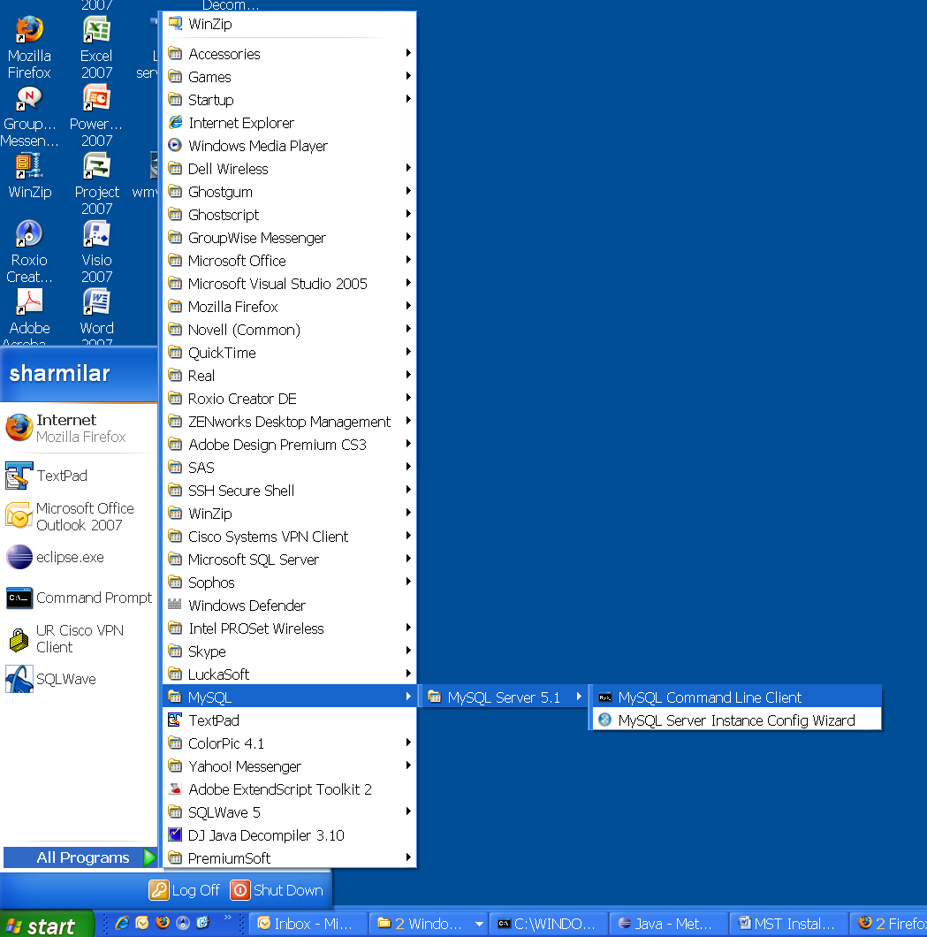
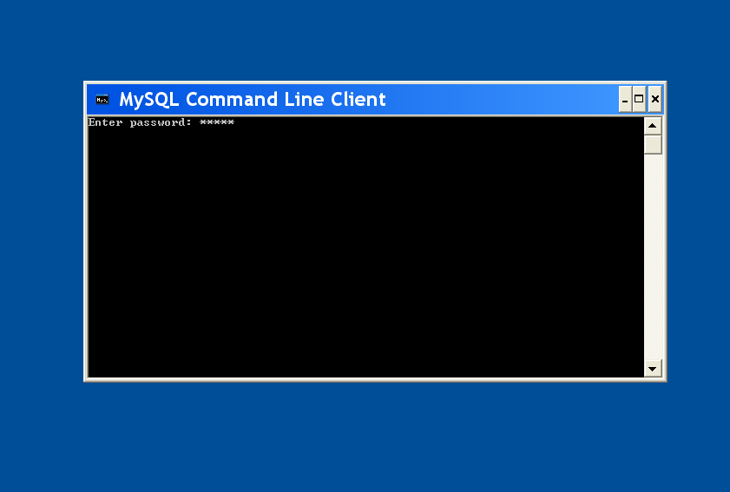
Enter the database password (i.e. the one given while installing the MySQL Server in Section 1.3 of this document)

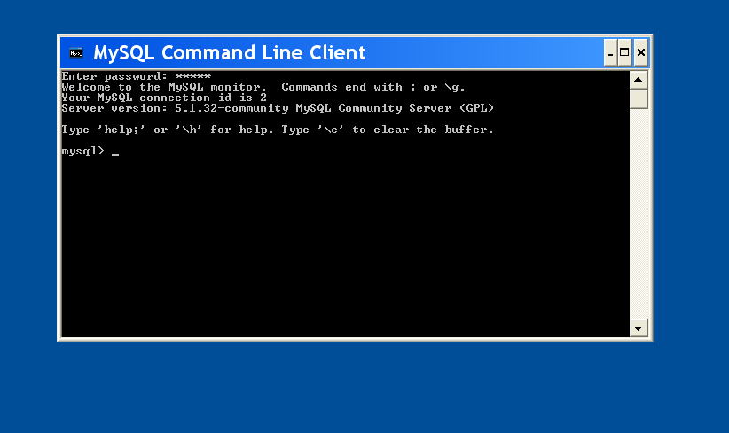

You will now be given a MySQL prompt.
The next step is to run the script to create the database ‘MetadataServicesToolkit’. The command to run the script is:
source <path_to_sql_script>
where <path_to_sql_script> is the path where the SQL script is located.

The SQL script is located inside the <tomcat_working_dir>\MST-instances\MetadataServicesToolkit\sql\create_database_script.sql

Note: In case of multiple installations, open the create_database_script.sql and change the database name from default ‘MetadataServicesToolkit’ to a different name and then run the script.

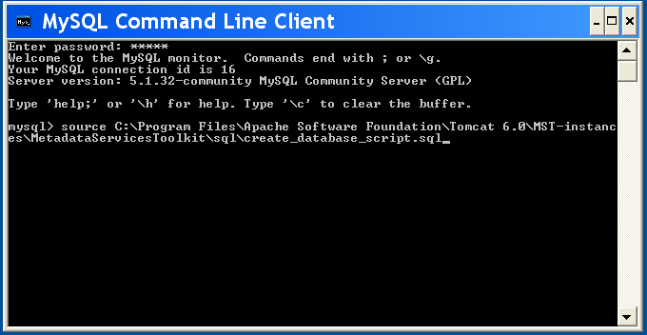

This will create the database and the screen will look like the screenshot below.

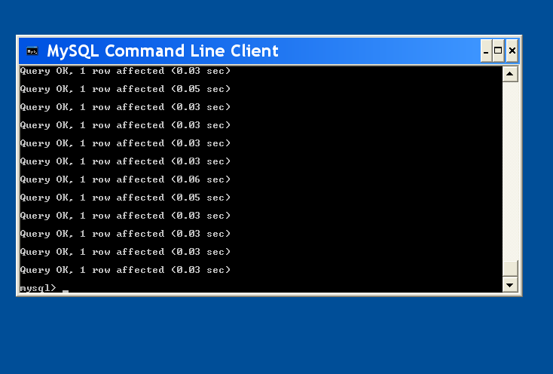

Customize configuration files

MetadataServicesToolkit_config.xml
Go to <tomcat_working_dir>\MST-instances\MetadataServicesToolkit (C:\Program Files\Apache Software Foundation\Tomcat 6.0\MST-instances\MetadataServicesToolkit) and open MetadataServicesToolkit_config.xml in either Notepad or Wordpad.

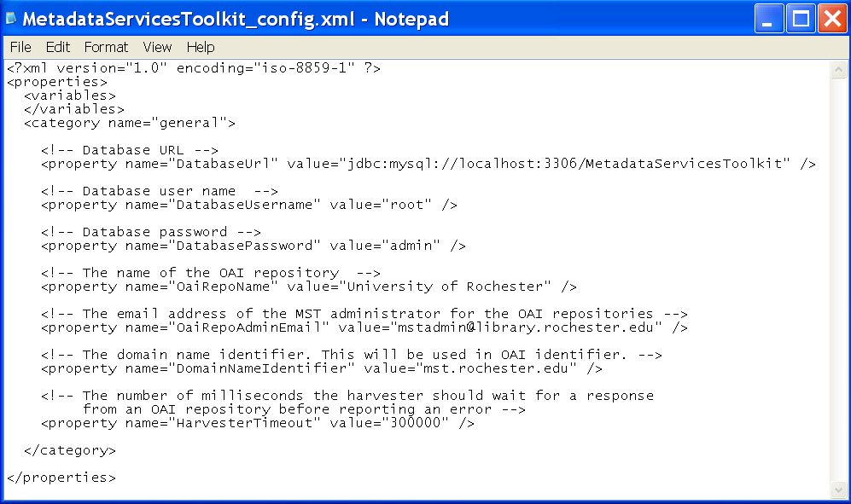
Property name | Description
DatabaseUrl | URL to connect to database. Make sure the database host  and port number and database name are correct
DatabaseUsername | Database user name
DatabasePassword | Database password
OaiRepoName | The name of the OAI repository
OaiRepoAdminEmail | The email address of the MST administrator for the OAI repositories
DomainNameIdentifier | The domain name of the server. Domain name is used as prefix in constructing OAI identifier.
HarvesterTimeout | The number of milliseconds the harvester should wait for a response from an OAI repository before reporting an error

Make the necessary changes to represent your institution’s information, then save and close.

Log4j.config.txt
Note: Skip this section if you are using the default war file name and default instance name ‘MetadataServicesToolkit’. In this case the file will not need editing.
Go to <tomcat_working_dir>\MST-instances\MetadataServicesToolkit (C:\Program Files\Apache Software Foundation\Tomcat 6.0\MST-instances\MetadataServicesToolkit) and open log4j.config.txt in Notepad or Wordpad.
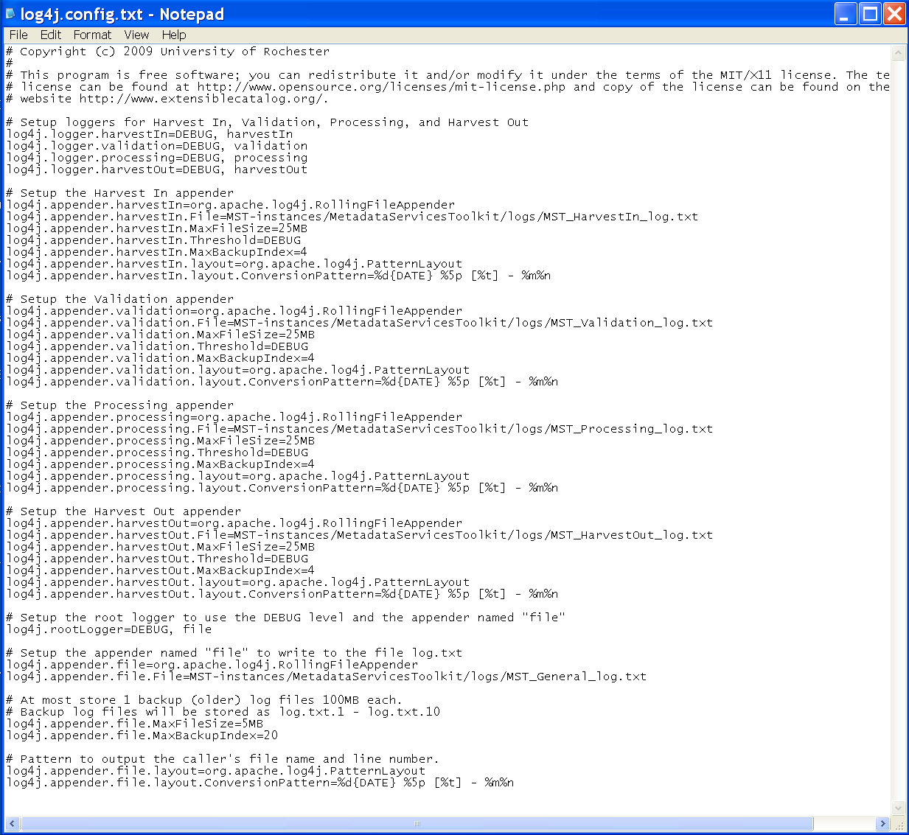
Change the path where log files should be created.
log4j.appender.harvestIn.File=MST-instances/<war_file_name>/logs/MST_HarvestIn_log.txt
log4j.appender.validation.File= MST-instances/<war_file_name>/logs/MST_Validation_log.txt
log4j.appender.processing.File= MST-instances/<war_file_name>/logs/MST_Processing_log.txt
log4j.appender.harvestOut.File= MST-instances/<war_file_name>/logs/MST_HarvestOut_log.txt
log4j.appender.file.File= MST-instances/<war_file_name>/logs/MST_General_log.txt

By default, logs will created under <tomcat_working_dir>\MST-instances\MetadataServicesToolkit\logs (C:\Program Files\Apache Software Foundation\Tomcat 6.0\MST-instances\MetadataServicesToolkit).
Optionally, the logging level can also be changed here.

SolrConfig.xml
Note: Skip this section if you are using the default war file name and default instance name ‘MetadataServicesToolkit’. In this case the file will not need editing.
Go to <tomcat_working_dir>\MST-instances\MetadataServicesToolkit\solr\conf (C:\Program Files\Apache Software Foundation\Tomcat 6.0\MST-instances\MetadataServicesToolkit\solr\conf) and open SolrConfig.xml in Notepad or Wordpad.
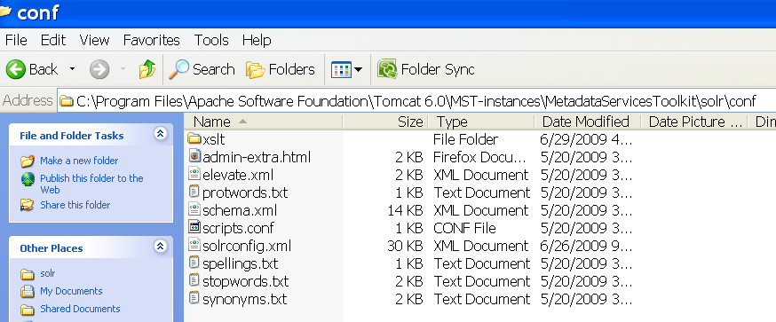

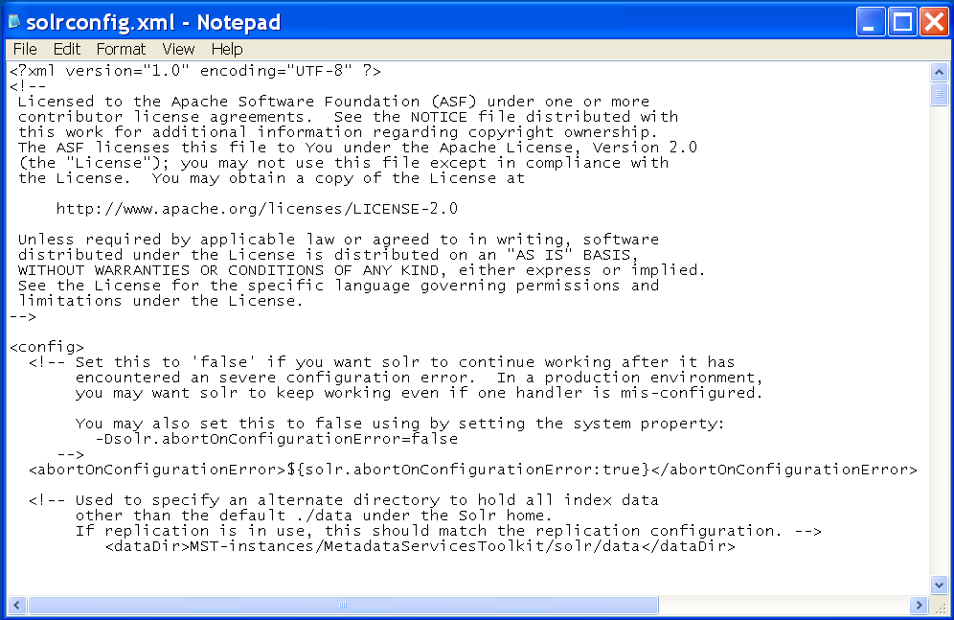
Change the path where data (index) has to be created.
<dataDir>MST-instances/<war_file_name>/solr/data</dataDir>

By default the data is created under <tomcat_working_dir>\MST-instances\MetadataServicesToolkit\solr\data.

Service configuration folder
Download the zip file for service from http://code.google.com/p/xcmetadataservicestoolkit/downloads/list
The zip file will contain abservices folder with following structure:
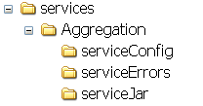
Unzip and extract into <tomcat_working_dir>\MST-instances\MetadataServicesToolkit\
Repeat the above steps to install more services.

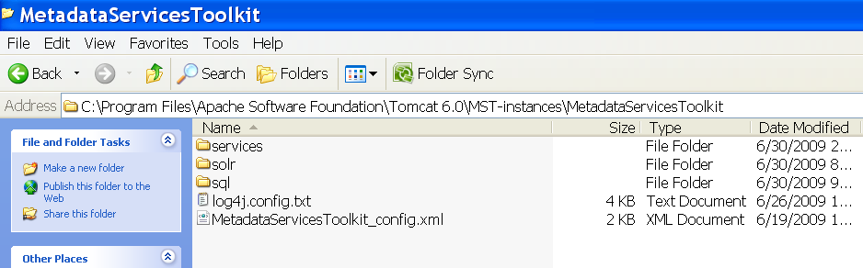

Deploy WAR file

MoveMetadataServicesToolkit.war from <tomcat_working_dir>\MST-instances to <tomcat__install_folder>\webapps (C:\Program Files\Apache Software Foundation\Tomcat 6.0\webapps)
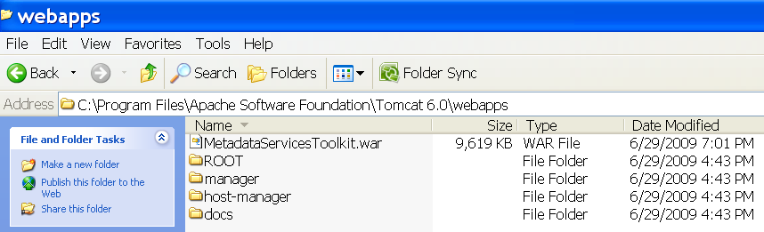

Start Server
Go to Start -> Control panel
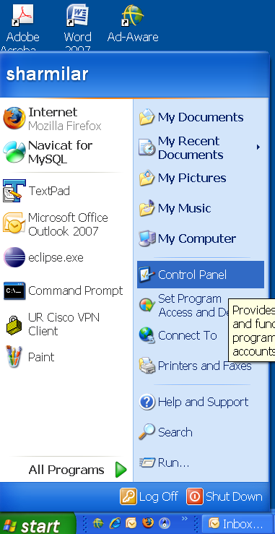

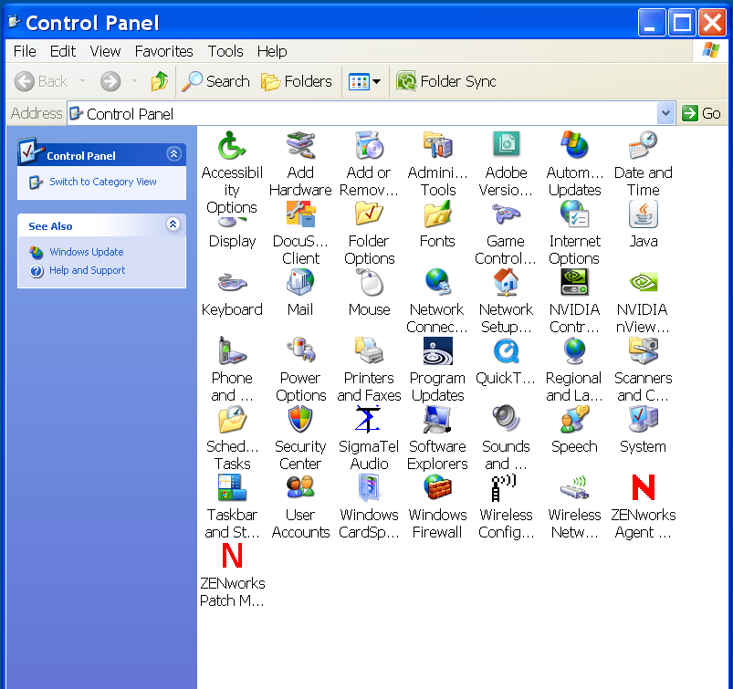

Open ‘Administrative tools’.

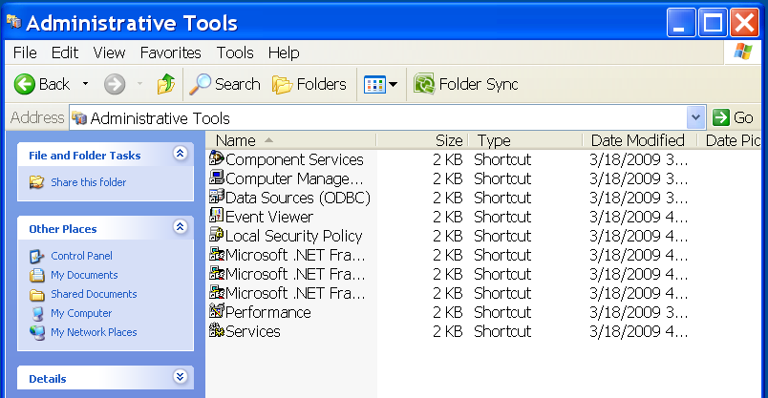

Open ‘Services’
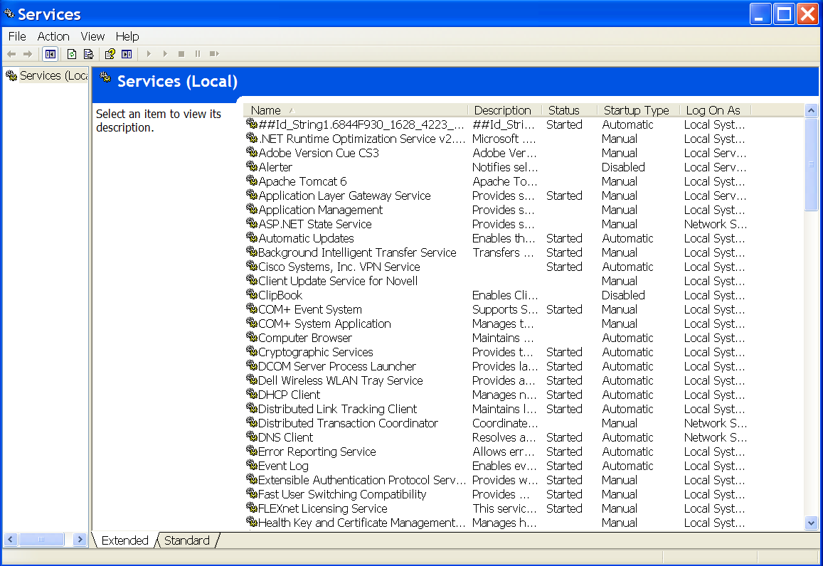

Locate ‘Apache Tomcat 6’. If status is ‘Started’ then right click and select ‘Stop’.
Note: The Tomcat server needs to be stopped and started to load the MST application.
Now start the server by right clicking and selecting ‘Start’. The status will change to ‘Started’ if Tomcat server is started.
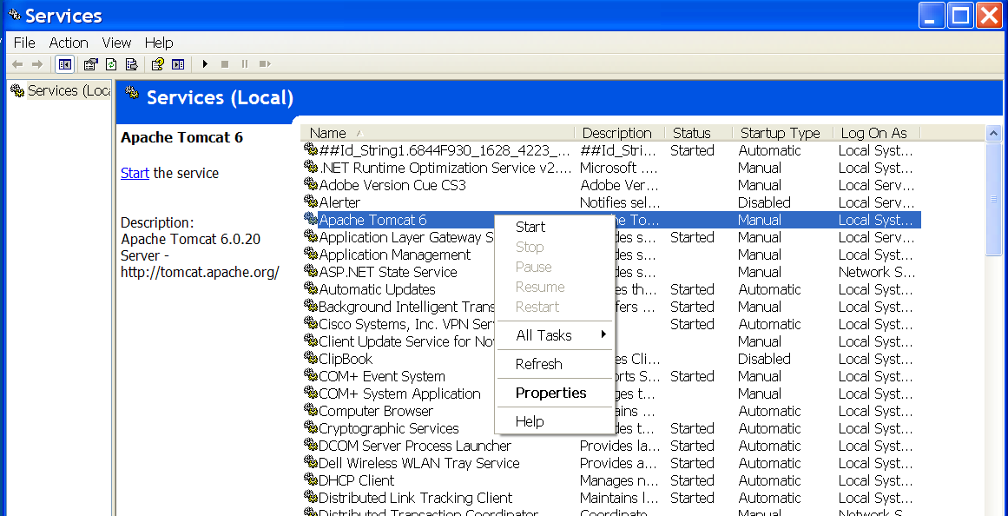

The server can be stopped by right click ->stop.

Installing the Metadata Services Toolkit in Unix

Download Metadata Services Toolkit
Download the MetadataServicesToolkit.zip from http://code.google.com/p/xcmetadataservicestoolkit/downloads/list
Step 1: Unzip and extract the contents into <tomcat_working_dir>.
What is the <tomcat_working_dir>?
The location of this directory differs depending upon the way Tomcat is installed. If a zip file is used to install Tomcat then <tomcat_folder_path>\bin is your <tomcat_working_dir>.
This document assumes that MST is installed on Unix and a zip file is used to install Tomcat. In this case the <tomcat_working_dir> is /usr/local/tomcat /bin.
Following is a screen shot of the tomcat_working_dir with the MST release zip file extracted into it.
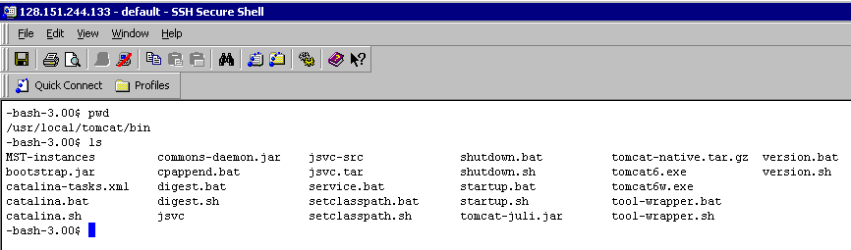

This will create a folder called ‘MST-instances’ inside the tomcat_working_dir. ‘MST-instances’ will contain an instance folder for each MST installation. The instance folder name should match the WAR file name. The path for instance folder will be <tomcat_working_dir>\MST-instances\<war_file_name>.

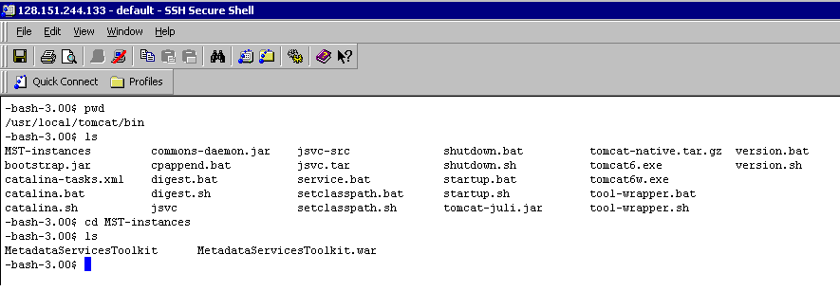
By default, the war file is called MetadataServicesToolkit.war, so the instance folder name is ‘MetatdataServicesToolkit’. In this document the default path of the default instance would be: <tomcat_working_dir>\MST-instances\MetadataServicesToolkit. This is where all configuration files and folders for that instance of MetadataServicesToolkit (MST) are located.

Changing the Default WAR File name and Instance Folder Name to Enable Multiple Installations of the MST
Extract the zip file to <tomcat_working_dir> and change the WAR file name to say MetadataServicesToolkit_ production.war. Next, change the instance folder name to <tomcat_working_dir>\MST-instances\MetadataServicesToolkit_production to match the WAR file name.
There will be a need to change the default WAR file name and instance folder(<tomcat_working_dir>\MST-instances\MetadataServicesToolkit) name in case of multiple installation where <tomcat_working_dir>\ MST-instances\MetadataServicesToolkit already exists and has configuration details of the MetadataServicesToolkit.

Setup database

Go to folder where MySQL is installed. In this case it is /usr/local/mysql. To login into MySQL use following command
mysql --user=<user_name> --password=<password>
Use the user name and password given while installing MySQL server.
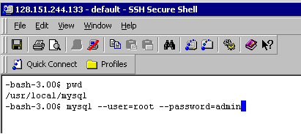
You have now successfully logged into MySql server.
Run the script to create the database ‘MetadataServicesToolkit’. The command to run the script is:
source <path_to_sql_script>
<path_to_sql_script> is the path where the SQL script is located.
The SQL script is inside the <tomcat_working_dir>\MST-instances\MetadataServicesToolkit\sql\create_database_script.sql

Note: In case of multiple installations, open the create_database_script.sql and change the database name from default ‘MetadataServicestoolkit’ to a different name and then run script.

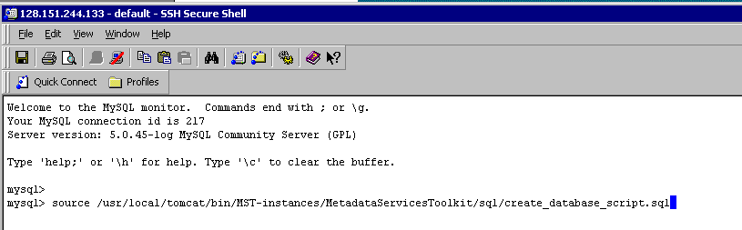

Customize configuration files

MetadataServicesToolkit_config.xml
Go to the <tomcat_working_dir>/MST-instances/MetadataServicesToolkit (usr/local/tomcat/bin/MST-instances/MetadataServicesToolkit) and open MetadataServicesToolkit_config.xml using vi editor or any other editor.

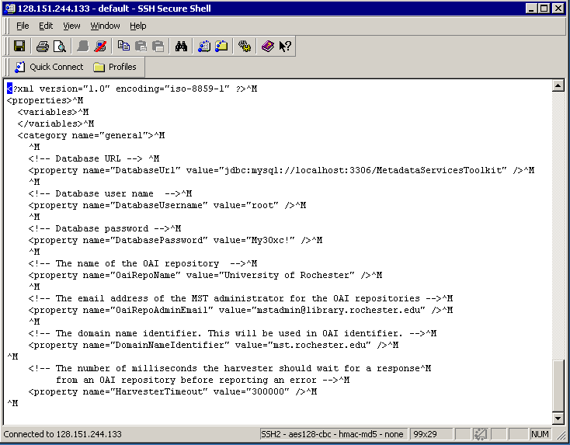
Property name | Description
DatabaseUrl | URL to connect to database. Make sure the database host  and port number and database name are correct
DatabaseUsername | Database user name
DatabasePassword | Database password
OaiRepoName | The name of the OAI repository
OaiRepoAdminEmail | The email address of the MST administrator for the OAI repositories
DomainNameIdentifier | The domain name of the server. Domain name is used as prefix in constructing OAI identifier.
HarvesterTimeout | The number of milliseconds the harvester should wait for a response from an OAI repository before reporting an error

Make necessary changes to represent your institution’s information, then save and close.

Log4j.config.txt
Note: Skip this section if you are using the default war file name and default instance name ‘MetadataServicesToolkit’. In this case the file will not need editing.

Go to <tomcat_working_dir>/MST-instances/MetadataServicesToolkit (usr/local/tomcat/bin/MST-instances/MetadataServicesToolkit) and open log4j.config.txt using vi or any other editor.
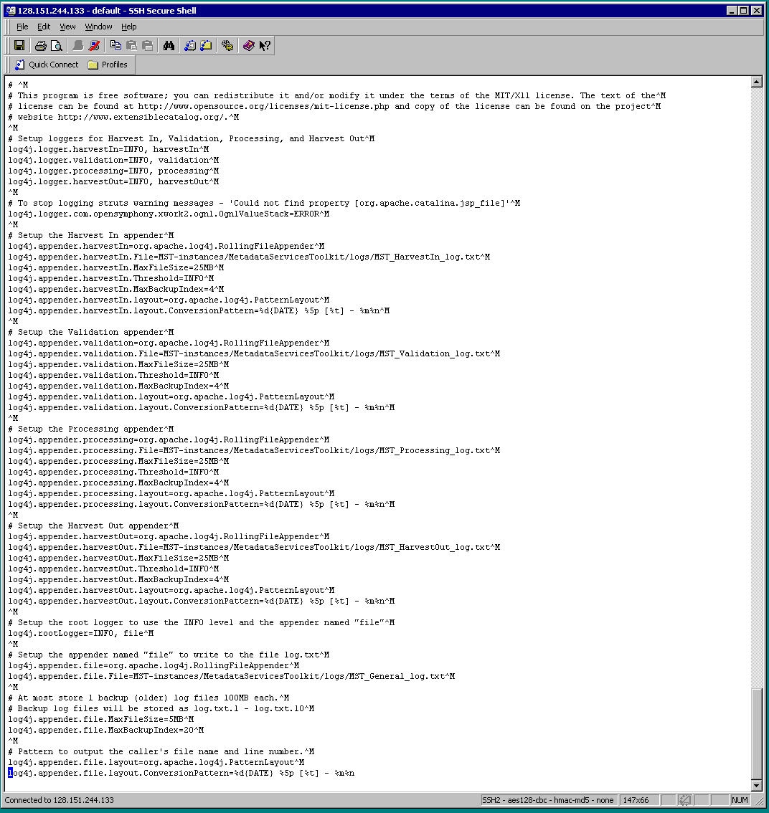
Change the path where log files should be created.
Note: If using the default war file name then there is no need to edit the file.
log4j.appender.harvestIn.File=MST-instances/<war_file_name>/logs/MST_HarvestIn_log.txt
log4j.appender.validation.File= MST-instances/<war_file_name>/logs/MST_Validation_log.txt
log4j.appender.processing.File= MST-instances/<war_file_name>/logs/MST_Processing_log.txt
log4j.appender.harvestOut.File= MST-instances/<war_file_name>/logs/MST_HarvestOut_log.txt
log4j.appender.file.File= MST-instances/<war_file_name>/logs/MST_General_log.txt

By default, logs will created under <tomcat_working_dir>/MST-instances/MetadataServicesToolkit/logs (usr/local/tomcat/bin/MST-instances/MetadataServicesToolkit).
Optionally, the logging level can be changed here.

SolrConfig.xml
Note: Skip this section if you are using the default war file name and default instance name ‘MetadataServicesToolkit’. In this case the file will not need editing.
Go to <tomcat_working_dir>/MST-instances/MetadataServicesToolkit/solr/conf (usr/local/tomcat/bin/MST-instances/MetadataServicesToolkit /solr/conf) and open SolrConfig.xml in vi or any other editor.
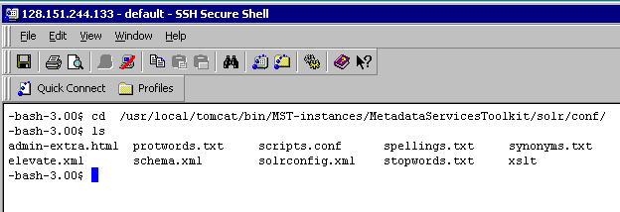

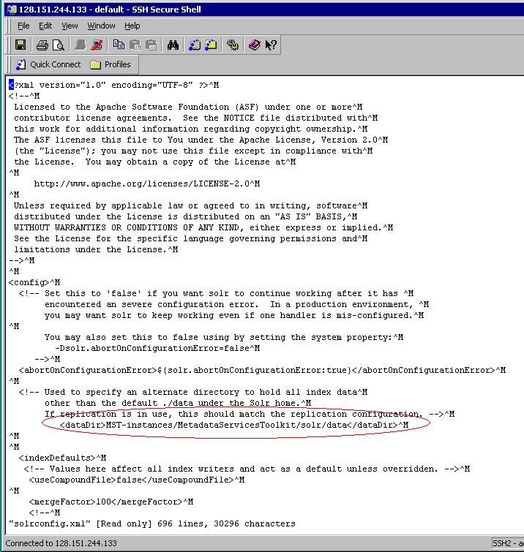
Change the path where the data (index) has to be created.
<dataDir>MST-instances/<war_file_name>/solr/data</dataDir>

Note: If using default war file name then there is no need to edit the file.
By default, the data is created under
<tomcat_working_dir>/MST-instances/MetadataServicesToolkit/solr/data.

Service configuration folder
Download the zip file for the XC metadata service from: http://code.google.com/p/xcmetadataservicestoolkit/downloads/list
The zip will contain services folder with following structure:
Unzip and extract into <tomcat_working_dir>/MST-instances/MetadataServicesToolkit/
Repeat above steps to install additional services.

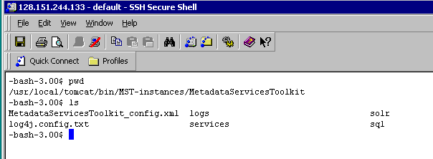

Deploy the WAR file

Move MetadataServicesToolkit.war from
<tomcat_working_dir>/MST-instances(usr/local/tomcat/bin/MST-instances/) to <tomcat_install_folder>/webapps (usr/local/tomcat/webapps)

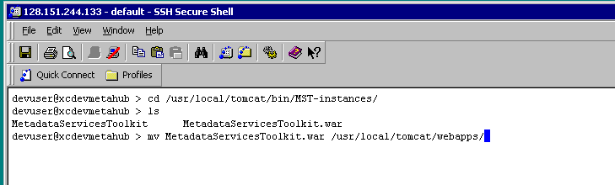

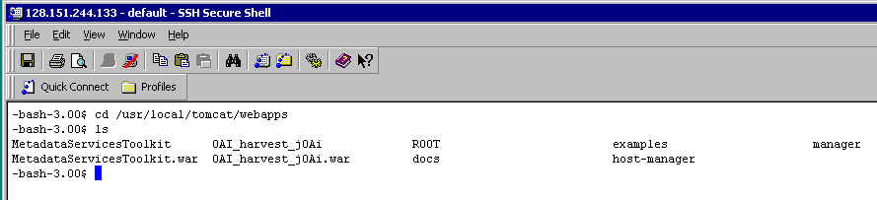

Start server

Go to <tomcat_install_folder>/bin. In this case it is usr/local/tomcat/bin. Run the server using the command:
startup.bat
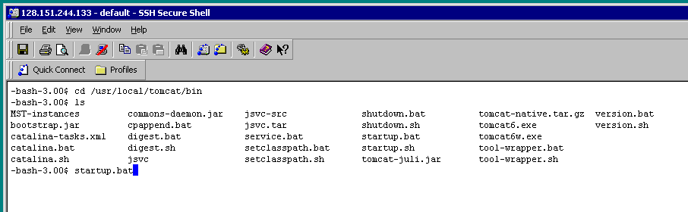

Stop Server
Note: Stop server only when you want to bring down Metadata Services Toolkit.
The server can be stopped using the command:
shutdown.bat

Browse and setup the Metadata Services Toolkit

Login
Open browser and enter URL
http://<host_name>:<port_number>/<war_file_name>/index.jsp
By default, the URL is
http://localhost:8080/MetadataServicesToolkit/index.jsp
The login screen will be displayed.
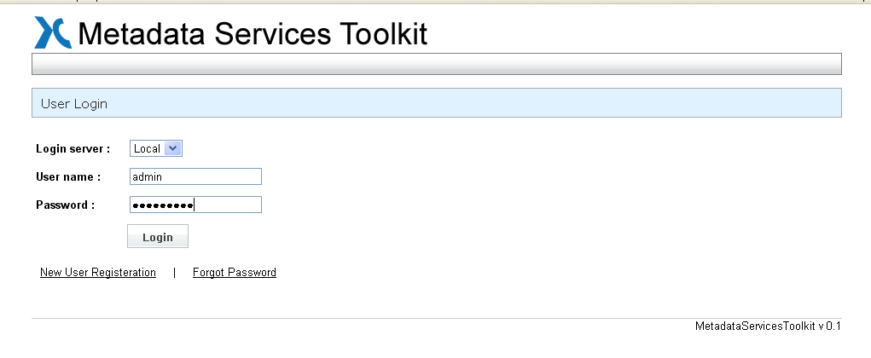
Enter user name : admin
Enter Password : mst4world
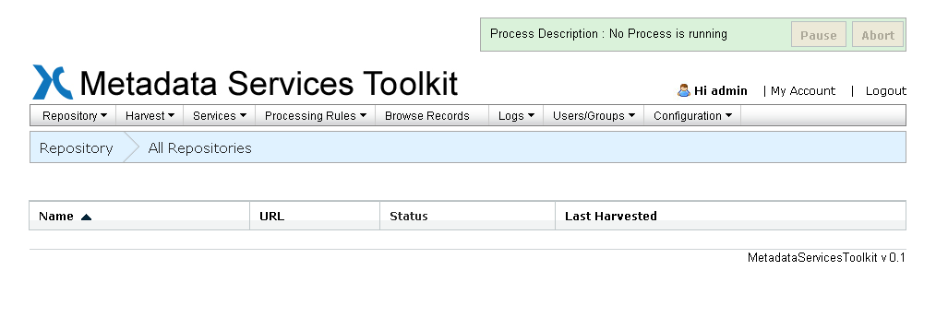
You are now logged into the Metadata Services Toolkit application.

My account
Click on ‘My account’ in the upper right hand corner.

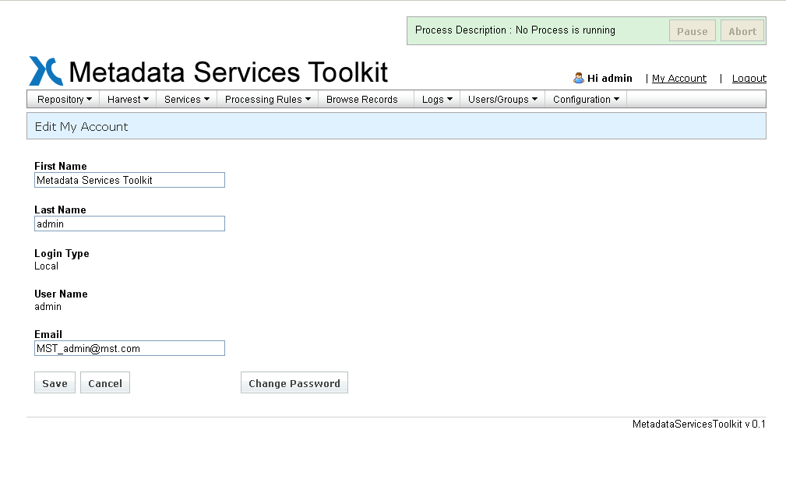
Enter a valid email address for ‘admin’. (The default email address ‘MST_admin@mst.com’ is a dummy address). A valid admin email is required in order to send emails when a new user registers, to reset the admin password if it is forgotten, or when an error occurs in MST, etc. For security reasons, change the password by clicking on the ‘Change Password’ button.

Email setup
Click on ‘Configuration’ menu and select ‘Email configuration’. Enter the information to setup email for the application.
Note: If email information is not set up, then users cannot register with the system and the email functionality will not be functioning.
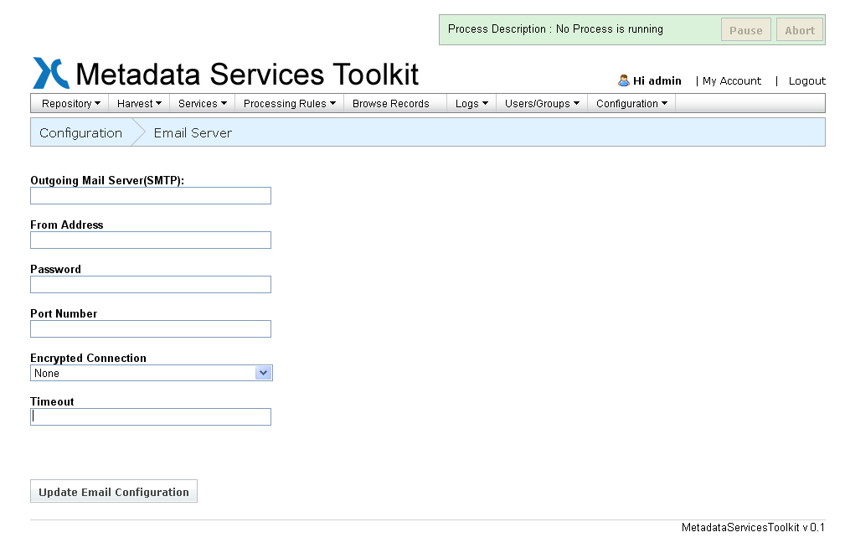
The MetadataServicesToolkit is successfully installed!

Uninstalling the MST and Installing a New Version from Scratch
In some cases, it may be necessary to totally uninstall the MST software and all of the metadata contained within it. This may be needed at times when many changes are being made to the software code. Follow the following instructions:
- Delete the ‘MST-instances’ folder under tomcat or tomcat/bin, depending upon how Tomcat was installed. (Tomcat is usually in C:\Program Files\Apache Software Foundation\Tomcat 6.0).
- Delete the MetadataServicesToolkit.war and MetadataServicesToolkit folder under tomcat/webapps.
- Follow the instructions in Section 2(or section 3 for UNIX) of this manual to set up a new MST for windows.

Upgrading the Metadata Services Toolkit
“Upgrade”, in this case, means just upgrading the MST software while maintaining the data within the Toolkit. When upgrading, there will already be a MetadataServicesToolkit application with a configuration folder under <tomcat_working_dir>\MST-instances\MetadataServicesToolkit. Since the data will be maintained, make sure the ‘logs’ and ‘data’ folder under <tomcat_working_dir>\ MST-instances\MetadataServicesToolkit is not deleted and the data in the database is not deleted, as described below:
    - Stop the Tomcat server.(Refer to Stop server )
    - Download the new MetadataServicesToolkit.zip from http://code.google.com/p/xcmetadataservicestoolkit/downloads/list
Unzip and extract the contents into <tomcat_working_directory>
Make sure you do not replace or delete the ‘logs’ and ‘data’ folder that already exist. If the ‘data’ folder is deleted then you will lose all of the harvested data.
    - Update database:
Run the update_database_script.sql instead of create_database_script.sql. (Note: running create_database_script.sql will delete all of the data)
Follow instructions in Setup database
    - Customize configuration files (refer to Customize Configuration files)
    - Go to <tomcat_install_folder>\webapps and delete the MetadataServicesToolkit.war and MetadataServicesToolkit folder. Deploy the new WAR file(refer to Deplpy WAR file)
    - Run MetadataServicesToolkit(refer Start Server)

