2m temperature from C-CTM had better timing than 10m temperature

I moved O-CTM one hour so it would match C-CTM 2m temp better (but the agreement is not perfect)

BUT O-CTM 10m temp agrees with obs better if I reverse the hour shift

AND O-CTM 2m and 10m temp peak at the same time:

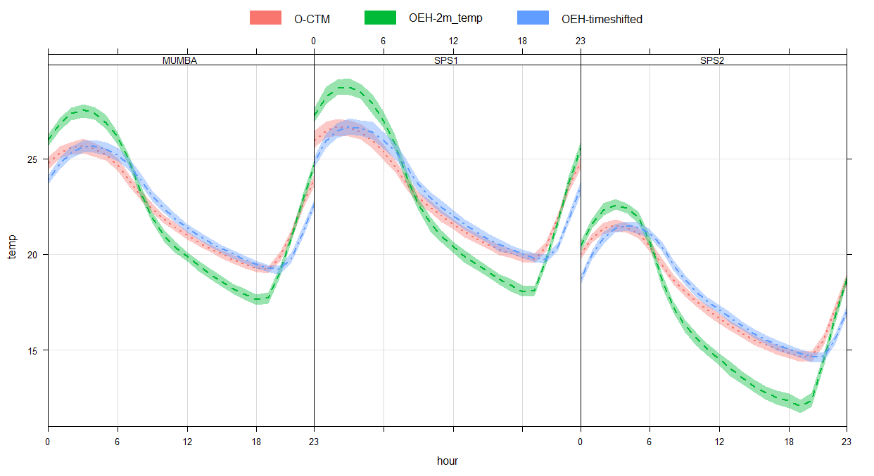

C-CTM 10m temp and 2m temp don’t align in time!!

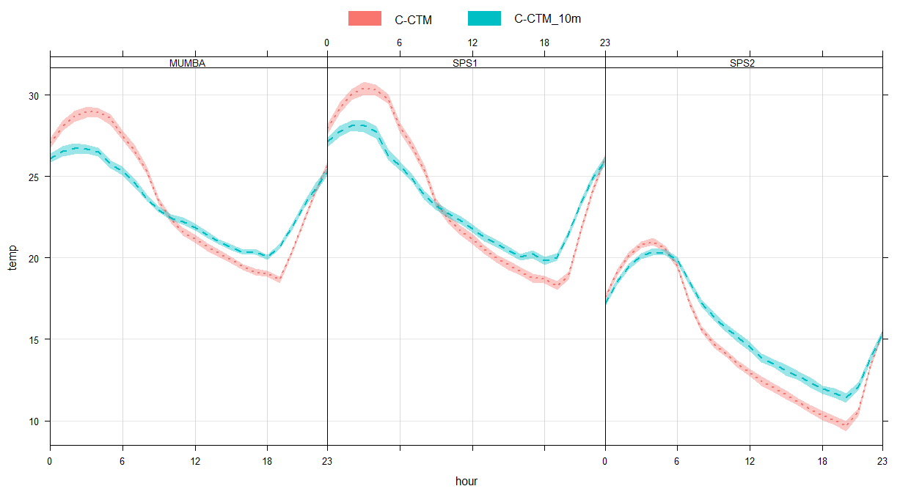

Since 2m look better in terms of timing against obs, align 10m with 2m temp (+1 hour for summer campaigns, -1 hour for SPS2 (extraction code is different for SPS2, so a different time step is not impossible)

The question then is, what to do with the AQ output…

This is ozone and 2m temp – assuming 2m has right timing, then +1 to all campaigns for ozone would look better?

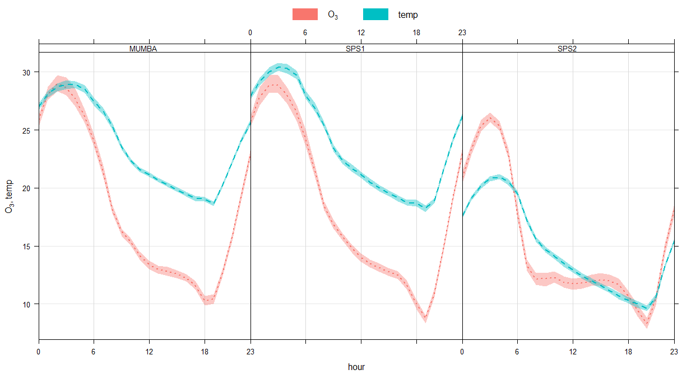

This is ozone vs 10m temperature:

