**COP4710 – Theory and Structure of Databases**

**Summer 2016**

**Homework 2**

Due Sunday Night, May 22, 2016

►Eric Adams◄

Give *very* short answers.

1. Create an ER model for a Hotel Reservation System for a hotel chain. Include some attributes for each entity. (Hint: There are four entities).

• Each ***Hotel*** in a different *hotel number* and *address*.

• A ***Room*** in each hotel has its own *room number* and *guest capacity*.

• A room reservation is called a ***Booking***, and each booking starts on a certain date. The *check-in-date* and *duration* are recorded.

• Each booking is made by a ***Guest***. Each guest has a guest *number* and a *contact phone*.

Hint: The Association data pattern (which we’ll learn about soon) comes in handy here. It’s an expansion of the M:M relationship which we’ll learn about soon.

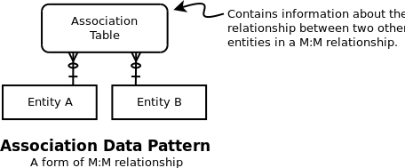

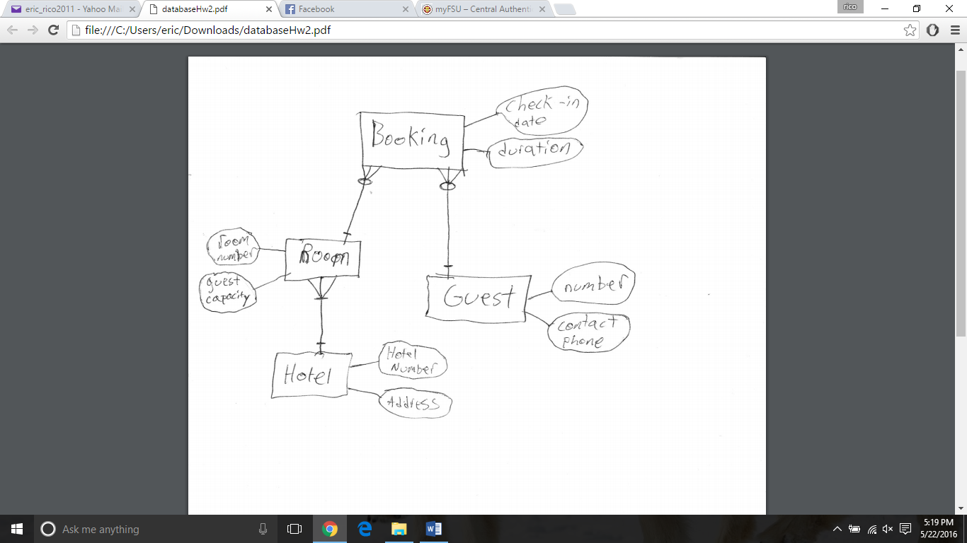

Make sure you note the:

a. Maximum and minimum cardinalities.

b. Point out any weak entity and tell why it's weak.

Room is ID-dependent on Hotel, and so is a weak entity.

Booking is ID-dependent on Room and Guest, and so is a weak entity.

c. Describe why a mandatory relationship in your diagram is mandatory.

(Deciding whether participation is mandatory or optional depends on the business rules we want to enforce. Often you could decide either way, so be sure to tell why).

Hotel to room is a mandatory relationship because in order for a building to count as a hotel it must have rooms to rent out.