Userguide AngularBlog

Installation
Angular blog can be obtained from https://github.com/ea234/AngularBlog
git clone https://github.com/ea234/AngularBlog.git
After the git clone is done, the Angular components have to be installed. This is done with the command "npm install," which must be run within the AngularBlog directory.

ea234@MsiZ370:~$ cd angular
ea234@MsiZ370:~/angular$ git clone https://github.com/ea234/AngularBlog.git
Klone nach &apos;AngularBlog&apos; …
remote: Enumerating objects: 776, done.
remote: Counting objects: 100% (776/776), done.
remote: Compressing objects: 100% (358/358), done.
remote: Total 776 (delta 567), reused 611 (delta 402), pack-reused 0 (from 0)
Empfange Objekte: 100% (776/776), 1.08 MiB | 12.76 MiB/s, fertig.
Löse Unterschiede auf: 100% (567/567), fertig.
ea234@MsiZ370:~/angular$ cd AngularBlog/
ea234@MsiZ370:~/angular/AngularBlog$ npm install
npm warn deprecated inflight@1.0.6: This module is not supported, and leaks memory. Do not use it. Check out lru-cache if you want a good and tested way to coalesce async requests by a key value, which is much more comprehensive and powerful.
npm warn deprecated rimraf@3.0.2: Rimraf versions prior to v4 are no longer supported
npm warn deprecated glob@7.2.3: Glob versions prior to v9 are no longer supported

added 1003 packages, and audited 1004 packages in 7s

176 packages are looking for funding
run `npm fund` for details

5 vulnerabilities (3 low, 2 high)

To address issues that do not require attention, run:
npm audit fix

To address all issues (including breaking changes), run:
npm audit fix --force

Run `npm audit` for details.
ea234@MsiZ370:~/angular/AngularBlog$

Application Start
To start the application you need 2 terminals.
In one terminal you have to start the Json-Server, with „npm run server“
In the other terminal you have to start the Application with „ng serve“.
Both comands must be run within the application root directory.
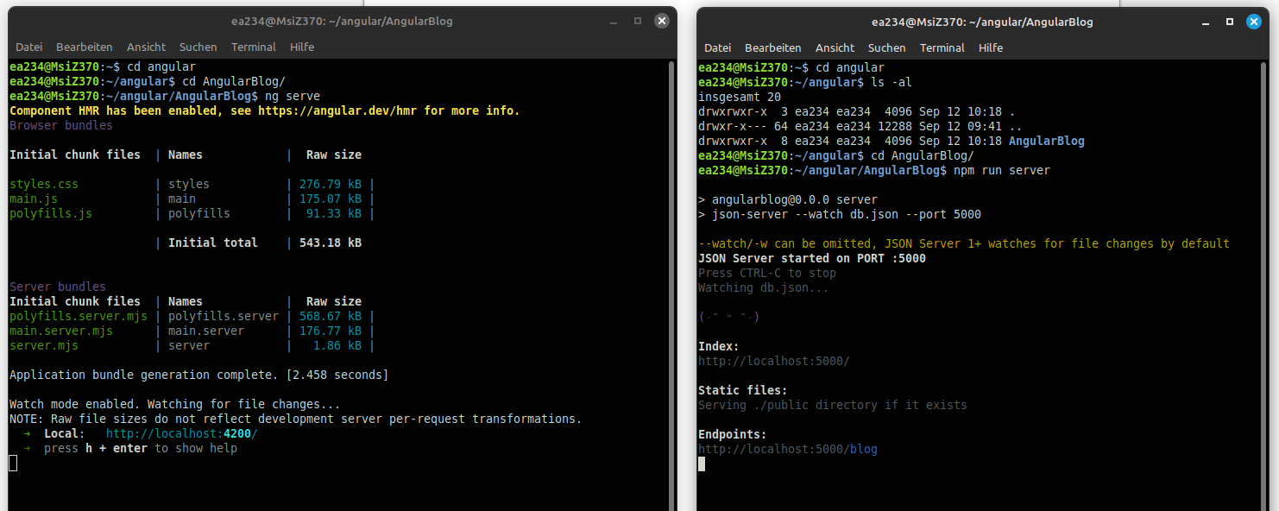
The application is now accessable with http://localhost:4200/blog
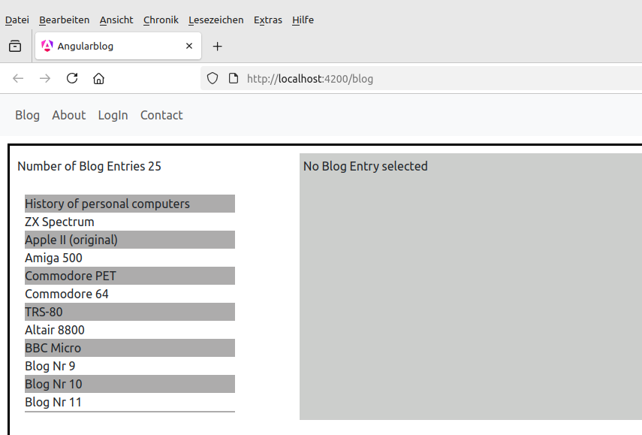

The json-Server ist accessable with „http://localhost:5000/blog“
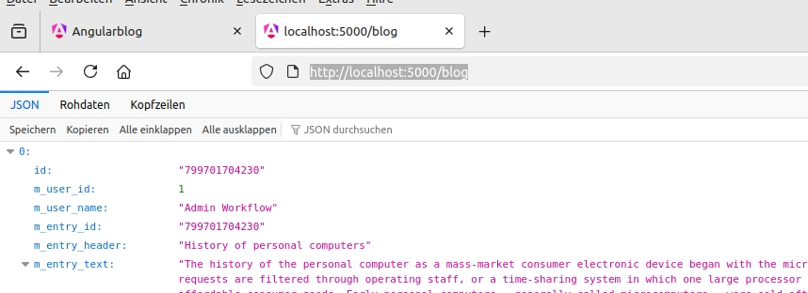

Startpage
The startpage shows a list of the blog-entries from the json server.
It also shows the number of blog-entries.
Initially there ist no blog-entry selected, to test the „BlogDetailEmptyComponent“.
The BlogDetailEmptyComponent is a placeholder, wich only displays a Message.
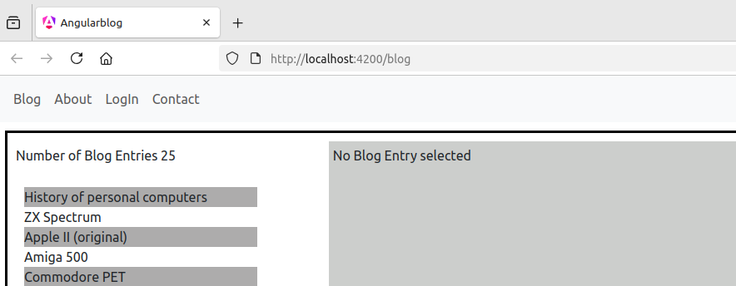
If an blog-entry is selected, it will be shown with the „BlogDetailLongComponent“.
This component is started with a route, which has the blog-entry-id as parameter.
This parameter is used to get the blog-entry from the server.
The Component uses the BlogJsonserverService, to communicate with the json-server.
If the blog-entry is not found, the component will show an alternate text.
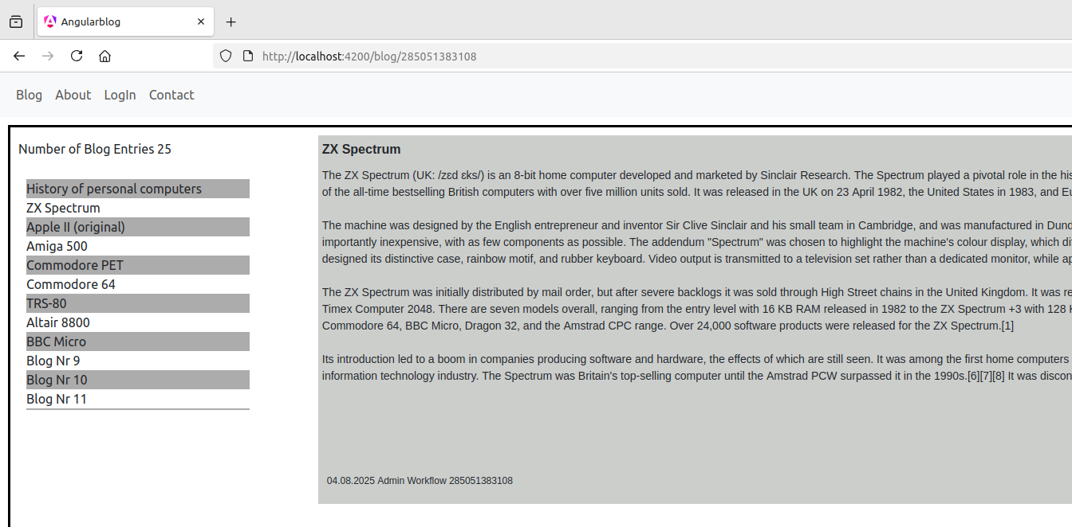

Log-In and BlogUser
This test application uses 2 predefined users, which are defined in the Service „BlogUserService“.
One user with the status „logged out“, the user id 0 and the name „Guest“.
One user with the status „logged in“, the user id 1 and the name „admin“.
All other users will have the user id 2, with the name from the login-form.

The login-form consist out of the 2 inputs „user name“ and „user password“.
Since there isn’t a real user-database behind it, the password for the login is „login“.
Errors will be displayed.
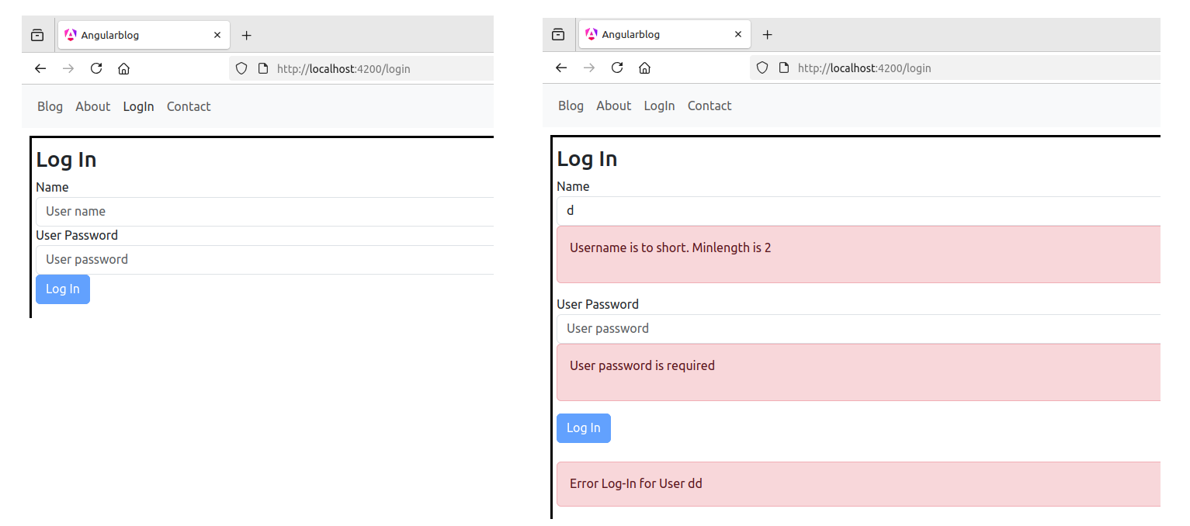
If the login is successfull, the following message is displayed.
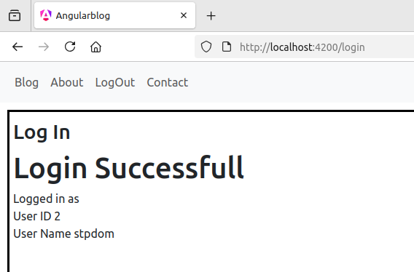

In the header component, there is now a „LogOut“ link displayed.
After a log in, you can navigate again to the blog section.

Blogview for logged in Users
If a user is logged in, a button for new blog entries is shown.
In the blog list, there is a link to edit the blog entry.
This link is only shown, when the entry-user-id matches with the logged in user-id.
