Search Application – Phase 1

Search Application is an application that can be used to search tweets or comparable data of your choice.

This document contains details on Installing and Running this application using Tweet and Amazon

datasets.

Before you start running our backend application, please install the driver (NodeJS) to connect to MongoDB.

## Install:

1. Check if Node and NPM are already installed by running the following commands on terminal:
2. which node
3. which npm

You will get the following output if it is already installed (**Skip the next install section**).

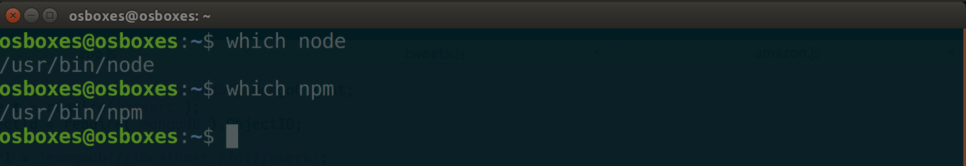

If these commands return no output but just pass silently, then you must install them (**follow the install section**).

1. Install Node and NPM

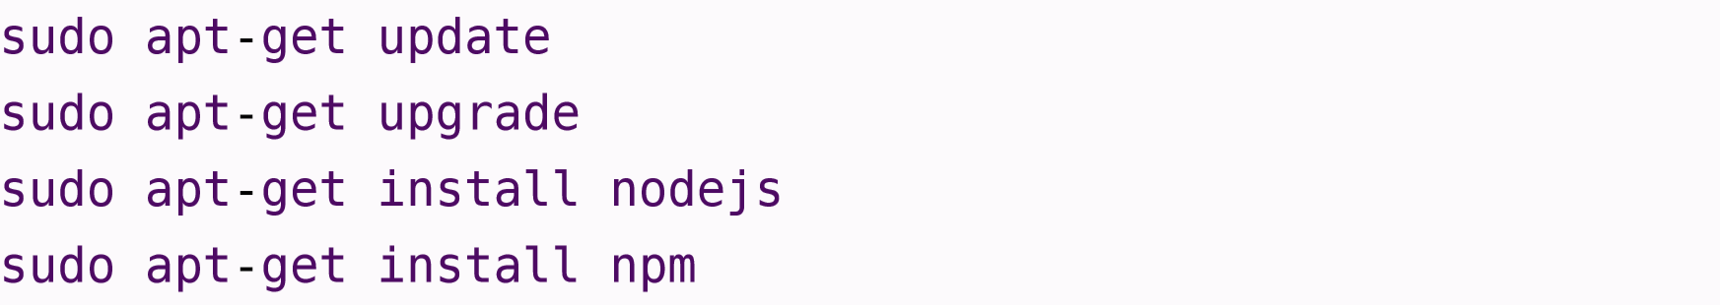

1. Initialize npm by running - **npm init**
2. Install MongoDB package for NodeJS.



## Running Backend Application for tweets collection:

Prerequisites:

1. Save tweets.js file in your home directory
2. Download tweets_sandy.csv collection from <http://kelvin.ist.rit.edu/~mjmic> and save it in your home directory
3. Import the tweets

(**Note:** Make sure you exit the mongo shell (using **exit**) and issue the following command at the system prompt)

**mongoimport --headerline --db users --collection tweets_sandy --drop --type csv --file tweets_sandy.csv**

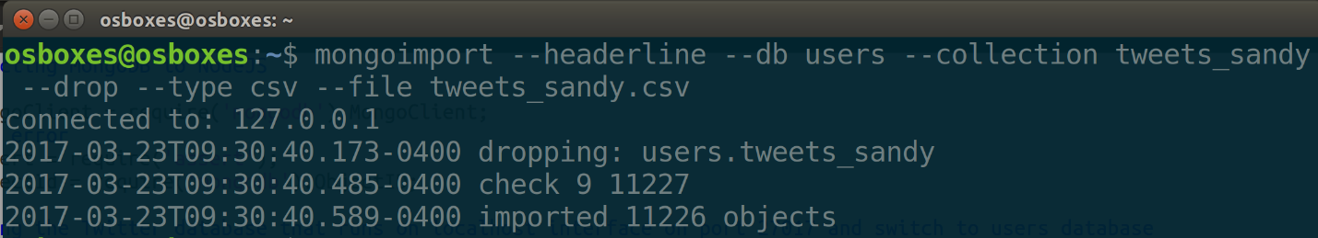

1. Start mongo client by running **mongo**

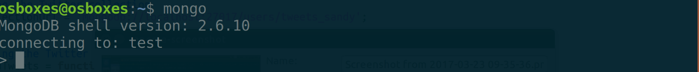

1. Access Users database by running **use users**

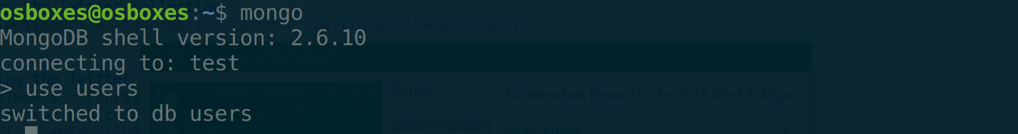

1. Show that you have tweets_sandy collection under users database by running **show collections**

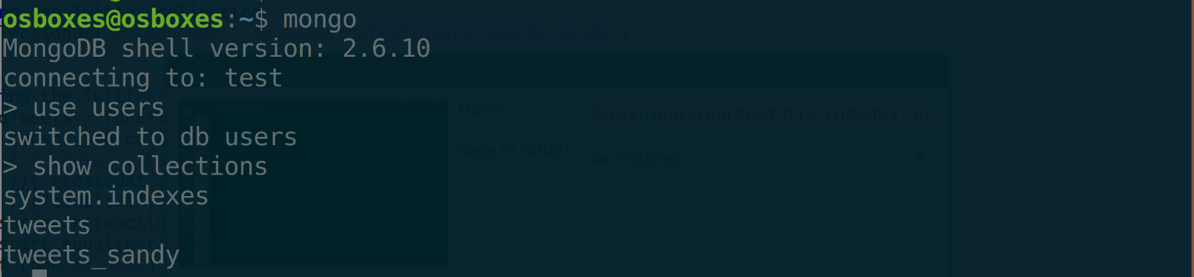

1. Exit mongo client by running **exit**

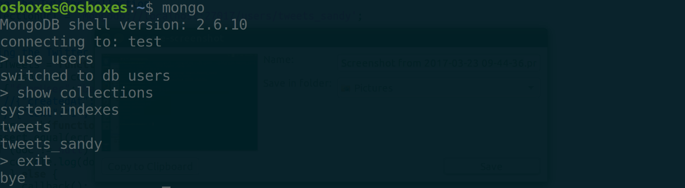

1. Run the program using **node tweets.js**



You will get the following output:

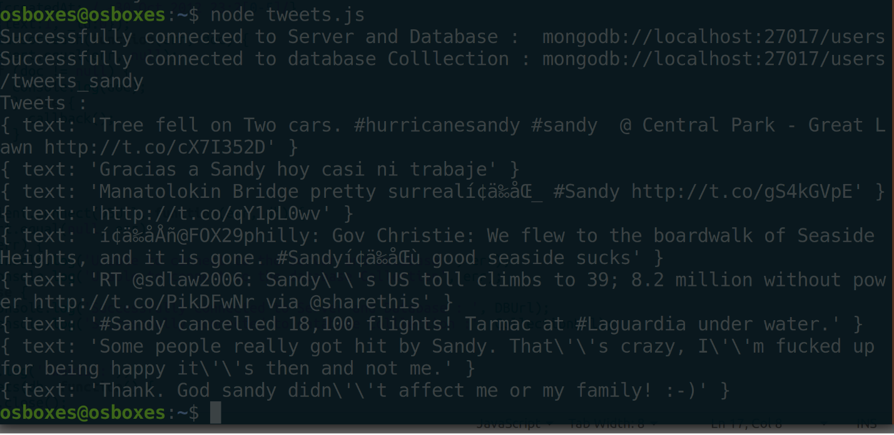

## Running Backend Application for amazon collection:

Prerequisites:

1. Save amazon.js file in your home directory
2. Download tweets_sandy.csv collection from RIT myCourses and save it in your home directory
3. Import amazon

(**Note:** Make sure you exit the mongo shell (using **exit**) and issue the following command at the system prompt)

**mongoimport --headerline --db users --collection Amazon_Automotive --drop --type json --file Amazon_Automotive.json**

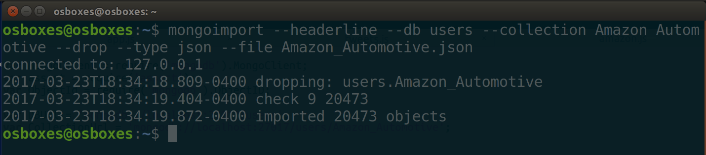

1. Start mongo client by running **mongo**

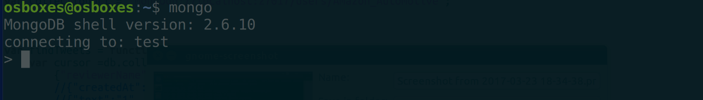

1. Access Users database by running **use users**

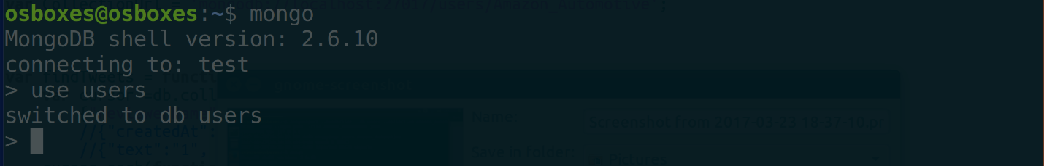

1. Show that you have Amazon_Automotive collection under users database by running **show collections**

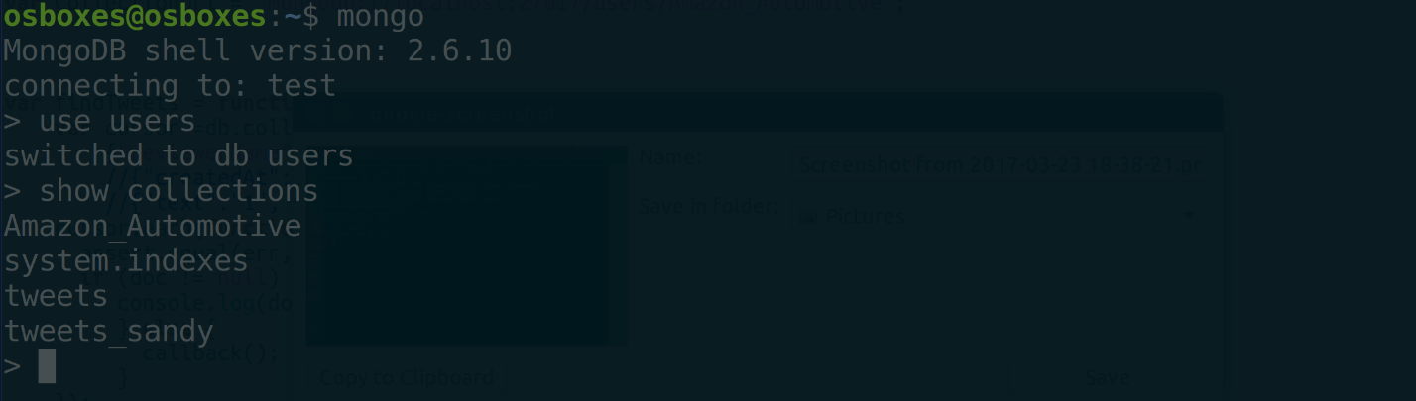

1. Exit mongo client by running **exit**

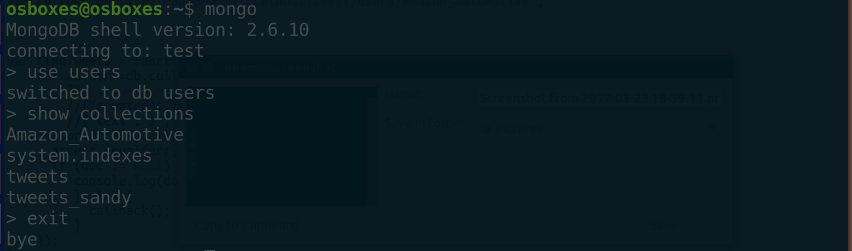

1. Run the program using **node amazon.js**



You will get the following output:

